Supplemental Material
Methods
Motion Correction. The individual T1-MRI sequence was regarded as the reference volume and all subsequent scans were rigidly co-registered to native space (SPM 12, Wellcome Trust Center for Neuroimaging, UCL). All dynamic PET images were corrected for motion by rigid co-registration between each frame with the individual T1-MRI image. Within the spatial correspondence of MR sequence and PET frames, TOF-MRA to native space was performed using translation (3 parameter) followed by a rigid registration (6 parameter), and the same matrices were applied to the targeted ICA mask. The co-registration between PET frames and FLAIR images\ infarction volume was achieved by same steps. All co-registration were visually confirmed using ITK-SNAP version 3.8.
PVE. A modified Mueller-Gaertner method was employed for partial volume effect (PVE) correction (1,2). The tracer concentration of background potentially spilled over into the ICV mask (spill-out correction) at the initial time points, and a strong radial tracer concentration gradient was determined toward the brain (spill-in correction) at the late time points. The accurate tracer concentration estimation of the targeted ICV mask entails the account the radial, circumferential, and temporal variabilities of the background activity surrounding the ICV mask. A 3D isotropic Gaussian function with 3 mm full width at half maximum (FWHM) was used to represent the PET/MR scanner’s point spread function. The detailed PVE correction producers were described previously (2,3).
CMRGlc calculation. After the motion and PVE corrections, the IDIF was derived and interpolated with a step length of 1. The voxel-wise Patlak graphical analysis was employed to generate the absolute CMRGlc map by the time-activity curve (IDIF) derived from corrected PET frames (4). In this analysis, a linear regression function was fitted to the Patlak graphical analysis–transformed data, including data from 25 min after injection until the end of the study (9 time points). The CMRGlc parametric images (umol/100 g/min) was then derived by the slope of the linear regression which multiplied by the individual plasma glucose level (mmol/L) and divided by the lumped constant (0.89, irreversible FDG model)(5). All quantification analysis were performed in the MATLAB 2016b platform.
SUVR calculation. For the assessment of the potential of noninvasive quantification modeling, an alternative approach was performed that involved calculating the ratio of the average activity concentration in the VOI to that in a reference region. The static PET frame and T1-MRI image were first co-registered with rigid-body intermodal registration. The T1-MRI sequence was segmented into gray matter (GM), white matter (WM), and cerebrospinal fluid (CSF) probability maps. The transformation matrix derived from standard SPM T1-MRI segmentation was used to transfer the whole cerebellum mask from the standard Montreal Neurological Institute (MNI) space to native PET space. The SUVR map was obtained by count normalizing each voxel’s intensity to the mean activity concentration in a reference region (whole cerebellum).

Table S1. The diagnostic performances (area of curve, AUC) of quantitative values.
 | HC-preoperative |  |  | HC-postoperative
 | CMRGlc | SUVR | P | CMRGlc | SUVR | P
MCA | 0.966±0.02 | 0.826±0.06 | 0.037 | 0.911±0.04 | 0.775±0.07 | 0.04
PCA | 0.966±0.02 | 0.697±0.08 | 0.001 | 0.954±0.02 | 0.851±0.06 | 0.09
ACA | 0.938±0.03 | 0.714±0.08 | 0.005 | 0.901±0.05 | 0.677±0.08 | 0.006
BA | 0.966±0.02 | 0.779±0.07 | 0.019 | 0.923±0.04 | 0.692±0.08 | 0.028
CA | 0.923±0.04 | 0.743±0.07 | 0.046 | 0.820±0.07 | 0.828±0.06 | 0.93
P value was derived from DeLong et al test.

Figure S1. The PET/MR data acquisition.
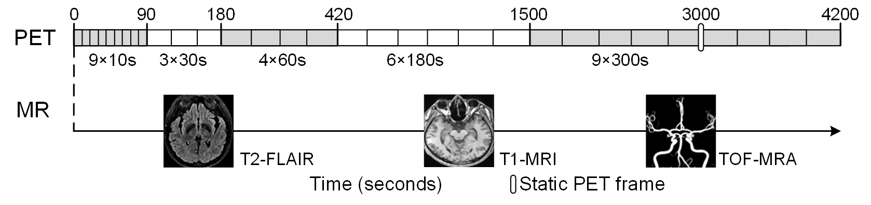
Figure S2. The supratentorial cerebral arterial territories were overlapped on T1-MRI image at the Montreal Neurological Institute space.
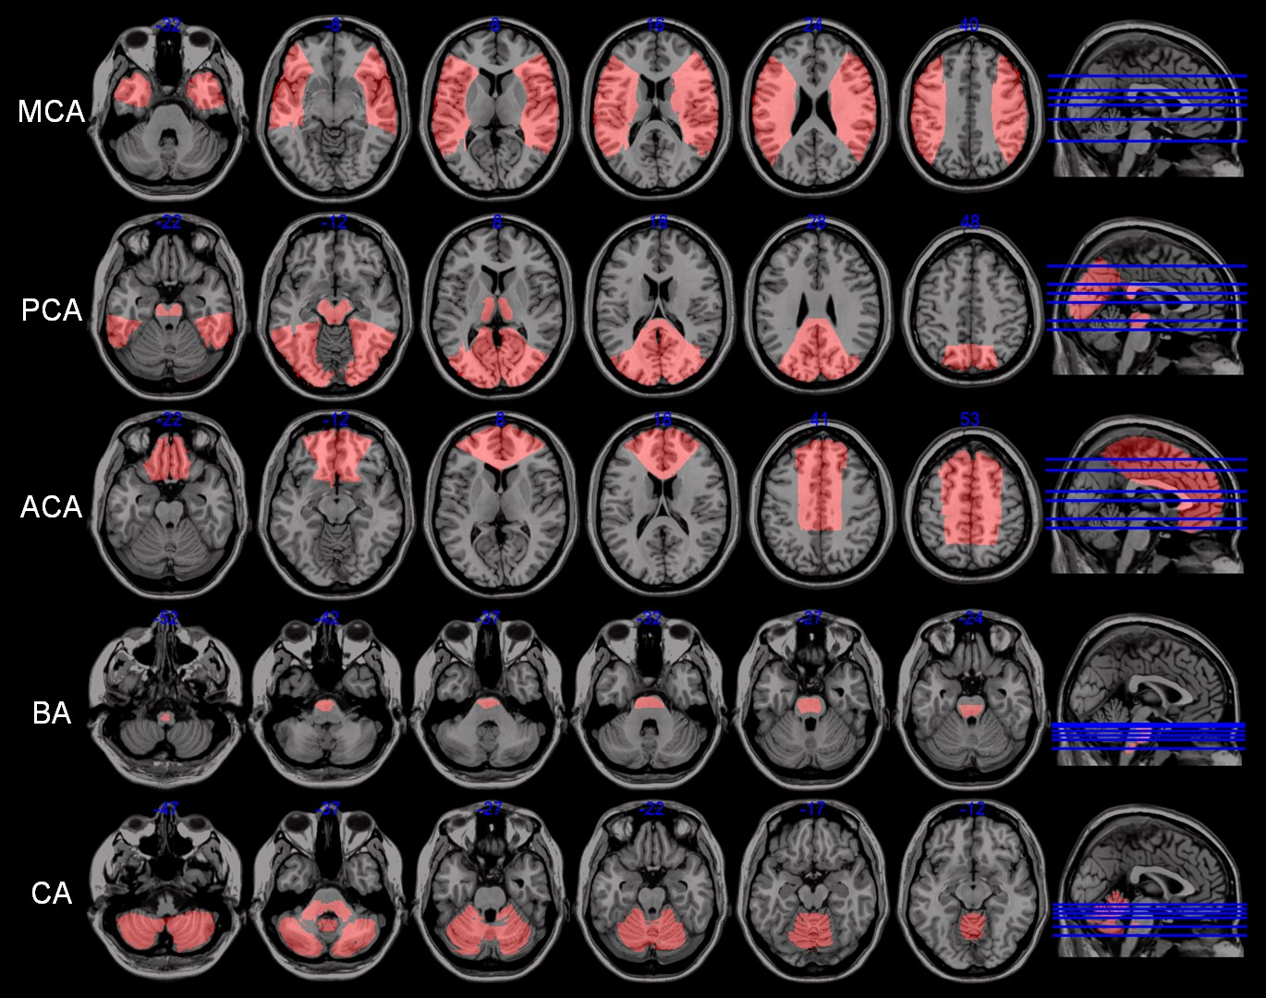

Figure S3. The bilateral (left) and unilateral (right) petrous ICA masks derived from a representative healthy control (M, 60 y) and a ICVD patient (M, 43 y).
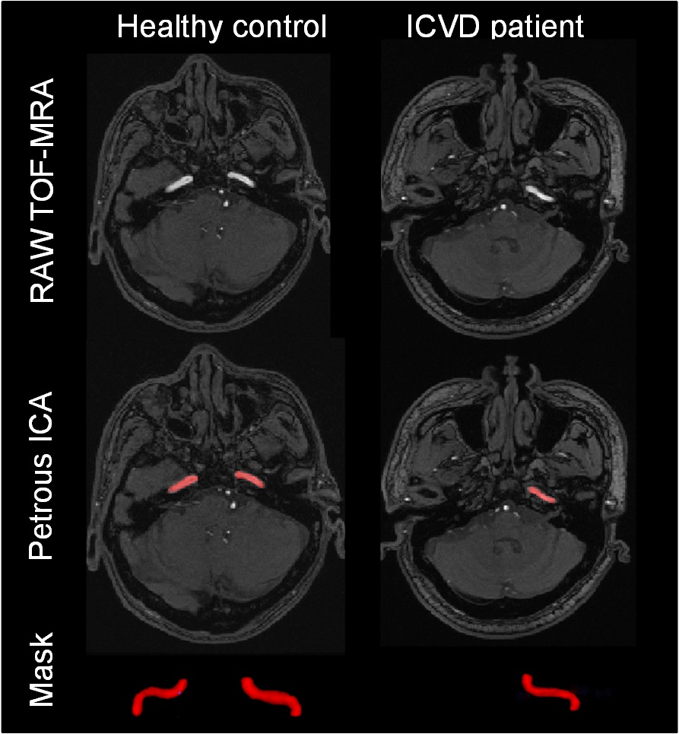

Figure S4. The raw and PVE-corrected IDIF curve from a representative healthy control (M, 60 y) and a ICVD patient (M, 43 y).
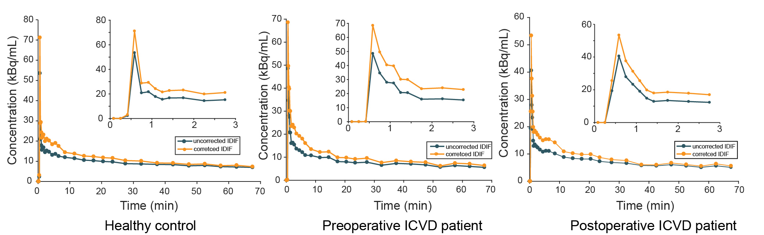

Figure S5. Bland-Altman plot of cerebral arterial territories (anterior, middle, and posterior cerebral artery (ACA, MCA, and PCA), basilar artery (BA), and cerebellar artery (CA) territory) demonstrates close agreement for CMRGlc values from unilateral and bilateral IDIF.
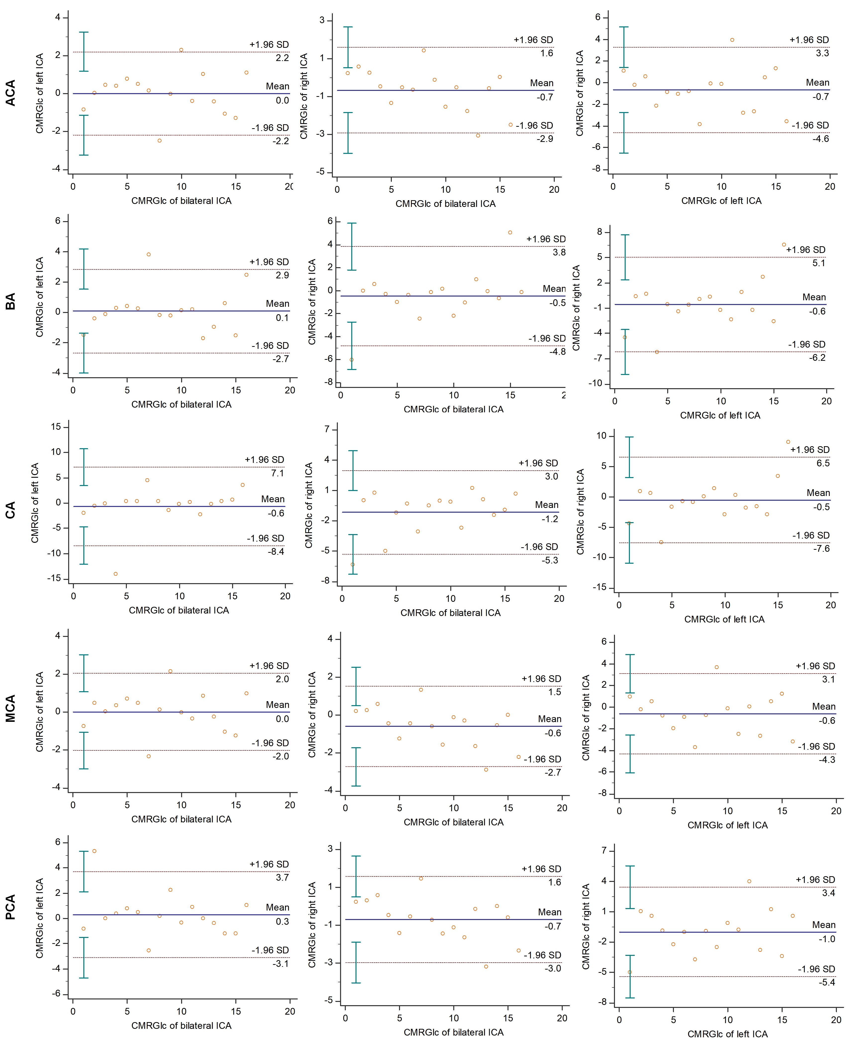

Figure S6. The relationship between mRS score and CMRGlc values and SUVR.

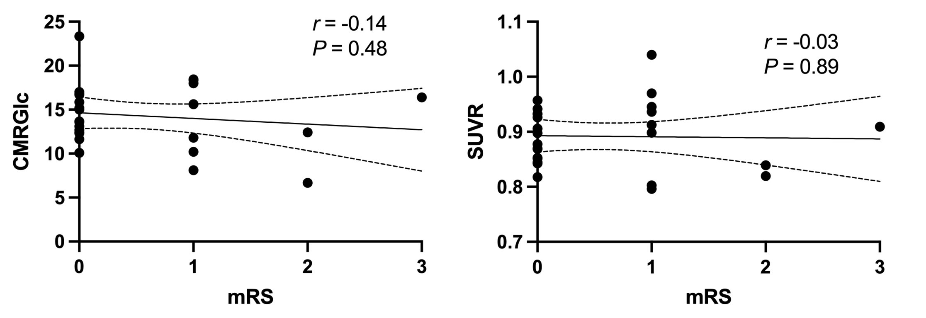

Reference
1. Müller-Gärtner HW, Links JM, Prince JL, et al. Measurement of radiotracer concentration in brain gray matter using positron emission tomography: MRI-based correction for partial volume effects. J Cereb Blood Flow Metab. 1992;12:571-583.

2. Sundar LK, Muzik O, Rischka L, et al. Towards quantitative [18F]FDG-PET/MRI of the brain: Automated MR-driven calculation of an image-derived input function for the non-invasive determination of cerebral glucose metabolic rates. J Cereb Blood Flow Metab. 2019;39:1516-1530.

3. Shiyam Sundar LK, Muzik O, Rischka L, et al. Promise of Fully Integrated PET/MRI: Noninvasive Clinical Quantification of Cerebral Glucose Metabolism. J Nucl Med. 2020;61:276-284.

4. Patlak CS, Blasberg RG. Graphical evaluation of blood-to-brain transfer constants from multiple-time uptake data. Generalizations. J Cereb Blood Flow Metab. 1985;5:584-590.

5. Graham MM, Muzi M, Spence AM, et al. The FDG lumped constant in normal human brain. J Nucl Med. 2002;43:1157-1166.

