Additional file 1

Integrated transcriptome sequencing approach provides insights into the mechanism of stamen petaloidy in Clivia miniata
Xinghua Zhao¹, Ling Yue¹, Dan Li¹, Xiuli Feng¹, Xi Ren¹, Jingyu Yue², Jiajun Lei²*
¹Institute of Floriculture, Liaoning Academy of Agricultural Sciences, Shenyang 110161, Liaoning, China
²College of Horticulture, Shenyang Agricultural University, Shenyang, 110866, Liaoning, China
* Corresponding author
E-mail address: Jiajun Lei (jiajunlei@syau.edu.cn); Tel.: +86 13478198765.

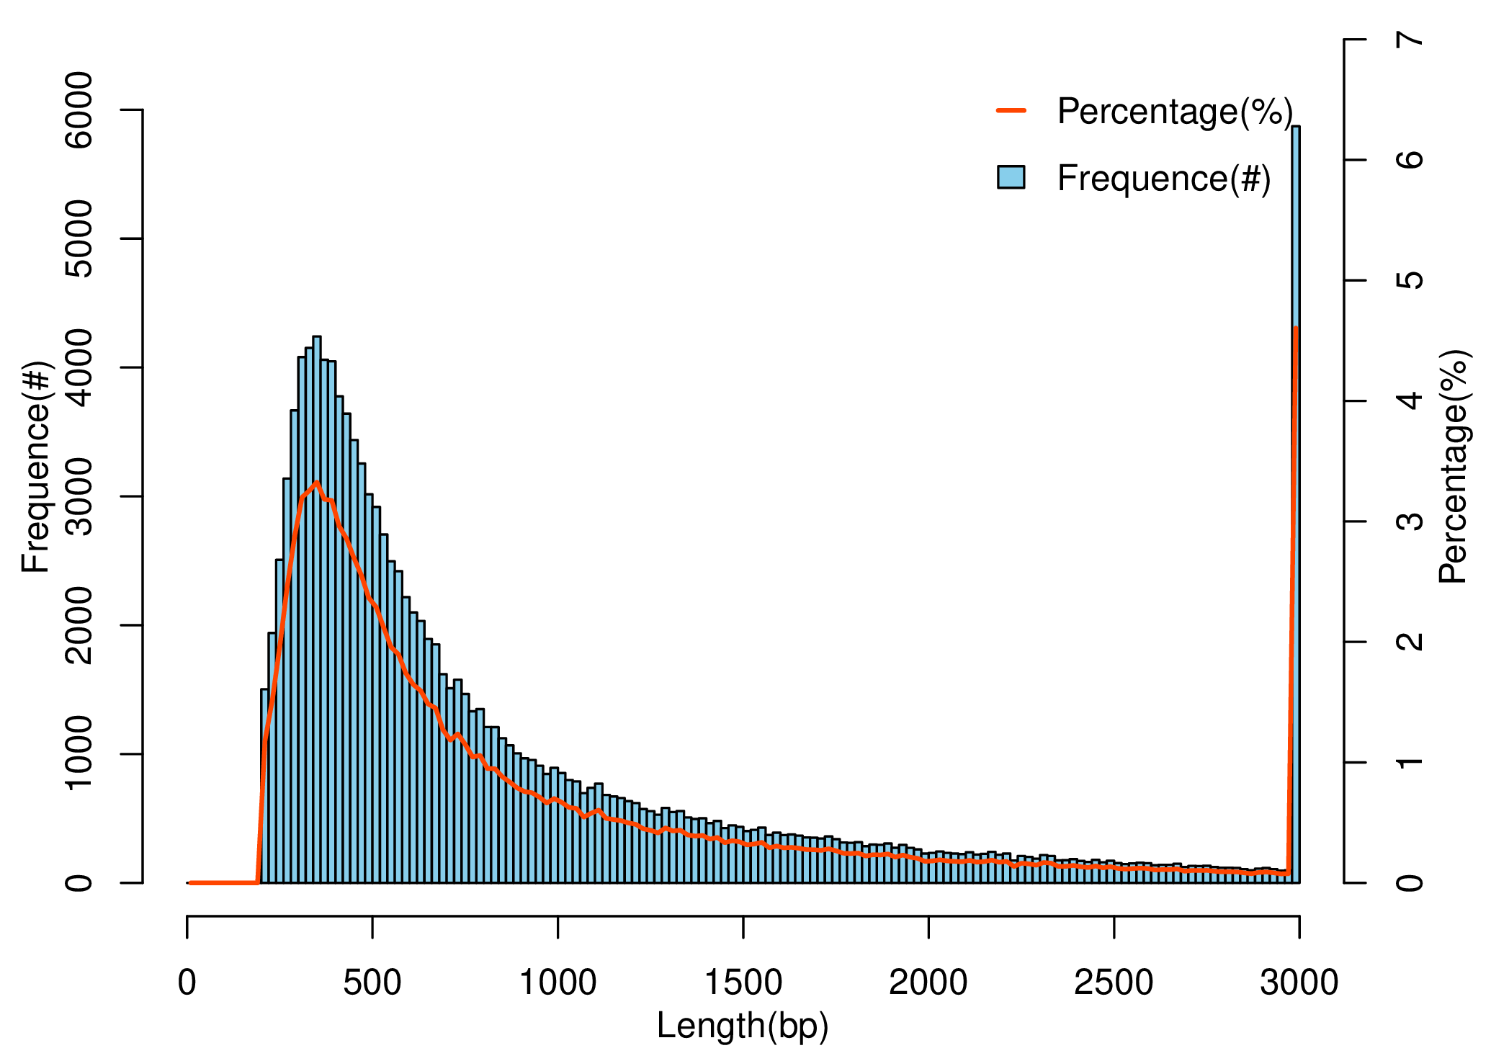
Figure S1. Length distribution of Unigene.
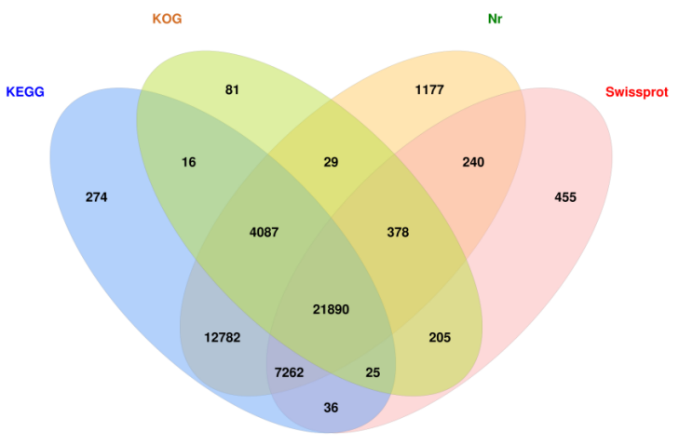
Figure S2. The numbers of unigenes annotated in four database (KOG, SwissProt, KEGG, Nr) at an E-value < 10⁻⁵.
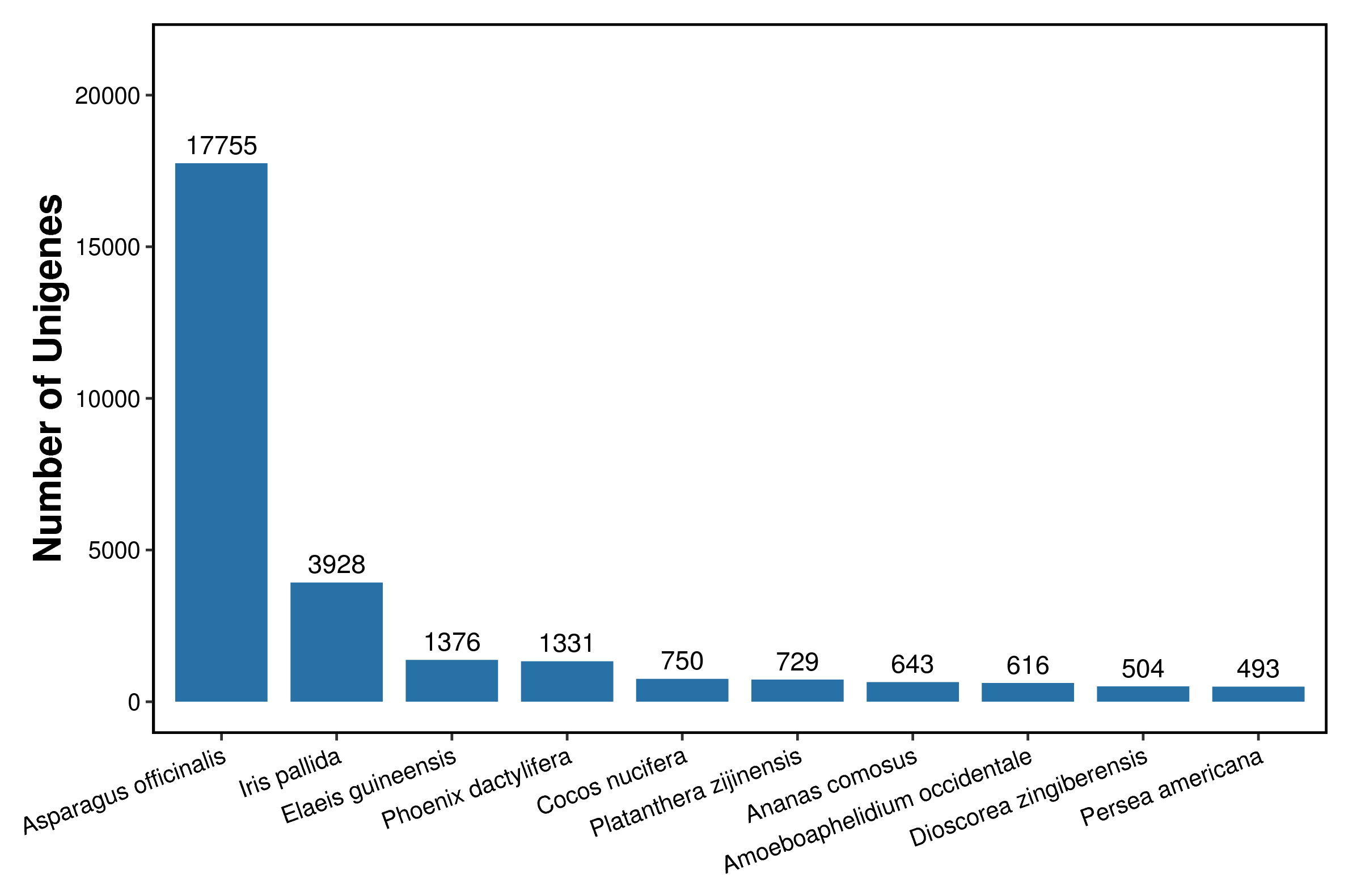
Figure S3. Number of homologous sequences from various species matched to Unigene sequences in the Nr database.
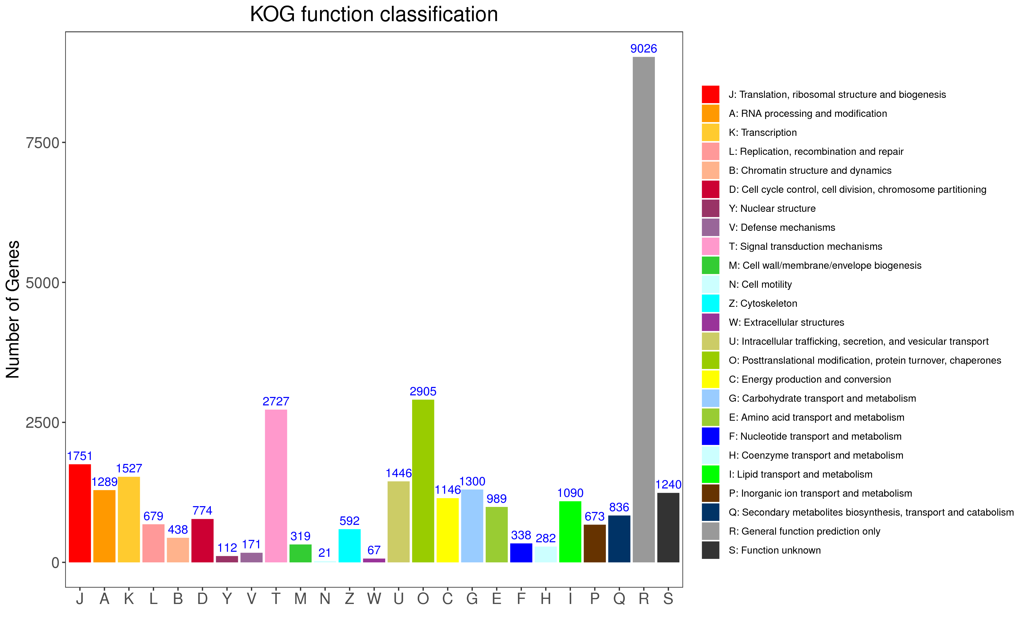
Figure S4. KOG classification statistics.
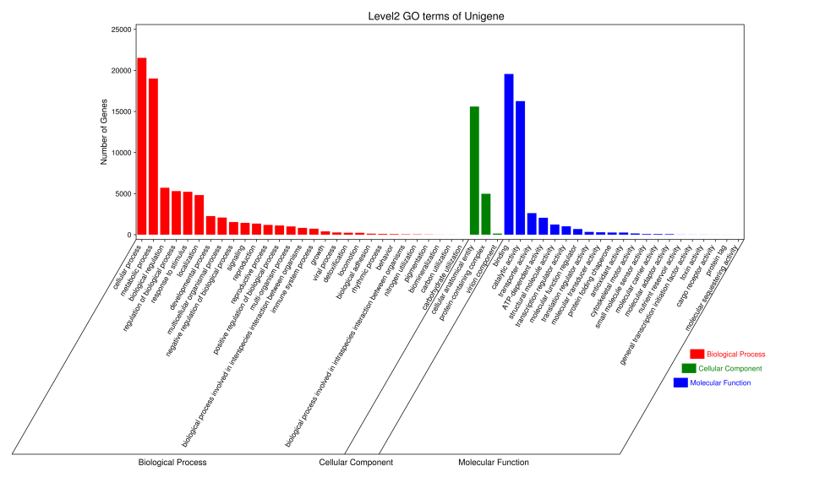
Figure S5. GO secondary classification statistics.
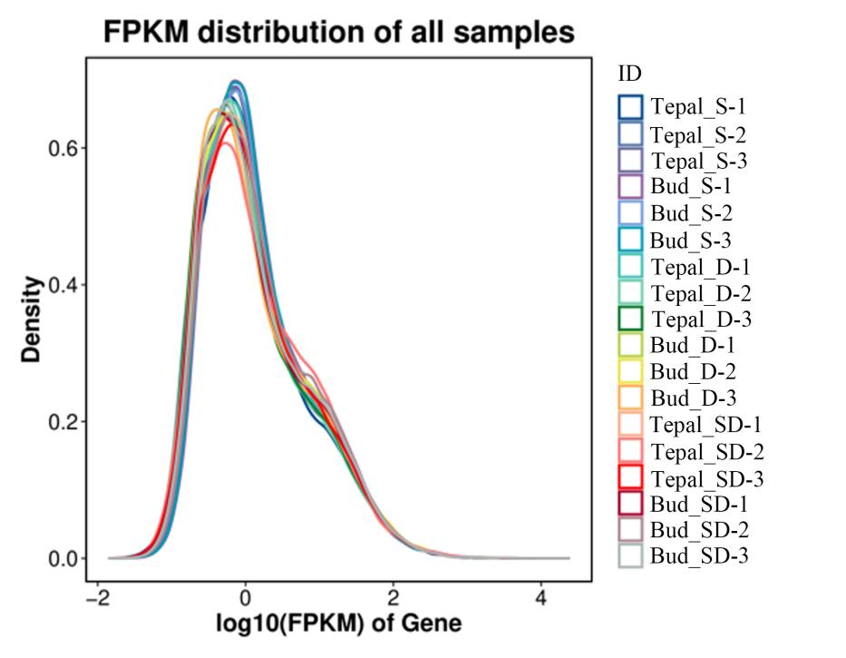
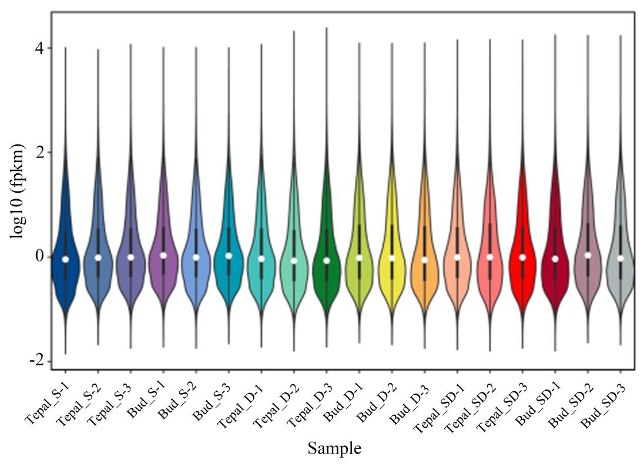
Figure S6. Gene expression abundance distribution plot and sample expression violin plot.
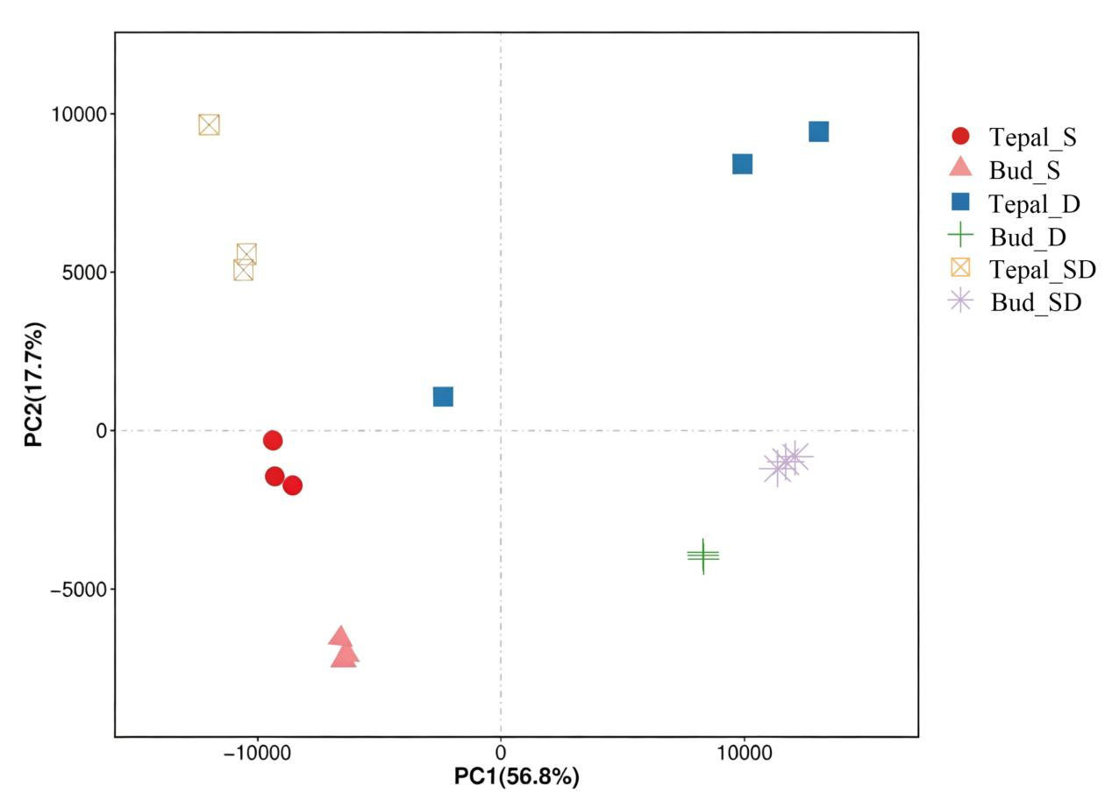
Figure S7. Sample principal component analysis.

