Organophosphate esters in children and adolescents in Liuzhou city, China: Concentrations, exposure assessment and predictors
Meng Yu, ¹ Xiang Li, ¹ Bingqing Liu, ³ Yaping Li, ¹ Ling Liu, ¹ Limei Wang, ¹ Lulu Song, ^{1, 4} Youjie Wang, ^{1,4} Liqin Hu, *^{, 2} Surong Mei, **, ¹

¹ State Key Laboratory of Environment Health (Incubation), Key Laboratory of Environment and Health, Ministry of Education, Key Laboratory of Environment and Health (Wuhan), Ministry of Environmental Protection, School of Public Health, Tongji Medical College, Huazhong University of Science and Technology, #13 Hangkong Road, Wuhan, Hubei, 430030, China
² Wuhan Children's Hospital (Wuhan Maternal and Child Healthcare Hospital), Tongji Medical College, Huazhong University of Science and Technology, Wuhan, Hubei, China
³ Department of Women’s Healthcare, Women’s Hospital, Zhejiang University School of Medicine, #1 Xueshi Road, Hangzhou, Zhejiang, 310006, China
⁴ Department of Maternal and Child Health, School of Public Health, Tongji Medical College, Huazhong University of Science and Technology, Wuhan, Hubei, China

** Corresponding author address: School of Public Health, Tongji Medical College, Huazhong University of Science and Technology, 13 Hangkong Road, Wuhan 430030, China.
E-mail: surongmei@hust.edu.cn.
* Corresponding author address: Wuhan Children's Hospital (Wuhan Maternal and Child Healthcare Hospital), Tongji Medical College, Huazhong University of Science and Technology, Wuhan, Hubei, China.
E-mail: liqinhu1992@163.com.

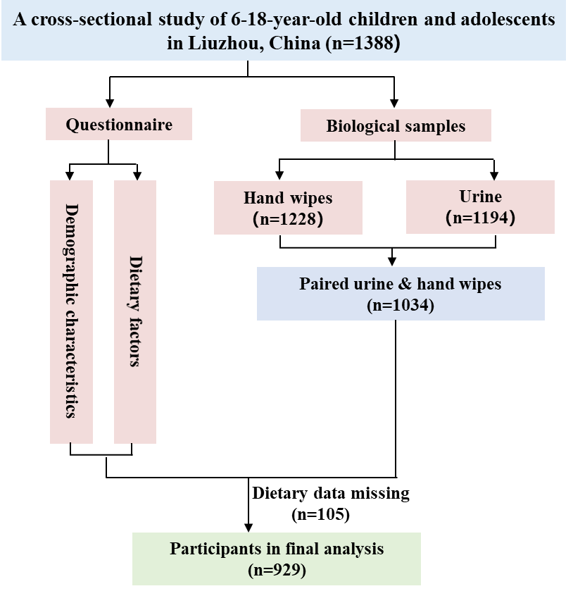Fig S1. The detailed inclusion criteria for the study participants.

Table S1. Weekly consumption of seven foodstuffs.
Food group | N | Non-consumers (%) | Median | P25 | P95
Meat | 929 | 11.3 | 4 | 2 | 10
Fish | 929 | 35.3 | 1 | 0 | 3
Eggs | 929 | 15.1 | 3 | 1 | 7
Dairy products | 929 | 16.8 | 4 | 2 | 7
Fruits | 929 | 10.0 | 4 | 2 | 7
Vegetables | 929 | 9.8 | 6 | 3 | 11
Beans | 929 | 19.9 | 2 | 1 | 7

Table S2. Parameters used for the calculation of estimated daily intake (EDI).
Parameter | TCIPP | TDCIPP | TPHP | TBOEP
MWp | 327.6 | 430.9 | 326.3 | 398.5
MWm | 309.1 | 320.0 | 250.2 | 298.3
FUE ª based on human liver S9 fraction experiment | 0.28 | 0.68 | 0.19 | 0.16
F_{UE} ª based on human liver microsome (HLM) experiment | 0.33 | 0.46 | 0.41 | 0.81
Note: ª (Van den Eede et al., 2013)

Table S3. Parameters used for calculation of EDI by different age and gender groups.
Age groups | V_{urine} (mL)
children (6-11 years) | 600 ª
female adolescents (12-15 years) | 950 ª
male adolescents (12-15 years) | 950 ª
female adolescents (16-18 years) | 1200 ª
male adolescents (16-18 years) | 1400 ª
Note: ª (Zhang et al., 2018b)

Table S4. Parameters used for the calculation of dermal exposure dose (DED).
Parameter | TCEP | TCIPP | TDCIPP | TPHP | EHDPHP | TBOEP | TCrP
AF (%) | 28 ª | 25 ª | 13 ª | 22 ^{b} | 22 ^{b} | 22 ^{b} | 22 ^{b}
Note: ª (Abou-Elwafa Abdallah et al., 2016)
^{b} Other OPEs were estimated with the average dermal accessibility rate (22%) for TCEP, TCIPP, and TDCIPP

Table S5. Parameters used for the calculation of DED by different age and gender groups.
Age groups | Head (m²) | Hand (m²)
children (6-11 years) | 0.066 ª | 0.051 ª
adolescents (12-15 years) | 0.073 ª | 0.072 ª
adolescents (16-18 years) | 0.075 ª | 0.083 ª
Note: ª (USEPA, 2011)

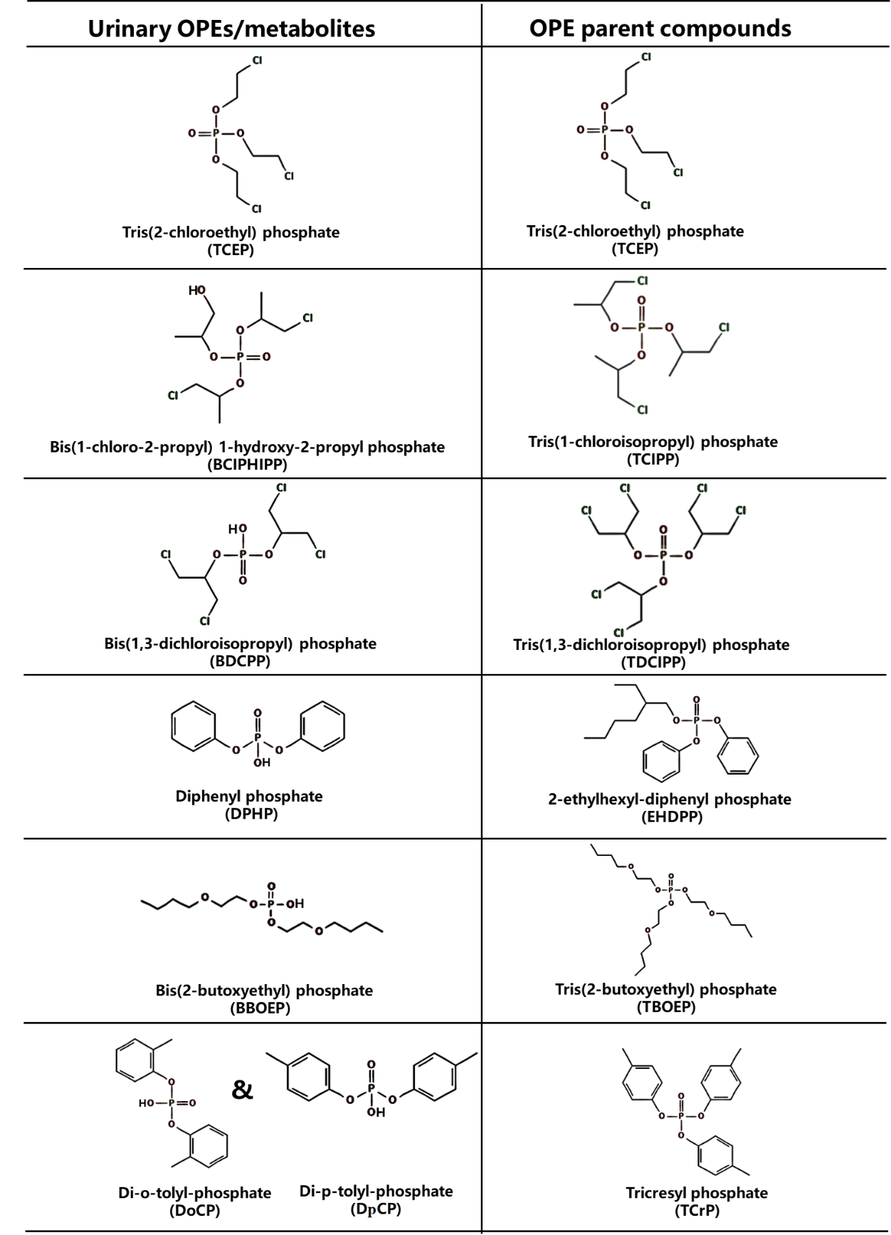
Fig S2. OPE metabolites in urine and their parent compounds in hand wipes were simultaneously entered into the multivariate linear regression models, in which the structures of compounds were uploaded from PubChem Compound.

Table S6. Comparison of median concentrations of OPE metabolites (ng/mL) reported in various studies.
Countries | Population | Sample year | TCEP | BCIPHIPP | BDCIPP | DBP | 4-OH-DPHP | DPHP | BBOEP | DoCP & DpCP | References
Southwest China  (n=929) | Children and adolescents  (6-18 years) ª | 2018 | 0.27 | 0.37 | 0.19 | nd | nd | 0.22 | 0.16 | 0.05 | This study
Eastern China  (n=306) | Adolescents  (12-15 years) ^{b} | 2015 | 0.28 | 1.47 | 6.17 | 2.54 | nd | 0.42 | 0.11 |  | (Ding et al., 2019)
South China  (n=411) | Children  (6-14 years) ª | 2015 |  |  | 0.05 | 0.12 |  | 0.28 | 0.05 | 0.02 | (Chen et al., 2018)
Central China  (n=227) | Children  (0-5 years) ^{b} | 2016 |  |  | 0.08 | 0.06 |  | 0.27 | 0.04 | 0.004 | (Zhang et al., 2018a)
13 cities in China  (n=323) | General population  (1-97 years) ^{b} |  |  |  | 0.15 | 0.30 |  | 0.29 | 0.026 |  | (Zhang et al., 2018b)
Hong Kong, China  (n=31) | Children  (4-6 years) ^{b} | 2016 | 0.02 |  |  |  |  |  |  |  | (Li et al., 2019)
USA  (n=427) | Adolescents  (12-19 years) ^{b} | 2013-2014 |  |  | 1.43 | 0.21 |  | 1.44 |  |  | (Ospina et al., 2018)
USA  (n=203) | Children  (3-6 years) ª | 2014-2016 |  | 1.3 | 6.0 |  |  | 2.3 |  |  | (Hoffman et al., 2018)
Belgium  (n=582) | Adolescents  (14-15 years) ª | 2017–2018 | nd | 0.71 | 0.34 | nd | nd | 1.37 | nd |  | (Bastiaensen et al., 2021)
Norway  (n=54) | Children  (6-12 years) ª | 2012 |  |  | 0.23 | nd |  | 1.0 | nd |  | (Cequier et al., 2015)
Australia  (n=400, 20 pools) | Children  (0-5 years) ^{c} | 2014–2015 | nd | 0.43 | 2.60 |  |  | 25 | 0.32 |  | (He et al., 2018b)
Australia  (n=51) | Children  (0-2 years) ^{b} | 2015-2016 |  | 0.93 | 3.30 |  |  | 1.0 | 0.10 |  | (He et al., 2018a)
Continued
Japan  (n=128) | Children  (7-12 years) ^{b} | 2009-2010 | 0.05 | 0.38 | 0.13 | nd | nd | 0.46 | 0.11 |  | (Bastiaensen et al., 2019)
Japan  (n=400) | Children  (7 years) ^{b} | 2012-2017 |  | 0.18 | 0.07 | nd | 0.22 | 0.32 | 0.20 |  | (Bastiaensen et al., 2020)
Note: ª Specific gravity corrected median concentration
^{b} uncorrected median concentration
^{c} pooled mean concentration

Table S7. Comparison of concentrations of OPEs (ng/wipe) reported in various studies.
Countries | Population | Sample year | TCEP | TCIPP | TDCIPP | TPHP | EHDPP | TBOEP | TCrP | References
Southwest China  (n=929) | Children and adolescents  (6-18 years) ª | 2018 | 0.90 | 9.49 | 2.02 | 3.76 | 10.9 | 0.32 | 0.78 | This study
South China  (n=51) | Adults  (>18 years) ª | 2015-2016 | 2.6 | 6.7 | 7.2 | 4.4 | 8.7 | 2.4 | nd | (Tan et al., 2018)
South China  (n=31) | Children ª  (1-5 years) ª | 2015-2016 | 3.0 | 4.6 | 14.8 | 3.3 | 6.7 | 3.0 | nd | (Tan et al., 2018)
Central China  (n=38) | Adults  (>18 years) ª |  | 1.2 | 21 | 1.3 | 19.7 | nd | 5.6 | 0.4 | (Tao et al., 2018)
USA  (n=77) | Children  (3-6 years) ª | 2005-2011 | 47.5 | 71.60 | 132.4 | 18.29 | 22.90 |  |  | (Hammel et al., 2020)
USA  (n=202) | Children  (3-6 years) ^{b} | 2014-2016 | 27.5 | 89.8 | 143.6 | 18.2 | 14.9 | 740.8 |  | (Phillips et al., 2018)
USA  (n=43) | Children  (2-5 years) ^{b} | 2009-2010 | nd | 31.3 | 74.2 |  |  |  |  | (Stapleton et al., 2014)
Netherlands  (n=21) | Children  (8-18 months) ª | 2013 | 6.9 | 65 | 25 | 4.7 |  |  | 1.3 | (Sugeng et al., 2017)
Netherlands  (n=50) | Children  (8-18 months) ª | 2013 | 25 | 4.5 | 2.8 | 2.9 |  |  |  | (Sugeng et al., 2020)
Sweden  (n=100) | Children  (4 years) ª | 2015 | nd | nd | nd | 12 |  | 220 |  | (Larsson et al., 2018)
Norway  (n=61) | Adults  (>18 years) ª | 2013-2014 | nd | 37 | nd | nd | 11 | 46 | nd | (Xu et al., 2016)
Note: ª Median concentration
^{b} Geometric mean concentration

References
Abou-Elwafa Abdallah, M., Pawar, G., Harrad, S., 2016. Human dermal absorption of chlorinated organophosphate flame retardants; implications for human exposure. Toxicol Appl Pharmacol. 291, 28-37.
Bastiaensen, M., Ait Bamai, Y., Araki, A., Goudarzi, H., Konno, S., Ito, S., Miyashita, C., Yao, Y., Kishi, R., Covaci, A., 2020. Temporal trends and determinants of PFR exposure in the Hokkaido Study. Int J Hyg Environ Health. 228, 113523.
Bastiaensen, M., Ait Bamai, Y., Araki, A., Van den Eede, N., Kawai, T., Tsuboi, T., Kishi, R., Covaci, A., 2019. Biomonitoring of organophosphate flame retardants and plasticizers in children: Associations with house dust and housing characteristics in Japan. Environ Res. 172, 543-551.
Bastiaensen, M., Gys, C., Colles, A., Verheyen, V., Koppen, G., Govarts, E., Bruckers, L., Morrens, B., Loots, I., De Decker, A., Nelen, V., Nawrot, T., De Henauw, S., Van Larebeke, N., Schoeters, G., Covaci, A., 2021. Exposure levels, determinants and risk assessment of organophosphate flame retardants and plasticizers in adolescents (14–15 years) from the Flemish Environment and Health Study. Environment International. 147, 106368.
Cequier, E., Sakhi, A. K., Marcé, R. M., Becher, G., Thomsen, C., 2015. Human exposure pathways to organophosphate triesters - a biomonitoring study of mother-child pairs. Environ Int. 75, 159-65.
Chen, Y., Fang, J., Ren, L., Fan, R., Zhang, J., Liu, G., Zhou, L., Chen, D., Yu, Y., Lu, S., 2018. Urinary metabolites of organophosphate esters in children in South China: Concentrations, profiles and estimated daily intake. Environmental Pollution. 235, 358-364.
Ding, J., Deng, T., Ye, X., Covaci, A., Liu, J., Yang, F., 2019. Urinary metabolites of organophosphate esters and implications for exposure pathways in adolescents from Eastern China. Sci Total Environ. 695, 133894.
Hammel, S. C., Hoffman, K., Phillips, A. L., Levasseur, J. L., Lorenzo, A. M., Webster, T. F., Stapleton, H. M., 2020. Comparing the Use of Silicone Wristbands, Hand Wipes, And Dust to Evaluate Children's Exposure to Flame Retardants and Plasticizers. Environ Sci Technol. 54, 4484-4494.
He, C., English, K., Baduel, C., Thai, P., Jagals, P., Ware, R. S., Li, Y., Wang, X., Sly, P. D., Mueller, J. F., 2018a. Concentrations of organophosphate flame retardants and plasticizers in urine from young children in Queensland, Australia and associations with environmental and behavioural factors. Environmental Research. 164, 262-270.
He, C., Toms, L. L., Thai, P., Van den Eede, N., Wang, X., Li, Y., Baduel, C., Harden, F. A., Heffernan, A. L., Hobson, P., Covaci, A., Mueller, J. F., 2018b. Urinary metabolites of organophosphate esters: Concentrations and age trends in Australian children. Environ Int. 111, 124-130.
Hoffman, K., Hammel, S. C., Phillips, A. L., Lorenzo, A. M., Chen, A., Calafat, A. M., Ye, X., Webster, T. F., Stapleton, H. M., 2018. Biomarkers of exposure to SVOCs in children and their demographic associations: The TESIE Study. Environment International. 119, 26-36.
Larsson, K., de Wit, C. A., Sellström, U., Sahlström, L., Lindh, C. H., Berglund, M., 2018. Brominated Flame Retardants and Organophosphate Esters in Preschool Dust and Children's Hand Wipes. Environ Sci Technol. 52, 4878-4888.
Li, N., Ho, W., Sun Wu, R. S., Ying, G. G., Wang, Z., Jones, K., Deng, W. J., 2019. Organophosphate flame retardants and bisphenol A in children's urine in Hong Kong: has the burden been underestimated? Ecotoxicol Environ Saf. 183, 109502.
Ospina, M., Jayatilaka, N. K., Wong, L.-Y., Restrepo, P., Calafat, A. M., 2018. Exposure to organophosphate flame retardant chemicals in the U.S. general population: Data from the 2013–2014 National Health and Nutrition Examination Survey. Environment International. 110, 32-41.
Phillips, A. L., Hammel, S. C., Hoffman, K., Lorenzo, A. M., Chen, A., Webster, T. F., Stapleton, H. M., 2018. Children's residential exposure to organophosphate ester flame retardants and plasticizers: Investigating exposure pathways in the TESIE study. Environ Int. 116, 176-185.
Stapleton, H. M., Misenheimer, J., Hoffman, K., Webster, T. F., 2014. Flame retardant associations between children's handwipes and house dust. Chemosphere. 116, 54-60.
Sugeng, E. J., de Cock, M., Leonards, P. E. G., van de Bor, M., 2020. Toddler behavior, the home environment, and flame retardant exposure. Chemosphere. 252, 126588.
Sugeng, E. J., Leonards, P. E. G., van de Bor, M., 2017. Brominated and organophosphorus flame retardants in body wipes and house dust, and an estimation of house dust hand-loadings in Dutch toddlers. Environ Res. 158, 789-797.
Tan, H., Chen, D., Peng, C., Liu, X., Wu, Y., Li, X., Du, R., Wang, B., Guo, Y., Zeng, E. Y., 2018. Novel and Traditional Organophosphate Esters in House Dust from South China: Association with Hand Wipes and Exposure Estimation. Environ Sci Technol. 52, 11017-11026.
Tao, Y., Shang, Y., Li, J., Feng, J., He, Z., Covaci, A., Wang, P., Luo, J., Mao, X., Shi, B., Hu, L., Luo, D., Mei, S., 2018. Exposure to organophosphate flame retardants of hotel room attendants in Wuhan City, China. Environ Pollut. 236, 626-633.
USEPA, 2011. Exposure Factors Handbook; EPA/600/R-09/052F. U.S. Environmental Protection Agency, Washington, DC.
Van den Eede, N., Maho, W., Erratico, C., Neels, H., Covaci, A., 2013. First insights in the metabolism of phosphate flame retardants and plasticizers using human liver fractions. Toxicol Lett. 223, 9-15.
Xu, F., Giovanoulis, G., van Waes, S., Padilla-Sanchez, J. A., Papadopoulou, E., Magnér, J., Haug, L. S., Neels, H., Covaci, A., 2016. Comprehensive Study of Human External Exposure to Organophosphate Flame Retardants via Air, Dust, and Hand Wipes: The Importance of Sampling and Assessment Strategy. Environ Sci Technol. 50, 7752-60.
Zhang, B., Lu, S., Huang, M., Zhou, M., Zhou, Z., Zheng, H., Jiang, Y., Bai, X., Zhang, T., 2018a. Urinary metabolites of organophosphate flame retardants in 0-5-year-old children: Potential exposure risk for inpatients and home-stay infants. Environ Pollut. 243, 318-325.
Zhang, T., Bai, X. Y., Lu, S. Y., Zhang, B., Xie, L., Zheng, H. C., Jiang, Y. C., Zhou, M. Z., Zhou, Z. Q., Song, S. M., He, Y., Gui, M. W., Ouyang, J. P., Huang, H. B., Kannan, K., 2018b. Urinary metabolites of organophosphate flame retardants in China: Health risk from tris(2-chloroethyl) phosphate (TCEP) exposure. Environ Int. 121, 1363-1371.

