Supporting Information for
Tropical forest loss causes observed reductions in downwind tropical precipitation

Edward W. Butt^{1*}, Callum Smith¹, Jessica C. A. Baker¹, Steve R. Arnold¹, Murilo R. Lemes², Gilvan Sampaio² and Dominick V. Spracklen¹
¹School of Earth and Environment, University of Leeds, Leeds, UK
²National Institute for Space Research: Instituto Nacional de Pesquisas Espaciais, São José dos Campos, State of São Paulo, Brazil

Contents of this file
Figures: Supplementary Figures 1 to 36

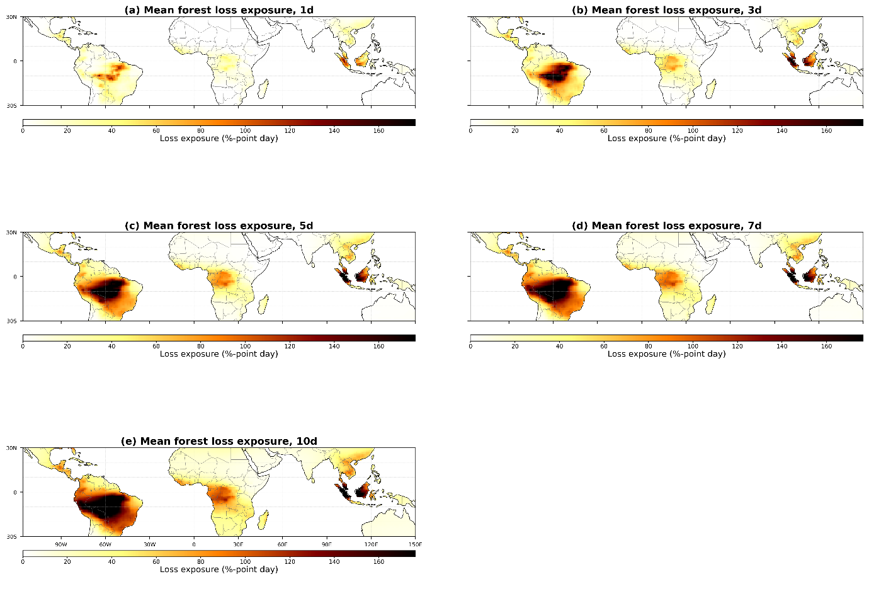
Supplementary Figure S1. Annual mean (2001 to 2024) (a) 1-, (b) 3-, (c) 5-, (d) 7-, and (e) 10-day cumulative air mass exposure to forest loss. Forest loss data in is from GFC.

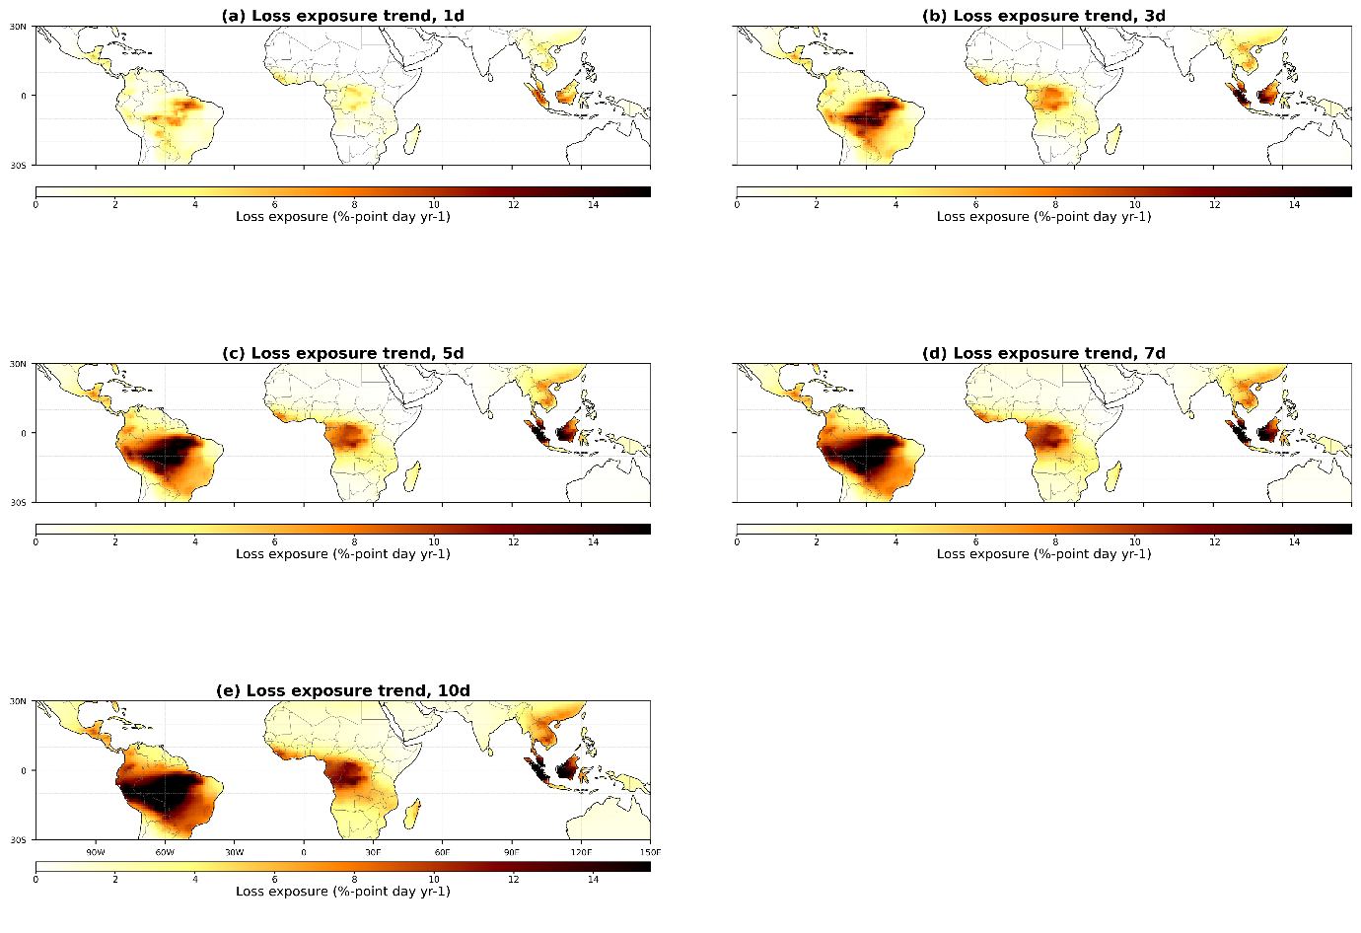
Supplementary Figure S2. Annual trend (2001 to 2024) for (a) 1-, (b) 3-, (c) 5-, (d) 7-, and (e) 10-day cumulative air mass exposure to forest loss.

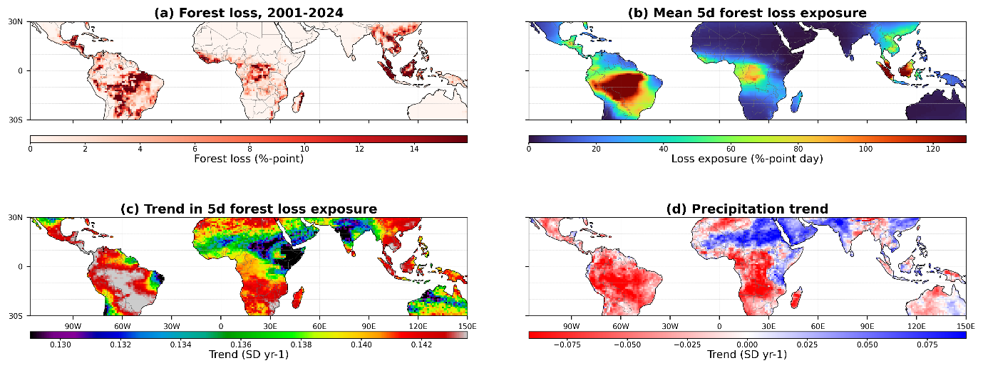
Supplementary Figure S3. Forest loss and rainfall trends (2001 to 2024). (a) Forest percentage-point loss (b) Mean 5-d cumulative air mass exposure to forest loss, (c) Trend in annual preceding 5-d cumulative air mass exposure to forest loss, (d) Trend in annual rainfall calculated as the average of six satellite datasets. Forest loss data in (a) is from GFC. The colour bar range in (b) is the interpercentile range (5th–95th) of the trend. Trends reported in (c) and (d) are shown as the slope divided by the standard deviation or standard deviations per year (SD yr⁻¹).

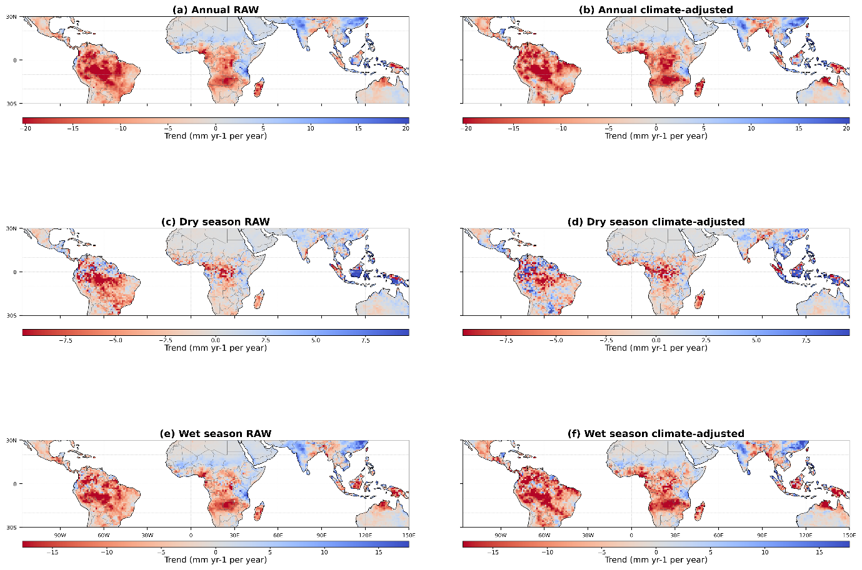
Supplementary Figure S4. Comparison of raw and climate mode–adjusted precipitation trends. Spatial patterns of annual (a–b), dry season (c–d), and wet season (e–f) precipitation trends over 2001–2024, shown for raw observations (left column) and after removing variability associated with major climate modes (right column; ENSO, IOD, ATL3). Trends are expressed in mm yr⁻¹ per year. Climate-adjusted trends closely resemble the raw trends across regions and seasons, with consistent drying over the Amazon and parts of central Africa, indicating that the long-term precipitation changes are not primarily driven by large-scale climate variability.

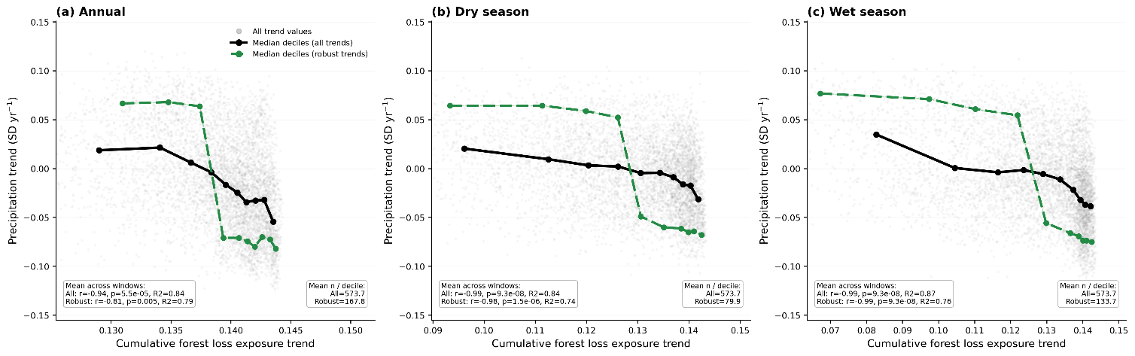
Supplementary Figure S5. Relationship between 5-day cumulative forest-loss exposure trends and precipitation trends across the tropics. Precipitation trends (SD yr⁻1) are shown as a function of trends in 5-day cumulative forest loss exposure along air-mass trajectories (SD yr⁻1) for annual (a), dry-season (b) and wet-season (c) rainfall. Grey points show trends for all tropical grid cells. Black lines show median precipitation trends across deciles of forest loss exposure trends for all grid cells, and dashed green lines show the corresponding relationship when restricted to grid cells with robust precipitation trends. Insets within panels report summary statistics for the median decile relationships, including Spearman correlation (r), significance (p), coefficient of determination (R²), and linear slope, alongside the mean number of samples per decile.

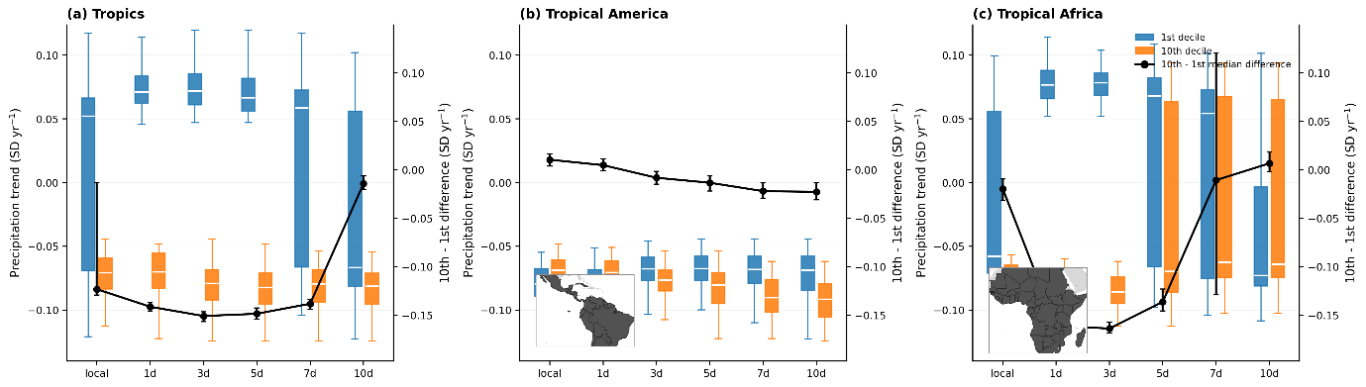
Supplementary Figure S6. Annual precipitation trends vs forest-loss exposure (standardised).
As in Fig. 3, but using standardised relative precipitation trends (SD yr⁻¹). Boxplots show precipitation trends for grid cells in the lowest (1st decile; blue) and highest (10th decile; orange) trends in forest-loss exposure, evaluated locally and along 1–10 day back trajectories. Black lines denote the median difference (10th – 1st decile; right-hand y-axis) with 95% confidence intervals from bootstrap resampling. Patterns are consistent with absolute trends, with the strongest contrasts emerging for multi-day (3–7 day) exposure windows across the Pantropics.

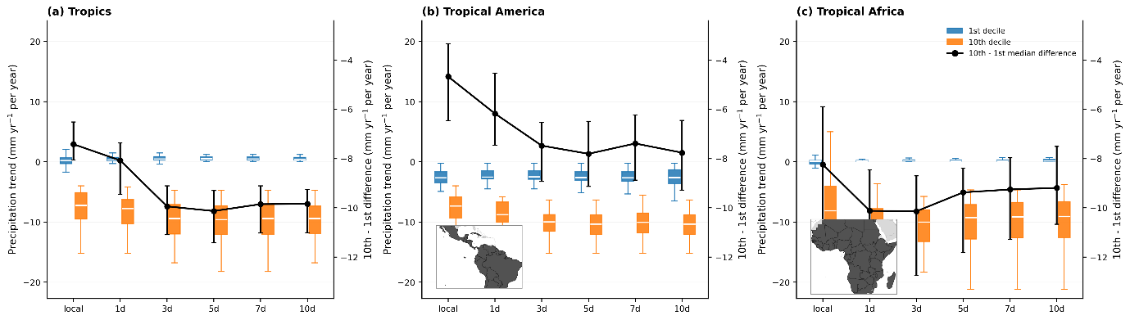
Supplementary Figure S7. Dry-season precipitation trends vs forest-loss exposure (absolute).
As in Fig. 3, but for dry-season precipitation trends (mm yr⁻¹ per year). Across regions, grid cells with the greatest increase in forest-loss exposure exhibit systematically more negative dry-season precipitation trends than those with the smallest increase. Differences strengthen from local to multi-day exposure, with the largest contrasts occurring for 3–10 day trajectories. The black line shows the median difference (10th – 1st decile; right-hand y-axis) with 95% confidence intervals.

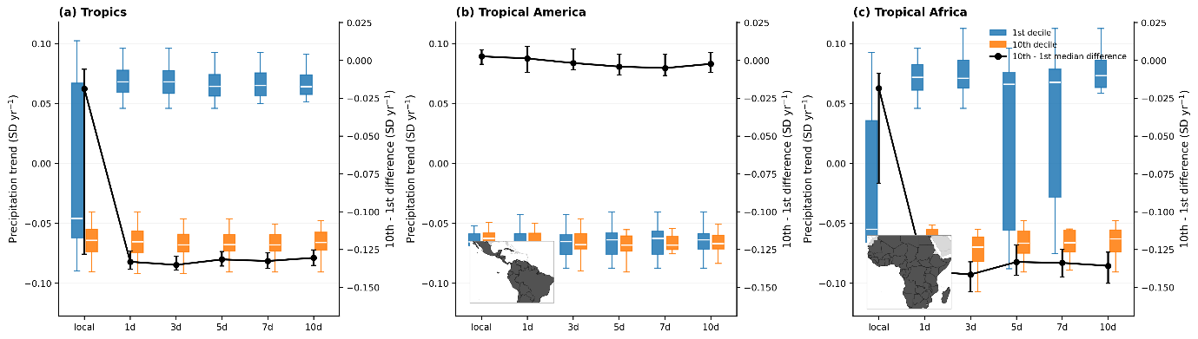
Supplementary Figure S8. Dry-season precipitation trends vs forest-loss exposure (standardised).
As in Supplementary Fig. S7, but using standardised relative precipitation trends (SD yr⁻¹). The relative analysis confirms that regions with the greatest increase in forest-loss exposure exhibit more negative dry-season trends across most exposure windows. Strongest contrasts occur for multi-day (≥3 day) exposure, indicating that drying extends beyond local variability envelopes. Median differences (black line) are shown on the right-hand y-axis with 95% confidence intervals.

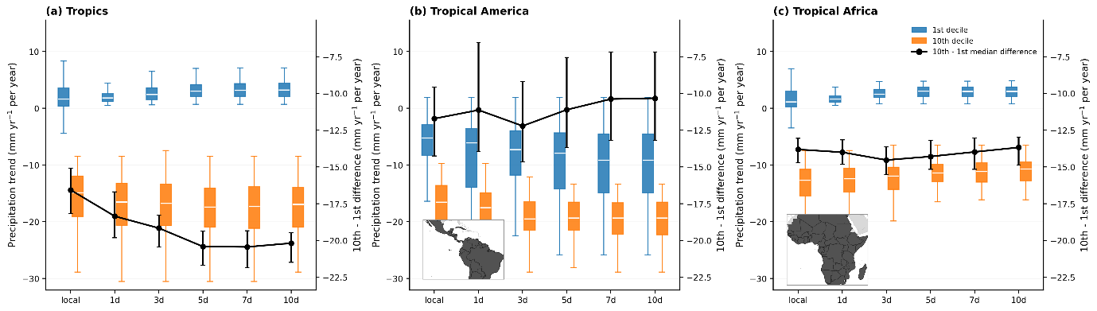
Supplementary Figure S9. Wet-season precipitation trends vs forest-loss exposure (absolute).
As in Fig. 3, but for wet-season precipitation trends (mm yr⁻¹ per year). The largest contrasts between exposure deciles occur during the wet season, particularly for 5–10 day trajectories, indicating substantially stronger rainfall declines in regions with the greatest increase in forest-loss exposure. Black lines show the median difference (10th – 1st decile; right-hand y-axis) with 95% confidence intervals.

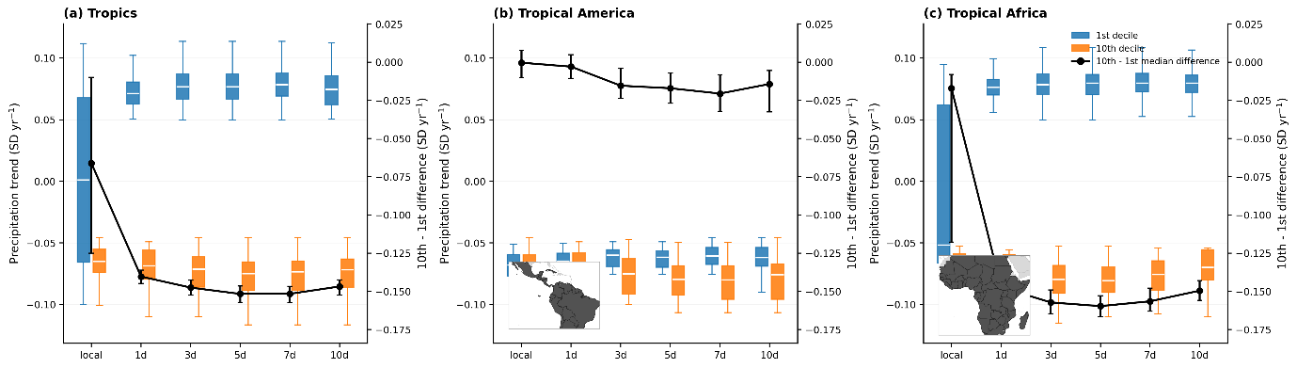
Supplementary Figure S10. Wet-season precipitation trends vs forest-loss exposure (standardised).
As in Supplementary Fig. S9, but using standardised relative precipitation trends (SD yr⁻¹). Results confirm a robust relative decline in wet-season precipitation associated with increased forest-loss exposure across multi-day trajectories. The largest standardised contrasts occur for 3–7 day exposure windows. Median differences (black line) are shown on the right-hand y-axis with 95% confidence intervals.

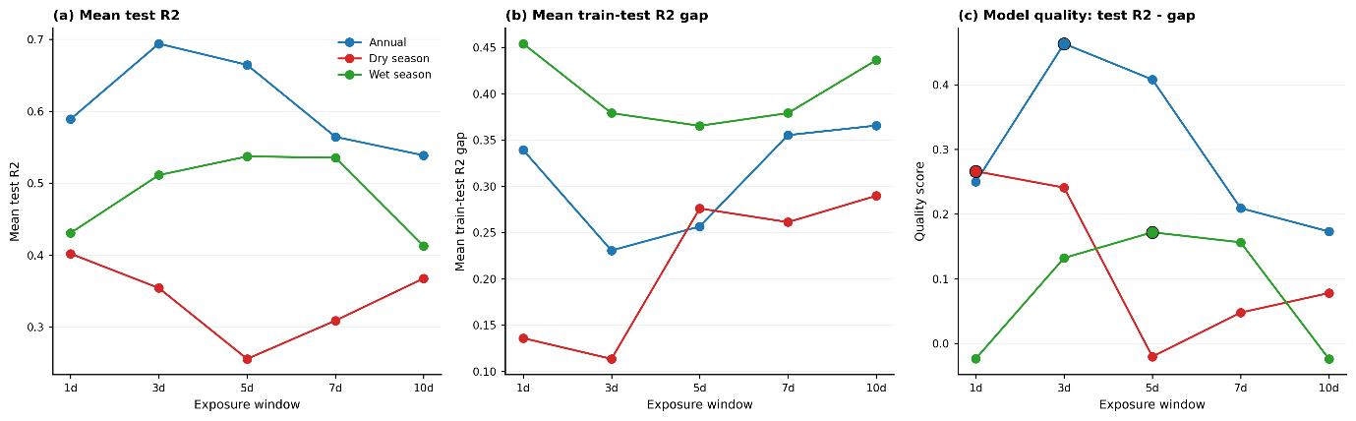
Supplementary Figure S11. Model performance and generalisation across exposure windows.
(a) Mean test R² for models predicting precipitation trends from trajectory-derived exposure metrics, shown as a function of exposure window length for annual, dry-season and wet-season models. (b) Corresponding mean train–test R² gap, indicating the degree of overfitting. (c) Model quality score, defined as test R² minus the train–test R² gap, which balances predictive skill against generalisation. Models are trained on robust precipitation grid cells only and combine absolute and relative trend formulations.

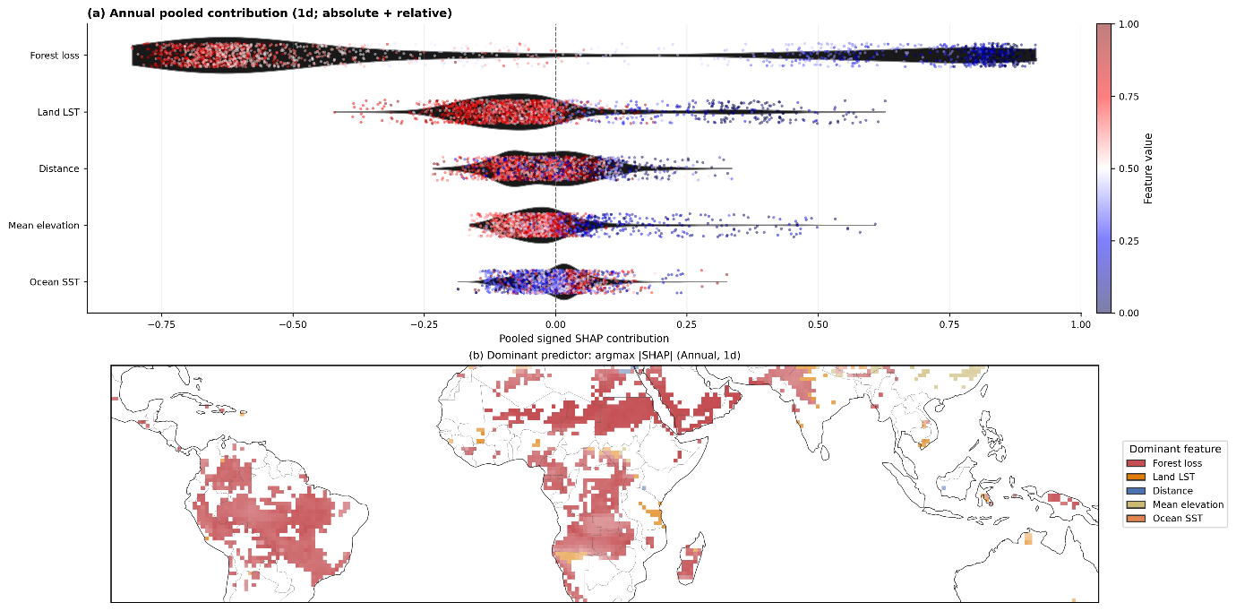
Supplementary Figure S12. As in Fig. 4, but for alternative 1-day exposure windows. SHAP values are computed for each model, converted to signed fractional contributions, and pooled across model families using ensemble weights (Methods). Results are shown for robust precipitation grid cells only.

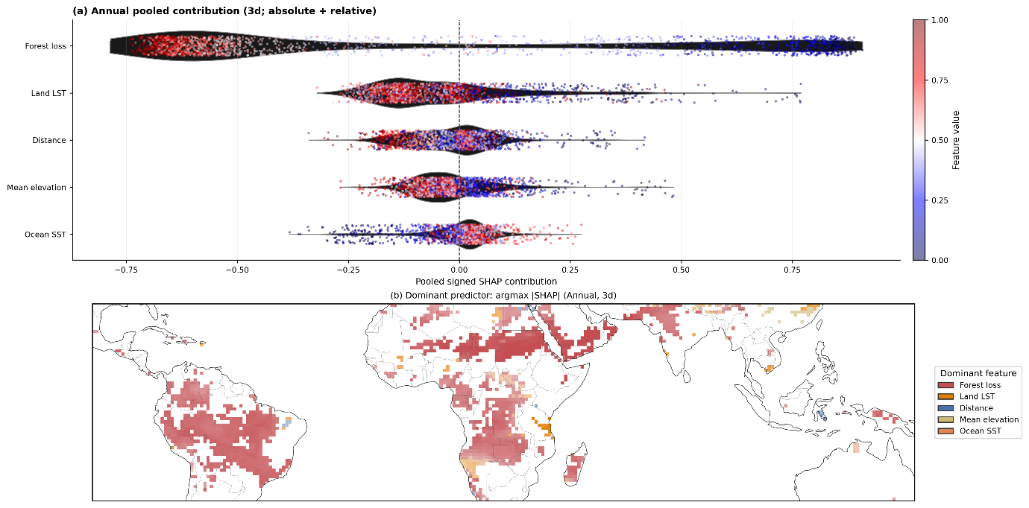
Supplementary Figure S13. As in Fig. 4, but for alternative 3-day exposure window. SHAP values are computed for each model, converted to signed fractional contributions, and pooled across model families using ensemble weights (Methods). Results are shown for robust precipitation grid cells only.

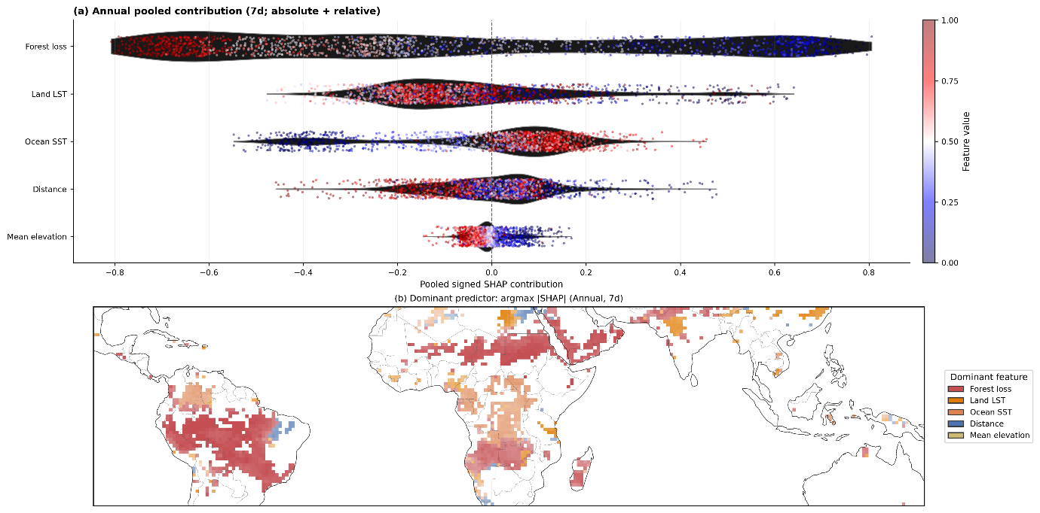
Supplementary Figure S14. As in Fig. 4, but for alternative 7-day exposure window. SHAP values are computed for each model, converted to signed fractional contributions, and pooled across model families using ensemble weights (Methods). Results are shown for robust precipitation grid cells only.

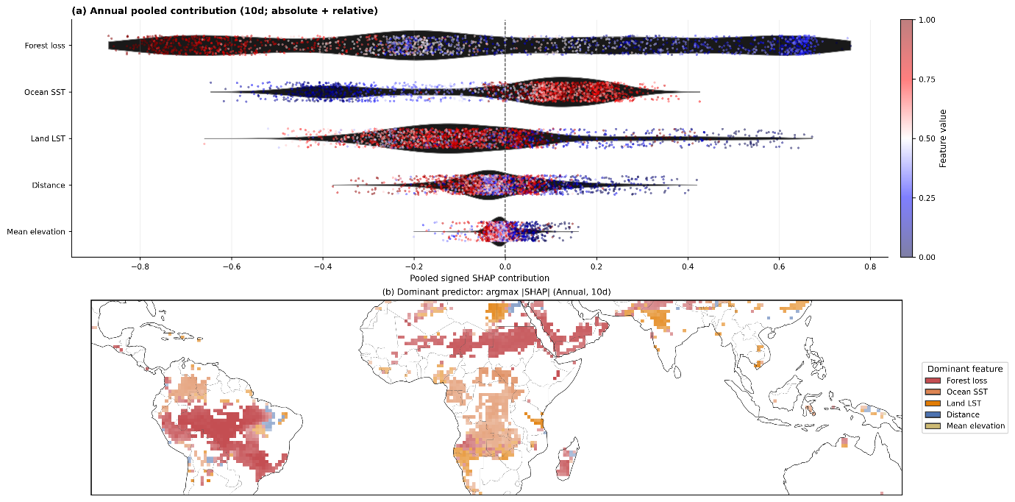
Supplementary Figure S15. As in Fig. 4, but for alternative 10-day exposure window. SHAP values are computed for each model, converted to signed fractional contributions, and pooled across model families using ensemble weights (Methods). Results are shown for robust precipitation grid cells only.

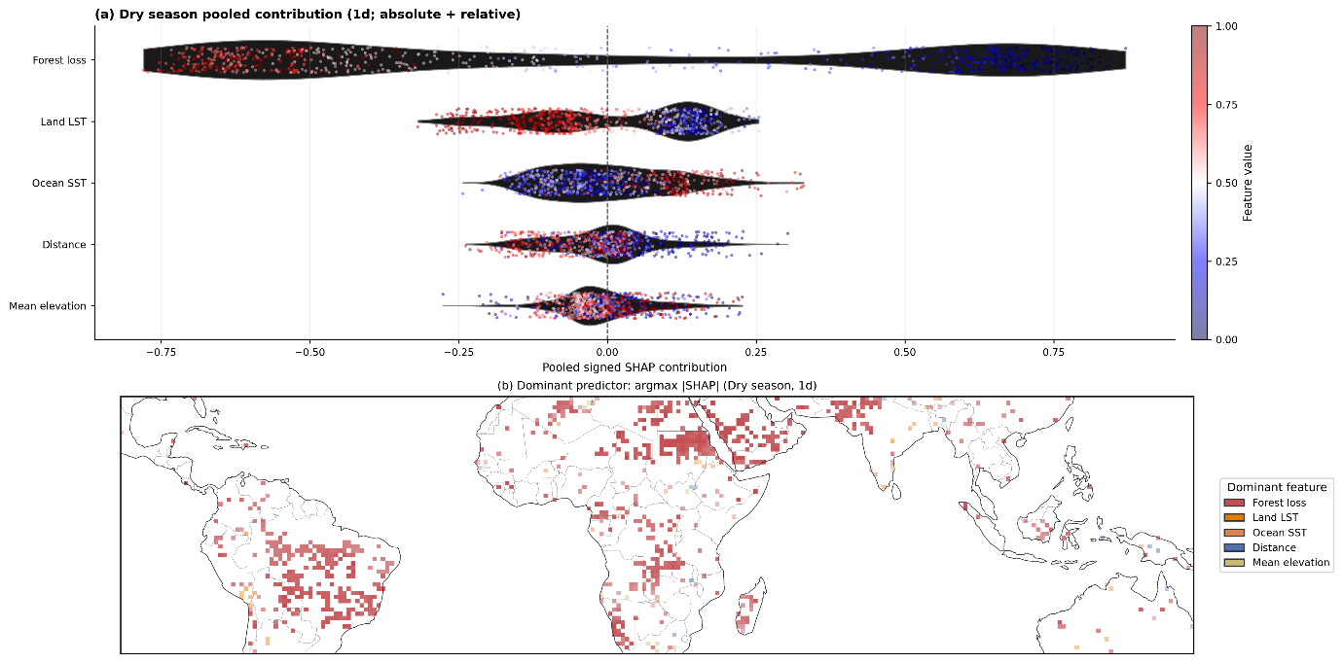
Supplementary Fig. S16. As in Fig. 4, but for dry-season rainfall trends across 1-day exposure window. SHAP values are computed for each model, converted to signed fractional contributions, and pooled across model families using ensemble weights (Methods). Results are shown for robust precipitation grid cells only.

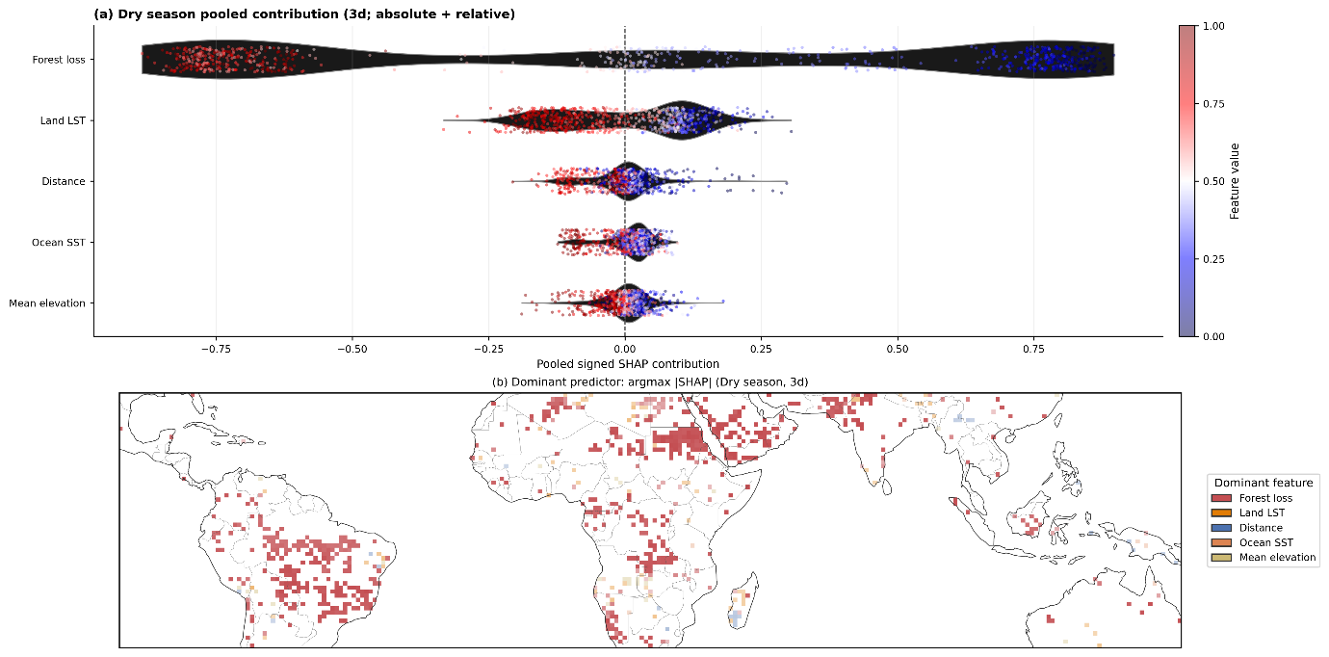
Supplementary Fig. S17. As in Fig. 4, but for dry-season rainfall trends across 3-day exposure window. SHAP values are computed for each model, converted to signed fractional contributions, and pooled across model families using ensemble weights (Methods). Results are shown for robust precipitation grid cells only.

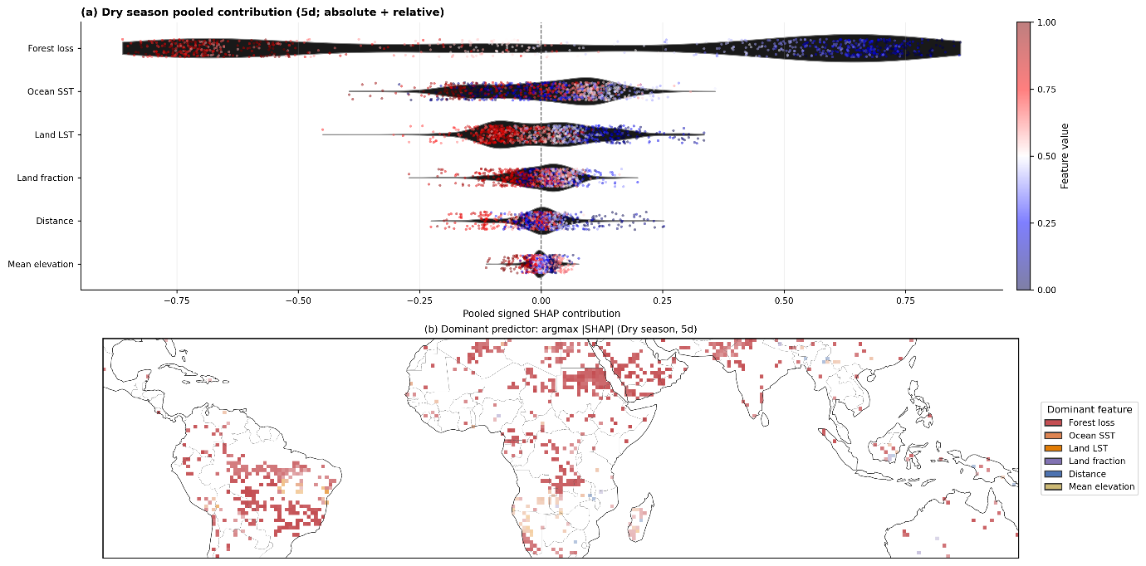
Supplementary Fig. S18. As in Fig. 4, but for dry-season rainfall trends across 5-day exposure window. SHAP values are computed for each model, converted to signed fractional contributions, and pooled across model families using ensemble weights (Methods). Results are shown for robust precipitation grid cells only.

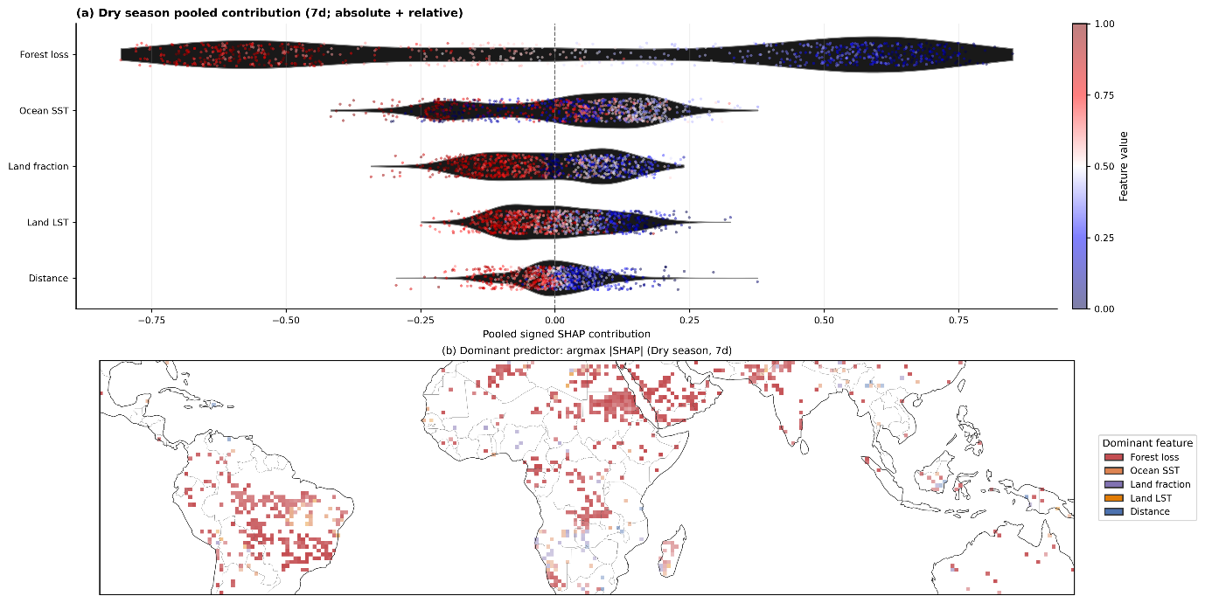
Supplementary Fig. S19. As in Fig. 4, but for dry-season rainfall trends across 7-day exposure window. SHAP values are computed for each model, converted to signed fractional contributions, and pooled across model families using ensemble weights (Methods). Results are shown for robust precipitation grid cells only.

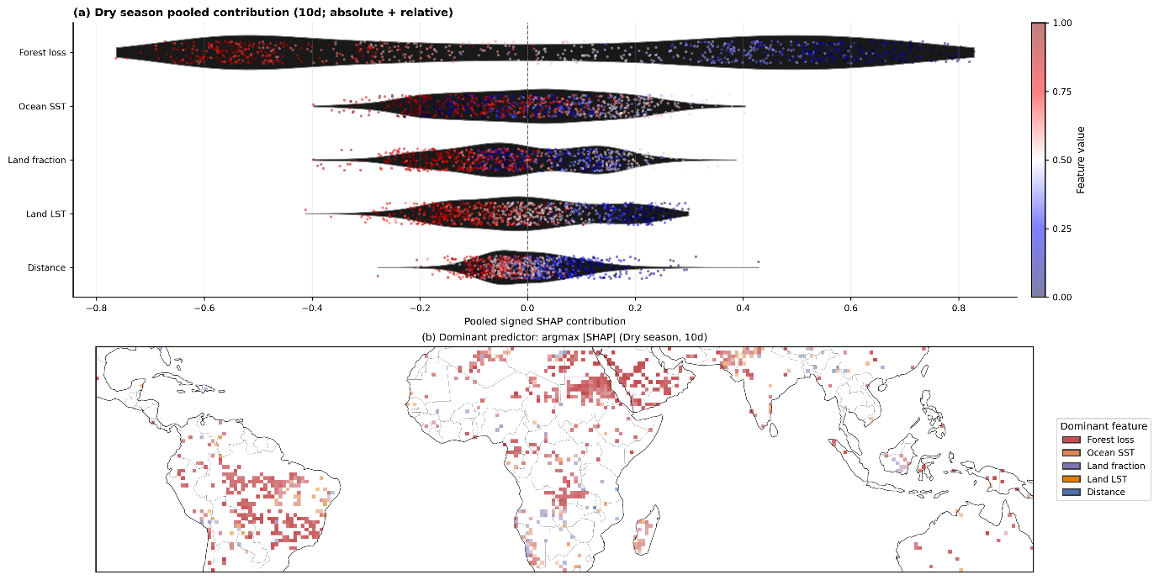
Supplementary Fig. S20. As in Fig. 4, but for dry-season rainfall trends across 10-day exposure window. SHAP values are computed for each model, converted to signed fractional contributions, and pooled across model families using ensemble weights (Methods). Results are shown for robust precipitation grid cells only.

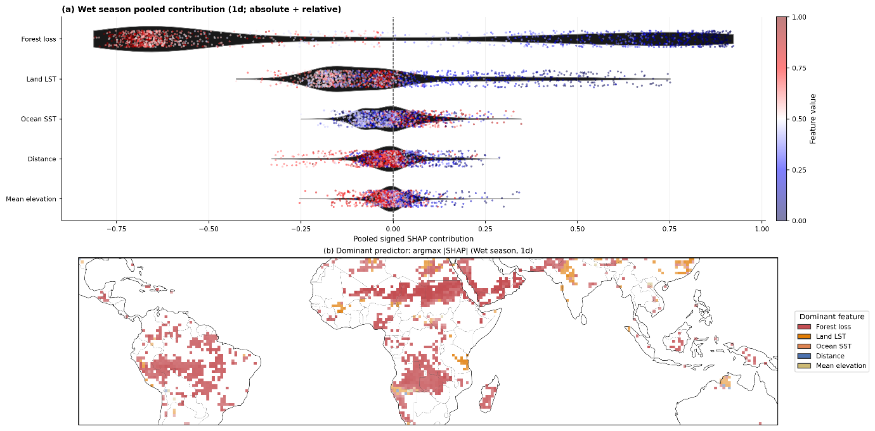
Supplementary Fig. S21. As in Fig. 4, but for wet-season rainfall trends across 1-day exposure window. SHAP values are computed for each model, converted to signed fractional contributions, and pooled across model families using ensemble weights (Methods). Results are shown for robust precipitation grid cells only.

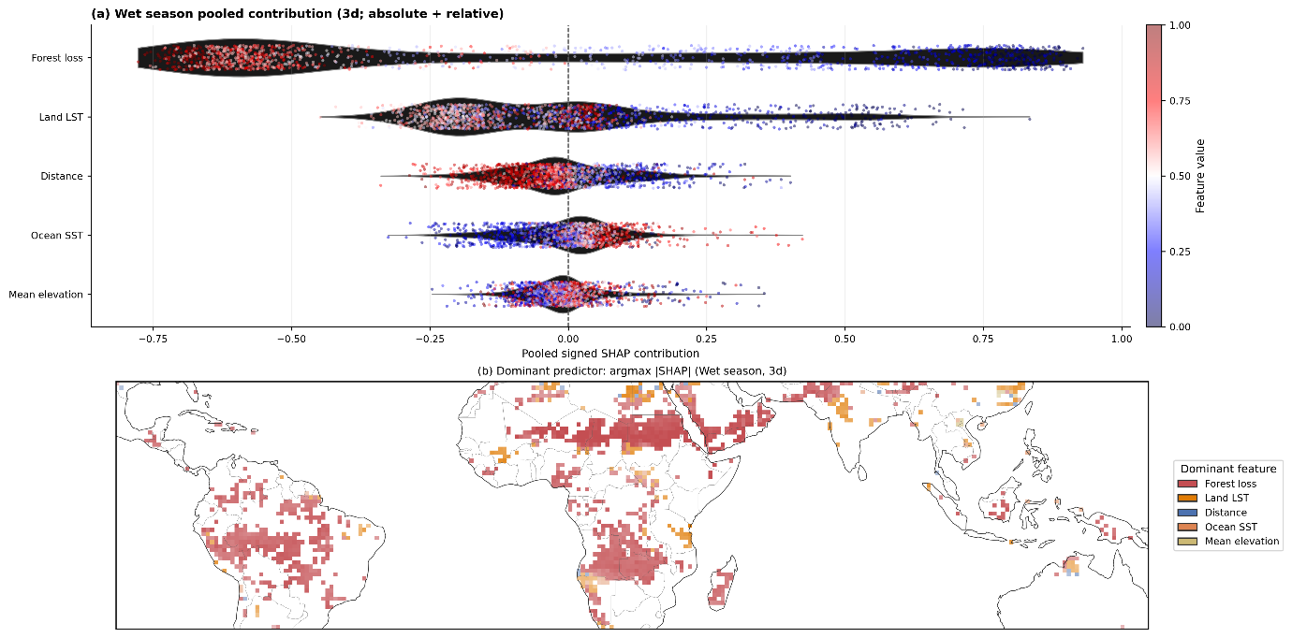
Supplementary Fig. S22. As in Fig. 4, but for wet-season rainfall trends across 3-day exposure window. SHAP values are computed for each model, converted to signed fractional contributions, and pooled across model families using ensemble weights (Methods). Results are shown for robust precipitation grid cells only.

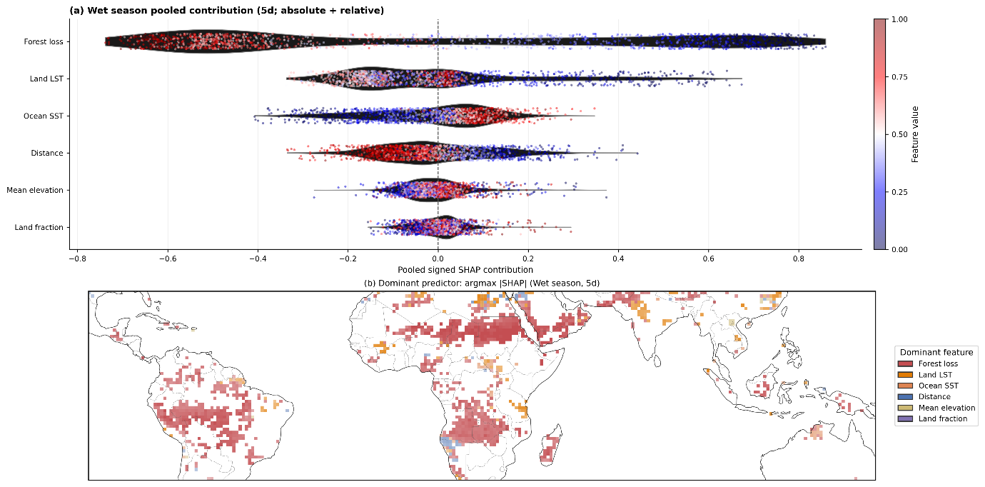
Supplementary Fig. S23. As in Fig. 4, but for wet-season rainfall trends across 5-day exposure window. SHAP values are computed for each model, converted to signed fractional contributions, and pooled across model families using ensemble weights (Methods). Results are shown for robust precipitation grid cells only.

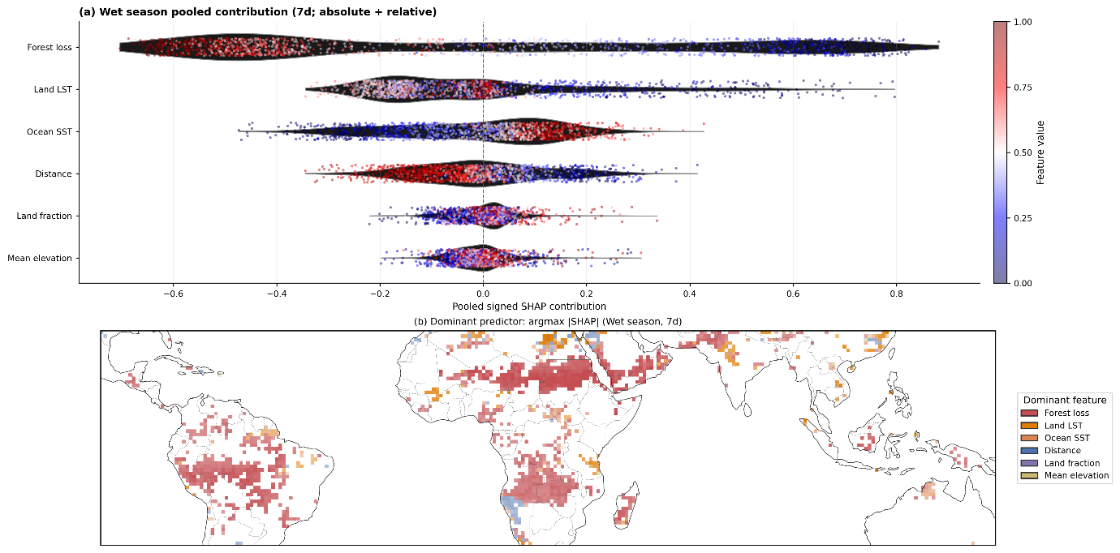
Supplementary Fig. S24. As in Fig. 4, but for wet-season rainfall trends across 7-day exposure window. SHAP values are computed for each model, converted to signed fractional contributions, and pooled across model families using ensemble weights (Methods). Results are shown for robust precipitation grid cells only.

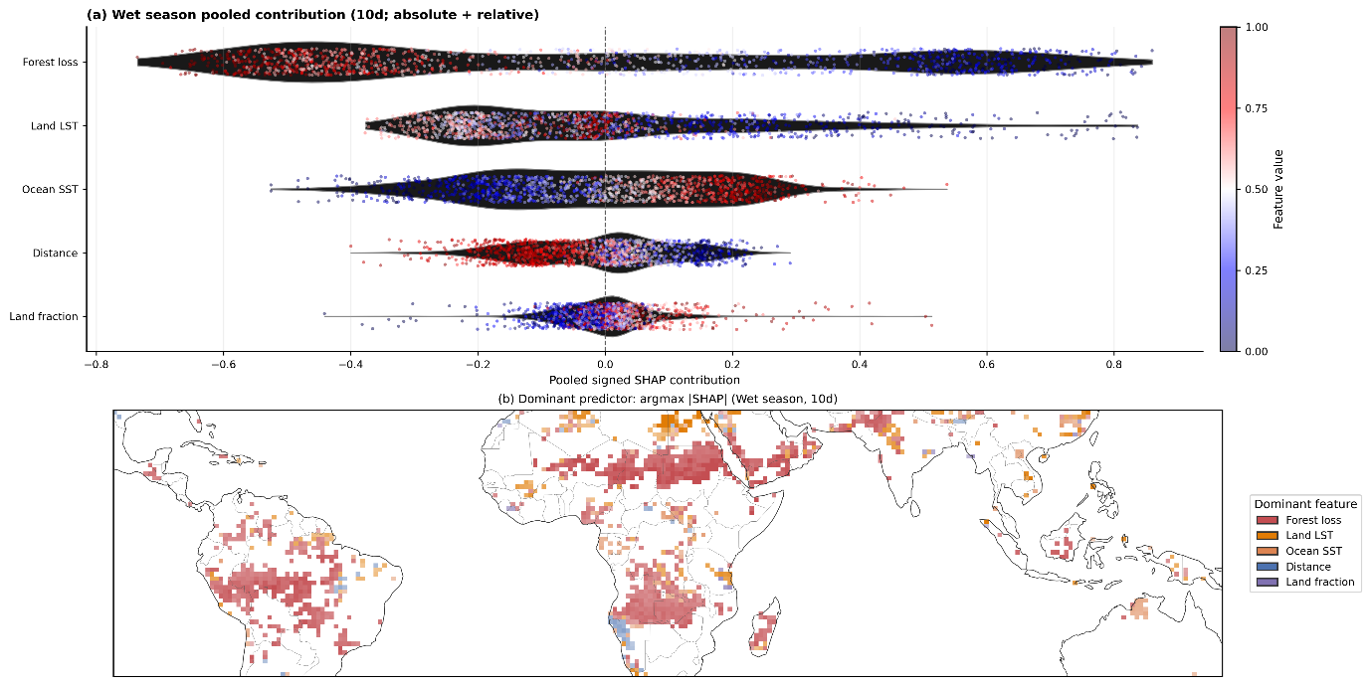
Supplementary Fig. S25. As in Fig. 4, but for wet-season rainfall trends across 10-day exposure window. SHAP values are computed for each model, converted to signed fractional contributions, and pooled across model families using ensemble weights (Methods). Results are shown for robust precipitation grid cells only.

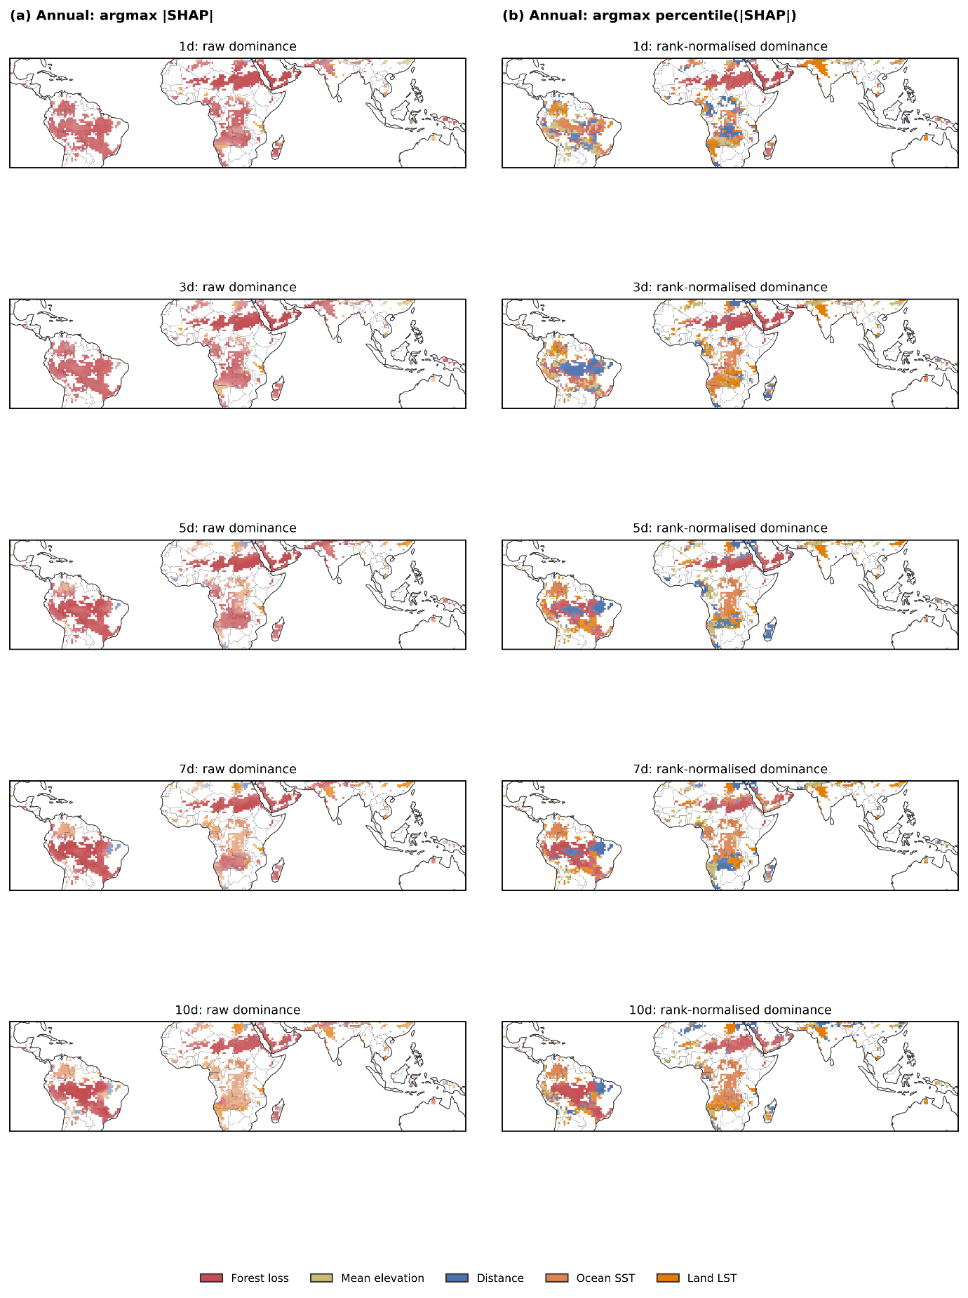
Supplementary Figure S26. Dominant predictors for annual rainfall trends using absolute and rank-normalised SHAP contributions. Dominance is defined using ensemble-pooled SHAP values (column (a), argmax |SHAP|) and evaluated using rank-normalised SHAP magnitudes (column (b)) (Methods). Results are restricted to robust precipitation grid cells.

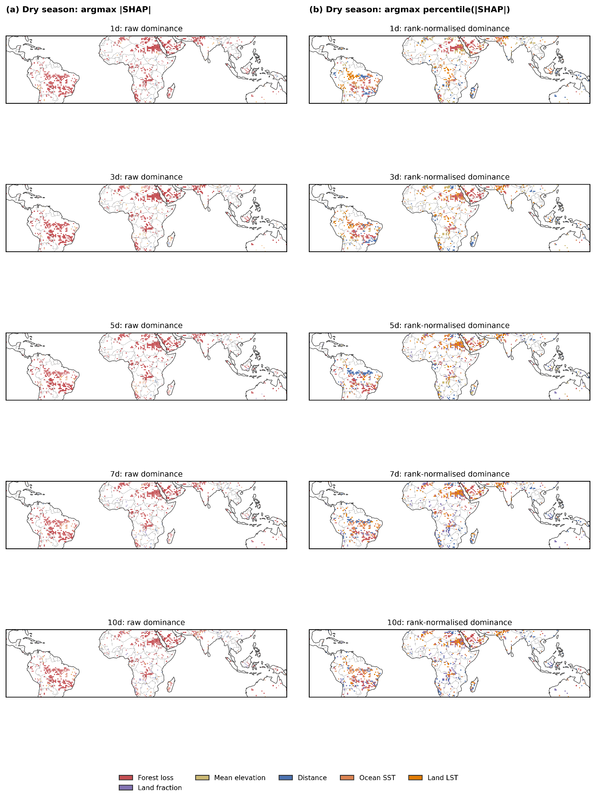
Supplementary Figure. S27. Dominant predictors for dry-season rainfall trends using absolute and rank-normalised SHAP contributions. Dominance is defined using ensemble-pooled SHAP values (column (a), argmax |SHAP|) and evaluated using rank-normalised SHAP magnitudes (column (b)) (Methods). Results are restricted to robust precipitation grid cells.

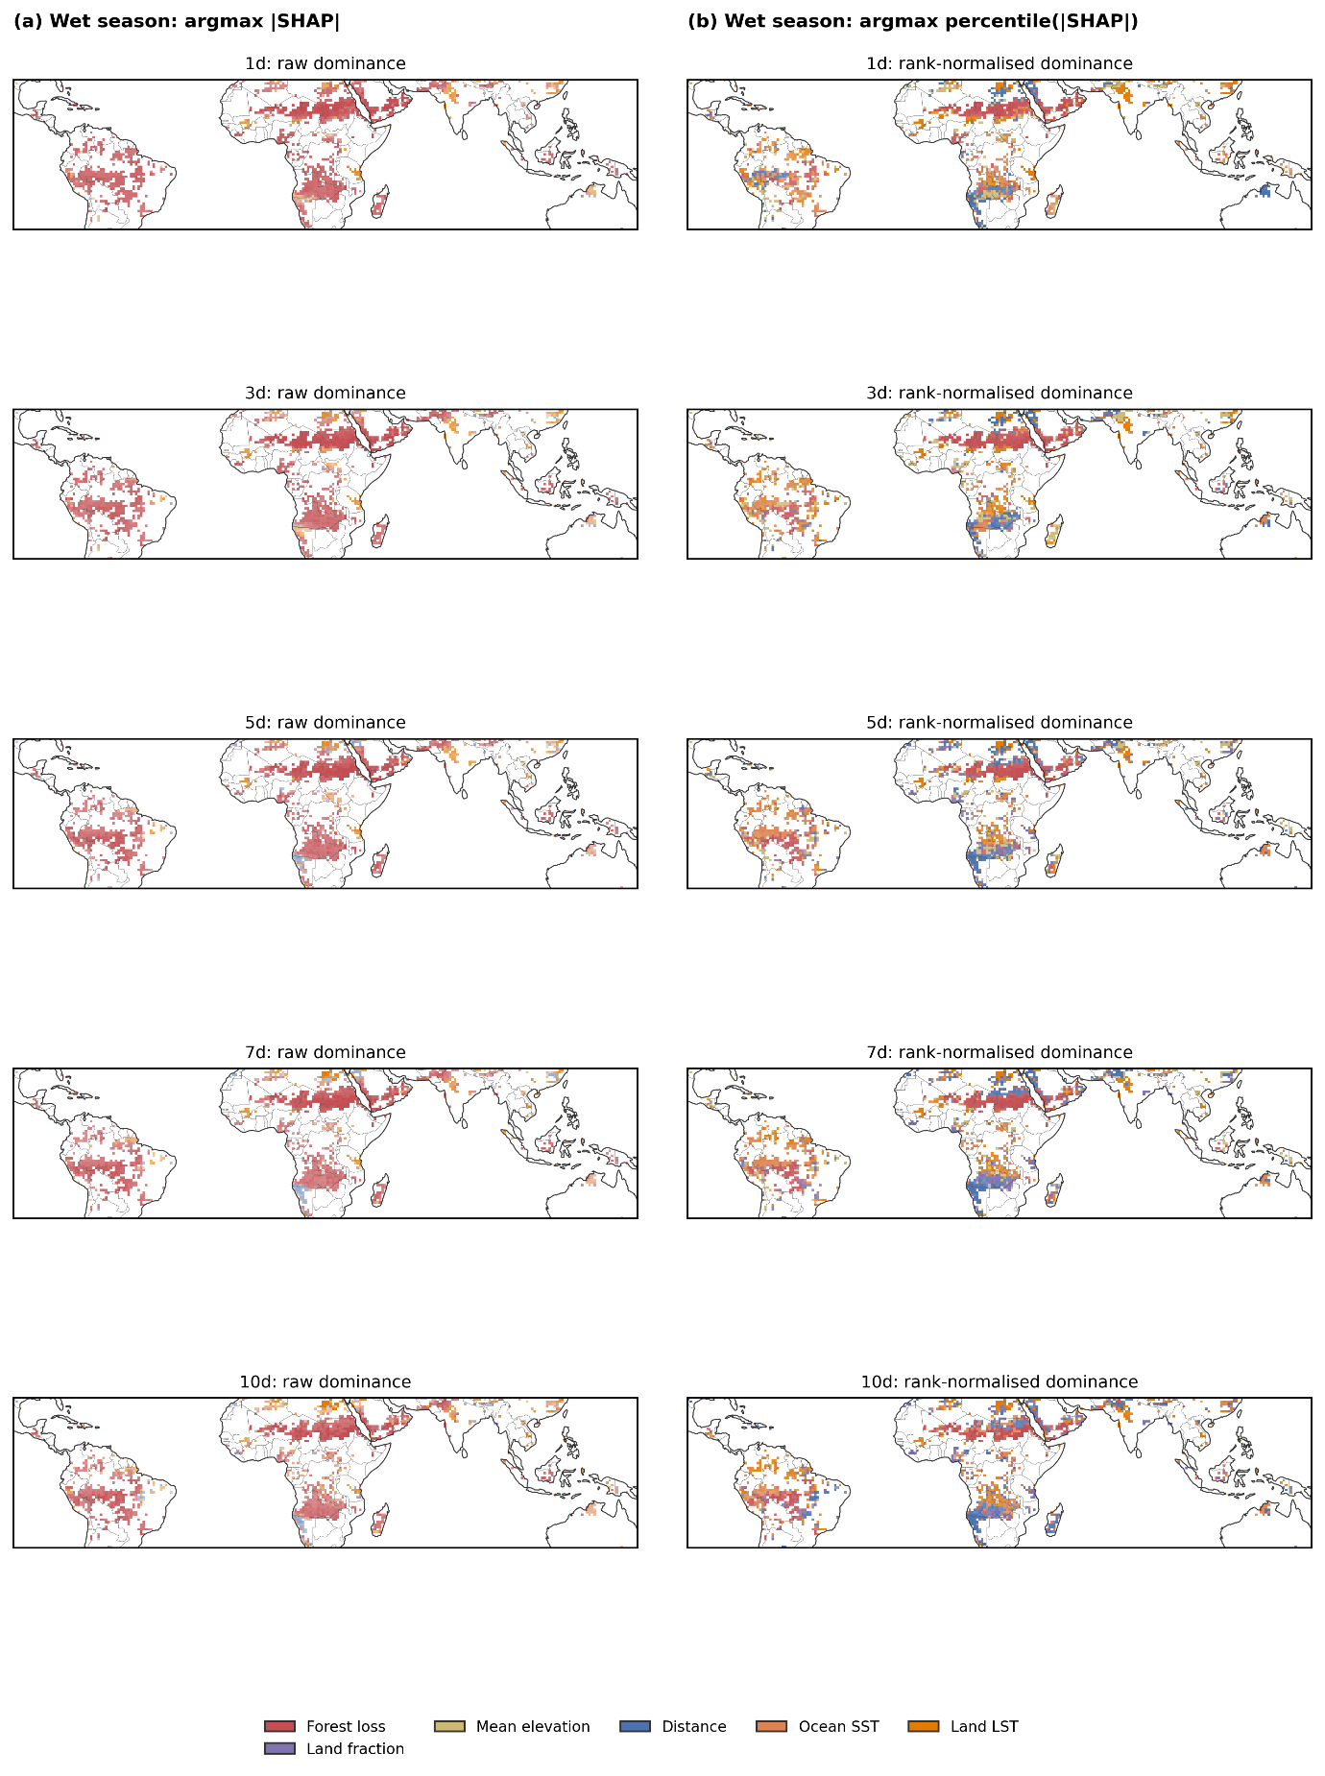
Supplementary Fig. S28. Dominant predictors for wet-season rainfall trends using absolute and rank-normalised SHAP contributions. Dominance is defined using ensemble-pooled SHAP values (column (a), argmax |SHAP|) and evaluated using rank-normalised SHAP magnitudes (column (b)) (Methods). Results are restricted to robust precipitation grid cells.

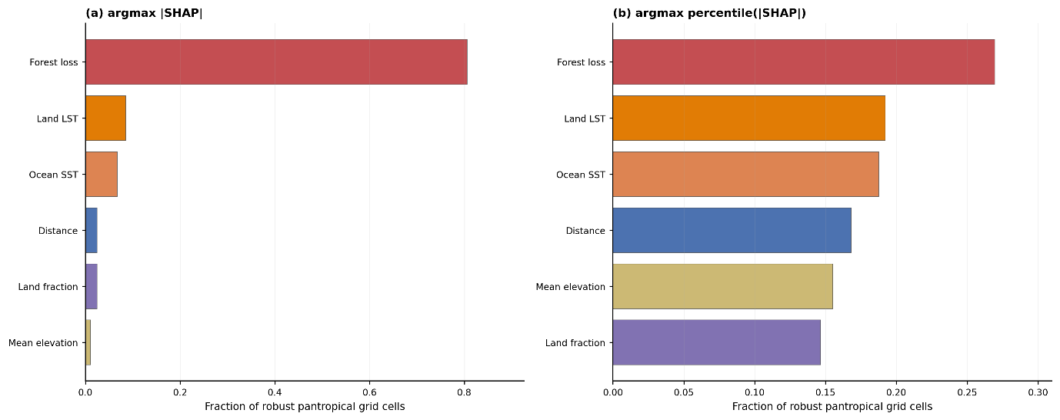
Supplementary Figure S29. Fraction of grid cells dominated by each predictor across model configurations.
Fractional occurrence of the dominant predictor across robust pantropical grid cells, defined using (a) the feature with the largest absolute SHAP contribution (argmax |SHAP|) and (b) the feature with the largest rank-normalised SHAP contribution (argmax percentile(|SHAP|)). SHAP values were computed for an ensemble of tree-based models (Random Forest, Extra Trees, XGBoost and CatBoost) trained to predict precipitation trends from trajectory-derived exposure metrics using spatial cross-validation. For each model configuration (season: annual, dry, wet; exposure window: 1–10 days; trend formulation: absolute and relative), feature contributions were first converted to signed fractional SHAP values and then pooled across model families using performance-based ensemble weights. Dominant predictors were identified at each grid cell for each configuration, and the fractions shown here represent averages across all configurations, combining exposure windows, seasons and trend formulations. Rank-normalisation rescales SHAP magnitudes to percentiles within each grid cell to reduce the influence of differing feature variances and improve comparability among predictors.

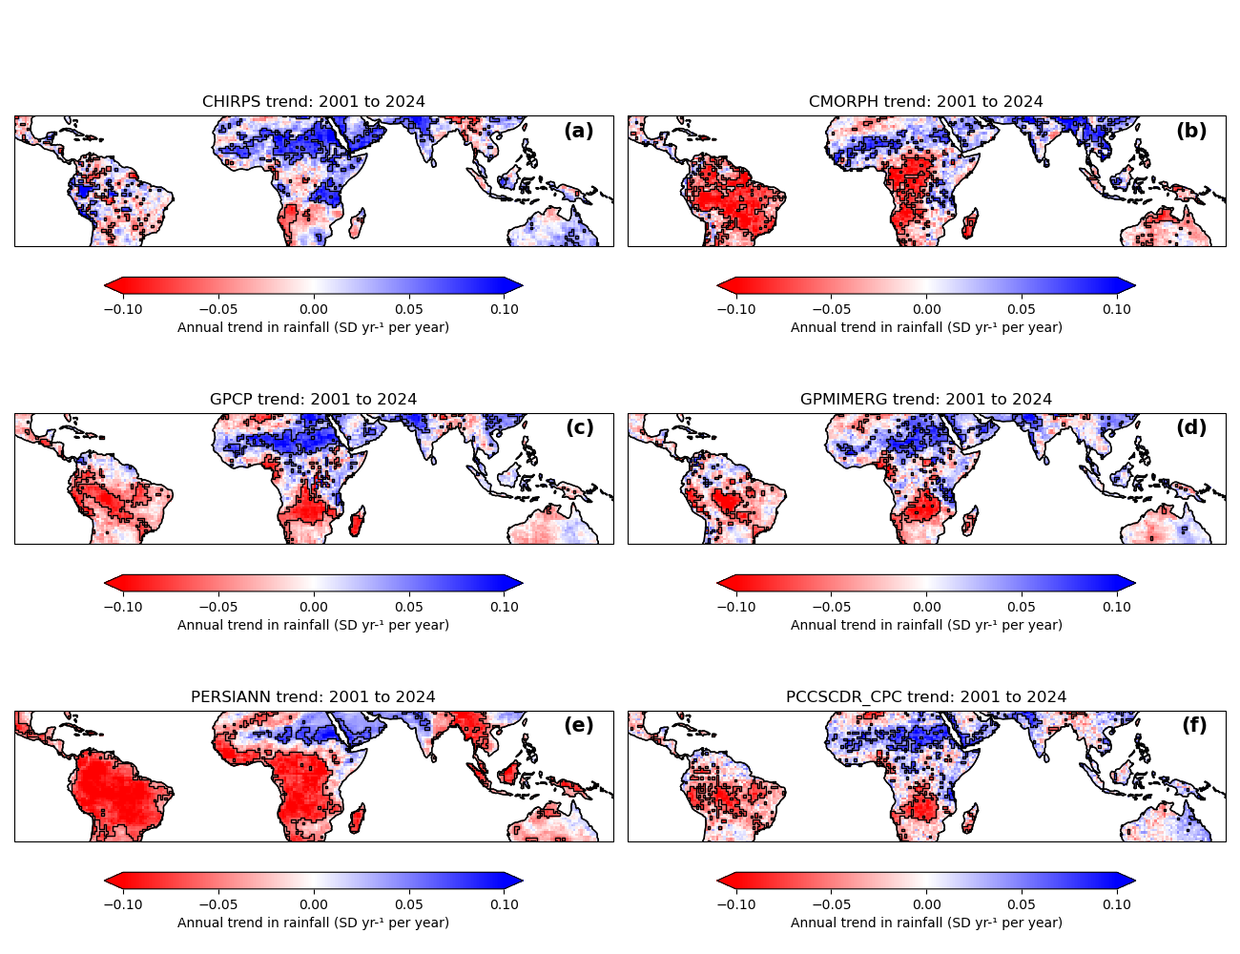
Supplementary Figure S30. Annual normalised precipitation trend (stardard deviations (SD) yr⁻¹) for the six datasets used in this sudy. Black polygons identify locations of rainfall trend robustness and stability (see Methods).

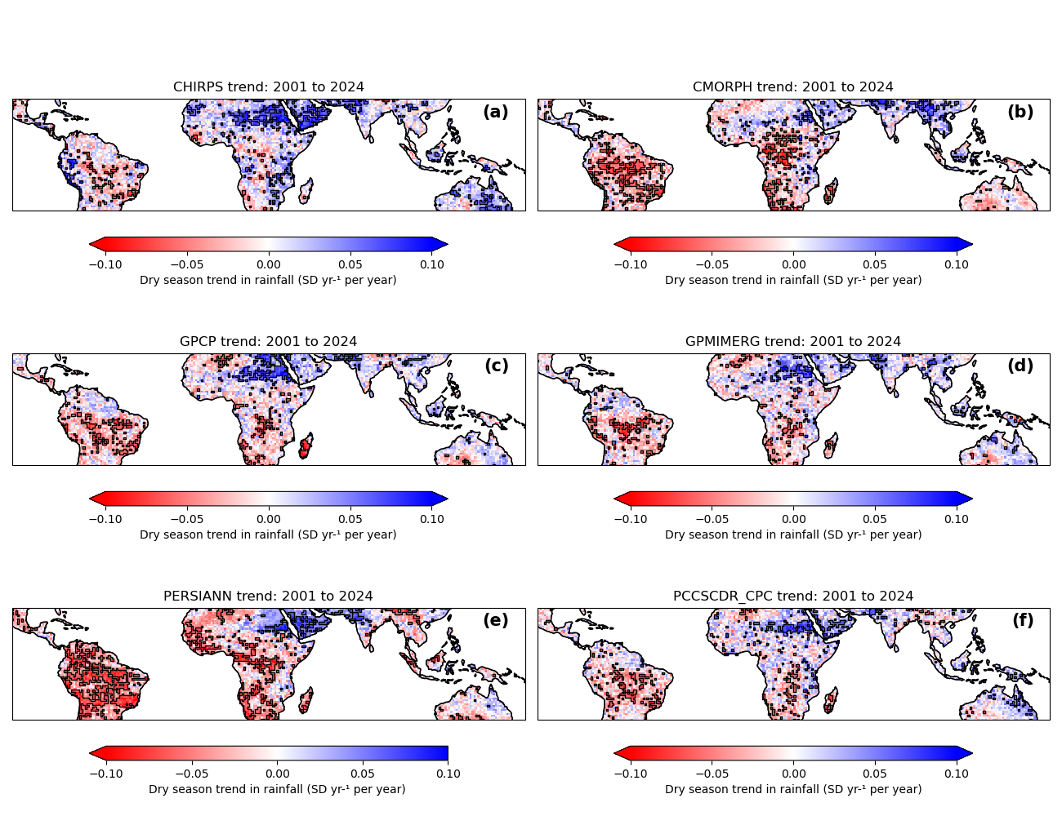
Supplementary Figure S31. Dry season normalised precipitation trend (SD yr⁻¹) for the six datasets used in this study. Black polygons identify locations of rainfall trend robustness and stability (see Methods).

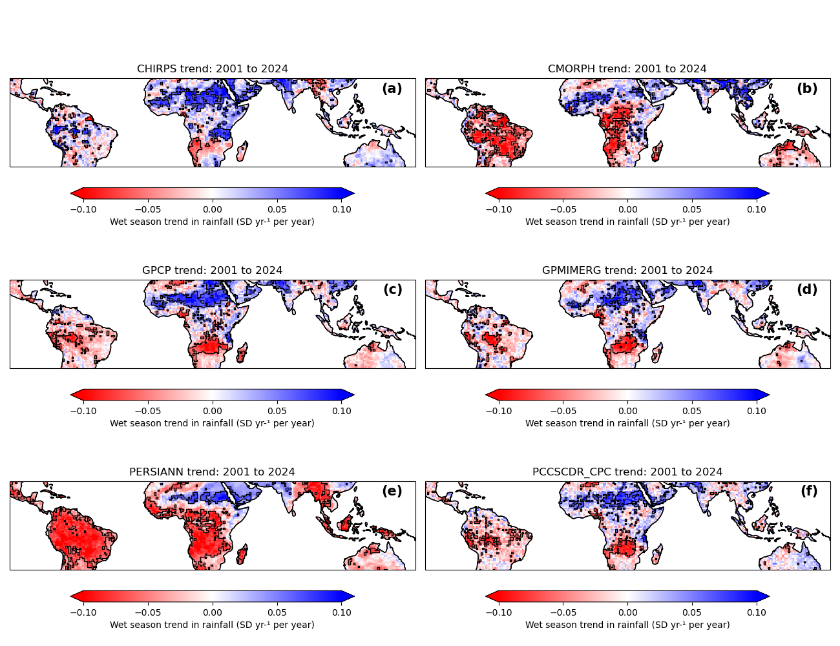
Supplementary Figure S32. Wet season normalised precipitation trend (SD yr⁻¹) for the six datasets used in this study. Black polygons identify locations of rainfall trend robustness and stability (see Methods).

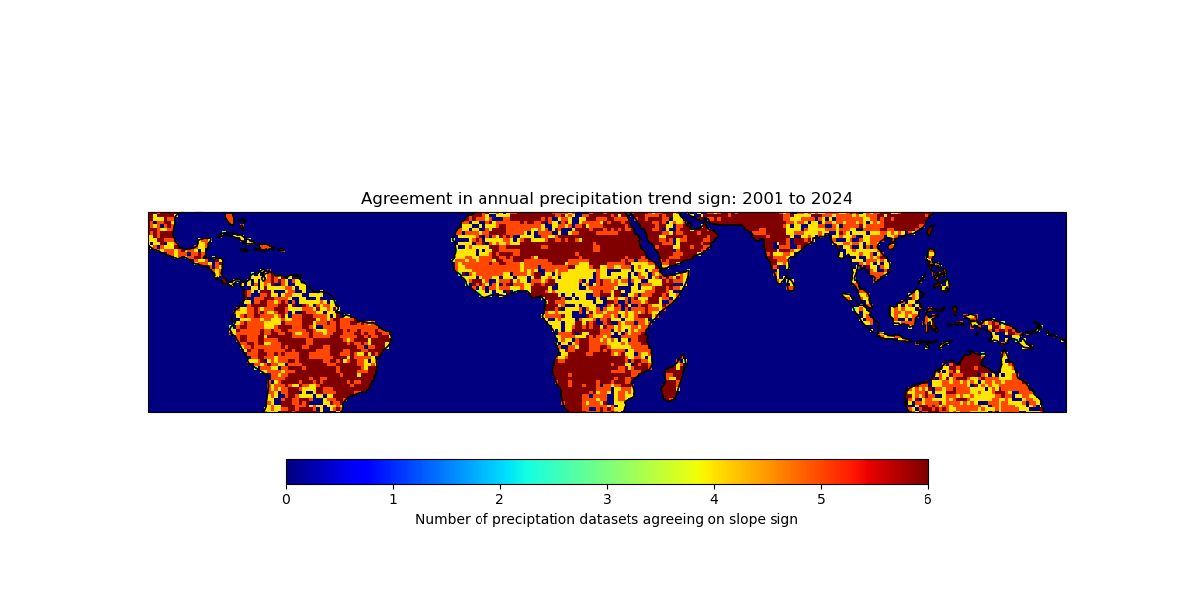
Supplementary Figure S33. Annual trend sign agreement across the six precitation datasets used in this study.

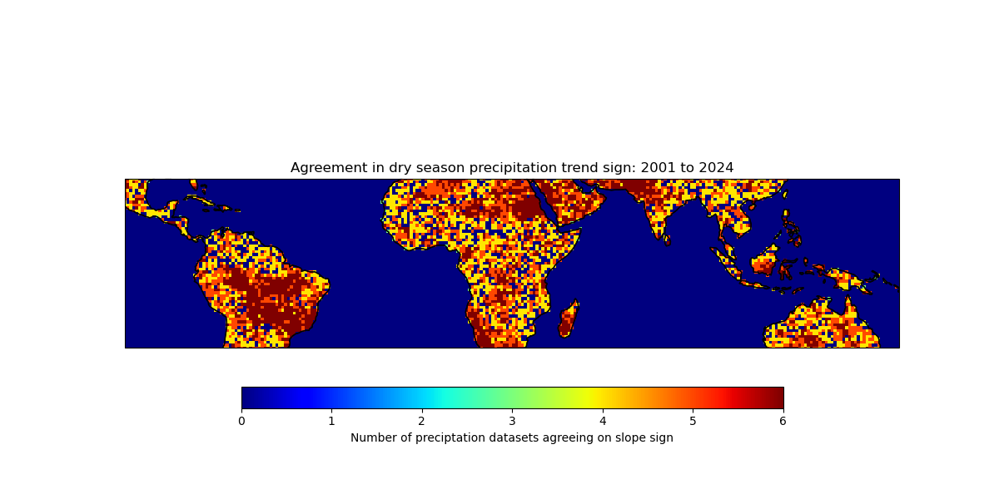
Supplementary Figure S34. Dry season trend sign agreement across the six precitation datasets used in this study.

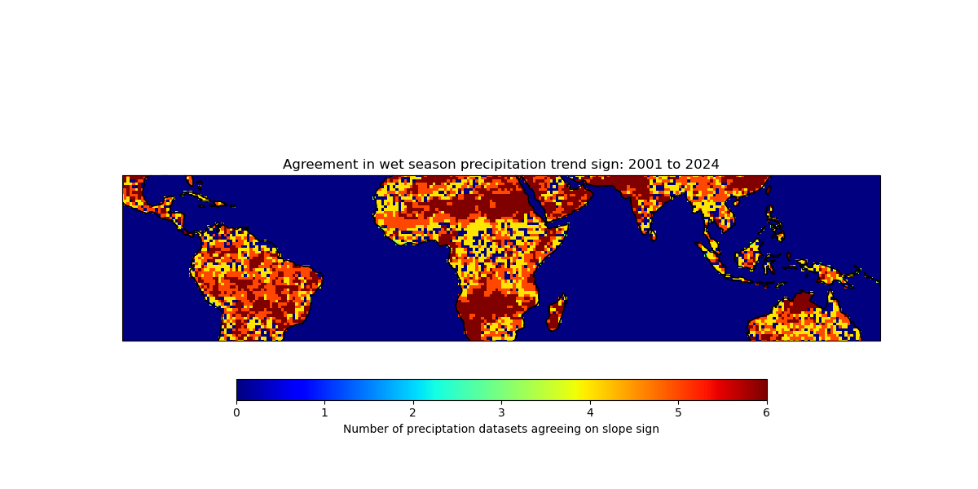
Supplementary Figure S35. Wet season trend sign agreement across the six precitation datasets used in this study.

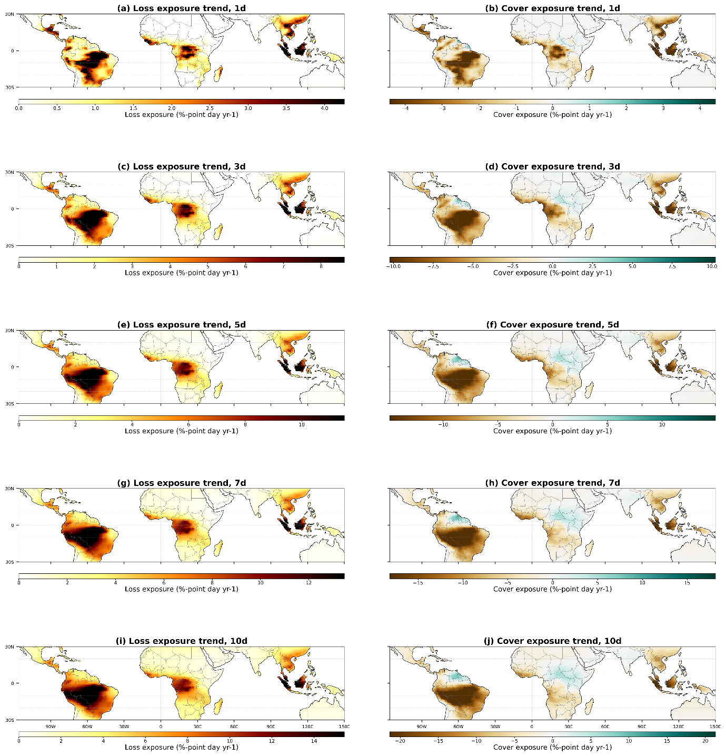
Supplementary Figure S36. Trends in upwind exposure to forest loss and forest cover across trajectory windows.
Spatial patterns of annual trends (2001–2024) in cumulative upwind exposure to forest loss (left column; a, c, e, g, i) and forest cover (right column; b, d, f, h, j) for 1-, 3-, 5-, 7-, and 10-day air-mass trajectories. Exposure is expressed as percentage-point day per year. Increasing loss exposure broadly coincides with decreasing cover exposure across major tropical regions, reflecting coherent signals of land-cover change along air-mass pathways. The magnitude of exposure trends increases with trajectory length, with strongest signals over the southern Amazon, central Africa, and parts of Southeast Asia.

