Supplementary materials for “Revisiting core structure and energy of screw dislocations in α-quartz”

Ikuchi Funahashi^{1,*}, Ryo Kobayashi², Satoshi Ohmura³, and Kenji Kawai¹

¹ The University of Tokyo, 7-3-1 Hongo Bunkyo-ku, Tokyo, Japan
² Nagoya Institute of Technology, Gokiso-cho, Showa-ku, Nagoya, Aichi, Japan
³ Ehime University, 2-5 Bunkyo-cho, Matsuyama, Ehime, Japan

Table S1 List of simulation systems used in this study. The notation of dislocation types follows Heggie and Nylén (1984)

Number | Dislocation line  direction | Dipole spacing (Å) | Dislocation type 1 | Dislocation type 2
1 | $$a$$ | 400 | BSH+ | BSH−
2 | $$a$$ | 400 | BST+ | BST−
3 | $$a$$ | 400 | BSD+ | BSD−
4 | $$a$$ | 300 | BSH+ | BSH−
5 | $$a$$ | 300 | BST+ | BST−
6 | $$a$$ | 300 | BSD+ | BSD−
7 | $$a$$ | 400 | BSH+ | BST−
8 | $$a$$ | 400 | BST+ | BSH−
9 | $$c$$ | 400 | PSH+ | PSH−
10 | $$c$$ | 400 | PST+ | PST−
11 | $$c$$ | 300 | PSH+ | PSH−
12 | $$c$$ | 300 | PST+ | PST−
13 | $$c$$ | 400 | PSH+ | PST−
14 | $$c$$ | 400 | PST+ | PSH−

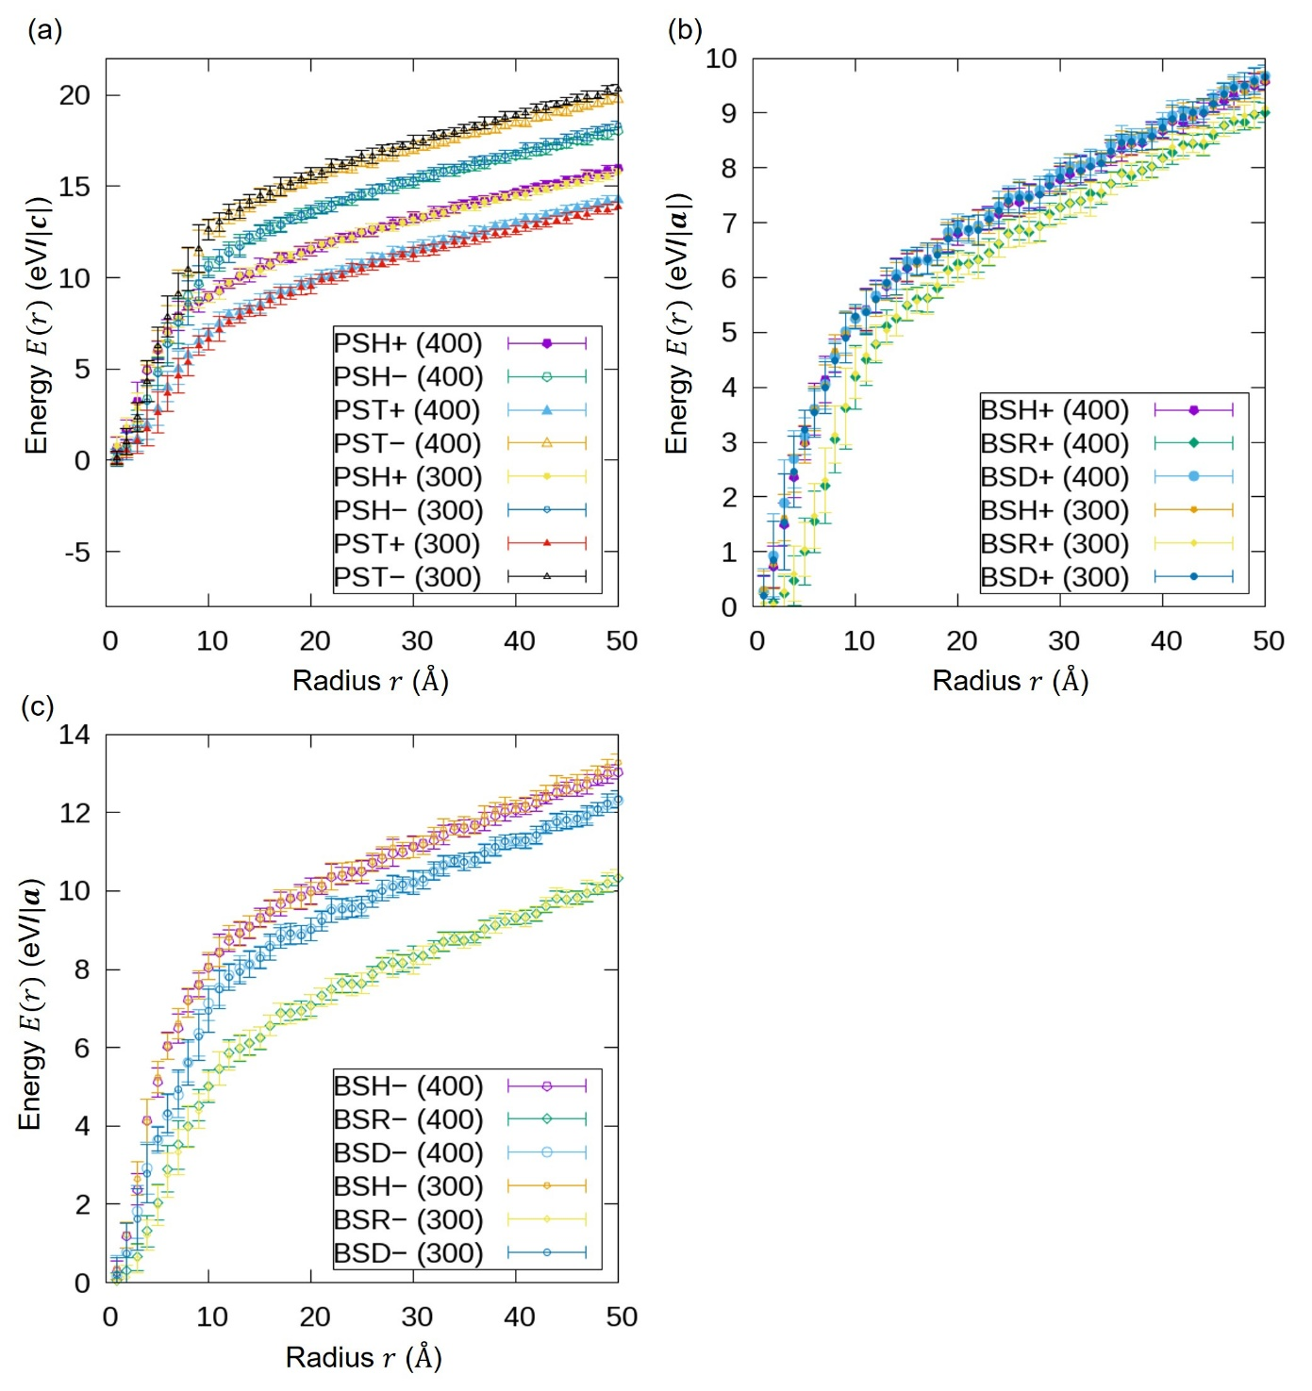
Fig. S1 Comparison of energy-radius profiles for full-sized and reduced-spacing systems, with dipole spacings of roughly 400 Å and 300 Å, respectively. These profiles are presented in the same manner as those of Figure 2 in the main text. (a) Profiles for dislocations along the $c$-axis. (b) Profiles for dislocations with Burgers vector parallel to the $a$-axis. (c) Profiles for dislocations with Burgers vector antiparallel to the $a$-axis

