Nepalese life expectancy and cause-specific life years lost by subnational populations- Supplemental materials

Jibesh Acharya^{1 *}, Vladimir Canudas-Romo²
* Correspondence: acharyajibesh@gmail.com
¹ Population and Statistics Research Hub, Lalitpur, Nepal
² School of Demography, The Australian National University

S1. Degree of Urbanization in Nepal 2
S2. Recording of deaths in the Census 3
S3. Mapping of census-reported causes of death to ICD-10 categories 4
S4. Smoothing of Age-Specific Mortality Rates 5
S5. Data and Mortality Measures 7
S6. Cause-specific deaths by sex and place of residence 8
S8. Comparison of truncated life expectancy (0-95) and life expectancy at birth published by NSO 11
References 12

S1. Degree of Urbanization in Nepal
The Degree of Urbanization (DEGURBA) is an internationally harmonized method that classifies settlements along the rural–urban continuum using gridded population data ($1 {km}^{2}$), density thresholds, and spatial contiguity. In Nepal, it addresses limitations of administrative urban definitions by providing a consistent, spatially explicit classification. The method first classifies grid cells by population density and then aggregates contiguous cells to form settlement clusters. Three main classes are defined: Urban Centres, Urban Clusters, and Rural Areas. Urban Centres are clusters with density ≥1,500 persons/km² (15 per hectare) and population ≥50,000. Urban Clusters have density ≥300 persons/km² (3 per hectare) and population ≥5,000. Rural Areas include all remaining low-density cells. For interpretability, these were further aggregated into three categories: urban, peri-urban, and rural, where peri-urban areas represent transitional zones between dense urban and rural settlements [1]. Figure S1 shows the DEGURBA classification in Nepal.
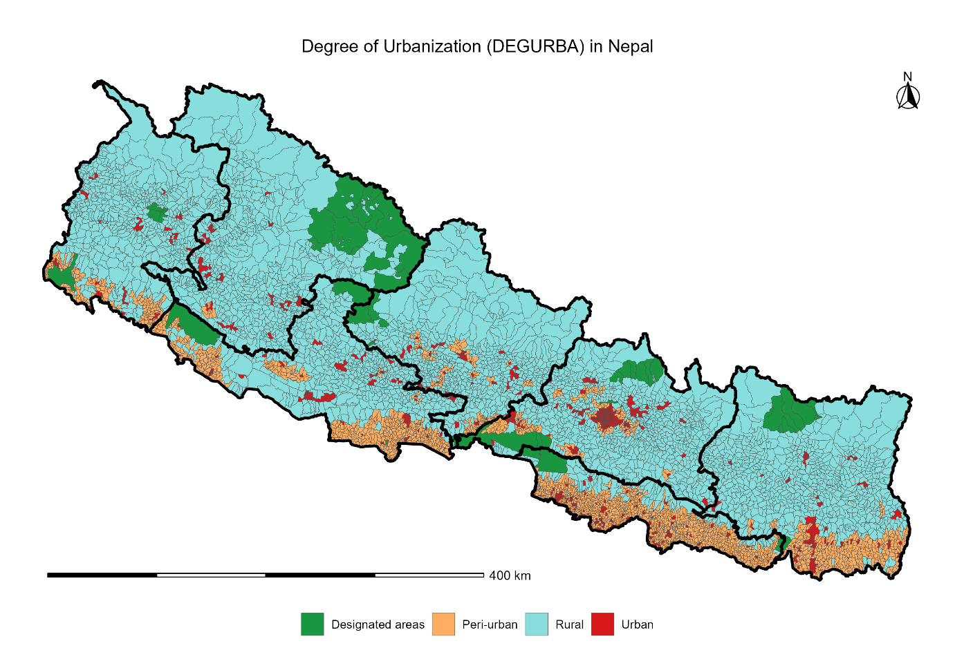
Figure S1. Degree of Urbanization (DEGURBA) in Nepal

S2. Recording of deaths in the Census
Information on deaths was collected at the household level using a structured census questionnaire. Each household was asked whether any member had died during the 12 months preceding the census. If a death was reported, detailed information was collected for each deceased individual [2].
Household-level questions
- In the past 12 months, has any member of this household died?
- If yes, number of deaths in the household?
Individual-level information collected for each deceased person
- Name of the deceased
- Sex (male/female)
- Age at death (in completed years)
- Reported main cause of death (as stated by the respondent), categorized as:
  - Cause of death categories recorded in the census
  - Communicable diseases (including COVID-19)
  - Non-communicable diseases
  - Road accidents
  - Other accidents
  - Pregnancy and delivery complications
  - Suicide
  - Crime/murder
  - Natural calamities
  - Others / unspecified
- Additional question for females aged 15–49 years: What was the status of the deceased woman at the time of death?
  - Pregnant
  - During delivery
  - Within 6 weeks after delivery
  - Other
The causes of death were reported by household respondents and were not initially coded according to the International Classification of Diseases (ICD). Therefore, these categories represent broad, non-medical classifications and may be subject to misclassification.

S3. Mapping of census-reported causes of death to ICD-10 categories
For analytical purposes, the reported causes of death were mapped to ICD-10 broad categories in accordance with standard WHO classifications.
Table S1 shows the classification of the causes of death reported in the census to ICD-10 codes.

Table S1. Mapping of census-reported causes of death to ICD-10 categories

Cause of death | ICD10 Code | ICD10 Category
Communicable diseases (including COVID-19) | A00–B99, U07 | Infectious and parasitic diseases
Non-communicable diseases | C00–N99 | Non-communicable diseases
Pregnancy/delivery complications | O00–O99 | Maternal causes
Road accidents | V01–V89 | Transport accidents
Other accidents | W00–X59 | Unintentional injuries
Natural disasters | X30–X39 | Exposure to natural forces
Suicide | X60–X84 | Intentional self-harm
Crime/murder | X85–Y09 | Assault (homicide)
Unspecified causes | R00–R99 | Symptoms, signs, and ill-defined conditions

S4. Smoothing of Age-Specific Mortality Rates
Observed age-specific mortality rates (m_{x}) exhibited irregularities due to small sample sizes and age misreporting. We therefore applied the log-quadratic model of Wilmoth et al. (2012), which expresses the logarithm of age-specific mortality as a quadratic function of child mortality with an age-specific adjustment term:
log(m_{x}) = a_{x} + b_{x}h + c_{x}h² + ν_{x}k,
where h = log(₅q₀) is the log of the under-five probability of death, k is a scalar capturing deviations from the standard age pattern, and a_{x}, b_{x}, c_{x}, ν_{x} are published age-specific coefficients taken directly from Wilmoth et al. (2012) [3].
The model was fitted separately by sex and place of residence using two empirical inputs: the under-five probability of death (₅q₀) and the adult conditional probability of death (₄₅q₁₅, probability of dying between ages 15 and 60). ₅q₀ was derived from observed mortality rates at ages 0–4 by combining the infant probability of death (₁q₀) and child probability (₄q₁) using Coale–Demeny mean-age-at-death formulas. ₄₅q₁₅ was computed directly from observed five-year age-specific rates for ages 15–59 under the exponential survival assumption. Given these two inputs, the adjustment parameter k was solved via numerical root-finding such that the fitted life table reproduces the observed ₄₅q₁₅ conditional on ₅q₀.
The resulting smoothed age-specific death rates were used to construct complete period life tables for each stratum–sex combination. Single-year death rates were additionally obtained by fitting a cubic spline through the midpoints of the smoothed five-year rates on the log scale, used for comparative age analyses. Figure S2 illustrates the observed and smoothed mortality rates on the log scale by sex and place of residence.
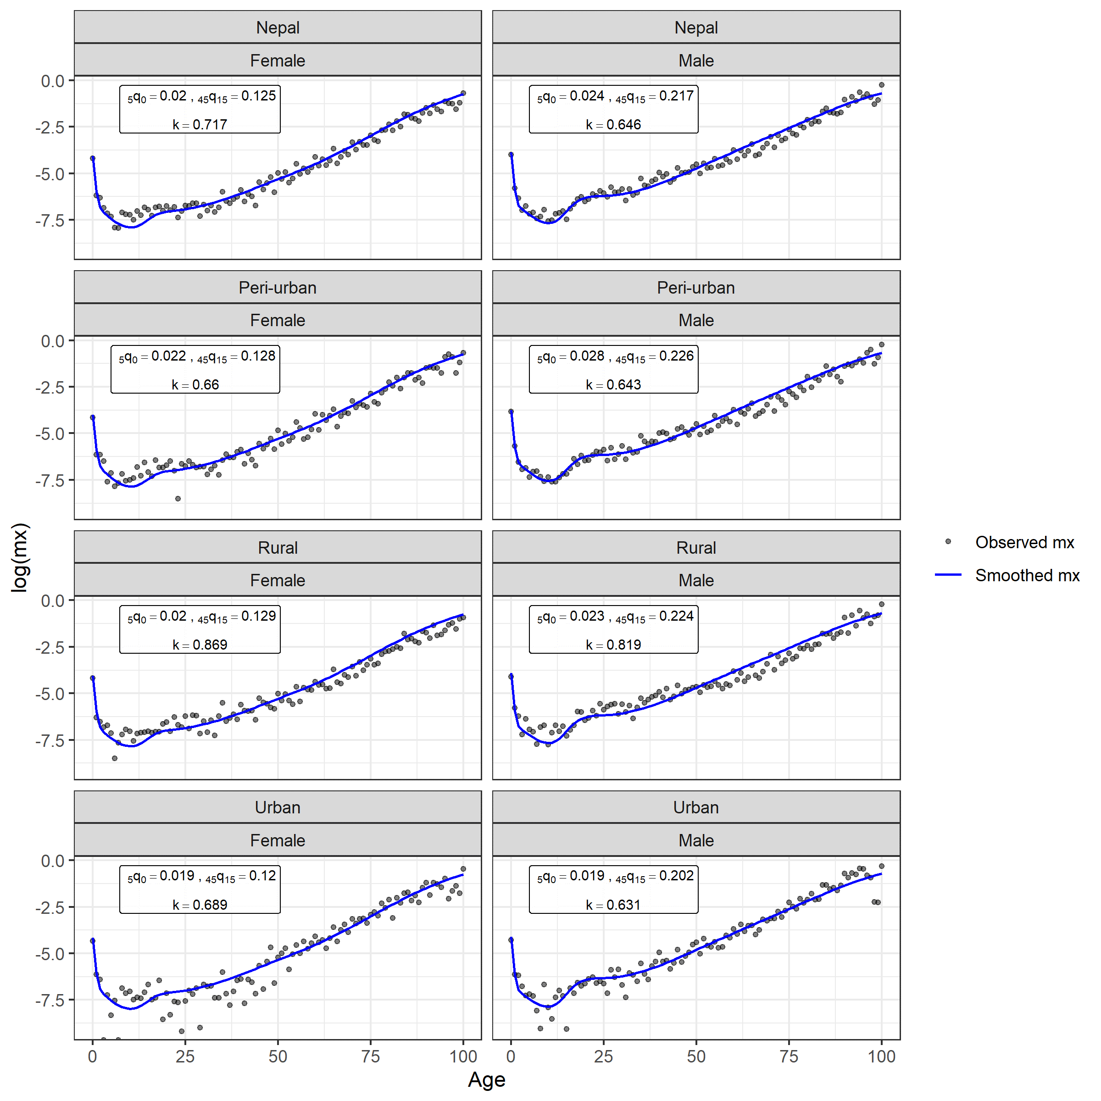

Figure S2. Observed and log-quadratic fitted age-specific mortality rates

S5. Data and Mortality Measures
Age-specific mortality rates
Age -specific mortality rates were computed as:
mx=DxEx, Dx=c​Dx,c
where:
$D_{x}$ = deaths at age $x$; $E_{x}$ = population exposure at age $x$; $D_{x,c}$ = deaths at age $x$ due to cause $c$
Life Table construction
- Average fraction of the age interval lived by those who die (a_{x}): For ages other than 0, a_{x} = 0.5. For age 0, sex-specific adjustments are applied:
  - a₀ (Male) = 0.045 + 2.684 × m₀ if m₀ < 0.107; else 0.330
  - a₀ (Female) = 0.053 + 2.800 × m₀ if m₀ < 0.107; else 0.350
- The probability of dying between ages $x$ and $x+1$: $q_{x}=\frac{m_{x}}{[1+(1-a_{x})m_{x}]}$
- The probability of survival: $p_{x}=1-q_{x}$
- The survivorship function is computed recursively: $l_{x+1}=l_{x}p_{x}$
- The number of deaths in each age interval: $d_{x}=l_{x}q_{x}$
- Person-years lived in each age interval: $L_{x}=l_{x+1}+a_{x}d_{x}$ and for the open-ended interval: $L_{ω}=\frac{l_{ω}}{m_{ω}}$
- The total number of person-years remaining above age $x$: $T_{x}=\sum_{y=x}^{ω}{L_{y}}$
- Life expectancy at age $x$: $e_{x}=\frac{T_{x}}{l_{x}}$
Truncated Life Expectancy
- The truncated life expectancy from birth to age $95$: $​_{95}e_{0}=\frac{\sum_{x=0}^{95-1}{L_{x}}}{l_{0}}$
Life Years Lost (LYL)
- The total life years lost before age $95$: $95-​_{95}e_{0}=\sum_{x=0}^{95-1}{d_{x}}(95-(x+a_{x}))$
Cause-specific Decomposition
Cause-specific contributions in LYL were obtained by redistributing life table deaths according to the observed cause-of-death proportions.
- The proportion of deaths due to the cause $c$ at age $x$: πx,c=Dx,cDx, c​πx,c=1
- Cause-specific life table deaths: $d_{x,c}=d_{x}π_{x,c}$
- LYL by cause satisfies: LYL=c​LYLc

Confidence Intervals
Uncertainty in life table–based measures was estimated using a Monte Carlo simulation approach. We generated 1,000 bootstrap replications of age-specific deaths assuming a Poisson distribution with mean equal to observed deaths. For each replication, mortality rates were recalculated using simulated deaths and person-years exposure derived from life table survivorship (l_{x}​). A complete life table was then reconstructed for each simulated mortality schedule. Age-specific cause-of-death counts were also resampled using a Poisson distribution, conditional on observed cause-specific deaths. These were combined with each simulated life table to compute cause-specific life years lost (LYL). To ensure internal consistency between total life expectancy and cause-specific decomposition, a constraint-preserving shift was applied to simulated LYL estimates. The 95% uncertainty intervals were obtained from the 2.5th and 97.5th percentiles of the adjusted bootstrap distribution. For life expectancy at birth, the corresponding distribution was derived algebraically from total life years lost.

S6. Cause-specific deaths by sex and place of residence
Table S2 presents the cause-specific distribution of deaths by sex and place of residence.

Table S2: Cause-specific deaths by sex and place of residence

Cause of death | Female |  |  | Male
Cause of death | Urban | Rural | Peri-urban | Urban | Rural | Peri-urban
Non-communicable disease | 12358 (54.59%) | 15023 (53.05%) | 15708 (48.44%) | 15821 (50.42%) | 19138 (49.13%) | 21168 (47.85%)
Others | 5464 (24.14%) | 6859 (24.22%) | 8456 (26.08%) | 5668 (18.06%) | 8380 (21.51%) | 9717 (21.97%)
Communicable disease | 2746 (12.13%) | 2671 (9.43%) | 3519 (10.85%) | 5809 (18.51%) | 4684 (12.02%) | 5248 (11.86%)
Natural disasters | 857 (3.79%) | 1123 (3.97%) | 2030 (6.26%) | 1337 (4.26%) | 1490 (3.82%) | 2749 (6.21%)
Other accident | 494 (2.18%) | 1034 (3.65%) | 1135 (3.5%) | 1118 (3.56%) | 2352 (6.04%) | 2220 (5.02%)
Suicide | 293 (1.29%) | 875 (3.09%) | 571 (1.76%) | 607 (1.93%) | 1457 (3.74%) | 1141 (2.58%)
Road accident | 176 (0.78%) | 221 (0.78%) | 416 (1.28%) | 717 (2.29%) | 970 (2.49%) | 1390 (3.14%)
Not reported | 75  (0.33%) | 147 (0.52%) | 248 (0.76%) | 26  (0.08%) | 101 (0.26%) | 175  (0.4%)
Pregnancy/delivery complications | 82  (0.36%) | 197  (0.7%) | 209 (0.64%) | - | - | -
Crime/murder | 39  (0.17%) | 155 (0.55%) | 88  (0.27%) | 150 (0.48%) | 341 (0.88%) | 369 (0.83%)
Don't know | 54  (0.24%) | 15  (0.05%) | 47  (0.14%) | 123 (0.39%) | 42  (0.11%) | 58  (0.13%)

S7. Distribution of Life Years Lost by Age, Sex, and Residence
Table S3 presents the distribution of LYL across various age groups, sex, and place of residence.

Table S3: Distribution of Life Years Lost by age, sex, and place of residence
Cause of death | Age | Peri-urban |  | Urban |  | Rural |  | Nepal
Cause of death | Age | Male | Female | Male | Female | Male | Female | Male | Female
Communicable | 0 | 0.34 | 0.42 | 0.62 | 0.01 | 0.45 | 0.23 | 0.44 | 0.24
Injuries | 0 | 0.28 | 0.3 | 0.12 | 0.12 | 0.47 | 0.38 | 0.31 | 0.27
NCD | 0 | 0.9 | 0.53 | 0.28 | 1.03 | 0.6 | 0.71 | 0.66 | 0.72
Others | 0 | 0.67 | 0.44 | 0.5 | 0.3 | 0.33 | 0.28 | 0.51 | 0.35
Communicable | 0-4 | 0.09 | 0.08 | 0.03 | 0.09 | 0.02 | 0.08 | 0.05 | 0.09
Injuries | 0-4 | 0.14 | 0.13 | 0.09 | 0.07 | 0.12 | 0.1 | 0.12 | 0.11
NCD | 0-4 | 0.22 | 0.14 | 0.17 | 0.22 | 0.22 | 0.21 | 0.21 | 0.17
Others | 0-4 | 0.15 | 0.15 | 0.12 | 0.03 | 0.13 | 0.08 | 0.14 | 0.1
Communicable | 5-9 | 0.03 | 0.03 | 0.04 | 0.03 | 0.02 | 0.03 | 0.02 | 0.02
Injuries | 5-9 | 0.1 | 0.06 | 0.04 | 0.04 | 0.09 | 0.07 | 0.08 | 0.06
NCD | 5-9 | 0.09 | 0.07 | 0.08 | 0.07 | 0.09 | 0.07 | 0.09 | 0.07
Others | 5-9 | 0.06 | 0.05 | 0.04 | 0.04 | 0.05 | 0.04 | 0.05 | 0.05
Communicable | 10-14 | 0.01 | 0.03 | 0.03 | 0.02 | 0.02 | 0.03 | 0.02 | 0.03
Injuries | 10-14 | 0.12 | 0.06 | 0.07 | 0.04 | 0.11 | 0.08 | 0.11 | 0.06
NCD | 10-14 | 0.07 | 0.06 | 0.06 | 0.06 | 0.06 | 0.04 | 0.07 | 0.05
Others | 10-14 | 0.04 | 0.03 | 0.02 | 0.03 | 0.03 | 0.03 | 0.03 | 0.03
Communicable | 15-19 | 0.01 | 0.05 | 0.05 | 0.04 | 0.03 | 0.05 | 0.03 | 0.05
Injuries | 15-19 | 0.29 | 0.1 | 0.22 | 0.08 | 0.29 | 0.13 | 0.27 | 0.1
NCD | 15-19 | 0.14 | 0.08 | 0.12 | 0.08 | 0.12 | 0.07 | 0.13 | 0.08
Others | 15-19 | 0.08 | 0.04 | 0.04 | 0.05 | 0.05 | 0.04 | 0.06 | 0.04
Communicable | 20-24 | 0.04 | 0.08 | 0.08 | 0.05 | 0.05 | 0.06 | 0.06 | 0.07
Injuries | 20-24 | 0.4 | 0.1 | 0.3 | 0.09 | 0.41 | 0.14 | 0.38 | 0.11
NCD | 20-24 | 0.18 | 0.1 | 0.15 | 0.09 | 0.16 | 0.1 | 0.16 | 0.1
Others | 20-24 | 0.08 | 0.05 | 0.06 | 0.06 | 0.07 | 0.03 | 0.07 | 0.04
Communicable | 25-29 | 0.08 | 0.1 | 0.12 | 0.06 | 0.07 | 0.07 | 0.09 | 0.08
Injuries | 25-29 | 0.34 | 0.08 | 0.23 | 0.07 | 0.37 | 0.12 | 0.32 | 0.09
NCD | 25-29 | 0.19 | 0.11 | 0.18 | 0.12 | 0.17 | 0.14 | 0.18 | 0.12
Others | 25-29 | 0.08 | 0.07 | 0.07 | 0.07 | 0.08 | 0.04 | 0.08 | 0.06
Communicable | 30-34 | 0.12 | 0.1 | 0.16 | 0.07 | 0.1 | 0.07 | 0.12 | 0.08
Injuries | 30-34 | 0.27 | 0.08 | 0.16 | 0.07 | 0.31 | 0.11 | 0.25 | 0.08
NCD | 30-34 | 0.26 | 0.16 | 0.25 | 0.16 | 0.23 | 0.19 | 0.25 | 0.17
Others | 30-34 | 0.09 | 0.08 | 0.07 | 0.07 | 0.1 | 0.05 | 0.08 | 0.07
Communicable | 35-39 | 0.17 | 0.1 | 0.21 | 0.09 | 0.13 | 0.08 | 0.16 | 0.09
Injuries | 35-39 | 0.24 | 0.09 | 0.15 | 0.08 | 0.29 | 0.11 | 0.23 | 0.09
NCD | 35-39 | 0.38 | 0.26 | 0.35 | 0.24 | 0.34 | 0.28 | 0.35 | 0.26
Others | 35-39 | 0.1 | 0.07 | 0.07 | 0.06 | 0.12 | 0.07 | 0.09 | 0.07
Communicable | 40-44 | 0.21 | 0.1 | 0.27 | 0.13 | 0.2 | 0.1 | 0.22 | 0.11
Injuries | 40-44 | 0.24 | 0.09 | 0.15 | 0.07 | 0.29 | 0.12 | 0.23 | 0.1
NCD | 40-44 | 0.54 | 0.39 | 0.48 | 0.37 | 0.49 | 0.38 | 0.5 | 0.39
Others | 40-44 | 0.12 | 0.08 | 0.09 | 0.05 | 0.14 | 0.07 | 0.12 | 0.06
Communicable | 45-49 | 0.26 | 0.13 | 0.35 | 0.18 | 0.29 | 0.13 | 0.29 | 0.14
Injuries | 45-49 | 0.28 | 0.1 | 0.16 | 0.06 | 0.31 | 0.14 | 0.25 | 0.1
NCD | 45-49 | 0.78 | 0.54 | 0.71 | 0.52 | 0.71 | 0.52 | 0.73 | 0.52
Others | 45-49 | 0.16 | 0.1 | 0.13 | 0.07 | 0.18 | 0.09 | 0.16 | 0.09
Communicable | 50-54 | 0.31 | 0.19 | 0.43 | 0.22 | 0.36 | 0.15 | 0.36 | 0.18
Injuries | 50-54 | 0.33 | 0.12 | 0.19 | 0.08 | 0.31 | 0.14 | 0.28 | 0.11
NCD | 50-54 | 1.07 | 0.68 | 0.99 | 0.66 | 1.03 | 0.73 | 1.03 | 0.69
Others | 50-54 | 0.24 | 0.14 | 0.2 | 0.12 | 0.25 | 0.12 | 0.23 | 0.13
Communicable | 55-59 | 0.37 | 0.22 | 0.56 | 0.24 | 0.41 | 0.17 | 0.44 | 0.21
Injuries | 55-59 | 0.35 | 0.13 | 0.22 | 0.1 | 0.32 | 0.13 | 0.3 | 0.12
NCD | 55-59 | 1.41 | 0.85 | 1.26 | 0.85 | 1.4 | 0.97 | 1.36 | 0.89
Others | 55-59 | 0.35 | 0.22 | 0.28 | 0.18 | 0.34 | 0.16 | 0.33 | 0.19
Communicable | 60-64 | 0.42 | 0.22 | 0.68 | 0.25 | 0.45 | 0.21 | 0.5 | 0.22
Injuries | 60-64 | 0.37 | 0.16 | 0.25 | 0.12 | 0.31 | 0.12 | 0.32 | 0.14
NCD | 60-64 | 1.71 | 1.08 | 1.56 | 1.11 | 1.76 | 1.22 | 1.68 | 1.13
Others | 60-64 | 0.47 | 0.35 | 0.35 | 0.27 | 0.44 | 0.25 | 0.43 | 0.29
Communicable | 65-69 | 0.41 | 0.23 | 0.71 | 0.28 | 0.44 | 0.22 | 0.5 | 0.24
Injuries | 65-69 | 0.39 | 0.2 | 0.26 | 0.14 | 0.3 | 0.13 | 0.32 | 0.16
NCD | 65-69 | 1.86 | 1.32 | 1.8 | 1.42 | 1.97 | 1.5 | 1.88 | 1.4
Others | 65-69 | 0.61 | 0.54 | 0.42 | 0.37 | 0.54 | 0.42 | 0.54 | 0.45
Communicable | 70-74 | 0.33 | 0.25 | 0.59 | 0.29 | 0.36 | 0.21 | 0.41 | 0.25
Injuries | 70-74 | 0.36 | 0.26 | 0.26 | 0.14 | 0.25 | 0.16 | 0.3 | 0.19
NCD | 70-74 | 1.77 | 1.48 | 1.87 | 1.68 | 1.91 | 1.7 | 1.85 | 1.61
Others | 70-74 | 0.72 | 0.76 | 0.45 | 0.55 | 0.65 | 0.64 | 0.62 | 0.66
Communicable | 75-79 | 0.21 | 0.22 | 0.37 | 0.27 | 0.23 | 0.18 | 0.27 | 0.22
Injuries | 75-79 | 0.28 | 0.29 | 0.24 | 0.12 | 0.19 | 0.18 | 0.24 | 0.2
NCD | 75-79 | 1.41 | 1.41 | 1.6 | 1.67 | 1.5 | 1.64 | 1.5 | 1.57
Others | 75-79 | 0.7 | 0.93 | 0.47 | 0.75 | 0.68 | 0.82 | 0.63 | 0.84
Communicable | 80-84 | 0.12 | 0.15 | 0.18 | 0.19 | 0.11 | 0.13 | 0.14 | 0.16
Injuries | 80-84 | 0.15 | 0.24 | 0.15 | 0.1 | 0.12 | 0.16 | 0.14 | 0.17
NCD | 80-84 | 0.81 | 1.02 | 0.96 | 1.21 | 0.85 | 1.15 | 0.87 | 1.13
Others | 80-84 | 0.5 | 0.83 | 0.43 | 0.77 | 0.53 | 0.8 | 0.49 | 0.8
Communicable | 85-89 | 0.05 | 0.06 | 0.06 | 0.09 | 0.04 | 0.07 | 0.05 | 0.07
Injuries | 85-89 | 0.05 | 0.13 | 0.06 | 0.07 | 0.05 | 0.09 | 0.05 | 0.1
NCD | 85-89 | 0.28 | 0.47 | 0.34 | 0.53 | 0.3 | 0.48 | 0.3 | 0.49
Others | 85-89 | 0.23 | 0.46 | 0.24 | 0.48 | 0.24 | 0.48 | 0.24 | 0.47
Communicable | 90+ | 0.01 | 0.01 | 0.01 | 0.01 | 0.01 | 0.01 | 0.01 | 0.01
Injuries | 90+ | 0.01 | 0.03 | 0.01 | 0.02 | 0.01 | 0.02 | 0.01 | 0.02
NCD | 90+ | 0.04 | 0.08 | 0.05 | 0.09 | 0.04 | 0.08 | 0.04 | 0.08
Others | 90+ | 0.04 | 0.09 | 0.05 | 0.11 | 0.04 | 0.11 | 0.04 | 0.1

S8. Comparison of truncated life expectancy (0-95) and life expectancy at birth published by NSO

Table S4 compares the truncated life expectancy from birth to age 95 (₀e₉₅) with the life expectancy at birth (e₀) published by NSO [4].

Table S4: Comparison of truncated life expectancy (0-95) and life expectancy at birth

Regions | Truncated life expectancy (0-95) |  | NSO life expectancy at birth
Regions | Male | Female | Male | Female
Nepal | 67.53 | 73.54 | 68.70 | 74.30
Urban | 68.75 | 74.04 | 69.30 | 74.30
Peri-urban | 66.79 | 73.20 | 69.00 | 73.80
Rural | 67.35 | 73.31 | 69.00 | 75.70

References

1. National Statistics Office. Degree of Urbanization (DEGURBA) in Nepal. 2024.
2. National Statistics Office. National Population and Housing Census 2021, 12th Population Census. https://microdata.nsonepal.gov.np/index.php/catalog/124/download/1367. Accessed 19 Apr 2026.
3. Wilmoth J, Zureick S, Canudas-Romo V, Inoue M, Sawyer C. A flexible two-dimensional mortality model for use in indirect estimation. Popul Stud (NY). 2012;66:1–28. https://doi.org/10.1080/00324728.2011.611411.
4. National Statistics Office. Mortality in Nepal. Kathmandu; 2025.

