Supplementary material
a)  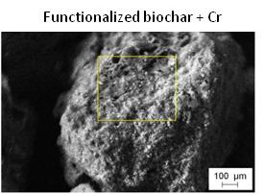 | b)  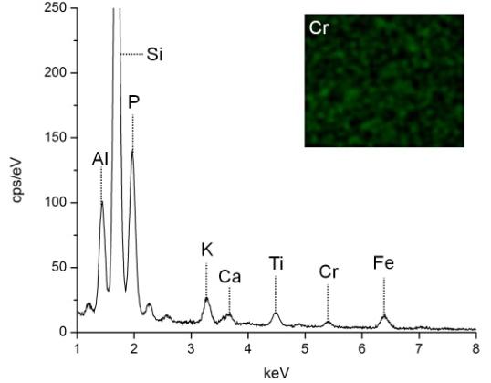
Fig. A. SEM/EDX spectra after chromium adsorption onto functionalized biochar: a) micrograph of functionalized biochar loaded with Cr, b) EDX spectrum of the yellow square inside a, indicating the presence of P and Cr. The image inside b represents Cr distribution on the biochar.

a)  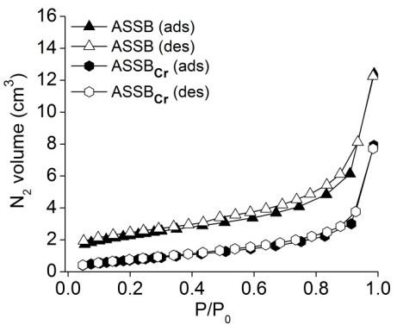 | b)  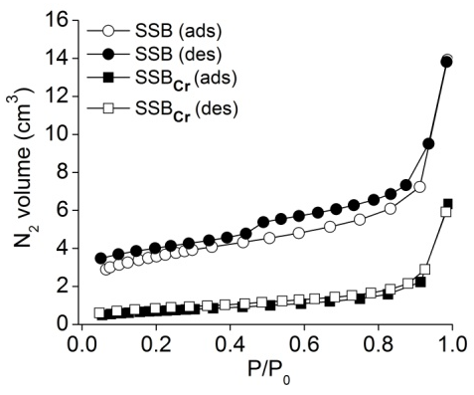
Fig. B. N₂ adsorption isotherms at 77 K of adsorbents before and after Cr adsorption, a) functionalized biochar and b) non-functionalized biochar.

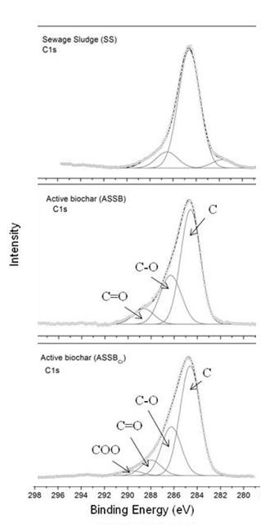
Fig. C. Deconvolution of XPS C1s for Sewage Sludge and functionalized biochar (before and after adsorption)

Table A. Element composition of the materials determined by SEM/EDS
Material | Si | Fe | Al | Ca | K | Mg | P | Cr
 | ----------------------------- % -----------------------------
SS | 7.84 | 4.89 | 4.09 | 2.18 | 1.50 | 0.97 | *ND | ND
SSB | 8.20 | 7.62 | 5.62 | 3.73 | 1.54 | 0.98 | ND | ND
SSB_{Cr} | 9.40 | 6.69 | 6.02 | 2.99 | 0.99 | 0.88 | ND | 0.14
ASSB | 10.62 | 2.93 | 1.92 | 0.69 | ND | ND | 7.03 | ND
ASSB_{Cr} | 11.72 | 2.23 | 2.03 | 0.63 | ND | ND | 7.05 | 0.57
*ND – not detected. (Limit detection = 0.1 %)

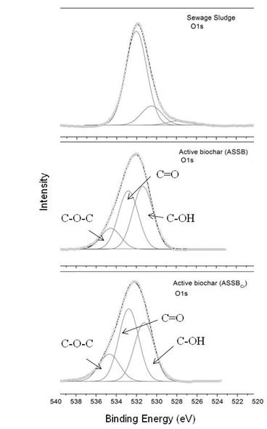
Fig. D. Deconvolution of XPS O1s for sewage sludge and functionalized biochar (before and after adsorption)

