Table I. ASUWOG FA scoring system.
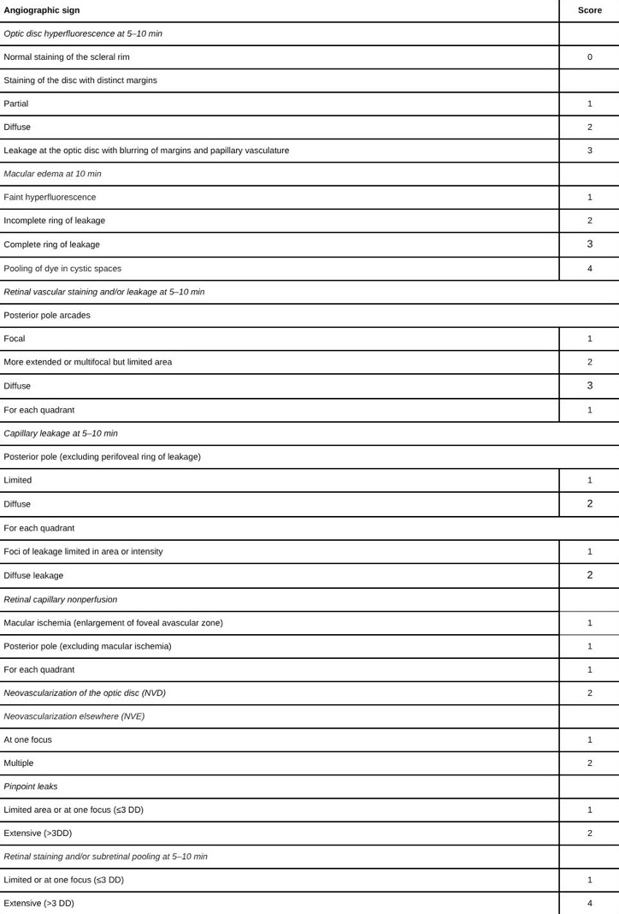

Table II. Demographic and clinical characteristics of the participants
 | Group 1 Patients  (n=37 eyes) | Group 2 Patients  (n=42) | Controls  (n=40) | p
Gender, n (%)  Female  Male | 18 (48.60)  19 (51.40) | 15 (35.70)  27 (64.30) | 21 (52.50)  19 (47.50) | 0.278*
Mean age (years) ± SD (range) | 37.35±10.62  35.00 (21.00-63.00) | 36.21±7.08  36.00 (24.00-56.00) | 33.50±9.84  31.00 (18.00-60.00) | 0.129**
Duration of BD (years) | 6.49±3.76  5.00 (1.00-17.00) | 6.71±4.55  5.50 (1.00-20.00) | - | 0.929***
Number of uveitis relapses | 2.59±1.18  3.00 (1.00-6.00)
Time interval between remission and activation  (months) | 14.2 ± 8.6  12.0 (8–18)
Treatment n (%)  Azathioprine  Colchicine  Azathioprine+Colchicine  Adalimumab  Infliximab  Interferon | 5 (13.5)  9 (24.30)  6 (16.20)  12 (32.4)  3 (8.1)  2 (5.40) | 17 (40.50)  25 (59.50)  5 (11.90)  -  -  2 (4.80) | - | -
Mean BCVA (LogMar)± SD (range) | 0.31±0.26  0.20 (0.00-1.00) | 0.02±0.05  0.00 (0.00-0.20) | 0.00±0.00  0.00 (0.00-0.00) | <0.001**

BD: Behcet’s disease, BCVA: Best corrected visual acuity, SD: Standard deviation
*: Pearson Chi−Square test
**: Kruskal−Wallis test
***: Mann −Whitney U test

Table III. Parameters from the OCT, OCT-A, and EDI-OCT images of all the participants
 | Group 1  (n=37) ª | Group 2  (n=42) ^{b} | Controls  (n=40) ^{c} | p* | Post hoc**
Mean CMT (μm) | 262.62±30.53  270.00 (200.00-335.00) | 275.57±22.97  275.00 (233.00-347.00) | 275.47±20.30  276.50 (236.00-314.00) | 0.025
Central RNFL Thickness (μm) | 101.21±14.15  100.00 (67.00-131.00) | 101.47±9.65  100.50 (88.00-128.00) | 103.35±7.84  103.50 (89.00-126.00) | 0.262
FAZ (µm²) | 290.21 ±60.01  310.12 (150.02-390.0) | 250.02±40.02  260.3 (170.04-400.11) | 230.02±50.07  240.02 (100.05-320.02) | 0.001 | a-b:0.030  a-c: 0.003
CVD- superficial (%) | 47.69±2.96  47.80 (40.30-51.60) | 50.49±3.32  50.40 (43.80-60.40) | 52.21±1.39  52.00 (50.00-55.50) | <0.001 | a-b:0.003  a-c<0.001  b-c:0.024
CVD (parafoveal)  superficial (%) | 48.76±4.41  49.40 (36.30-55.70) | 51.36±2.92  52.00 (45.90-60.10) | 52.86±1.34  52.90 (50.50-55.90) | <0.001 | a-b:0.021  a-c<0.001  b-c: 0.042
CVD-deep  (%) | 47.81±4.41  48.40 (36.30-55.70) | 51.88±3.94  52.10 (40.80-60.10) | 53.53±2.37  53.05 (49.80-58.70) | <0.001 | a-b<0.001  a-c<0.001
CVD (parafoveal)  deep (%) | 49.54±5.05  49.90 (38.60-58.40) | 53.33±4.22  53.95 (42.70-61.20) | 54.41±2.73  54.00 (50.00-60.60) | <0.001 | a-b:0.003  a-c<0.001
CVD  (radial peripapillary) (%) | 48.28±2.86  48.90 (40.00-53.90) | 49.03±2.69  48.95 (41.70-53.10) | 57.82±2.77  58.30 (50.80-62.50) | <0.001 | a-b<0.001  b-c<0.001
Sub foveal  ChT (μm) | 266.27±28.64  270.00 (190.00-315.00) | 219.28±20.25  220.00 (182.00-277.00) | 219.65±15.51  217.00 (185.00-258.00) | <0.001 | a-b<0.001  a-c<0.001
BD: Behcet’s disease, BCVA: Best corrected visual acuity, SD: Standard deviation
CMT: Central macular thickness, RNFL: Retina nerve fiber layer FAZ: Foveal avascular zone, CVD: Capillary vessel density ChT: Choroidal thickness
*: Kruskal‒Wallis test
**: Mann‒Whitney U test

Table IV: Relationships between OCT, EDI-OCT, and OCTA parameters and FA scores across with treatment groups
 | Anti-TNF | Azathioprine | Colchicine | Colchicine+  Azathioprine | Interferon | p
Mean CMT (μm) | 253.0 ± 31.1 | 271.0 ± 22.1 | 270.3±18.9 | 278.8 ± 42.5 | 231.5±26.2 | 0.186
Central RNFL Thickness (μm) | 101.2 ± 9.8 | 104.5 ± 8.2 | 106.1 ± 7.4 | 103.3 ± 9.1 | 98.6 ± 10.5 | 0.278
FAZ (µm²) | 0.307±0.065 | 0.344±0.037 | 0.252±0.052 | 0.252. ± 0052 | 0.312±0.035 | 0.105
CVD- superficial (%) | 46.43±3.32 | 48.58 ± 1.84 | 50.01 ± 1.37 | 47.22 ± 2.90 | 45.95 ± 2.62 | 0.051
CVD (parafoveal)  superficial (%) | 49.43±4.72 | 50.58 ± 1.14 | 52.01 ±2.47 | 49.22 ± 2.90 | 47.65 ± 1.52 | 0.121
CVD-deep  (%) | 46.85±4.11 | 49.22 ± 3.20 | 50.62 ± 2.94 | 44.75 ± 5.36 | 48.15 ± 7.71 | 0.134
CVD (parafoveal)  deep (%) | 47.65±5.21 | 50.42 ± 2.25 | 52.31 ± 2.14 | 45.75 ± 4.12 | 49.27 ± 3.11 | 0.15
CVD  (radial peripapillary) (%) | 47.57 ± 2.75 | 49.44 ± 2.56 | 49.12 ± 2.02 | 49.53 ± 2.33 | 43.20 ± 4.53 | 0.113
Sub foveal  ChT (μm) | 259.7 ± 32.9 | 268.2 ± 8.44 | 278.0 ± 25.0 | 255.0 ± 29.5 | 292.0 ± 26.9 | 0.363
FA score | 16.27±4.22 | 8.20±2.28 | 11.56±3.54 | 10.83±2.86 | 17.0±15.56 | 0.007

CMT: Central macular thickness, RNFL: Retinal nerve fiber layer FAZ: Foveal avascular zone,
CVD: Capillary vessel density ChT: Choroidal thickness, Anti TNF: Antitumor necrosis factor (Adalimumab, Infliksimab)

Table V: Comparison of OCT, OCT-A, and EDI-OCT parameters between the BD without uveitis group and the control group.
 | Group 2  (n=42) ^{b} | Controls  (n=40) ^{c} | p*
Mean CMT (μm) | 275.57±22.97  275.00 (233.00-347.00) | 265.47±20.30  266.50 (203.00-314.00) | 0.099
Central RNFL Thickness (μm) | 101.47±9.65  100.50 (88.00-128.00) | 103.35±7.84  103.50 (89.00-126.00) | 0.213
FAZ (µm²) | 250.02±40.02  260.3 (170.04-400.11) | 230.02±50.07  240.02 (100.05-320.02) | 0.079
CVD- superficial (%) | 50.49±3.32  50.40 (43.80-60.40) | 52.21±1.39  52.00 (50.00-55.50) | 0.008
CVD (parafoveal)  superficial (%) | 51.36±2.92  52.00 (45.90-60.10) | 52.86±1.34  52.90 (50.50-55.90) | 0.014
CVD-deep  (%) | 51.88±3.94  52.10 (40.80-60.10) | 53.53±2.37  53.05 (49.80-58.70) | 0.055
CVD (parafoveal)  deep (%) | 53.33±4.22  53.95 (42.70-61.20) | 54.41±2.73  54.00 (50.00-60.60) | 0.346
CVD  (radial peripapillary) (%) | 49.03±2.69  48.95 (41.70-53.10) | 57.82±2.77  58.30 (50.80-62.50) | <0.001

Sub foveal  ChT (μm) | 219.28±20.25  220.00 (182.00-277.00) | 219.65±15.51  217.00 (185.00-258.00) | 0.831

CMT: Central macular thickness, RNFL: Retinal nerve fiber layer FAZ: Foveal avascular zone,
CVD: Capillary vessel density ChT: Choroidal thickness
*: Mann‒Whitney U Test

Table VI: Relationships between OCT, EDI-OCT, and OCTA parameters and disease duration, number of relapses, and visual acuity in BU patients
 | Duration of Disease |  | Number of relaps |  | VA (logMAR) |  | Time interval between remission and activation
 | r | p* | r | p* | r | p* | r | p*
Mean CMT (μm) | -0.144 | 0.394 | -0.263 | 0.116 | -0.061 | 0.719 | -0.14 | 0.173
Central RNFL Thickness (μm) | -0.150 | 0.375 | 0.057 | 0.735 | -0.406 | 0.013 | -0.23 | 0.302
FAZ (µm²) | 0.087 | 0.609 | -0.189 | 0.262 | -0.325 | 0.050 | 0.041 | 0.224
CVD- superficial (%) | -0.169 | 0.319 | 0.018 | 0.914 | -0.164 | 0.332 | -0.17 | 0.29
CVD (parafoveal)  superficial (%) | -0.132 | 0.436 | -0.015 | 0.931 | 0.041 | 0.808 | 0.14 | 0.345
CVD-deep  (%) | -0.174 | 0.302 | -0.068 | 0.690 | -0.109 | 0.522 | -0.11 | 0.451
CVD (parafoveal)  deep (%) | -0.195 | 0.248 | -0.071 | 0.675 | -0.143 | 0.399 | -0.18 | 0.415
CVD  (radial peripapillary) (%) | -0.026 | 0.880 | -0.239 | 0.154 | -0.538 | 0.001 | -0.16 | 0.312
Sub foveal  ChT (μm) | 0.189 | 0.262 | -0.023 | 0.893 | -0.079 | 0.642 | 0.171 | -0.32
VA: Vision Acuity CMT: Central macular thickness, RNFL: Retinal nerve fiber layer FAZ: Foveal avascular zone,
CVD: Capillary vessel density ChT: Choroidal thickness
*: Spearman correlation test

Table VII. Relationships between FA score, CMT (μm), FAZ (µm ²) and OCTA imaging outcomes in BU patients
 | FA score |  | CMT (μm) |  | FAZ (µm²)
 | r | p* | r | p* | r | p*
Mean CMT (μm) | -0.211 | 0.210 | - | - | -0.347 | 0.035
Central RNFL Thickness (μm) | -0.027 | 0.874 | 0.085 | 0.619 | 0.208 | 0.218
FAZ (µm²) | 0.449 | <0.001 | -0.347 | 0.035 | - | -
CVD- superficial (%) | -0.696 | <0.001 | 0.337 | 0.042 | -0.356 | 0.030
CVD (parafoveal)  superficial (%) | -0.573 | <0.001 | 0.288 | 0.083 | -0.272 | 0.104
CVD-deep  (%) | -0.593 | <0.001 | 0.078 | 0.647 | -0.346 | 0.036
CVD (parafoveal)  deep (%) | -0.546 | <0.001 | -0.052 | 0.759 | -0.151 | 0.371
CVD  (radial  peripapillary) (%) | -0.330 | 0.046 | 0.204 | 0.225 | 0.105 | 0.537
Sub foveal  ChT (μm) | -0.021 | 0.901 | -0.128 | 0.451 | 0.210 | 0.213
FA: Flourescein angiography CMT: Central macular thickness OCTA: Optic coherence tomography angiography, RNFL: Retinal nerve fiber layer FAZ: Foveal avascular zone
CVD: Capillary vessel density ChT: Choroidal thickness
*: Spearman correlation test

Table VIII: ROC Analysis Table of OCT-A Parameters in Patients with BU
 | FAZ | Sub foveal  ChT (μm) | CVD- superficial (%) | CVD-parafoveal  superficial (%) | CVD-deep  (%) | CVD- parafoveal  deep (%) | CVD-radial peripapillary  (%)
Cutoff value | ≥0.270 | ≥238.000 | ≤49.000 | ≤50.000 | ≤50.650 | ≤52.550 | ≤53.450
AUC (95% CI) | 0.669 (0.539-0.799) | 0.895 (0.817-0.972 | 0.722 (0.611-0.833) | 0.676 (0.559-0.794) | 0.767 (0.664-0.871) | 0.725 (0.612-0.837) | 0.992 (0.980-0.999)
Sensitivity (95% CI) | 64.86 (47.46-79.79) | 86.49 (71.23-95.46) | 62.16 (46.94-77.88) | 56.76 (39.49-72.90) | 67.57 (50.21-81.99) | 67.57 (50.21-81.99) | 97.30 (85.84-99.93)
Specificity (95% CI) | 61.90 (45.64-76.43) | 88.10 (74.37-96.02) | 63.41 (46.94-77.88) | 64.29 (48.03-78.45) | 66.67 (50.45-80.43) | 64.29 (48.03-78.45) | 95.24 (83.84-99.42)
PPV (95% CI) | 60.00 (48.82-70.23) | 86.49 (73.57-93.64) | 60.53 (48.81-71.14) | 58.33 (46.08-69.64) | 64.10 (52.43-74.31) | 62.50 (51.19-72.59) | 94.74 (82.30-98.59)
NPV (95% CI) | 66.67 (54.86-76.69) | 88.10 (76.47-94.40) | 65.00 (53.62-74.89) | 62.79 (52.27-72.23) | 70.00 (58.31-79.56) | 69.23 (57.30-79.05) | 97.56 (85.25-99.64)
Accuracy (95% CI) | 63.29 (51.69-73.86) | 87.34 (77.95-93.76) | 62.82 (51.13-73.50) | 60.76 (49.13-71.56) | 67.09 (55.60-77.25) | 65.82 (54.29-76.13) | 96.20 (89.30-99.21)
FAZ: Foveal avascular zone, CVD: Capillary vessel density, ChT: Choroidal thickness, CI: Confidence interval, AUC: Area under the curve, PPV: Positive predictive value, NPV: Negative predictive value

