Tailoring NIR-II photoluminescence of single thiolated Au25 nanoclusters by selective binding to proteins

Franck Bertorelle,^{1,2} K. David Wegner,³ Martina Perić Bakulić,⁴ Hussein Fakhouri,^{1,4} Clothilde Comby-Zerbino,¹ Amin Sagar,⁵ Pau Bernadó,⁵ Ute Resch-Genger,³ Vlasta Bonačić-Koutecký,^{4,6} Xavier Le Guével^{7,*} and Rodolphe Antoine^{1,*}

1) Institut lumière matière, UMR5306, Université Claude Bernard Lyon1-CNRS, Univ. Lyon 69622, Villeurbanne cedex, France. rodolphe.antoine@univ-lyon1.fr
2) Unit Function & Protein Engineering UMR CNRS 6286, University of Nantes, Nantes Cedex, France
3) Federal Institute for Materials Research and Testing (BAM), Richard-Willstaetter-Str. 11, 12489 Berlin, Germany
4) Center of Excellence for Science and Technology-Integration of Mediterranean Region (STIM) at Interdisciplinary Center for Advanced Sciences and Technology (ICAST), University of Split, Poljička cesta 35, 21000 Split, Croatia.
5) Centre de Biologie Structurale, Université de Montpellier, INSERM, CNRS. 29 rue de Navacelles 34090 Montpellier - France
6) Chemistry Department, Humboldt University of Berlin, Brook-Taylor-Strasse 2, 12489 Berlin, Germany.
7) Institute for Advanced Biosciences, Univ. Grenoble Alpes/INSERM1209/CNRS-UMR5309, Grenoble, France. xavier.le-guevel@univ-grenoble-alpes.fr

Supporting information

METHODS.
Materials. Tetrachloroauric(III) acid trihydrate(HAuCl4·3H2O), 4-mercaptobenzoic acid (pMBA) were obtained from Acros Organics. Milli-Q water with a resistivity of 18.2 MΩ cm was used for all experiments. Cysteine and bovine serum albumin (BSA) were purchased from Sigma-Aldrich.
Synthesis of Au₂₅pMBA_{(18-x)}Cys_{x} with x=0, 2, 5, 18. Au₂₅ nanoclusters protected with mercaptobenzoic acid (para isomer) were synthesized as described elsewhere.¹ Mixed liganded nanoclusters Au₂₅pMBA_{(18-x)}Cyst_{x} with x= 2, 5, 18, were synthesized through a ligand exchange reaction. Ligand exchange occurs with an appropriate amount of cysteine (2 or 5 equivalents) in water at pH ~10 (2h under soft agitation). Clusters were precipitated with a methanol/acetic acid solution to remove the pMBA released and dried at air. Au₂₅Cys₁₈ was synthesized as described elsewhere.²
Synthesis of BSA-Au₂₅. 400 mg of BSA were dissolved in 20 mL in PBS buffer (pH 8). Au₂₅pMBA₁₈ dispersed in water was added to BSA solution in excess or in default (molar ratio of 1.2:1 or 1:3). A gentle stirring was continued for 3 days. Ultracentrifugation enabled the concentration of NCs with a membrane NMWL of 10 kDa. A purification step was conducted with 10% Acrylamide SDS-PAGE gel separation. The colored bands corresponding to Au₂₅pMBA₁₈ and BSA-Au₂₅ were extracted and dissolved in water, purified by dialysis for 2 days and dried by lyophilisation. However, in the case of excess of BSA was used, the separation is much more difficult to realize between BSA-Au₂₅ and free BSA (fig S1).
Instruments. MS of BSA-Au₂₅pMBA₁₈ cluster was measured using a Voyager-DE PRO Biospectrometry Workstation from Applied Biosystems. A pulsed nitrogen laser of 337 nm was used for ionizing the sample, and sinapic acid was used as the matrix. The as-prepared Au₂₅pMBA_{(18-x)}Cys_{x} NCs were characterized by mass spectrometry. The monodispersity in terms of molecular weight the prepared gold clusters was verified by electrospray ionization (ESI) on a commercial quadrupole time-of-flight (micro-qTOF, Bruker-Daltonics, Bremen, Germany, mass resolution ∼10 000).
Circular dichroism (CD) spectra were obtained using a J-810 CD spectrophotometer (Jasco)Steady-state photoluminescence spectra were measured from 600 – 1750 nm with a calibrated FSP 920 (Edinburgh Instruments, Edinburgh, United Kingdom) spectrofluorometer equipped with a nitrogen-cooled PMT R5509P. Time-resolved measurements were performed in the wavelength region of 300 – 1100 nm using a FLS 920 (Edinburgh Instruments, Edinburgh, United Kingdom) lifetime spectrofluorometer equipped with an EPL-510 (Edinburgh Instruments, Edinburgh, United Kingdom) picosecond pulsed diode laser (excitation wavelength of 510±10 nm; power of 5mW) and a fast PMT R2658P from Hamamatsu, respectively. UV-vis spectra in solution were recorded using an AvaSpec-2048 fiber optic spectrometer and an AvaLight-DH-S deuterium halogen light source.
Relative measurements of photoluminescence QYs (Φf,x) were performed using the dye IR125 dissolved in dimethylsulfoxide (DMSO) as reference. The QY of this dye was previously determined to Φ_{f,st} = 0.23). The relative QYs were calculated according to the formula of Demas and Crosby³, see equation below.

$$Φ_{f,x}=Φ_{f, st}\frac{F_{x}}{F_{st}}∙\frac{f_{st}(λ_{ex,st})}{f_{x}(λ_{ex,x})}∙\frac{n_{x}^{2}(λ_{ex,x})}{n_{st}^{2}(λ_{ex,st})}$$

where the subscripts x, st, and ex denote sample, standard and excitation, respectively. $f\left(λ_{ex}\right)$ is the absorption factor, $F$ the integrated spectral fluorescence photon flux, and $n$ the refractive index of the solvents used (DMSO for IR125; water for Au nanoclusters).
All spectroscopic measurements were done in a 1 cm quartz cuvette from Hellma GmbH at room temperature using air-saturated solutions.
Small-Angle X-ray Scattering measurements and analyses. SAXS data for BSA and BSA-Au₂₅ were collected at the SWING beamline at the SOLEIL synchrotron, France, equipped with an Eiger 4M detector with a sample-to-detector distance of 1.5 m.⁴ The parameters used for SAXS data collection are given in Table S3. All the data were collected in SEC-SAXS mode with a Superdex 200 Increase 10/300 GL column (GE Healthcare). The proteins were concentrated to 10 (BSA) and 5 (BSA-Au₂₅) mg/mL and centrifuged at 20,000 x g immediately before injecting onto the column. 80 µL of each sample were injected into the column and the flow rate was maintained at 0.4 mL/min. The initial data processing steps including masking and azimuthal averaging were performed using the program FOXTROT. The selection of frames corresponding to sample and buffer, and the buffer subtraction were performed with CHROMIXS.⁵ The final buffer subtracted and averaged SAXS profiles were analyzed using ATSAS 2.8 software package,⁶ including AUTORG for calculating the radius of gyration, R_{g}, and the extrapolated I(0) value, GNOM⁷ to compute the pair-wise distance distribution, p(r), and DATBAYES⁸ for the calculation of the molecular weight by bayesian estimate from four different approaches. The evaluation of the agreement of a structural model to a SAXS curve was performed with the program CRYSOL⁹ setting the number of spherical harmonics to 40. Normal mode refinement of the different structural models of BSA-Au₂₅ using the experimental SAXS curve was performed with the program SREFLEX.¹⁰

Computational. Density functional theory (DFT) has been used to determine the structural properties of liganded Au NCs: Au₂₅pMBA₁₈ and Au₂₅pMBA₁₆Cys₂. SVP atomic orbital basis set¹³ was used for gold and sulfur atoms and 3-21G split-valence basis set^{11, 12} for ligands. Relativistic effective core potential (RECP) of the Stuttgart group¹⁴ was employed for gold atoms. Coordinates for the starting structure were taken from crystal structure of Au₂₅(SCH₂CH₂Ph)₁₈.¹⁵ The optimization of structure was performed with PBE functional^{16, 17} implemented in Gaussian computational chemistry software.¹⁸

One-photon (OPA) spectra were obtained using the time-dependent density functional (TD-DFT) and Coulomb-attenuated version of Becke’s three-parameter non-local exchange functional together with the Lee–Yang–Parr gradient-corrected correlation functional (CAM-B3LYP)¹⁹ implemented in Gaussian. Polarizable embedding-quantum mechanics (PEQM) method with monopoles taken from structure optimization, implemented in Dalton package programs²⁰ has been used within the QM/MM approach for calculation of two-photon absorption (TPA) spectra.²¹ In this approach QM part includes Au₂₅L₁₈ (L=SCH₃). TPA cross section (σ) was obtained using either single residue or double residue quadratic response procedure.^{22, 23}

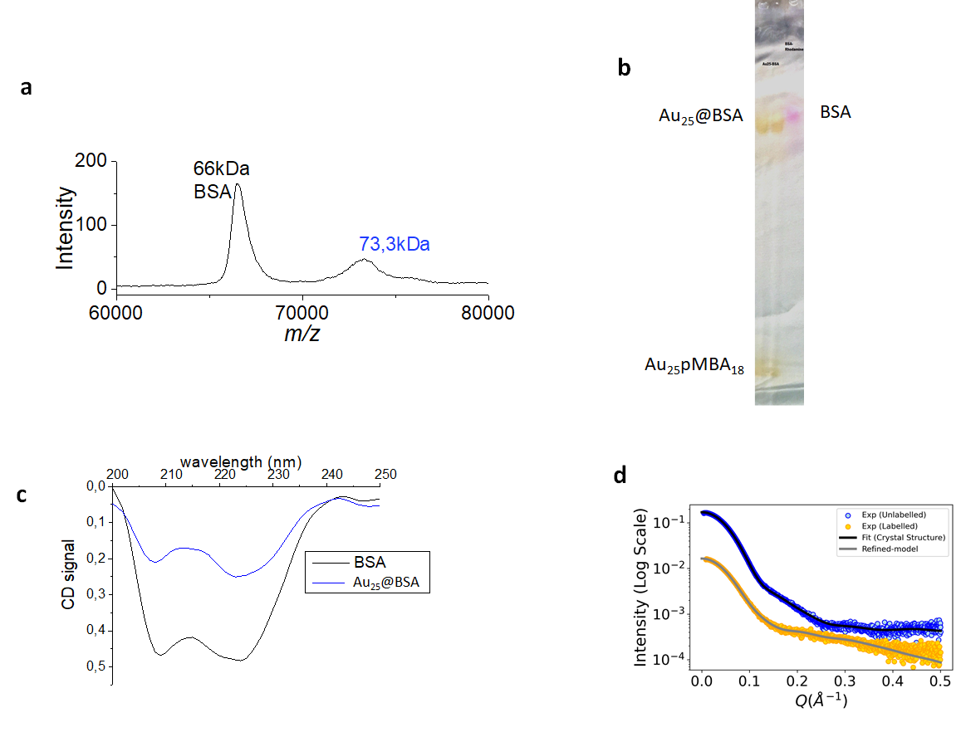
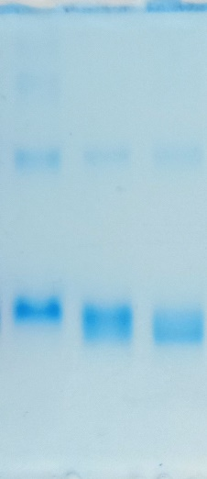
a)
A
B
C
b)

Figure S1 : a) PAGE before extraction of BSA-Au₂₅pMBA₁₈ (synthesis with an excess of Au₂₅pMBA₁₈) (left) and pure BSA (right) colored by rhodamine dye. B) PAGE analysis of final complex samples. A: pure BSA, B: BSA-Au₂₅pMBA₁₈ (excess of BSA during synthesis), C: BSA-Au₂₅pMBA₁₈ (excess of Au₂₅pMBA₁₈ during synthesis). Proteins are stain with Coomassie blue.
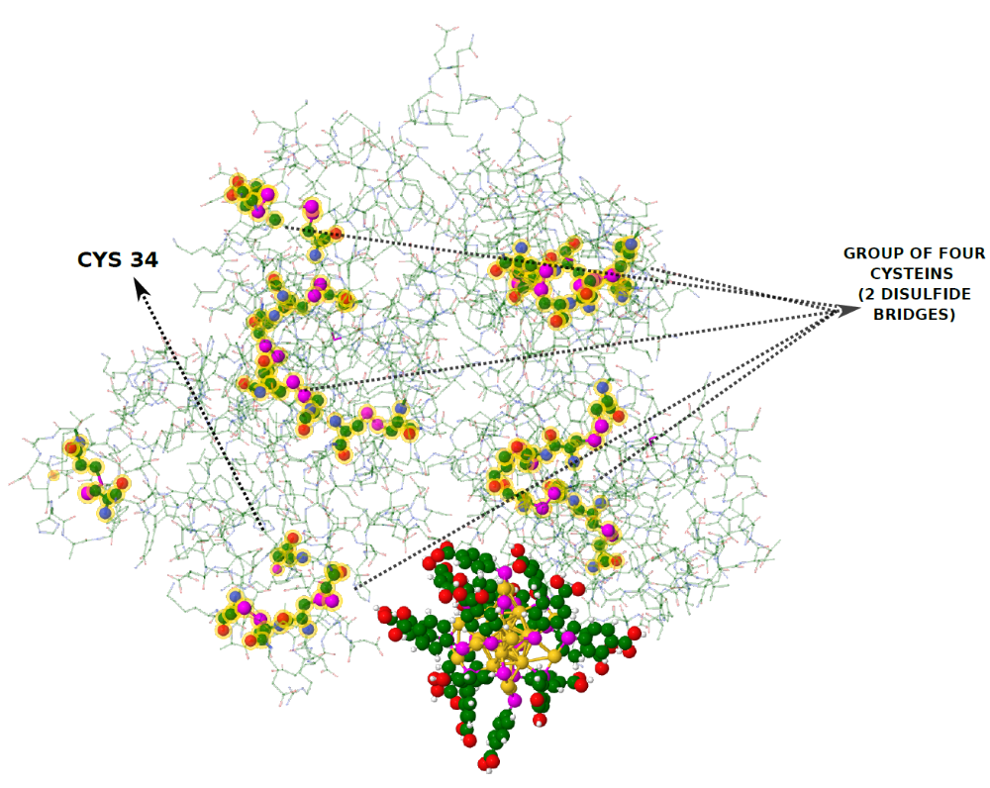
Figure S2: Crystal structure of BSA and DFT structure of Au₂₅pMBA₁₈. Cysteine residues in BSA are highlighted.

Figure S3: Circular dichroism spectra of BSA (black) and Au₂₅-BSA (blue). Spectra are normalized based on protein concentration (114 µg/ml) determined by a Bradford assay.

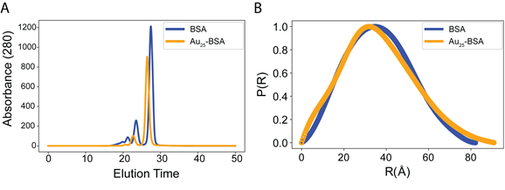
Figure S4 : A) The size exclusion chromatography elution profiles for BSA (Blue) and Au₂₅-BSA (Orange) showing a reduction in the elution time for Au₂₅-BSA. B) The pairwise distance distribution curves obtained by Indirect Fourier Transformations of the SAXS profile using GNOM for BSA (Blue) and Au₂₅-BSA (Orange).

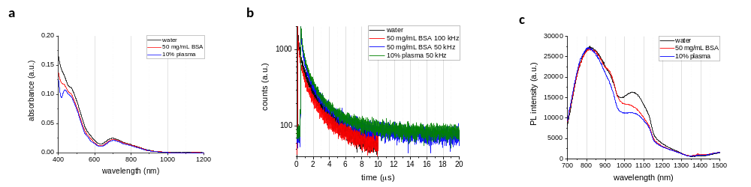
Figure S5 : a) Absorbance spectra of BSA-Au₂₅ in presence of BSA or plasma (10%). b) PL lifetime decay of BSA-Au₂₅, and in addition with BSA and plasma (𝜆_{exc.} 485nm; 𝜆_{em.} 920nm). c) PL spectra of BSA-Au₂₅ in water, with BSA, and with plasma using 𝜆_{exc.} 400 nm.

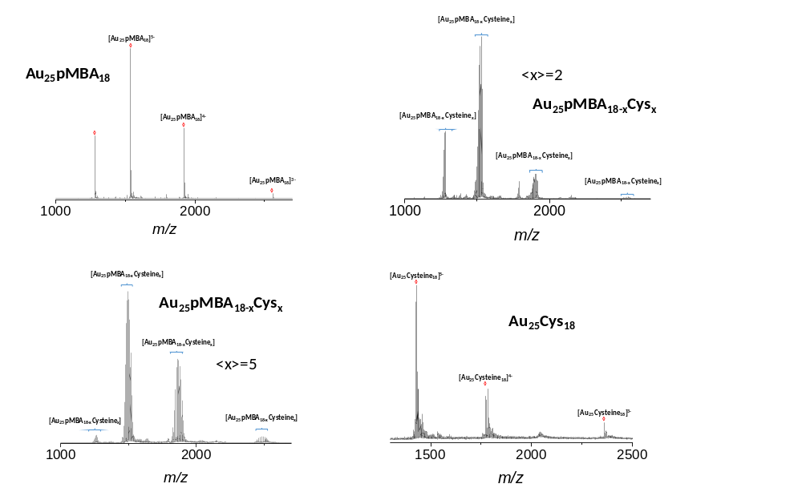
Figure S6 : ESI-MS spectra of Au₂₅pMBA_{(18-x)}Cys_{x}. For mixed pMBA/Cys liganded NCs, a distribution of exchange surface ligand is observed with <x> = 2 and 5 whenlLigand exchange occurs with 2 and 5 equivalent amounts of cysteine, respectively.

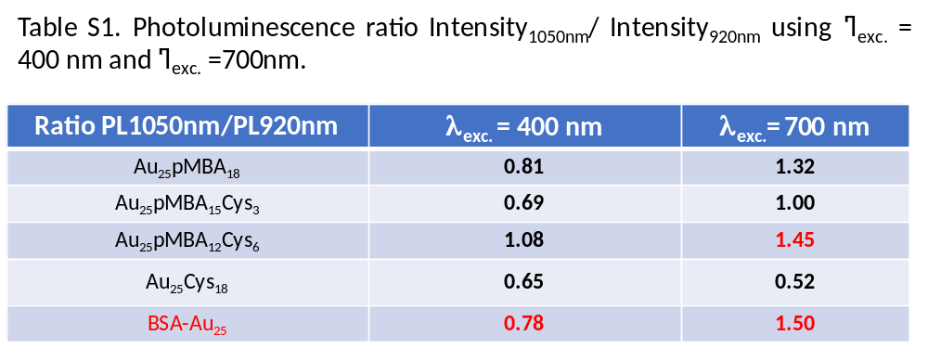

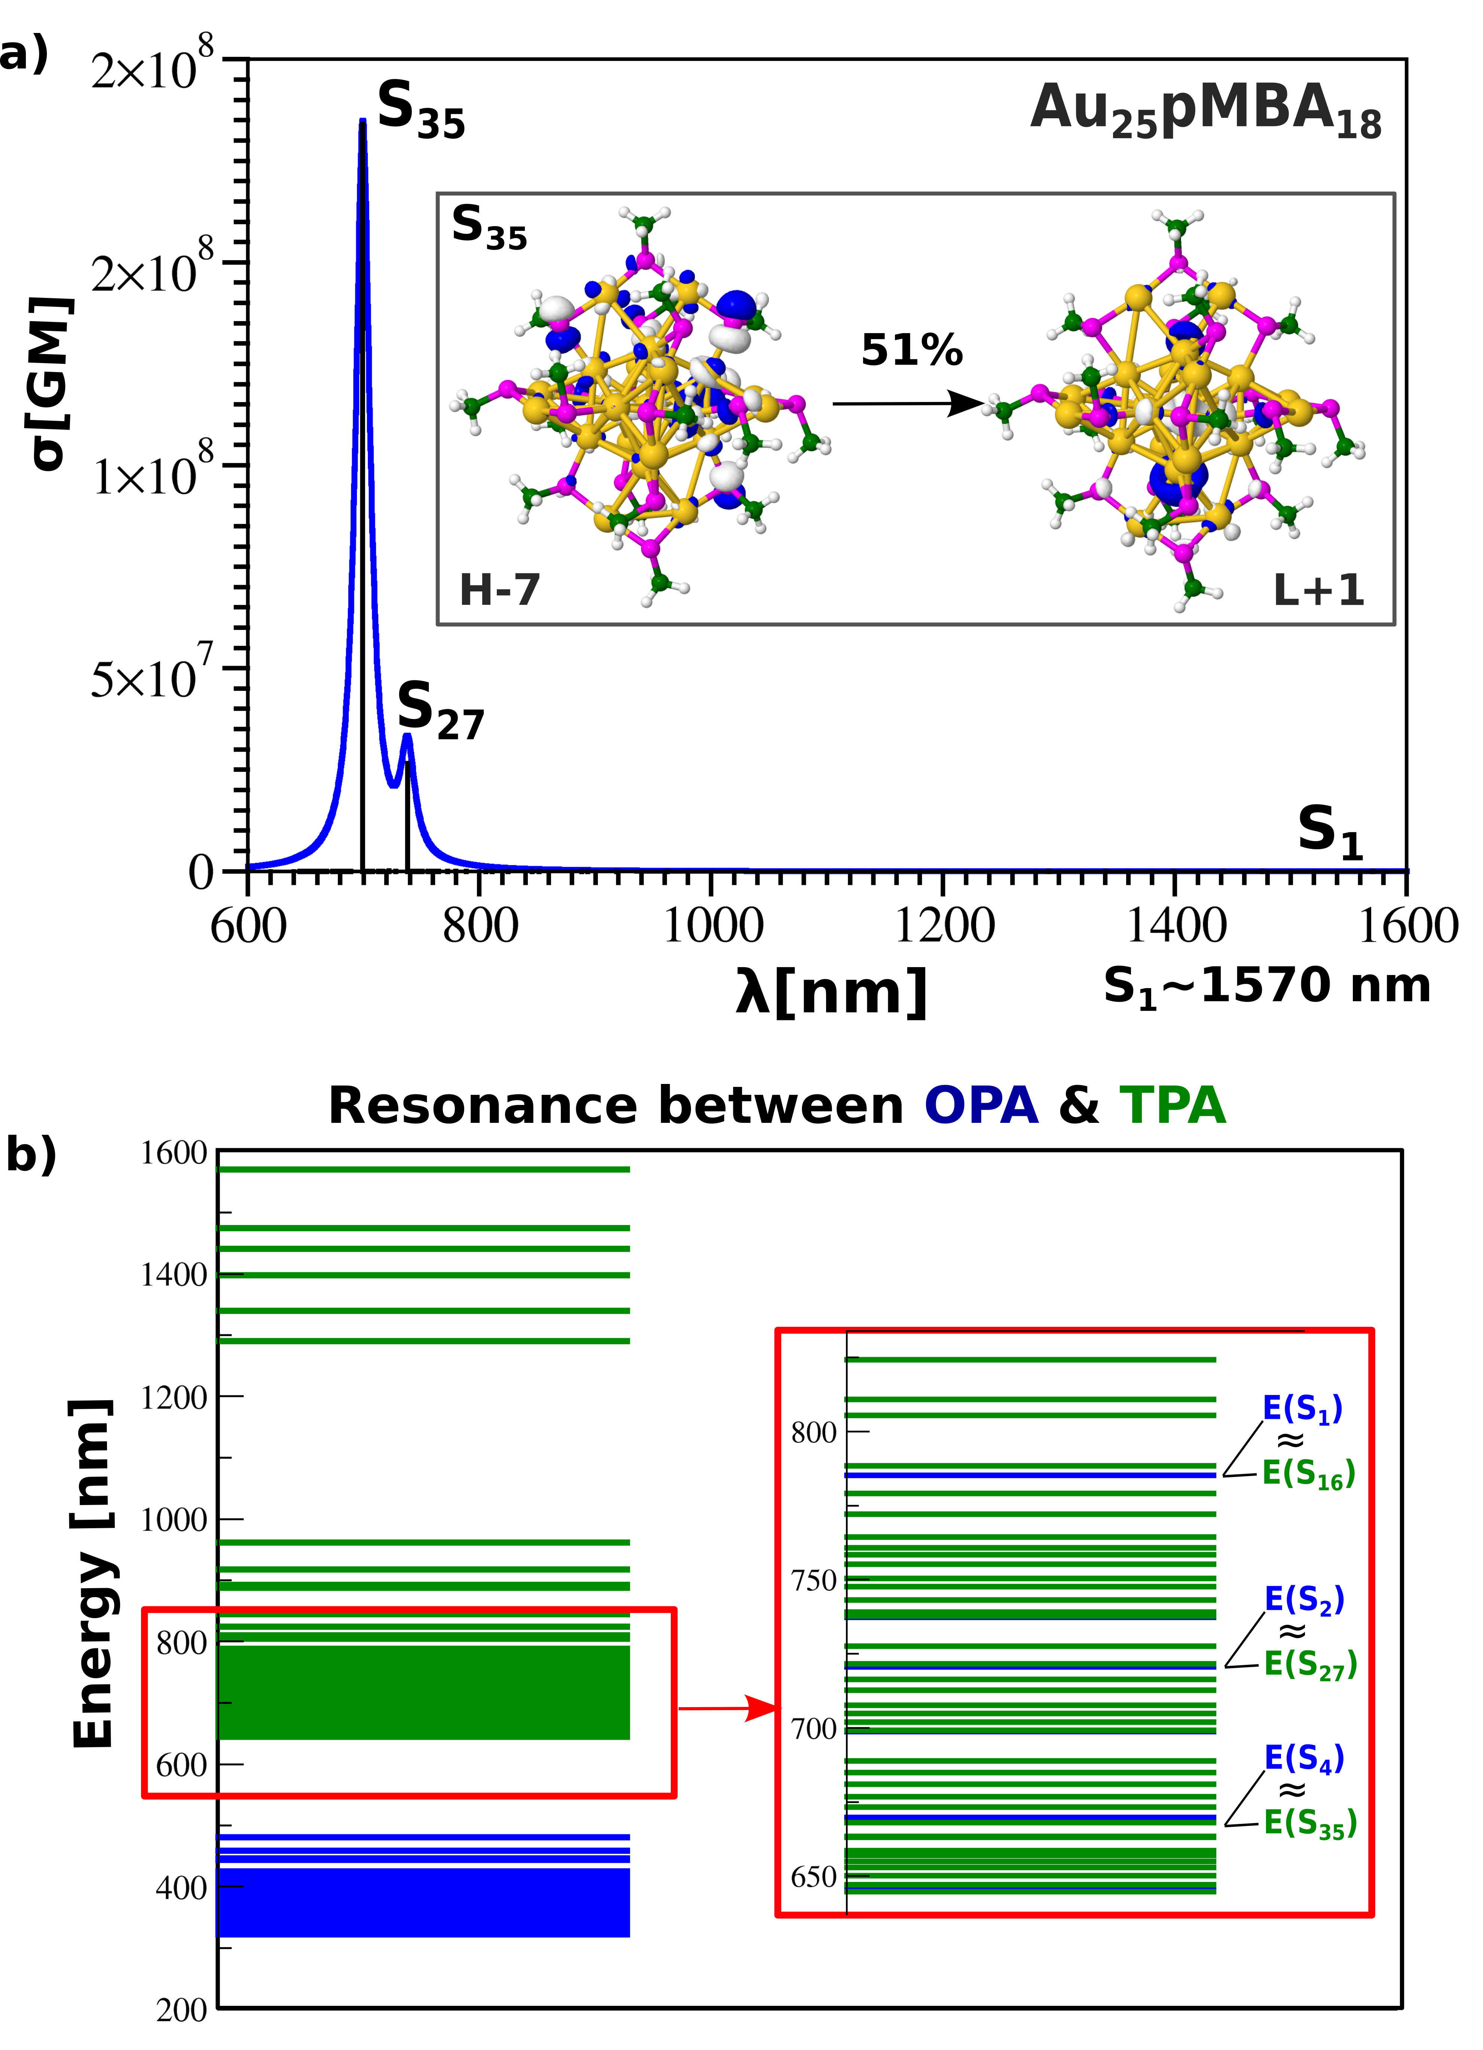
Figure S7: TD-DFT results on a) two-photon (TPA) absorption of Au₂₅pMBA₁₆Cys₂) responsible excitations and b) energies of OPA (blue) and TPA (green) states in nm illustrating the resonance between S₁ OPA and S₅₀ TPA excited states. Excitations for S₁-S₁₀ states involve core-interface and pMBA ligand. For higher states (S₁₀<) the cysteine is present in excitations too (compare Table S2).

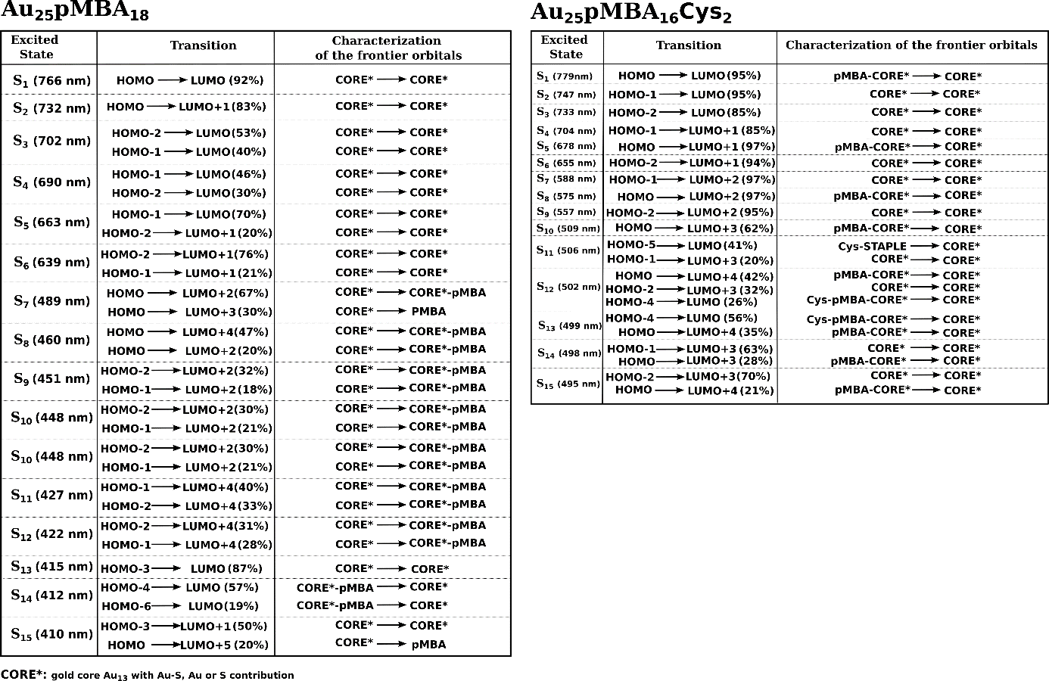

Table S2: Transitions considered for higher excited states. The characterization of the frontier orbitals involved in the corresponding transitions are also shown. Core: gold core of the Au₂₅ cluster; staple and Cys orbitals based on the V-shaped –S–Au–S–Au–S– semirings.

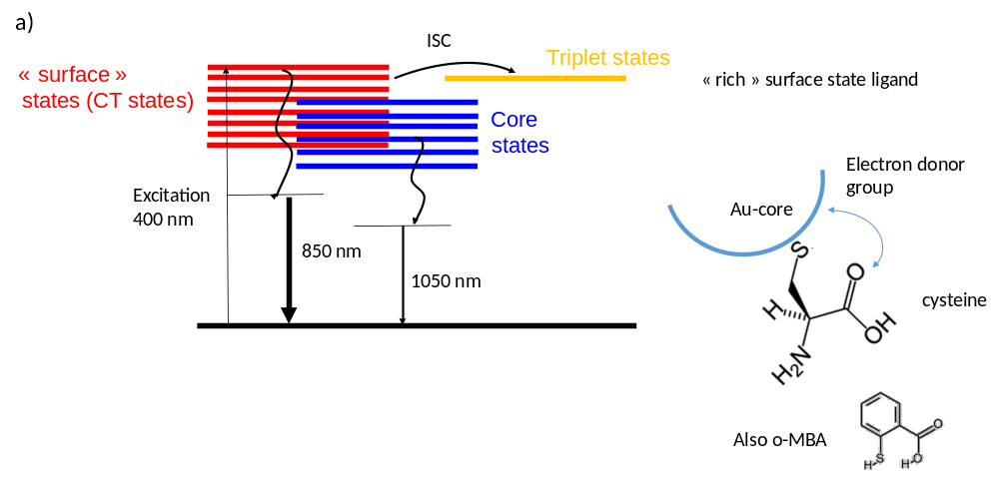

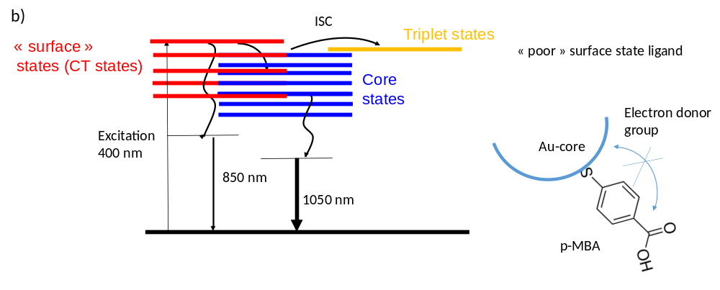
Figure S8: Proposed mechanism of emissions in Au25 nanoclusters with different surface ligands.

Table S3 : SAXS table.
Data-collection parameters | BSA | BSA-Au₂₅
Instrument | SWING (SOLEIL Synchrotron)
Beam geometry | Point collimation
Detector | EigerX4M
Wavelength (Å) | 1.0332
Sample to detector distance | 1.5 m
Measured q range (Å⁻¹) | 0.004-0.57
Temperature (K) | 283
Exposure time (ms) | 990 ms *2100 frames
Concentration (mg mL⁻¹) | 10 | 5
Molecular weight (M_{r}) from sequence (Kda) | 66.5 | 74.0
Software employed
Primary data reduction | FOXTROT
Data processing | CHROMIXS
Guinier Analysis | PRIMUS QT
IFT Analysis | GNOM 4.6
Model Validation | CRYSOL
Normal Mode Analysis | SREFLEX
Three-dimensional graphics representations | PyMOL, VMD
Structural parameters†
I(0) (AU) [from P(r)] | 0.09 | 0.02
R_{g} (Å) [from P(r)] | 27.89 | 28.34
I(0) (AU) (from Guinier) | 0.09 ± 2.6e-05 | 0.02 ± 1.7e-04
R_{g} (Å) (from Guinier) | 27.95 ± 0.02 | 28.16 ± 0.05
D_{max} (Å) | 82.1 | 90.8
Molecular weight (M_{r}) (Bayesian Estimate) | 62.3 | Not determined
SASBDB Entry | To be done | To be done

References:

1. Bertorelle F, et al. Isomeric Effect of Mercaptobenzoic Acids on the Synthesis, Stability, and Optical Properties of Au25(MBA)18 Nanoclusters. ACS Omega 3, 15635-15642 (2018).

2. Yu Y, Luo Z, Yu Y, Lee JY, Xie J. Observation of Cluster Size Growth in CO-Directed Synthesis of Au25(SR)18 Nanoclusters. ACS Nano 6, 7920-7927 (2012).

3. Crosby GA, Demas JN. Measurement of photoluminescence quantum yields. Review. journal of physical chemistry 75, 991-1024 (1971).

4. David G, Pérez J. Combined sampler robot and high-performance liquid chromatography: a fully automated system for biological small-angle X-ray scattering experiments at the Synchrotron SOLEIL SWING beamline. Journal of Applied Crystallography 42, 892-900 (2009).

5. Panjkovich A, Svergun DI. CHROMIXS: automatic and interactive analysis of chromatography-coupled small-angle X-ray scattering data. Bioinformatics (Oxford, England) 34, 1944-1946 (2018).

6. Franke D, et al. ATSAS 2.8: a comprehensive data analysis suite for small-angle scattering from macromolecular solutions. Journal of Applied Crystallography 50, 1212-1225 (2017).

7. Svergun DI. Determination of the regularization parameter in indirect-transform methods using perceptual criteria. Journal of Applied Crystallography 25, 495-503 (1992).

8. Hajizadeh NR, Franke D, Jeffries CM, Svergun DI. Consensus Bayesian assessment of protein molecular mass from solution X-ray scattering data. Scientific Reports 8, 7204 (2018).

9. Svergun D, Barberato C, Koch MHJ. CRYSOL– a Program to Evaluate X-ray Solution Scattering of Biological Macromolecules from Atomic Coordinates. Journal of Applied Crystallography 28, 768-773 (1995).

10. Panjkovich A, Svergun DI. Deciphering conformational transitions of proteins by small angle X-ray scattering and normal mode analysis. Physical chemistry chemical physics : PCCP 18, 5707-5719 (2016).

11. Binkley JS, Pople JA, Hehre WJ. Self-consistent molecular orbital methods. 21. Small split-valence basis sets for first-row elements. Journal of the American Chemical Society 102, 939-947 (1980).

12. Dobbs KD, Hehre WJ. Molecular orbital theory of the properties of inorganic and organometallic compounds. 6. Extended basis sets for second-row transition metals. Journal of Computational Chemistry 8, 880-893 (1987).

13. Weigend F, Ahlrichs R. Balanced basis sets of split valence, triple zeta valence and quadruple zeta valence quality for H to Rn: Design and assessment of accuracy. Physical Chemistry Chemical Physics 7, 3297-3305 (2005).

14. Dolg M, Stoll H, Preuss H. Energy‐adjusted ab initio pseudopotentials for the rare earth elements. The Journal of Chemical Physics 90, 1730-1734 (1989).

15. Zhu M, Aikens CM, Hollander FJ, Schatz GC, Jin R. Correlating the Crystal Structure of A Thiol-Protected Au25 Cluster and Optical Properties. Journal of the American Chemical Society 130, 5883-5885 (2008).

16. Perdew JP, Wang Y. Accurate and simple analytic representation of the electron-gas correlation energy. Physical Review B 45, 13244-13249 (1992).

17. Perdew JP, Burke K, Ernzerhof M. Generalized Gradient Approximation Made Simple. Physical Review Letters 77, 3865-3868 (1996).

18. Frisch MJ, et al. Gaussian 16 Rev. C.01.) (2016).

19. Yanai T, Tew DP, Handy NC. A new hybrid exchange–correlation functional using the Coulomb-attenuating method (CAM-B3LYP). Chemical Physics Letters 393, 51-57 (2004).

20. Aidas K, et al. The Dalton quantum chemistry program system. Wiley Interdisciplinary Reviews: Computational Molecular Science 4, 269-284 (2014).

21. Frediani L, Rinkevicius Z, Ågren H. Two-photon absorption in solution by means of time-dependent density-functional theory and the polarizable continuum model. The Journal of Chemical Physics 122, 244104 (2005).

22. Kraisler E, Hodgson MJP, Gross EKU. From Kohn–Sham to Many-Electron Energies via Step Structures in the Exchange-Correlation Potential. Journal of Chemical Theory and Computation 17, 1390-1407 (2021).

23. Norman P. A perspective on nonresonant and resonant electronic response theory for time-dependent molecular properties. Physical Chemistry Chemical Physics 13, 20519-20535 (2011).

