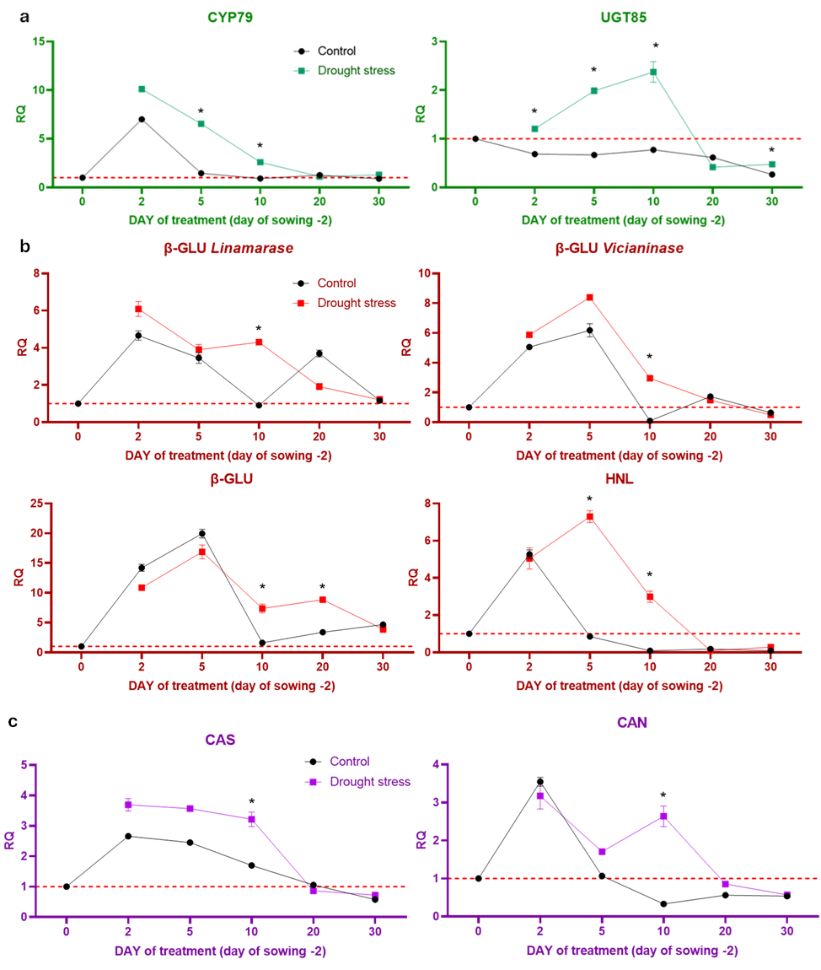
Supplementary figure 1 Transcript levels of cyanogenic glycosides metabolism genes in Linola flax under control and moderate drought stress conditions (0,5% mannitol)
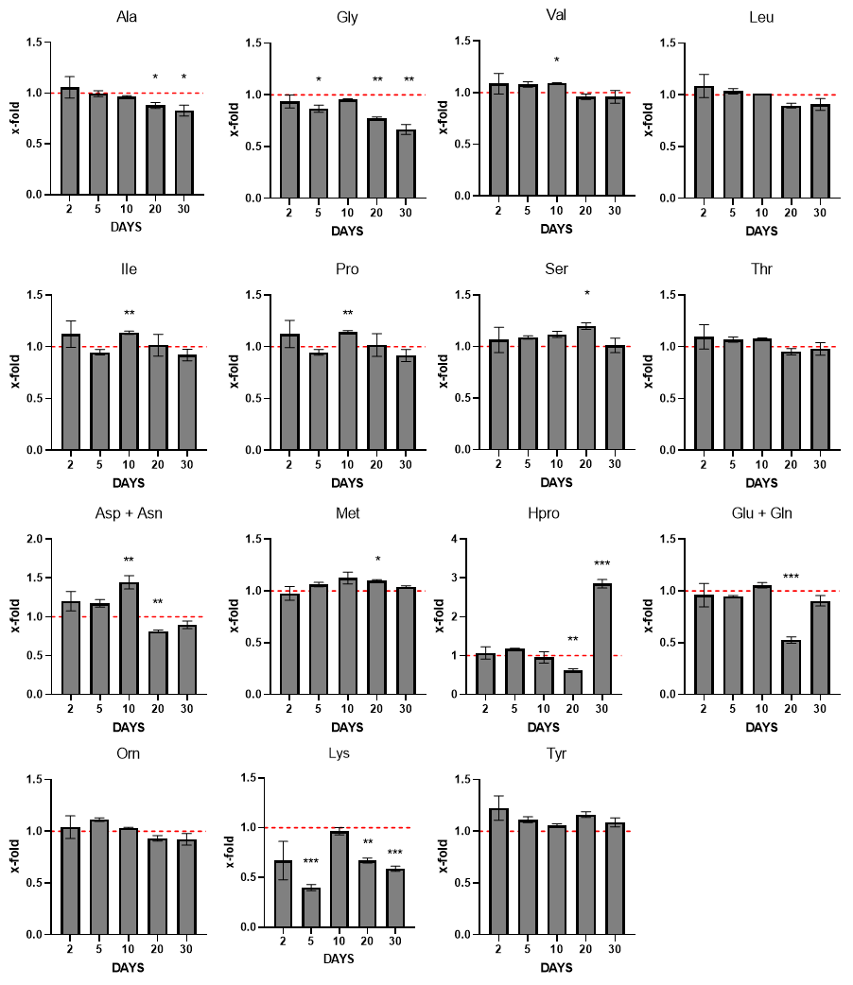
Supplementary figure 2 Relative changes in amino acid content in Linola flax under severe drought stress

