Supplementary Information
This material supports the main manuscript. The contents are as follows.
- Flagging prompt
- Labeling prompt
- Co-occurrence network construction process
- Second-order difference analysis for determining thresholding values
- Co-occurrence network visualization
- Annotation by domain experts
- Causal relation extraction method selection
- Edge selection process in causal relation extraction
- Training ClimateBERT
- Comparison of performance between weak labeling vs. weak + gold labeling (using dummy data)
- Stage 1 Evaluation
- Data generation prompt
- Stage 2 Evaluation
- Integrated causal networks
- Network clustering method selection
- Backbones
- Sensitivity analysis in network clustering

1 Flagging prompt
The large language model (LLM) adopted in this study was Generative Pre-trained Transformer (GPT)-5.2. OpenAI recommends fixing parameters, such as seed, temperature, max tokens, and the prompt, to increase output determinism. Because GPT-5 models do not allow temperature settings, this study fixed the other parameters (seed and max tokens) to make the output as deterministic as possible. GPT-5.2 is used for judging whether the noun phrases are climate-related terms (flagging) and judging which category the nodes are classified as (labeling).

The details of the flagging prompts used for co-occurrence network construction and causal relation extraction are as follows.

You assist with selecting variable names from climate-related documents. You receive short noun phrases and must decide whether each phrase should be INCLUDED (flag = 1) as a meaningful variable, or EXCLUDED (flag = 0).

Inclusion rules (flag = 1):
- Include reasonably specific variables or phenomena related to:
- natural hazards, climate or ecosystem states or changes
(e.g., heatwave, drought, flood, sea-level rise, crop yield, crop production, biodiversity, coastal erosion, desertification, soil moisture deficit, temperature anomaly, ocean acidification, land use change, thawing permafrost, ice sheet disintegration, changes in atmospheric circulation),
- social outcomes and socioeconomic conditions
(e.g., mortality, heat-related mortality, morbidity, hospital admission, GDP, undernutrition, displacement, migration, resettlement, unemployment, labor productivity, labor demand, poverty, inequality, food insecurity, water insecurity, school attendance, learning loss, mental health impacts, social conflict, livelihood)
- concrete name of adaptation or mitigation policies, interventions, or actions
(e.g., social safety net, adaptive social protection, cash transfer program, insurance scheme, disaster risk financing, early warning system, flood protection infrastructure, irrigation system, cooling center, air conditioning, green infrastructure, emission trading scheme, carbon tax, seawall).
- Include other specific variables
(e.g., tourism, recreation, resilience, hydropower)

Exclusion rules (flag = 0):
- Exclude broad concepts/abstract nouns that are too generic without clear subject or object/generic nouns without modifiers.
Examples to be excluded: adaptation, maladaptation, adaptation plan, adaptation action, anticipatory action, adaptation limit, economic loss, noneconomic loss, climate service, extreme weather, climate variability, fire risk, climate change, climate change impact, global warming, global warming level, climate shock, disturbance, environmental change, sustainability, sustainable development, human health, ecosystems, developing country, previous work, hazard, disease, disaster, study, results, land, grassland, savanna, forest, trees, people, households, population, area, region, port, delta, rain, Aedes, justice, conservation, exposure, phenology, intervention, vulnerability, age, abundance, environment, agriculture, productivity, capita, debt, cost, risk, injury, action, incidence, elevation, decline, shock, protection, cooperation, threats, consumption, deaths, policies, impacts, issues, challenges, opportunities, diversity, diversification, business, disease, market, preparedness, war, insecurity, price.
Output format:
- Always respond with a single JSON object with the key ‘results’.
- ‘results’ must be a list of objects, each with:
- ‘candidate_id’: the id provided in the prompt,
- ‘flag’: 1 if the phrase should be included, 0 otherwise.
Example output: {“results”: [{“candidate_id”: 123, “flag”: 1},{“candidate_id”: 124, “flag”: 0}]}
Do not include any explanation text. Return only valid JSON.

2 Labeling prompt
The details of the labeling prompts used for co-occurrence network construction and causal relation extraction are shown below.

You are a climate policy and risk expert. Your task is to judge whether a given phrase from a scientific or policy document represents a climate-related variable or indicator about loss, damage, or adaptation. You must not invent new terms. Judge only the given candidate phrase itself, optionally using the sample context.
The allowed categories are as follows.
- Loss
Variables about irreversible harm caused by climate change, for example, through the complete destruction or permanent reduction in the functioning of assets, infrastructure, or resources, the complete submergence of small island nations due to sea-level rise, the irreversible extinction of a species, or the permanent loss of cultural heritage sites due to erosion caused by extreme weather events. Variables are irreversible and non-substitutable, such as life, species (biodiversity), land, culture, etc. Variables are discrete, which can be represented by 1 (something exists) or 0 (something has gone). For example, variables include mortality, income loss, crop yield loss, biodiversity loss, and welfare loss.
- Damage
Variables about harmful effects and costs associated with climate change that can be quantified and potentially compensated (including economic, social, and environmental costs). Variables are temporary or partially reversible and often involve repair, restoration, or compensation; for example, the destruction of infrastructure by hurricanes, economic losses due to crop failure caused by drought, or the costs of relocating coastal communities due to erosion and rising sea levels. Variables include substitutable matters, such as artificial capital, financial assets, etc. Variables are continuous, which can be represented as a value from 0 to 1. For example, variables include physical damages to assets or infrastructure caused by climate hazards, such as infrastructure damage, housing damage, property damage, damaged roads, and damaged crops.
- Adaptation
Variables about the process of adjustment to the actual or expected climate and its effects to moderate harm or exploit beneficial opportunities. In natural systems, adaptation is the process of adjustment to the actual climate and its effects; human intervention may facilitate adjustment to the expected climate and its effects. The costs of measures to be taken in the future are not included. For example, the costs of mitigation and adaptation, as well as that of behavioral change, are not included.
- Other
Anything else.
If a phrase could be seen as both loss and damage, choose the single category that best reflects how the phrase is most commonly used as a variable:
- Use the loss category when it mostly captures reductions or welfare, health, or economic losses.
- Use the damage category when it mostly captures physical damage to assets, buildings, or infrastructure.
Output format:
- Always respond with a single JSON object with the key ‘results’.
- ‘results’ must be a list of objects, each with:
- ‘candidate_id’: the id provided in the prompt,
- ‘category’: one of the allowed categories
Example output: {“results”: [{“candidate_id”: 123, “category”: “loss”}, {“candidate_id”: 124, “category”: “other”}]}
Do not include any explanation text. Return only valid JSON.

3 Co-occurrence network construction process
Supplementary Figure 1 summarizes the co-occurrence network construction process, together with the number of phrases, nodes, and edges. Through these multiple steps, the nodes and edges were extracted from the public documents.
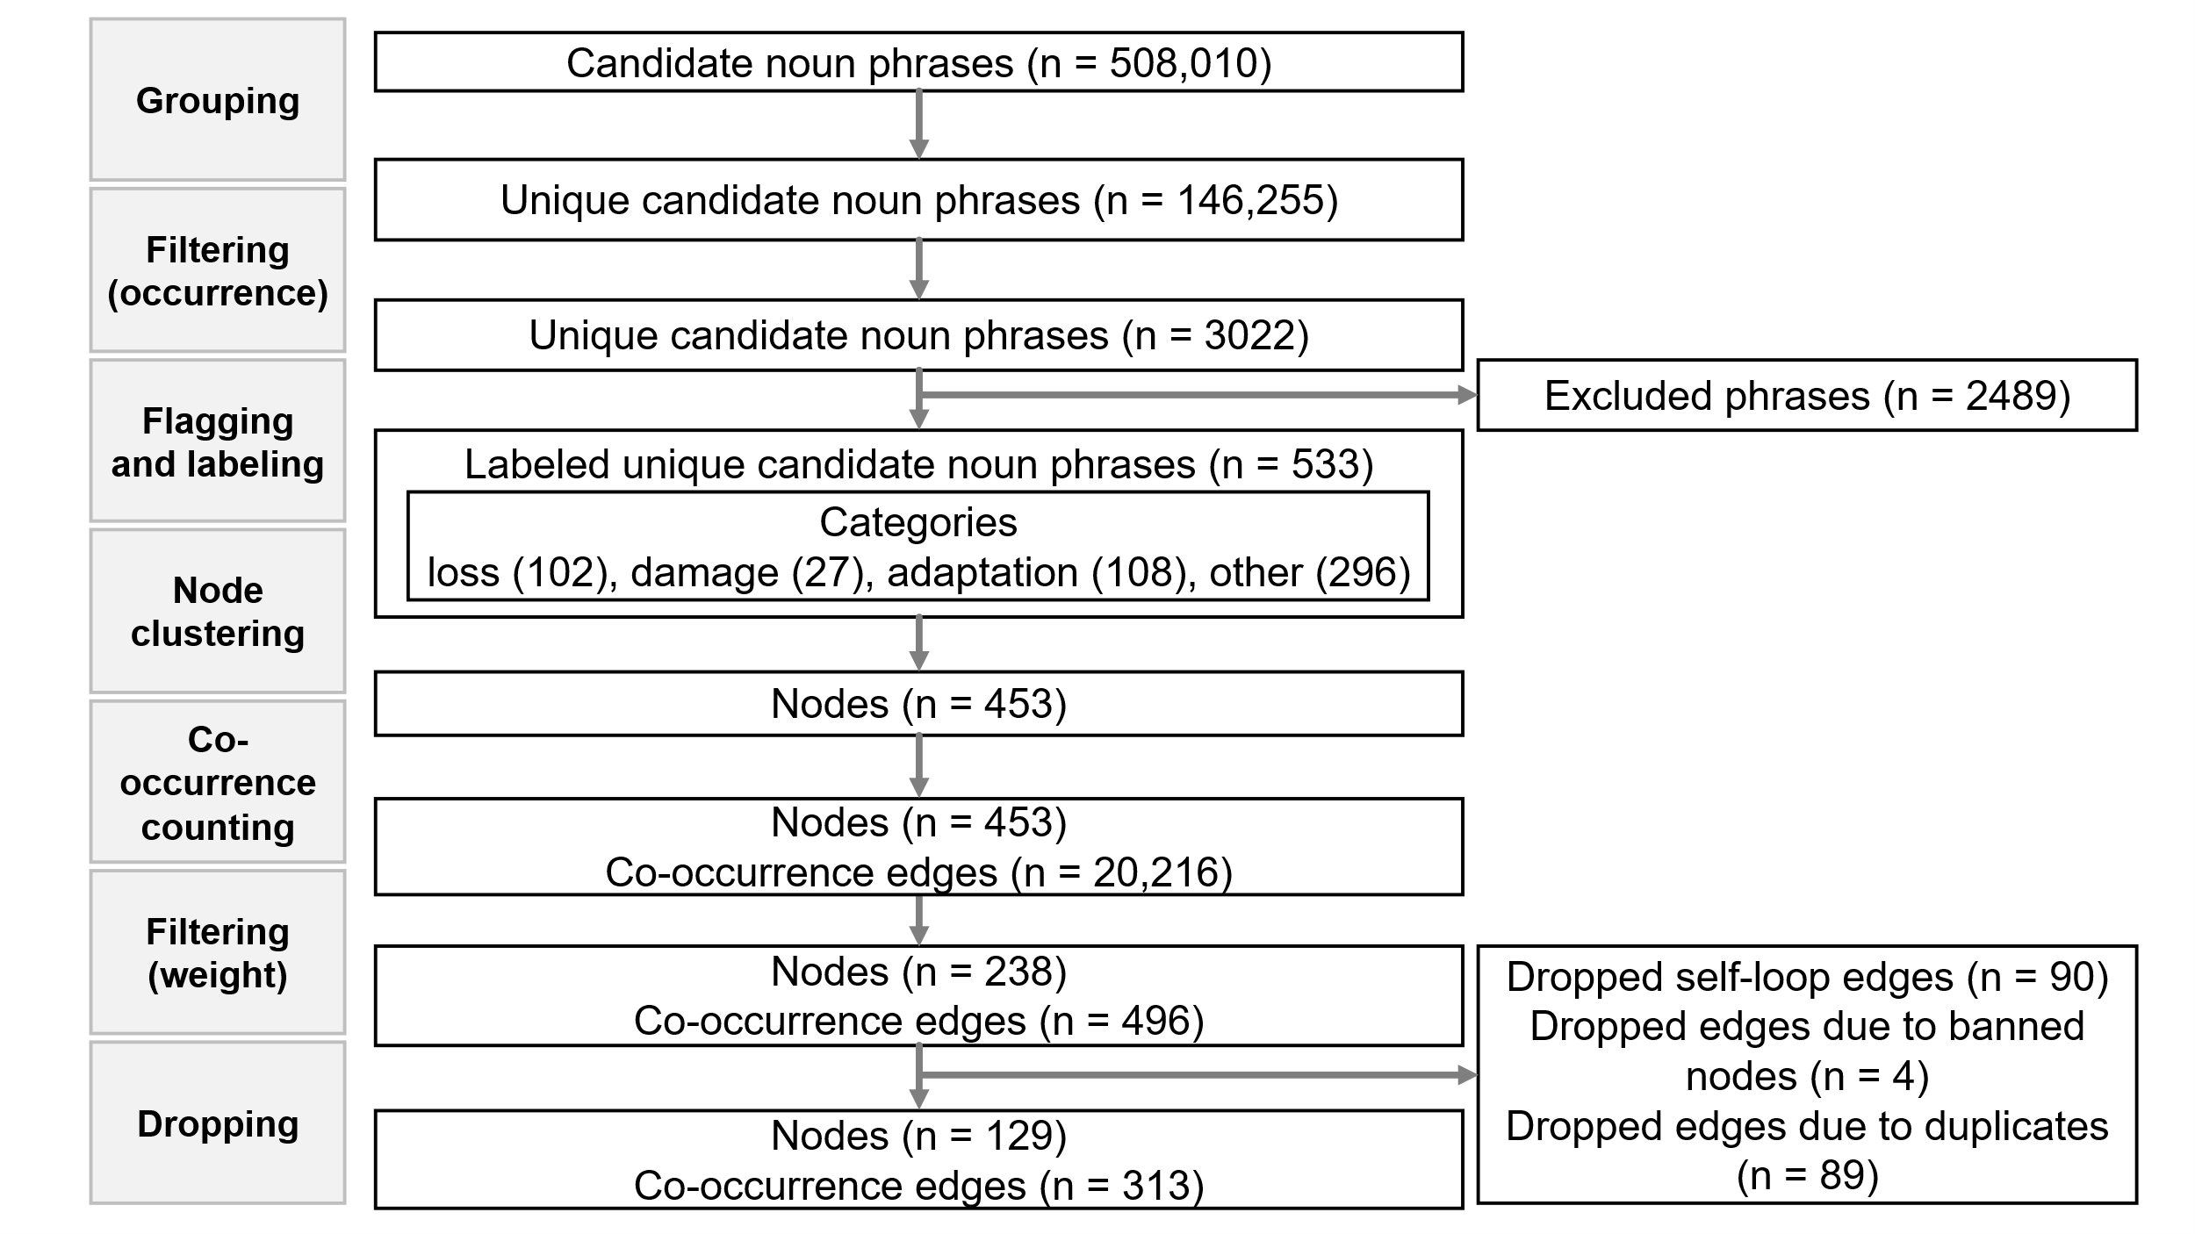
Supplementary Fig. 1 Co-occurrence network construction process. The process filters the information in the documents step-by-step and extracts nodes and edges that are necessary for building a co-occurrence network.

4 Second-order difference analysis for determining thresholding values
In the construction of the co-occurrence network, the threshold is chosen at the elbow point on the curve relating the retention ratio (percentage of retained candidates) to the minimum occurrence. This point is identified by approximating the elbow as the location of maximum curvature on the retention-threshold curve (Supplementary Figure 2a). Likewise, nodes whose weights exceed a minimum weight threshold are retained; the threshold is determined at the elbow point with the greatest curvature, identified using second‑order difference analysis (Supplementary Figure 2b).
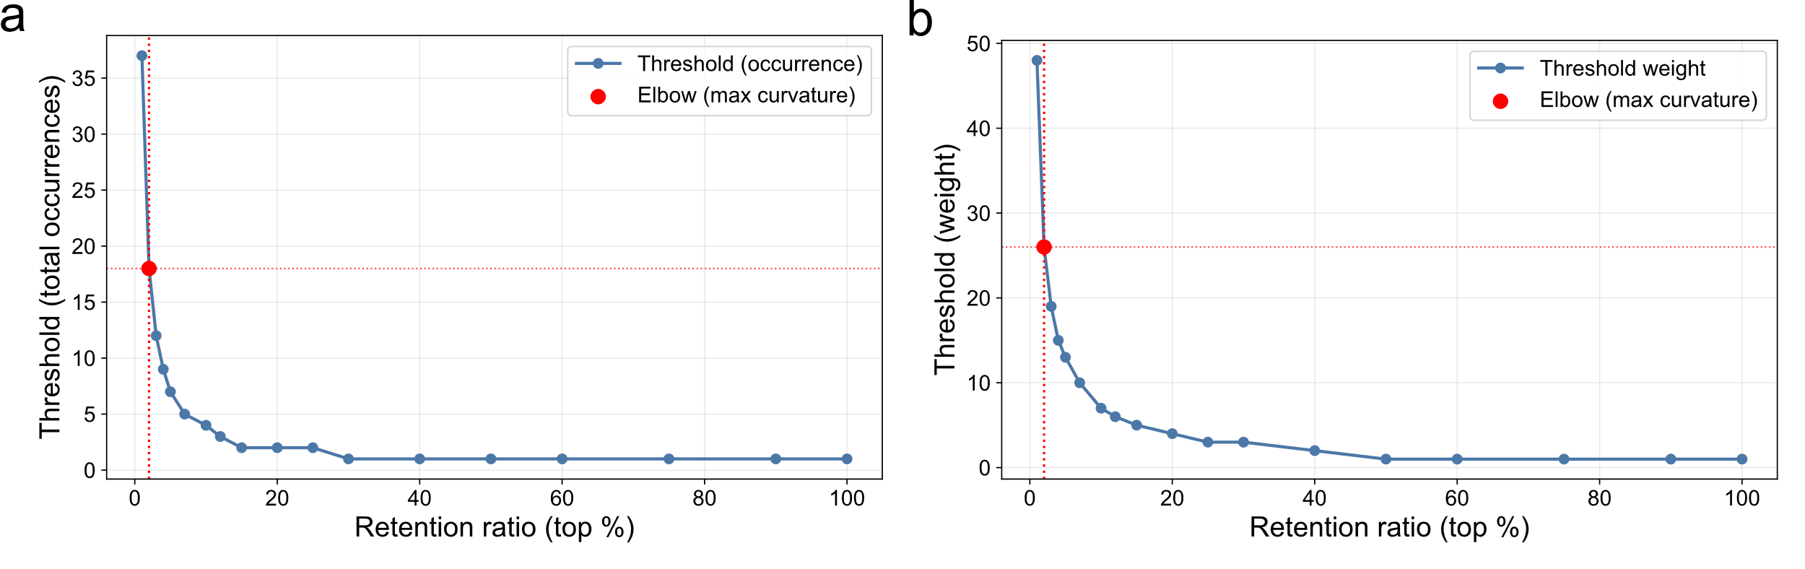
Supplementary Fig. 2 Retention ratio vs. threshold with elbow point. a) Total occurrence: the second difference becomes maximum when the thresholding value is set to 18. b) Weight: the second difference becomes maximum when the thresholding value is set to 26.

This approach is consistent with curvature-based elbow (knee) detection methods, which define a knee as the point of maximum curvature and characterize it as a beneficial operating point that provides a good trade-off between competing factors (Satopaa et al. 2011). A recent study also suggested that the elbow can be a practically optimal trade-off point between cost and performance (Antunes et al. 2025).

5 Co-occurrence network visualization
Supplementary Figure 3 shows the constructed co-occurrence network.
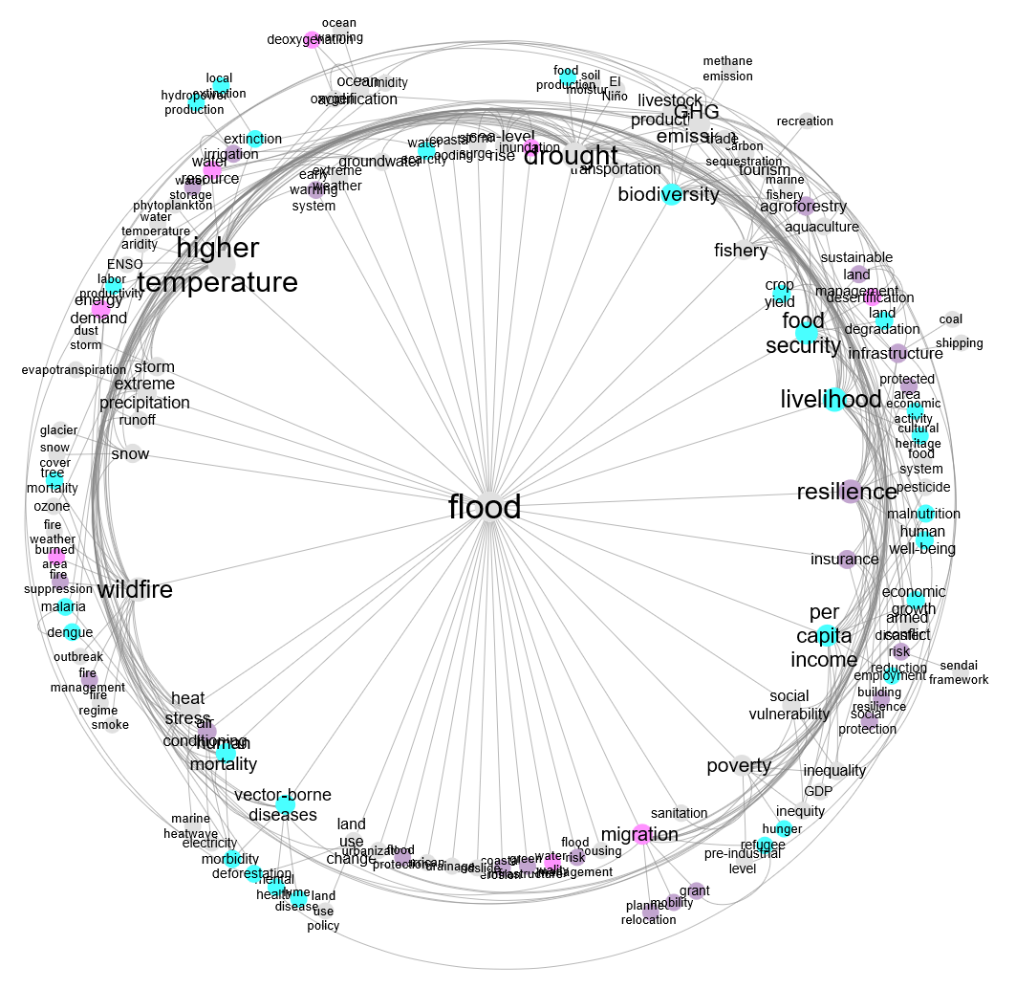
Supplementary Fig. 3 Co-occurrence network built from co-occurrence edges. The node color corresponds to the labels: purple (adaptation), pink (damage), light blue (loss), and gray (other). Nodes with higher degrees are drawn with larger text and node sizes.

The nodes with the top 10 degree and betweenness centrality are as follows:
- Degree (in descending order)
flood (43), higher temperature (35), drought (31), livelihood (24), wildfire (24), resilience (23), food security (19), per capita income (17), biodiversity (16), greenhouse gas (GHG) emission (16)
- Betweenness centrality (in descending order)
flood (0.31), higher temperature (0.24), drought (0.15), wildfire (0.14), resilience (0.12), livelihood (0.10), migration (0.07), GHG emission (0.06), biodiversity (0.05), per capita income (0.04)
Flood ranked highest in both degree and betweenness centrality and was the network’s largest hub. Climate hazards, including higher temperature, drought, and wildfire, also ranked high in both metrics and formed the network’s core structure.

6 Annotation by domain experts
Supplementary Table 1 summarizes the domain experts’ primary fields and years of experience.

Supplementary Table 1. Experts’ primary fields of expertise and approximate years of experience
 | Primary field of expertise | Approximate years of experience
Annotator 1 | Climate Impact Assessment, Climate Policy Analysis | 30
Annotator 2 | Agricultural Meteorology, Climate Impact Assessment, Climate Change Adaptation | 20
Annotator 3 | Climate Science | 20
Annotator 4 | Economics, Human Health | 10
Note: The four domain experts implemented annotation (affording relation types and directions for each co-occurrence edge).

Multiple domains related to climate change were covered, and multidisciplinary perspectives were reflected in the annotations. The team consisted of experienced annotators. Annotators 1, 2, and 3 had decades of professional experience. Annotator 4 was a specialist in the social sciences and thus ideal for ensuring balanced expertise.

7 Causal relation extraction method selection
Existing causal relation extraction approaches were broadly reviewed to select the best method for causal relation extraction. A previous survey classified these approaches into three groups: knowledge-based, statistical machine learning-based, and deep learning-based (Yang et al. 2022).

Knowledge-based approaches
Knowledge-based approaches to causal relation extraction rely on predetermined causal connectives, such as because or due to, or on manually defined syntactic patterns to identify causal relations (Yang et al. 2022). Dictionary- and rule-based techniques have been applied to extract causal drug-adverse effect relations (Kang et al. 2014). Rule-based techniques have also been used to extract causal pairs from news articles using patterns, such as because, due to, and after (Radinsky et al. 2012). While these knowledge-based approaches provide explicit patterns, they are dependent on domain-specific linguistic structures and therefore have limited applicability across domains (Yang et al. 2022). By contrast, machine learning- and deep learning-based approaches can capture more implicit causal relations, but require large-scale annotated datasets and computational resources (Yang et al. 2022).

Statistical machine learning-based approaches
Statistical machine learning-based approaches to causal relation extraction classify causality using features such as n-grams, dependency structures, and the presence or absence of cue words and employ methods such as conditional random fields (CRFs) and support vector machines (Oh et al. 2013; Hidey and McKeown 2016). However, these approaches rely on manual feature design, which limits their extraction performance.

Deep learning-based approaches
Deep learning-based approaches for causal extraction are diverse, and several studies have reported that they not only achieve higher performance than traditional rule-based and machine learning-based methods (Li et al. 2021), but also are advantageous for extracting implicit causal relations (Ali et al. 2023). These deep learning models encode sentences or sentence pairs as distributed representations by using encoders such as convolutional neural networks (CNNs), bidirectional long short-term memory (BiLSTM), or bidirectional encoder representations from transformers (BERT). A key feature of these models is that they judge causal versus noncausal relations and extract causal elements based only on learned representations, without relying on external knowledge or manually crafted rules (Yang et al. 2022). This line of work includes various approaches, such as causal extraction based on CNNs and BiLSTM (Akkasi 2021), a method that introduces dual grid tagging for event-causal extraction (Cui et al. 2022), and a joint learning model that performs relation extraction and function detection concurrently for biological expression language (BEL) causal relations (Li et al. 2023). It also includes the BiGRU-Attention-CRF model, which achieved an F1 score of 81.06% on the SemEval 2010 Task 8 dataset (Channing 2024). In particular, BERT-based models have been reported to outperform traditional methods in BEL causal relation extraction tasks (Shao et al. 2021), demonstrating the strength of deep language models in capturing contextual information. Furthermore, Causal-BERT has been evaluated as having the ability to detect implicit causality by recognizing contextual and lexical patterns even when no explicit connective is present, demonstrating its usefulness for implicit causal detection (Khetan et al. 2022).

Deep learning has also been applied to causal extraction in short and noisy text environments such as social media. The method proposed by Ahne et al. (2022) adopts a two-stage design: causal sentence classification with BERTweet, followed by cause-and-effect span extraction with BERT and CRF. Even under conditions with many abbreviations and noise, such as Twitter data related to diabetes, the method shows relatively good performance, achieving a recall of about 0.68 in causal sentence detection.

Methods that combine explicit knowledge or structural information with neural representation learning have also been proposed. For example, one approach incorporates lexical knowledge from WordNet and FrameNet into CNNs and uses these features together with data-driven representations to extract causal relations (Li and Mao 2019). Another framework integrates knowledge-attention based on a causal associative link network with multi-scale CNN features, followed by sequence labeling with a BiLSTM-CRF model (Yu 2022). In addition, a model has been reported in which relational features are strengthened by a dependency-tree-based graph attention network and further refined by a bidirectional graph convolutional network to obtain deeper causal representations (Chen 2022). Moreover, for causal relation extraction across news articles, story-tree information has been incorporated as constraints in an integer linear programming framework to optimize classification results (Zhang 2023). However, these approaches involve dual costs because they require both the preparation of knowledge resources or rules and the training of deep learning models.

In recent years, methods that extract causal relations with prompt design alone have been proposed. Chatwal et al. (2025) reported that, in causal relation extraction from financial disclosure documents, a prompt using few-shot examples and chain-of-thought instructions achieved the highest performance. Meanwhile, approaches that integrate LLMs with knowledge bases have been introduced. Stegnar et al. (2024) used OntoGPT to align causal variables with ontology concepts and strengthen a causal graph with domain knowledge. Furthermore, Lecu et al. (2024) described causal relation extraction using an LLM integrated with a knowledge graph. However, these approaches require the construction of ontologies or knowledge graphs, resulting in preparation costs.

The selection criteria for the causal relation extraction method consist of the following three requirements:
(i) Both explicit and implicit causal relations can be extracted.
(ii) Causal sentences can be detected, and the cause-and-effect spans within those sentences can be extracted.
(iii) The method is applicable within an existing framework.
This study does not aim to develop a new model or update benchmark results.
Given these requirements, the two-stage BERT pipeline proposed by Ahne et al. (2022) is considered the most suitable option. Their approach uses a simple combination of BERT and CRF without depending on knowledge graphs, which reduces complexity in model design. In addition, policy documents contain less noise and have a more stable writing style than the text data they use (Twitter text data). Therefore, the use of policy documents is expected to yield better performance. Accordingly, the causal relation extraction adopts this pipeline. Because the text data to be used are related to climate and environment, BERTweet is replaced with ClimateBERT.

8 Edge selection process in causal relation extraction
Supplementary Figure 4 shows the edge selection process in causal relation extraction, together with the number of sentences or edges. The numbers of total original sentences, of causal sentences after stage 1, which is consistent with the number of spans after stage 2, of edges before cleaning, which remained after flagging to spans in postprocessing, and of edges after cleaning are shown by region and sector.
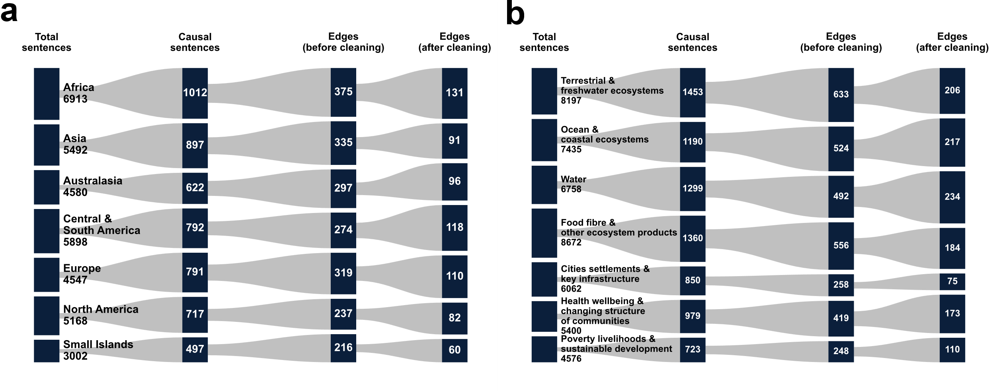
Supplementary Fig. 4 Edge selection process in causal relation extraction. a) By region. b) By sector.

By region, 41 self-loops, 72 duplicates, and 863 isolated pairs were removed. Additionally, 292 edges were removed because they did not have the maximum network diameter, resulting in a total of 688 edges remaining. Likewise, by sector, 45 self-loops, 134 duplicates, and 1021 isolated pairs were removed. Additionally, 484 edges were removed because they did not have the maximum network diameter, resulting in a total of 1199 edges remaining.

9 Training ClimateBERT

9.1 Assignment of weak labels
Sentences are first given weak labels in a mechanical way. If a sentence contains any of a predefined set of terms, it is treated as a positive example (causal: 1). If none of these terms appear, the sentence is treated as a negative example (causal: 0).

Predefined set of terms
- C-SIGNAL (mark-up textual elements that indicate the presence of a causal relation = C-LINK)
  - Prepositions: due to, as a result of, because of, in response to, in the absence of
  - Conjunctions: because, thereby
- C-LINK
  - CAUSE-type verbs: cause(s), drive(s), induce(s), influence(s), lead(s), trigger(s), result(s) in, increase(s), decrease(s), reduce(s), affect(s), contribute(s) to, exacerbate(s), undermine(s), accelerate(s)
  - ENABLE-type verbs: allow(s), enable(s), permit(s)
  - PREVENT-type verbs: prevent(s), constrain(s), restrict(s), discourage(s), hinder(s), restrain(s), protect(s)
- Passive forms of C-LINK
  - caused by, driven by, induced by, influenced by, led by, triggered by, resulting from, increased by, decreased by, reduced by, affected by, contributed to by, exacerbated by, undermined by, accelerated by, enabled by, permitted by, allowed by, prevented by, constrained by, restricted by, discouraged by, hindered by, restrained by, protected from

For negation, because some negation cues (e.g., not, unlikely) do not always cancel causal assertions depending on sentence structure, one negation cue at most is allowed. This conservative setting avoids excessive false negatives while retaining potentially informative causal statements. Although allowing one negation may introduce a few borderline sentences, the causal relation extraction is primarily based on the above causal markers, and the subsequent deep learning is robust to small amounts of noise. Therefore, the resulting causal network is unlikely to be affected in a way that changes the main conclusions.

9.2 Assignment of gold labels
Sentences that include cues of implicit causality, such as expressions suggesting causal meaning from context or phrases that may indicate counterfactual causality, are inspected manually. When a sentence is judged to express causality, the weak label is corrected so that instances that were automatically assigned as negative become positive.

Cues of implicit causality or phrases that may indicate counterfactual causality
- Noun phrases
  - the impact(s) of X on Y, the effect(s) of X on Y, the influence of X on Y, the consequence(s) of X, the role of X in Y, X as a driver of Y, X as a determinant of Y
- Counterfactuals & interventions
  - If X occurs, Y follows; If X increases, Y will increase; If X were absent, Y would decrease; Had X not occurred, Y would not have happened
- Other phrases
  - Following X, Y increased; After X, Y declined; The introduction of X was followed by Y; The removal of X led to Y

10 Comparison of performance between weak labeling vs. weak + gold labeling (using dummy data)
Using dummy data on region-specific climate and environmental conditions generated by an LLM, performance was compared between training only with weak labeling and training with weak labeling combined with a small amount of gold labeling for causal relation extraction. Weak labels were automatically assigned to all 498 sentences using rule-based labeling. For gold labeling, weak labels (0) were manually corrected to positive (1) for 30 of these 498 sentences. For evaluation, both models were compared under identical conditions using weak-label data (a fixed 10% subset) that did not include the manually corrected sentences.

Supplementary Table 2. Key performance values
Labeling | Threshold | Accuracy | Precision | Recall | F1 | ROC-AUC | PR-AUC
Weak | 0.6000 | 0.8000 | 0.7778 | 0.7000 | 0.7368 | 0.8450 | 0.8424
Weak + Gold | 0.4500 | 0.8400 | 0.7500 | 0.9000 | 0.8182 | 0.9300 | 0.9056
Note: Table shows the results of a comparison of classification performance between weak vs. weak + gold labeling.

The model trained using only weak labels showed a high optimal F1 threshold (0.60) and tended to be relatively conservative in its classification, resulting in lower recall compared with precision. By contrast, the model trained after manually correcting 30 weak labels from the entire dataset showed a lower optimal threshold (0.45) and significantly improved recall. In addition to the F1 score, the area under the curve (AUC), including the receiver operating characteristic (ROC)-AUC curve and the precision-recall (PR)-AUC curve, also increased in the manually corrected model, which suggests that manual correction of a small number of weak labels improves performance in identifying positives based on weak labels.

11 Stage 1 evaluation
Supplementary Table 3 summarizes the key performance values.

Supplementary Table 3. Key performance values of stage 1
 | Threshold | Accuracy | Precision | Recall | F1 | ROC-AUC | PR-AUC
Region | 0.9500 | 0.9730 | 0.8307 | 0.9979 | 0.9066 | 0.9753 | 0.7118
Sector | 0.9500 | 0.9720 | 0.8398 | 0.9925 | 0.9098 | 0.9922 | 0.9532
Note: Table shows the fine-tuned ClimateBERT’s classification performance indicators by region and sector.

Using the validation data, the F1 score reached its maximum at a decision threshold of t = 0.950. At this threshold, the precision was 0.831 (region) and 0.840 (sector), recall was 0.998 (region) and 0.993 (sector), and F1 was 0.907 (region) and 0.910 (sector). These results indicate that the trained model captured the pattern despite the class imbalance.

Supplementary Figure 5 shows the ROC and PR curves.
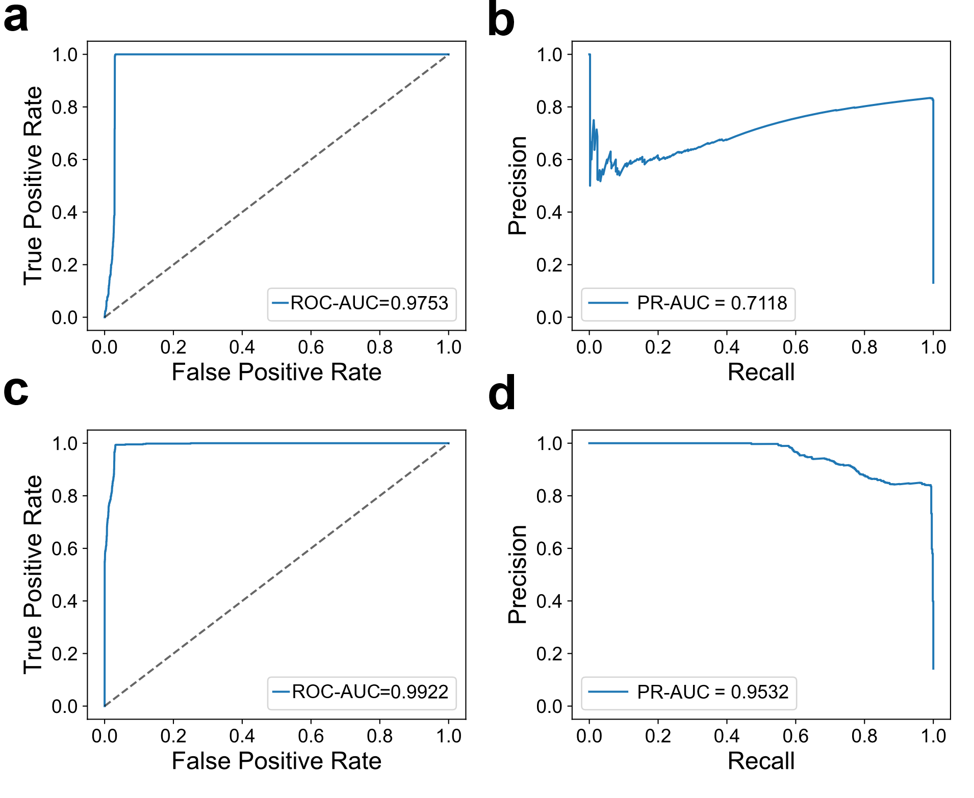
Supplementary Fig. 5 Areas under the receiver operating characteristic (ROC) and precision-recall (PR) curves. a) ROC curve by region. b) PR curve by region. c) ROC curve by sector. d) PR curve by sector.
The ROC-AUC and PR-AUC were also high. In particular, the PR-AUC was about 4.8 times higher than the positive rate of the dataset (0.149) by region and about 5.7 times higher than the positive rate of the dataset (0.167) by sector, indicating an improvement in ranking performance under weak labels.

Supplementary Figure 6 shows confusion matrices at the best F1 threshold.
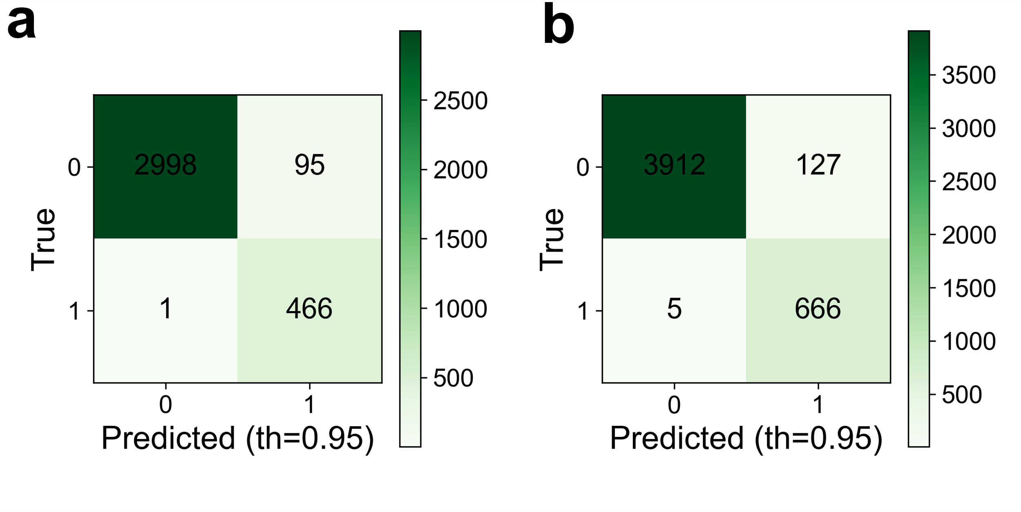
Supplementary Fig. 6 Confusion matrices (at best F1 threshold). a) By region. b) By sector.

Recall remained high (close to 1.0) even at a threshold of 0.95, suggesting that the model shows almost no false positives and assigns high positive scores with strong confidence to sentences labeled as positive by the weak labels.

12 Data generation prompt
The prompt for generating training sample datasets for CRF learning is as follows.

Generate training samples in Beginning–Inside–Outside (BIO) format for cause–effect relationships related to climate change impacts (loss, damage, and adaptation). Each sample should be a single sentence annotated with BIO tags for cause and effect.

Output format: JSONL, where each line is: {“tokens”: [...], “tags”: [...]}

Tag set:
- B-CAUSE, I-CAUSE: Beginning and inside of the cause span
- B-EFFECT, I-EFFECT: Beginning and inside of the effect span
- O: Outside any span

Requirements:
- Each sentence must contain exactly one cause and one effect.
- Ensure len(tokens) == len(tags).
- Tokenization should be based on whitespace splitting.
- Include a variety of terms related to loss, damage, and adaptation.
- Include both explicit and implicit causal relationships.
- Do NOT include multiple causes or effects in one sentence.
- Provide 200 examples.

Important rules:
- X = CAUSE, Y = EFFECT.
- Verbs, auxiliaries, and punctuation should be tagged as O.
- Cause-and-effect spans should include only the relevant nouns or adjectives.

Include these causal patterns:
- Explicit patterns:
- C-SIGNAL
- C-LINK
- Passive forms of C-LINK
- Implicit patterns:
- Noun phrases
- Counterfactuals & interventions
- Other phrases

Examples:
{“tokens”: [“Sea”, “level”, “rise”, “causes”, “coastal”, “erosion”, “.”], “tags”: [“B-CAUSE”, “I-CAUSE”, “I-CAUSE”, “O”, “B-EFFECT”, “I-EFFECT”, “O”]}

13 Stage 2 evaluation
Supplementary Figure 7 shows the token-level confusion matrix of BIO tags.
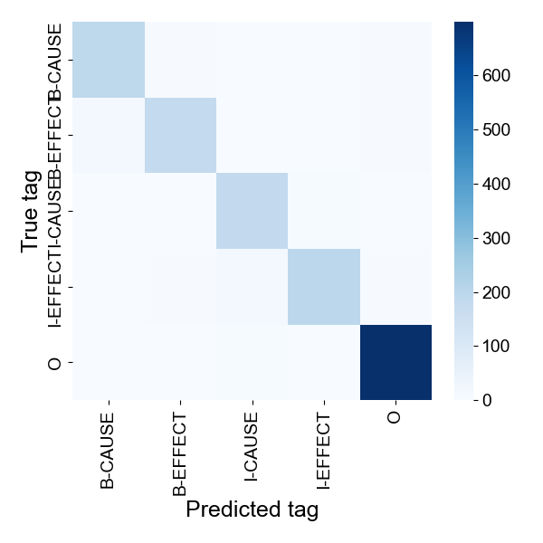
Supplementary Fig. 7 Token-level confusion matrix of BIO tags. Overall, the diagonal is prominent, and the model correctly predicts most BIO tags, including B-CAUSE, I-CAUSE, B-EFFECT, I-EFFECT, and O. Particularly, as shown by the dark cell in the bottom right, the O tag is predicted with high accuracy.
Supplementary Table 4. Per-entity precision, recall, and F1 scores
Type | Precision | Recall | F1
CAUSE | 0.8905 | 0.9350 | 0.9122
EFFECT | 0.9521 | 0.8950 | 0.9227
Note: Table shows the cause-and-effect prediction performance for the trained conditional random field model.

The model was tested on a held-out dataset. The precision was 0.890 (cause) and 0.952 (effect), recall was 0.935 (cause) and 0.895 (effect), and F1 score was 0.912 (cause) and 0.923 (effect). These results indicate that extraction was performed in a stable way.

14 Integrated causal networks
Supplementary Figures 8–21 illustrate the integrated causal networks. Node colors are as follows: purple for adaptation, pink for damage, light blue for loss, and gray for other. Edge colors are as follows: green for skeleton-derived edges, blue for causal relation extraction-derived edges, and red for edges derived from both. Integrating skeleton with a causal network derived from causal relation extraction resulted in finding bypass pathways, which could not be found with only either of them.
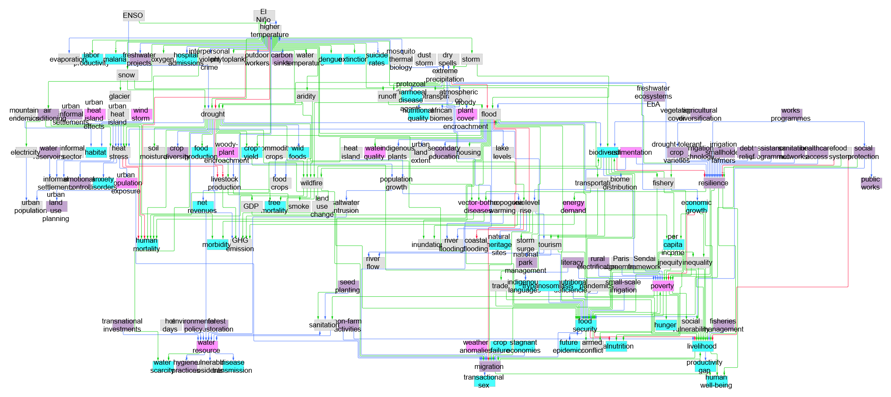
Supplementary Fig. 8 Integrated causal network of Africa. Bypass examples: wildfire → tree mortality (wildfire → GHG emission → higher temperature → drought → tree mortality), flood → crop yield (flood → transportation → energy demand → GHG emission → higher temperature → drought → crop yield).

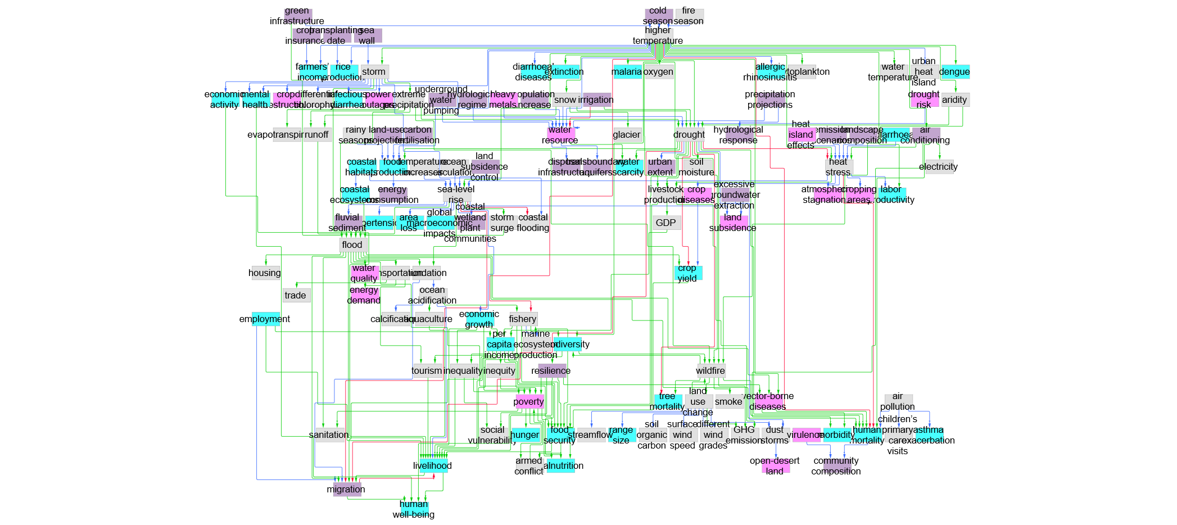
Supplementary Fig. 9 Integrated causal network of Asia. Bypass examples: higher temperature → labor productivity (higher temperature → heat stress → labor productivity), employment → livelihood (employment → migration → livelihood).

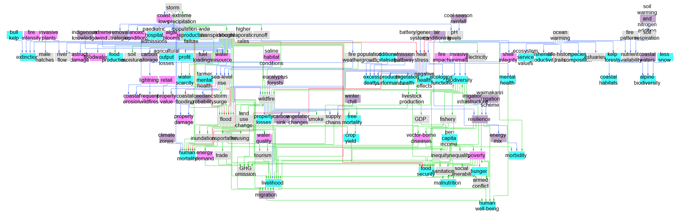
Supplementary Fig. 10 Integrated causal network of Australasia. Bypass examples: drought → water scarcity (drought → water resource → water scarcity), air conditioning → morbidity (air conditioning → heat stress → morbidity).

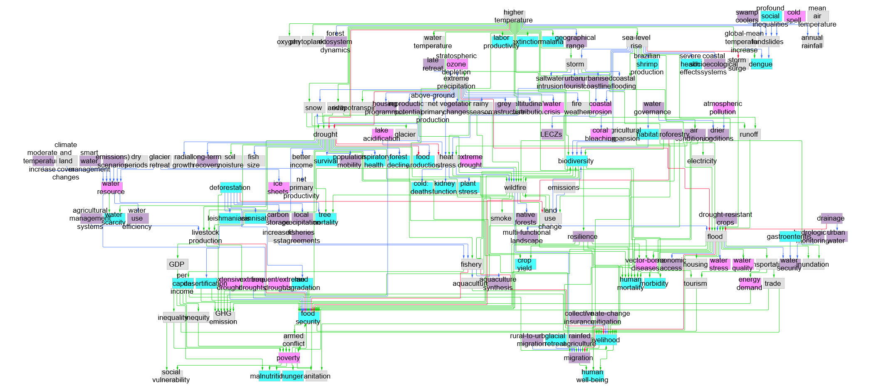
Supplementary Fig. 11 Integrated causal network of Central and South America. Bypass examples: heat stress → mortality (heat stress → wildfire → mortality), extreme precipitation → runoff (extreme precipitation → snow → runoff).

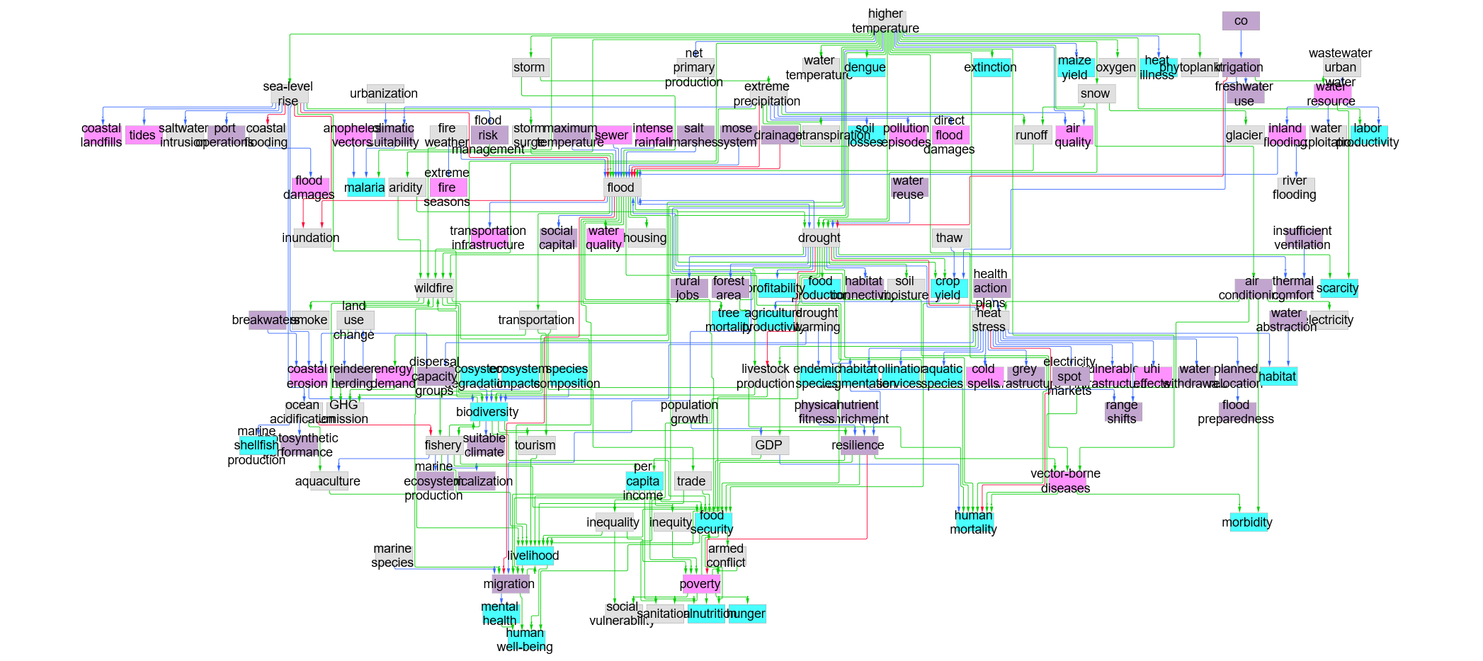
Supplementary Fig. 12 Integrated causal network of Europe. Bypass examples: migration → human well-being (migration → mental health → human well-being), fishery → livelihood (fishery → aquaculture → livelihood).

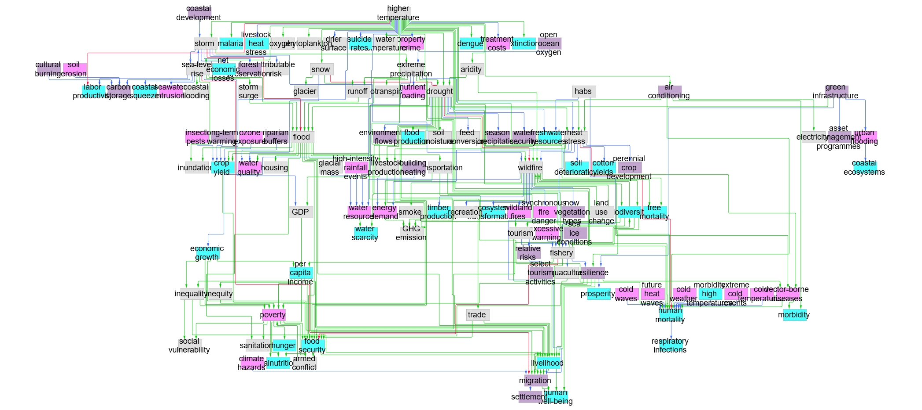
Supplementary Fig. 13 Integrated causal network of North America. Bypass examples: drought → water scarcity (drought → wildfire → water resource → water scarcity), tourism → livelihood (tourism → fishery → livelihood).

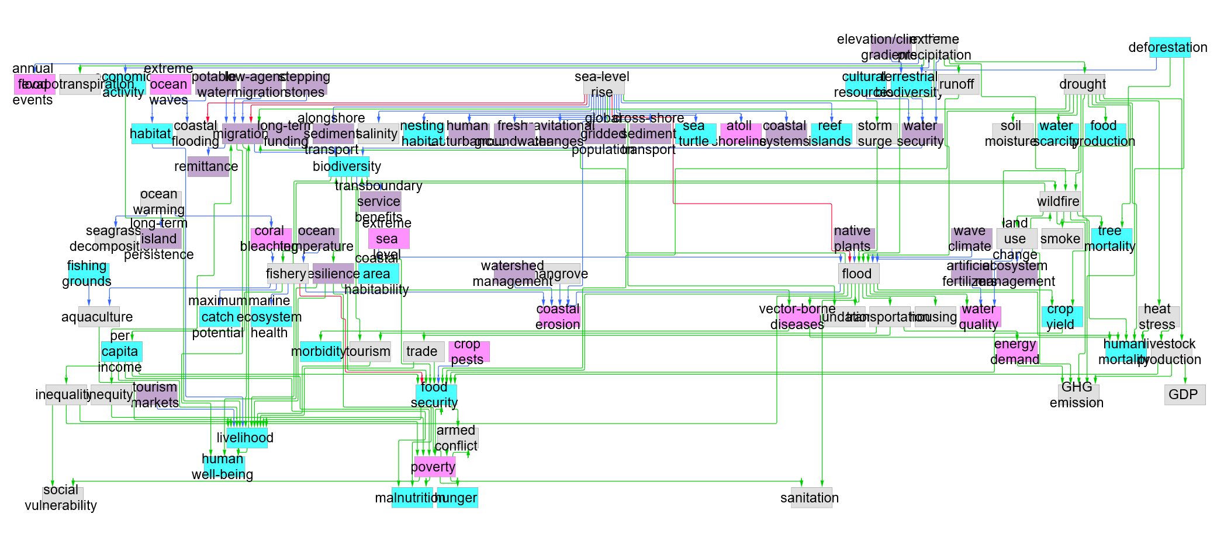
Supplementary Fig. 14 Integrated causal network of Small Islands. Bypass examples: wildfire → mortality (wildfire → land use change → flood → mortality), migration → livelihood (migration → biodiversity → food security → livelihood).

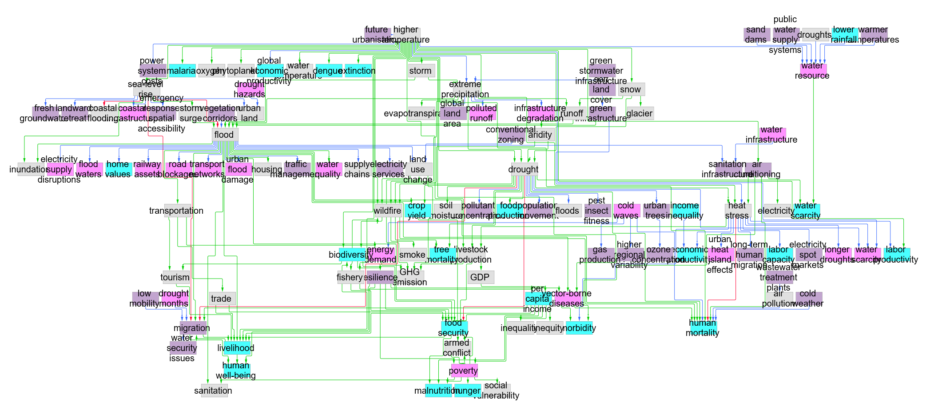
Supplementary Fig. 15 Integrated causal network of Cities. Bypass examples: higher temperature → labor productivity (higher temperature → heat stress → labor productivity), air conditioning → morbidity (air conditioning → heat stress → morbidity).

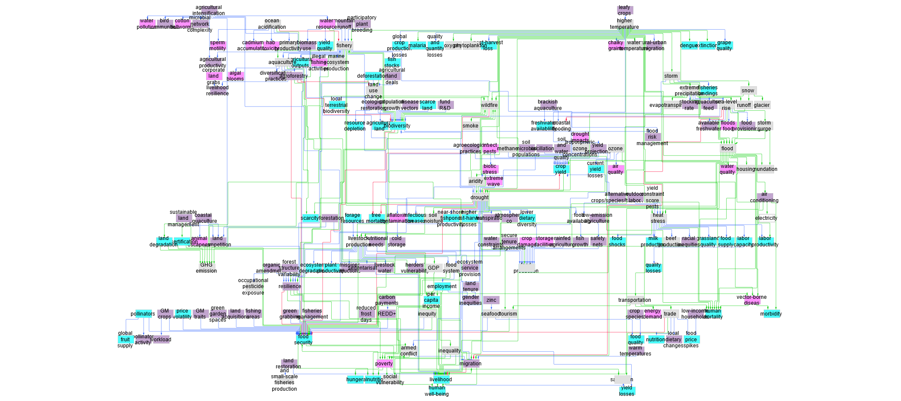
Supplementary Fig. 16 Integrated causal network of Food. Bypass examples: food security → livelihood (food security → armed conflict → migration → livelihood), food system → livelihood (food system → employment → livelihood).

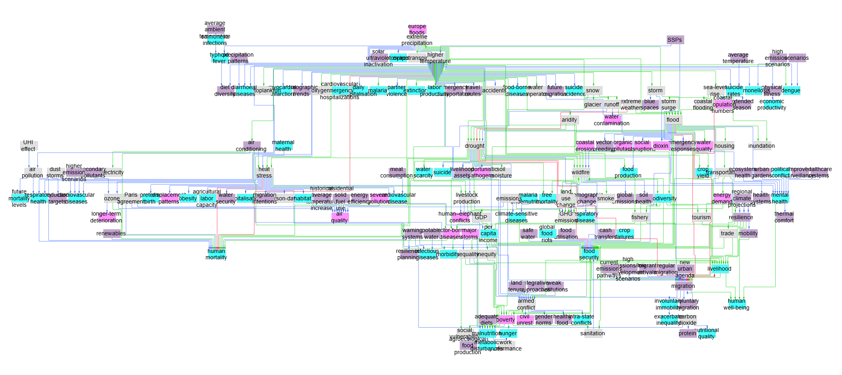
Supplementary Fig. 17 Integrated causal network of Health. Bypass examples: food security → armed conflict (food security → livelihood → migration → armed conflict), flood → sanitation (flood → resilience → poverty → sanitation).

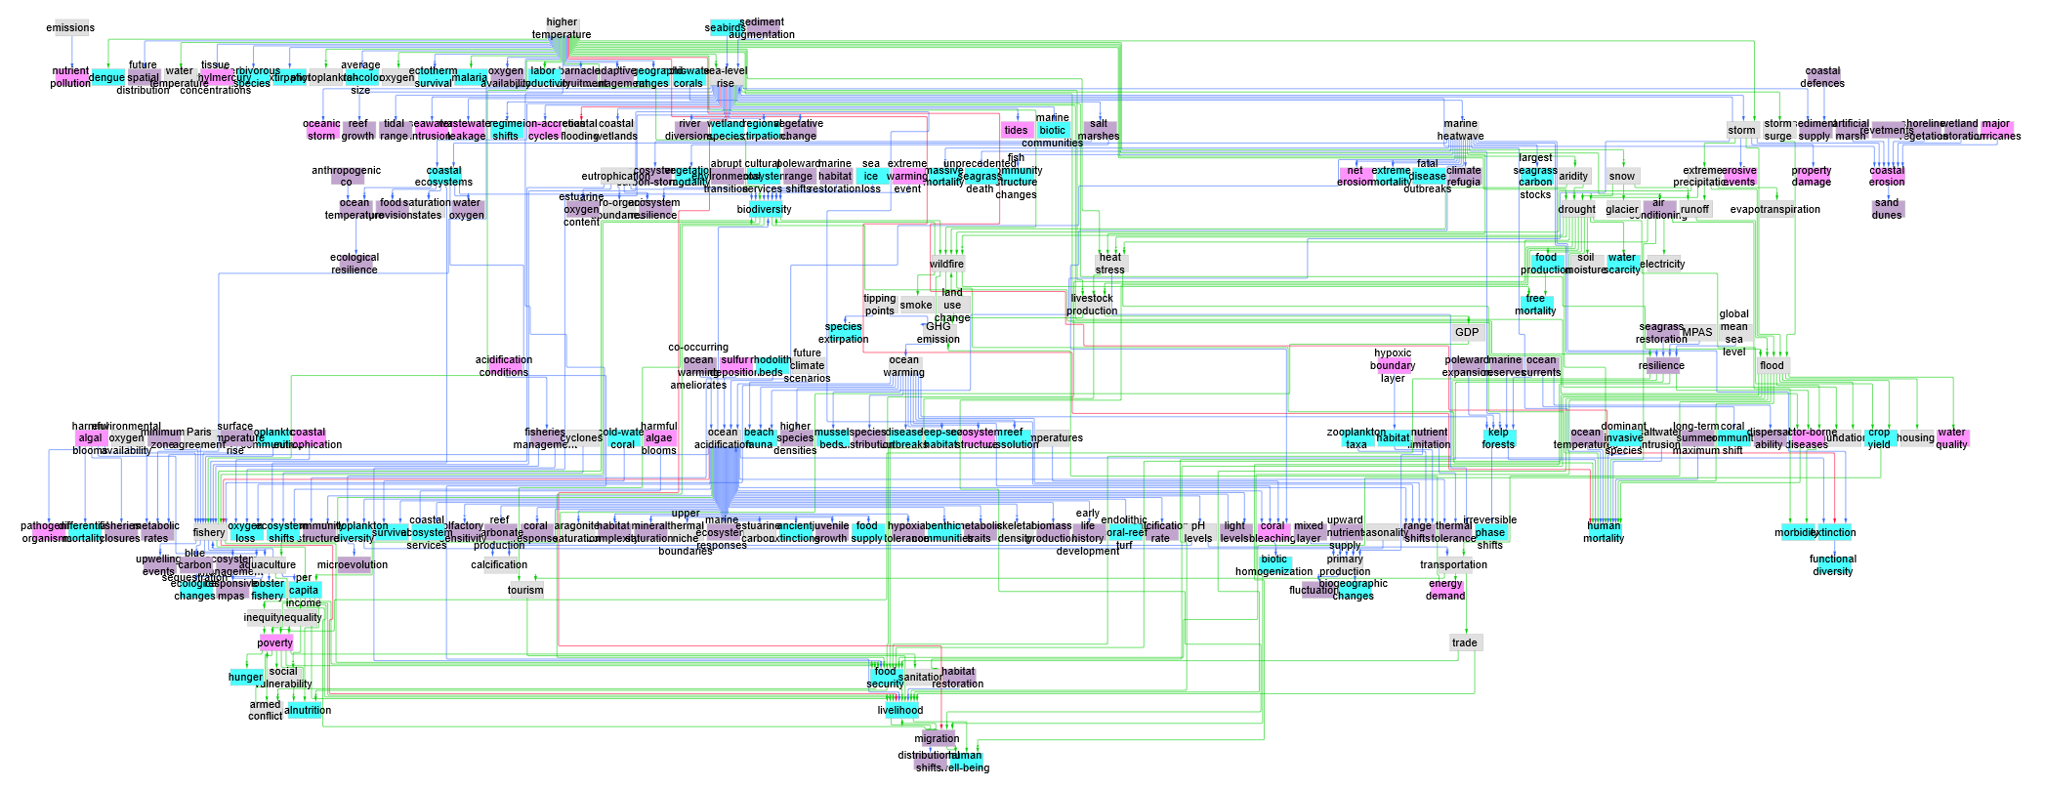
Supplementary Fig. 18 Integrated causal network of Ocean. Bypass examples: fishery → income (fishery → aquaculture → income), higher temperature → sea-level rise (higher temperature → storm → sea-level rise).
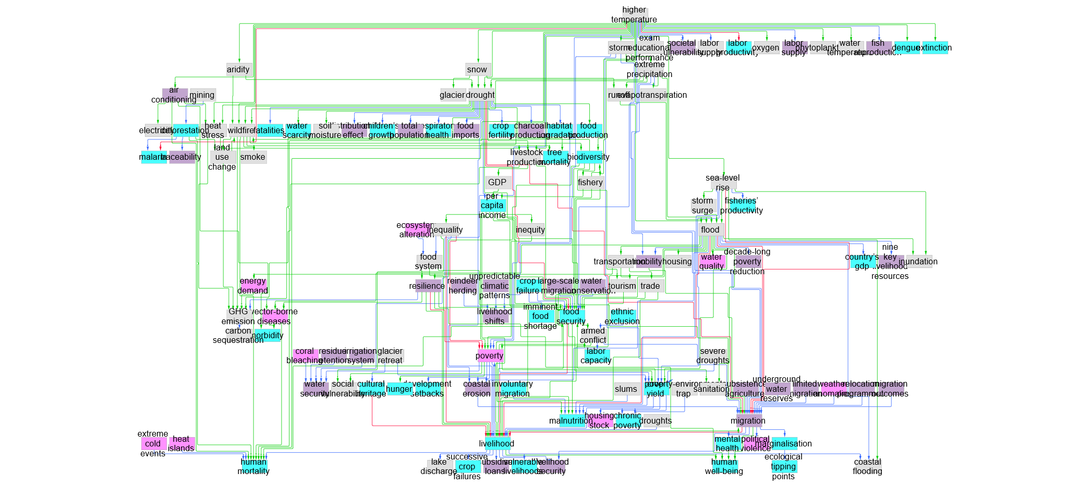
Supplementary Fig. 19 Integrated causal network of Poverty. Bypass examples: livelihood → migration (livelihood → poverty → armed conflict → migration), food security → malnutrition (food security → livelihood → poverty → malnutrition).
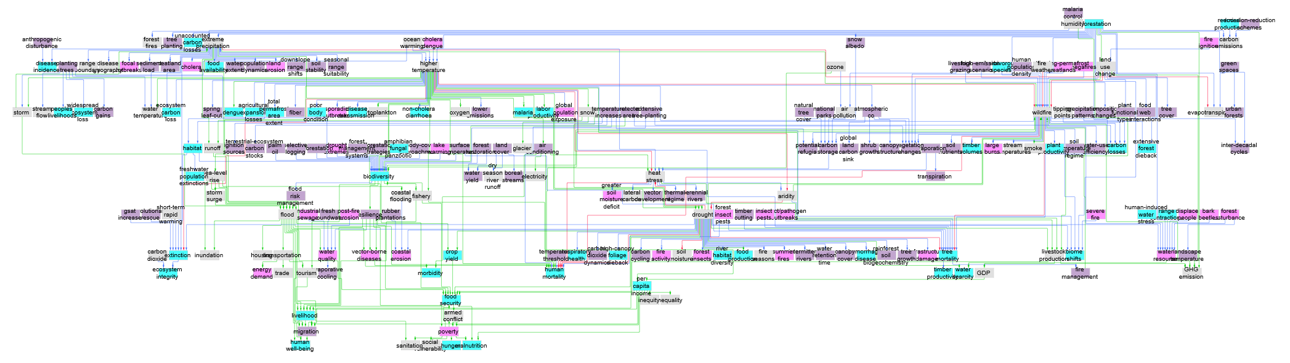
Supplementary Fig. 20 Integrated causal network of Terrestrial. Bypass examples: wildfire → biodiversity (wildfire → habitat → biodiversity), deforestation → land use change (deforestation → wildfire → land use change).
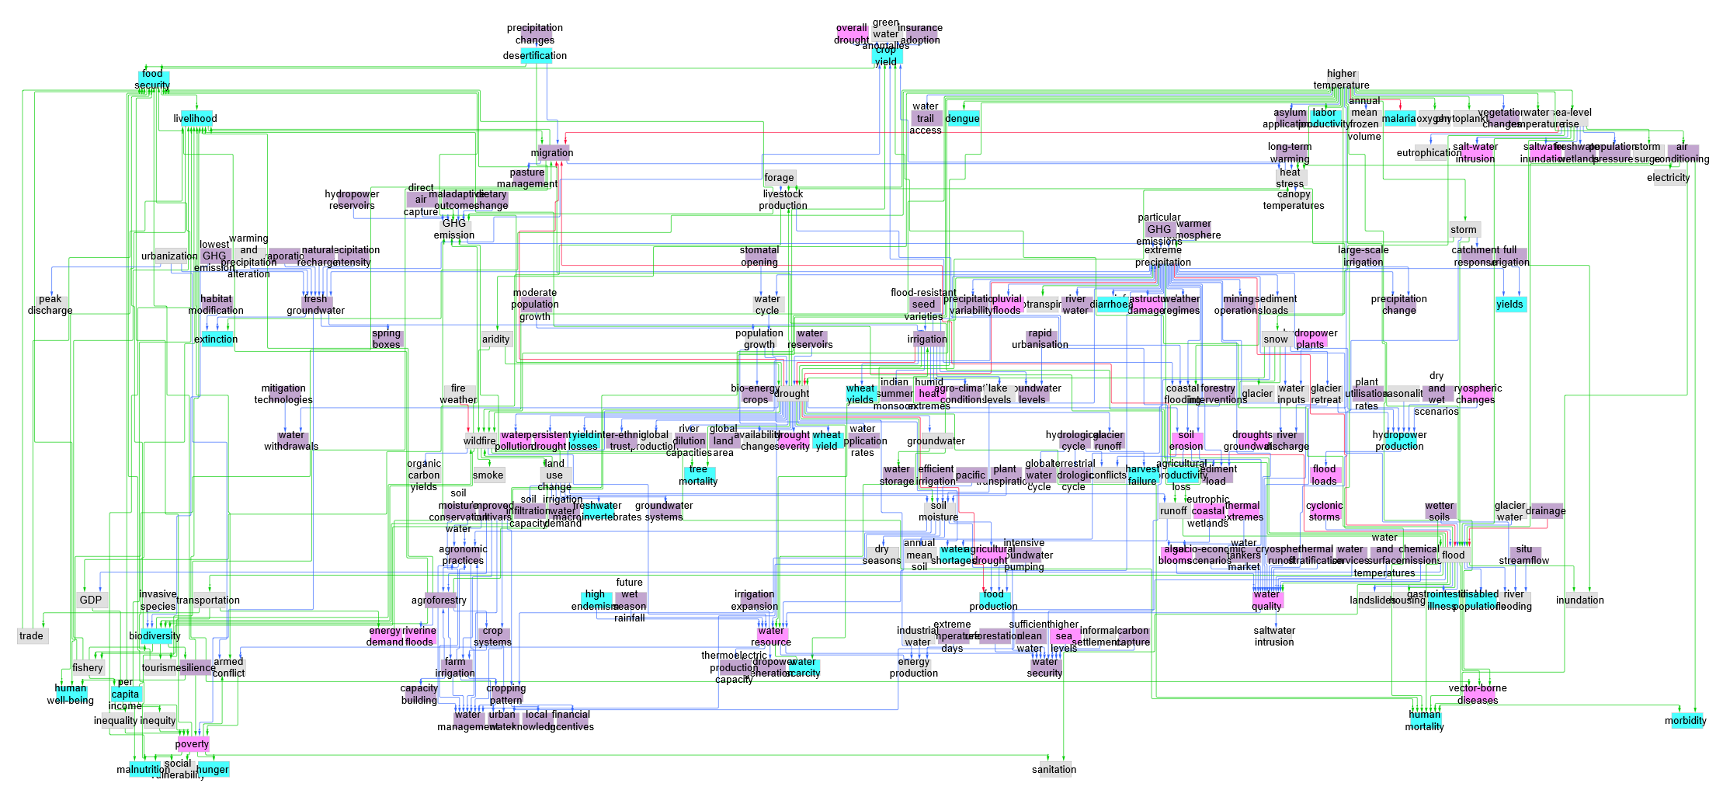
Supplementary Fig. 21 Integrated causal network of Water. Bypass examples: drought → water scarcity (drought → wildfire → water resource → water scarcity), drought → crop yield (drought → heat stress → crop yield).

15 Network clustering method selection
For the typification of integrated networks, a distance matrix is created and clustering is performed. Because the number of networks is small and scatterplots would provide limited insight, hierarchical clustering is selected. The reasons for choosing structural distance, text distance, and the method for combining these distances when constructing the distance matrix are as follows.

First, it is necessary to consider which structural distance to adopt. Graph edit distance, the distance minimizing node-edge editing costs, is a computationally complex problem that suffers from growing search spaces and high memory consumption (Abu-Aisheh et al. 2015). The Weisfeiler–Lehman kernel, a structural comparison method based on iterative neighborhood label refinement (Shervashidze et al. 2011), requires specific libraries and complex configuration, and thus, its priority is lower. On the other hand, the Network Laplacian Spectral Descriptor (NetLSD), a method that represents a network as a single multidimensional vector, has the advantage of representing local to global structures in a continuous manner and is less sensitive to network size or node order (Tsitsulin et al. 2018). Therefore, in this study, the signature vector from NetLSD was used, and the distance $D_{struct}$ was calculated using the Euclidean distance (L2 distance) between signatures.

Next, regarding text distance, given that approaches such as the Fréchet inception distance, which compares distributions using their means and covariance matrices of deep feature embeddings (Heusel et al. 2017), are relatively complex to implement in practice, the cosine distance between the mean embedding vectors of node texts was adopted. Specifically, the unique node text of each network was vectorized, and the obtained embeddings were averaged to create a text signature vector (mean embedding) for the network. The cosine distance between text signature vectors was calculated to define the text distance $D_{text}$.

Both structural distance and text distance are independent metrics suitable for measuring network distance. Therefore, when constructing the distance matrix for network clustering, neither is actively discarded. Instead, efforts are made to find a balance between the two. Concatenating structural feature vectors and text mean embedding into a single feature makes it difficult to adjust for dimensionality. Multiple kernel learning, which synthesizes structural and textual kernels with optimal weights (Gönen and Alpaydın 2011), or manifold alignment, which aligns latent spaces between structures and texts (Wang and Mahadevan 2009), may require careful regularization, particularly when data are limited (i.e., there are at most seven comparable networks by region and sector). On the other hand, for the linear sum of structural distance and text distance $α∙D_{struct}+(1-α)∙D_{text}$, its meaning of the weight $α$ is intuitive and explainability is high. Thus, the linear sum was adopted in this study.

16 Backbones
The common patterns of the integrated causal networks (backbones) observed across all regions (Supplementary Figure 22) and sectors (Supplementary Figure 23) are illustrated as follows.
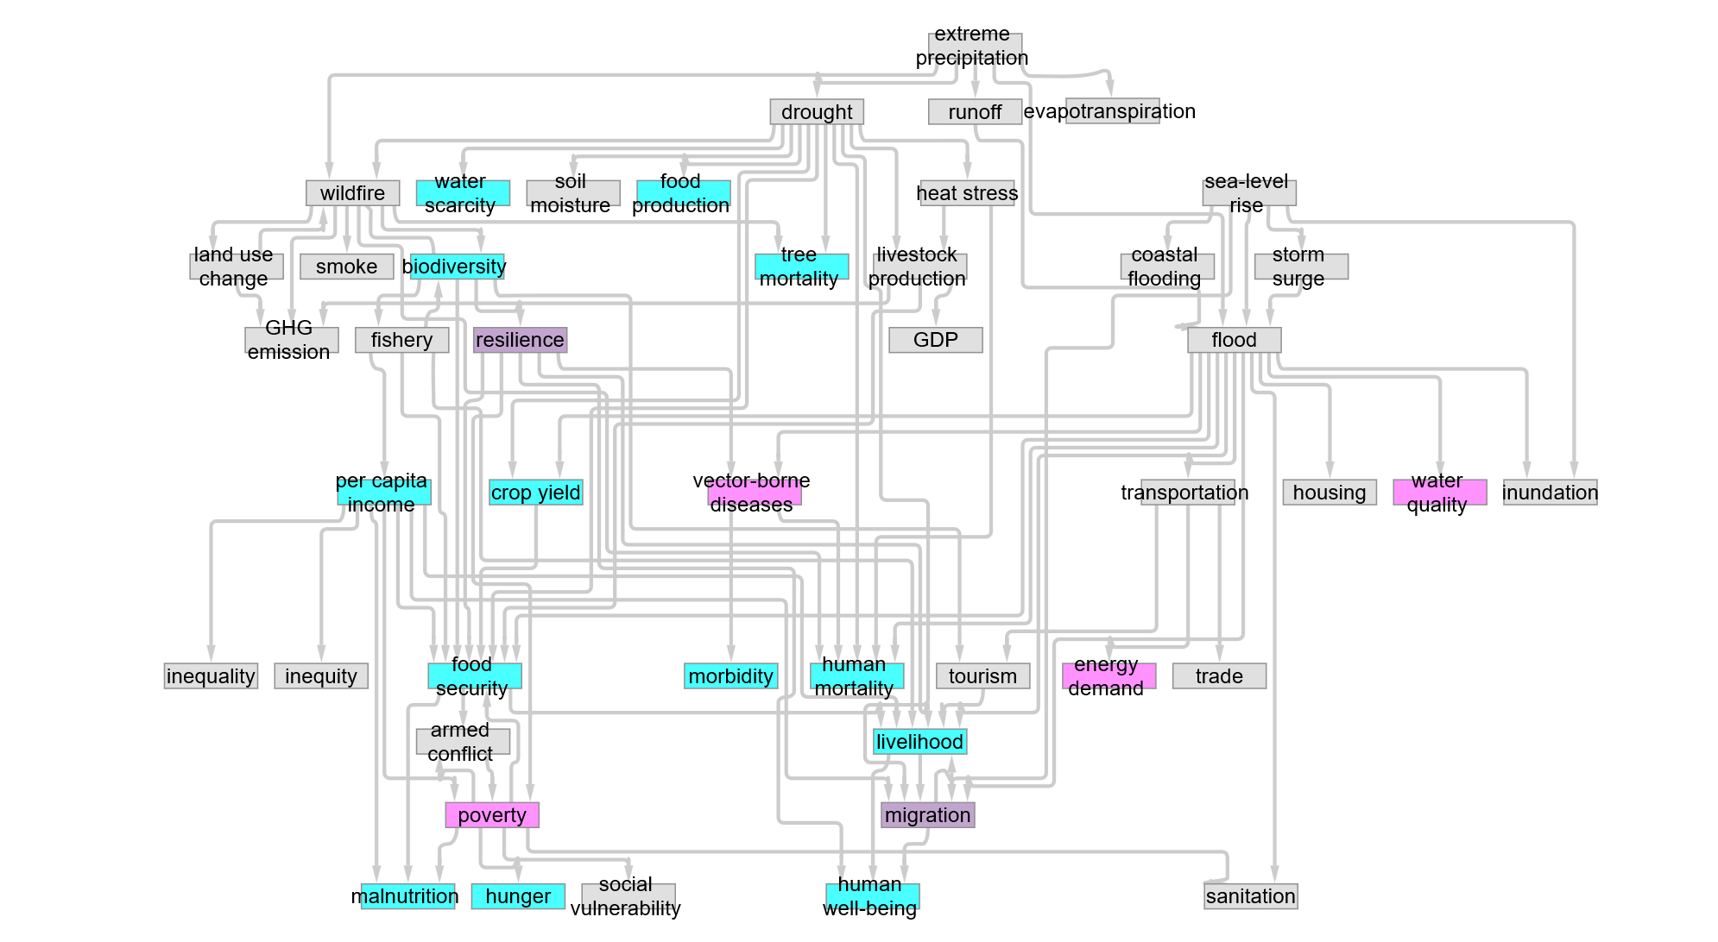
Supplementary Fig. 22 A backbone structure observed across all regions. Upstream climate hazards, such as drought, extreme precipitation, and sea-level rise, are the starting point, from which cascading impacts spread to agriculture, ecosystems, health, the economy, and infrastructure. At the downstream, poverty, hunger, and human well-being are observed, reflecting an outcome where the causal effects converge on social vulnerability and welfare.
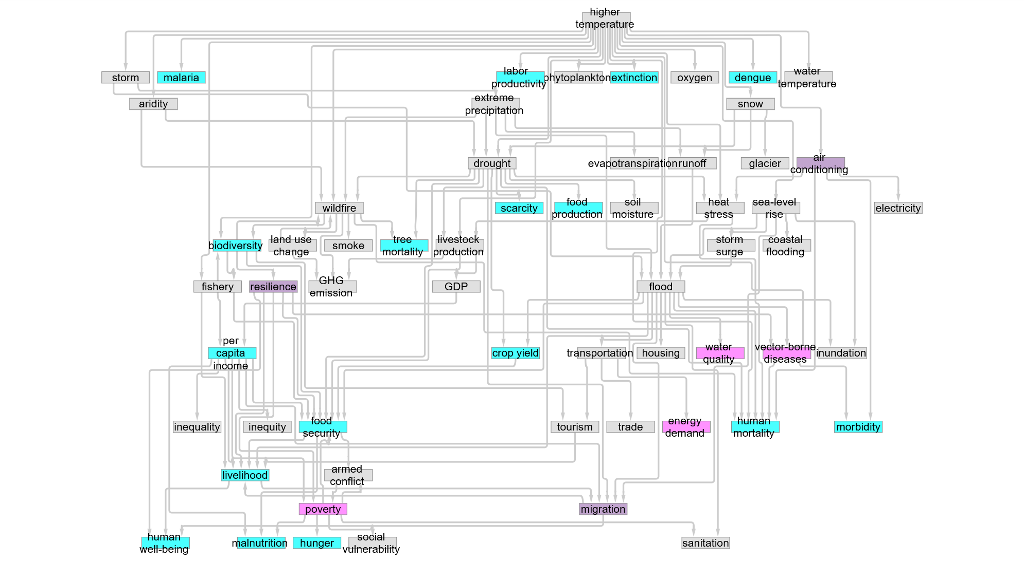
Supplementary Fig. 23 A backbone structure observed across all sectors. Similar to the previous diagram, the flow from upstream climate hazards to agriculture, ecosystems, and the economy, and then to people’s lives and welfare, is consistent. Meanwhile, this diagram includes more detailed health-related elements such as malaria, dengue, oxygen, and air conditioning.

17 Sensitivity analysis in network clustering
Supplementary Figure 24 shows the results of a one-factor-at-a-time sensitivity analysis, i.e., how the results change when only $α$ is changed.
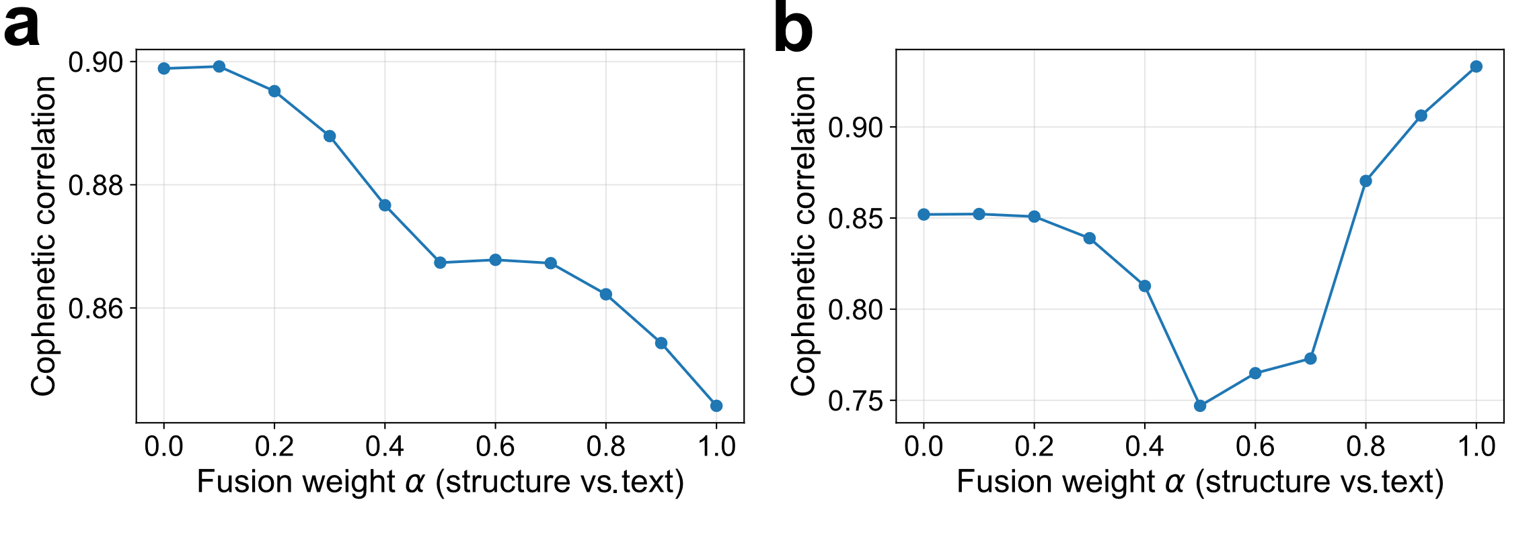
Supplementary Fig. 24 Relationship between $α$ and the cophenetic correlation coefficient. a) By region. b) By sector.

By region, the correlation was highest when $α$ was 0.1, and decreased as $α$ increased to increase the weight of the structural distance. That is, the text distance reproduces the cluster structure more stably. By sector, the correlation decreased around $α$ values ranging from 0.4 to 0.6. Increasing $α$ further increased the correlation, which reached a maximum at $α=1$. In other words, increasing the weight of the structural distance reproduces the cluster structure more stably. Essentially, these two types of region- and sector-specific networks differ in terms of which distance should be prioritized.

References
Abu-Aisheh Z, Raveaux R, Ramel JY et al (2015) An exact graph edit distance algorithm for solving pattern recognition problems. In: Proceedings of the International Conference on Pattern Recognition Applications and Methods - Volume 1 (ICPRAM 2015). SCITEPRESS - Science and Technology Publications, Lda, Setubal, PRT, 271–278. https://doi.org/10.5220/0005209202710278
Ahne A, Khetan V, Tannier X et al (2022) Extraction of explicit and implicit cause-effect relationships in patient-reported diabetes-related tweets from 2017 to 2021: deep learning approach. JMIR Med Inform 10(7):e37201. https://doi.org/10.2196/37201
Akkasi A, Moens MF (2021) Causal relationship extraction from biomedical text using deep neural models: A comprehensive survey. J Biomed Inform 119, 103820. https://doi.org/10.1016/j.jbi.2021.103820
Ali W, Zuo W, Ying W et al (2023) Causality extraction: A comprehensive survey and new perspective. J King Saud Univ - Comput Inf Sci, Volume 35, Issue 7. https://doi.org/10.1016/j.jksuci.2023.101593
Antunes M, Estro T, Bhandari P et al (2025) Kneeliverse: A universal knee-detection library for performance curves. SoftwareX 30:102161. https://doi.org/10.1016/j.softx.2025.102161
Chatwal P, Agarwal A, Mittal A (2025) Enhancing Causal Relationship Detection Using Prompt Engineering and Large Language Models. In: Proceedings of the Joint Workshop of the 9th Financial Technology and Natural Language Processing (FinNLP), the 6th Financial Narrative Processing (FNP), and the 1st Workshop on Large Language Models for Finance and Legal (LLMFinLegal) pp. 248-252, Abu Dhabi, UAE. Association for Computational Linguistics. https://aclanthology.org/2025.finnlp-1.26/
Channing O (2024) Causal Relationship Extraction Using BiGRU-Attention-CRF with Character Features and Iterated Dilated CNNs. Trans Comput Sci Methods 4(10). https://www.pspress.org/index.php/tcsm/article/view/131
Chen Y, Wan W, Hu J et al (2022) Complex causal extraction of fusion of entity location sensing and graph attention networks. Information 13(8) 364. https://doi.org/10.3390/info13080364
Cui S, Sheng J, Cong X et al (2022) Event causality extraction with event argument correlations. In: Proceedings of the 29th International Conference on Computational Linguistics pp. 2300-2312, Gyeongju, Republic of Korea. International Committee on Computational Linguistics. https://aclanthology.org/2022.coling-1.201/
Gönen M, Alpaydin E (2011) Multiple kernel learning algorithms. J Mach Learn Res 12, 2211-2268. https://dl.acm.org/doi/10.5555/1953048.2021071
Heusel M, Ramsauer H, Unterthiner T et al (2017) Gans trained by a two time-scale update rule converge to a local nash equilibrium. In: Proceeding of the 31st Conference on Neural Information Processing Systems (NIPS 2017) pp. 6629-6640, Long Beach, CA, USA. https://dl.acm.org/doi/10.5555/3295222.3295408
Hidey C, McKeown K (2016) Identifying causal relations using parallel Wikipedia articles. In: Proceedings of the 54th Annual Meeting of the Association for Computational Linguistics (Volume 1: Long Papers) pp. 1424-1433, Berlin, Germany. Association for Computational Linguistics. https://doi.org/10.18653/v1/P16-1135
Kang N, Singh B, Bui C et al (2014) Knowledge-based extraction of adverse drug events from biomedical text. BMC Bioinform 15(1) 64. https://doi.org/10.1186/1471-2105-15-64
Khetan V, Ramnani R, Anand M et al (2022) Causal BERT: Language Models for Causality Detection Between Events Expressed in Text. In: Arai K (eds) Intelligent Computing. Lecture Notes in Networks and Systems vol 283. Springer, Cham. https://doi.org/10.1007/978-3-030-80119-9_64
Lecu A, Groza A, Hawizy L (2024) Using LLMs and ontologies to extract causal relationships from medical abstracts. Procedia Comput Sci 244, 443-452. https://doi.org/10.1016/j.procs.2024.10.219
Li D, Wu P, Dong Y et al (2023) Joint learning-based causal relation extraction from biomedical literature. J Biomed Inform 139, 104318. https://doi.org/10.1016/j.jbi.2023.104318
Li P, Mao K (2019) Knowledge-oriented convolutional neural network for causal relation extraction from natural language texts. Expert Syst Appl 115, 512-523. https://doi.org/10.1016/j.eswa.2018.08.009
Li Z, Li Q, Zou X et al (2021) Causality extraction based on self-attentive BiLSTM-CRF with transferred embeddings. Neurocomputing 423, 207-219. https://doi.org/10.1016/j.neucom.2020.08.078
Oh JH, Torisawa K, Hashimoto C et al (2013) Why-question answering using intra-and inter-sentential causal relations. In: Proceedings of the 51st Annual Meeting of the Association for Computational Linguistics (Volume 1: Long Papers), pages 1733–1743, Sofia, Bulgaria. Association for Computational Linguistics. https://aclanthology.org/P13-1170/
Radinsky K, Davidovich S, Markovitch S (2012) Learning causality for news events prediction. In: Proceedings of the 21st international conference on World Wide Web (WWW’12). Association for Computing Machinery, New York, NY, USA, 909-918. https://doi.org/10.1145/2187836.2187958
Satopaa V, Albrecht J, Irwin D et al (2011) Finding a “kneedle” in a haystack: Detecting knee points in system behavior. In: 2011 31st international conference on distributed computing systems workshops, Minneapolis, MN, USA, 2011, pp. 166-171. https://doi.org/10.1109/ICDCSW.2011.20
Shao Y, Li H, Gu J et al (2021) Extraction of causal relations based on SBEL and BERT model. Database, 2021, baab005. https://doi.org/10.1093/database/baab005
Shervashidze N, Schweitzer P, Van Leeuwen EJ et al (2011) Weisfeiler-lehman graph kernels. J Mach Learn Res 12(9) 2539-2561. https://dl.acm.org/doi/10.5555/1953048.2078187
Stegnar J, Rožanec JM, Leban G et al (2024) Enhancing causal graphs with domain knowledge: Matching ontology concepts between ontologies and raw text data. Proc Inf Soc. pp.7-11 https://doi.org/10.70314/is.2024.sikdd.25
Tsitsulin A, Mottin D, Karras P et al (2018) NetLSD: Hearing the Shape of a Graph. In Proceedings of the 24th ACM SIGKDD International Conference on Knowledge Discovery & Data Mining (KDD’18). Association for Computing Machinery, New York, NY, USA, 2347-2356. https://doi.org/10.1145/3219819.3219991
Wang C, Mahadevan S (2009) A General Framework for Manifold Alignment. In: AAAI fall symposium: manifold learning and its applications pp. 79-86. https://aaai.org/papers/00852-852-a-general-framework-for-manifold-alignment/
Yang J, Han SC, Poon J (2022) A survey on extraction of causal relations from natural language text. Knowl Inf Syst 64(5) 1161-1186. https://doi.org/10.1007/s10115-022-01665-w
Yu X, Wang X, Luo X et al (2022) Multi-scale event causality extraction via simultaneous knowledge-attention and convolutional neural network. Expert Syst 39(5) e12952. https://doi.org/10.1111/exsy.12952
Zhang C, Lyu J, Xu K (2023) A storytree-based model for inter-document causal relation extraction from news articles. Knowl Inf Syst 65(2) 827-853. https://doi.org/10.1007/s10115-022-01781-7

