Supplementary Information
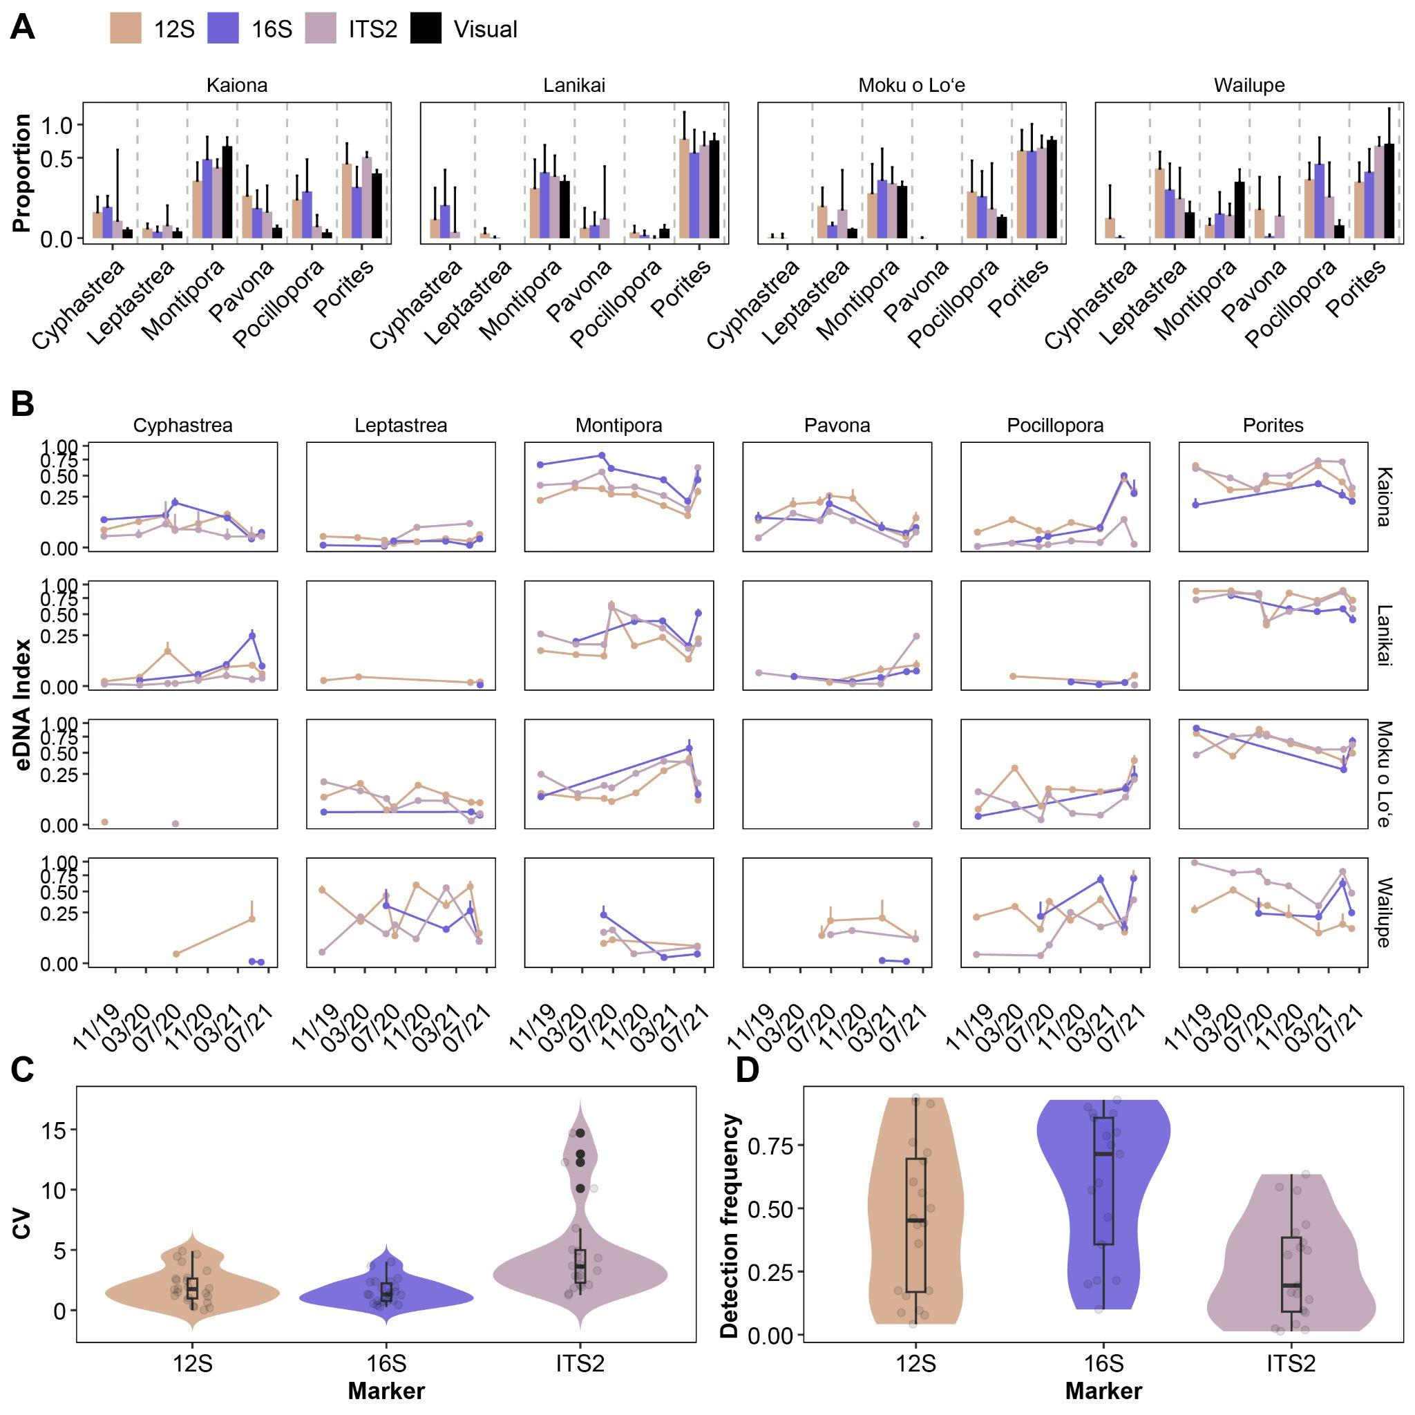
Figure S1. (a) Proportion of eDNA contribution (based on eDNA index) across the three coral-specific metabarcoding markers (12S, 16S, ITS2) and visual percent cover for coral genera detected at the four temporal monitoring sites on Oʻahu, Hawaiʻi. (b) eDNA index contributions recovered through time across markers and sites. (c) Coefficient of variation (CV) of abundance-based signal intensity and (d) temporal detection frequency, calculated as the proportion of timepoints in which a genus was detected within each site for each marker. Points represent individual samples; boxplots and violin plots summarize distributions across markers.
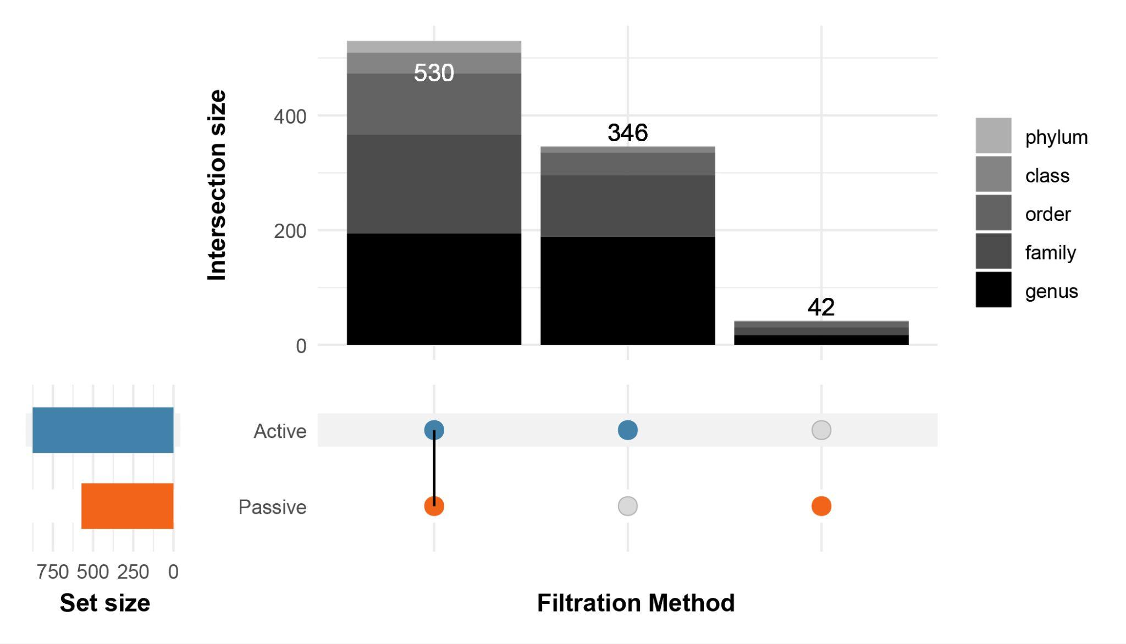
Figure S2. Overlap of detected zero-radius operational taxonomic units (zOTUs) between active and passive filtration methods. The UpSet plot (top) summarizes taxa detected in environmental DNA samples that were identified to the lowest possible taxonomic rank: phylum, class, order, family, genus. Intersection bars (top) are stacked by taxonomic rank, showing the number of zOTUs shared between filtration methods or unique to a method. Set size bars (left) indicate the total number of taxa detected per filtration method.
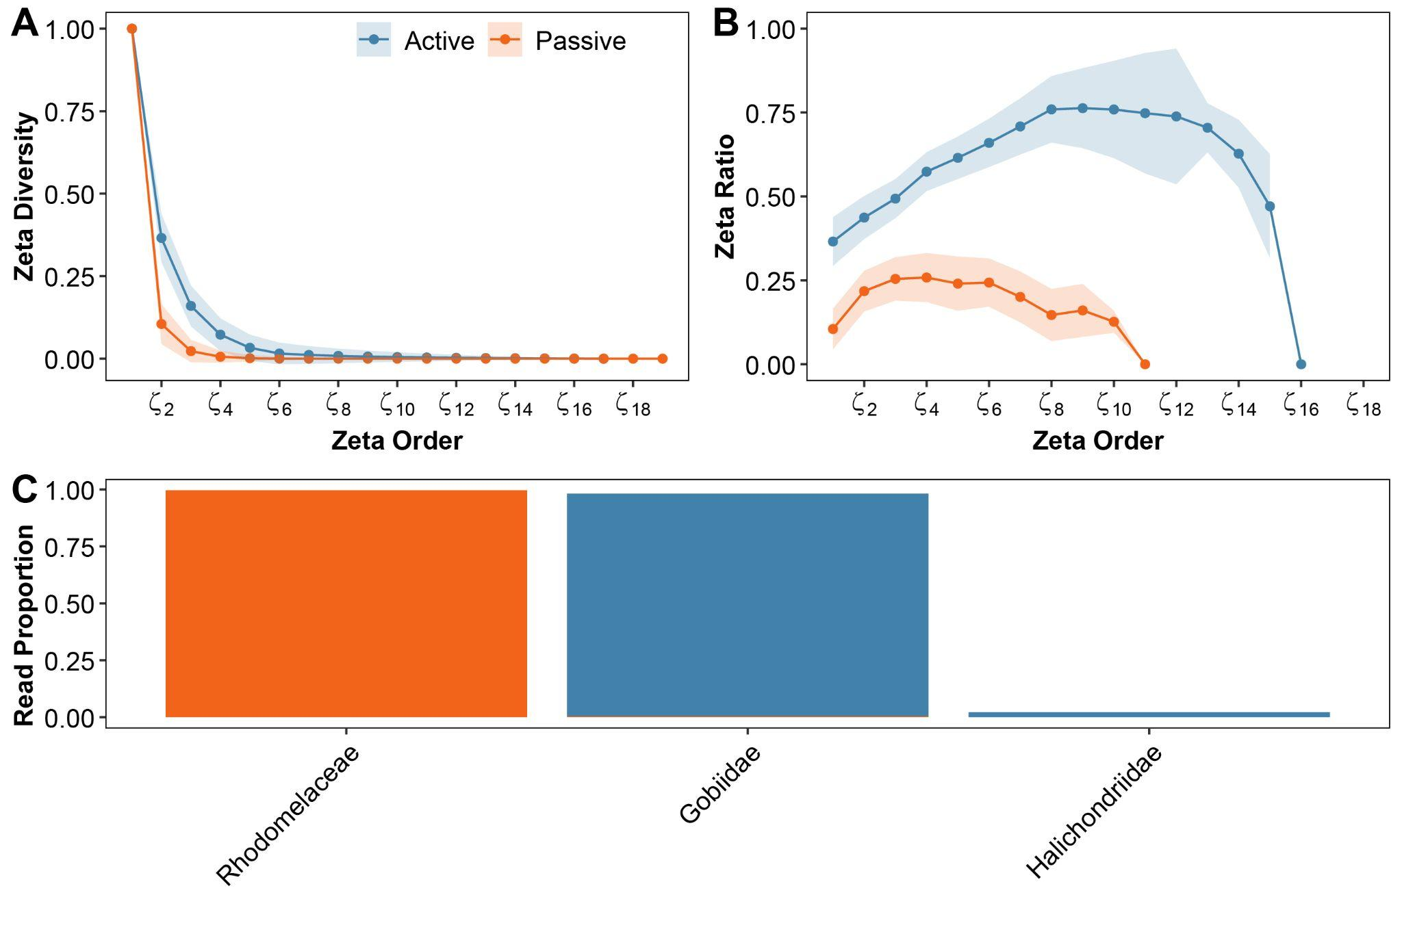
Figure S3. Zeta diversity and core taxa by filtration method (active vs. passive). (a) Decline in shared zero-radius operational taxonomic units (zOTUs) and (b) retention ratio across zeta orders. (c) Relative eDNA read proportions for core families detected by filtration method. Proportions were calculated within each filtration method with stacked bars indicating contributions from each filtration method.
Table S1. Detection of scleractinian coral genera across sites using conventional visual benthic surveys and three coral-specific eDNA metabarcoding markers (12S, 16S, ITS2). Presence is indicated by “X”. Totals represent the number of genus detections per method across all sites.

Site | Genus | Visual | 12S eDNA | 16S eDNA | ITS2 eDNA
Kaiona | Porites spp. | X | X | X | X
Kaiona | Pocillopora spp. | X | X | X | X
Kaiona | Montipora spp. | X | X | X | X
Kaiona | Pavona spp. | X | X | X | X
Kaiona | Leptastrea spp. | X | X | X | X
Kaiona | Cyphastrea spp. | X | X | X | X
Lanikai | Porites spp. | X | X | X | X
Lanikai | Pocillopora spp. | X | X | X | X
Lanikai | Montipora spp. | X | X | X | X
Lanikai | Pavona spp. |  | X | X | X
Lanikai | Leptastrea spp. |  | X | X
Lanikai | Cyphastrea spp. |  | X | X | X
Moku o Loʻe | Porites spp. | X | X | X | X
Moku o Loʻe | Pocillopora spp. | X | X | X | X
Moku o Loʻe | Montipora spp. | X | X | X | X
Moku o Loʻe | Pavona spp. |  |  |  | X
Moku o Loʻe | Leptastrea spp. | X | X | X | X
Moku o Loʻe | Cyphastrea spp. |  | X |  | X
Wailupe | Porites spp. | X | X | X | X
Wailupe | Pocillopora spp. | X | X | X | X
Wailupe | Montipora spp. | X | X | X | X
Wailupe | Pavona spp. |  | X | X | X
Wailupe | Leptastrea spp. | X | X | X | X
Wailupe | Cyphastrea spp. |  | X | X
Total |  | 17 | 23 | 22 | 22
Table S2. Linear mixed-effects model (LMM) and generalized linear mixed-effects model (GLMM) results comparing temporal variability among coral eDNA markers. Two response variables were analyzed: (i) the coefficient of variation (CV) of abundance-based signal intensity, and (ii) detection frequency (presence/absence), modeled with binomial error structure. Marker identity was included as a fixed effect in both models, with site and genus included as random intercepts to account for spatial structure and repeated measures. Parameter estimates (β), standard errors (SE), t-values with degrees of freedom (df), z-values, and p-values are reported relative to the reference marker (12S).

Metric | Fixed effect | Estimate (β) | SE | z-value | t_{df} | p
CV (LMM) | Intercept | -2.23 | 2.67 | - | -0.84_{3.99} | 0.45
CV (LMM) | 16S | -0.20 | 0.19 | - | -1.05_{56.2} | 0.30
CV (LMM) | ITS2 | 0.96 | 0.19 | - | 5.06_{56.3} | < 0.001
Detection frequency (GLMM) | Intercept | -0.70 | 0.53 | -1.32 | - | 0.19
Detection frequency (GLMM) | 16S | 0.64 | 0.17 | 3.69 | - | < 0.001
Detection frequency (GLMM) | ITS2 | -1.83 | 0.10 | -19.1 | - | < 0.001

Table S3. Taxa uniquely detected by active (2-L water filtration) versus passive eDNA collection for coral reef-associated metazoans and macroalgae. Taxa are organized by taxonomic rank (phylum to genus) and listed only if detected exclusively by one method across all samples.

Method | Rank | Unique taxa
Active | phyla | Xenacoelomorpha
Active | classes | Acoela, Arachnida, Branchiopoda, Cephalopoda, Chondrichthyes, Leptocardii, Mammalia, Palaeonemertea, Thecostraca, Trematoda
Active | orders | Acoela, Amphioxiformes, Archinemertea, Artiodactyla, Atheriniformes, Aulopiformes, Azygiida, Beloniformes, Blenniiformes, Characiformes, Cheilostomatida, Chondrillida, Cichliformes, Cladophorales, Coronatae, Cycloneritida, Cyprinodontiformes, Dendroceratida, Diplostraca, Ellobiida, Elopiformes, Holocentriformes, Istiophoriformes, Lophiiformes, Lutjaniformes, Mugiliformes, Myliobatiformes, Neogastropoda, Octopoda, Ophiurida, Pectinida, Perciformes, Polyarthra, Ralfsiales, Rhodachlyales, Sphacelariales, Testudines, Trochida, Trombidiformes
Active | families | Acestrorhamphidae, Actiniidae, Aeolidiidae, Anchimolgidae, Anomiidae, Antennariidae, Aplysinidae, Atherinidae, Belonidae, Blenniidae, Boloceroididae, Branchiostomatidae, Caliphyllidae, Canuellidae, Caprellidae, Caulacanthaceae, Cephalotrichidae, Cheloniidae, Cichlidae, Cladonematidae, Cladophoraceae, Congridae, Corycaeidae, Corynidae, Delphinidae, Dictyodendrillidae, Discodorididae, Dorvilleidae, Dysideidae, Ectocarpaceae, Eleotridae, Ellobiidae, Elopidae, Epialtidae, Galaxauraceae, Gelidiellaceae, Gigartinaceae, Golfingiidae, Grapsidae, Gymnodorididae, Halacaridae, Heteropiidae, Hippolytidae, Hirudinellidae, Holocentridae, Hydractiniidae, Iotrochotidae, Irciniidae, Istiophoridae, Kallymeniaceae, Kirchenpaueriidae, Kyphosidae, Leucettidae, Lineidae, Linuchidae, Lutjanidae, Macrotrichidae, Mesosporaceae, Mithracidae, Mugilidae, Muricidae, Myliobatidae, Nephtheidae, Neritidae, Octopodidae, Oncaeidae, Ophiactidae, Orbiniidae, Palaemonidae, Pandeidae, Phloeodictyidae, Phyllodocidae, Planaxidae, Poeciliidae, Polynemidae, Polynoidae, Pomacentridae, Portunidae, Processidae, Protodrilidae, Pseudoceratinidae, Pyramidellidae, Rhizophyllidaceae, Rhodachlyaceae, Saccocirridae, Sagartiidae, Sagittiferidae, Scorpaenidae, Smaragdinellidae, Soleneiscidae, Sphacelariaceae, Spirostyliferinidae, Stichodactylidae, Stichopodidae, Sycettidae, Synaptidae, Synodontidae, Talitridae, Tetillidae, Thalassematidae, Thalestridae, Thoosidae, Thorectidae, Tripterygiidae, Tritoniidae, Trochidae, Watersiporidae, Xanthidae
Active | genera | Abdopus, Abudefduf, Aetobatus, Aiptasia, Alectona, Amansia, Anchimolgus, Antennarius, Astyanax, Asymmetron, Atherinomorus, Atys, Bathygobius, Bestiolina, Biuve, Boloceroides, Botrylloides, Brachidontes, Breviturma, Cacospongia, Calliotrochus, Calotomus, Canthigaster, Caprella, Carminodoris, Caulacanthus, Centroceras, Cephalothrix, Ceratodictyon, Chaetonotus, Chelidonura, Chelonia, Chlorurus, Chondracanthus, Cinachyra, Cirripectes, Cladonema, Cladophora, Clathria, Claudrilus, Coeloplana, Coelothrix, Conger, Convolutriloba, Cosmocalanus, Crouania, Cupolaconcha, Cyerce, Dasysiphonia, Dendropoma, Diplomma, Dodecaceria, Dolabrifera, Dorvillea, Dysidea, Echinothrix, Ectenurus, Ectocarpus, Eleotris, Elops, Elysia, Enneapterygius, Entomacrodus, Eudactylopus, Eviota, Farranula, Fasciospongia, Galaxaura, Gelidiella, Gnatholepis, Gymnodoris, Gymnothorax, Herdmania, Hinea, Hippolyte, Hydractinia, Hydroclathrus, Hydrolithon, Igernella, Iotrochota, Ircinia, Jania, Kirchenpaueria, Kyphosus, Lamprohaminoea, Leodice, Leucandra, Linopherus, Linuche, Lissodendoryx, Lutjanus, Macrothrix, Malacoceros, Marionia, Meiodrilus, Melampus, Meredithia, Mesospora, Metopograpsus, Micippa, Monia, Monocorophium, Morula, Mugil, Myrianida, Myripristis, Naineris, Naso, Nematonereis, Neoniphon, Nephasoma, Nerilla, Nicidion, Nicolea, Nikoides, Oceanapia, Octopus, Odontosyllis, Oncaea, Ophiactis, Ophiocomella, Opisthosyllis, Osmundea, Osteomugil, Otohimella, Otopleura, Palisada, Pandeopsis, Paralepidonotus, Phanerophthalmus, Pharyngocirrus, Phyllodoce, Pilodius, Pione, Plakobranchus, Platybelone, Plectroglyphidodon, Pleurehdera, Poecilia, Polydactylus, Polydora, Polyplectana, Porphyridium, Portieria, Pristiapogon, Protodrilus, Pseudoceratina, Psilogobius, Pyura, Raphidrilus, Rhinecanthus, Rhodachlya, Rhombognathus, Rhyncholagena, Rosenvingea, Sargassum, Sargocentron, Sarotherodon, Saurida, Scarus, Scorpaenodes, Scottolana, Selar, Simocarcinus, Soleneiscus, Sphacelaria, Stelletta, Stenopeltis, Stereonephthya, Stethojulis, Stichopus, Stilophora, Styliferina, Sycettusa, Sycon, Syllidia, Syllis, Synodus, Terebella, Tetranemertes, Thalamita, Thelepus, Trochonerilla, Tursiops, Ululania, Uropterygius, Viatrix, Watersipora
Passive | phyla | Phaeophyceae
Passive | classes | Cubozoa
Passive | orders | Acrochaetiales, Carditida, Carybdeida, Macrodasyida, Monhysterida, Ostreoida, Palmariales, Siphonostomatoida, Trachymedusae
Passive | families | Acrochaetiaceae, Alatinidae, Carditidae, Clytiidae, Ectinosomatidae, Leptocytheridae, Opheliidae, Palmariaceae, Pennellidae, Rhodymeniaceae, Rhopalonematidae, Schindleriidae, Thaumastodermatidae, Xyalidae
Passive | genera | Acrochaetium, Aglaura, Alatina, Clytia, Daptonema, Diplodasys, Erythrocolon, Halichaetoderma, Lernaeenicus, Melanothamnus, Nannocalanus, Palmaria, Philinopsis, Polycarpa, Polyophthalmus, Schindleria, Tolypiocladia

Table S4. Observed and extrapolated asymptotic richness of zero-radius operational taxonomic units (zOTUs) across regions (Keʻehi and Maunalua) and eDNA collection methods (active vs. passive) for each genetic marker: algae (23S), corals/sponges (16S), total eukaryotes (18S), fish (MFU), and macroinvertebrates (COI). Extrapolated richness estimates are presented as mean ± standard error (SE).
Marker | Grouping | Observed Richness | Extrapolated (± SE)
Algae (23S) | Overall | 127 | 148 ± 12
Algae (23S) | Active | 92 | 120 ± 15
Algae (23S) | Passive | 109 | 176 ± 27
Algae (23S) | Keʻehi | 61 | 91 ± 13
Algae (23S) | Maunalua | 90 | 98 ± 8
Corals/sponges (16S) | Overall | 31 | 32 ± 1
Corals/sponges (16S) | Active | 31 | 32 ± 1
Corals/sponges (16S) | Passive | 23 | 47 ± 17
Corals/sponges (16S) | Keʻehi | 19 | 23 ± 7
Corals/sponges (16S) | Maunalua | 31 | 32 ± 2
Eukaryotes (18S) | Overall | 1049 | 1307 ± 34
Eukaryotes (18S) | Active | 778 | 963 ± 32
Eukaryotes (18S) | Passive | 786 | 1089 ± 36
Eukaryotes (18S) | Keʻehi | 560 | 796 ± 33
Eukaryotes (18S) | Maunalua | 699 | 790 ± 18
Fish (MFU) | Overall | 118 | 144 ± 12
Fish (MFU) | Active | 114 | 131 ± 10
Fish (MFU) | Passive | 36 | 70 ± 16
Fish (MFU) | Keʻehi | 35 | 52 ± 14
Fish (MFU) | Maunalua | 112 | 140 ± 11
Inverts (COI) | Overall | 1164 | 1831 ± 67
Inverts (COI) | Active | 1015 | 1477 ± 52
Inverts (COI) | Passive | 328 | 884 ± 97
Inverts (COI) | Keʻehi | 365 | 998 ± 93
Inverts (COI) | Maunalua | 934 | 1312 ± 51

Table S5. Significant indicator taxa associated with each embayment region (Keʻehi and Maunalua Bay) based on indicator species analysis of eDNA metabarcoding data. Taxa are listed with their corresponding genetic marker and indicator value (stat). P-values (p.val) and multiple testing-corrected p-values (p.adj; Benjamini-Hochberg) are reported.

Region | Taxa | Marker | stat | p.val | p.adj
Keʻehi | Bivalvia (Mollusca) | Eukaryotes (18S) | 0.377 | <0.001 | 0.001
Keʻehi | Chlorophyceae (Chlorophyta) | Eukaryotes (18S) | 0.364 | <0.001 | 0.001
Keʻehi | Polychaeta (Annelida) | Eukaryotes (18S) | 0.35 | 0.001 | 0.008
Keʻehi | Bivalvia (Mollusca) | Inverts (COI) | 0.315 | <0.001 | 0.007
Keʻehi | Gastropoda (Mollusca) | Eukaryotes (18S) | 0.281 | 0.002 | 0.008
Maunalua | Florideophyceae (Rhodophyta) | Eukaryotes (18S) | 0.518 | <0.001 | 0.001
Maunalua | Ulvophyceae (Chlorophyta) | Eukaryotes (18S) | 0.481 | <0.001 | 0.001
Maunalua | Malacostraca (Arthropoda) | Inverts (COI) | 0.357 | 0.001 | 0.014
Maunalua | Ascidiacea (Chordata) | Eukaryotes (18S) | 0.348 | <0.001 | 0.003
Maunalua | Calcarea (Porifera) | Eukaryotes (18S) | 0.337 | 0.004 | 0.015
Maunalua | Echinoidea (Echinodermata) | Eukaryotes (18S) | 0.311 | 0.003 | 0.015
Maunalua | Acoela (Xenacoelomorpha) | Inverts (COI) | 0.309 | 0.003 | 0.026
Maunalua | Homoscleromorpha (Porifera) | Inverts (COI) | 0.301 | 0.003 | 0.026
Maunalua | Ophiuroidea (Echinodermata) | Eukaryotes (18S) | 0.255 | 0.008 | 0.028
Maunalua | Compsopogonophyceae (Rhodophyta) | Eukaryotes (18S) | 0.241 | 0.019 | 0.064
Maunalua | Polyplacophora (Mollusca) | Eukaryotes (18S) | 0.206 | 0.036 | 0.106
Maunalua | Tentaculata (Ctenophora) | Eukaryotes (18S) | 0.191 | 0.037 | 0.106

Table S6. Significant indicator taxa associated with sampling site locations based on indicator species analysis. Taxa are listed with their corresponding genetic marker and indicator value (stat). P-values (p.val) and multiple testing-corrected p-values (p.adj; Benjamini-Hochberg) are reported.
Region | Site | Group | Marker | stat | p.val | p.adj
Keʻehi | MK01 | Chaetodontidae (Chordata) | Fish (MFU) | 0.913 | 0.001 | 0.018
Keʻehi | MK01 | Bivalvia (Mollusca) | Eukaryotes (18S) | 0.701 | 0.004 | 0.039
Keʻehi | MK02 | Polysiphonia (Rhodophyta) | Algae (23S) | 0.894 | 0.001 | 0.027
Keʻehi | MK02 | Polychaeta (Annelida) | Eukaryotes (18S) | 0.780 | <0.001 | 0.015
Maunalua | MM01 | Madagascaria (Rhodophyta) | Algae (23S) | 0.727 | 0.003 | 0.039
Maunalua | MM01 | Polyplacophora (Mollusca) | Eukaryotes (18S) | 0.756 | <0.001 | 0.011
Maunalua | MM02 | Liagora (Rhodophyta) | Algae (23S) | 0.651 | 0.005 | 0.042
Maunalua | MM03 | Gracilaria (Rhodophyta) | Algae (23S) | 0.686 | 0.004 | 0.042
Maunalua | MM05 | Chondria (Rhodophyta) | Algae (23S) | 0.597 | 0.003 | 0.023
Maunalua | MM10 | Scyphozoa (Cnidaria) | Eukaryotes (18S) | 0.687 | 0.002 | 0.023
Maunalua | MM10 | Acanthophora (Rhodophyta) | Algae (23S) | 0.618 | 0.001 | 0.017
Maunalua | MM11 | Ascidiacea (Chordata) | Eukaryotes (18S) | 0.687 | 0.002 | 0.023
Maunalua | MM12 | Holothuroidea (Echinodermata) | Eukaryotes (18S) | 0.924 | <0.001 | 0.004
Maunalua | MM12 | Turbinaria (Ochrophyta) | Algae (23S) | 0.762 | 0.001 | 0.027
Maunalua | MM12 | Phaeophyceae (Ochrophyta) | Eukaryotes (18S) | 0.692 | 0.001 | 0.009
Maunalua | MM18 | Pilidiophora (Nemertea) | Eukaryotes (18S) | 0.815 | 0.006 | 0.041

Table S7. Significant indicator taxa associated with eDNA sampling method (active vs. passive) based on indicator species analysis. Taxa are listed with their corresponding genetic marker and indicator value (stat). P-values (p.val) and multiple testing-corrected p-values (p.adj; Benjamini-Hochberg) are reported.

Method | Taxa | Marker | stat | p.val | p.adj
Active | Calcarea (Porifera) | Eukaryotes (18S) | 0.524 | <0.001 | 0.001
Active | Demospongiae (Porifera) | Inverts (COI) | 0.512 | <0.001 | <0.001
Active | Malacostraca (Arthropoda) | Inverts (COI) | 0.488 | <0.001 | <0.001
Active | Polychaeta (Annelida) | Inverts (COI) | 0.466 | <0.001 | <0.001
Active | Anthozoa (Cnidaria) | Inverts (COI) | 0.459 | <0.001 | <0.001
Active | Hydrozoa (Cnidaria) | Inverts (COI) | 0.444 | <0.001 | <0.001
Active | Phaeophyceae (Ochrophyta) | Inverts (COI) | 0.438 | <0.001 | <0.001
Active | Acoela (Xenacoelomorpha) | Inverts (COI) | 0.423 | <0.001 | <0.001
Active | Demospongiae (Porifera) | Eukaryotes (18S) | 0.414 | <0.001 | 0.001
Active | Gastropoda (Mollusca) | Inverts (COI) | 0.409 | <0.001 | <0.001
Active | Poritidae (Cnidaria) | Corals/sponges (16S) | 0.405 | <0.001 | 0.002
Active | Ulvophyceae (Chlorophyta) | Eukaryotes (18S) | 0.393 | <0.001 | 0.001
Active | Ulvophyceae (Chlorophyta) | Inverts (COI) | 0.377 | <0.001 | <0.001
Active | Actinopteri (Chordata) | Inverts (COI) | 0.376 | <0.001 | <0.001
Active | Enopla (Nemertea) | Inverts (COI) | 0.372 | <0.001 | <0.001
Active | Florideophyceae (Rhodophyta) | Inverts (COI) | 0.371 | <0.001 | <0.001
Active | Holothuroidea (Echinodermata) | Inverts (COI) | 0.354 | <0.001 | 0.001
Active | Labridae (Chordata) | Fish (MFU) | 0.315 | 0.001 | 0.015
Active | Ascidiacea (Chordata) | Inverts (COI) | 0.297 | <0.001 | <0.001
Active | Pomacentridae (Chordata) | Fish (MFU) | 0.287 | <0.001 | 0.007
Active | Florideophyceae (Rhodophyta) | Eukaryotes (18S) | 0.275 | 0.008 | 0.046
Active | Homoscleromorpha (Porifera) | Inverts (COI) | 0.275 | 0.006 | 0.01
Active | Echinoidea (Echinodermata) | Inverts (COI) | 0.251 | 0.002 | 0.005
Active | Mullidae (Chordata) | Fish (MFU) | 0.249 | 0.004 | 0.029
Active | Irciniidae (Porifera) | Corals/sponges (16S) | 0.245 | 0.001 | 0.003
Active | Holocentridae (Chordata) | Fish (MFU) | 0.241 | <0.001 | 0.005
Active | Kyphosidae (Chordata) | Fish (MFU) | 0.239 | 0.002 | 0.017
Active | Hypnea (Chlorophyta) | Algae (23S) | 0.237 | 0.002 | 0.026
Active | Porphyridium (Rhodophyta) | Algae (23S) | 0.236 | <0.001 | 0.009
Active | Cephalopoda (Mollusca) | Inverts (COI) | 0.232 | 0.006 | 0.01
Active | Enteropneusta (Hemichordata) | Inverts (COI) | 0.226 | 0.034 | 0.05
Active | Monogononta (Rotifera) | Inverts (COI) | 0.224 | 0.002 | 0.004
Active | Halichondriidae (Porifera) | Corals/sponges (16S) | 0.214 | 0.002 | 0.007
Active | Palaeonemertea (Nemertea) | Inverts (COI) | 0.214 | 0.029 | 0.045
Active | Homoscleromorpha (Porifera) | Eukaryotes (18S) | 0.212 | <0.001 | 0.001
Active | Mycalidae (Porifera) | Corals/sponges (16S) | 0.204 | 0.006 | 0.019
Active | Thecostraca (Arthropoda) | Inverts (COI) | 0.204 | 0.012 | 0.02
Active | Cichlidae (Chordata) | Fish (MFU) | 0.164 | 0.002 | 0.017
Active | Aiptasiidae (Cnidaria) | Corals/sponges (16S) | 0.144 | <0.001 | 0.002
Active | Chromadorea (Nematoda) | Inverts (COI) | 0.139 | 0.028 | 0.045

Table S8. Complete metazoan and limu (algae) species list detected across regions and markers.

