Assessing intergenerational and environmentally dependent inbreeding depression in a wild bird population
Supplementary information
Table S1. MCMC animal models summary
Fitness measure | F_{ROH} pmean | F_{ROH} pMCMC | GRM prop. variance
FYS | 0.171 | 0.510 | <0.001
Lifespan | -7.93 | <0.001 | <0.001
LRS | -8.74 | <0.001 | <0.001

Table S1. Summary of MCMCglmm animal models of the effect of individual inbreeding coefficients on first-year survival (FYS), lifespan, and lifetime reproductive success (LRS, number of offspring survived to first-year), with the proportion of variance explained by the genomic relatedness matrix.

Table S2. Sex differences in fitness measures
Fitness measure | Mean (males) | SD (males) | Mean (females) | SD (females) | Wilcox test sig value
FYS | 0.448 | 0.498 | 0.459 | 0.499 | W = 134746, p-value = 0.7144
Lifespan | 4.6 | 3.678 | 4.932 | 3.81 | W = 139520, p-value = 0.1858
LRS | 2.38 | 3.55 | 2.33 | 3.043 | W = 137301, p-value = 0.375

Table S2. Comparison of means across males and females for first-year survival (FYS), lifespan, and lifetime reproductive success (LRS, number of offspring survived to first-year), in the Cousin island population of Seychelles warblers 1997 – 2023.

Table S3. GLMM of Parental F_{ROH} on reproductive count, split by sex.
Model | - Females n = 246 |  |  |  | - Males n =253
Fixed Effects | Beta | SE | Stat | p-value | Beta | SE | Stat. | p-value
(Intercept) | 6.73 | 1.35 | 4.98 | <0.001 | 4.57 | 1.17 | 3.89 | <0.001
Individual F_{ROH} | -1.28 | 0.853 | -1.5 | 0.133 | 0.074 | 0.613 | 0.12 | 0.904
Social Father F_{ROH} | -0.99 | 0.997 | -0.993 | 0.321 | -0.29 | 0.661 | -0.438 | 0.661
Genetic Father F_{ROH} | -0.011 | 1.09 | -0.01 | 0.992 | 0.077 | 0.737 | 0.104 | 0.917
Mother F_{ROH} | -1.09 | 0.8 | -1.37 | 0.171 | 0.463 | 0.555 | 0.834 | 0.405
Mean annual rainfall over lifespan | 1.35 | 1.03 | 1.31 | 0.19 | 0.015 | 0.618 | 0.024 | 0.981
Mean variance in annual rainfall over lifespan | -0.428 | 0.723 | -0.592 | 0.554 | -1.14 | 0.722 | -1.58 | 0.115
Presence of sibling in nest | 0.812 | 0.951 | 0.854 | 0.393 | 2.15 | 0.953 | 2.26 | 0.024
Hatch year | 0.978 | 0.946 | 1.03 | 0.301 | 1.64 | 0.703 | 2.34 | 0.019
Lifespan | -2.4 | 0.521 | -4.61 | <0.001 | -1.91 | 0.528 | -3.62 | <0.001

Table S3. Model of the effect of parental and individual inbreeding coefficients (F_{ROH}) on whether individuals reproduce or not (structural zero component of zero inflated Poisson GLMM) in the Cousin Island population of Seychelles warblers, 1997 – 2023.

Table S4. EPP model
Model | - First-year Survival |  |  |  | - Lifespan |  |  |  | - Reproduction 0/1 |  |  |  | - Reproduction Count
Fixed Effects | log(OR) | SE | Stat. | p-value | Beta | SE | Stat. | p-value | Beta | SE | Stat. | p-value | Beta | SE | Stat. | p-value
(Intercept) | -0.133 | 0.298 | -0.445 | 0.656 | 1.22 | 0.24 | 5.07 | <0.001 | -11.5 | 6.46 | -1.78 | 0.075 | 0.766 | 0.092 | 8.35 | <0.001
Individual FROH | -0.047 | 0.3 | -0.157 | 0.875 | -0.266 | 0.107 | -2.48 | 0.013 | -2.89 | 2.2 | -1.31 | 0.19 | -0.122 | 0.112 | -1.09 | 0.277
Social Father FROH | 0.596 | 0.304 | 1.96 | 0.05 | 0.068 | 0.106 | 0.642 | 0.521 | -0.592 | 0.97 | -0.61 | 0.542 | 0.002 | 0.125 | 0.016 | 0.987
Genetic Father FROH | -0.156 | 0.304 | -0.514 | 0.607 | 0.183 | 0.125 | 1.47 | 0.142 | 1.01 | 1.67 | 0.605 | 0.545 | 0.121 | 0.109 | 1.1 | 0.27
Mother FROH | -0.133 | 0.298 | -0.445 | 0.656 | 0.046 | 0.121 | 0.376 | 0.707 | -3.96 | 2.57 | -1.54 | 0.123 | -0.077 | 0.116 | -0.666 | 0.505
Sex | -0.693 | 0.295 | -2.34 | 0.019 | 0.109 | 0.1 | 1.09 | 0.276
Helpers in natal territory – 1 | -0.047 | 0.41 | -0.115 | 0.908 | 0.382 | 0.164 | 2.32 | 0.02
2 | 15 | 883 | 0.017 | 0.986 | 0.112 | 0.738 | 0.151 | 0.88
3
Annual rainfall in hatch year | 0.188 | 0.291 | 0.648 | 0.517
Variance in rainfall in hatch year | 0.126 | 0.298 | 0.423 | 0.672
Mean annual rainfall over lifespan |  |  |  |  | -0.295 | 0.125 | -2.36 | 0.018
Mean variance in annual rainfall over lifespan |  |  |  |  | 0.44 | 0.123 | 3.58 | <0.001
Presence of sibling in nest | -0.239 | 0.378 | -0.632 | 0.527 | -0.013 | 0.134 | -0.097 | 0.923
Natal group size | -0.027 | 0.32 | -0.085 | 0.932 | -0.018 | 0.073 | -0.242 | 0.809
Hatch year |  |  |  |  | -0.651 | 0.135 | -4.82 | <0.001
Lifespan |  |  |  |  |  |  |  |  | -46 | 24.7 | -1.86 | 0.062 | 1.28 | 0.118 | 10.9 | <0.001
Random effects |  |  | Variance | Std. Dev. |  |  | Variance | Std. Dev. |  |  | Variance | Std. Dev. |  |  | Variance | Std. Dev.
Mum |  |  |  |  |  |  | 0.1649 | 0.4060 |  |  | 0.6679 | 0.8172 |  |  | 0.08667 | 0.2944
Dad |  |  |  |  |  |  | 0.1612 | 0.4015

Table S4. Model results investigating relationship between parental inbreeding coefficients (F_{ROH}) and a) first-year survival (FYS), binomial GLMM; b) lifespan, count of years survived, Poisson GLMM; c) reproduction 0/1 (whether or not a bird reproduced at all, zero-inflated component of Poisson GLMM; d) reproduction count (total number of offspring that survived to one year), conditional component of Poisson ZI -GLMM, in the Cousin Island population of Seychelles warblers that are the result of extra pair paternity ,1997-2023 (n =204).

Figure S1

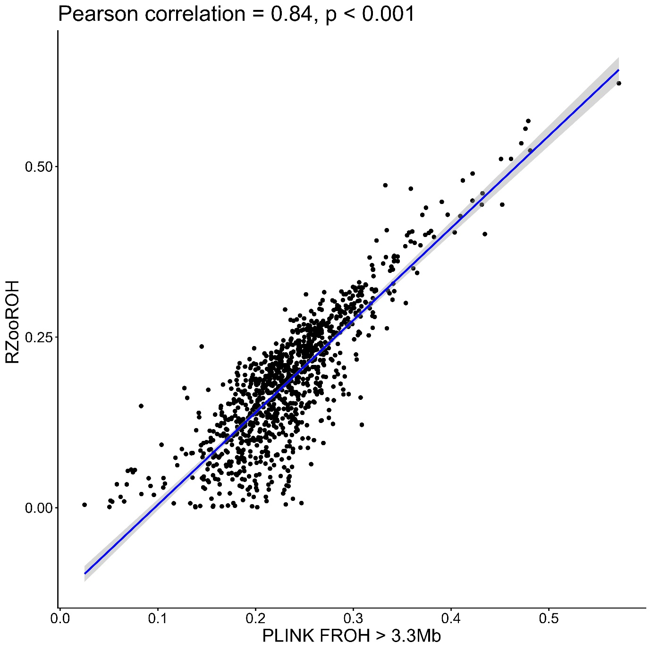
Figure S1
Comparison of F_{ROH} calculation methods. PLINK includes homozygous segments longer than 3.3Mb, while RZooROH classes segments that are homozygous by descent from 10 generations ago according to a rules based model. Dots are individual genomes of Seychelles warblers on Cousin Island 1997-2023 (n = 1019), the line is a linear model with 95% CI shading.

