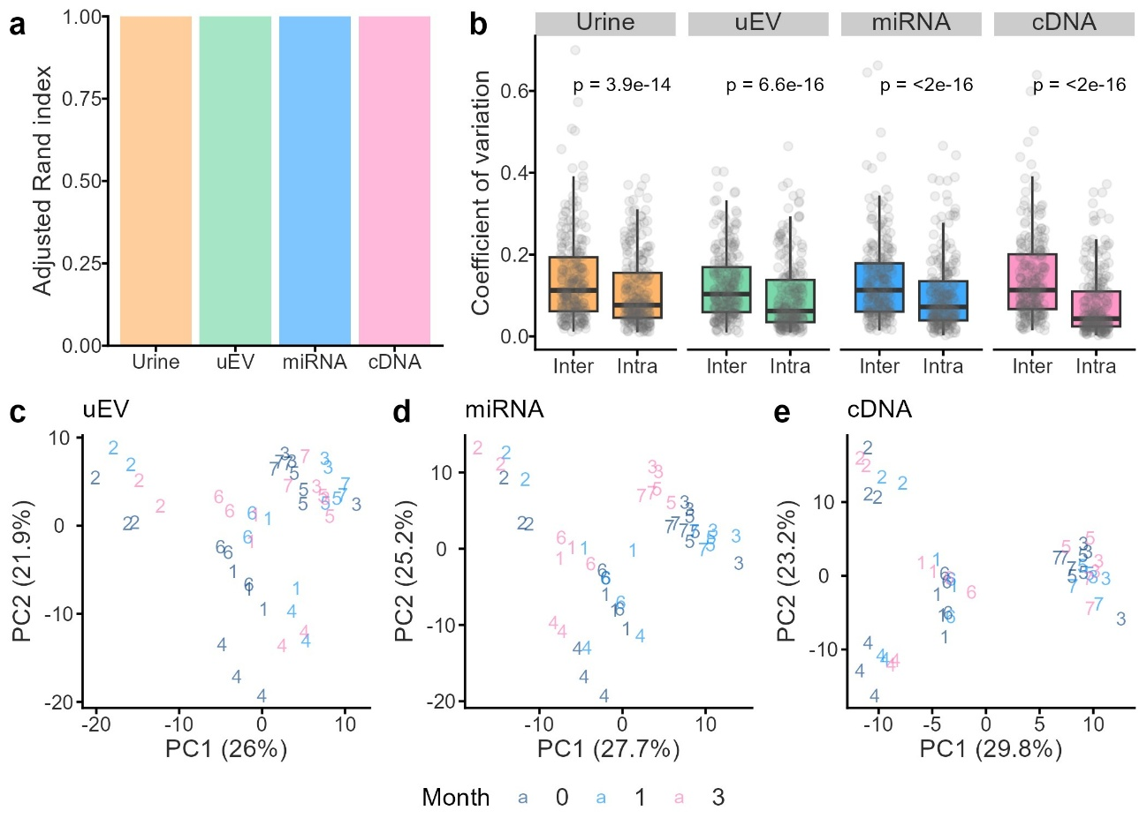

Supplementary Figure S1. Variance of miRNA profiles across the storage periods. (a) Adjusted Rand index representing clustering accuracy for urine samples stored for 0–12 months and uEVs, miRNAs, and cDNAs samples stored for 0–3 months. (b) Comparison of intra-sample and inter-sample CVs for urinary RNA materials. CVs were calculated for each miRNA across four sample types: urine (0–12 months), urinary extracellular vesicles (uEV), total miRNA, and cDNA (0–3 months). (c–e) Principal component analysis of miRNA profiles. Color-coded numbers indicate individual participants.

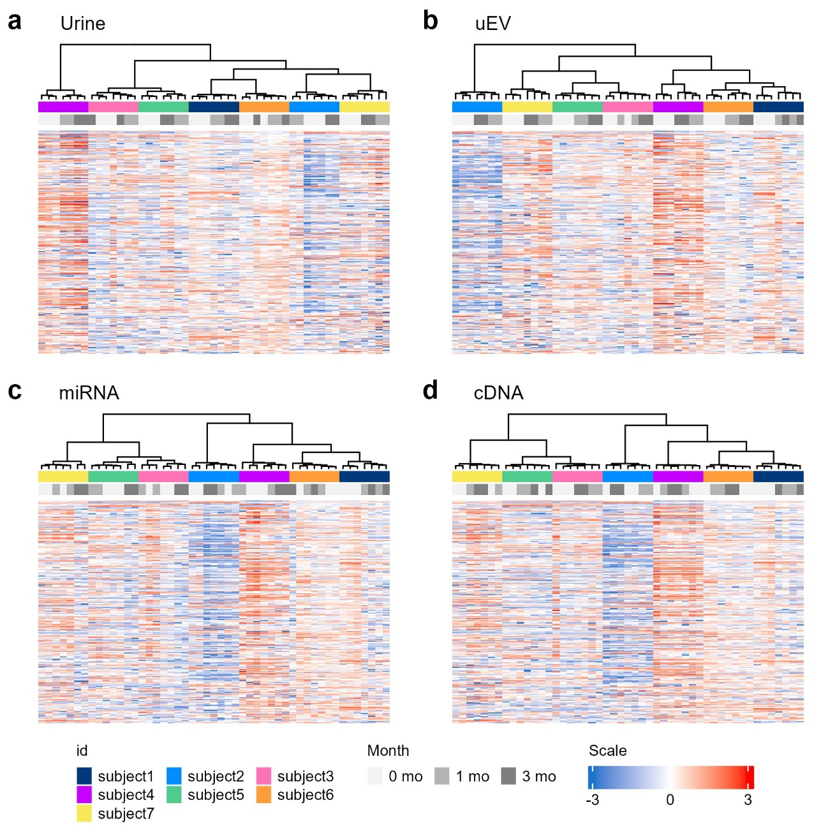
Supplementary Figure S2. Hierarchical clustering analysis of samples stored for 0–3 months. (a) Urine samples, (b) uEVs, (c) miRNAs, and (d) cDNAs. For urine samples stored for 0–12 months, see Fig. 2c.

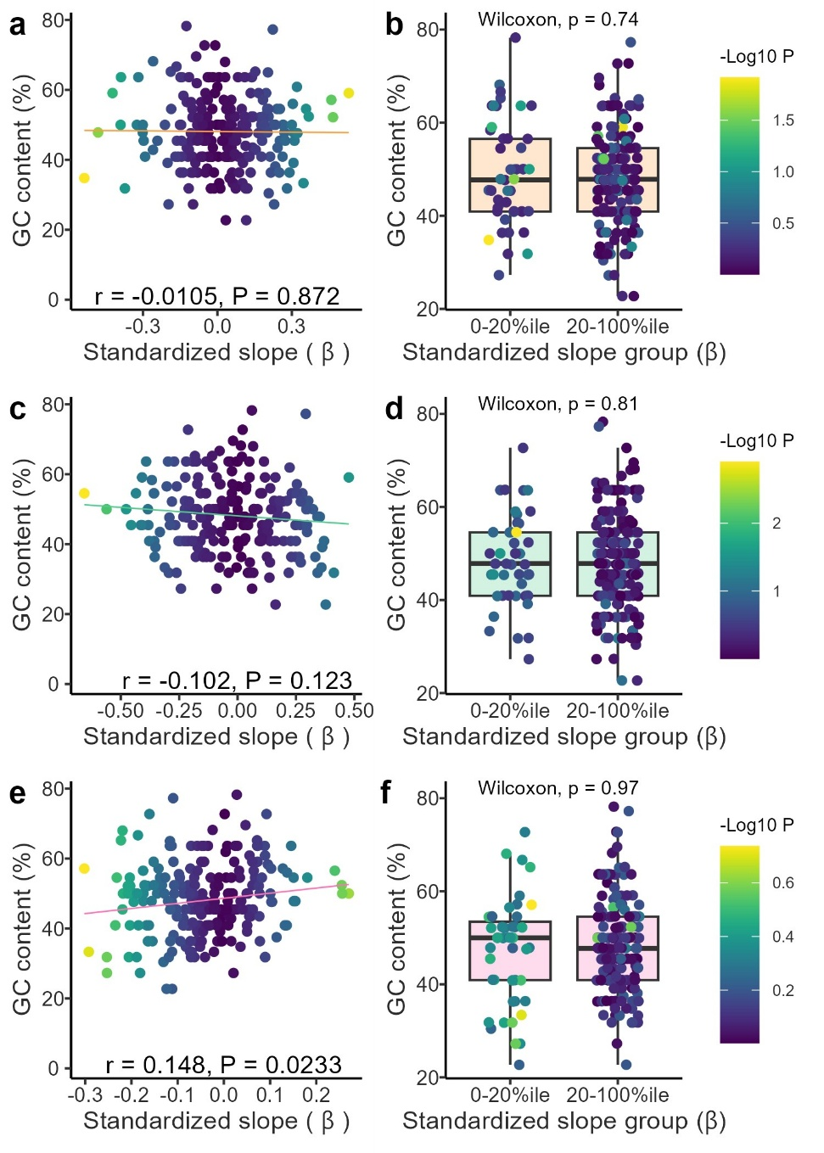
Supplementary Figure S3. Decay of miRNAs according to the GC content. Relationship between the GC content and the slope of changes in miRNA expression during storage as urine (a), uEVs (c), and cDNAs (e). Unadjusted P values are indicated by color. The slopes and P values for urine, uEVs, and cDNAs were derived from Fig. 2a, b, and d, respectively. Comparison of the GC content between the miRNAs in the bottom 0th–20th percentile (0–20%ile) and the 20th–100th percentile (20–100%ile) of slopes for urine (b), uEVs (d), and cDNAs (f). P values were calculated using the Wilcoxon rank-sum test.

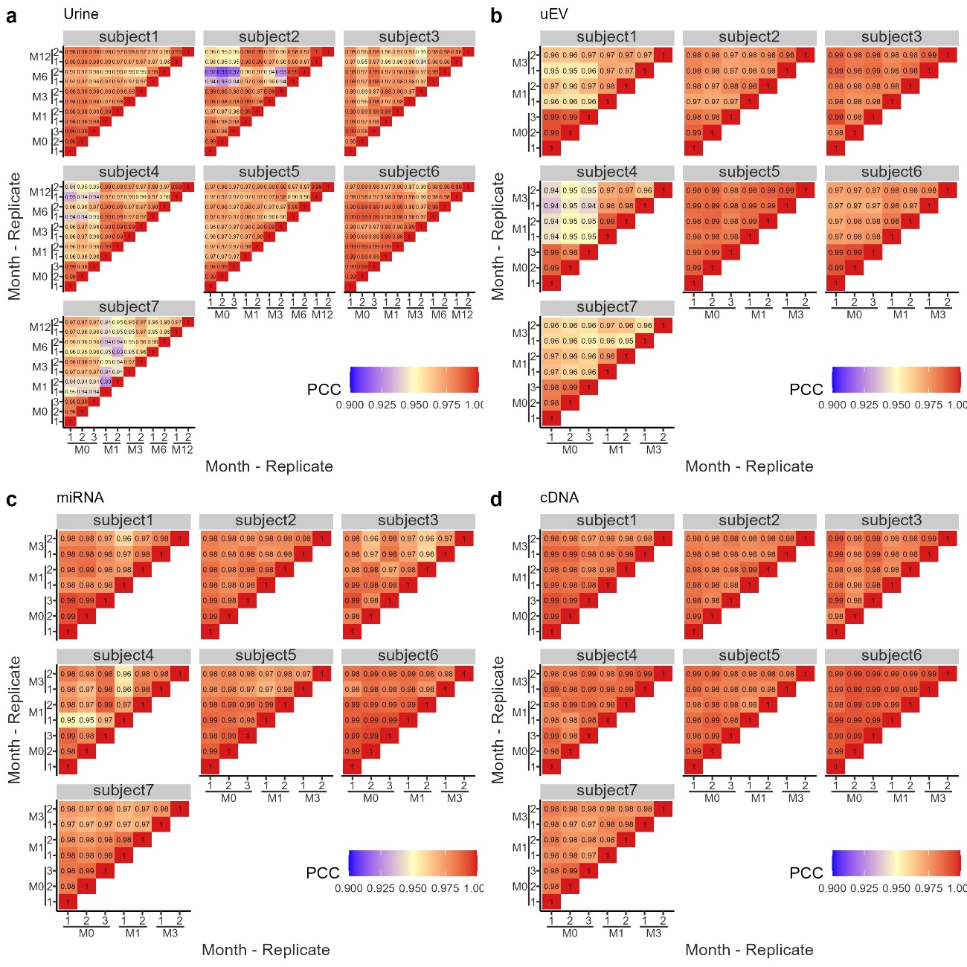

Supplementary Figure S4. Pearson correlation coefficients (PCCs) among all combinations of samples and replicates. PCCs were calculated for all pairwise comparisons across replicates and timepoints for (a) urine, (b) uEVs, (c) miRNAs, and (d) cDNAs.

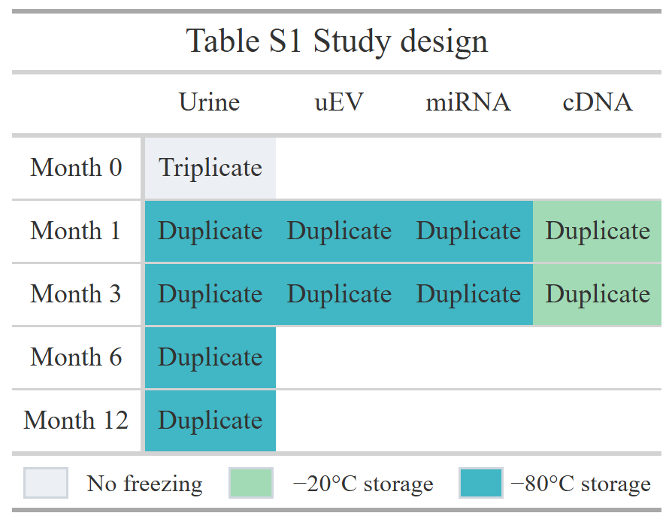

Table S2 Participants
Subject | Age | Sex
subject1 | 30-40 | Female
subject2 | 30-40 | Male
subject3 | 40-50 | Male
subject4 | 40-50 | Female
subject5 | 20-30 | Female
subject6 | 30-40 | Male
subject7 | 30-40 | Male

