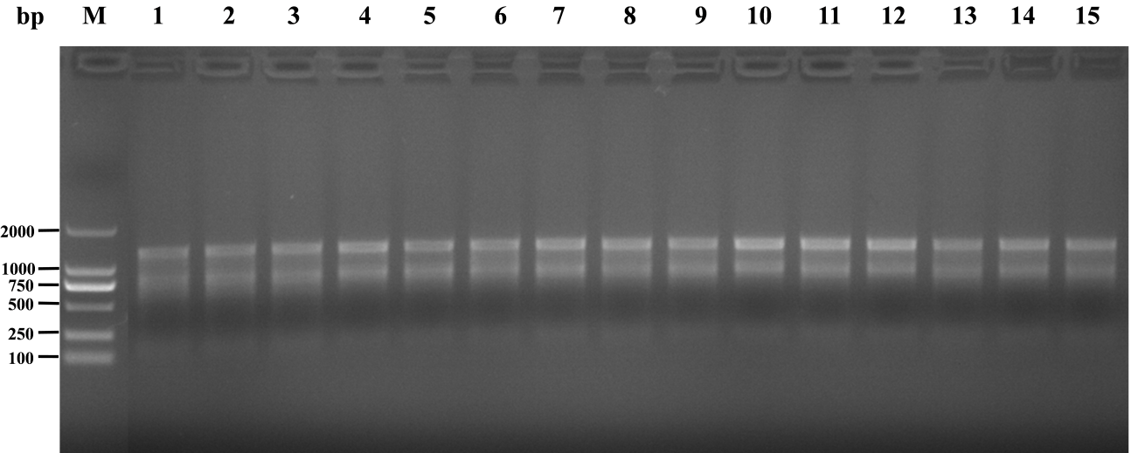
Fig. S1 RNA quality test results of tomato leaf tissue
M : Marker ; 1-3 : RNA of tomato leaf tissue in CK control group, 4-6 : RNA of tomato leaf tissue in EA control group, 7-9 : RNA of tomato leaf tissue in NKZ-259 treatment group, 10-12 : RNA of tomato leaf tissue in MeDHPQCA treatment group. 13-15 : RNA of tomato leaf tissue in DHPQCA treatment group
Fig. S2 RNA quality test results of cucumber leaf tissue
M : Marker ; 1-3 : RNA of cucumber leaf tissue in CK control group, 4-6 : RNA of cucumber leaf tissue in EA control group, 7-9 : RNA of cucumber leaf tissue in NAA control group, 10-12 : RNA of cucumber leaf tissue in NKZ-259 treatment group. 13-15 : RNA of cucumber leaf tissue in DHPQCA treatment group
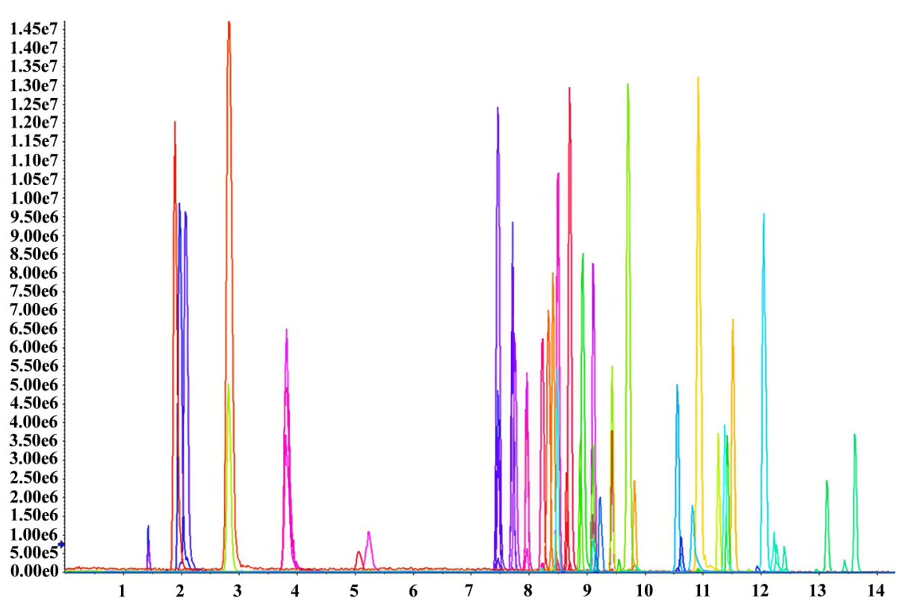
Fig. S3 XIC Chromatogram of Standard Mixture

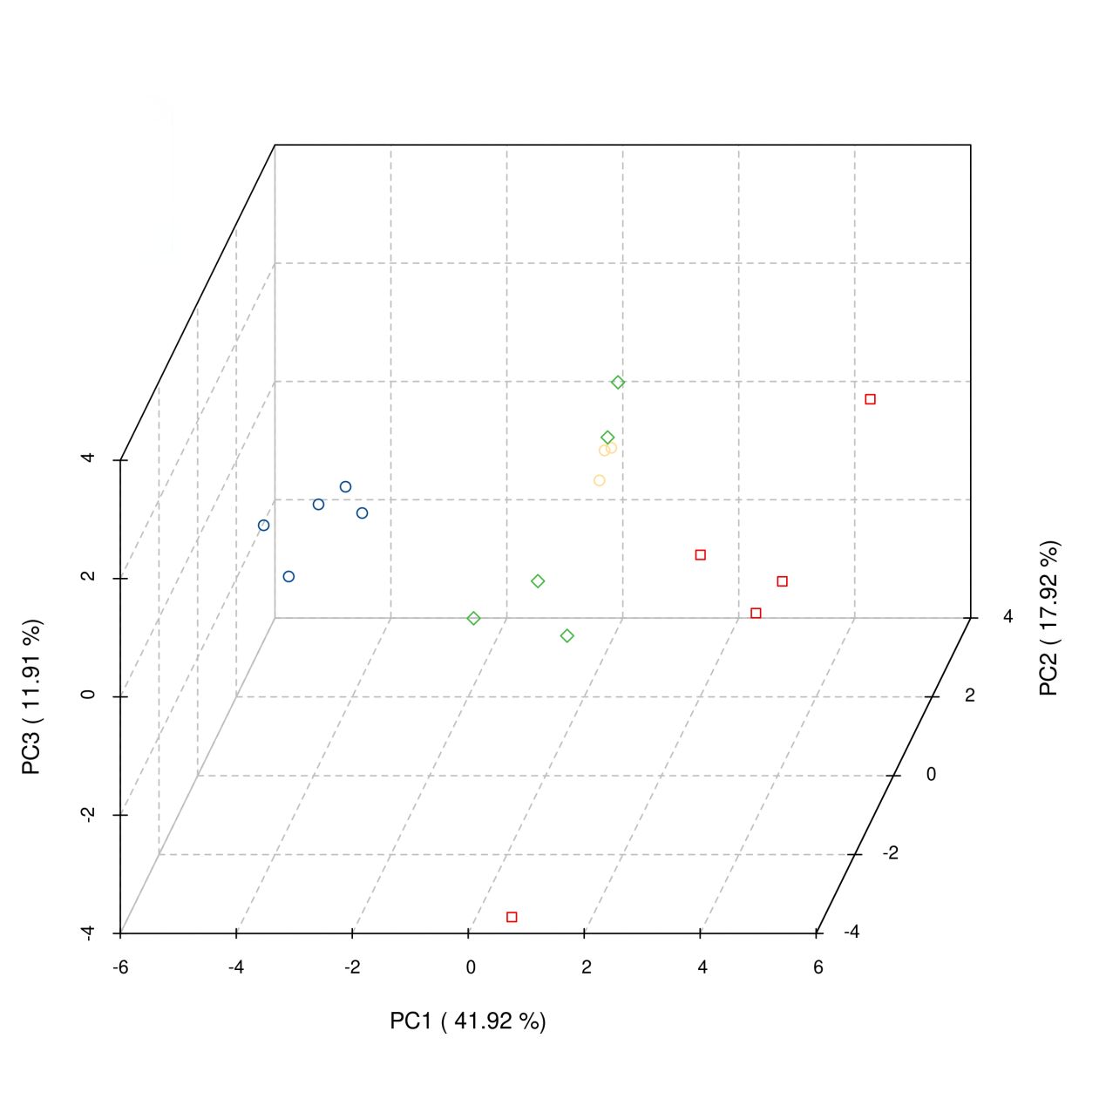
Fig. S4 PCA of differential hormones in tomato
Blue: Solvent control (0.1% v/v anhydrous ethanol); Red: DHPQCA treatment group; Green: MeDHPQCA treatment group; Yellow: Sample mixture for quality control.

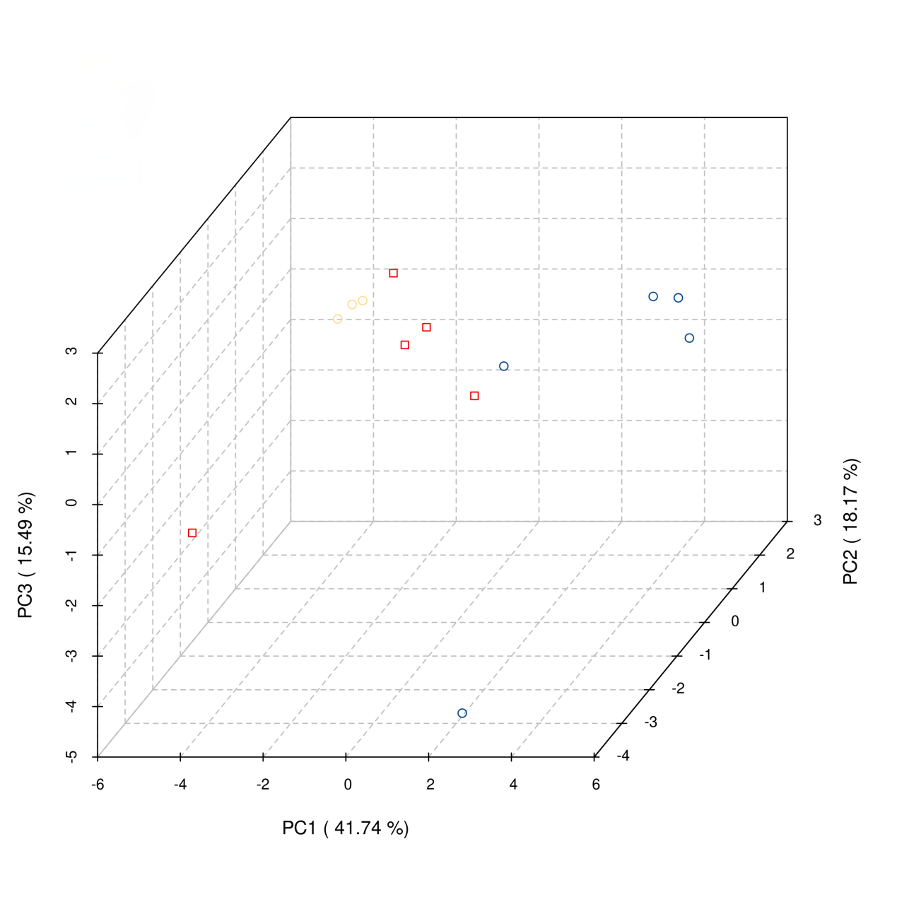
Fig. S5 PCA of differential hormones in cucumber
Blue: Solvent control (0.1% v/v anhydrous ethanol); Red: DHPQCA treatment group; Yellow: Sample mixture for quality control.

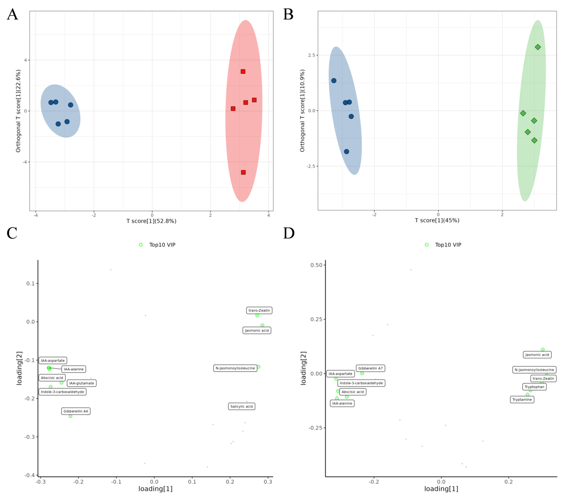
Fig. S6 OPLS-DA Analysis of Treatment Groups in Tomato. Score plot for the DHPQCA vs Solvent control comparison (A) and MeDHPQCA vs Solvent control comparison (B); loading plot for the DHPQCA vs Solvent control comparison (C) and MeDHPQCA vs Solvent control comparison (D).
Blue: Solvent control (0.1% v/v anhydrous ethanol); Red: DHPQCA treatment group; Green: MeDHPQCA treatment group; Yellow: Sample mixture for quality control.

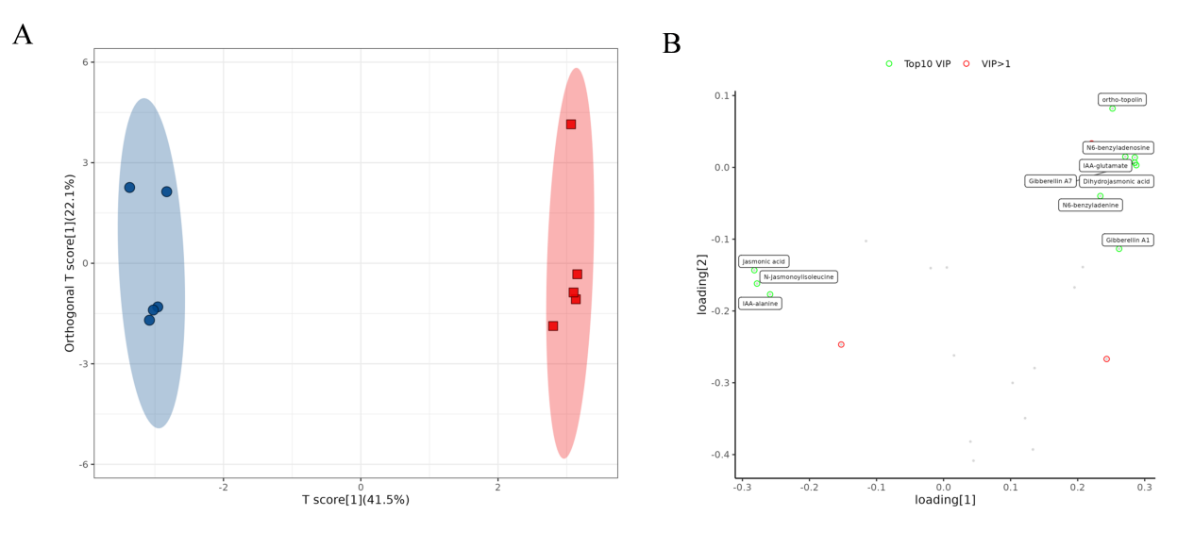
Fig. S7 OPLS-DA score plot of the comparison groups in the cucumber (A) and OPLS-DA loading plot of the comparison groups in the cucumber (B).
Blue: Solvent control (0.1% v/v anhydrous ethanol); Red: DHPQCA treatment group; Yellow: Sample mixture for quality control.

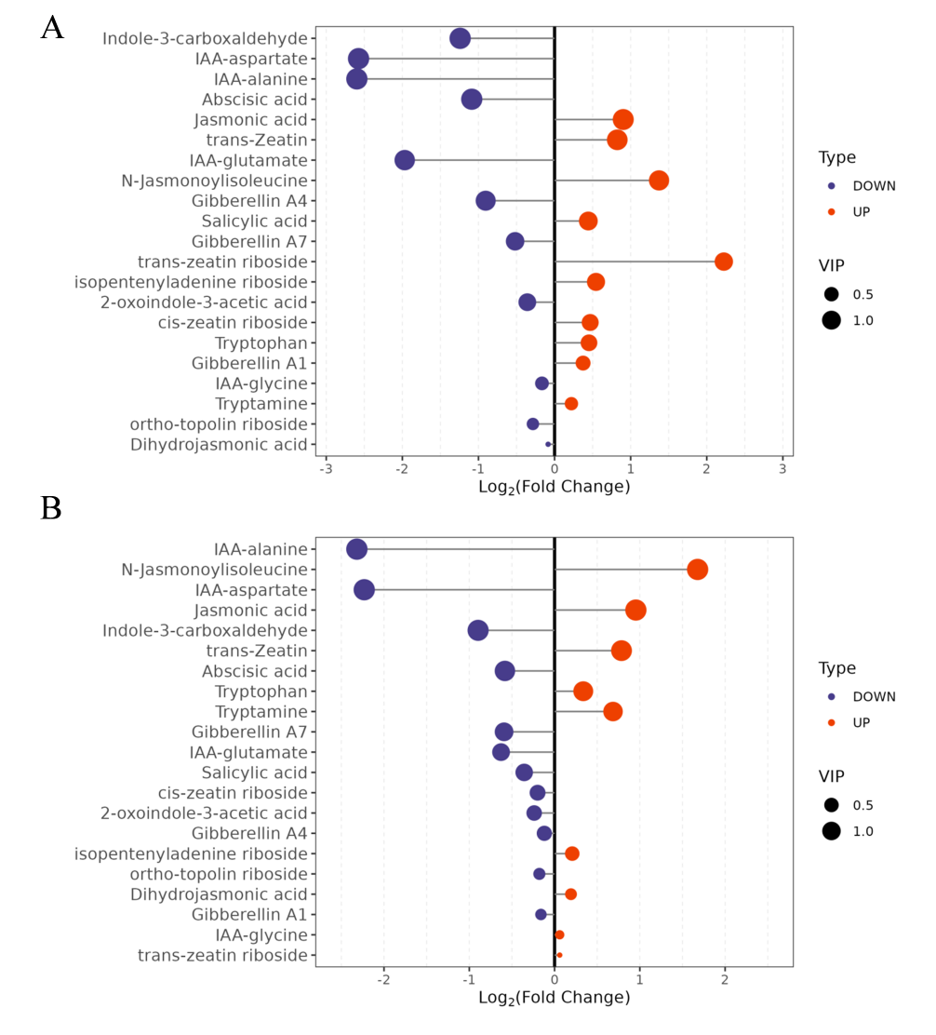
Fig. S8 Changes in relative composition of tomato endogenous hormones for the DHPQCA vs Solvent control comparison (A) and MeDHPQCA vs Solvent control comparison (B). The horizontal axis represents log₂ (Fold Change); the vertical axis lists hormone names. Data points in blue (left side) and red (right side) indicate decreased and increased hormone levels, respectively.

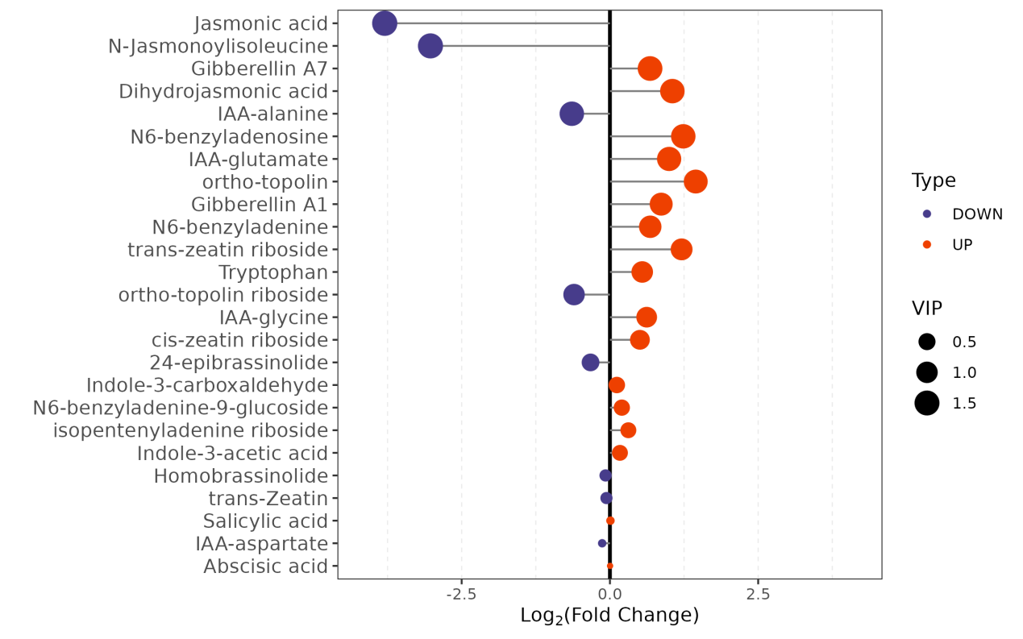
Fig. S9 Changes in relative composition of cucumber endogenous hormones under DHPQCA. The horizontal axis represents log₂ (Fold Change); the vertical axis lists hormone names. Data points in blue (left side) and red (right side) indicate decreased and increased hormone levels, respectively.

Table S1. CAS of 47 plant hormones.
Name | Abbreviation | CAS
trans-Zeatin | tZ | 1637-39-4
trans-Zeatin riboside | tZR | 6025-53-2
Dihydrozeatin | DHZ | 23599-75-9
Dihydrozeatin riboside | DHZR | 22663-55-4
cis-zeatin riboside | cZR | 15896-46-5
N⁶-isopentenyladenine | IP | 2365-40-4
isopentenyladenine riboside | IPR | 7724-76-7
para-topolin | pT | 80054-30-4
para-topolin riboside | pTR | 23666-24-2
meta-topolin | mT | 75737-38-1
meta topolin riboside | mTR | 110505-76-5
ortho-topolin | oT | 20366-83-0
ortho-topolin riboside | oTR | 50868-58-1
N⁶-benzyladenine | BAP | 1214-39-7
N⁶-benzyladenosine | BAPR | 4294-16-0
N⁶-benzyladenine-9-glucoside | BAP9G | 4294-17-1
Kinetin | K | 525-79-1
Kinetin riboside | KR | 4338-47-0
Tryptamine | TRA | 61-54-1
Tryptophan | TRP | 73-22-3
Indol-3-acetamide | IAM | 879-37-8
2-oxoindole-3-acetic acid | OxIAA | 2971-31-5
Indole-3-acetic acid | IAA | 87-51-4
Methyl indole-3-acetate | MeIAA | 1912-33-0
Indole-3-acetonitrile | IAN | 771-51-7
3-Indolebutyric acid | IBA | 133-32-4
Indole-3-carboxaldehyde | ICA | 487-89-8
Melatonin | MT | 73-31-4
IAA-glycine | IAA-Gly | 13113-08-1
IAA-glutamate | IAA-Glu | 57105-48-3
IAA-alanine | IAA-Ala | 57105-39-2
IAA-leucine | IAA-Leu | 36838-63-8
IAA-aspartate | IAA-Asp | 2456-73-7
Jasmonic acid | JA | 6894-38-8
N-Jasmonoylisoleucine | JA-ILE | 120330-93-0
Dihydrojasmonic acid | 9,10-dh-JA | 98674-52-3
Salicylic acid | SA | 69-72-7
Methyl salicylate | MESA | 119-36-8
Abscisic acid | ABA | 14375-45-2
Gibberellin A₃ | GA₃ | 1977/6/5
Gibberellin A₁ | GA₁ | 545-97-1
Gibberellin A₇ | GA₇ | 510-75-8
Gibberellin A₅ | GA₅ | 561-56-8
Gibberellin A₄ | GA₄ | 468-44-0
Brassinolide | BL(BR) | 72962-43-7
24-epibrassinolide | epiBL | 78821-43-9
Homobrassinolide | homoBL | 74174-44-0

Table S2. Metabolite Ion Peak Table
Name | Ionization mode | Ion pair | Retention time (min)
OxIAA | Positive | 192.2/146.1 | 8.95
IBA | Positive | 204/186 | 11.15
ABA | Negative | 263.2/153.1 | 10.95
cZR | Positive | 352.2/220.105 | 8.18
GA₁ | Negative | 347.102/259.101 | 9.62
GA₇ | Negative | 329/211 | 11.84
IAA-Ala | Positive | 247.2/130.106 | 9.88
IAA-Asp | Positive | 291.2/130.1 | 9.51
IAA-Glu | Positive | 305.2/130.105 | 8.94
ICA | Positive | 146/118 | 10.01
IPR | Positive | 336.3/204.101 | 9.65
JA | Negative | 209.2/58.8 | 11.27
KR | Positive | 348.2/216.101 | 9.16
MT | Positive | 233/174 | 10.2
mTR | Positive | 374.2/242.103 | 8.95
MeIAA | Positive | 190.086/130.065 | 12.07
MESA | Positive | 153/121 | 12.87
IP | Positive | 204.201/136.003 | 9.05
JA-ILE | Positive | 324.3/151.2 | 12.16
SA | Negative | 137/92.8 | 10.55
tZ | Positive | 220.2/136.2 | 5.84
tZR | Positive | 352.3/220.101 | 8.02
TRA | Positive | 161.1/144.1 | 7.67
TRP | Positive | 205.097/188.07 | 6.3

Plant | Sample name | Raw Reads | Clean Reads | Clean Bases | Error  Rate (%) | Q20  (%) | Q30  (%) | GC  Content (%)
Tomato | T_CK_1 | 77126244 | 75617298 | 11.1G | 0.01% | 98.94 | 96.65 | 42.59
Tomato | T_CK_2 | 67286554 | 66423002 | 9.57G | 0.01% | 98.97 | 96.78 | 40.51
Tomato | T_CK_3 | 78598048 | 77566352 | 11.11G | 0.01% | 99.01 | 96.93 | 40.69
Tomato | T_EA_1 | 61243628 | 60595806 | 8.87G | 0.01% | 99 | 96.83 | 41.57
Tomato | T_EA_2 | 53610786 | 52936308 | 7.69G | 0.01% | 99 | 96.86 | 42.3
Tomato | T_EA_3 | 62002772 | 61285514 | 8.95G | 0.01% | 98.93 | 96.64 | 40.16
Tomato | T_CK_N_1 | 66759740 | 65838070 | 9.8G | 0.01% | 99.22 | 97.52 | 42.51
Tomato | T_CK_N_2 | 59243248 | 58782212 | 8.72G | 0.01% | 99.22 | 97.42 | 42.45
Tomato | T_CK_N_3 | 43537192 | 43199442 | 6.43G | 0.01% | 99.11 | 97.07 | 42.4
Tomato | T_NKZ_259_1 | 57942030 | 57272758 | 8.37G | 0.01% | 98.92 | 96.63 | 40.42
Tomato | T_NKZ_259_2 | 66063796 | 65387320 | 9.51G | 0.01% | 98.98 | 96.82 | 40.9
Tomato | T_NKZ_259_3 | 67753172 | 66890192 | 9.74G | 0.01% | 98.96 | 96.77 | 40.9
Tomato | T_D1_1 | 60267546 | 59715630 | 8.73G | 0.01% | 99.04 | 96.96 | 41.59
Tomato | T_D1_2 | 71734304 | 70984516 | 10.35G | 0.01% | 98.98 | 96.77 | 41.29
Tomato | T_D1_3 | 63776718 | 63036418 | 9.18G | 0.01% | 98.93 | 96.62 | 41.52
Tomato | T_D2_1 | 56249872 | 55660728 | 8.11G | 0.01% | 99.01 | 96.88 | 41.28
Tomato | T_D2_2 | 57390556 | 56809632 | 8.31G | 0.01% | 98.97 | 96.8 | 41.58
Tomato | T_D2_3 | 68219240 | 67422362 | 9.81G | 0.01% | 99.02 | 96.93 | 41.37
Cucumber | C_CK_1 | 43876890 | 43441906 | 6.33G | 0.01 | 98.87 | 96.52 | 41.40
Cucumber | C_CK_2 | 41297128 | 40941416 | 5.99G | 0.01 | 98.97 | 96.73 | 42.24
Cucumber | C_CK_3 | 44883432 | 4420436 | 6.49G | 0.01 | 98.83 | 96.37 | 42.12
Cucumber | C_EA_1 | 46791100 | 46422784 | 6.78G | 0.01 | 98.99 | 96.82 | 42.25
Cucumber | C_EA_2 | 41572188 | 41226392 | 6.04G | 0.01 | 98.93 | 96.60 | 42.88
Cucumber | C_EA_3 | 44405086 | 43955156 | 6.42G | 0.01 | 98.84 | 96.38 | 41.80
Cucumber | C_CK_N_1 | 42787580 | 42382804 | 6.2G | 0.01 | 98.91 | 96.55 | 42.40
Cucumber | C_CK_N_2 | 46953926 | 46580336 | 6.83G | 0.01 | 98.92 | 96.62 | 42.60
Cucumber | C_CK_N_3 | 40876092 | 40537080 | 5.92G | 0.01 | 98.94 | 96.66 | 43.31
Cucumber | C_NKZ_259_1 | 45140468 | 44672476 | 6.5G | 0.01 | 98.82 | 96.33 | 41.78
Cucumber | C_NKZ_259_2 | 39329542 | 38941780 | 5.69G | 0.01 | 98.90 | 96.55 | 41.75
Cucumber | C_NKZ_259_3 | 46145418 | 45493086 | 6.53G | 0.01 | 98.92 | 96.73 | 40.68
Cucumber | C_D1_1 | 45138418 | 44789596 | 6.54G | 0.01 | 98.96 | 96.73 | 42.57
Cucumber | C_D1_2 | 40020184 | 39673732 | 5.78G | 0.01 | 99.00 | 96.80 | 43.33
Cucumber | C_D1_3 | 43668666 | 43212482 | 6.29G | 0.01 | 98.86 | 96.46 | 41.84
Table S3. Illumina sequencing and transcriptome assembly
Table S4. Reads alignment results with reference
Plant | Sample name | Total reads | Total mapped | Multiple mapped | Uniquely mapped | Reads  map to '+' | Reads map to '-' | Non-splice reads | Splice reads
Tomato | T_CK_1 | 75617298 | 70652522 | 1207081 | 69445441 | 34707679 | 34737762 | 46611327 | 22834114
Tomato | T_CK_2 | 66423002 | 55898802 | 839461 | 55059341 | 27533405 | 27525936 | 40454767 | 14604574
Tomato | T_CK_3 | 77566352 | 73297228 | 1334667 | 71962561 | 35978427 | 35984134 | 52700729 | 19261832
Tomato | T_EA_1 | 60595806 | 49217921 | 898319 | 48319602 | 24155995 | 24163607 | 32260646 | 16058956
Tomato | T_EA_2 | 52936308 | 49753460 | 850062 | 48903398 | 24448445 | 24454953 | 32892440 | 16010958
Tomato | T_EA_3 | 61285514 | 30749703 | 448111 | 30301592 | 15148238 | 15153354 | 20228106 | 10073486
Tomato | T_CK_N_1 | 65838070 | 46673384 | 769768 | 45903616 | 22944745 | 22958871 | 28710346 | 17193270
Tomato | T_CK_N_2 | 58782212 | 54084374 | 870220 | 53214154 | 26601126 | 26613028 | 34304382 | 18909772
Tomato | T_CK_N_3 | 43199442 | 38881843 | 609483 | 38272360 | 19131826 | 19140534 | 24553042 | 13719318
Tomato | T_NKZ_259_1 | 57272758 | 39348081 | 698448 | 38649633 | 19322589 | 19327044 | 26123263 | 12526370
Tomato | T_NKZ_259_2 | 65387320 | 49926739 | 817152 | 49109587 | 24555795 | 24553792 | 33101715 | 16007872
Tomato | T_NKZ_259_3 | 66890192 | 52700980 | 1019691 | 51681289 | 25838835 | 25842454 | 34480147 | 17201142
Tomato | T_D1_1 | 59715630 | 52903207 | 818558 | 52084649 | 26039811 | 26044838 | 34405604 | 17679045
Tomato | T_D1_2 | 70984516 | 63159627 | 1056218 | 62103409 | 31053456 | 31049953 | 42400409 | 19703000
Tomato | T_D1_3 | 63036418 | 52622134 | 887754 | 51734380 | 25866102 | 25868278 | 34047171 | 17687209
Tomato | T_D2_1 | 55660728 | 51579452 | 796456 | 50782996 | 25393769 | 25389227 | 35243278 | 15539718
Tomato | T_D2_2 | 56809632 | 52903459 | 1027148 | 51876311 | 25941529 | 25934782 | 35588234 | 16288077
Tomato | T_D2_3 | 67422362 | 61555921 | 1052574 | 60503347 | 30253558 | 30249789 | 41267557 | 19235790
Cucumber | C_CK_1 | 43441906 | 42267213 | 706883 | 41560330 | 20779049 | 20781281 | 29737431 | 11822899
Cucumber | C_CK_2 | 40941416 | 39882265 | 703742 | 39178523 | 19590918 | 19587605 | 26469793 | 12708730
Cucumber | C_CK_3 | 44420436 | 42922291 | 772029 | 42150262 | 21075424 | 21074838 | 29274188 | 12876074
Cucumber | C_EA_1 | 46422784 | 45342284 | 876001 | 44466283 | 22235963 | 22230320 | 30289601 | 141766
Cucumber | C_EA_2 | 41226392 | 40098864 | 726281 | 39372583 | 19683289 | 19689294 | 26504284 | 12868299
Cucumber | C_EA_3 | 43955156 | 42679689 | 798642 | 41881047 | 20937847 | 20943200 | 29238277 | 12642770
Cucumber | C_CK_N_1 | 42382804 | 41352201 | 849801 | 40502400 | 20251108 | 20251292 | 26786881 | 13715519
Cucumber | C_CK_N_2 | 46580336 | 45428961 | 866968 | 44561993 | 22271829 | 22290164 | 29889333 | 14672660
Cucumber | C_CK_N_3 | 40537080 | 39463300 | 1191432 | 38271868 | 19130797 | 19141071 | 23424653 | 14847215
Cucumber | C_NKZ_259_1 | 44672476 | 43483819 | 844152 | 42639667 | 21316488 | 21323179 | 29377546 | 13262121
Cucumber | C_NKZ_259_2 | 38941780 | 37905957 | 768186 | 37137771 | 18565296 | 18572475 | 25797041 | 11340730
Cucumber | C_NKZ_259_3 | 45493086 | 43945262 | 679396 | 43265866 | 21631556 | 21634310 | 32546839 | 10719027
Cucumber | C_D1_1 | 44789596 | 43319244 | 891860 | 42427384 | 21202500 | 21224884 | 28538784 | 13888600
Cucumber | C_D1_2 | 39673732 | 38768667 | 842704 | 37925963 | 18955813 | 18970150 | 24793742 | 13132221
Cucumber | C_D1_3 | 43212482 | 40055247 | 785132 | 39270115 | 19631324 | 19638791 | 27497049 | 11773066

Table S5 List of qRT-CPR primers for DEG
Plant | Gene number | Forward primer (5’ - 3’) | Reverse primer (5’ - 3’)
Tomato | Solyc06g060340.3 | CAGTGAAGGAGGTCCATTGT | ATCTCATTGATTGGGACACC
Tomato | Solyc11g005340.2 | GTGGAGAGTTAAGGATTGAAGC | AACCTTGTGGGTTGAAGATG
Tomato | Solyc01g087590.3 | TTGGTGACAACAGAAGATGG | AACCATCACGTCCAAGTTTC
Tomato | Solyc06g035700.1 | GATCGTGCATACTCCTACCC | TTCCTCTTCGTCCACAAACT
Tomato | Solyc03g031860.3 | TGCCTCAAGATGAATTAGCA | CTGAGCTCAATTCTGTCACG
Tomato | Solyc11g042560.1 | TGGTTGGGGAGTTATCAGAA | GAGCTGCCATTTGTACGTCT
Tomato | Solyc12g009200.2 | CAACTAGCCCTAATGGGATG | GTGATCCTCTTCCCCACATA
Tomato | Solyc06g073260.3 | AATGAGAGGAAGCCAGAACA | GGGTTGAATAGCAACCAAAC
Tomato | Solyc03g093180.1 | CATTTGGTGAGTCTGTTGGA | CAGCAATATTAGCAGCCACA
Tomato | Solyc03g080150.3 | GGACTCACCAGCAAATAACC | TCATAGCCAAGTCCTCCAGT
Tomato | Solyc02g081330.3 | GCCCTAATGCATCACACATA | ACAAGTCCATACGCATTCCT
Tomato | Solyc04g007630.2 | CAAACGTAAACCAATGCAGA | CATCCACTGATTTCACACCTT
Tomato | Solyc12g094720.2 | GATTTGATAGAAGCTGGCAAAG | CAGTCTGTTGTAAATCCCATTG
Tomato | Solyc03g005020.3 | CACCCTTGACGCTAGAGATT | TGAGAATGATGCCAAAGCTA
Tomato | Solyc10g086180.2 | AAGCATCATCCTGGACAAAT | CCACTGTGGTGACGTTCTAA
Tomato | Solyc01g096670.3 | TGGCTATTCCCATTCCTTTA | AAAAGCATCGGAATCTAACG
Tomato | Solyc08g065940.3 | TTGAATCTCCTCCGATGACT | GTCGGAGTTGTTGGCATACT
Tomato | Solyc02g085800.1 | ATCGTCTTCCTGCTGCTTAC | TGGCTACGTGATAAGCAATG
Tomato | Solyc01g005300.3 | GGGTCCTGAACGAATTGTAT | ATGGCAAGGTGTATTCCAGT
Tomato | Solyc09g065800.3 | GTACGCAGCAATGAATACCA | GACGGTTTTGGAGAAATCAG
Tomato | Solyc01g099650.3 | TTGCTCTCGAATCATCAGAA | CAATTTCTCCAACACCTGAAC
Tomato | Solyc10g078770.2 | AGCCAATGTTCAAGAGAAGG | CAGTGGCACCATAACCAGTA
Tomato | Solyc08g005610.3 | AAGATTGATCATGGCGATTT | GCTTGTAGGACACTGGGATT
Tomato | Solyc12g011450.2 | AGCTGTGCTAGGTTTCCAAG | CTTGAGTTCAGCAAATGTGG
Tomato | Solyc03g045070.1 | GGATTCTTCATGGGAAGCTA | CCAACAACAGCATCAACTACA
Tomato | Solyc02g077300.2 | TTATTGATTGGGCATCTCCT | GGGAGAAGAAGACATGGTTG
Tomato | Solyc09g083190.3 | AGCCTTATCCACGTATAGCC | ACTGAATTGGGAACTGGAAT
Tomato | Solyc02g080530.3 | CTGGACTCAACAAGGAGGAT | GCCCTCCTAGAGCAACAATA
Tomato | Solyc08g079750.3 | CCTTTGTATTCTCCGTCCAC | TGAAATGGTTGTTGTTCTGG
Tomato | Solyc07g066310.3 | CAAAGTTGTGGCTAGTGGTG | TGGGACTGTATCCATCAACA

Plant | Gene number | Forward primer (5’ - 3’) | Reverse primer (5’ - 3’)
Tomato | Solyc08g005680.3 | CTCTGACAGTGTCTGCTCGT | GCCCATCTCCTATTACCATC
Tomato | Solyc04g078900.3 | GCTTCTTGAGTGTGTCAAGG | CACATCAGCTACAGCCTCTC
Tomato | Solyc12g098350.1 | TGTTCTCCAACACCAACATC | TGCTGGTAGTACGTCTGGAA
Tomato | Solyc07g015860.3 | ATGAACCGTCTCAGGACATT | TCATTTGTGTCTTCCAGCAC
Tomato | Solyc07g007870.3 | TAGCATATGGGCAAACTGAA | GACGACCATATGACACGAGA
Tomato | Solyc12g015880.2 | GGACCAGCTTGAATACCTTG | CTCCTCTACCTTTCCTTCC
Tomato | Solyc07g061720.3 | TAAAGCCAACTCCAAGAACC | CCATAACCAAAAGGATCAGC
Tomato | Solyc04g016430.3 | ATATCCGCCTCCATGTTTAC | AAGAGTGAGGGCATTGAGTC
Tomato | ENSRNA050029626 | TTTGAGGGGGATGTTGTCT | GAGAGGAATGAAGCCTGGTC
Tomato | GAPDH | CAGGAACCCTGAAGATATCCC | GCAGTTGGTACTCTGAAGGCC
Cucumber | CsaV4_1G002969 | TGCGAGTACATGCCCAAAGT | ACAGAAGGACAAGCAGCCTC
Cucumber | CsaV4_1G003004 | GGTCCAAACTGGAGCAACTC | ACGGAGAGGCCGTATTTTCT
Cucumber | CsaV4_6G000607 | AGTCCGGAACAAACACTTGG | GGTGAAGGTGTCGCCTATGT
Cucumber | CsaV4_6G003200 | GTTTACCCATGGCTTGCACT | ATCGGCAAGGTCAACAAGTC
Cucumber | CsaV4_4G002440 | TTCATGACGCATTGCGGTTG | CAGCGATTGTCGCACAACAT
Cucumber | CsaV4_1G001285 | ACATTCTCATCGGCCTCACC | CAGCTGGTCGGACACGTAAT
Cucumber | CsaV4_5G001931 | CATCCAAAACGCCTCTTGTT | TGACTTCAGGAGGAGGAGGA
Cucumber | CsaV4_4G001894 | TGGTGCCAGACTCATTCGAC | GGACAAGCCTTTTCGACTGC
Cucumber | CsaV4_3G004569 | TCGTTGGTGTTGCAGCTAGT | GTGGTCAGTGTAGCGTAGCA
Cucumber | CsaV4_6G001683 | TGAGCACCTCTTTCGCTCAA | CCAATACGGGCTTCCTTGGT
Cucumber | CsaV4_4G001896 | TCAACACCTGGAGCTGACAC | ACATCGTGGCCTTCTGATCC
Cucumber | CsaV4_2G003103 | AGCTGAAGGCGAAACGAGAA | GAAGGCCAAAGTTGTGAGGC
Cucumber | CsaV4_4G001893 | TCTCCACTCCAGGAGCTTCA | CCGGTGGTTCCAGTCTTAGG
Cucumber | CsaV4_2G001340 | CAAGCTGCCCTAAGAGGAGA | GTAGGCGCCATTGTTGGACT
Cucumber | CsaV4_1G001327 | GCACTTTCGATACTCCTGAAGAA | AGGAGGAGGAGGATGAACAAG
Cucumber | CsaV4_3G001270 | TTCACCTCCTCATCCTCCTAAC | AGGTCTTCCAAAACCCTACCAT
Cucumber | CsaV4_5G002021 | GGTGCAGGAGTTAGGGCATT | CGCACTCTTTCCACTCCACT
Cucumber | CsaV4_5G003409 | TTCGACCCATTGGGGTTAGC | CCAAATTCTCCACTGGCCCT
Cucumber | CsaV4_5G001728 | TACGGCACCAGCATAAGAAG | TTGGTGACGATGATTCGTTT
Cucumber | CsaV4_2G003571 | GAAGATGAATGCAGAAGTGGTTC | AGTCCAAAACCTTGAGCTTTACC
Cucumber | CsaV4_3G002717 | AAGCACCATCAACCTTGCCT | CTCTGCGGACCAACTACCAA
Cucumber | Actin | GCCTGCTATGTATGTTGCCATC | CAAGAGCAACATATGCCAGCT

Table S6. Linear Regression Equation for Plant Hormones
Name | Regression equation | Correlation coefficient
OxIAA | y=162722404.3702x+51237.1099 | R²=0.9957
IBA | y=378322257.5029x+276397.0756 | R²=0.9939
ABA | y=16337926.8533x+6878.1274 | R²=0.9986
cZR | y=870016047.7832x+130770.2913 | R²=0.9938
GA₁ | y=1384814.8040x +117133.6229 | R²=0.9904
GA₇ | y =234203494.5733x +24415.1092 | R²=0.9964
IAA-Ala | y=272659137.0070x +11841.4228 | R²=0.9919
IAA-Asp | y=89309486.5253x+37514.6179 | R²=0.9955
IAA-Glu | y=354609440.7099x+8293.1286 | R²=0.9972
ICA | y=386166963.8513x+314305.6435 | R²=0.9901
IPR | y=1127949038.1816x+81982.0253 | R²=0.9960
JA | y=45396003.3516x+12447.3998 | R²=0.9981
KR | y=4133361952.2084x+50605.6318 | R²=0.9906
MT | y=3422303145.5804x+682729.3091 | R²=0.9900
mTR | y=595104059.1408x+612774.5554 | R²=0.9910
MeIAA | y=2056974424.1866x+129311.7909 | R²=0.9979
MESA | y=372748431.9575x+215040.9684 | R²=0.9993
IP | y=784775861.0272x+56692.2378 | R²=0.9937
JA-ILE | y=23832870.3718x+2327.3608 | R²=0.9980
SA | y=82275644.9434x+64616.6436 | R²=0.9992
tZ | y=276868752.3415x+240324.7547 | R²=0.9908
tZR | y=319181886.8764x+62207.1232 | R²=0.9924
TRA | y=151867623.0410x+177515.1836 | R²=0.9951
TRP | y=112672539.2105x+745644.0034 | R²=0.9994
Note: Y represents the peak area (μV·S); X represents the concentration (mg/L).

Table S7. Transcribed data validated by qRT-PCR of tomato after irrigation treatment with DHPQCA
Gene_id | Relative expression (R/S)
Gene_id | RNA-seq | qRT-PCR
Solyc02g066920.3 | 5.23 | 3.78
Solyc07g007280.3 | 5.12 | 2.17
Solyc06g060340.3 | 4.79 | 5.87
Solyc11g005340.2 | 4.73 | 3.25
Solyc01g087590.3 | 4.41 | 3.81
Solyc06g035700.1 | 4.31 | 3.19
Solyc03g031860.3 | 4.16 | 5.34
Solyc11g042560.1 | 4.16 | 3.69
Solyc12g009200.2 | 4.06 | 4.86
Solyc06g073260.3 | 3.73 | 3.75
Solyc03g093180.1 | 3.62 | 4.69
Solyc03g080150.3 | 3.55 | 3.12
Solyc02g081330.3 | 3.17 | 2.74
Solyc04g007630.2 | 3.04 | 3.79
Solyc12g094720.2 | 3.02 | 3.99
Solyc03g005020.3 | -3.01 | -4.11
Solyc10g086180.2 | -3.11 | -3.36
Solyc01g096670.3 | -3.78 | -2.72
Solyc08g065940.3 | -3.82 | -3.19
Solyc02g085800.1 | -4.60 | -3.27
ENSRNA050029626 | -5.22 | -2.34
Solyc09g065800.3 | -5.50 | -2.81
Solyc01g099650.3 | -6.80 | -3.54

Table S8. Transcribed data validated by qRT-PCR of tomato after irrigation treatment with MeDHPQCA
Gene_id | Relative expression (R/S)
Gene_id | RNA-seq | qRT-PCR
Solyc06g060340.3 | 4.42 | 2.99
Solyc11g005340.2 | 5.37 | 2.64
Solyc06g035700.1 | 3.77 | 1.90
Solyc11g042560.1 | 4.07 | 2.96
Solyc03g093180.1 | 3.85 | 3.19
Solyc10g078770.2 | 5.34 | 3.58
Solyc12g011450.2 | 5.03 | 1.78
Solyc08g005610.3 | 4.91 | 1.67
Solyc03g045070.1 | 3.97 | 3.10
Solyc02g077300.2 | 3.81 | 1.64
Solyc09g083190.3 | 3.45 | 3.73
Solyc02g080530.3 | 3.35 | 1.72
Solyc08g079750.3 | 3.21 | 1.90
Solyc07g066310.3 | 2.61 | 1.20
Solyc08g005680.3 | 2.05 | 2.02
Solyc04g078900.3 | 1.56 | 2.05
Solyc12g098350.1 | 1.48 | 1.33
Solyc07g015860.3 | 1.46 | 1.31
Solyc07g007870.3 | -2.29 | -1.38
Solyc12g015880.2 | -3.14 | -2.41
Solyc07g061720.3 | -3.17 | -3.71
Solyc04g016430.3 | -4.58 | -1.72
Solyc01g005300.3 | -5.63 | -7.07

Table S9. Transcribed data validated by qRT-PCR of cucumber after irrigation treatment with DHPQCA
Gene_id | Relative expression (R/S)
Gene_id | RNA-seq | qRT-PCR
CsaV4_1G002969 | 9.16 | 3.30
CsaV4_1G003004 | 5.04 | 2.27
CsaV4_6G000607 | 3.31 | 1.09
CsaV4_6G003200 | 5.95 | 4.44
CsaV4_4G002440 | 5.70 | 9.83
CsaV4_1G001285 | 10.90 | 5.18
CsaV4_5G001931 | 9.23 | 2.79
CsaV4_4G001894 | 7.25 | 2.05
CsaV4_3G004569 | 7.05 | 1.53
CsaV4_6G001683 | 6.76 | 2.53
CsaV4_2G003103 | 6.59 | 4.61
CsaV4_4G001896 | 6.35 | 2.18
CsaV4_4G001893 | 5.51 | 0.95
CsaV4_2G001340 | 5.38 | 4.64
CsaV4_1G001327 | 5.33 | 6.54
CsaV4_3G001270 | 5.32 | 1.73
CsaV4_5G002021 | -5.41 | -1.61
CsaV4_5G003409 | -5.43 | -2.23
CsaV4_5G001728 | -6.02 | -2.71
CsaV4_2G003571 | -6.21 | -0.16
CsaV4_3G002717 | -7.77 | -2.52

