Supplementary Information
Extended data for figures and tables
Extended Data Fig. 5 | Projected changes in annual maximum wet-bulb temperature under future scenarios for four CMIP6 models, 2040–2100.
Projected changes in annual maximum wet-bulb temperature under future scenarios for four CMIP6 models (GFDL-ESM4, MPI-ESM1-2-LR, MRI-ESM2-0 and UKESM1-0-LL) for 2040–2100. Each panel shows the spatial distribution of annual maximum wet-bulb temperature (WBT_{max}) derived from the indicated CMIP6 model under three Shared Socioeconomic Pathways (SSP1-2.6, SSP2-4.5 and SSP5-8.5) for the time slices 2040, 2060, 2080 and 2100. WBT_{max}) is calculated from daily maximum temperature and daily mean relative humidity using Stull’s approximation. Colour scales are standardized across all panels (range: −32°C to 32°C for SSP1-2.6 and SSP2-4.5; −32°C to 35°C for SSP5-8.5) to facilitate inter-model and inter-scenario comparison. The four models exhibit qualitatively similar spatial patterns to CMCC-ESM2 (Fig. 5), with the most pronounced increases in extreme humid heat concentrated in tropical and subtropical regions under SSP5-8.5. However, UKESM1-0-LL consistently shows the highest upper extremes (up to 81.7°C by 2100), reflecting its higher equilibrium climate sensitivity.
Extended Data Table 5 | Summary statistics of annual maximum wet-bulb temperature for five CMIP6 models under three SSP scenarios (2040–2100).
For each model, scenario and time slice, the table reports the minimum, maximum, mean and standard deviation of annual maximum wet-bulb temperature (WBT_{max},°C) across all land grid cells at 0.25° resolution. WBT_{max}) is computed from daily maximum temperature and relative humidity using Stull’s approximation. The data illustrate inter-model differences in the magnitude and spatial distribution of extreme humid heat, with UKESM1-0-LL showing the highest maximum values (up to 81.7°C under SSP5-8.5 by 2100) and CMCC-ESM2 the lowest maxima (59.5°C under the same scenario). The standard deviation reflects the spatial heterogeneity of WBT_{max} within each model–scenario–year combination.

GFDL-ESM4
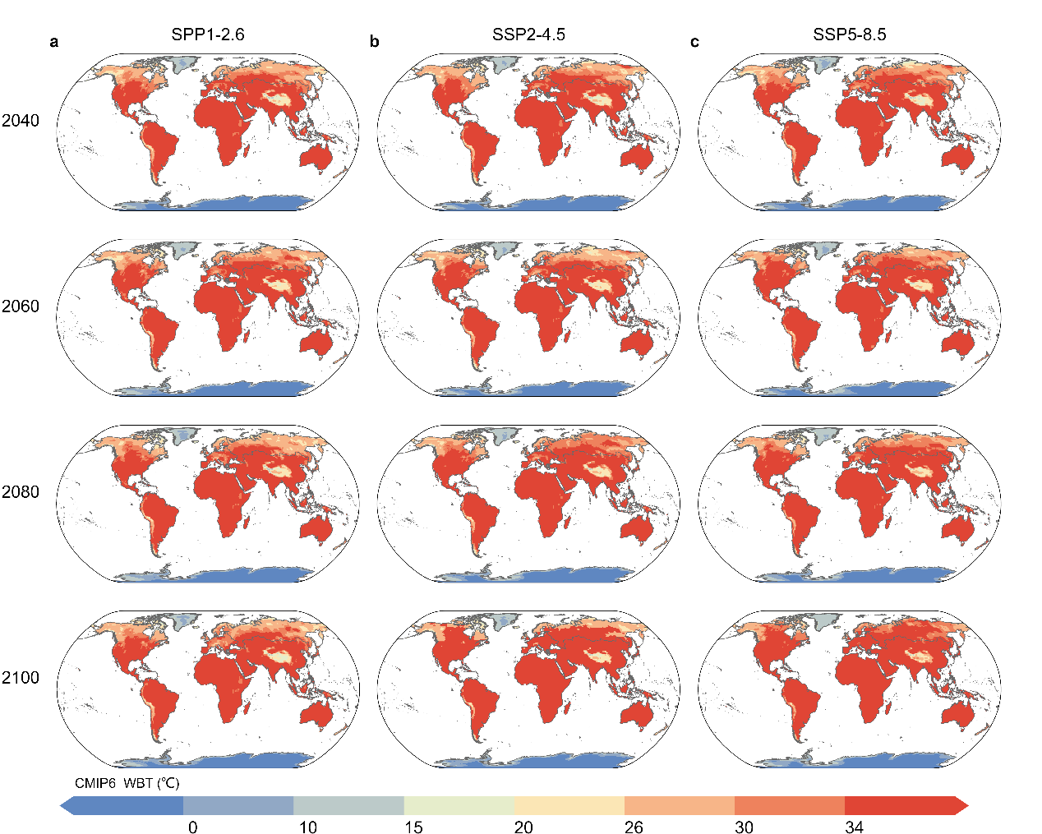
MPI‑ESM1‑2‑LR 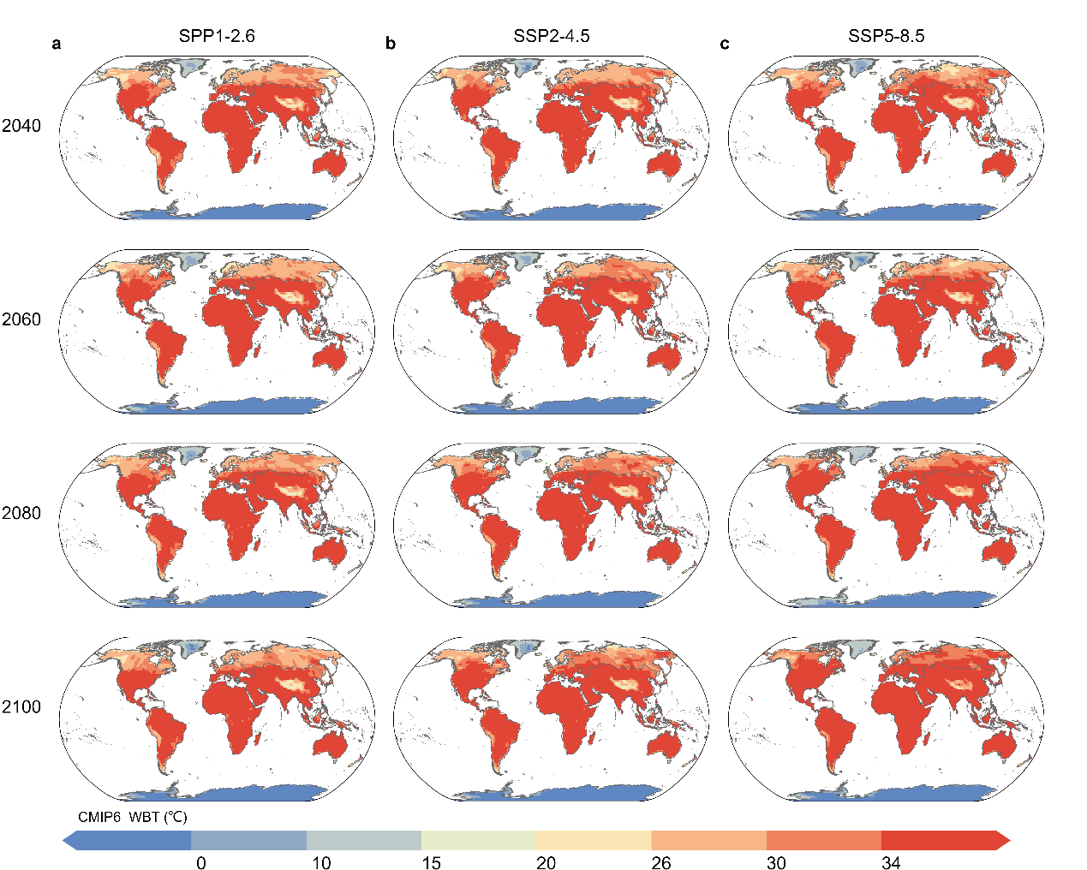

MRI-ESM2-0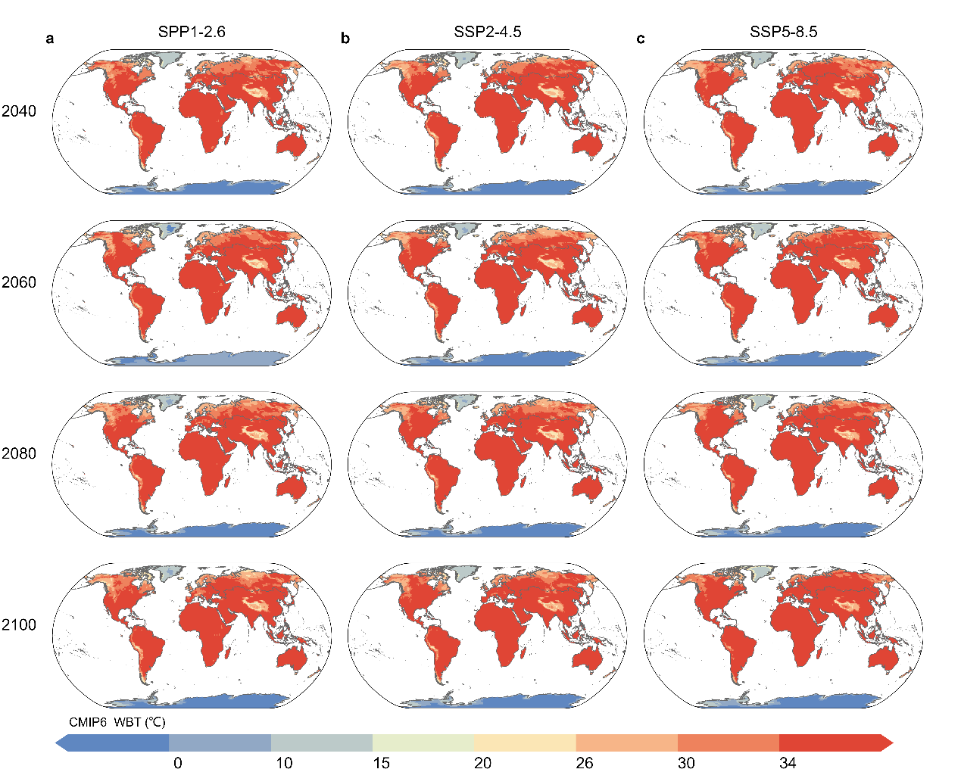

UKESM1‑0‑LL

Extended Data Table 5 | Summary statistics of annual maximum wet-bulb temperature for five CMIP6 models under three SSP scenarios (2040–2100).
For each model, scenario and time slice, the table reports the minimum, maximum, mean and standard deviation of annual maximum wet-bulb temperature (WBT_{max}​, °C) across all land grid cells at 0.25° resolution. WBT_{max}​ is computed from daily maximum temperature and relative humidity using Stull’s approximation. The data illustrate inter-model differences in the magnitude and spatial distribution of extreme humid heat, with UKESM1-0-LL showing the highest maximum values (up to 81.7°C under SSP5-8.5 by 2100) and CMCC-ESM2 the lowest maxima (59.5°C under the same scenario). The standard deviation reflects the spatial heterogeneity of WBT_{max}​ within each model–scenario–year combination.
Model | Scenario | Year | Min WBT  (°C) | Max WBT  (°C) | Mean WBT  (°C) | Std WBT (°C)
CMCC-ESM2 | ssp126 | 2040 | -13.75 | 52.53 | 17.14 | 16.07
CMCC-ESM2 | ssp126 | 2060 | -13.02 | 55.28 | 17.88 | 16.20
CMCC-ESM2 | ssp126 | 2080 | -13.52 | 55.33 | 18.27 | 16.22
CMCC-ESM2 | ssp126 | 2100 | -12.81 | 54.84 | 18.45 | 16.09
CMCC-ESM2 | ssp245 | 2040 | -14.74 | 55.02 | 17.20 | 16.12
CMCC-ESM2 | ssp245 | 2060 | -13.40 | 56.22 | 18.26 | 15.77
CMCC-ESM2 | ssp245 | 2080 | -14.18 | 54.59 | 18.52 | 16.84
CMCC-ESM2 | ssp245 | 2100 | -12.92 | 55.81 | 19.21 | 16.58
CMCC-ESM2 | ssp585 | 2040 | -10.39 | 55.10 | 17.90 | 15.30
CMCC-ESM2 | ssp585 | 2060 | -14.25 | 54.42 | 18.24 | 16.90
CMCC-ESM2 | ssp585 | 2080 | -9.46 | 54.48 | 20.11 | 16.09
CMCC-ESM2 | ssp585 | 2100 | -12.29 | 59.47 | 20.95 | 16.87
GFDL-ESM4 | ssp126 | 2040 | -31.72 | 52.05 | 18.31 | 23.45
GFDL-ESM4 | ssp126 | 2060 | -30.12 | 52.50 | 18.86 | 23.39
GFDL-ESM4 | ssp126 | 2080 | -29.06 | 52.65 | 18.99 | 23.01
GFDL-ESM4 | ssp126 | 2100 | -25.74 | 52.53 | 19.38 | 22.04
GFDL-ESM4 | ssp245 | 2040 | -31.33 | 52.52 | 18.71 | 23.29
GFDL-ESM4 | ssp245 | 2060 | -31.28 | 54.34 | 19.56 | 23.11
GFDL-ESM4 | ssp245 | 2080 | -28.70 | 55.34 | 20.35 | 22.77
GFDL-ESM4 | ssp245 | 2100 | -28.61 | 56.54 | 20.10 | 22.90
GFDL-ESM4 | ssp585 | 2040 | -30.62 | 53.92 | 18.88 | 23.27
GFDL-ESM4 | ssp585 | 2060 | -24.07 | 54.73 | 20.94 | 22.06
GFDL-ESM4 | ssp585 | 2080 | -27.31 | 54.92 | 21.13 | 23.01
GFDL-ESM4 | ssp585 | 2100 | -29.92 | 56.47 | 22.19 | 23.76
MPI-ESM1-2-LR | ssp126 | 2040 | -33.34 | 53.09 | 18.20 | 23.47
MPI-ESM1-2-LR | ssp126 | 2060 | -32.18 | 54.23 | 18.85 | 23.72
MPI-ESM1-2-LR | ssp126 | 2080 | -34.60 | 54.49 | 18.70 | 23.50
MPI-ESM1-2-LR | ssp126 | 2100 | -33.77 | 54.16 | 18.05 | 23.58
MPI-ESM1-2-LR | ssp245 | 2040 | -31.24 | 53.73 | 18.63 | 23.65
MPI-ESM1-2-LR | ssp245 | 2060 | -34.81 | 54.58 | 18.70 | 24.25
MPI-ESM1-2-LR | ssp245 | 2080 | -28.21 | 55.85 | 19.44 | 23.40
MPI-ESM1-2-LR | ssp245 | 2100 | -29.88 | 54.37 | 19.66 | 23.52
MPI-ESM1-2-LR | ssp585 | 2040 | -32.82 | 55.43 | 18.67 | 23.47
MPI-ESM1-2-LR | ssp585 | 2060 | -33.35 | 55.25 | 19.18 | 24.06
MPI-ESM1-2-LR | ssp585 | 2080 | -25.70 | 56.61 | 21.55 | 23.20
MPI-ESM1-2-LR | ssp585 | 2100 | -32.63 | 58.97 | 21.81 | 24.29
MRI-ESM2-0 | ssp126 | 2040 | -20.78 | 57.56 | 22.89 | 21.69
MRI-ESM2-0 | ssp126 | 2060 | -24.81 | 57.33 | 22.45 | 22.77
MRI-ESM2-0 | ssp126 | 2080 | -19.02 | 57.77 | 22.70 | 22.03
MRI-ESM2-0 | ssp126 | 2100 | -24.29 | 58.80 | 22.34 | 22.39
MRI-ESM2-0 | ssp245 | 2040 | -27.08 | 60.20 | 22.20 | 22.78
MRI-ESM2-0 | ssp245 | 2060 | -24.08 | 57.45 | 22.90 | 22.43
MRI-ESM2-0 | ssp245 | 2080 | -23.98 | 58.20 | 23.13 | 22.22
MRI-ESM2-0 | ssp245 | 2100 | -21.37 | 59.95 | 23.58 | 22.26
MRI-ESM2-0 | ssp585 | 2040 | -19.11 | 58.87 | 23.25 | 21.58
MRI-ESM2-0 | ssp585 | 2060 | -23.77 | 59.22 | 23.68 | 22.57
MRI-ESM2-0 | ssp585 | 2080 | -19.22 | 61.16 | 24.84 | 22.44
MRI-ESM2-0 | ssp585 | 2100 | -19.34 | 61.43 | 25.92 | 22.81
UKESM1-0-LL | ssp126 | 2040 | -16.19 | 72.20 | 22.30 | 21.58
UKESM1-0-LL | ssp126 | 2060 | -17.57 | 74.70 | 22.91 | 21.54
UKESM1-0-LL | ssp126 | 2080 | -19.40 | 70.07 | 22.67 | 22.46
UKESM1-0-LL | ssp126 | 2100 | -21.44 | 76.45 | 22.41 | 23.19
UKESM1-0-LL | ssp245 | 2040 | -19.49 | 77.69 | 22.23 | 22.33
UKESM1-0-LL | ssp245 | 2060 | -17.55 | 72.97 | 23.22 | 22.03
UKESM1-0-LL | ssp245 | 2080 | -18.03 | 76.35 | 24.13 | 22.57
UKESM1-0-LL | ssp245 | 2100 | -17.44 | 80.70 | 24.61 | 22.71
UKESM1-0-LL | ssp585 | 2040 | -17.50 | 76.80 | 22.73 | 22.61
UKESM1-0-LL | ssp585 | 2060 | -18.59 | 80.93 | 24.67 | 23.38
UKESM1-0-LL | ssp585 | 2080 | -13.96 | 81.69 | 26.93 | 22.46
UKESM1-0-LL | ssp585 | 2100 | -15.03 | 81.02 | 28.62 | 23.73
Extended Data Fig. 6 | Projected labour productivity loss and high-sensitivity zone exposure for four CMIP6 models, 2040–2100.
a–c, Spatial distribution of annual labour productivity loss (LP loss; percentage reduction in real labour productivity attributable to heat stress) under a, SSP1-2.6, b, SSP2-4.5 and c, SSP5-8.5 for the time slices 2040, 2060, 2080 and 2100. Regions are classified as low sensitivity (<1% loss), medium sensitivity (1–5% loss) or high sensitivity (>5% loss). Results are shown for GFDL-ESM4 (rows 1–2), MPI-ESM1-2-LR (rows 3–4), MRI-ESM2-0 (rows 5–6) and UKESM1-0-LL (rows 7–8). Colour scales are standardized across all panels.
d–f, Area and population exposure of high-sensitivity zones (LP loss >5%) under d, SSP1-2.6, e, SSP2-4.5 and f, SSP5-8.5. The left axis shows stacked bars representing the total area of low-, medium- and high-sensitivity zones (million km²). The right axis shows the population exposed to high-sensitivity zones (millions). Each panel presents results for all four models (GFDL-ESM4, MPI-ESM1-2-LR, MRI-ESM2-0 and UKESM1-0-LL) alongside the multi-model mean (black markers).
g, Growth factors of population exposure in high-sensitivity zones (>5% loss) relative to the 2040 baseline under three SSP scenarios. Under SSP5-8.5, exposure increases substantially across all models by 2100, with UKESM1-0-LL showing the largest growth (1.48×) and CMCC-ESM2 the smallest (1.16×). In contrast, under SSP1-2.6, growth factors remain close to unity (1.01–1.08×), indicating near stabilization of exposure after mid-century. The divergence between scenarios widens markedly after 2060, underscoring the critical role of emission pathways.

GFDL-ESM4
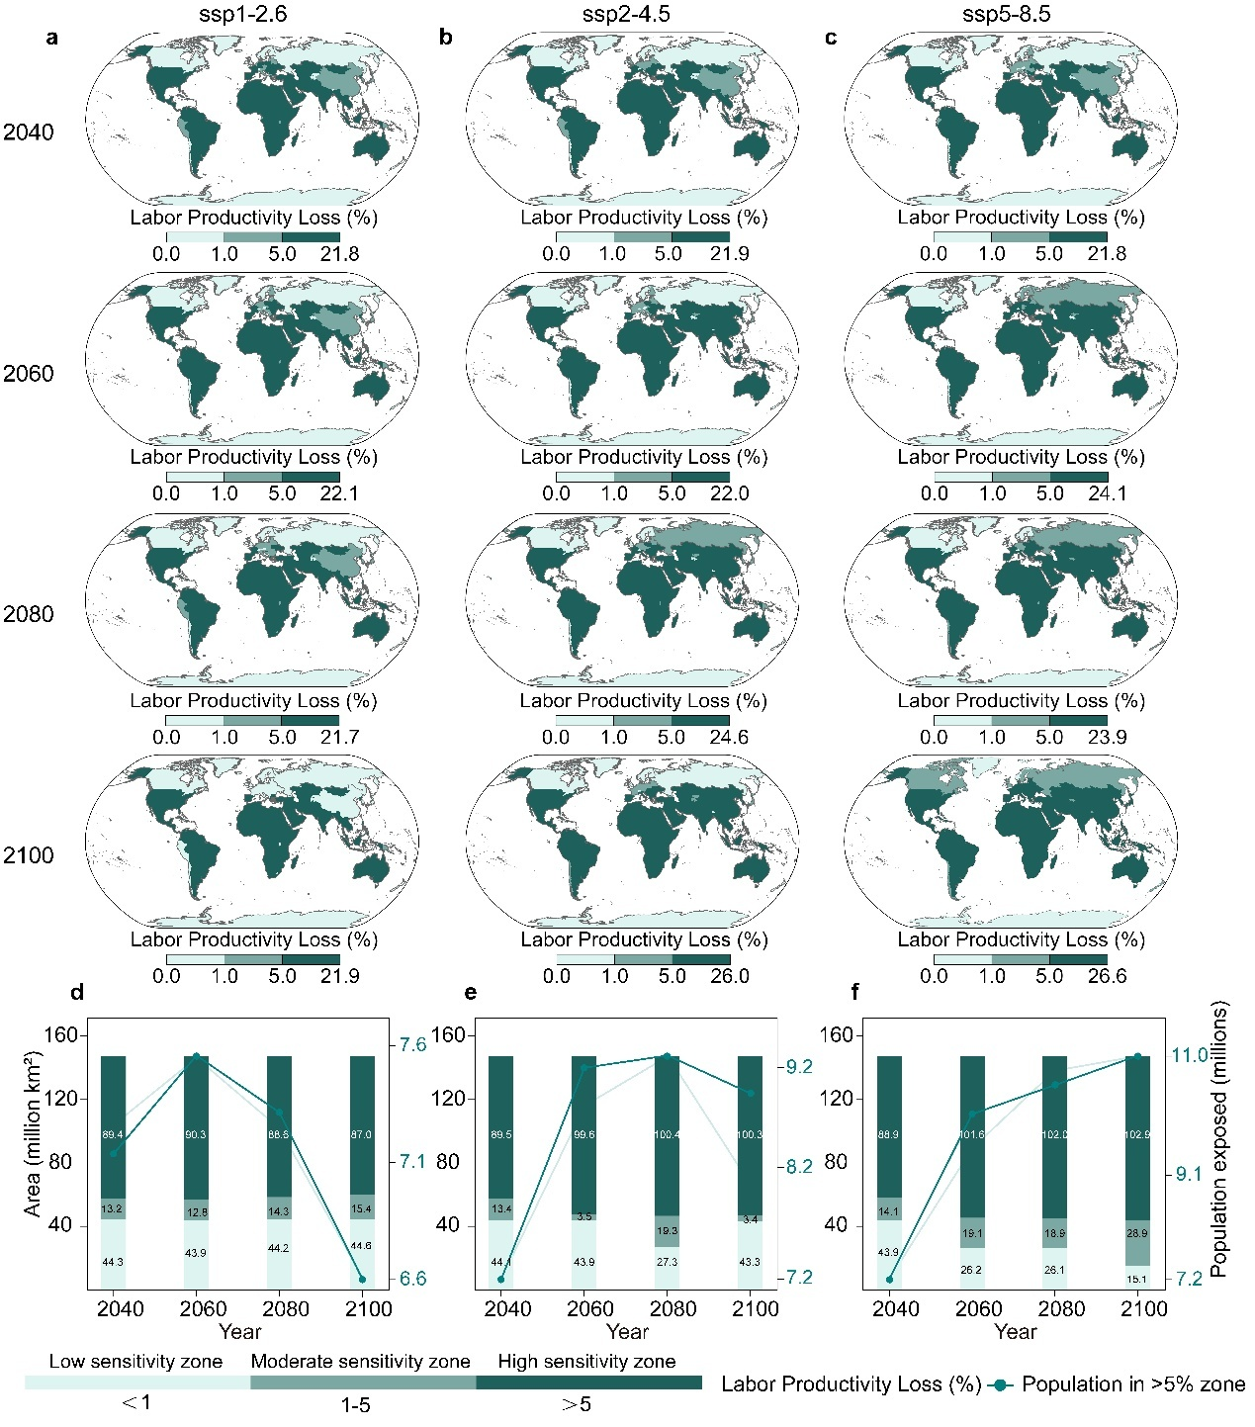

MPI‑ESM1‑2‑LR
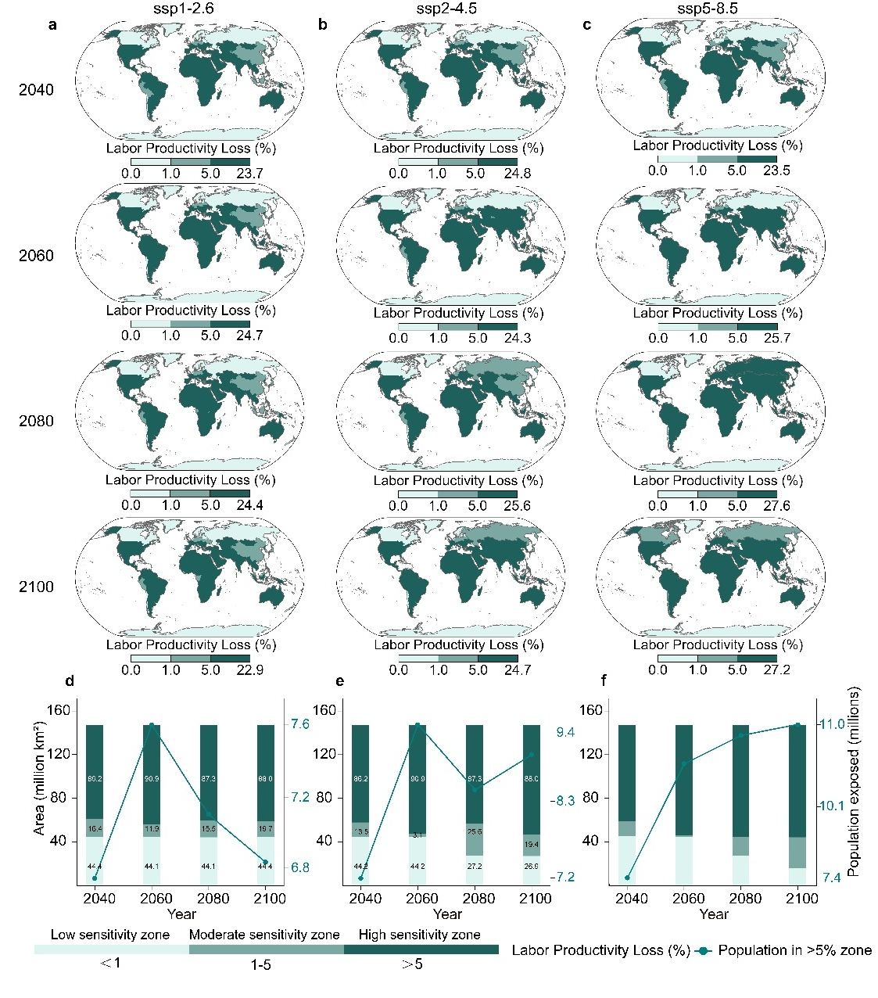

MRI‑ESM2‑0
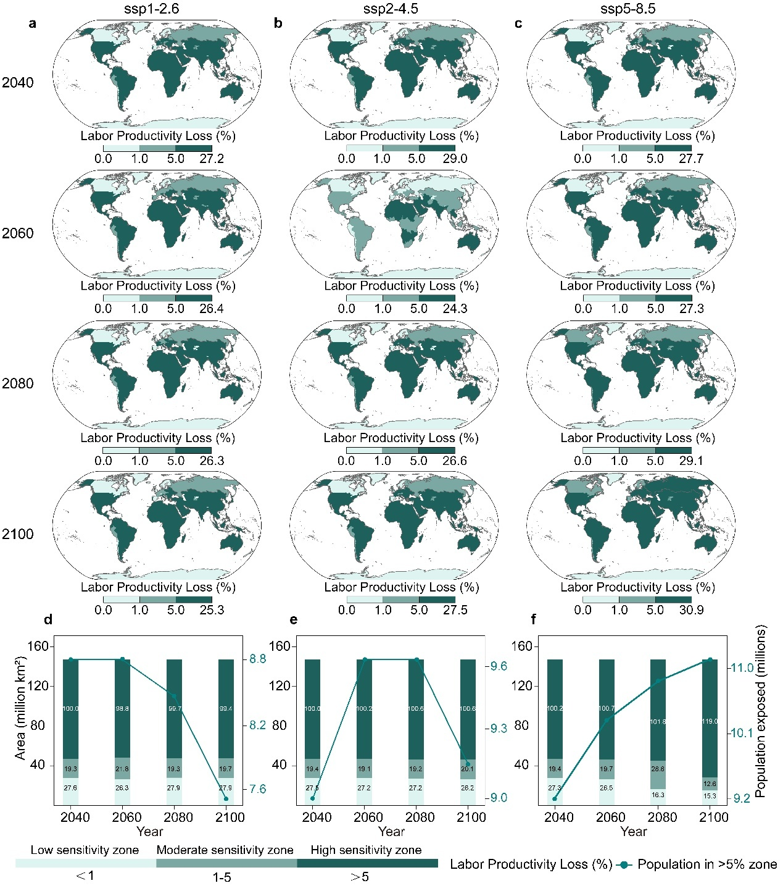

UKESM1‑0‑LL
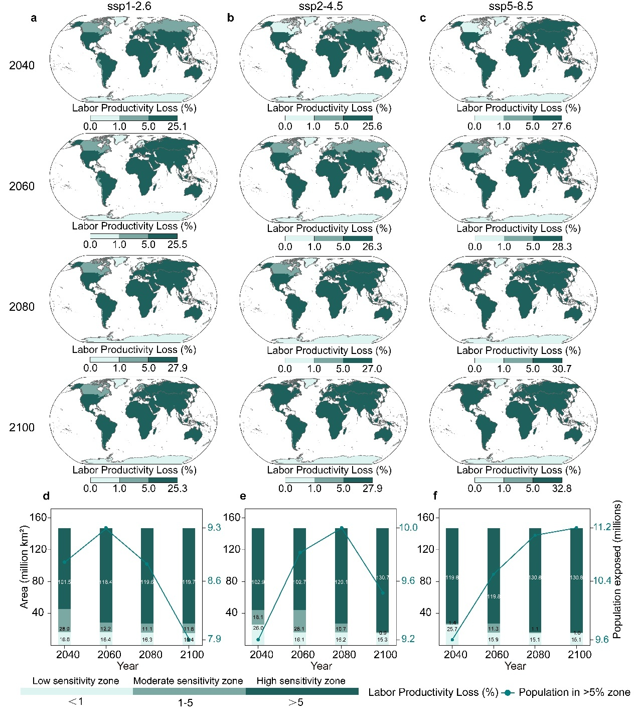
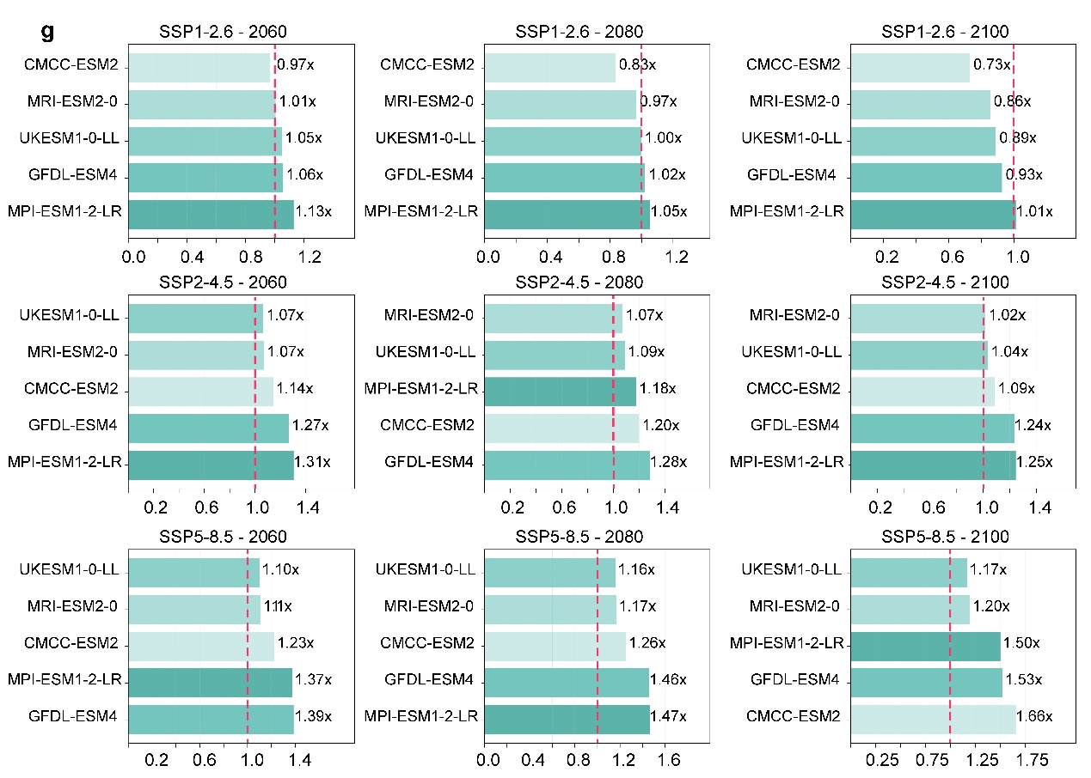
Extended Data Table 6 | multi-model comparison of high-sensitivity zone exposure under SSP5-8.5 (2100).
For each of the five CMIP6 models, the table reports the population exposed to high-sensitivity zones (>5% labour productivity loss) in millions, and the corresponding area of high-sensitivity zones (million km²). The multi-model mean is also provided. Under SSP5-8.5 by 2100, the exposed population ranges from 7.5 million (CMCC-ESM2) to 11.2 million (UKESM1-0-LL), whereas the high-sensitivity area ranges from 62.9 million km² (CMCC-ESM2) to 130.9 million km² (UKESM1-0-LL). The multi-model mean exposed population is 10.4 million, with a corresponding mean high-sensitivity area of 103.7 million km².
The four additional CMIP6 models (GFDL-ESM4, MPI-ESM1-2-LR, MRI-ESM2-0 and UKESM1-0-LL) show qualitatively similar spatial patterns of labour productivity loss to CMCC-ESM2, with high-sensitivity zones (>5% loss) expanding markedly under SSP5-8.5 after 2060 (Extended Data Fig. 6a–c). However, substantial quantitative differences persist: by 2100, the exposed population spans 7.5–11.2 million and the high-sensitivity area 62.9–130.9 million km² (Extended Data Table 6). The multi-model mean exposed population is 10.4 million, with a corresponding mean area of 103.7 million km² (Extended Data Fig. 6d–f).
Year | 2040 | 2060 | 2080 | 2100 | 2100
Model | Population  (millions) |  |  |  | High Area  (Million km²)
CMCC-ESM2 | 4.52 | 5.54 | 5.68 | 7.5 | 62.89
GFDL-ESM4 | 7.25 | 10.07 | 10.56 | 11.06 | 102.91
MPI-ESM1-2-LR | 7.37 | 10.12 | 10.81 | 11.08 | 102.87
MRI-ESM2-0 | 9.24 | 10.27 | 10.79 | 11.08 | 119.02
UKESM1-0-LL | 9.58 | 10.54 | 11.11 | 11.21 | 130.85
Multi-model mean | 7.59 | 9.31 | 9.79 | 10.39 | 103.71
Extended Data Detailed Table 6 | Complete area and population exposure by sensitivity zone for five CMIP6 models under three SSP scenarios (2040–2100). For each model, scenario and year, the table reports the area (million km²) and population (millions) for low-sensitivity (<1% loss), medium-sensitivity (1–5% loss) and high-sensitivity (>5% loss) zones.
Model | Scenario | Year | Low area | Mid area | High area | Low  pop | Mid  pop | High  pop
Model | Scenario | Year | (Million km²) |  |  | (Millions)
CMCC-ESM2 | ssp126 | 2040 | 84.30 | 36.18 | 26.96 | 3.15 | 2.04 | 4.13
CMCC-ESM2 | ssp126 | 2060 | 74.54 | 44.64 | 28.26 | 2.52 | 3.06 | 4.01
CMCC-ESM2 | ssp126 | 2080 | 75.19 | 46.52 | 25.73 | 2.56 | 3.08 | 3.44
CMCC-ESM2 | ssp126 | 2100 | 72.66 | 39.33 | 35.45 | 2.09 | 3.02 | 3.02
CMCC-ESM2 | ssp245 | 2040 | 80.11 | 43.41 | 23.92 | 2.77 | 3.01 | 3.77
CMCC-ESM2 | ssp245 | 2060 | 73.66 | 46.91 | 26.87 | 2.60 | 3.25 | 4.32
CMCC-ESM2 | ssp245 | 2080 | 73.67 | 23.25 | 50.52 | 2.54 | 3.02 | 4.53
CMCC-ESM2 | ssp245 | 2100 | 71.49 | 27.64 | 48.31 | 2.17 | 3.29 | 4.11
CMCC-ESM2 | ssp585 | 2040 | 77.24 | 28.25 | 41.95 | 2.81 | 2.43 | 4.52
CMCC-ESM2 | ssp585 | 2060 | 72.70 | 35.53 | 39.21 | 2.64 | 2.52 | 5.54
CMCC-ESM2 | ssp585 | 2080 | 67.48 | 25.89 | 54.07 | 1.77 | 3.70 | 5.68
CMCC-ESM2 | ssp585 | 2100 | 66.68 | 17.87 | 62.89 | 1.55 | 2.23 | 7.50
GFDL-ESM4 | ssp126 | 2040 | 44.35 | 13.20 | 89.42 | 0.39 | 1.81 | 7.10
GFDL-ESM4 | ssp126 | 2060 | 43.87 | 12.80 | 90.29 | 0.36 | 1.72 | 7.50
GFDL-ESM4 | ssp126 | 2080 | 44.17 | 14.25 | 88.55 | 0.33 | 1.48 | 7.27
GFDL-ESM4 | ssp126 | 2100 | 44.62 | 15.36 | 86.99 | 0.31 | 1.22 | 6.59
GFDL-ESM4 | ssp245 | 2040 | 44.06 | 13.37 | 89.54 | 0.33 | 1.99 | 7.22
GFDL-ESM4 | ssp245 | 2060 | 43.86 | 3.50 | 99.61 | 0.35 | 0.64 | 9.16
GFDL-ESM4 | ssp245 | 2080 | 27.26 | 19.30 | 100.41 | 0.19 | 0.62 | 9.27
GFDL-ESM4 | ssp245 | 2100 | 43.26 | 3.43 | 100.29 | 0.22 | 0.41 | 8.93
GFDL-ESM4 | ssp585 | 2040 | 43.90 | 14.15 | 88.92 | 0.35 | 2.15 | 7.25
GFDL-ESM4 | ssp585 | 2060 | 26.20 | 19.13 | 101.65 | 0.09 | 0.52 | 10.07
GFDL-ESM4 | ssp585 | 2080 | 26.09 | 18.86 | 102.02 | 0.09 | 0.48 | 10.56
GFDL-ESM4 | ssp585 | 2100 | 15.14 | 28.93 | 102.91 | 0.01 | 0.20 | 11.06
MPI-ESM1-2-LR | ssp126 | 2040 | 44.35 | 16.39 | 86.21 | 0.38 | 2.19 | 6.73
MPI-ESM1-2-LR | ssp126 | 2060 | 44.15 | 11.93 | 90.88 | 0.35 | 1.61 | 7.60
MPI-ESM1-2-LR | ssp126 | 2080 | 44.11 | 15.55 | 87.29 | 0.33 | 1.65 | 7.09
MPI-ESM1-2-LR | ssp126 | 2100 | 44.39 | 14.54 | 88.03 | 0.30 | 1.00 | 6.82
MPI-ESM1-2-LR | ssp245 | 2040 | 44.18 | 13.51 | 89.26 | 0.39 | 1.91 | 7.24
MPI-ESM1-2-LR | ssp245 | 2060 | 44.18 | 3.13 | 99.65 | 0.36 | 0.33 | 9.46
MPI-ESM1-2-LR | ssp245 | 2080 | 27.23 | 29.56 | 90.16 | 0.19 | 1.38 | 8.51
MPI-ESM1-2-LR | ssp245 | 2100 | 26.93 | 19.43 | 100.59 | 0.18 | 0.35 | 9.02
MPI-ESM1-2-LR | ssp585 | 2040 | 44.92 | 13.68 | 88.35 | 0.51 | 1.87 | 7.37
MPI-ESM1-2-LR | ssp585 | 2060 | 44.18 | 1.55 | 101.22 | 0.32 | 0.23 | 10.12
MPI-ESM1-2-LR | ssp585 | 2080 | 27.09 | 17.51 | 102.35 | 0.11 | 0.21 | 10.81
MPI-ESM1-2-LR | ssp585 | 2100 | 16.11 | 27.97 | 102.87 | 0.05 | 0.14 | 11.08
MRI-ESM2-0 | ssp126 | 2040 | 27.63 | 19.28 | 100.03 | 0.21 | 0.33 | 8.76
MRI-ESM2-0 | ssp126 | 2060 | 26.38 | 21.79 | 98.77 | 0.15 | 0.60 | 8.82
MRI-ESM2-0 | ssp126 | 2080 | 27.90 | 19.35 | 99.70 | 0.26 | 0.34 | 8.47
MRI-ESM2-0 | ssp126 | 2100 | 27.87 | 19.65 | 99.42 | 0.24 | 0.38 | 7.50
MRI-ESM2-0 | ssp245 | 2040 | 27.51 | 19.40 | 100.03 | 0.20 | 0.33 | 9.01
MRI-ESM2-0 | ssp245 | 2060 | 27.63 | 19.07 | 100.25 | 0.21 | 0.27 | 9.67
MRI-ESM2-0 | ssp245 | 2080 | 27.18 | 19.17 | 100.59 | 0.23 | 0.18 | 9.66
MRI-ESM2-0 | ssp245 | 2100 | 26.22 | 20.09 | 100.64 | 0.08 | 0.30 | 9.17
MRI-ESM2-0 | ssp585 | 2040 | 27.33 | 19.43 | 100.19 | 0.17 | 0.34 | 9.24
MRI-ESM2-0 | ssp585 | 2060 | 26.52 | 19.71 | 100.72 | 0.08 | 0.33 | 10.27
MRI-ESM2-0 | ssp585 | 2080 | 16.35 | 28.77 | 101.83 | 0.04 | 0.30 | 10.79
MRI-ESM2-0 | ssp585 | 2100 | 15.35 | 12.58 | 119.02 | 0.01 | 0.17 | 11.08
UKESM1-0-LL | ssp126 | 2040 | 16.57 | 28.88 | 101.50 | 0.11 | 0.28 | 8.91
UKESM1-0-LL | ssp126 | 2060 | 16.45 | 12.16 | 118.35 | 0.11 | 0.12 | 9.34
UKESM1-0-LL | ssp126 | 2080 | 16.28 | 11.06 | 119.62 | 0.04 | 0.14 | 8.89
UKESM1-0-LL | ssp126 | 2100 | 15.42 | 11.82 | 119.71 | 0.03 | 0.16 | 7.93
UKESM1-0-LL | ssp245 | 2040 | 26.01 | 18.07 | 102.87 | 0.07 | 0.30 | 9.17
UKESM1-0-LL | ssp245 | 2060 | 16.14 | 28.07 | 102.74 | 0.10 | 0.25 | 9.80
UKESM1-0-LL | ssp245 | 2080 | 16.16 | 10.72 | 120.08 | 0.03 | 0.06 | 9.98
UKESM1-0-LL | ssp245 | 2100 | 15.35 | 0.88 | 130.73 | 0.02 | 0.03 | 9.51
UKESM1-0-LL | ssp585 | 2040 | 25.73 | 1.44 | 119.79 | 0.06 | 0.11 | 9.58
UKESM1-0-LL | ssp585 | 2060 | 15.86 | 11.29 | 119.79 | 0.03 | 0.11 | 10.54
UKESM1-0-LL | ssp585 | 2080 | 15.07 | 1.09 | 130.79 | 0.00 | 0.02 | 11.11
UKESM1-0-LL | ssp585 | 2100 | 15.07 | 1.04 | 130.85 | 0.00 | 0.05 | 11.21
Extended Data Table 7 | multi-model global total labour time losses by scenario and year (billion hours).
Values represent multi-model means across five CMIP6 models (CMCC-ESM2, GFDL-ESM4, MPI-ESM1-2-LR, MRI-ESM2-0 and UKESM1-0-LL). Global total labour time losses increase from 0.113 billion hours in 2040 to 0.186 billion hours by 2100, with SSP5-8.5 contributing the largest share (49.5% by 2100).
Aggregated across all five models, global labour time losses rise from 0.113 billion hours in 2040 to 0.186 billion hours by 2100 (multi-model mean), with the share attributable to SSP5-8.5 increasing from 35.6% to 49.5% (Fig. 7a; Extended Data Table 7). UKESM1-0-LL projects the highest losses (0.0468 billion hours by 2100), whereas CMCC-ESM2 projects the lowest (0.0189 billion hours), corresponding to a factor of 2.5 difference across models. The inter-model spread widens over time, with the coefficient of variation increasing from 18% in 2040 to 23% in 2100 under SSP5-8.5.
Model | Scenario | Year | Total Loss Billion Hours
CMCC-ESM2 | ssp126 | 2040 | 0.0093
CMCC-ESM2 | ssp126 | 2060 | 0.0104
CMCC-ESM2 | ssp126 | 2080 | 0.0098
CMCC-ESM2 | ssp126 | 2100 | 0.0087
CMCC-ESM2 | ssp245 | 2040 | 0.0095
CMCC-ESM2 | ssp245 | 2060 | 0.0109
CMCC-ESM2 | ssp245 | 2080 | 0.0129
CMCC-ESM2 | ssp245 | 2100 | 0.0123
CMCC-ESM2 | ssp585 | 2040 | 0.0103
CMCC-ESM2 | ssp585 | 2060 | 0.0147
CMCC-ESM2 | ssp585 | 2080 | 0.0162
CMCC-ESM2 | ssp585 | 2100 | 0.0189
GFDL-ESM4 | ssp126 | 2040 | 0.0210
GFDL-ESM4 | ssp126 | 2060 | 0.0225
GFDL-ESM4 | ssp126 | 2080 | 0.0217
GFDL-ESM4 | ssp126 | 2100 | 0.0190
GFDL-ESM4 | ssp245 | 2040 | 0.0221
GFDL-ESM4 | ssp245 | 2060 | 0.0261
GFDL-ESM4 | ssp245 | 2080 | 0.0258
GFDL-ESM4 | ssp245 | 2100 | 0.0248
GFDL-ESM4 | ssp585 | 2040 | 0.0227
GFDL-ESM4 | ssp585 | 2060 | 0.0271
GFDL-ESM4 | ssp585 | 2080 | 0.0314
GFDL-ESM4 | ssp585 | 2100 | 0.0350
MPI-ESM1-2-LR | ssp126 | 2040 | 0.0192
MPI-ESM1-2-LR | ssp126 | 2060 | 0.0211
MPI-ESM1-2-LR | ssp126 | 2080 | 0.0195
MPI-ESM1-2-LR | ssp126 | 2100 | 0.0171
MPI-ESM1-2-LR | ssp245 | 2040 | 0.0197
MPI-ESM1-2-LR | ssp245 | 2060 | 0.0233
MPI-ESM1-2-LR | ssp245 | 2080 | 0.0215
MPI-ESM1-2-LR | ssp245 | 2100 | 0.0221
MPI-ESM1-2-LR | ssp585 | 2040 | 0.0204
MPI-ESM1-2-LR | ssp585 | 2060 | 0.0250
MPI-ESM1-2-LR | ssp585 | 2080 | 0.0292
MPI-ESM1-2-LR | ssp585 | 2100 | 0.0316
MRI-ESM2-0 | ssp126 | 2040 | 0.0281
MRI-ESM2-0 | ssp126 | 2060 | 0.0277
MRI-ESM2-0 | ssp126 | 2080 | 0.0272
MRI-ESM2-0 | ssp126 | 2100 | 0.0244
MRI-ESM2-0 | ssp245 | 2040 | 0.0283
MRI-ESM2-0 | ssp245 | 2060 | 0.0318
MRI-ESM2-0 | ssp245 | 2080 | 0.0321
MRI-ESM2-0 | ssp245 | 2100 | 0.0311
MRI-ESM2-0 | ssp585 | 2040 | 0.0298
MRI-ESM2-0 | ssp585 | 2060 | 0.0354
MRI-ESM2-0 | ssp585 | 2080 | 0.0400
MRI-ESM2-0 | ssp585 | 2100 | 0.0441
UKESM1-0-LL | ssp126 | 2040 | 0.0267
UKESM1-0-LL | ssp126 | 2060 | 0.0280
UKESM1-0-LL | ssp126 | 2080 | 0.0271
UKESM1-0-LL | ssp126 | 2100 | 0.0245
UKESM1-0-LL | ssp245 | 2040 | 0.0281
UKESM1-0-LL | ssp245 | 2060 | 0.0320
UKESM1-0-LL | ssp245 | 2080 | 0.0336
UKESM1-0-LL | ssp245 | 2100 | 0.0321
UKESM1-0-LL | ssp585 | 2040 | 0.0294
UKESM1-0-LL | ssp585 | 2060 | 0.0372
UKESM1-0-LL | ssp585 | 2080 | 0.0421
UKESM1-0-LL | ssp585 | 2100 | 0.0468

