Supplemental Table 1. Review of studies reporting on congenital cornea anesthesia (CCA)
Author | Year | Country | N | Age | Presentation | MRI finding
Kamal et al.(1)  With permission | 2020 | USA | 1 | 3-year old | Large central epithelial defect in the left eye | 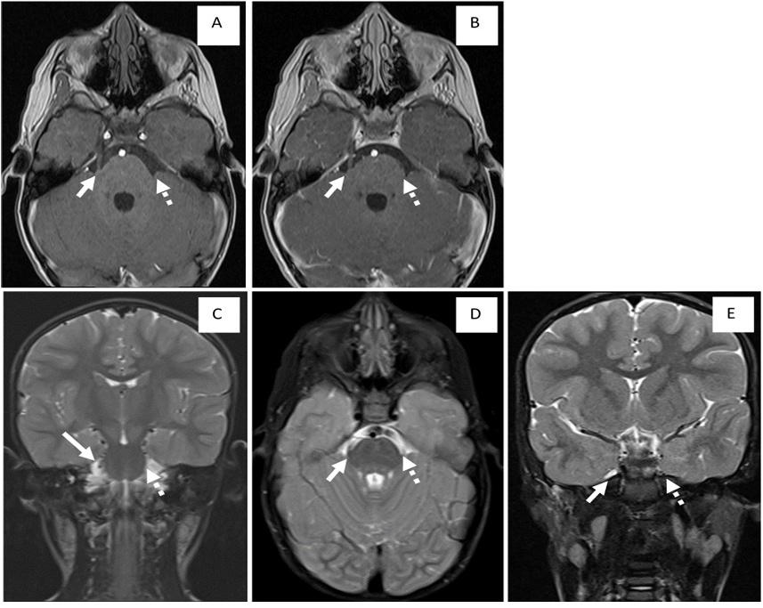  Absent left trigeminal nerve A—axial T1 precontrast, B—axial T1 postcontrast, C—coronal T2 FS (fat-suppressed), D—axial T2 FS; absent left Meckel's cave E—coronal T2 FS *normal is indicated by solid arrow, absent is indicated by dotted arrow.
Ohana et al.(2) | 2015 | France | 1 | 7-month old | Neurotrophic keratitis  Self-mutilation associated with anaesthesia in the distribution of the left trigeminal nerve. | Images can be seen here: https://pubmed.ncbi.nlm.nih.gov/25655592/  Agenesis of the left trigeminal nerve, with the absence of its cisternal segment (white circle), as compared with the other side (white arrow).
Jha et al.(3) With permission | 2015 | India | 1 | 11-year old | Loss of sensation over the left side of his face and cornea, reduced visual acuity due to neurotrophic keratitis. | 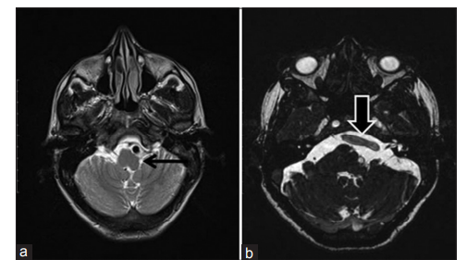  (a) Axial T2-weighted magnetic resonance imaging image showing an anomalous course of the left vertebral artery, with compression and flattening of the left inferior olivary nucleus (black arrow). (b) Axial constructive interference in a steady state sequence showing crossing of the anomalous left vertebral artery (black arrow)  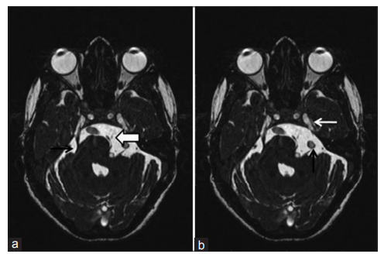  (a) Axial constructive interference in a steady state sequence image showing hypoplastic left preganglionic cisternal trigeminal nerve (white arrow), with normal right trigeminal nerve (black arrow). (b) The left facial nerve appears stretched by the ectatic left vertebral artery (black arrow). Also note that the Meckel’s cave and the porus trigeminus are empty (white arrow)
Morishige et al.(4)  With permission | 2014 | Japan | 1 | 16-months old | 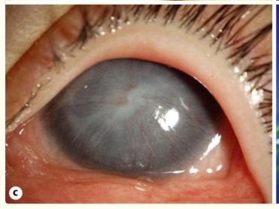  left-sided neovascularized corneal opacity and persistent corneal epithelial defect (Neurotrophic keratopathy) | 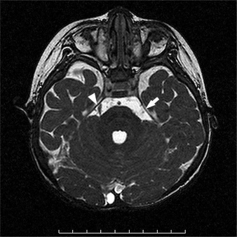  MRI of the patient at the level of the brain stem. The trigeminal nerve was observed on the right side of the brain stem (arrowhead) but not on the left side (arrow).
Villanueva et al.(5) | 2005 | USA | 2 | 6 and 3 years old | Case 1: Goldenhar syndrome with a central corneal scar and a flat limbal dermoid  Case 2: Goldenhar syndrome with hypoesthetic cornea | Case 1: Images can be seen here: https://pubmed.ncbi.nlm.nih.gov/15838455/  A) MRI, axial FIESTA sequence shows a normal right trigeminal nerve (arrow) exiting the lateral pons and coursing anteriorly to synapse with the Gasserian ganglion in Meckel’s cave. The left trigeminal nerve and Meckel’s cave are absent. (B) MRI, axial FIESTA sequence shows a normal right cranial nerve VII and VIII complex (arrow) crossing the cerebellopontine angle cistern before entering the internal auditory canal. (C) MRI, axial FIESTA sequence shows a hypoplastic cranial nerve VII and VIII complex (arrow) on the left.  Case 2: Images can be seen here: https://pubmed.ncbi.nlm.nih.gov/15838455  (A) MRI, axial FIESTA sequence, shows asymmetric size of cranial nerve VII and VIII complexes (arrows) with relative hypoplasia on the right. (B) MRI, axial FIESTA sequence shows asymmetry of the trigeminal nerves (arrows), with the right trigeminal nerve appearing smaller than the left.
Milne et al.(6) | 2005 | Canada | 1 | 31-year-old | persistent corneal erosions and ulceration over several years with unilateral anesthesia of the ophthalmic division of the trigeminal nerve | Case 1: Images can be seen here: https://pubmed.ncbi.nlm.nih.gov/16391646/  Consecutive coronal T1-weighted magnetic resonance image sequences show the trigeminal cranial nerves (arrows). The left trigeminal nerve was observed to be hypoplastic in comparison with the right trigeminal nerve, which extended from the brain stem to Meckel’s cave.

References
1. Kamal SM, Riccobono K, Kwok A, Edmond JC, Pflugfelder SC. Unilateral pediatric neurotrophic keratitis due to congenital left trigeminal nerve aplasia with PROSE (prosthetic replacement of the ocular surface ecosystem) treatment. American Journal of Ophthalmology Case Reports. 2020 Dec;20:100854.
2. Ohana M, Lipsker D, Chaigne D, Speeg-Schatz C, Sauer A. Unilateral Ulceration of the Cornea Secondary to Congenital Trigeminal Nerve Agenesis. European Journal of Ophthalmology. 2015 Jul;25(4):e35–7.
3. Jha A, Gupta P, Haroon M, Shah G, Gupta G, Khalid M. Trigeminal hypoplasia due to vertebrobasilar dolichoectasia: A new entity. J Pediatr Neurosci. 2015;10(2):153–5.
4. Morishige N, Morita Y, Yamada N, Nishida T, Sonoda KH. Congenital hypoplastic trigeminal nerve revealed by the manifestation of corneal disorders likely caused by a neural factor deficiency. Case Rep Ophthalmol. 2014 May;5(2):181–5.
5. Villanueva O, Atkinson DS, Lambert SR. Trigeminal nerve hypoplasia and aplasia in children with Goldenhar syndrome and corneal hypoesthesia. J AAPOS. 2005 Apr;9(2):202–4.
6. Milne AD, Chui L, Mishra AV, Maxner CE. Unilateral hypoplasia of the trigeminal ganglion. Can J Ophthalmol. 2005 Dec;40(6):772–4.

