Supplementary Material

Table S1. Growth of Amazonian Dark Earth isolates after 7 days of incubation in the control R2A medium (left), R2A supplemented with Mars regolith, and regolith-only medium.

Strain code | Taxonomy
TP3 | Bacillus thuringiensis  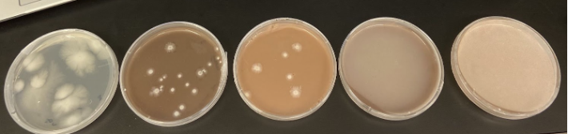
TP7 | Staphylococcus epidermidis  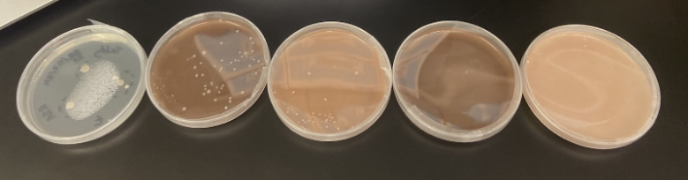
TP15a | Lysinibacillus xylanilyticus  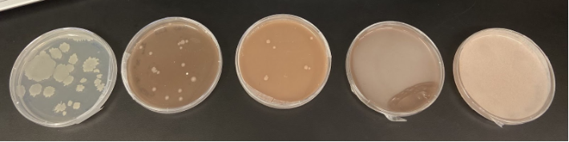
TP16 | Bacillus pseudomycoides  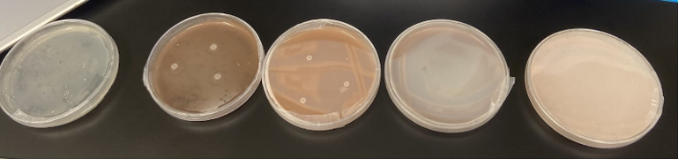
TP20 | Bacillus rhizoplanae  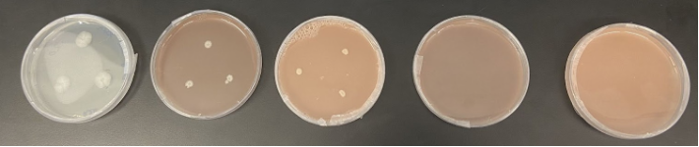
TP35 | Bacillus sp.  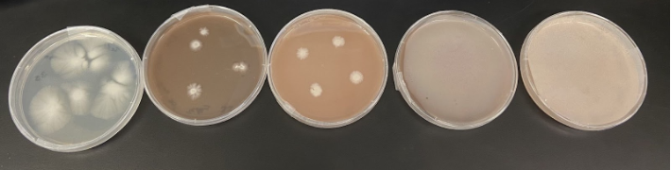
TP37 | Streptomyces cinnamoneus  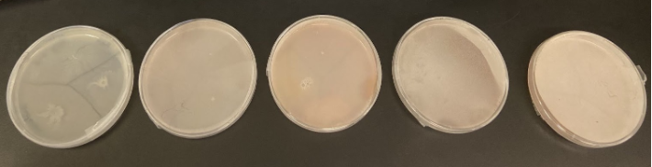
TP47b | Cohnella laeviribosi  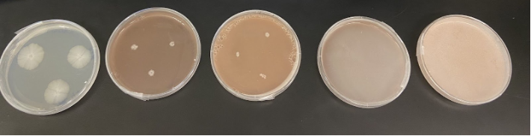
TP91 | Brevibacillus thermoruber  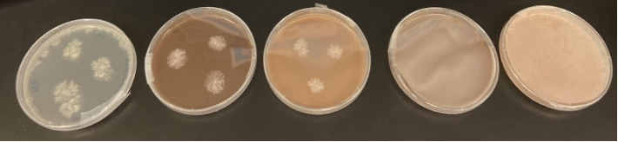
TP122 | Saccharococcus thermophilus  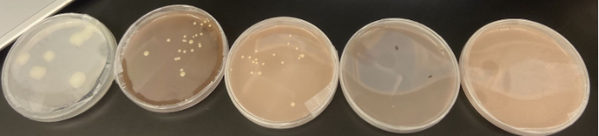
TP153 | Burkholderia lata  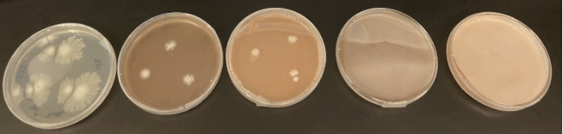
TP154 | Bacillus thuringiensis  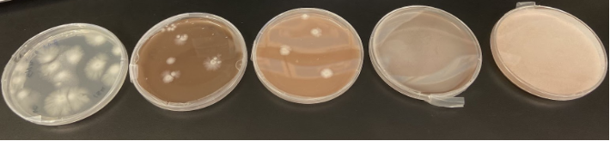
TP159 | Pseudomonas citronellolis  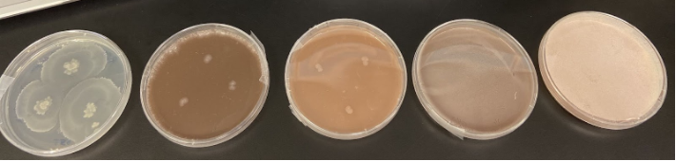

Table S2. Growth of Amazonian Dark Earth microorganisms in Mars regoliths (measured colony size in centimetres).
Isolate code | Taxonomy | Control | R2A MGS | R2A JEZ-1 | MGS-only | JEZ-1-only
TP3 | Bacillus thuringiensis | 1.5‒2.5 | 0.5‒0.8 | 0.7 | 0.3 | 0.2
TP5 | Fictibacillus rigui | - | - | - | - | -
TP7 | Staphylococcus sp. | 0.4‒0.6 | 0.3‒0.4 | 0.3 | 0.2 | -
TP15a | Lysinibacillus sp. | 1‒3 | 0.5 | 0.4 | 0.3 | -
TP16 | Bacillus pseudomycoides | 2‒3 | 0.7 | 0.4‒0.5 | - | -
TP20 | Bacillus rhizoplanae | 1‒1.5 | 0.5 | 0.4 | - | -
TP35 | Bacillus sp. | 2‒3 | 0.7‒1 | 0.8 | 0.3 | 0.3
TP37 | Streptomyces sp. | 3‒5 | 0.3‒0.4 | 0.4 | - | -
TP47b | Cohnella laeviribosi | 2 | 0.5 | 0.5 | 0.2 | -
TP59 | Streptomyces sp. | - | - | - | - | -
TP91 | Brevibacillus thermoruber | 2 | 1.5 | 1 | 0.3 | 0.1‒0.2
TP122 | Parageobacillus sp. | 1.2‒1.5 | 0.4 | 0.3 | 0.2 | 0.2
TP153 | Burkholderia sp. | 2‒3.5 | 0.7‒1 | 0.7 | 0.2 | 0.2
TP154 | Bacillus cereus | 1.5‒2 | 0.5‒1 | 0.8 | 0.2 | 0.2
TP159 | Pseudomonas sp. | 3.5‒5 | 0.5‒0.7 | 0.3‒0.4 | - | -
-: no recorded growth

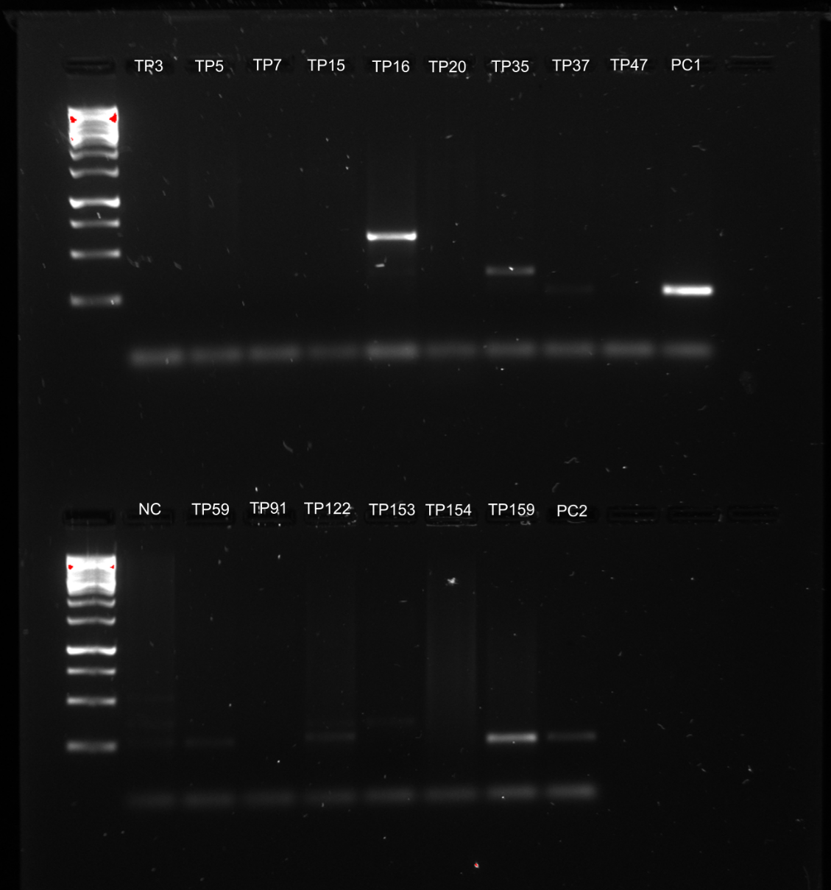
Figure S1. Agarose gel electrophoresis displaying PCR amplification products of the nifH gene from selected microbial isolates. Lane labels correspond to isolate IDs; molecular weight markers are shown in the first lane of each row. PC1 and PC2 denote positive controls, and NC indicates the negative control. Bands at the expected size confirm successful amplification of nifH in the corresponding isolates.

