High-Entropy Spinel Oxide Catalyst for Selective CO₂ hydrogenation to Methanol

Siyi Huang,^{1,+} Ting Zeng,^{1,+} Di Xu,¹* Guoqiang Hou,¹ Yangyang Li,¹ Ruosong He,¹ Hanzhu Zhang,¹ Jiajun Peng,¹ Hongmei Yang,⁴ Yao Wang,¹ Chun-Ran Chang,³ Xiang-Kui Gu,¹* Mingyue Ding^{1,2}*

¹ School of Power and Mechanical Engineering, Wuhan University, Wuhan, 430072, China
² Academy of Advanced Interdisciplinary Studies, Wuhan University, Wuhan, 430072, China
³ State Key Laboratory of Fluorine & Nitrogen Chemicals, School of Chemical Engineering and Technology, Xi’an Jiaotong University, Xi’an, 710049, China
⁴ Shanxi Key Laboratory of Coal-based Synthetic Oil Product Testing, Changzhi, 046000, China

*Correspondence author: x_d@whu.edu.cn, xiangkuigu@whu.edu.cn, dingmy@whu.edu.cn.
⁺These authors contributed equally to this work.

Table of Contents

Supplementary Methods
Supplementary Figures 1-29
Supplementary Tables 1-7
Supplementary References 1-31

Supplementary Methods

Synthesis of spinel oxides
A series of spinel oxide catalysts were synthesized by a polyvinylpyrrolidone (PVP) templated method¹. Takes the synthesis of ZCAFG-HEO catalyst as an example. Firstly, 4g of PVP was dissolved in 20 ml of H₂O. Then the solution was stirred by a magnetic agitator with the addition of 0.552 g of Zn(NO₃)₂·6H₂O, 0.540 g of Co(NO₃)₂·6H₂O, 1.392 g of Al(NO₃)₃·9H₂O, 0.749 g of Fe(NO₃)₃·9H₂O and 0.775 g of Ga(NO₃)₃·xH₂O, in which the PVP/metal salts weight ratio was 1. After 2 h of stirring, the uniform solution was placed in a freeze dryer and it was freeze dried for 48 h to remove water. The dried product was calcined in a muffle furnace at 600 °C (heating rate 1 °C·min⁻¹) for 6 h, yielding a catalyst composed of ZnCoAlFeGaO_{x}, which was named ZCAFG-HEO. Similarly, by varying the type and amount of metal added, ZnFeO_{x}, ZnFeGaO_{x} and ZnCoFeGaO_{x} catalysts were prepared and named ZF-LEO, ZFG-MEO, and ZCFG-HEO, respectively.

Catalyst characterization
The powder X-ray diffraction patterns of the investigated catalysts were recorded on a Rigaku Ultima IV diffractometer equipped with a Cu Kα radiation source over the 2θ range at 5-100° with a scanning speed of 4°·min⁻¹. The XRD profiles were further analyzed by the Rietveld refinement program.
In situ XRD measurements were performed using the same Rigaku Ultima IV X-ray diffractometer. A predetermined quantity of catalyst powder was loaded into the sample chamber of a reaction cell. The sample was initially heated to 300 °C at 5 °C·min⁻¹ under N₂ flow (30 mL·min⁻¹) and held isothermally for 1 h. The gas stream was then switched to a CO₂/H₂/N₂ mixture (2.5/7.5/90). After 1 h of stabilization, in situ XRD data were acquired at 300 °C using a tube voltage of 40 kV and tube current of 40 mA, over a 2θ range of 29°-79° at a scanning rate of 5 °C·min⁻¹. Subsequently, under the same gas and instrument conditions, spectra were collected sequentially at 350 °C, 400 °C, 450 °C, and 500 °C.
ICP-OES testing was conducted using an Agilent 5110 spectrometer to determine the precise content of target metal elements in the samples.
The textural properties of the catalysts were measured by N₂ physisorption at -196 °C on Micromeritics ASAP 240 instrument. Before measurement, the catalysts were pretreated at 200 °C for 3 h under vacuum. The Brunauer-Emmett-Teller (BET) method was applied to calculate the isotherm and the T-Plot method was used to calculate the pore volume.
Scanning electron microscopy (SEM) was conducted on a TESCAN MIRA 3 LMH microscope. Prior to characterization, the sample was dispersed in deionized water. Transmission electron microscopy (TEM) was performed on a JEM-F200 microscope equipped with a JED-2300T camera, operated at an accelerating voltage of 200 kV. Both low-magnification and high-resolution TEM (HRTEM) images were acquired. For sample preparation, the nanoparticle-containing ethanol suspension was drop-cast onto copper grids at room temperature. Particle size distributions were determined using Image J software, based on statistical analysis of at least 100 individual nanoparticles.
Raman spectra were performed on a Horiba LabRAM HR Evolution equipped with a charge-coupled device (CCD) detector. The sample were placed slide and detected at 532 nm.
H₂ temperature-programmed reduction (H₂-TPR) was performed on a Micromeritics Autochem II 2920 system equipped with a thermal conductivity detector (TCD). For each run, 100 mg of catalyst was pretreated in pure Ar at 150 °C for 2 h, then heated from 50 to 700 °C at 10 °C·min⁻¹ in 5 % H₂/Ar.
CO₂ temperature-programmed desorption (CO₂-TPD) was performed on the same Micromeritics AutoChem II 2920 instrument. In a typical procedure, 100 mg of sample was loaded into a quartz U-tube and pretreated at 300 °C under He flow for 1 h, followed by adsorption in 5 vol% CO₂/He for 30 min. After purging with He, the TPD profile was recorded from 50 to 650 °C at a heating rate of 10 °C·min⁻¹ using mass spectrometry (MS) detection.
X-ray photoelectron spectroscopy (XPS) was recorded on a Thermo ESCALAB XI+ (16 kV, 14.9 mA). All date were corrected by binding energy of C 1s (284.8 eV) as the reference.
The X-ray absorption fine structure (XAFS) analyses of the Fe K-edge were conducted utilizing a commercial Laboratory-Based XAFS spectrometer (RapidXAFS 2M, Anhui Absorption Spectroscopy Analysis Instrument Co., Ltd.). X-rays were generated via a Mo target X-ray source operated at 20 kV and 20 mA. A Ge (310) spherically bent crystal analyzer (SBCA) with a radius of curvature of 500 mm served as the monochromator, thereby ensuring a diffraction geometry approaching a 90-degree backscatter angle at the absorption edge. After monochromatization, the X-rays pass through the sample and were collected using a high-energy-resolution silicon drift detector (SDD) to obtain the X-ray intensity. The XAFS data were acquired in transmission mode. During the XAFS measurements, the position of the absorption edge (E₀) was calibrated using a standard metal foil sample, and all data collection occurred within a single time period.
Room temperature ⁵⁷Fe Mössbauer spectra of ZCAFG-HEO was recorded using a Topologic 500A spectrometer with ⁵⁷Co (Rh) as a γ-ray radioactive source. The velocity was calibrated by a standard α-Fe foil. The obtained spectra were fitted and analyzed using Moss Win.
In situ diffuse reflectance Fourier transform infrared spectroscopy (DRIFTS) were performed on a Nicolet iS50 FT-IR (Thermo Fisher Scientific) equipped with a MCT detector by the following procedures. Before the tests, 15 mg samples were loaded into the cell and heated at 350 °C for 1h under Ar flow, then cooled to 340 °C for testing. Background spectra were acquired at 340 °C before gas introduction. A gas mixture of H₂/CO₂/N₂ (3/1/36 mL⋅min⁻¹) was then introduced, and spectra were recorded at successive time intervals: 1, 5, 10, 20, 40, 60, 90 and 120 min. Subsequently, the feed gas was switched to H₂/N₂(4/36 mL⋅min⁻¹), and spectra were collected under the new atmosphere.

Catalytic performance evaluation
The hydrogenation of CO₂ was investigated in a fixed-bed reactor. Typically, 0.1 g catalyst was loaded into a stainless-steel tube reactor and in situ activated at 350 °C for 3 h under N₂ flow (30 mL⋅min⁻¹). After cooling to 200 °C, the reactant gas mixture (72% H₂, 24% CO₂, 4% N₂) was fed into the reactor, and the temperature and pressure were adjusted to the desired reaction conditions.
Online analysis was carried out using an online gas chromatograph (GC, Shanghai Ruimin 2060), with all products maintained in the gas phase. The reactor effluent was held at 150 °C and immediately directed to the sampling valve of the GC equipped with a thermal conductivity detector (TCD) and a flame ionization detector (FID). In general, H₂, N₂, CO, CH₄, and CO₂ were analyzed by TCD, whereas methanol and hydrocarbons were determined by FID. Product selectivity was calculated based on carbon balance. After quantification of all carbon-containing products, the balance of carbon for each test was consistently over 95.0%.
The CO₂ conversion [denoted as X(CO₂)] and the selectivity of the products (including CO, CH₄, MeOH, and C₂⁺ hydrocarbons) [denoted as S(product)] were calculated using an internal standard method. The space-time yield (STY) of methanol is denoted as STY(MeOH). Catalytic performance is calculated using the following formula:
$\text{X(CO}\text{2}\text{)}\text{ = }\frac{\text{n(C}{\text{O}}_{\text{2 in}}\text{)-n(C}{\text{O}}_{\text{2 out}}\text{)}}{\text{n(C}{\text{O}}_{\text{2 in}}\text{)}}\text{×100\%}$
$\text{S(MeOH)}=\frac{\text{n(MeOH)}}{nCO+\sum{[n(Ci)×i] }}\text{×100\%}$
$\text{S(CO)} \text{=}\frac{nCO}{nCO+\sum{[n(Ci)×i] }}\text{×}\text{100\%}$
$\text{S(Ci) }\text{=}\frac{n(Ci)×i}{nCO+\sum{[n(Ci)×i] }}\text{×}\text{100\%}$
$\text{STY(MeOH) }\text{=}\frac{\text{F(C}O_{2,in})×\text{X(CO}\text{2}\text{)}×\text{S(MeOH)}×M(MeOH)}{W_{Cat}}$
where “in” denotes inlet and “out” denotes outlet. F (CO_{2,in}) denotes the molar flow rate of CO₂ at the reactor inlet (mol/s). M(MeOH) = 32.04 g/mol represents the relative molecular mass of methanol, and W_{Cat} denotes the mass of catalyst used in the reaction (g).

Computational details
Spin-polarized DFT calculations were performed by Vienna ab initio Simulation Package (VASP)^{2,3}. The exchange-correlation interaction was described by the generalized gradient approximation (GGA) and Perdew-Burke-Ernzerhof (PBE) functional⁴. The core electrons were described with the projector augmented-wave (PAW) method and the Kohn-Sham equations were solved in a plane-wave basis sets with a kinetic energy cutoff of 400 eV kinetic cutoff energy⁵. The van der Waals interaction was described using DFT-D3⁶. The on-site Coulomb correction for the Co 3d and Fe d states was corrected by the DFT+U approach with a Ueff value of 3.4 eV^{{#6}} and 4.0 eV⁷, respectively. A high-entropy Zn_{0.5}Co_{0.5}AlFe_{0.5}Ga_{0.5}O₄ bulk model was computationally developed from the Zn(FeO₂)₂ spinel structure. We implemented with Co exclusively occupying the tetrahedral sites, while Al, Fe, and Ga were randomly distributed across the octahedral sites in a 2:1:1 ratio. An ensemble of 30 random configurations was generated, and the energetically most stable one was chosen for structural visualization and analysis using VESTA (Visualization for Electronic and Structural Analysis) software. The most stable (111) crystal facets⁸ were exposed containing octahedral and tetrahedral Fe or Zn atoms to investigate the stability caused by Zn and Fe, with fixing (or release) half atoms during calculation. 15 Å vacuum layer along z-direction was incorporated in all models to eliminate periodic interactions between adjacent slabs. A gamma k-point mesh was used to sample the surface Brillouin zone. The convergence criteria for the electronic self-consistent iteration and force were set to be 10⁻⁴ eV and 0.02 eV/Å, respectively. Transition states were located using the climbing image nudged elastic band (CI-NEB) methods⁹. The crystal orbital Hamilton population (COHP) was analyzed by the LOBSTER program^{10,11}. The corresponding normal mode vibrations were also used to calculate the ZPE correction and the vibrational partition function by vaspkit¹².

Supplementary Figures

Figure S1. Schematic illustration of the synthetic process for spinel catalysts.

Figure S2. Rietveld refinement XRD patterns of fresh (a) ZF-LEO, (b) ZFG-MEO and (c) ZCFG-MEO.

Figure S3. SEM images of fresh (a-b) ZF-LEO, (c-d) ZFG-MEO, (e-f) ZCFG-MEO, and (g-h) ZCAFG-HEO.

Figure S4. (a) TEM image and corresponding (b) particle size distribution graph of the fresh ZF-LEO.

Figure S5. (a) N₂ adsorption-desorption isotherms and (b) the BET surface area of the fresh catalysts.

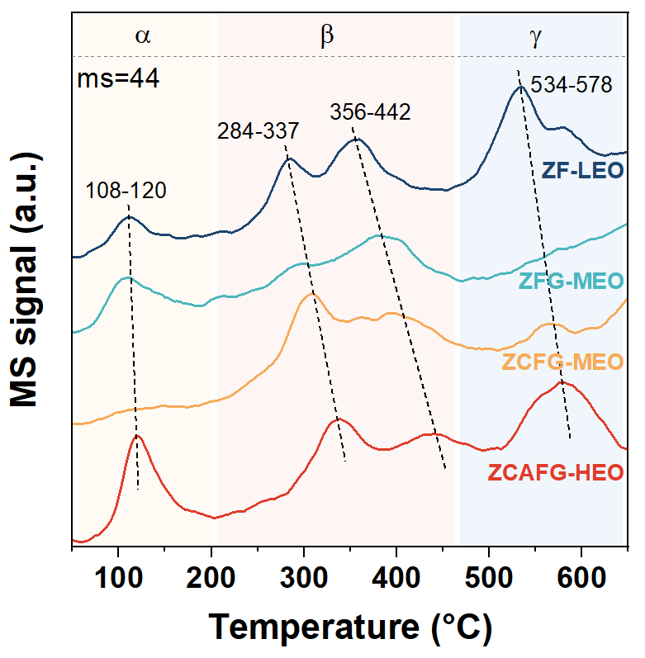
Figure S6. CO₂-TPD patterns of the fresh catalysts.

Figure S7. HRTEM image of the fresh ZF-LEO.

Figure S8. EDS mapping of the fresh ZF-LEO.

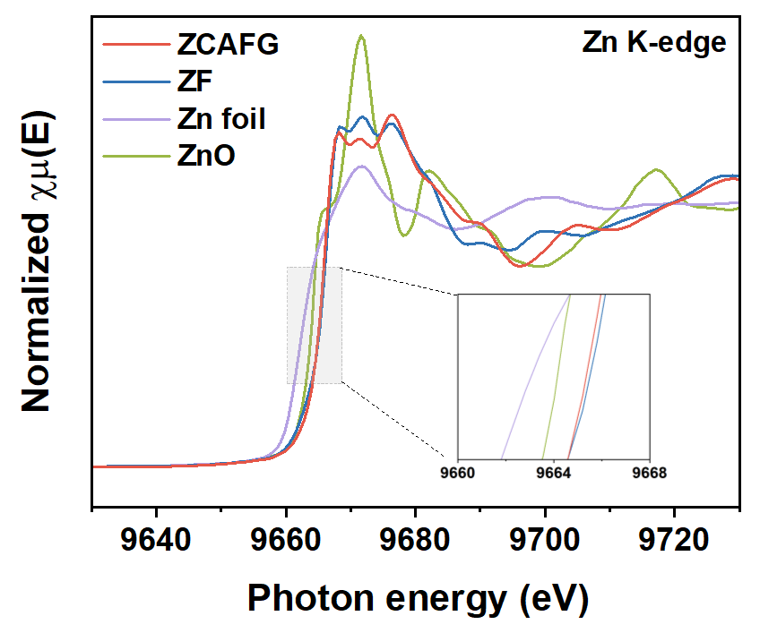
Figure S9. Zn K-edge XANES spectra of ZF-LEO and ZCAFG-HEO catalysts.

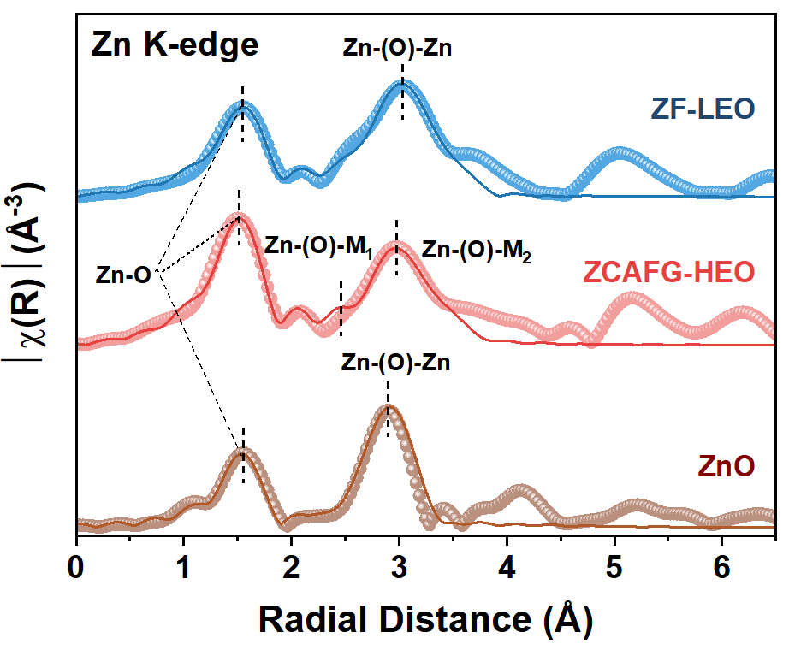
Figure S10. Zn K-edge Fourier-transformed intensities of EXAFS spectra of ZF-LEO and ZCAFG-HEO catalysts.

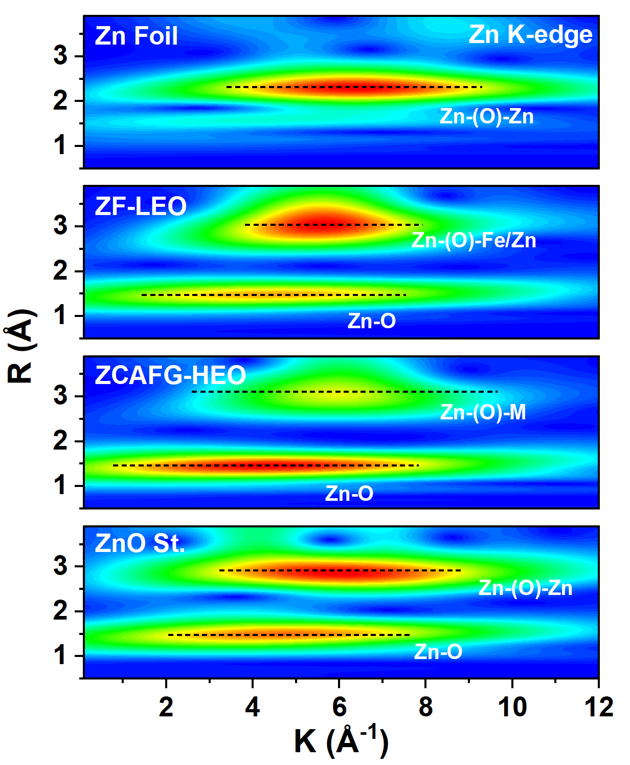
Figure S11. Zn K-edge wavelet transform (WT)-EXAFS spectra of the fresh ZF-LEO and ZCAFG-HEO.

Figure S12. Fe 2p XPS spectra of (a) ZF-LEO and (b) ZCAFG-HEO.

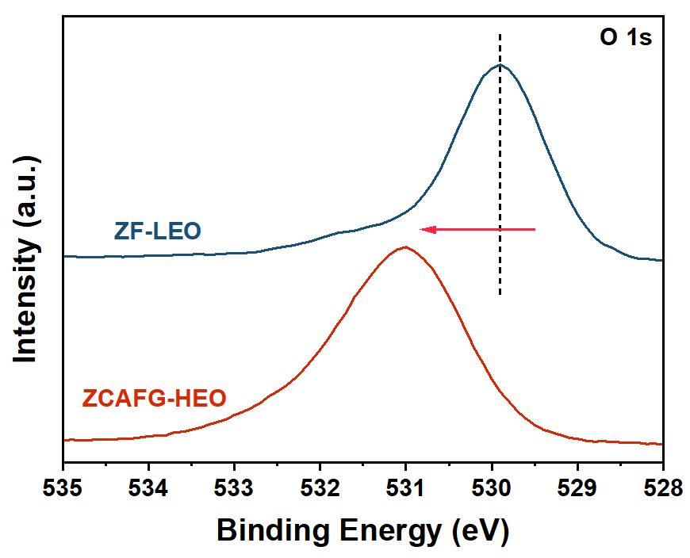
Figure S13. O 1s XPS spectra of the fresh catalysts.

Figure S14. Bader charge and the electron localization function (ELF) slice for the side view of (a) ZF-LEO and (b) ZCAFG-HEO.

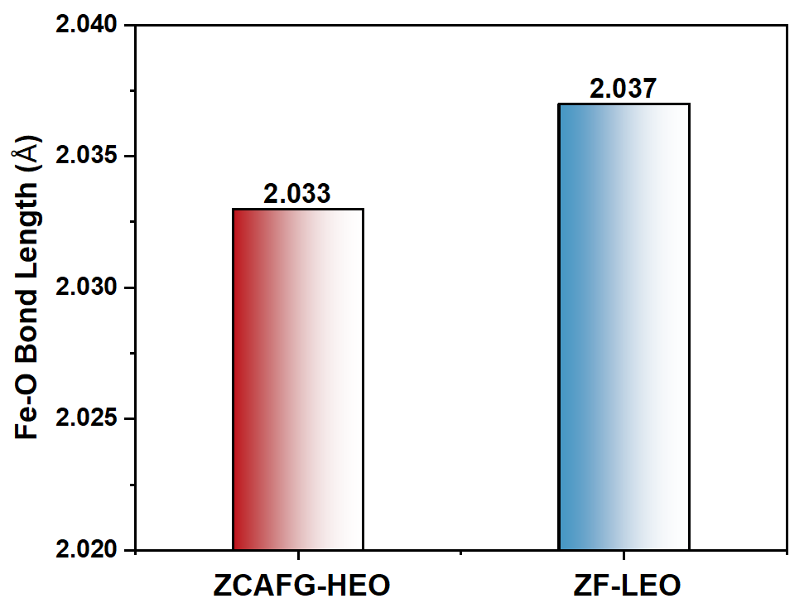
Figure S15. The Fe–O bond length of ZCAFG-HEO and ZF-LEO.

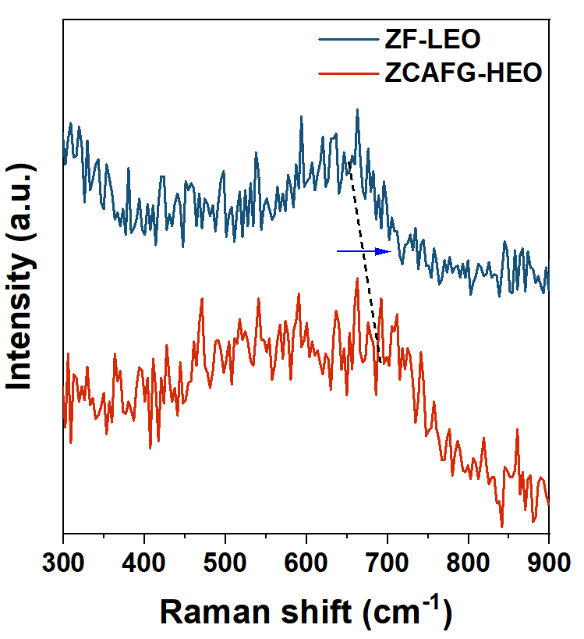
Figure S16. Raman spectra of ZCAFG-HEO and ZF-LEO.

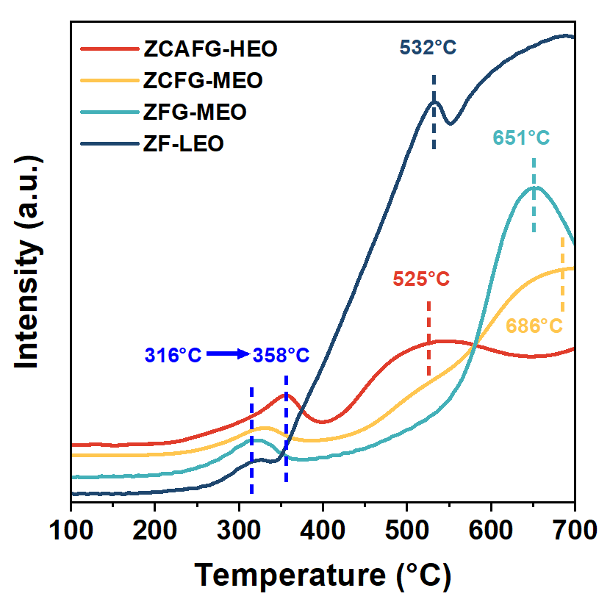
Figure S17. The H₂-TPR results for catalysts.

Figure S18 Catalytic performance of (a) ZFG-MEO and (b) ZCFG-MEO catalysts.
Reaction conditions: 5 MPa、24000 mL·g⁻¹·h⁻¹、280-360 °C、CO₂/H₂/N₂=24/72/4

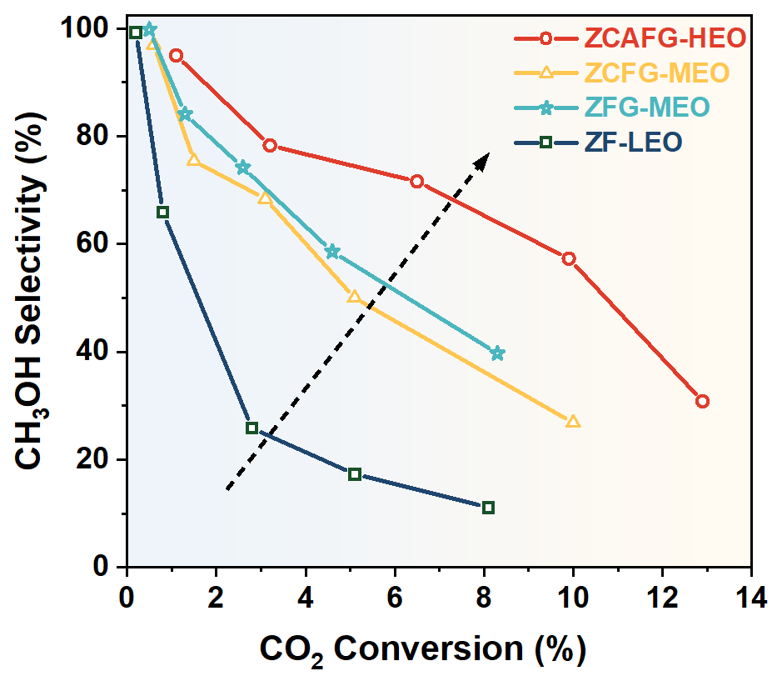
Figure S19. CH₃OH selectivity as a function of CO₂ conversion over different catalysts. Reaction conditions: 5 MPa, 24000 mL·g⁻¹·h⁻¹, 280-360 °C, CO₂/H₂/N₂=24/72/4

Figure S20. Catalytic performance at (a) different pressures and (b) different GHSV on ZCAFG-HEO catalyst. Reaction conditions: (a) reaction temperature of 320 °C, WHSV=24000 mL·g⁻¹·h⁻¹, (b) reaction temperature of 320 °C, a pressure of 5 MPa.

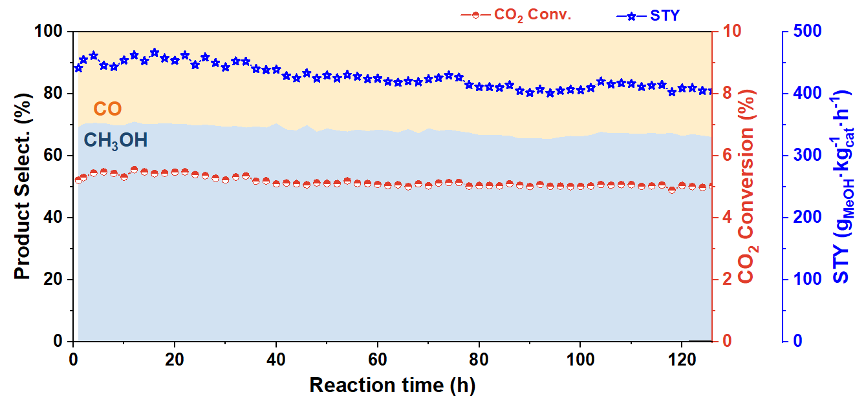
Figure S21. Stability test of ZCAFG-HEO catalyst. Reaction conditions: 5 MPa, 36000 mL·g⁻¹·h⁻¹, 320 °C, CO₂/H₂/N₂=24/72/4

Figure S22. (a)TEM image and (b) corresponding particle size distribution graph of the spent ZCAFG-HEO.

Figure S23. TEM of spent ZF-LEO catalysts.

Figure S24. EDX-mapping of the spent ZF-LEO catalyst.
Figure S25. In-situ DRIFTS spectra of ZF-LEO catalysts.

Figure S26. In-situ DRIFTS spectra of ZCAFG-HEO catalysts.

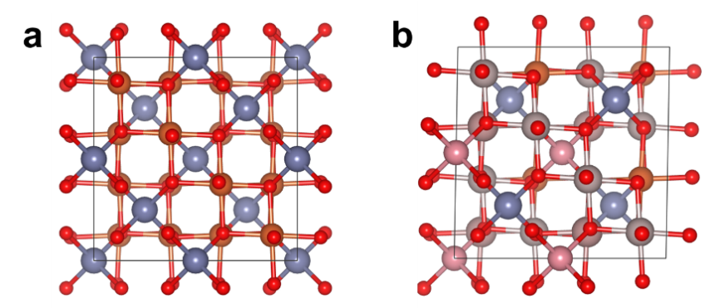
Figure S27. Optimized bulk structure of (a) ZF-LEO and (b) ZCAFG-HEO. Zinc (purple), Cobalt (pink), Aluminum (grey), Iron (yellow), Gallium (brown), and Oxygen (red).

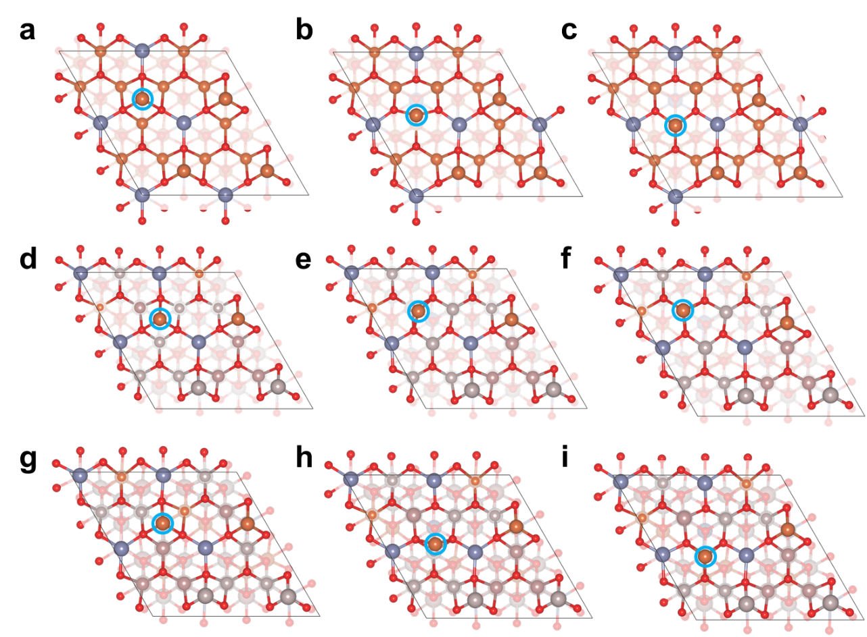
Figure S28. The optimized Fe segregation process. The initial state, transition state, and final state correspond respectively to (a-c) for ZF-LEO, and (d-f) over Ga_{L} as well as (g-i) over Al_{L} on ZCAFG-HEO. The migrating Fe atoms are highlighted with light blue circles. Zinc (purple), Cobalt (pink), Aluminum (grey), Iron (yellow), Gallium (brown), and Oxygen (red).

Figure S29. Bader charge and the electron localization function (ELF) slice for the side view of (a) ZF-LEO and (b) over Al_{L} on ZCAFG-HEO surfaces. (c) Crystal orbital Hamilton population (COHP) analysis between the transition-state Fe atom and surface O atom. Zinc (purple), Cobalt (pink), Aluminum (grey), Iron (yellow), Gallium (brown), and Oxygen (red).

Supplementary Tables

Table S1. Rietveld refinement factors (Rp, χ²), lattice constant (a,b,c), unit cell volume (V) obtained from Rietveld refinement of catalysts.
 | ZF-LEO | ZFG-MEO | ZCFG-MEO | ZCAFG-HEO
Space group | Fd3m | Fd3m | Fd3m | Fd3m
a=b=c (Å) | 8.4465 | 8.3966 | 8.3669 | 8.2123
V (Å³) | 602.592 | 591.974 | 585.714 | 553.845
R_{p} (%) | 2.71 | 3.83 | 2.27 | 1.96
χ² | 2.84 | 4.29 | 3.45 | 2.33

Table S2. Composition and structural properties of fresh catalysts.
Catalyst | Actual molar ratio (%)ª |  |  |  |  | S_{BET}  (m²∙g⁻¹)^{b} | D_{av}  (nm)^{c} | V_{t}  (cm³∙g⁻¹)^{d}
Catalyst | Zn | Co | Al | Fe | Ga | S_{BET}  (m²∙g⁻¹)^{b} | D_{av}  (nm)^{c} | V_{t}  (cm³∙g⁻¹)^{d}
ZF-LEO | 33.9 | - | - | 66.1 | - | 29.8 | 0.58 | 42.3
ZFG-MEO | 33.9 | - | - | 33.8 | 32.3 | 25.6 | 0.17 | 3.0
ZCFG-MEO | 17.0 | 16.1 | - | 33.5 | 33.4 | 30.2 | 0.17 | 3.0
ZCAFG-HEO | 17.6 | 16.4 | 31.9 | 16.8 | 17.3 | 50.0 | 0.16 | 3.4
Note:
a: Actual molar ratio was measured by ICP-OES.
b: S_{BET} is the Brunauer-Emmett-Teller (BET) specific surface area.
c: D_{av} is the average pore size.
d: V_{t} is the total pore volume.

Table S3. EXAFS fitting parameters at the Fe K-edge for various samples (related to Figure 1g).
Sample | Path | CN | R(Å) | σ² | ΔE₀ | R factor
Fe₂O₃ | Fe–O | 4.3±0.8 | 2.0±0.014 | 0.0112 | 1.0±1.2 | 0.0157
Fe₂O₃ | Fe–Fe₁ | 3.7±0.4 | 2.9±0.011 | 0.0062 | 1.0±1.2 | 0.0157
Fe₂O₃ | Fe–Fe₂ | 1.0±0.2 | 3.3±0.019 | 0.0113 | 1.0±1.2 | 0.0157
Fe₂O₃ | Fe–Fe₃ | 6.9±4.2 | 3.9±0.012 | 0.0062 | 1.0±1.2 | 0.0157
ZF-LEO | Fe–O | 5.0±0.2 | 2.01±0.006 | 0.0064 | 2.5±0.6 | 0.0059
ZF-LEO | Fe–(O)–Fe | 6.9±0.3 | 3.00±0.006 | 0.0084 | 2.5±0.6 | 0.0059
ZF-LEO | Fe–(O)–Zn | 3.4±0.4 | 3.51±0.009 | 0.0058 | 2.5±0.6 | 0.0059
ZCAFG-HEO | Fe–O | 4.4±0.3 | 1.98±0.016 | 0.0076 | 3.9±0.7 | 0.0162
ZCAFG-HEO | Fe–(O)–M₁ | 2.7±0.6 | 2.95±0.015 | 0.0091 | 3.9±0.7 | 0.0162
ZCAFG-HEO | Fe–(O)–M₂ | 3.3±0.7 | 3.45±0.015 | 0.0071 | 3.9±0.7 | 0.0162

Note: CN, coordination number; R, distance between absorber and backscatter atoms; σ², Debye-Waller factor to account for both thermal and structural disorders; ΔE₀, inner potential correction. R factor indicates the goodness of the fitting results.

Table S4. EXAFS fitting parameters at the Zn K-edge for various samples (related to Figure S10).
Sample | Path | CN | R(Å) | σ² | ΔE₀ | R factor
ZnO | Zn–O | 3.4±0.4 | 1.95±0.016 | 0.0041 | 2.9±1.0 | 0.0195
ZnO | Zn–(O)–Zn | 13.0±1.3 | 3.22±0.014 | 0.0093 | 2.9±1.0 | 0.0195
ZF-LEO | Zn–O | 3.3±0.4 | 1.97±0.014 | 0.0035 | 3.3±1.4 | 0.0111
ZF-LEO | Zn–(O)–Fe | 14.5±1.4 | 3.49±0.017 | 0.0063 | 3.3±1.4 | 0.0111
ZF-LEO | Zn–(O)–Zn | 8.1±1.5 | 3.65±0.022 | 0.0025 | 3.3±1.4 | 0.0111
ZCAFG-HEO | Zn–O | 3.2±0.2 | 1.94±0.009 | 0.0031 | 2.2±1.1 | 0.0144
ZCAFG-HEO | Zn–(O)–M₁ | 6.8±0.8 | 3.45±0.014 | 0.0079 | 2.2±1.1 | 0.0144
ZCAFG-HEO | Zn–(O)–M₂ | 3.5±0.7 | 3.80±0.025 | 0.0010 | 2.2±1.1 | 0.0144

Note: CN, coordination number; R, distance between absorber and backscatter atoms; σ², Debye-Waller factor to account for both thermal and structural disorders; ΔE₀, inner potential correction. R factor indicates the goodness of the fitting results.

Table S5. The catalytic performance of the catalysts at 320 °C (related to Figure 2c).
Sample | CO₂ Conv.(%) | Selectivity(C-mol%) |  |  |  |  |  | CH₃OH  STY
Sample | CO₂ Conv.(%) | CH₃OH | CO | CH₄ | C₂₊ |  | g·kg_{cat}⁻¹·h⁻¹
ZF-LEO | 2.8 | 25.8 | 56.6 | 15.1 | 2.5 |  |  | 59
ZFG-MEO | 2.6 | 74.2 | 25.4 | 0.4 | 0 |  |  | 158
ZCFG-MEO | 3.1 | 68.4 | 30.6 | 1.0 | 0 |  |  | 174
ZCAFG-HEO | 6.5 | 71.6 | 28.1 | 0.3 | 0 |  |  | 381
Reaction conditions: 5 MPa, 24,000 mL·g⁻¹·h⁻¹, 320 °C, CO₂/H₂/N₂=24/72/4.

Table S6. Comparison of the catalytic performance between our catalyst and the other reported catalysts. (related to Figure 2d).
catalyst | T  (°C) | P  (MPa) | CO₂  conversion  (%) | methanol selectivity(%) | GHSV  (ml·g⁻¹·h⁻¹) | CH₃OH  STY  (g·kg_{cat}⁻¹·h⁻¹) | ref
ZnFe₂O₄ | 300 | 5 | 5.8 | 70 | 2000 | 30 | [13]
ZnAl₂O_{x} | 300 | 3 | 3.9 | 68 | 6000 | 96.0 | [14]
ZnGa₂O_{x} | 300 | 3 | 4.5 | 78 | 6000 | 127.6 | [14]
ZnFe₂O_{x} | 300 | 3 | 6.2 | 17 | 6000 | 38.3 | [14]
ZnCr₂O_{x} | 300 | 3 | 2.4 | 8 | 6000 | 7.0 | [14]
ZnAl₂O_{x} | 280 | 3 | 4 | 40 | 1800 | 8.2 | [15]
ZnAl-C | 340 | 2 | 7.5 | 15 | 10000 | 38.6 | [16]
4wt%Cu-ZnAl₂O_{x} | 220 | 3 | 12.3 | 97.2 | 9000ª | 317 | [17]
ZnAl₂O_{x} | 220 | 3 | 6.2 | 38.2 | 9000ª | 63 | [17]
8wt%Cu-ZnAl₂O₄ | 220 | 3 | 11.3 | 85 | 9000ª | 248 | [18]
8wt%Cu-ZnAl₂O₄ | 200 | 3 | 12.9 | 95.9 | 9000ª | 328 | [19]
Mg_{0.2}Cu_{0.8}Al₂O₄ | 230 | 1 | 2 | 20 | 12000 | 14 | [20]
ZnO-ZrO₂ | 320 | 5 | 10 | 90 | 24000 | 737 | [21]
CPstd-ZnZrO_{x} | 320 | 5 | 6.3 | 84 | 24000 | 435.2 | [22]
In₂O₃/ZrO₂ | 300 | 5 | 11.1 | 63.2 | 21000 | 409.6 | [23]
Ni(6)-In₂O₃(31)-ZrO₂ | 260 | 3 | 7.5 | 51.8 | 30000 | 330 | [24]
Si/In₂O₃ | 310 | 3 | 7 | 85 | 18000 | 252 | [25]
95In₂O₃-5Al₂O₃ | 260 | 3 | 1.7 | 63 | 30000 | 74 | [26]
In₂O₃@ZrO₂ | 290 | 5 | 11.3 | 80.3 | 24000 | 620 | [27]
In₂O₃ | 330 | 3 | 9.9 | 72.3 | 12000 | 268.8 | [28]
h- In₂O₃-R | 300 | 5 | 6.7 | 99.5 | 20000 | 364.8 | [29]
In₂O₃ | 280 | 5 | 3.9 | 84 | 24000 | 220.8 | [30]
InZr | 300 | 5 | 13.4 | 70.4 | 20000 | 483 | [31]
ZCAFG-HEO | 340 | 5 | 9.9 | 57.3 | 24000 | 464 | This  work
ZCAFG-HEO | 320 | 5 | 4.9 | 73.3 | 36000 | 444 | This  work
ZCAFG-HEO | 320 | 5 | 3.8 | 72.7 | 48000 | 455 | This  work
ZCAFG-HEO | 320 | 5 | 3.3 | 73.3 | 60000 | 498 | This  work
ªThe unit of GSHV is h⁻¹.

Table S7. Determination of apparent activation energies and the pre-exponential factor of the catalysts.
 | ZF-LEO | ZFG-MEO | ZCFG-MEO | ZCAFG-HEO
line | y=-10.651x+15.23 | y=-11.108x+16.91 | y=-11.897x+18.33 | y=-13.791x+22.35
R² | 0.93 | 0.99 | 1.00 | 0.98
Ea | 88.55 kJ/mol | 92.35 kJ/mol | 98.91 kJ/mol | 114.66 kJ/mol
A₀ | 4.11×10⁶ | 2.21×10⁷ | 9.13×10⁷ | 5.09×10⁹
The apparent activation energies (E_{a}) of the catalysts were determined from the Arrhenius equation ((ln(K) =ln(A)-E_{a}/RT).

Supplementary References

1. Li, Y. et al. Cu-based high-entropy two-dimensional oxide as stable and active photothermal catalyst. Nat. Commun. 14, 3171 (2023).
2. Kresse, G. & Furthmüller, J. Efficiency of ab-initio total energy calculations for metals and semiconductors using a plane-wave basis set. Comput. Mater. Sci. 6, 15-50 (1996).
3. Han, S. J. et al. Identification of active sites for CO₂ hydrogenation in Fe catalysts by first-principles microkinetic modelling. J. Mater. Chem. A. 8, 13014-13023 (2020).
4. Perdew, J. P., Burke, K. & Ernzerhof, M. Generalized gradient approximation made simple. Phys. Rev. Lett. 77, 3865-3868 (1996).
5. Blochl, P. E. Projector augmented-+rave method. Phys. Rev. B. 50, 117979-175953 (1994).
6. Grimme, S., Antony, J., Ehrlich, S. & Krieg, H. A consistent and accurate ab initio parametrization of density functional dispersion correction (DFT-D) for the 94 elements H-Pu. ‌ J. Chem. Phys. 132, 154104 (2010).
7. Jain, A. et al. Formation enthalpies by mixing GGA and GGA + U calculations. Phys. Rev. B. 84, 1505-1509 (2011).
8. Song, Z. et al. Effect of Ti doping on heterogeneous oxidation of NO over Fe₃O₄ (111) surface by H₂O₂: A density functional study. Chem. Eng. J. 354, 517-524 (2018).
9. Henkelman, G., Uberuaga, B. P. & Jónsson, H. A climbing image nudged elastic band method for finding saddle points and minimum energy paths. J. Chem. Phys. 113, 9901-9904 (2000).
10. Maintz, S., Deringer, V. L., Tchougréeff, A. L. & Dronskowski, R. LOBSTER: A tool to extract chemical bonding from plane-wave based DFT. J. Comput. Chem. 37, 1030-1035 (2016).
11. Nelson, R. et al. LOBSTER : Local orbital projections, atomic charges, and chemical‐bonding analysis fromprojector‐augmented‐wave‐based density‐functional theory. J. Comput. Chem. 41, 1931-1940 (2020).
12. Wang, V., Xu, N., Liu, J., Tang, G. & Geng, W. VASPKIT: A user-friendly interface facilitating high-throughput computing and analysis using VASP code. Comput. Phys. Commun. 267, 108033 (2021).
13. Yang, H. et al. Tuning the selectivity of CO₂ hydrogenation to alcohols by crystal structure engineering. Chem. 10, 2245-2265 (2024).
14. Wang, M. et al. Spinel nanostructures for the hydrogenation of CO₂ to methanol and hydrocarbon chemicals. J. Am. Chem. Soc. 146, 14528-14538 (2024).
15. Zhang, X. et al. Reaction-driven surface reconstruction of ZnAl₂O₄ boosts the methanol selectivity in CO₂ catalytic hydrogenation. Appl. Catal. B Environ. 284, 119700 (2021).
16. Wang, T. et al. Unveiling the promotion role of ZnO on Zn-Al spinel oxide for CO₂ hydrogenation. J. Energy Chem. 100, 18-25 (2025).
17. Wang, S., Song, L. & Qu, Z. Cu/ZnAl₂O₄ catalysts prepared by ammonia evaporation method: Improving methanol selectivity in CO₂ hydrogenation via regulation of metal-support interaction. Chem. Eng. J. 469, 144008 (2023).
18. Song, L., Wang, H., Wang, S. & Qu, Z. Dual-site activation of H₂ over Cu/ZnAl₂O₄ boosting CO₂ hydrogenation to methanol. Appl. Catal. B Environ. 322, 122137 (2023).
19. Song, L., Liu, G. & Qu, Z. Cation rearrangement at tetrahedral sites in the Cu/ZnAl₂O₄ spinel enhancing CO₂ hydrogenation to methanol. Appl. Catal. B Environ. 362, 124742 (2025).
20. Tada, S. et al. Development of CO₂-to-methanol hydrogenation catalyst by focusing on the coordination structure of the Cu species in spinel-type oxide Mg_{1–x}Cu_{x}Al₂O₄. ACS Catal. 10, 15186-15194 (2020).
21. Feng, Z. et al. Asymmetric sites on the ZnZrO_{x} catalyst for promoting formate formation and transformation in CO₂ hydrogenation. J. Am. Chem. Soc. 145, 12663-12672 (2023).
22. Lee, K., Dickieson, M. P., Jung, M., Yang, Y. & Yan, N. Structure sensitivity of ZnZrO_{x} catalysts in CO₂ hydrogenation to methanol: Significance of surface oxygen content and synthesis strategy. ACS Catal. 14, 3074-3089 (2024).
23. Shen, C. et al. Highly active ternary Ir/In₂O₃-ZrO₂ catalyst for CO₂ hydrogenation towards methanol: The role of zirconia. Appl. Catal. B Environ. 361, 124683 (2025).
24. Liu, L., Gao, Y., Zhang, H., Kosinov, N. & Hensen, E. J. M. Ni and ZrO₂ promotion of In₂O₃ for CO₂ hydrogenation to methanol. Appl. Catal. B Environ. 356, 124210 (2024).
25. Wang, H. et al. Triple the steady-state reaction rate by decorating the In₂O₃ surface with SiO for CO₂ hydrogenation. J. Energy Chem. 95, 96-105 (2024).
26. Liu, L., Mezari, B., Kosinov, N. & Hensen, E. J. M. Al promotion of In₂O₃ for CO₂ hydrogenation to methanol. ACS Catal. 13, 15730-15745 (2023).
27. Cui, W. et al. Hybrid MOF template‐directed construction of hollow‐structured In₂O₃ @ZrO₂ heterostructure for enhancing hydrogenation of CO₂ to methanol. Small. 19, 2204914 (2023).
28. Wang, W. et al. Rational control of oxygen vacancy density in In₂O₃ to boost methanol synthesis from CO₂ hydrogenation. ACS Catal. 14, 9887-9900 (2024).
29. Dang, S. et al. Rationally designed indium oxide catalysts for CO₂ hydrogenation to methanol with high activity and selectivity. Sci. Adv. 6, eaaz2060 (2020).
30. Frei, M. S. et al. Role of zirconia in indium oxide-catalyzed CO₂ hydrogenation to methanol. ACS Catal. 10, 1133-1145 (2020).
31. Xu, L. et al. Interfacial‐confined oxygen vacancy clusters in ZrO₂‐supported In₂O_{3‐ x} catalysts boost methanol production from CO₂. Angew. Chem. Int. Ed. 64, e202508091 (2025).

