Table S1 shows describes the functional traits of aquatic insects involved in this study, covering aspects of life history, mobility, morphology, and ecology of aquatic insects. A total of 13 functional traits were analyzed to comprehensively evaluate the functional diversity of aquatic insects.

Table S1 Characteristic classification of aquatic insects
 | Traits | Categories
Life history | Voltinism | Semivoltine, univoltine, bior multivoltine
Life history | Adult life span | <1 week, <1 month, >1 month
Life history | Reproduction technique | Gonochoristic, hermaphrodite
Mobility | Occurrence in drift | Rare, common, abundant
Mobility | Swimming ability | Weak, medium, strong, none
Mobility | Respiration type | Tegumentary, branchia, air (spiracles, tracheae, plastrons)
Mobility | Adult flying ability | Yes/no
Morphology | Body size | Small (< 9 mm), medium (9-16 mm), large (> 16 mm)
Morphology | Body shape | Streamlined, not streamlined
Ecology | Rheophile | Depositional only, depositional and erosional, erosional
Ecology | Temperature preference | Cool, cool/warm eurythermal, warm
Ecology | Functional feeding groups | Collector-gatherers, collector-filterers, scrapers, predators, shredders, deposit feeder
Ecology | Habit | Climbers, burrowers, sprawlers, clingers, swimmers, skate

This Fig. S1 shows that buffer zones were delineated based on the Euclidean distance between the nearest and farthest points along the river channel, using each sampling site as the center, rather than applying fixed-width buffers on both sides of the river. The figure illustrates the resulting buffer zones and the spatial distribution of deciduous forest and natural forest for three representative sampling sites.

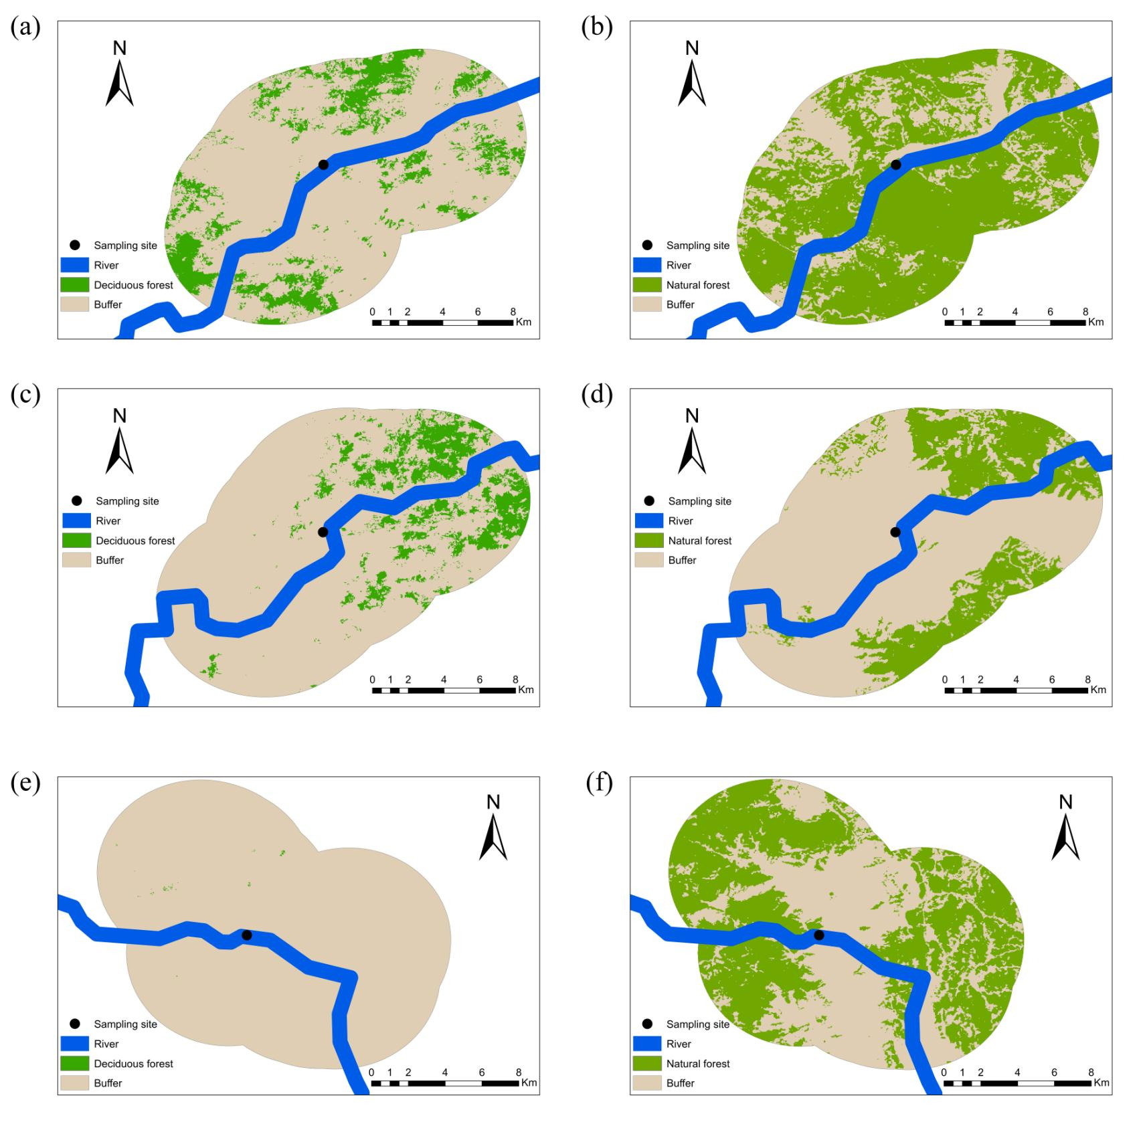
Figure S1. The buffer zone delineation of the three selected sampling sites and the spatial distribution of deciduous forest and natural forest (a and b correspond to site 1; c and d correspond to site 2; and e and f correspond to site 3).

This Fig. S2 shows that we divided the vegetation connectivity of the 198 samples we calculated into three groups through K-means clustering analysis, where H represents high vegetation connectivity, M represents medium vegetation connectivity, and L represents low vegetation connectivity.

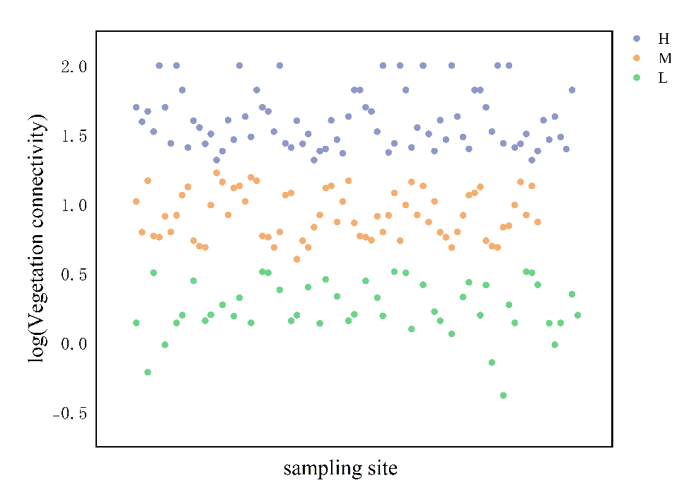
Figure S2. K-means clustering analysis chart of vegetation connectivity

Fig. S3 shows the changes in proportion of deciduous forest area and natural forest area with low, medium, and high vegetation connectivity. The results indicate that the proportion of deciduous forest area gradually increases from low vegetation connectivity to high vegetation connectivity, while the proportion of natural forest area is relatively low under low vegetation connectivity, and relatively stable under medium and high vegetation connectivity, with little difference.

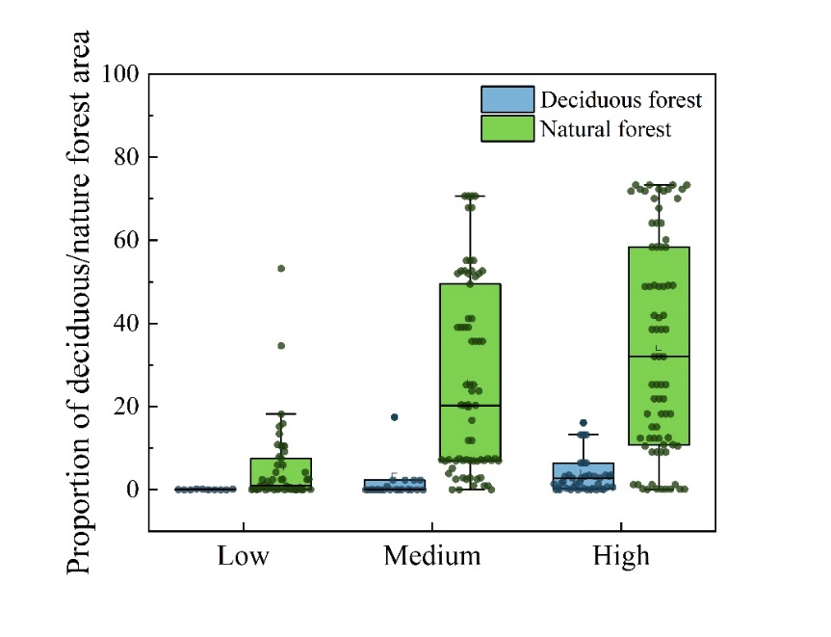
Figure S3. Changes in the proportion of deciduous forest area and natural forest area in three groups of vegetation connectivity.
Table S2 Kruskal–Wallis test displays significant difference in the proportion of deciduous forest area and natural forest area among low, medium, and high vegetation connectivity groups. This table evaluates the statistical analysis results of the impact of vegetation connectivity on the proportion of vegetation area. The degrees of freedom (DF) column indicates the DF used in the analysis, while the statistic column represents the test statistic values. The P-value column indicates the statistical significance, where values below 0.05 indicate a significant effect of vegetation connectivity on the proportion of vegetation area.

Table S2 Kruskal Wallis test shows that there are significant differences in the proportion of deciduous forest area and natural forest area among high, medium, and low vegetation connectivity groups.
Proportion of vegetation area | DF | Statistic | P value
Proportion of deciduous forest area | 2 | 30.23 | ＜0.0001
Proportion of natural forest area | 2 | 55.36 | ＜0.0001

This Fig. S4 shows the ternary diagrams of β-diversity partitioned into turnover and nestedness components for the EPT community under three levels of vegetation connectivity, where (a) represents low vegetation connectivity, (b) represents medium vegetation connectivity, and (c) represents high vegetation connectivity. Each point represents a sampling site, illustrating how β-diversity patterns vary across different levels of vegetation connectivity.
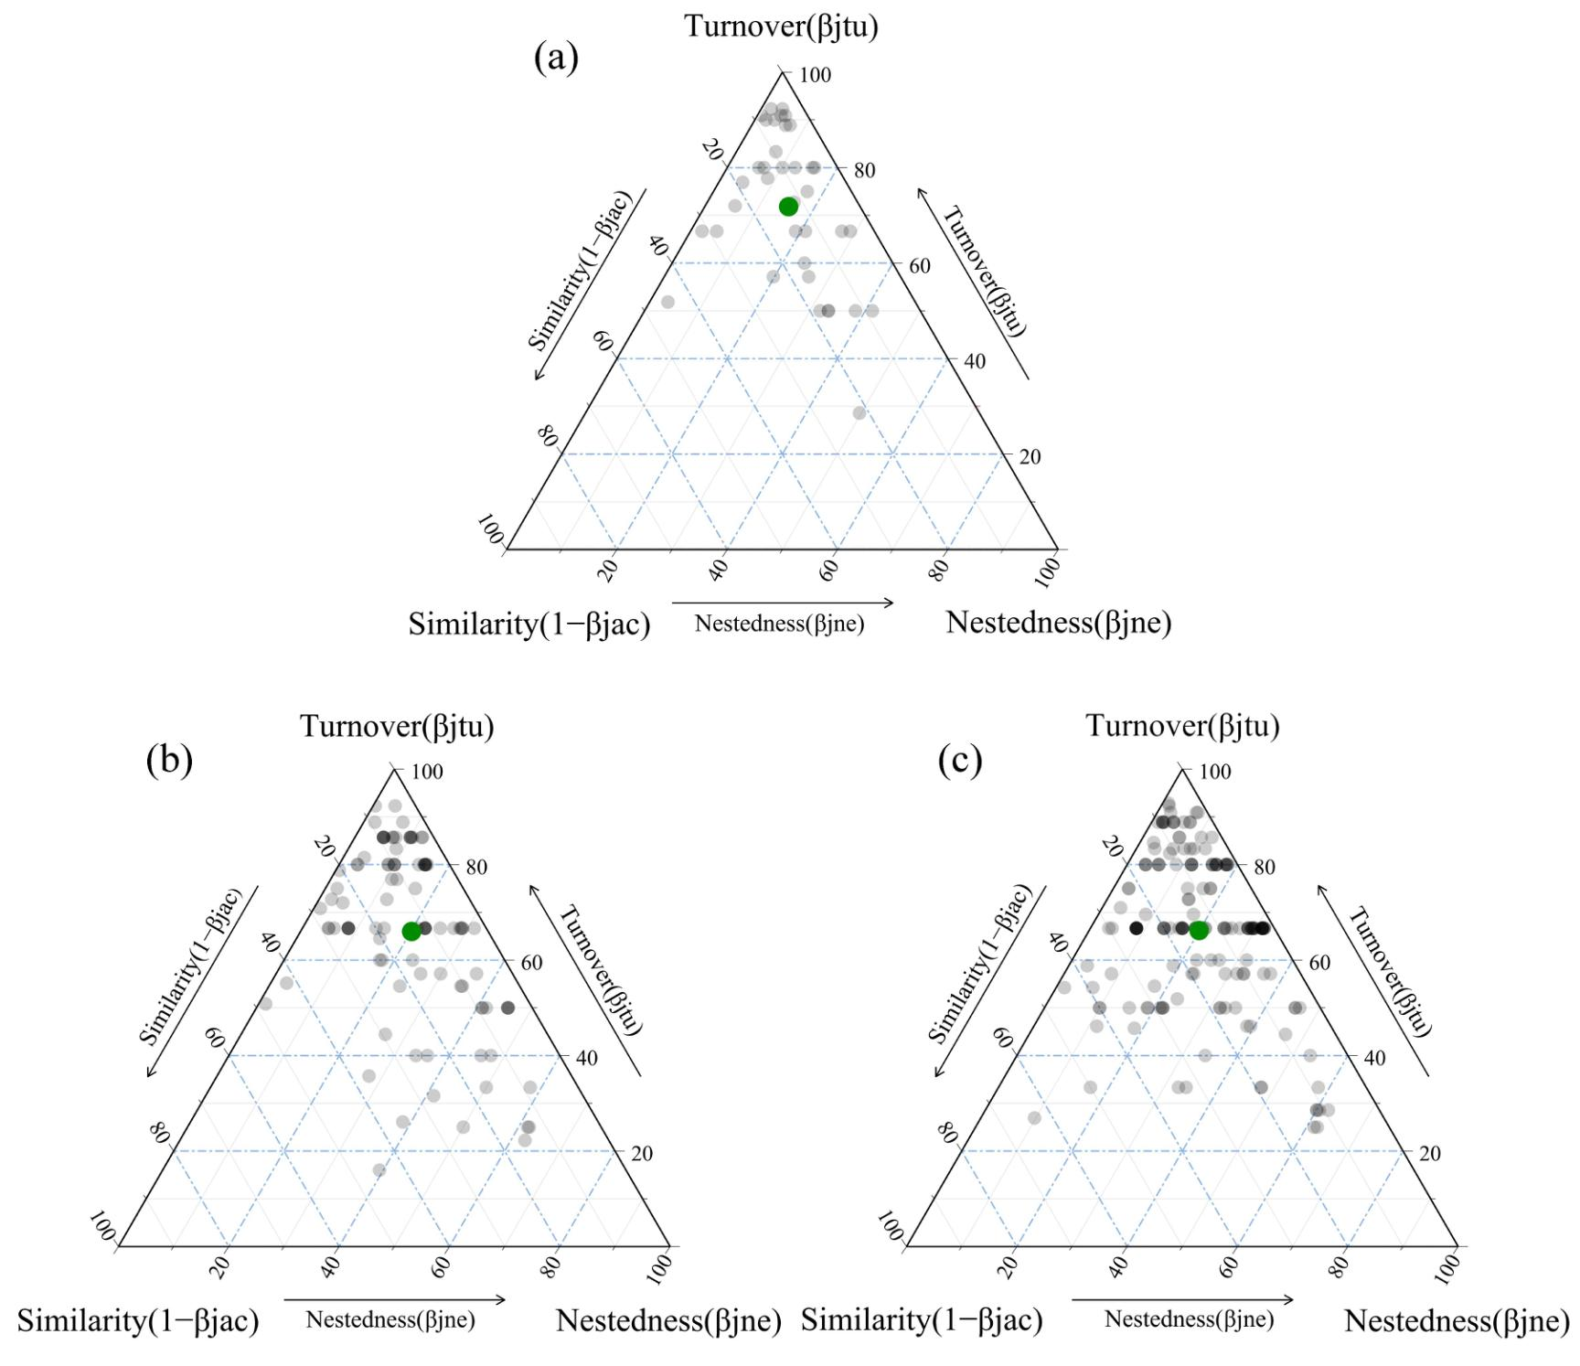
Figure S4. Ternary diagram of β-diversity (turnover, nestedness) of the EPT community under low, medium, and high connectivity (a: low vegetation connectivity; b: medium vegetation connectivity; c: high vegetation connectivity).

Fig. S5 shows the Non-metric Multidimensional Scaling (NMDS) ordination based on EPT species abundance data, illustrating the EPT community structure under different vegetation connectivity groups, where H represents high vegetation connectivity, M represents medium vegetation connectivity, and L represents low vegetation connectivity. The results showed that as vegetation connectivity increased, EPT community became more similar.

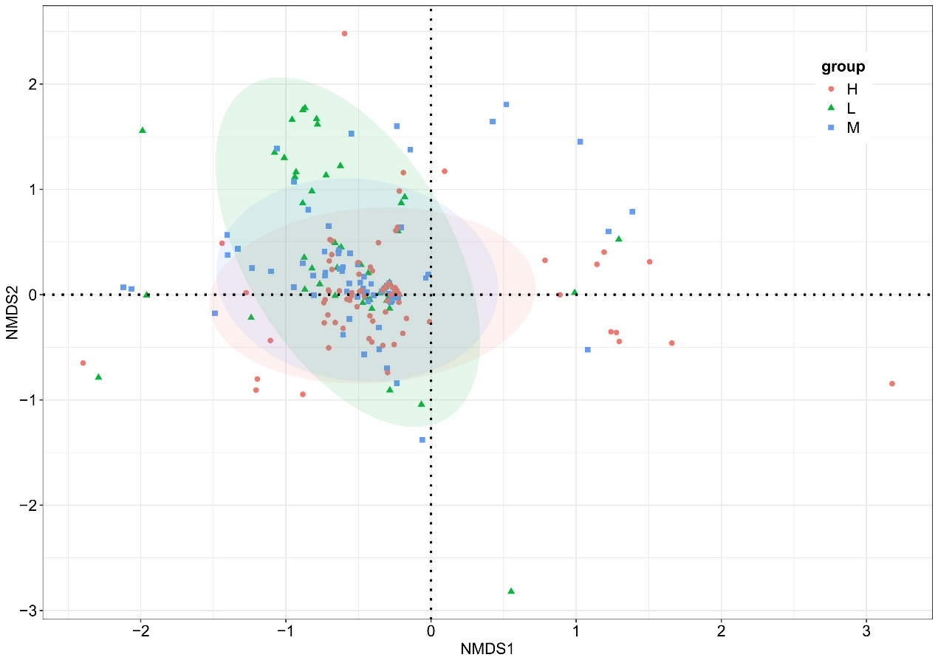
Figure S5. NMDS analysis of vegetation connectivity and EPT species abundance in riparian zones.

