Table S1. List of Antibodies
Antibody | Source (catalog)
S1PR1/EDG1 | Proteintech(55133-1-AP)
MCU/CCDC109A | Proteintech(86274-1-RR)
MT-ND1 | Servicebio(GB113284-100)
SDHB | ZENBIO(R381845)
MT-CO2 | Selleck(F2349)
UQCRC2 | Selleck(F1592)
STIM1 | ZENBIO(R25821)
COX4 | ZENBIO(T200147)
IL-33 | Proteintech(12372-1-AP)
IL-6 | Affinity(DF6087)
CD80 | Abmart(A0N0P2)
CD163 | Abmart(T56845S
NF-κB p65 | Proteintech(D3DUU0)
GAPDH | Servicebio (GB15002-100)
β-actin | Servicebio(GB15003-100)
Goat Anti-Mouse IgG (H+L) FITC | Affinity(S0007)
Goat Anti-Rabbit IgG (H+L) Fluor594 | Affinity(S0006)
Table S2. List of primers for qPCR
Human  Gene | Sequence (5‘-3’)
S1PR1 | Forward | 5'-TCATCGTCCGGCATTACAACTA-3'
 | Reverse | 5'-GAGTGAGCTTGTAGGTGGTG-3'
S1PR2 | Forward | 5'-ATGGGCAGCTTGTACTCGGAG-3'
 | Reverse | 5'-CAGCCAGCAGACGATAAAGAC -3'
S1PR3 | Forward | 5'-CTTGGTCATCTGCAGCTTCATC-3'
 | Reverse | 5'-TGCTGATGCAGAAGGCAATGTA-3'
S1PR4 | Forward | 5'-GACGCTGGGTCTACTATTGCC-3'
 | Reverse | 5'-CCTCCCGTAGGAACCACTG-3'
S1PR5 | Forward | 5'-GTGAGGTGGGAGCCATAGAA-3'
 | Reverse | 5'-TTGGCTGAGTCTCCCAGAGT-3'
CXCL14 | Forward | 5'-GGAAATGAAGCCAAAGTACCC-3'
 | Reverse | 5'-AGGCGTTGTACCACTTGATGA-3'
TGFβR2 | Forward | 5'-CAGAAATCCTGCATGAGC-3'
 | Reverse | 5'-GCAGCATCTTCCAGAATAAAG -3'
IL-33 | Forward | 5'-AGCAAAGTGGAAGAACACAGC-3'
 | Reverse | 5'-CTTCTTTGGCCTTCTGTTGG-3'
CXCL12 | Forward | 5'-ATGAACGCCAAGGTCGTG-3'
 | Reverse | 5'-CTTCGGGTCAATGCACACTT-3'
CXCL8 | Forward | 5'-ATACTCCAAACCTTTCCACCC-3'
 | Reverse | 5'-TCTGCACCCAGTTTTCCTTG-3'
LEP | Forward | 5'-GTGGCTTTGGCCCTATCTT-3'
 | Reverse | 5'-GCATACTGGTGAGGATCTGTTG-3'
IL-6 | Forward | 5'-GTAGCCGCCCCACACAGA-3'
 | Reverse | 5'-CATGTCTCCTTTCTCAGGGCTG-3'
TGFβR1 | Forward | 5'-TGGAGCCTGGACACGCAGTA-3'
 | Reverse | 5'-GCCCGGGTTATGCTGGTTG-3'
CCL21 | Forward | 5'-GCTATCCTGTTCTTGCCCCG-3'
 | Reverse | 5'-CCTTTCTTGCCAGTCTTGGAGG-3'
HMGB1 | Forward | 5'-GGCCTTCTTCCTCTTCTGCT-3'
 | Reverse | 5'-GCAACATCACCAATGGACAG-3'
Tables S3 Primer sequence for ChIP-qPCR(Human)
Target gene | Sequence (5‘-3’)
IL-6 | Forward  Reverse | TGGCAGCACAAGGCAAAC  TTCAGCCCACTTAGAGGAGGTTG
IL-33 | Forward  Reverse | TCCTCAGTATTTGCAAGAATTCCC  GGAGGGGTGACAAGTAACAGC
Table S4. shRNA Sequences for S1PR1 Knockdown
MOUSE  shRNA ID | Sequence (5‘-3’) |  | Oligo length（nt)
sh-S1PR1-1 | Forward | GATCCGACCTGTGACATCCTGTACAACTTCCTGTCAGATTGTACAGGATGTCACAGGTCTTTTTG | 65
 | Reverse | AATTCAAAAAGACCTGTGACATCCTGTACAATCTGACAGGAAGTTGTACAGGATGTCACAGGTCG | 65
sh-S1PR1-2 | Forward | GATCCCATGGAATTTAGCCGCAGCAACTTCCTGTCAGATTGCTGCGGCTAAATTCCATGTTTTTG | 65
 | Reverse | AATTCAAAAACATGGAATTTAGCCGCAGCAATCTGACAGGAAGTTGCTGCGGCTAAATTCCATGG | 65
sh-S1PR1-3 | Forward | GATCCCCATGTAAACTGGGTCAAGTTCTTCCTGTCAGAAACTTGACCCAGTTTACATGGTTTTTG | 65
 | Reverse | AATTCAAAAACCATGTAAACTGGGTCAAGTTTCTGACAGGAAGAACTTGACCCAGTTTACATGGG | 65
Table S5. siRNA Sequences for S1PR1 Knockdown
Human  siRNA ID | Sequence (5‘-3’) |  | Length(nt)
si-S1PR1-1 | sense  antisense | caguuuaaugcuguucucc  ggagaacagcattaaactg | 19  19
si-S1PR1-2 | sense  antisense | agacauaauggucucuggg  cccagagaccattatgtct | 19  19
si-S1PR1-3 | sense  antisense | uaggaagaagaguugacgu  acgtcaactcttcttccta | 19  19
Figure S1. Comparative molecular docking analyses of candidate traditional Chinese medicine–derived compounds targeting S1PR1.
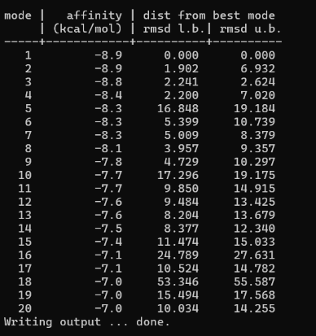
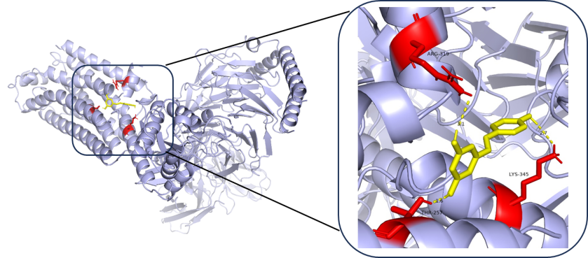

The S1PR1 protein is shown in purple, quercetin in yellow, and key interacting amino acid residues (ARG-149, TYR-58, MET-100, HIS-213, and ARG-313) in red. Yellow dashed lines indicate hydrogen bond interactions, with bond lengths labeled.
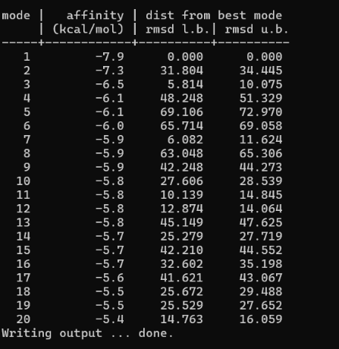
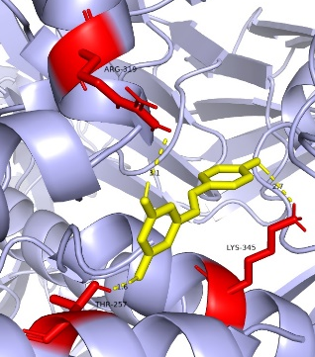
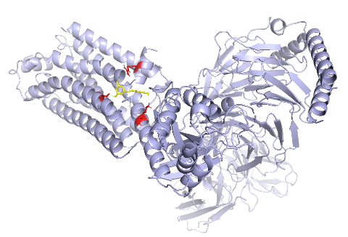

The S1PR1 protein is shown in purple, resveratrol in yellow, and key interacting amino acid residues (ARG-319, THR-257, and LYS-345) in red. Yellow dashed lines indicate hydrogen bond interactions, with bond lengths labeled.

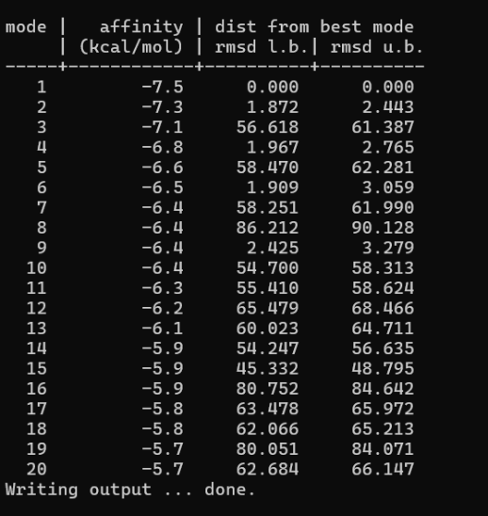
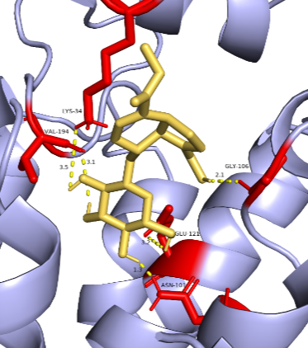
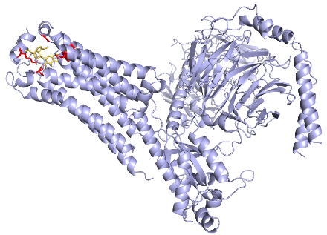

The S1PR1 protein is shown in purple, geniposide in yellow, and key interacting amino acid residues (LYS-34, VAL-194, ASN-101, GLU-121, and GLY-106) in red. Yellow dashed lines indicate hydrogen bond interactions, with bond lengths labeled.

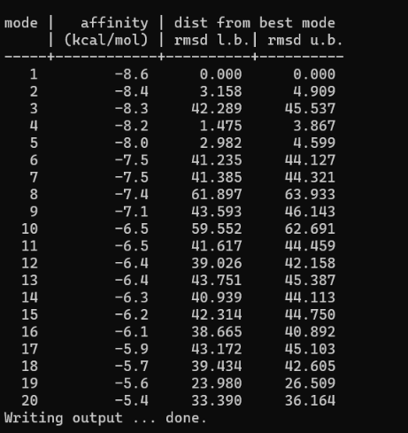
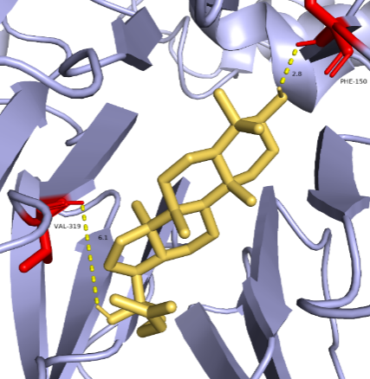
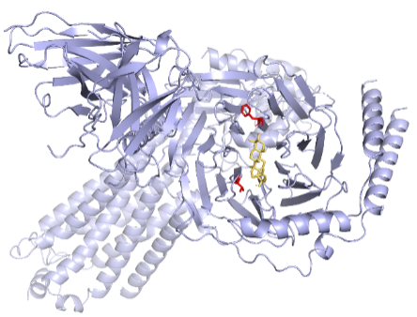

Ginsenosides are shown in yellow, and key interacting amino acid residues (PHE-150 and VAL-319) are shown in red. Yellow dashed lines indicate hydrogen bond interactions, with bond lengths labeled.

Figure S2. Confirmation of efficient S1PR1 knockdown in EMT-6 cells used for in vivo studies.

