Supplementary Information (SI)

Manuscript title: Enhancing electrical and thermoelectrical performance of Graphene nanosheets through geometrical defect engineering

Omar Hatem Nower, Alaa A. Al-jobory
Department of Physics, College of Science, University of Anbar, Anbar, Iraq
e-mail: oma24s2007@uoanbar.edu.iq
e-mail: a.al-jobory@uoanbar.edu.iq

Table 1: Summary of studied graphene nanosheet systems.
Models | Description of the strategy | The sub-system available in the appendix
Model1 | The reference (Bare-GNR) | Bare-GNR (Fig: S1(a))
Model2 | edge-to-center etching defects | GNR-ETC2, GNR-ETC3, GNR/GNR-ETC3 (Fig: S2(a,b,c))
Model3 | center-to-edge etching | GNR-CTE2 (Fig: S1(b))
Model4 | bidirectional etching | GNR-BE2 (Fig: S1(c))

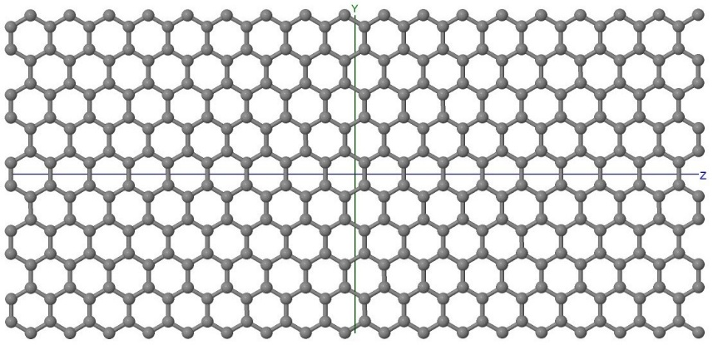
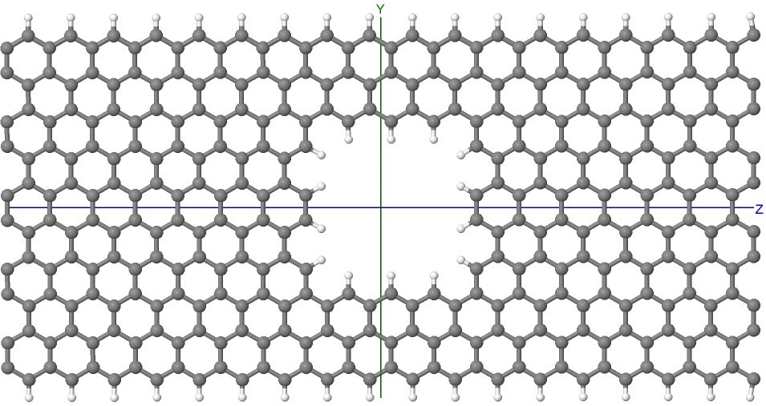
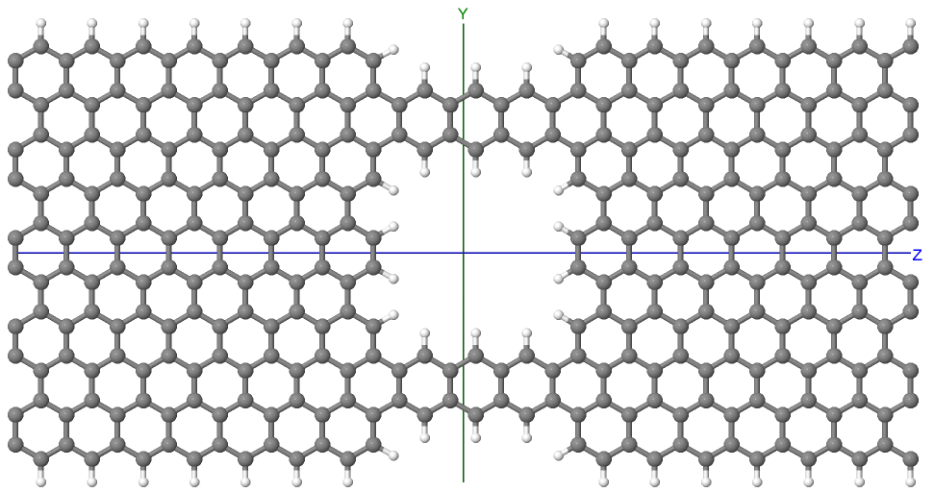
(a)
(b)
(c)
Figure S1: Geometric systems of graphene nanosheets under study, (a) Bare-GNR, (b) GNR-CTE2, (c) GNR-BE2

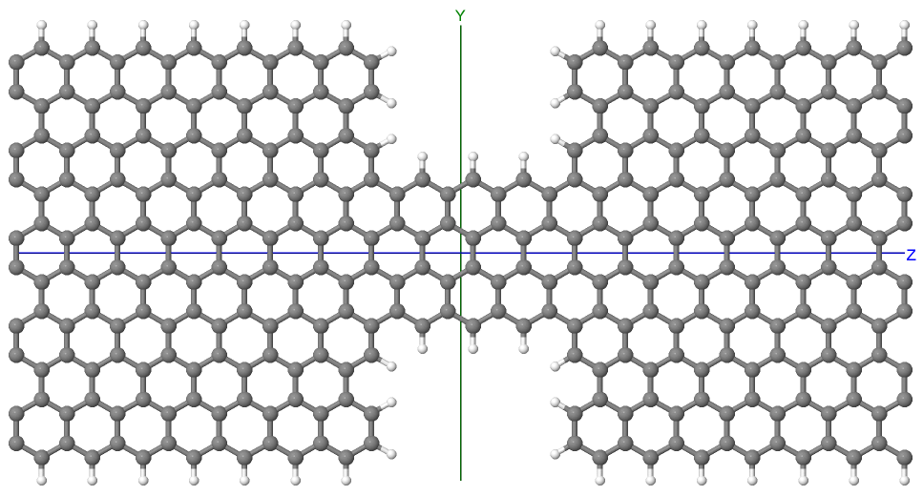
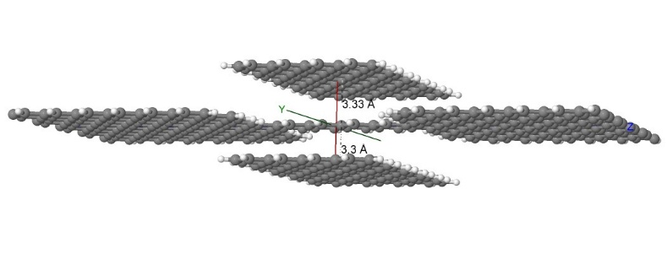
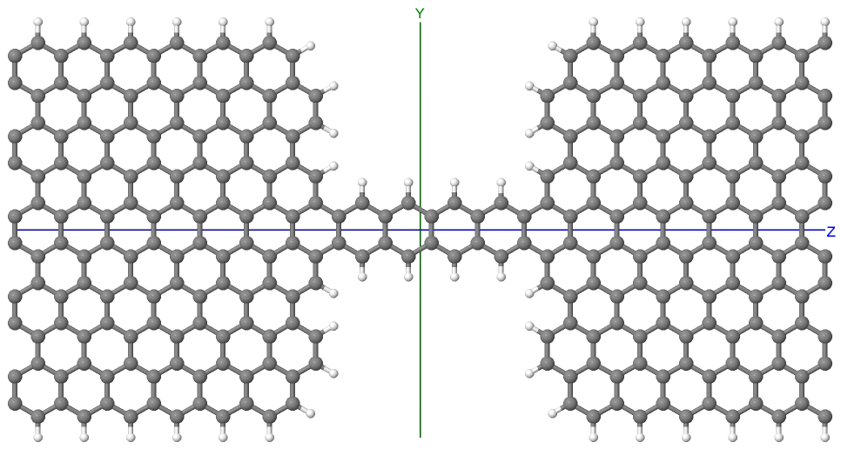
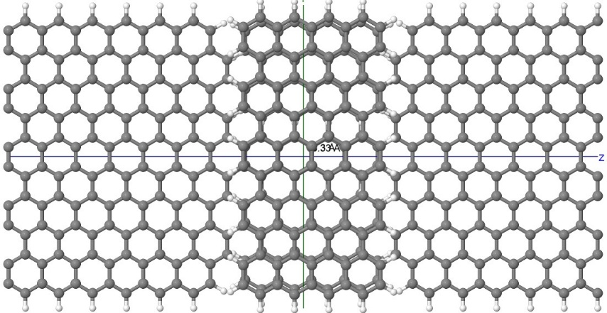
(a)
Side View
(b)
Top View
(c)
Figure S2: Geometric systems of graphene nanosheets under study, (a) GNR-ETC2, (b) GNR-ETC3,
(c) Top and side view of GNR/GNR-ETC3

