Table 1. Recovery and valid amount of questionnaire
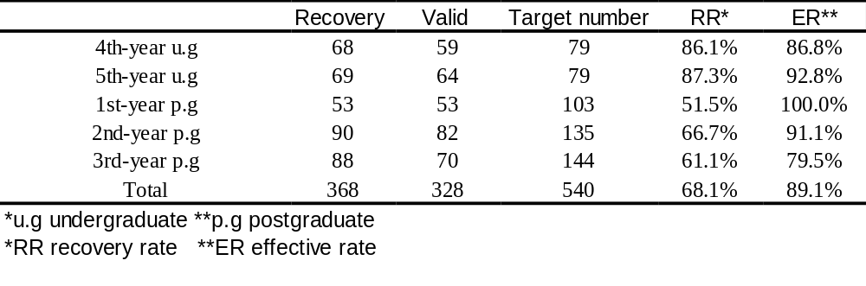

Table 2. Students response of the etiology, diagnosis and prevalence about MIH
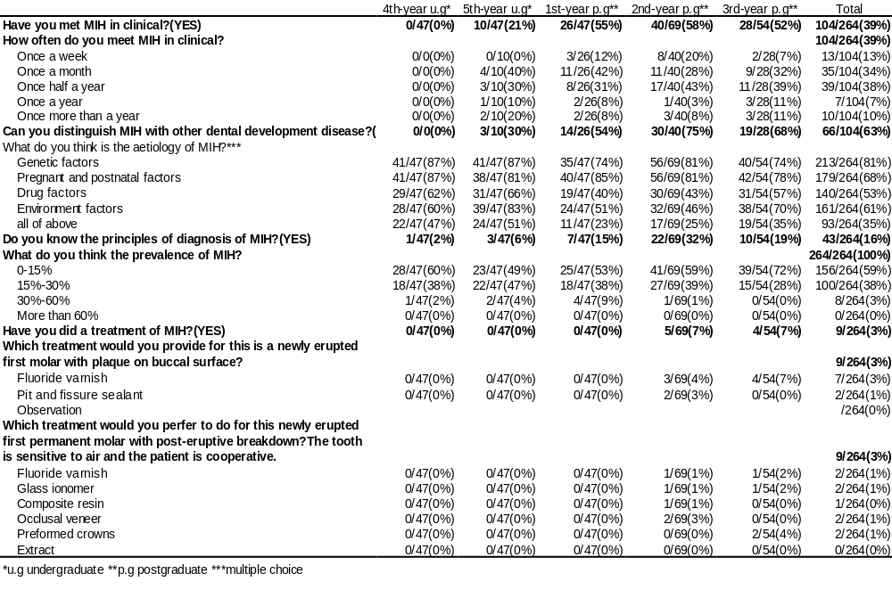

Table 3. Source of MIH knowledge and oral professional knowledge
