Supplementary Figures
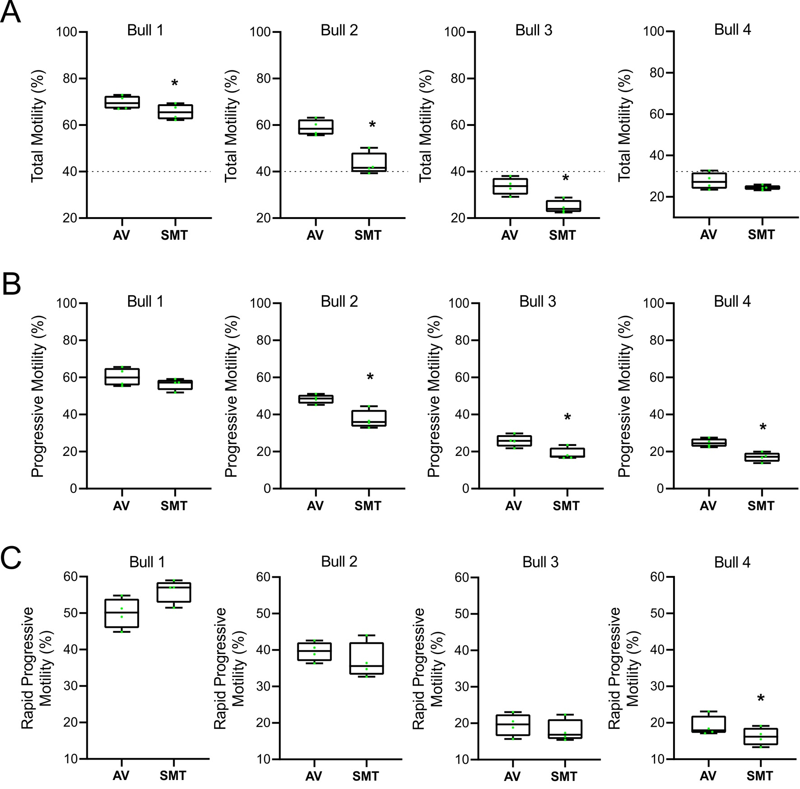

Supplementary Fig. 1 Comparative sperm motility percentage reports across individual bulls using AV and SMT software. The analysis includes semen samples of varying quality (Bull 1 to 4). The dotted line represents an arbitrary motility threshold for classification. The dots in the box plot represent individual data points. A. Total Motility. B. Progressive Motility. C. Rapid Progressive Motility. * indicates a statistically significant difference between the two CASA systems

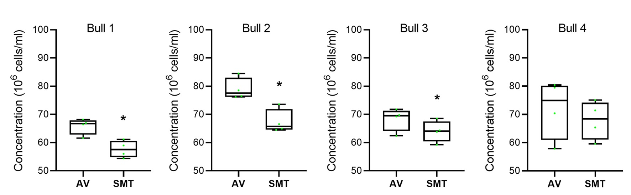
Supplementary Fig. 2 Comparative sperm concentration reports between AV and SMT software. The analysis includes semen samples from four different bulls (n=16 videos). The dots in the box plot represent individual data points. * indicates a statistically significant difference between the two CASA systems

