Supplementary Figures and Tables

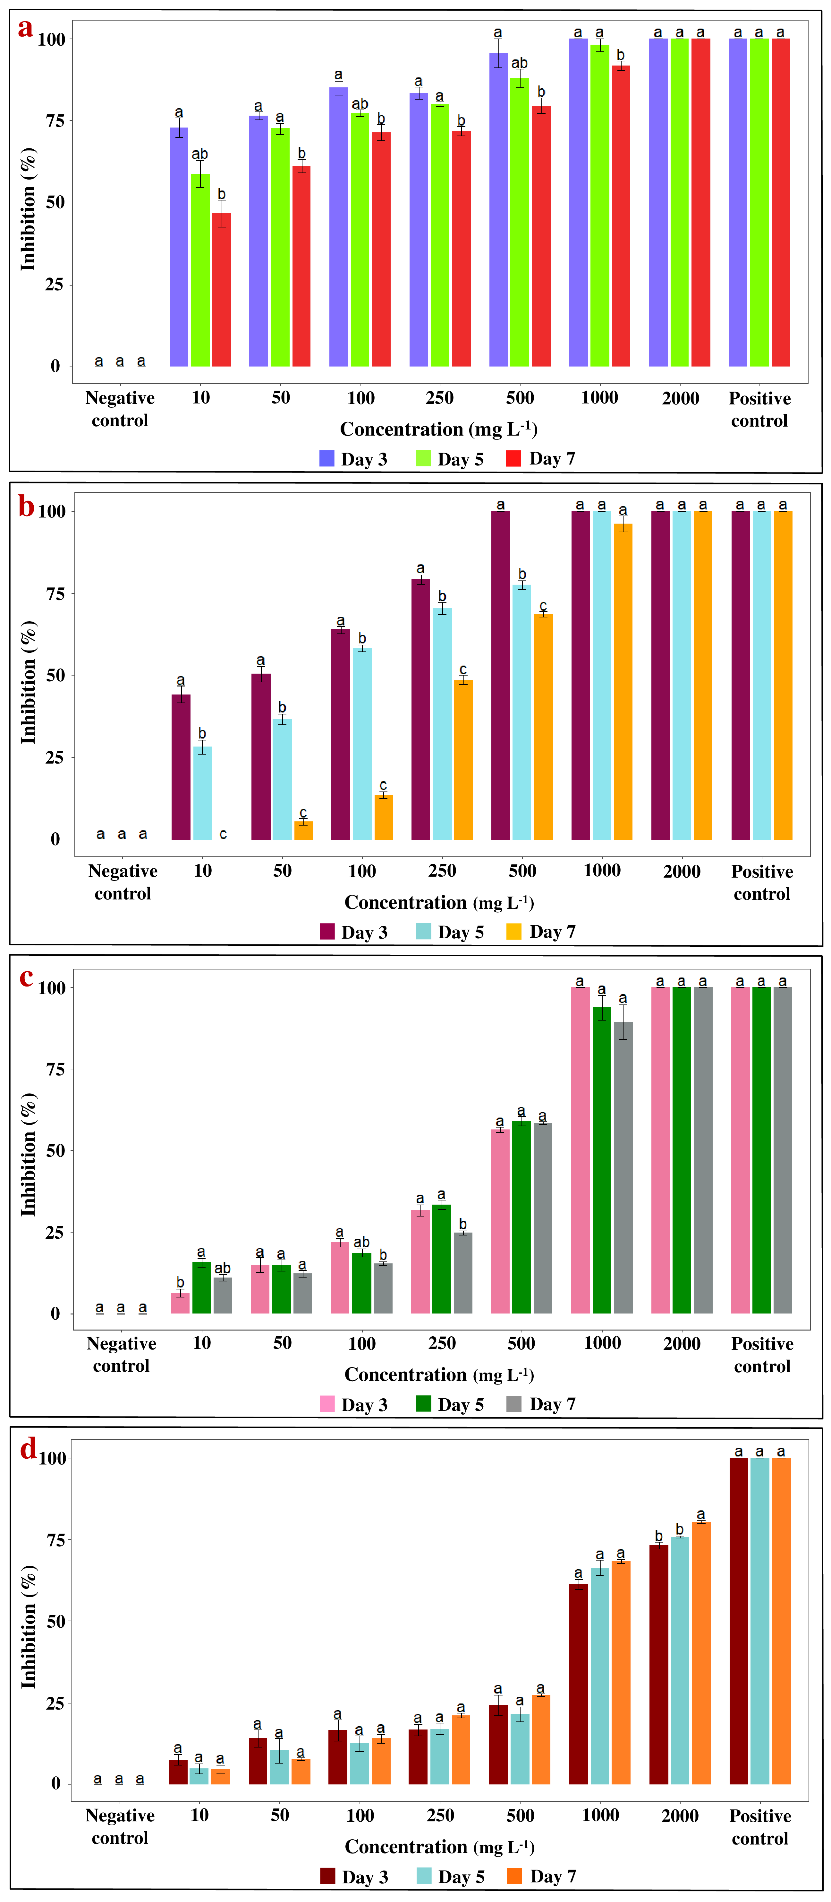
Fig. S.1. Bar plot analysis of ZnONPs (mg L⁻¹) showing percentage of inhibition against four phytopathogenic fungi at different concentrations and days intervals against: (a) Rhizoctonia solani, (b) Sclerotinia sclerotiorum, (c) Colletotrichum falcatum, and (d) Colletotrichum gloeosporioides. The inhibition percentages of specific concentrations of the ZnONPs, that exhibited significant differences, are represented by distinct letters based on Tukey’s test. Groups assigned different letters were significantly different, while those with same letter were not significantly different.

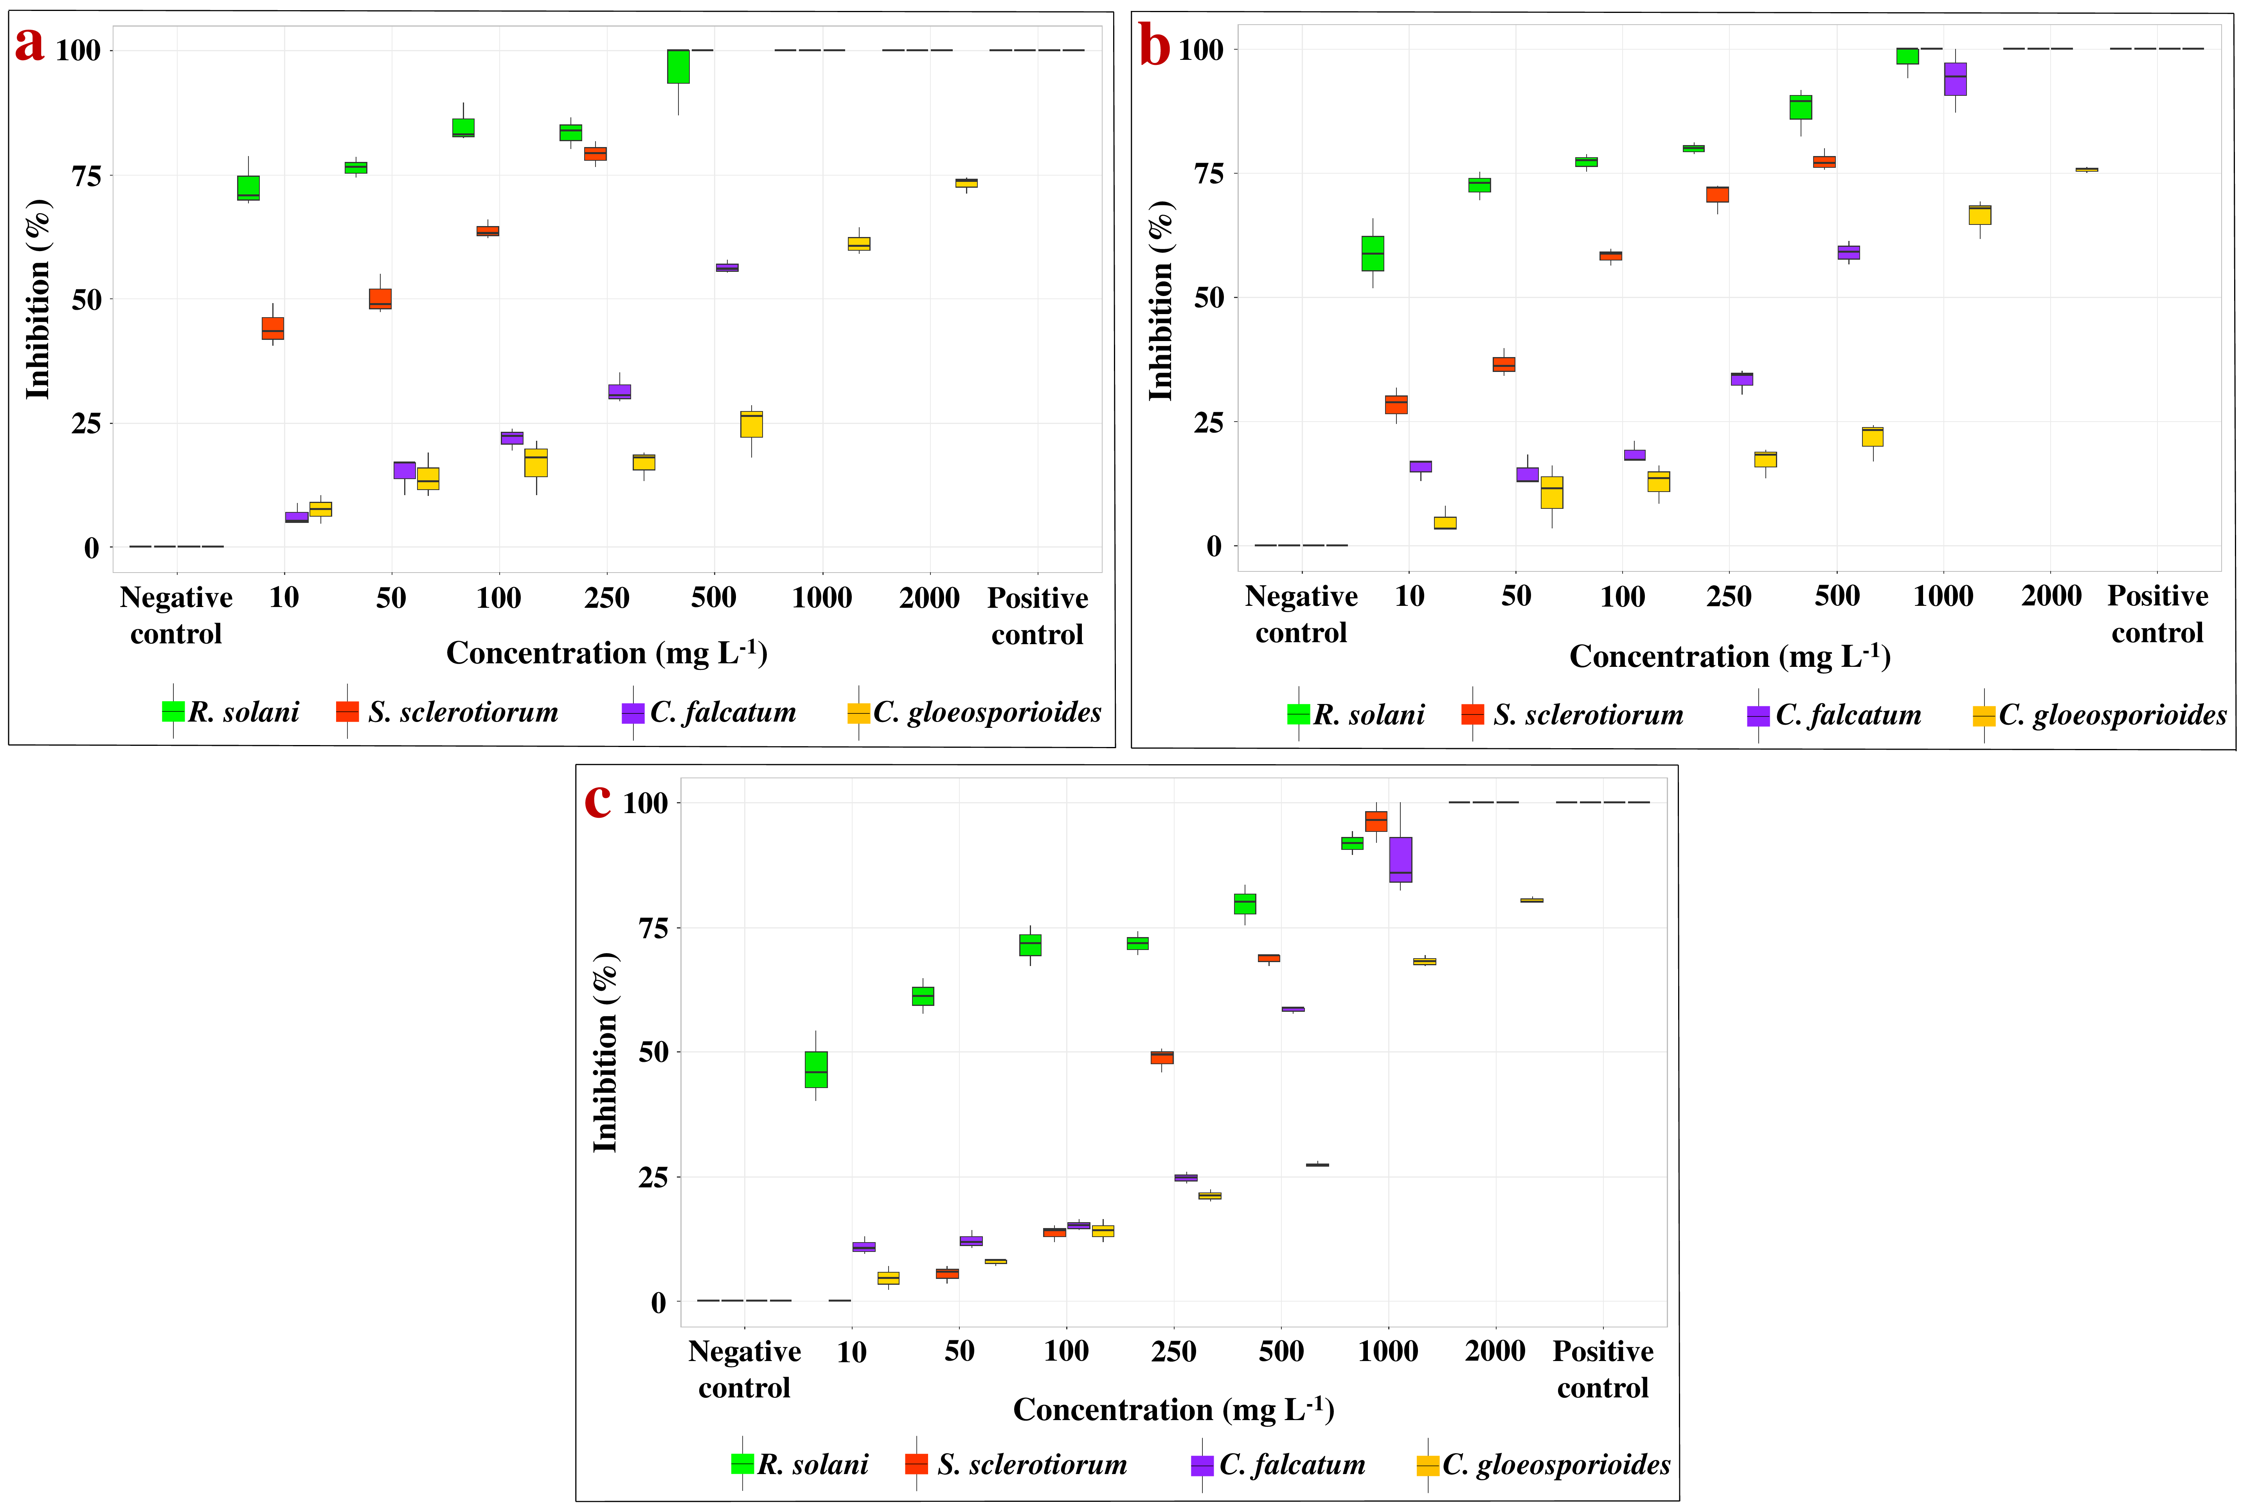
Fig. S.2. Box plot analysis illustrating the percentage of inhibition among all four phytopathogenic fungi at different concentrations of ZnONPs (mg L⁻¹) after different days of inoculation (a) Day 3, (b) Day 5, (c) Day 7.

Table S.1. Evaluation of the crystallite size of synthesized nanoparticles through X-ray diffraction analysis

Sample | 2θ (°) | (hkl) | FWHM (°) | D (nm) | D_{average} (nm)
ZnONPs | 31.8625 | 100 | 0.4418 | 17.29 | 12.28
ZnONPs | 34.4844 | 2 | 0.3400 | 22.32 | 12.28
ZnONPs | 36.3502 | 101 | 0.5302 | 14.24 | 12.28
ZnONPs | 47.8101 | 102 | 0.7765 | 9.35 | 12.28
ZnONPs | 56.6677 | 110 | 0.5990 | 11.67 | 12.28
ZnONPs | 62.9721 | 103 | 0.8100 | 8.36 | 12.28
ZnONPs | 68.0294 | 112 | 0.7760 | 8.49 | 12.28
ZnONPs | 69.2078 | 201 | 1.0010 | 6.53 | 12.28

Table S.2. Effect of ZnONPs on the suppression of anthracnose disease on Mangifera indica through detached fruit assay. Means in each column followed by the same letter were not significantly different (p < 0.05) as determined by the MANOVA and Tukey’s test. Values were the means of twenty-four replications ± standard deviation.

Treatments | Lesion diameter (mm) | Percentage of inhibition (%) | Diseased fruit area (%) | Lesion score
Control | 61.25 ±20.89ª | 0.00e | 100.00ª | 5.00ª
ZnONPs 500 mg L⁻¹ | 15.96 ±3.34^{b} | 73.95 ±5.46^{d} | 26.05 ±5.46^{b} | 1.88 ±0.34^{b}
ZnONPs 1000 mg L⁻¹ | 13.13 ±3.67^{bc} | 78.57 ±6.0^{d} | 21.43 ±6.0^{b} | 1.50 ±0.51^{b}
ZnONPs 2000 mg L⁻¹ | 11.54 ±3.41^{bcd} | 81.16 ±5.57^{bc} | 18.84 ±5.57^{cd} | 1.33 ±0.48^{c}
Untreated | 0.00^{d} | 100.00ª | 0.00e | 0.00^{d}

Table S.3. Effect of ZnONPs on the suppression of banded leaf and sheath blight disease on Zea mays through detached leaf assay. Means in each column followed by the same letter were not significantly different (p < 0.05) as determined by the MANOVA and Tukey’s test. Values were the means of nine replications ± standard deviation.

Treatments | Lesion diameter (mm) | Percentage disease incidence (%) | Percentage disease reduction (%) | Diseased leaf area (%) | Lesion score
Control | 15.33 ±2.93ª | 25.56 ±4.88ª | 0.00^{d} | 100.00ª | 9.00ª
ZnONPs 500 mg L⁻¹ | 5.00 ±2.06^{b} | 8.33 ±3.44^{b} | 69.39 ±12.62^{c} | 30.62 ±12.62^{b} | 3.22 ±2.11^{b}
ZnONPs 1000 mg L⁻¹ | 2.22 ±1.86^{cd} | 3.70 ±3.09^{cd} | 86.39 ±11.36ª | 13.61 ±11.37^{d} | 1.11 ±1.17^{cd}
ZnONPs 2000 mg L⁻¹ | 0.00^{d} | 0.00^{d} | 100.00ª | 0.00^{d} | 0.00^{d}
Untreated | 0.00^{d} | 0.00^{d} | 100.00ª | 0.00^{d} | 0.00^{d}

Table S.4. Effect of ZnONPs on the suppression of sheath blight disease on Oryza sativa through detached leaf assay. Means in each column followed by the same letter were not significantly different (p < 0.05) as determined by the MANOVA and Tukey’s test. Values were the means of nine replications ± standard deviation.

Treatments | Lesion diameter (mm) | Percentage disease incidence (%) | Percentage disease reduction (%) | Diseased leaf area (%) | Lesion score
Control | 11.33 ±18.32ª | 18.89 ±30.53ª | 0.00^{c} | 100.00ª | 9.00ª
ZnONPs 500 mg L⁻¹ | 3.0 ±2.18^{b} | 5.0 ±3.63^{b} | 73.53 ±19.23^{b} | 26.48 ±19.24^{b} | 2.89 ±2.76^{b}
ZnONPs 1000 mg L⁻¹ | 2.11 ±1.62^{b} | 3.52 ±2.69^{b} | 81.37 ±14.26^{ab} | 18.63 ±14.26^{bc} | 1.89 ±1.69^{bc}
ZnONPs 2000 mg L⁻¹ | 0.00^{b} | 0.00^{b} | 100.00ª | 0.00^{c} | 0.00^{c}
Untreated | 0.00^{b} | 0.00^{b} | 100.00ª | 0.00^{c} | 0.00^{c}

