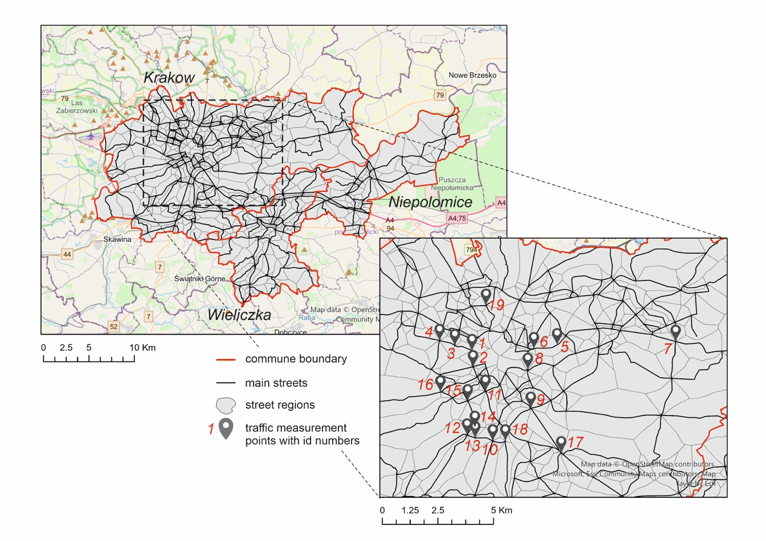

Fig. S1 Traffic volume measurement points along 19 major road crossings in Krakow

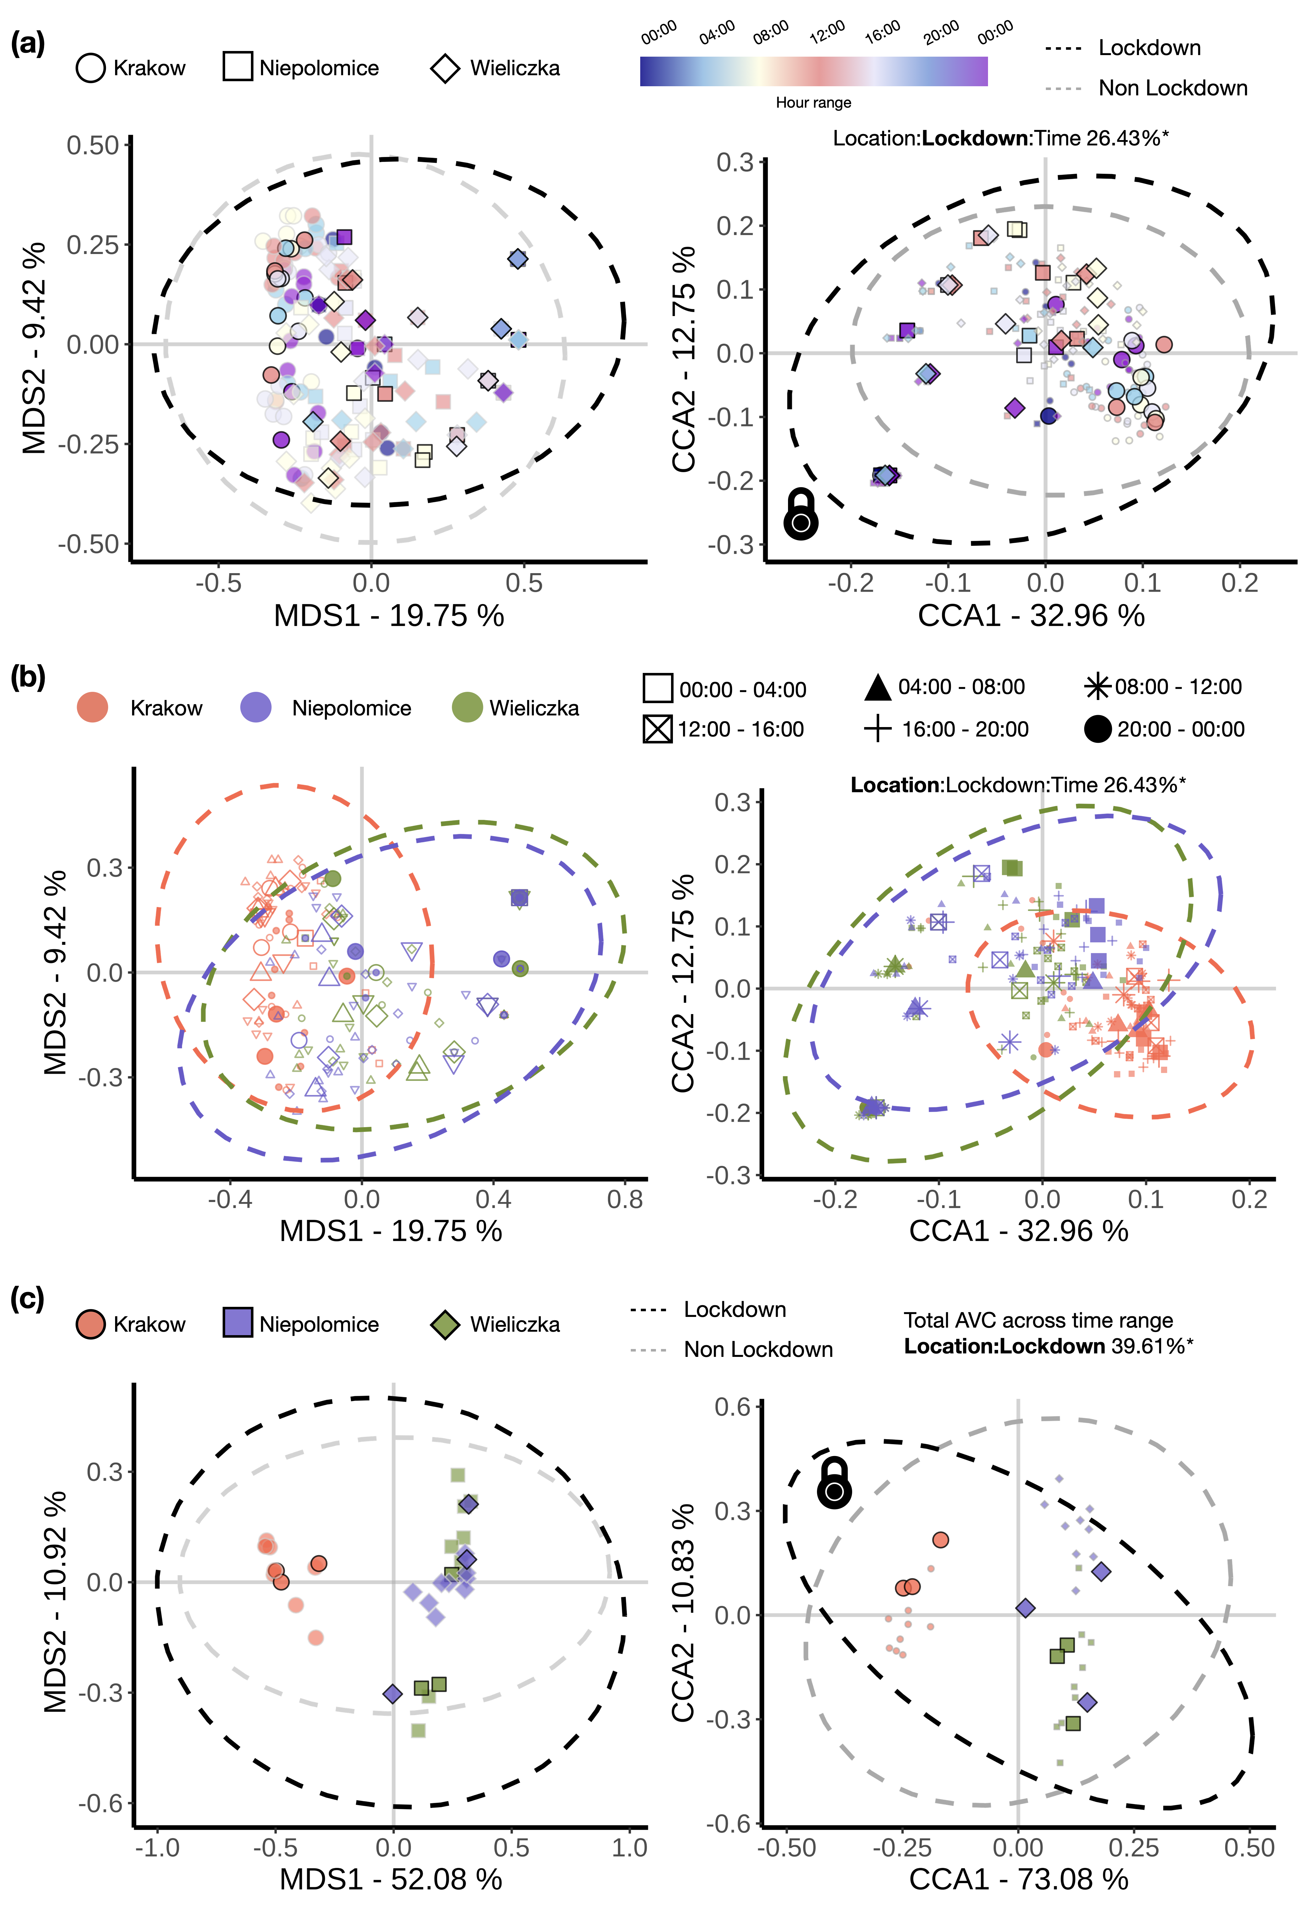
Fig.S2 Multivariate analysis using Jaccard index performed by unconstrained (MDS; on the left) and constrained ordination (CCA; on the right). The ellipses represent 95% of the confidence interval. (a-b) The AVC dataset was used for the multivariate analysis stratified by time period, month and year; (a) The shape represents the corresponding locations; colours represent the time range. The size of the year representing 2020 is larger relative to other. Constrained ordination (right) was conducted by constraining location, time range and lockdown as a fixed factors and conditioning year and month as random factors; (b) The colours represent location, and the shapes represent the time range; (c) The total AVC was estimated over the time period for month and year. The shape and colour represent the corresponding locations and the line colour represent the lockdown status

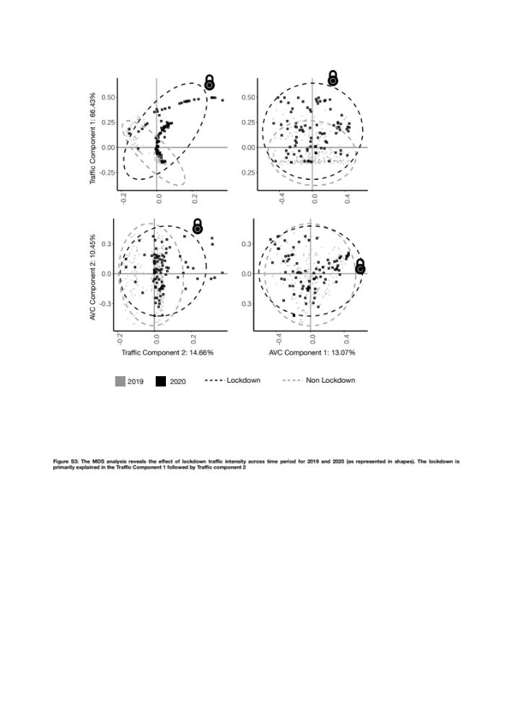

Fig. S3 The integrated MDS analysis shows the effect of lockdown on traffic intensity and AVC across time period for 2019 and 2020 (as represented in colours). The variation is primarily explained in the traffic and AVC Components (MDS), 1 and 2. The spread of the 95% confidence interval (ellipses) shows the maximum variance explained by the lockdown for the respective components

