Mapping Nutrition Interventions in Guatemala To Identify Opportunities to Improve Coverage and Coordination: Supplementary Appendix

Table of Contents:

Survey for Mapping Nutrition Stakeholders in Guatemala: English and Spanish versions

Supplementary Figure 1: Examples of data visualizations using mapping tool.

Supplementary Table 1: Priority areas and specific activities included in the National Strategy for the Prevention of Chronic Malnutrition

Supplementary File 1. The survey included both sections for collecting identifiable institutional data destined for display on the web-based mapping (section A) as well as a section for collecting anonymized data in aggregate (section B).

English Version

Section A: Identifiable institutional data.

1. Institution Name:
1.1. Institution Sector:
- Academic
- National Religious
- International Religious
- Bilateral Aid Organization
- International Nongovernmental Organization
- National Nongovernmental Organization
- Community Based Organization
- Private Sector
2. What is the geographic area (s) in which your institution works?

Department:
Municipality:
3. How long has your organization's nutrition program been around?
Number of months:
Number of years:
4. What is the name of your organization's nutrition program?

5. Describe the area in which the nutrition program focuses:
- Provision of primary care services
- Education and behavior change
- Water sanitation and hygiene
- Household income generation
- Others (describe)
6. What are the activities you implement in your program? (Only open the categories selected in question 5)

Provision of Primary Care Services
- Promotion of adequate breastfeeding and complementary feeding practices
- Promotion of handwashing and hygiene habits
- Deworming
- Supplementation (women of childbearing age, pregnant women, children 6m to 5yrs)
- Food fortification
- Prevention and treatment of acute malnutrition
- Prenatal care
- Growth control and monitoring
- Vaccination
- Pregnancy spacing
- Control and treatment of respiratory infections and diarrheal diseases

Water Sanitation and Hygiene
- Water treatment
- Safe water in the home
- Wastewater treatment
- Access to water
- Conservation and protection of water sources
- Surveillance of water quality
- Improved household flooring materials
- Smoke-free household environment
- Disposal of solid waste

Household Income Generation
- Increased productivity of basic grains
- Increased availability of animal protein
- Increased availability of native vegetables and plants
- Cultivation of fruit trees
- Grain quality management
- Post-harvest handling (silting, storage)
- Irrigation practices
- Soil conservation practices
- Fruit processing
- Access to micro credit
- Product commercialization
- Increase in family income, via surplus agriculture production
- Remunerated reforestation

Education and Behavior Change
- Promotion of health, hygiene, food and nutrition
- Female Empowerment

7. Do you have educational interventions?
- Yes
- No
7.1. If the answer is yes, what topics does it include?
- Handwashing
- Food handling
- Safe Water
- Pregnant woman care
- Newborn Care
- Importance and benefits of breast milk
- Importance of vaccination
- Family planning
- Frequent illnesses
- Complementary food
- Early cognitive stimulation for children
- Family Economy
- Floor care
- Safe storage of grains

8. What groups are your target population? (allow multi-select)
- Pregnant women
- Infants (under 1 year old)
- Children between 1 to 2 years
- Children between 2 to 5 years
- Children over 5 years old
- Men of Reproductive Age
- Women of Childbearing Age
- Others (describe)
8.1. How many program beneficiaries? (Only open the categories selected in question 7)
- No. Pregnant women:
- No. Infants (under 1 year old) :
- No. Children between 1 to 2 years:
- No. Children between 2 to 5 years:
- No. Children over 5 years old:
- No. Men of Reproductive Age:
- No. Women of Childbearing Age:
- No. Others (describe):
9. Describe the platform / channel used to deliver the service:
- Medical Clinics
- Schools
- Facilities of the Organization
- In the Houses of the Beneficiaries
- Nutritional Recovery Centers
- Convergence Centers
- Municipal Halls
- Health Centers

10. Do you have a nutritionist in your team?
- Yes
- No
11. What is the specific goal of the program that your organization leads? Ex. Reduce an x% of chronic child malnutrition in xx time.
12. Is your organization interested in collaborating with other organizations?
- Yes
- No
12.1. What type of collaboration does your organization need?
- Cost-sharing
- Training
- Technical advice
- Materials
- Opportunities of growth for team members
- Benefits from referrals
- Transportation
- Sharing of information between similar projects
- Goods supplier
- Others (describe)
12.2. What type of collaboration can your organization provide?
- Cost-sharing
- Training
- Technical advice
- Materials
- Opportunities of growth for team members
- Benefits from referrals
- Transportation
- Sharing of information between similar projects
- Goods supplier
- Others (describe)
13. If you are chosen for the second phase of the study according to our statistically representative sample, would you be interested in participating? (Provide description of the second phase to refresh their memory)
- Yes
- No
13.1. If the answer is Yes, provide the best contact information:
Email:
Telephone:
Section B: Anonymized data in aggregate

1. Institutional role of the person filling out this survey:
- Organization supervisor
- Nutrition Program supervisor
- Field technician
- Other (describe)
2. How many team members work in this program?
Number of people:
3. From the total of team members, please list how many work in the following tasks:
- Administration
- Field supervision
- Field work
- M/E
4. Describe who is in charge of the supervision and administration of the program:
Profession:
Department of work:
Municipality of work:
5. Does the personnel receive trainings?
- Yes
- No
5.1. If the answer is yes, describe the periodicity.
- Weekly
- Biweekly
- Monthly
- Quarterly
- Semester
- Annual
- Others (describe)

5.2. If the answer is yes, who is responsible for providing the trainings?
- Organization supervisor:
- Immediate bosses:
- External consultants:
- Others (describe)
6. Select your target population’s ethnicity:
- Mestizo or Ladino
- Xinca
- Garifuna
- Maya
- N/A

7.1. In what languages is the program available? (list with 25 options)
7.2. In what languages is the didactic material for the program available? (list with 25 options)
8. Do you know the annual budget of the program?
- Yes
- No
8.1. If your answer is yes, your approximate total annual budget is:
- From $ 1,000 to $ 10,000
- From $10,000 to $ 30,000
- From $30,000 to $50,000
- More than $50,000
9.1. How does the organization recruit and register beneficiaries?
- Referrals from another organization or program
- Direct recruitment
- Self-enrollment
9.2. What are the eligibility criteria for recruitment and registration?
- Specific church members
- Poverty index
- Weight-height index
- Geographical location
- Pregnancy
- Gender
- Age
- Other (describe)

9.2.1 If you use weight and height indicators (option chosen in 9.2), what indicators do you use?
- Weight for height
- Brachial circumference for age
- Body mass index (BMI) for age
- Height and head circumference for age
- Weight gain speed
- Weight loss
- Inadequate nutrient intake

10. The funds from your institution are:
- To provide funding to projects from other institutions
- Funding received from other institutions to finance your own projects
- Both
10.1. Based on the previous question, to which organizations do you provide funding? (List the organizations)

10.2. Based on the previous question, from which organizations do you receive funding? (List the organizations)

11. What has been the theoretical orientation or guidelines of programming?
- Thousand days framework
- Food Security and Nutrition Strategy
- INCAP Guidelines
- International Guidelines
- In-House guidelines
- Guidelines from another organization
- Food Security Law
- SESAN National Food and Nutrition Security Strategy
- Food Security Policy
- SUN Movement
- Standards for the First and Second Level of Health Care
- Others (describe)

12. Do you measure the results of your program?
- Yes
- No
12.1. If the answer to question 12 is yes, what are the indicators you measure? (This opens the indicators per area of focus chosen in question 4 of the open data questionnaire)

Provision of primary care services
- Proportion of children under one year of age with a primary series of vaccination
- Proportion of children aged one to two years with a complete vaccination schedule
- Proportion of children under two years of age, with two deliveries of powdered vitamins and minerals
- Proportion of children under one year of age with a vitamin A dose delivery
- Proportion of children under one year to under two years with two deliveries of doses of vitamin A (one semester)
- Proportion of children under two years of age who present cases of ARFs (pneumonia) treated with therapeutic zinc
- Proportion of children under two years of age who present cases of ADDs treated with therapeutic zinc
- Proportion of children from one year to under two years with two doses of dewormer (one semester)
- Proportion of pregnant women with four deliveries of iron and folic acid
- Proportion of pregnant women detected in the first trimester of pregnancy
- Proportion of pregnant women with four prenatal checkups
- Proportion of boys and girls under one year of age with at least eight weight and height controls
- Proportion of children from one year to under two with at least eight weight and height controls
- Percentage of water supply systems with bacteriological test
- Percentage of water supply systems with residual chlorine test
Education and behavior change
- Families with children under two years old trained in poultry vaccination
- Families with children under two years old trained in gardens with native plants
- Families with children under two years old trained in soil conservation
- Families with children under two years old trained in food storage and processing
- Families with children under two years trained fruit nurseries
- Families with children under two years trained water harvesting
- Families with children under two years old trained in organizing to link to the market
- Families with children under two years of age and pregnant or breastfeeding women who receive conditional cash transfers
Water sanitation and hygiene
- Percentage of communities with water systems
- Percentage of water systems with disinfection equipment
- Percentage of water systems with bacteriological contamination
- Percentage of water sources used to supply a water system contaminated by solid waste dumps
- Percentage of water coverage
- Percentage of budget assigned and executed for water and sanitation actions
- Percentage of homes that are connected to the sewerage network
- Percentage of communities that have a wastewater treatment system
- Percentage of communities with wastewater treatment systems operating efficiently
- Percentage of dwellings with adequate disposal of excreta
- Percentage of rural communities with solid waste collection service
- Percentage of CODEDES and COMUDES sensitized on the issue of water and sanitation
- Percentage of COCODES that manage water supply systems
- Percentage of sites for the final disposal of solid waste that comply with Environmental regulations
Household income generation
- Percentage of mothers who report doing the prioritized practices
- Percentage of families that report participating in an educational action related to the strategy
- Number of communities that implement a prevention plan for chronic malnutrition

12.2. If the answer to question 12 is yes, how often do you perform the measurements?
- Monthly
- Quarterly
- Semester
- Annual
- Others (describe)
12.3. If the answer to question 12 is yes, how do you store your information?
- Physical
- Digital
12.4. If the answer to question 12 is yes, who do you present your results to?
- Board of directors
- Donors
- Team members
- The community
- Others (describe)
13. Do you know if there are other organizations that are working in the same area as your program?
- Yes
- No
14. Do you collaborate with these organizations?
- Yes
- No
14.1. If the response to question 14 is yes, through which medium?
- E-mails
- Periodic in-person meetings
- Virtual meetings through Skype, Hangouts, etc.
- Phone calls
- COCOSAN
- COMUSAN
- CODESAN
- Others (specify)

14.2. If the answer is yes, what motivated you to do it?
- To receive technical advice
- To scale coverage in the field
- Supplies
- Financial donations
- Others (describe)
14.3. If the answer is yes, in what area have you received collaboration?
- Provision of primary care services
- Education and behavior change
- Water sanitation and hygiene
- Household income generation
- Others (describe)

14.4. If the answer is yes, list the name of the organizations you have collaborated with:
1.
2.
3.
4.
Option to open more spaces

14.5. If the answer is no, why?
- Difficult road access
- We don't have internet access
- We don't see the need
- Previous conflicts that distanced both organizations
- Others (describe)
15. Does the program involve the community?
- Yes
- No
15.1. If the answer is yes, what role do the community members play in the processes of your program?
- Supervision
- Execution
- Management
- Coordination
- Reception
- Others (specify)
16. ¿Is your COMUSAN /COCOSAN active?
- Yes
- No
16.1. If the answer is yes, does your organization participate in it?
- Yes
- No
16.1.1. If the answer is yes, with what periodicity?
- Monthly
- Quarterly
- Semester
- Annual
- Others (describe)
17. Has the quantity of beneficiaries diminished?
- Yes
- No
17.1. If the answer is yes, list the most common causes of this:
- Little community identification with the practice that your program suggests
- Long distances to receive the benefit
- Lack of time of the beneficiary
- Limitation of human resources of the institution
- Limitation of the financial resources of the institution
Spanish Version

Section A: Identifiable institutional data.

1. Nombre de la institución:
1.1. Área Rectora:
- Civil
- Pública
- Iniciativa Privada
- Organismo Internacional
2. ¿Cuál es el (las) área geográfica (s) en la que trabaja su institución?
Nombre de Departamento:
Nombre de municipio:
3. ¿Cuánto tiempo lleva el programa de nutrición de su organización?
No. de Meses:
No. de Años:
4. ¿Cuál es el nombre del programa de nutrición de su organización?
5. Describa la categoría en la cual se enfoca el programa de nutrición:
- Primer Nivel de Atención
- Educación para el cambio de comportamiento
- Agua y saneamiento
- Disponibilidad y Economía familiar
- Otros (describa)
6. ¿Cuáles son las actividades concretas que implementan en el programa? (Solo abrir categorías que seleccionaron en pregunta 5)

Primer Nivel de Atención
- Control prenatal
- Control y monitoreo de crecimiento
- Desparasitación
- Suplementación a MEF, ME, niños 6m a 5 años
- Vacunación
- Espaciamiento intergenésico
- Promoción de la lactancia materna y apoyo de la alimentación complementaria
- Promoción de Lavado de manos y hábitos higiénicos
- Control y tratamiento de infecciones respiratorias y/o enfermedades diarreicas
- Fortificación en alimentos

Educación para el cambio de comportamiento
- Promoción de salud, higiene, y alimentación
- Empoderamiento (apropiación y gestión demanda)

Agua y saneamiento
- Tratamiento de Agua
- Agua segura en el hogar
- Tratamiento de aguas servidas
- Acceso a agua
- Conservación y protección de fuentes de agua
- Vigilancia del Agua
- Piso firme
- Ambiente libre de humo
- Disposición de excretas

Disponibilidad y economía familiar
- Aumento de productividad de granos básico (Más maíz y frijol)
- Promoción del aumento de disponibilidad de proteína de origen animal (reducir la mortalidad aviar)
- Aumento de la disponibilidad de hortalizas y plantas nativas (que se produzca más)
- Fomento de plantas frutales
- Tratamiento y de manejo de calidad del grano
- Manejo post cosecha (silo, prácticas)
- Riego (Agua para producción, cosecha de agua)
- Prácticas de conservación de suelos
- Procesamiento de frutas
- Acceso a microcrédito
- Comercialización de productos
- Incremento de ingresos familiar, vía agricultura (excedente).
- Reforestación remunerada con salario mínimo
7. ¿Tienen intervenciones educativas?
- Si
- No
7.1. Si la respuesta es Si, ¿Qué temas incluyen?
- Lavado de manos
- Manipulación de alimentos
- Agua Segura
- Cuidados de la mujer embarazada
- Cuidados de un Recién nacido
- Importancia y beneficios de la leche materna
- Importancia de la vacunación
- Planificación familiar
- Enfermedades frecuentes
- Alimentación complementaria
- Estimulación temprana para niños
- Economía Familiar
- Cuidado del suelo
- Almacenamiento seguro del grano

8. ¿Qué grupos son su población objetivo? (Opción de escoger más de una)
- Mujeres Embarazadas
- Lactantes (menos de 1 año)
- Niños Entre 1 a 2 años
- Niños mayores de 2 a 5 años
- Niños mayores de 5 años
- Hombres en Edad Reproductiva
- Mujeres en Edad Fértil
- Otros (describa)
8.1. ¿Cuántas personas se benefician del programa? (Solo abrir categorías que seleccionaron en pregunta 7)
- No. de Mujeres Embarazadas:
- No. de Lactantes (menos de 1 año):
- No. de Niños Entre 1 a 2 años:
- No. de Niños mayores de 2 a 5 años:
- No. de Niños mayores de 5 años:
- No. de Hombres en Edad Reproductiva:
- No. de Mujeres en Edad Fértil:
- Otros (describa):
9. Describa cual es la plataforma/canal utilizado para entrega del servicio:
- Clínicas Médicas
- Escuelas
- Instalaciones de La Organización
- En las Casas de los Beneficiados
- Centros de Recuperación Nutricional
- Centros de Convergencia
- Salones Municipales
- Centros de Salud

10. ¿Entre los integrantes del equipo de su programa cuentan con nutricionista?
- Si
- No
11. ¿Cuál es la meta específica del programa que su organización lidera? Ej; Disminución en % de la desnutrición crónica en xx tiempo.
12. ¿Estaría interesada su organización en colaborar con otras organizaciones?
- Si
- No
12.1. ¿Qué tipo de colaboración necesita como organización?
- Económica
- Capacitación
- Asesoría Técnica
- Materiales
- Oportunidades para el Crecimiento de Nuestros Colaboradores
- Beneficios por Referencias
- Transporte
- Compartir Información de Proyectos en Común
- Proveedor de Insumos
- Otros (describa)
12.2. ¿Qué tipo de colaboración puede aportar como organización?
- Económica
- Capacitación
- Asesoría Técnica
- Materiales
- Oportunidades para el Crecimiento de Sus Colaboradores
- Beneficios por Referencias
- Transporte
- Compartir Información de Proyectos en Común
- Proveedor de Insumos
- Otros (describa)
13. Si es elegido para la segunda fase del estudio por medio del cálculo de la muestra estadística, ¿Estaría interesado en participar? (Sacar explicación de la segunda fase para refrescar la memoria)
- Si
- No
13.1. Si la respuesta es Sí, Llenar información para contacto:
Correo electrónico:
Teléfono:
Section B: Anonymized data in aggregate

1. Cargo en la institución de quien llenará este instrumento
- Supervisor de la Organización
- Supervisor del Programa de Nutrición
- Técnico De Campo
- Otro (describa)
2. ¿Cuántos integrantes tiene el equipo que trabaja en el programa?
No. De Personas:
3. Del número de colaboradores favor liste cuantos trabajan en:
- Administración
- Supervisión de Campo
- Trabajo de campo
- Monitoreo y Evaluación
4. Describa quien es el encargado (a) de la supervisión y administración del programa que llevan a cabo:

Profesión:
Departamento en el que labora:
Municipio en el que labora:
5. ¿El personal de este programa recibe capacitaciones?
- Si
- No
5.1. Si la respuesta anterior es si, describa la periodicidad.
- semanal
- quincenal
- mensual
- trimestral
- semestral
- anual
- otros (describa)

5.2. Si la respuesta anterior es si, ¿Quién es el responsable de impartir las capacitaciones?
- Supervisor de la Organización
- Jefes inmediatos
- Asesores Externos
- Otros (describa)
6. Seleccione la etnia de su población objetivo:
- Mestiza o Ladina
- Xinca
- Garifuna
- Maya
- No es medible
7.1. ¿En que idiomas esta disponible el servicio de su programa? (lista con los 25)
7.2. ¿En que idiomas esta disponible el material didáctico que utilizan en el programa? (lista con los 25)
8. ¿Sabe el presupuesto que maneja el programa anualmente?
- Si
- No
8.1. Si su respuesta es Sí, en un aproximado su presupuesto anual es:
- De $ 1,000 a $ 10,000
- De $10,000 a $ 30,000
- De $30,000 a $50,000
- Más de $50,000
9.1. ¿Cuáles son los enfoques de la organización para el reclutamiento e inscripción de la población beneficiada?
- Referencias de otra institución o programa
- Reclutamiento directo
- Auto inscripción
9.2. ¿Cuáles son los criterios de reclutamiento e inscripción?
- Ser Miembros de una Iglesia
- Índices de Pobreza
- Indicadores de Peso/Talla
- Área Geográfica
- Embarazo
- Género
- Edad
- Otro (describa)

9.2.1 Sí usan indicadores de peso/talla (escogido en 9.2), ¿qué indicadores usan?
- Peso para la estatura
- Perímetro braquial para la edad
- índice de masa corporal (IMC) para la edad
- Estatura Perímetro cefálico para la edad
- Velocidad de peso
- Pérdida de peso
- Ingesta inadecuada de nutrientes
10. Los fondos de su institución son:
- Para aportar dinero para proyectos de otras instituciones
- Recibidos de otras instituciones para financiar sus proyectos
- Ambas
10.1. En base a la pregunta anterior, ¿A qué organizaciones les dan fondos? (Liste las organizaciones)

10.2. En base a la pregunta anterior, ¿De que organizaciones reciben fondos? (Liste las organizaciones)

11. ¿Cuál ha sido la fuente de teoría en la que se basa su programa?
- Ventana de los mil días
- Estrategia en SAN
- Guías INCAP
- Guías Internacionales
- Normas Propias de la Institución
- Normas Propias de Otra Institución que les Compartió
- Ley de Seguridad Alimentaria
- Estrategia para la Reducción de Desnutrición Crónica
- Política de Seguridad Alimentaria
- Movimiento SUN
- Normas para el Primero y Segundo Nivel de Atención en Salud
- Otros (describa)

12. ¿Miden los resultados de su programa?
- Si
- No
12.1. Si la respuesta a la pregunta 12 es sí, ¿Cuáles son los indicadores que miden? (Esto despliega los indicadores que corresponden a la categoría de enfoque elegida en pregunta 4 de sección A)

Primer Nivel de Atención
- Proporción de niños menores de un año con serie primaria de vacunación
- Proporción de niños de uno a dos años con esquema completo de vacunación
- Proporción de niños menores de dos años, con dos entregas de vitaminas y minerales espolvoreados
- Proporción de niños menores de un año con una entrega de dosis de vitamina A
- Proporción de niños menores de un año a menores de dos años con dos entregas de dosis de vitamina A (una semestral)
- Proporción de niños menores de dos años que presentan casos de IRAs (neumonía) tratados con zinc terapéutico
- Proporción de niños menores de dos años que presentan casos de EDAs tratados con zinc terapéutico
- Proporción de niños de un año a menores de dos años con dos dosis de desparasitante (una semestral)
- Proporción de mujeres embarazadas con cuatro entregas de hierro y ácido fólico
- Proporción de mujeres embarazadas detectadas en el primer trimestre de embarazo
- Proporción de mujeres embarazadas con cuatro controles prenatales
- Proporción de niños y niñas menores de un año con al menos ocho controles de peso y talla
- Proporción de niños de un año a menores de dos años con al menos ocho controles de peso y talla
- Porcentaje de sistemas de abastecimiento de agua con test bacteriológico
- Porcentaje de sistemas de abastecimiento de agua con test cloro residual
Disponibilidad y economía familiar
- Familias con menores de dos años capacitadas en vacunación de aves de corral
- Familias con menores de dos años capacitadas en huertos con plantas nativas
- Familias con menores de dos años capacitadas en conservación de suelos
- Familias con menores de dos años capacitadas en almacenamiento y procesamiento de alimentos
- Familias con menores de dos años capacitadas viveros frutales
- Familias con menores de dos años capacitadas cosecha de agua
- Familias con menores de dos años capacitadas organización para vincularse al mercado
- Familias con menores de dos años y mujeres embarazadas o en período de lactancia que reciben transferencias monetarias condicionadas
Agua y saneamiento
- Porcentaje de comunidades con sistemas de agua
- Porcentaje de sistemas de agua con equipo de desinfección
- Porcentaje de sistemas de agua con contaminación bacteriológica
- Porcentaje de fuentes de agua utilizadas como abastecimiento de un sistema de agua contaminada por vertederos de desechos sólidos
- Porcentaje de cobertura de agua
- Porcentaje de presupuesto asignado y ejecutado a las acciones de agua y saneamiento
- Porcentaje de viviendas que están conectadas a la red de alcantarillado
- Porcentaje de comunidades que cuentan con sistema de tratamiento de aguas residuales
- Porcentaje de comunidades con sistemas de tratamiento de aguas residuales operando eficientemente
- Porcentaje de viviendas con disposición adecuada de excretas
- Porcentaje de comunidades rurales con servicio de recolección de desechos sólidos
- Porcentaje de CODEDES y COMUDES sensibilizados en el tema de agua y saneamineto
- Porcentaje de COCODES que administran sistemas de abastecimiento de agua
- Porcentaje de sitios para la disposición final de desechos sólidos que cumplen con la normativa ambiental
Cambio de comportamiento
- Porcentaje de madres que reportan realizar las prácticas priorizadas
- Porcentaje de familias que reportan participar en una acción educativa relacionada con la estrategia
- Número de comunidades que implementan un plan de prevención para la desnutrición crónica
12.2. Si la respuesta a la pregunta 12 es sí, ¿Cada cuanto realizan las mediciones?
- mensual
- trimestral
- semestral
- anual
- otros (describa)
12.3. Si la respuesta a la pregunta 12 es sí, ¿Por qué medio almacenan su información?
- Físico
- Digital
12.4. Si la respuesta a la pregunta 12 es sí, ¿A quiénes presentan los resultados de las mediciones?
- Junta Directiva de la Organización
- Donadores
- Miembros del Equipo
- La comunidad
- Otros (describa)
13. ¿Sabe sí hay organizaciones que están trabajando en el (las) área (s) en la que se encuentra su programa?
- Si
- No
14. ¿Colabora con estas organizaciones?
- Si
- No
14.1. Si la respuesta a la pregunta 14 es sí, ¿Por qué medio?
- Correos Electrónicos
- Reuniones periódicas en persona
- Vías electrónicas, ej; Skype, Hangouts, etc.
- Llamadas Telefónicas
- COCOSAN
- COMUSAN
- CODESAN
- Otros (especificar)

14.2. Si la respuesta es Sí, ¿Qué los motivo a hacerlo?
- Recibir asesorías técnicas
- Aprovechar su cobertura en campo
- Insumos que Producen
- Donación Económica
- Otros (describa)
14.3. Si la respuesta es Sí, ¿En que área ha recibido colaboración?
- Primer Nivel de Atención
- Educación para el cambio de comportamiento
- Agua y saneamiento
- Disponibilidad y economía familiar
- Otros (describa)
14.4. Si la respuesta es Sí, listar el nombre de las organizaciones de quien ha recibido colaboración:
1.
2.
3.
4.
Opción para abrir más espacios

14.5. Si la respuesta es No, ¿Por qué?
- Difícil acceso vial
- No tenemos acceso a internet
- No vemos la necesidad
- Conflictos previos que distanciaron a ambas organizaciones
- Otros (describa)
15. ¿El programa involucra a la comunidad?
- Si
- No
15.1. Si la respuesta es Sí, ¿qué papel juegan los miembros de la comunidad en los procesos de su programa?
- Supervisión
- Ejecución
- Gestión
- Coordinación
- Recepción
- Otros (especifique)
16. ¿Está su COMUSAN /COCOSAN activa?
- Si
- No
16.1. Si la respuesta es Si, ¿Participa su organización en ella?
- Si
- No
16.1.1. Si la respuesta es Si, ¿Con que periodicidad?
- mensual
- trimestral
- semestral
- anual
- otros (describa)
17. ¿Ha disminuido la cantidad de sus beneficiarios?
- Si
- No
17.1. Si su respuesta es Si, listar las causas más comunes de esto;
- Poca identificación de la comunidad con la práctica que su programa sugiere
- Largas distancias para recibir el beneficio
- Falta de tiempo del beneficiado
- Limitación de recurso humano de la institución
- Limitación de recurso económico de la institución

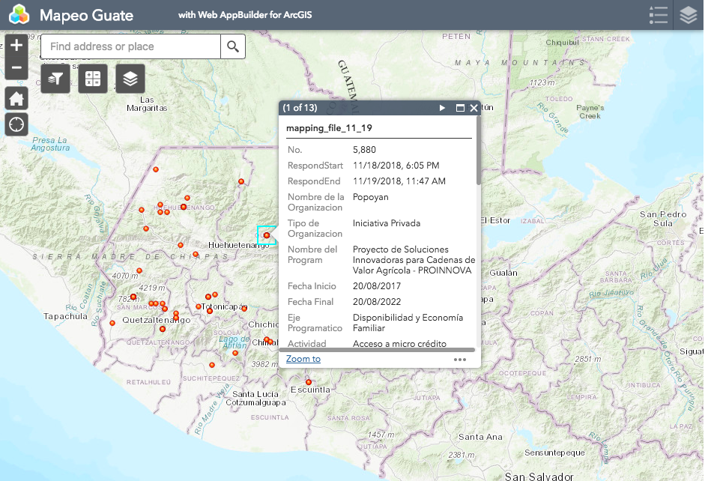
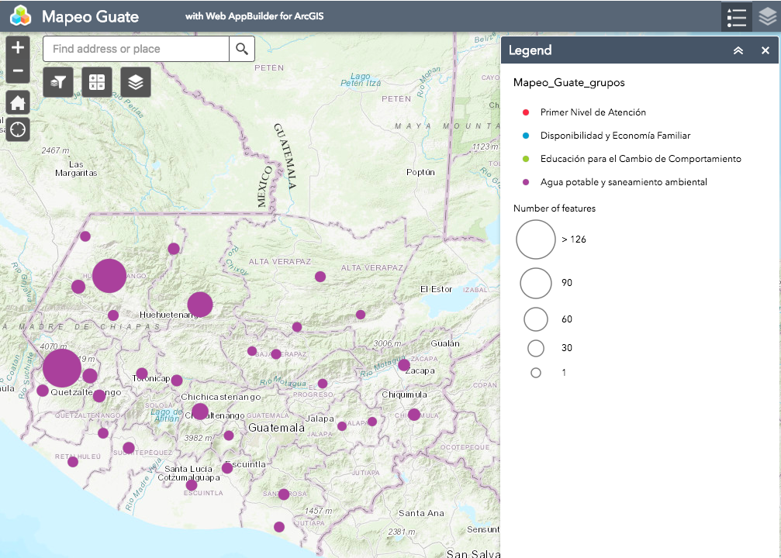
B
A
Figure 1. Examples of data visualizations using mapping tool. (A) Total number of Water Sanitation and Hygiene activities per municipal unit. (B) Municipal units with any micro-credit program implementation. Hovering over individual locations provides additional institution- and location-specific information.

Table 1. Priority areas and specific activities included in the National Strategy for the Prevention of Chronic Malnutrition. Activities are further classified as addressing the immediate (nutrition specific) or underlying (nutrition sensitive) determinants of nutrition.

Activities according to Priority Area | Nutrition Sensitive (SN) / Specific (SP)
Provision of Primary Care Services  Promotion of adequate breastfeeding and complementary feeding practices  Promotion of handwashing and hygiene habits  Deworming  Supplementation (women of childbearing age, pregnant women, children 6m to 5yrs)  Food fortification  Prevention and treatment of acute malnutrition  Prenatal care  Growth control and monitoring  Vaccination  Pregnancy spacing  Control and treatment of respiratory infections and diarrheal diseases | SP  SP  SP  SP  SP  SP  SP  SP  SP  SN  SP
Water Sanitation and Hygiene  Water treatment  Safe water in the home  Wastewater treatment  Access to water  Conservation and protection of water sources  Surveillance of water quality  Improved household flooring materials  Smoke-free household environment  Disposal of solid waste | SN  SN  SN  SN  SN  SN  SN  SN  SN
Household Income Generation  Increased productivity of basic grains  Increased availability of animal protein  Increased availability of native vegetables and plants  Cultivation of fruit trees  Grain quality management  Post-harvest handling (silting, storage)  Irrigation practices  Soil conservation practices  Fruit processing  Access to micro credit  Product commercialization  Increase in family income, via surplus agriculture production  Remunerated reforestation | SN  SN  SN  SN  SN  SN  SN  SN  SN  SN  SN  SN  SN
Education and Behavior Change  Promotion of health, hygiene, food and nutrition  Female Empowerment | SP  SN

