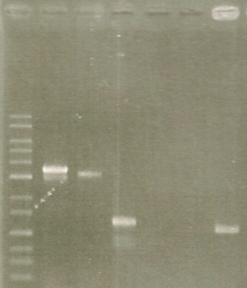
M
1
2
3
4
5
6
(kb)

3
2

1

Fig. S1. PCR for the mutant strain ΔdegP to examine desired homologous recombination at the locus of degP gene. Lane M, kb-ladder; lane 1, PCR for the genome DNA of the wild type strain M. ruber H328 with primers (degP/F1-Hind and degP/R4-Xba); lane 2, PCR for the genome DNA of the mutant strain ΔdegP with the same primers; lane 3, PCR for the genome DNA of the wild type strain with primers (degP/ORF/Fw and degP/ORF/Rv); lane 4, PCR for the genome DNA of the mutant strain ΔdegP with the same primers; lane 5, PCR for the genome DNA of the wild type strain with primers (htk/Fw-Pst and htk/Rv-Pst); lane 6, PCR for the genome DNA of the mutant strain ΔdegP with the same primers.

Fig. S1 Asano et al.

Table S1. DNA primers used for plasmid construction and screening of degP gene in the strain H328.

name | Sequence (5’ → 3’) | Description or reference
degP/F1-Hind | CCCAAGCTTACCTGTGGCACAGGTGGGTT | Construction of 5’-flanking region (1.0 kbp) of degP gene as forward primer
degP/R2-Pst | GAACTGCAGCTCAAAGACCTCCACCTAGC | Construction of 5’-flanking region (1.0 kbp) of degP gene as reverse primer
degP/F3-Pst | GAACTGCAGGAGGGTTTTCCTTTGCTTC | Construction of 3’-flanking region (1.0 kbp) of degP gene as forward primer
degP/R4-Xba | TGCTCTAGACTCATTGACGATGATACGCA | Construction of 3’-flanking region (1.0 kbp) of degP gene as reverse primer
htk/Fw-Pst | GAACTGCAGCGTTGACGGCGGATATGGTA | Construction of the open reading frame of htk gene as forward primer
htk/Rv-Pst | GAACTGCAGCGTAACCAACATGATTAACA | Construction of the open reading frame of htk gene as reverse primer
degP/ORF/Fw | ATGTCCATGAGAAATTCTTC | Construction of the open reading frame of degP gene as forward primer
degP/ORF/Rv | TTAGCGGATCACCTGCGGCA | Construction of the open reading frame of degP gene as reverse primer

