Supplementary material
Two fungal flavonoid-specific glucosidases/rutinosidases for rutin hydrolysis and rutinoside synthesis under homogeneous and heterogeneous reaction conditions
Michael Kotik¹, Hana Javůrková¹, Katerina Brodsky^{1,2}, Helena Pelantová¹
¹ Institute of Microbiology of the Czech Academy of Sciences, Vídeňská 1083, CZ 14220, Prague 4, Czech Republic
² Department of Biochemistry and Microbiology, University of Chemistry and Technology Prague, Technická 3, CZ 16628 Prague 6, Czech Republic

Contents
Page
HPLC analysis of compounds 1–6 and their aglycones (Table S1) 3
Molecular docking of 2 to AnRut: hydrophobic interactions (Table S2) 4
Molecular docking of 2 to AnRut: hydrophobic interactions (Table S3) 5
Molecular docking of 1 to AnRut: π-π Interactions (Table S4) 6
Molecular docking of 1 to AnRut: π-π Interactions (Table S5) 7
Specific hydrolytic activities of McGlc and PcGlc (Table S6) 8
¹H and ¹³C NMR data of compound 6 (Table S7) 9
¹H and ¹³C NMR data of compound 7 (Table S8) 10
¹H and ¹³C NMR data of compound 8 (Table S9) 11
Superposition of AnRut, McGlc and PcGlc structures (Fig. S1) 12
Hydrophobic and π-π interactions of bound compounds 1 and 2 (Fig. S2) 13
Glycoprotein staining of McGlc and PcGlc (Fig. S3) 14
Activity-pH relationships (Fig. S4) 15
Activity-temperature relationships (Fig. S5) 16
Thermal stabilities (Fig. S6) 17
Initial velocity data of 5 (Fig. S7) 18
Initial velocity data: hydrolysis of 1 (Fig. S8) 19
Initial velocity data: hydrolysis of 2 (Fig. S9) 20
Initial velocity data: hydrolysis of 3 (Fig. S10) 21
Initial velocity data: hydrolysis of 4 (Fig. S11) 22
Enzymatic reactions with transglycosylation products: TLC analysis (Fig. S12) 23
Initial velocity data: hydrolysis of 2 in the presence of 6 (Fig. S13) 24
Transglycosylations with 2 in solution: varying the acceptor conc. (Fig. S14) 25
Time courses of transglycosylations in solution (McGlc, PcGlc) (Fig. S15) 26
Time courses of transglycosylations in solution (McGlc) (Fig. S16) 27
Hydrolysis of 2 in suspension (Fig. S17) 28
Transglycosylations with 2-phenylethanol or 1,2-hexanediol (Fig. S18) 29
Mass spectrometry analysis of compound 6 (Fig. S19) 30
¹H NMR spectrum of compound 6 (Fig. S20) 31
¹³C NMR spectrum of compound 6 (Fig. S21) 32
Mass spectrometry analysis of compounds 7/8 (Fig. S22) 33
¹H NMR spectra of compounds 7/8 (Fig. S23) 34
¹³C NMR spectra of compounds 7/8 (Fig. S24) 35
Transglycosylations with 2 in suspension using McGlc (Fig. S25) 36
Transglycosylations with 2 in suspension using PcGlc (Fig. S26) 37
Time courses of transglycosylations with 2 in suspension (Fig. S27) 38
Reaction scheme of retaining McGlc and PcGlc (Fig. S28) 39
References 4
Table S1 HPLC analysis of compounds 1–6 and their corresponding aglyconesª
Compound | λ [nm]^{b} | Retention time [min]
1 | 360 | 2.4
2 | 360 | 2.3
Quercetin | 360 | 3.8
3 | 285 | 2.9
Hesperetin | 285 | 4.8
4 | 370 | 2.8
Isorhamnetin | 370 | 5.1
5 | 340 | 2.9
Diosmetin | 340 | 4.9
6 | 257 | 2.0
2-Phenylethanol | 257 | 2.5
ª Gradients: 0–3 min, 7–30 % B; 3–5 min, 30 % B; 5–7 min, 30–7 % B; 7–7.5 min, 7 % B. Mobile phase A: CH₃CN/H₂O/HCO₂H (5:95:0.1; v/v/v); mobile phase B: CH₃CN/H₂O/HCO₂H (80:20:0.1; v/v/v)
^{b} Selected wavelength

Table S2 Molecular docking of 2 to the active site of AnRut. Hydrophobic interactions between bound 2 and residues in the +1 subsiteª
AnRut atom | Atom in 2 | Distance [Å] | Interaction strength
2035 CG LEU 162 | 5537 C6 | 4.90 | 0.676
2037 CD1 LEU 162 | 5535 C5 | 4.22 | 0.942
2037 CD1 LEU 162 | 5537 C6 | 3.93 | 0.780
2041 CD2 LEU 162 | 5537 C6 | 4.57 | 0.824
2055 CG2 THR 163 | 5590 C38 | 4.91 | 0.674
2906 CE MET 218 | 5532 C3 | 4.59 | 0.818
2906 CE MET 218 | 5534 C4 | 4.62 | 0.807
2906 CE MET 218 | 5535 C5 | 4.16 | 0.963
2906 CE MET 218 | 5537 C6 | 3.66 | 0.268
2951 CG PHE 221 | 5534 C4 | 4.86 | 0.672
2951 CG PHE 221 | 5535 C5 | 4.73 | 0.718
2954 CD2 PHE 221 | 5532 C3 | 4.61 | 0.758
2954 CD2 PHE 221 | 5534 C4 | 3.77 | 0.723
2954 CD2 PHE 221 | 5535 C5 | 3.70 | 0.594
2954 CD2 PHE 221 | 5537 C6 | 4.53 | 0.787
2954 CD2 PHE 221 | 5542 C10 | 4.67 | 0.737
2958 CE2 PHE 221 | 5534 C4 | 3.98 | 0.976
2958 CE2 PHE 221 | 5535 C5 | 3.57 | 0.346
2958 CE2 PHE 221 | 5537 C6 | 4.48 | 0.803
2958 CE2 PHE 221 | 5542 C10 | 4.71 | 0.723
2960 CZ PHE 221 | 5535 C5 | 4.54 | 0.784
2964 CA GLY 222 | 5542 C10 | 4.48 | 0.839
2964 CA GLY 222 | 5545 C13 | 4.01 | 0.901
2964 CA GLY 222 | 5548 C15 | 3.88 | 0.675
3574 CD1 PHE 261 | 5548 C15 | 4.66 | 0.741
3578 CE1 PHE 261 | 5542 C10 | 4.38 | 0.838
3578 CE1 PHE 261 | 5548 C15 | 4.71 | 0.725
3582 CZ PHE 261 | 5542 C10 | 4.84 | 0.680
3941 CB TYR 284 | 5542 C10 | 3.99 | 0.859
3941 CB TYR 284 | 5545 C13 | 3.95 | 0.800
3941 CB TYR 284 | 5548 C15 | 3.73 | 0.425
3944 CG TYR 284 | 5542 C10 | 4.09 | 0.940
3944 CG TYR 284 | 5545 C13 | 4.84 | 0.681
3944 CG TYR 284 | 5548 C15 | 4.41 | 0.828
3947 CD2 TYR 284 | 5542 C10 | 3.63 | 0.468
3947 CD2 TYR 284 | 5548 C15 | 4.11 | 0.932
3951 CE2 TYR 284 | 5542 C10 | 4.39 | 0.835
3991 CE1 TYR 286 | 5532 C3 | 3.95 | 0.985
3991 CE1 TYR 286 | 5534 C4 | 4.79 | 0.698
3993 CE2 TYR 286 | 5532 C3 | 4.65 | 0.743
3993 CE2 TYR 286 | 5534 C4 | 4.86 | 0.672
4007 CG GLU 287 | 5532 C3 | 4.86 | 0.693
4007 CG GLU 287 | 5545 C13 | 4.93 | 0.664
5338 CH2 TRP 374 | 5563 C24 | 4.81 | 0.711
ª See Fig. S3 for the numbering of the substrate atoms

Table S3 Molecular docking of 2 to the active site of AnRut. π-π Interactions between bound 2 and residues in the +1 subsiteª
AnRut atom | Atom in 2 | Distance [Å] | Interaction strength
2954 CD2 PHE 221 | 5535 C5 | 3.70 | 0.844
2954 CD2 PHE 221 | 5537 C6 | 4.53 | 0.532
2954 CD2 PHE 221 | 5540 O8 | 4.01 | 1.000
2958 CE2 PHE 221 | 5537 C6 | 4.48 | 0.181
2958 CE2 PHE 221 | 5540 O8 | 4.50 | 1.000
2960 CZ PHE 221 | 5544 C12 | 4.90 | 0.524
3574 CD1 PHE 261 | 5550 C16 | 4.31 | 0.902
3578 CE1 PHE 261 | 5543 C11 | 4.48 | 1.000
3578 CE1 PHE 261 | 5548 C15 | 4.71 | 0.105
3578 CE1 PHE 261 | 5550 C16 | 3.97 | 1.000
3582 CZ PHE 261 | 5543 C11 | 4.75 | 0.125
3947 CD2 TYR 284 | 5543 C11 | 3.70 | 0.111
3947 CD2 TYR 284 | 5548 C15 | 4.11 | 0.140
3947 CD2 TYR 284 | 5550 C16 | 3.45 | 1.000
3951 CE2 TYR 284 | 5543 C11 | 3.97 | 1.000
3951 CE2 TYR 284 | 5544 C12 | 4.89 | 0.253
3951 CE2 TYR 284 | 5550 C16 | 4.37 | 1.000
3991 CE1 TYR 286 | 5531 C2 | 4.38 | 1.000
3991 CE1 TYR 286 | 5532 C3 | 3.95 | 0.344
3993 CE2 TYR 286 | 5532 C3 | 4.65 | 0.485
3993 CE2 TYR 286 | 5540 O8 | 4.22 | 1.000
3995 CZ TYR 286 | 5531 C2 | 4.41 | 1.000
ª See Fig. S3 for the numbering of the substrate atoms

Table S4 Molecular docking of 1 to the active site of AnRut. Hydrophobic interactions between bound 1 and residues in the +1 subsiteª
AnRut atom | Atom in 2 | Distance [Å] | Interaction strength
2035 CG LEU 162 | 5537 C6 | 4.69 | 0.759
2037 CD1 LEU 162 | 5535 C5 | 4.04 | 0.982
2037 CD1 LEU 162 | 5537 C6 | 3.76 | 0.455
2041 CD2 LEU 162 | 5537 C6 | 4.33 | 0.904
2906 CE MET 218 | 5532 C3 | 4.53 | 0.836
2906 CE MET 218 | 5534 C4 | 4.62 | 0.836
2906 CE MET 218 | 5535 C5 | 4.06 | 0.997
2906 CE MET 218 | 5537 C6 | 3.55 | 0.063
2951 CG PHE 221 | 5534 C4 | 4.90 | 0.657
2951 CG PHE 221 | 5535 C5 | 4.74 | 0.715
2954 CD2 PHE 221 | 5532 C3 | 4.70 | 0.728
2954 CD2 PHE 221 | 5534 C4 | 3.83 | 0.839
2954 CD2 PHE 221 | 5535 C5 | 3.74 | 0.679
2954 CD2 PHE 221 | 5537 C6 | 4.57 | 0.773
2954 CD2 PHE 221 | 5542 C10 | 4.51 | 0.793
2954 CD2 PHE 221 | 5545 C13 | 4.88 | 0.666
2958 CE2 PHE 221 | 5534 C4 | 4.00 | 0.970
2958 CE2 PHE 221 | 5535 C5 | 3.59 | 0.385
2958 CE2 PHE 221 | 5537 C6 | 4.51 | 0.793
2958 CE2 PHE 221 | 5542 C10 | 4.56 | 0.777
2960 CZ PHE 221 | 5535 C5 | 4.50 | 0.796
2964 CA GLY 222 | 5542 C10 | 4.50 | 0.833
2964 CA GLY 222 | 5545 C13 | 3.79 | 0.531
2964 CA GLY 222 | 5548 C15 | 3.72 | 0.406
3574 CD1 PHE 261 | 5548 C15 | 4.65 | 0.744
3578 CE1 PHE 261 | 5542 C10 | 4.42 | 0.826
3578 CE1 PHE 261 | 5548 C15 | 4.66 | 0.742
3582 CZ PHE 261 | 5542 C10 | 4.82 | 0.687
3941 CB TYR 284 | 5542 C10 | 4.10 | 0.987
3941 CB TYR 284 | 5545 C13 | 4.35 | 0.891
3941 CB TYR 284 | 5548 C15 | 3.79 | 0.524
3944 CG TYR 284 | 5542 C10 | 4.19 | 0.903
3944 CG TYR 284 | 5548 C15 | 4.47 | 0.806
3947 CD2 TYR 284 | 5542 C10 | 3.76 | 0.711
3947 CD2 TYR 284 | 5548 C15 | 4.19 | 0.903
3951 CE2 TYR 284 | 5542 C10 | 4.48 | 0.803
3991 CE1 TYR 286 | 5532 C3 | 3.99 | 0.972
3991 CE1 TYR 286 | 5534 C4 | 4.85 | 0.676
3993 CE2 TYR 286 | 5532 C3 | 4.75 | 0.712
3993 CE2 TYR 286 | 5534 C4 | 4.98 | 0.631
4007 CG GLU 287 | 5545 C13 | 4.85 | 0.697
5338 CH2 TRP 374 | 5563 C24 | 4.95 | 0.659
ª See Fig. S3 for the numbering of the substrate atoms

Table S5 Molecular docking of 1 to the active site of AnRut. π-π Interactions between bound 1 and residues in the +1 subsiteª
AnRut atom | Atom in 2 | Distance [Å] | Interaction strength
2954 CD2 PHE 221 | 5535 C5 | 3.77 | 0.816
2954 CD2 PHE 221 | 5537 C6 | 4.57 | 0.490
2954 CD2 PHE 221 | 5540 O8 | 3.86 | 1.000
2958 CE2 PHE 221 | 5537 C6 | 4.51 | 0.195
2958 CE2 PHE 221 | 5540 O8 | 4.35 | 1.000
2960 CZ PHE 221 | 5544 C12 | 4.80 | 0.578
3574 CD1 PHE 261 | 5550 C16 | 4.40 | 0.811
3578 CE1 PHE 261 | 5543 C11 | 4.53 | 1.000
3578 CE1 PHE 261 | 5548 C15 | 4.66 | 0.077
3578 CE1 PHE 261 | 5550 C16 | 4.02 | 1.000
3582 CZ PHE 261 | 5543 C11 | 4.76 | 0.120
3947 CD2 TYR 284 | 5543 C11 | 3.82 | 0.155
3947 CD2 TYR 284 | 5550 C16 | 3.46 | 1.000
3951 CE2 TYR 284 | 5543 C11 | 4.07 | 1.000
3951 CE2 TYR 284 | 5550 C16 | 4.37 | 1.000
3991 CE1 TYR 286 | 5531 C2 | 4.54 | 0.994
3991 CE1 TYR 286 | 5532 C3 | 3.99 | 0.103
3993 CE2 TYR 286 | 5532 C3 | 4.75 | 0.534
3993 CE2 TYR 286 | 5540 O8 | 4.30 | 1.000
3995 CZ TYR 286 | 5531 C2 | 4.56 | 1.000
ª See Fig. S3 for the numbering of the substrate atoms

Table S6 Specific hydrolytic activities of McGlc and PcGlc for compounds 1, 2, 9 and 10. The activities for 2 were determined in the presence or absence of glucose, rhamnose or rutinose
Compoundª | Added carbohydrateª | Specific activity^{b}  [μmol min^{–1} mg^{–1}]
 |  | McGlc | PcGlc
1 | – | 69.8 ± 5 | 42.8 ± 7
2 | – | 31 ± 2 | 55 ± 4
2 | β-D-glucose | 30 ± 3 | 52 ± 3
2 | α-L-rhamnose | 30 ± 3 | 52 ± 4
2 | rutinose | 30 ± 3 | 53 ± 5
9 | – | 0.2 ± 0.1 | 0.2 ± 0.1
10 | – | 0.1 ± 0.05 | 1.1 ± 0.5
ª Concentration: 2.0 mM
^{b} The measurements were performed in triplicate

Table S7 ¹H and ¹³C NMR data of compound 6 (399.87 MHz for ¹H, 100.55 MHz for ¹³C, D₂O, 30 ºC)
 | Atom | δ_{C} | m. | δ_{H} | n_{H} | m. | J [Hz]
Glc | 1 | 102.62 | D | 4.461 | 1 | d | 8.0
 | 2 | 73.29 | D | 3.253 | 1 | dd | 9.3, 8.0
 | 3 | 75.97 | D | 3.471 | 1 | dd | 9.3, 9.1
 | 4 | 69.97 | D | 3.391 | 1 | dd | 9.7, 9.1
 | 5 | 75.00 | D | 3.553 | 1 | ddd | 9.7, 6.2, 2.0
 | 6 | 67.15 | T | 3.999 | 1 | dd | 11.6, 2.0
 |  |  |  | 3.695 | 1 | dd | 11.6, 6.2
Rha | 1‘ | 100.87 | D | 4.834 | 1 | dm | 1.8
 | 2‘ | 70.33 | D | 3.977 | 1 | dd | 3.5, 1.8
 | 3‘ | 70.47 | D | 3.792 | 1 | dd | 9.8, 3.5
 | 4‘ | 72.31 | D | 3.444 | 1 | dd | 9.8, 9.5
 | 5‘ | 68.94 | D | 3.754 | 1 | dq | 9.8, 6.3
 | 6‘ | 16.93 | Q | 1.295 | 3 | d | 6.3
aglycone | 1“ | 71.17 | T | 4.130 | 1 | ddd | 10.2, ΣJ = 13.8
 |  |  |  | 3.941 | 1 | ddd | 10.2, ΣJ = 14.0
 | 2“ | 35.54 | T | 2.981 | 2 | dd | ΣJ = 13.9
 | ipso- | 138.98 | S | - | 0 | -
 | ortho- | 129.27 | D | 7.375  . | 2 | m
 | meta- | 128.95 | D | 7.400 | 2 | m
 | para- | 126.84 | D | 7.312 | 1 | m

Table S8 ¹H and ¹³C NMR data of the major diastereomer of compound 7 (700.13 MHz for ¹H, 176.05 MHz for ¹³C, D₂O and MeOD (9:1, v/v), 30 ºC)
A | Atom | δ_{C} | m. | δ_{H} | n_{H} | m. | J[Hz] | HMBC^{x}
Glc | 1 | 103.21 | D | 4.377 | 1 | d | 7.9 | 1”
 | 2 | 73.47 | D | 3.251 | 1 | dd | 9.6, 7.9
 | 3 | 75.90 | D | 3.425 | 1 | dd | 9.6, 8.9
 | 4 | 69.95 | D | 3.352 | 1 | dd | 9.9, 8.9
 | 5 | 74.96 | D | 3.499 | 1 | ddd | 9.9, 5.8, 2.0
 | 6 | 66.95 | T | 3.941 | 1 | dd | 11.6, 2.0 | 1’
 |  |  |  | 3.646 | 1 | dd | 11.6, 5.8
Rha | 1’ | 100.81 | D | 4.758 | 1 | d | 1.8 | 6
 | 2’ | 70.35 | D | 3.905 | 1 | dd | 3.5, 1.8
 | 3’ | 70.51 | D | 3.717 | 1 | dd | 9.6, 3.5
 | 4’ | 72.33 | D | 3.379 | 1 | dd | 9.6, 9.6
 | 5’ | 68.85 | D | 3.679 | 1 | dq | 9.6, 6.3
 | 6’ | 16.90 | Q | 1.246 | 3 | d | 6.3
aglycone | 1” | 74.55 | T | 3.856 | 1 | dd | 10.7, 3.1 | 1
 |  |  |  | 3.487 | 1 | dd | 10.7, 7.8
 | 2” | 70.75 | D | 3.795 | 1 | m | ΣJ = 23.8
 | 3” | 32.27 | T | 1.46^{H} | 1 | m
 |  |  |  | 1.41^{H} | 1 | m
 | 4” | 27.16 | T | 1.34^{H} | 1 | m
 |  |  |  | 1.27^{H} | 1 | m
 | 5” | 22.22 | T | 1.28^{H} | 2 | m
 | 6” | 13.41 | Q | 0.847 | 3 | t | 7.1
^{H} … HSQC readout; ^{x} … diagnostic C to H correlations

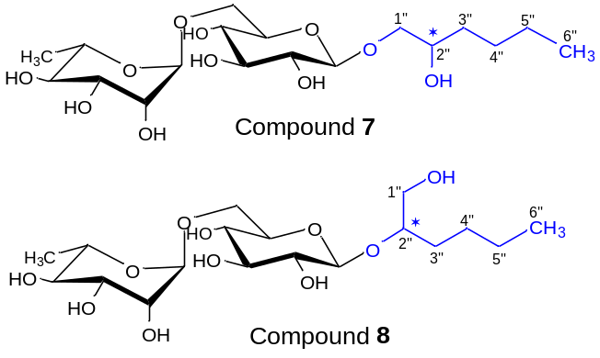
The approximate molar ratio of both pairs of epimers (diastereomers) in the 7/8 mixture is
7^{major} : 8^{major} : 7^{minor} : 8^{minor} = 56 : 21 : 14 : 9.

Table S9 ¹H and ¹³C NMR data of the major diastereomer of compound 8 (700.13 MHz for ¹H, 176.05 MHz for ¹³C, D₂O and MeOD (9:1, v/v), 30 ºC)
B | Atom | δ_{C} | m. | δ_{H} | n_{H} | m. | J[Hz] | HMBC^{x}
Glc | 1 | 102.53 | D | 4.473 | 1 | d | 7.9 | 2”
 | 2 | 73.66 | D | 3.227 | 1 | dd | 9.6, 7.9
 | 3 | 76.09 | D | 3.420 | 1 | dd | 9.6, 8.9
 | 4 | 69.92 | D | 3.358 | 1 | dd | 9.8, 8.9
 | 5 | 74.89 | D | 3.473 | 1 | ddd | 9.8, 6.0, 1.9
 | 6 | 66.87 | T | 3.934 | 1 | dd | 11.4, 1.9 | 1’
 |  |  |  | 3.598 | 1 | dd | 11.4, 6.0
Rha | 1’ | 100.74 | D | 4.747 | 1 | dm | 1.8 | 6
 | 2’ | 70.38 | D | 3.896 | 1 | dd | 3.5, 1.8
 | 3’ | 70.53ª | D | 3.725 | 1 | dd | 9.6, 3.5
 | 4’ | 72.37ª | D | 3.38^{H} | 1 | m
 | 5’ | 68.83 | D | 3.66^{H} | 1 | m
 | 6’ | 16.92 | Q | 1.249 | 3 | d | 6.3
aglycone | 1” | 63.59 | T | 3.647 | 1 | dd | 12.3, 3.7
 |  |  |  | 3.544 | 1 | dd | 12.3, 5.8
 | 2” | 81.75 | D | 3.753 | 1 | m |  | 1
 | 3” | 30.79 | T | 1.54^{H} | 2 | m
 | 4” | 27.00 | T | 1.31^{H}  . | 2 | m
 | 5” | 22.11ª | T | 1.29^{H} | 2 | m
 | 6” | 13.45ª | Q | 0.852 | t | 7.1
^{H} … HSQC readout; ª … tentative assignment; ^{x} … diagnostic C to H correlations

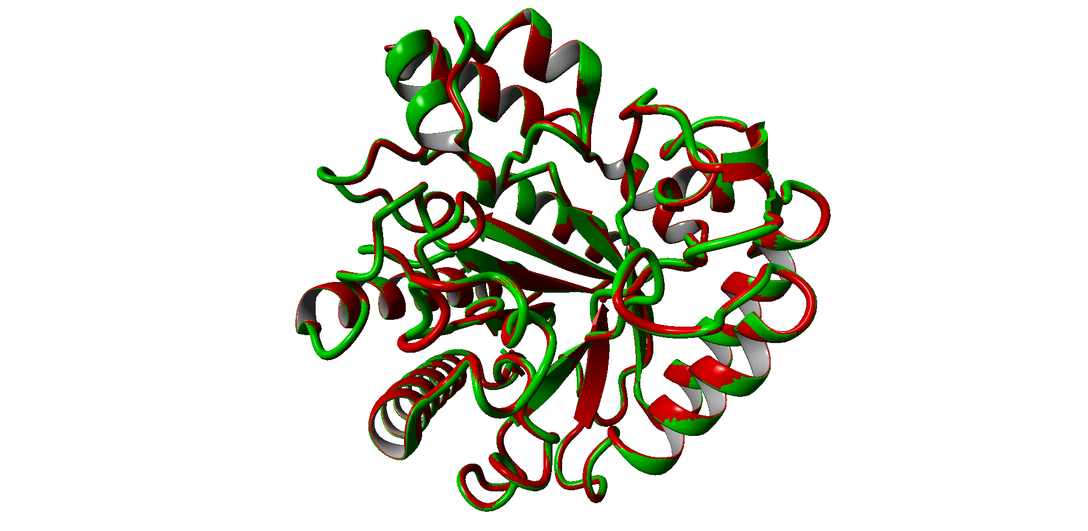
a

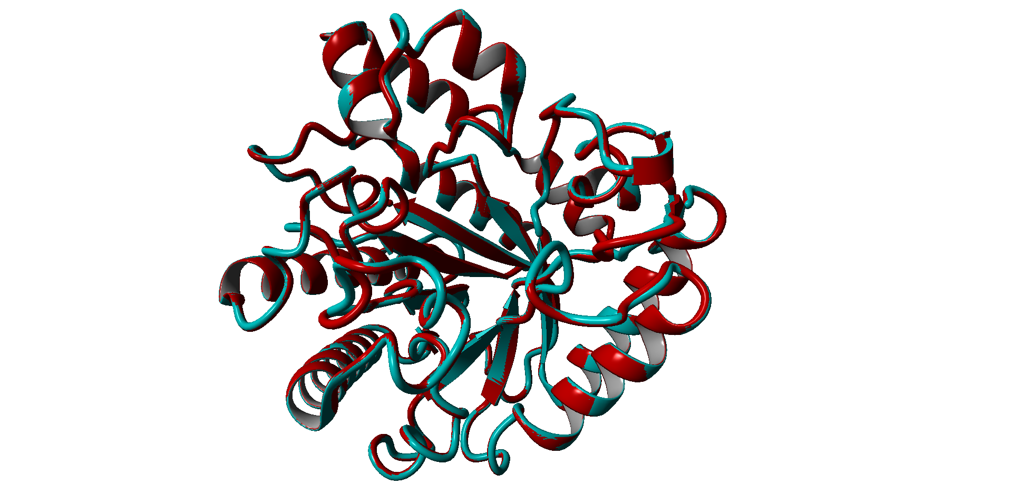
b
c

AnRut (210, 319) PQSYTLEPINEPADNNTNMVV GTGKFPVFVGEWAIQATYNNT
McGlc (231, 339) PQSYTIEPINEPVDN-HDFST GDGKFPTFVGEWAIQTGGKNE
PcGlc (219, 327) PQSYTLSPINEPVDN-RDFST GDGKFPTFVGEWAIEAS-DND

Fig. S1 Superposition of the ribbon diagrams of the experimentally determined AnRut structure in red (Pachl et al. 2020) and the modelled structures of McGlc and PcGlc. The coordinates of the AnRut X-ray structure were used as a template (NCBI accession number 6I1A). The model quality estimates GMQE and QMEAN Z-score are given for each model (Benkert et al. 2011). a Modelled structure of McGlc in green; GMQE: 0.78; QMEAN Z-score: –0.74. b Modelled structure of PcRut in blue; GMQE: 0.80; QMEAN Z-score: –0.35. c Sequence alignment of AnRut with McGlc and PcGlc. Only the two segments around the acid/base catalyst (in red: E210, E231 and E219 for AnRut, McGlc and PcGlc, respectively) and the catalytic nucleophile (in orange: E319, E339 and E327 for AnRut, McGlc and PcGlc, respectively) are shown. The numbering refers to the translated nucleotide sequences

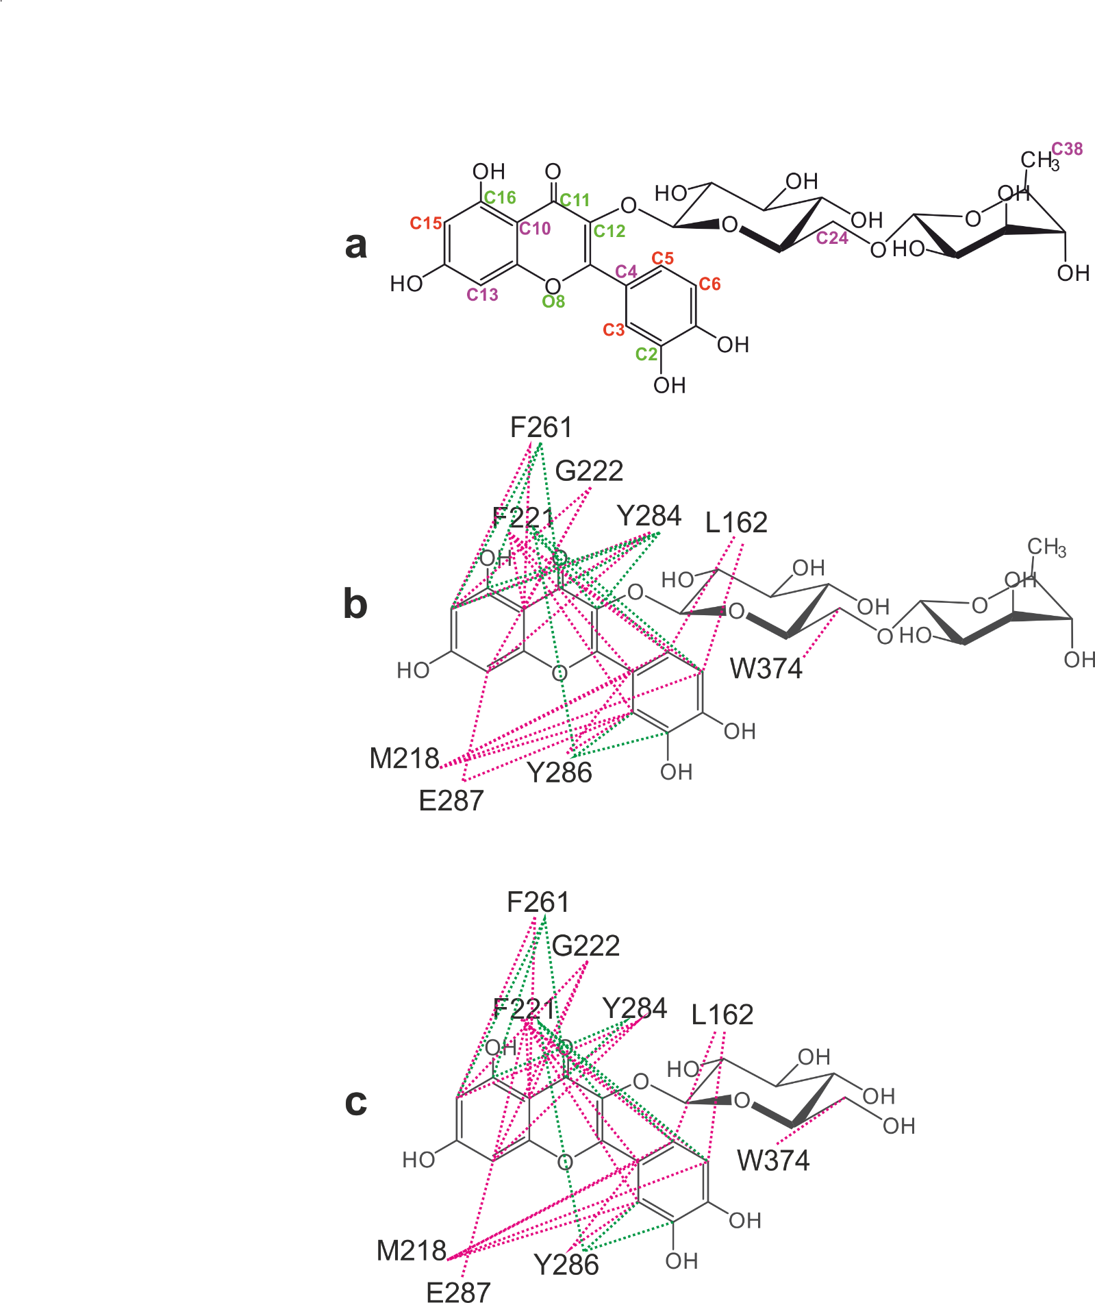
Fig. S2 Visualization of hydrophobic and π-π interactions between the side chains of AnRut and bound substrates 1 or 2 based on the molecular docking analysis (Tables S2–S5). a Atom labelling in 2; substrate atoms that were involved in hydrophobic interactions are labelled in magenta; atoms that were involved in π-π interactions are labelled in green; atoms that were involved in both types of interactions are indicated in red. b Hydrophobic (dashed lines in magenta) and π-π interactions (green lines) between AnRut and compound 2. c Hydrophobic and π-π interactions between AnRut and compound 1

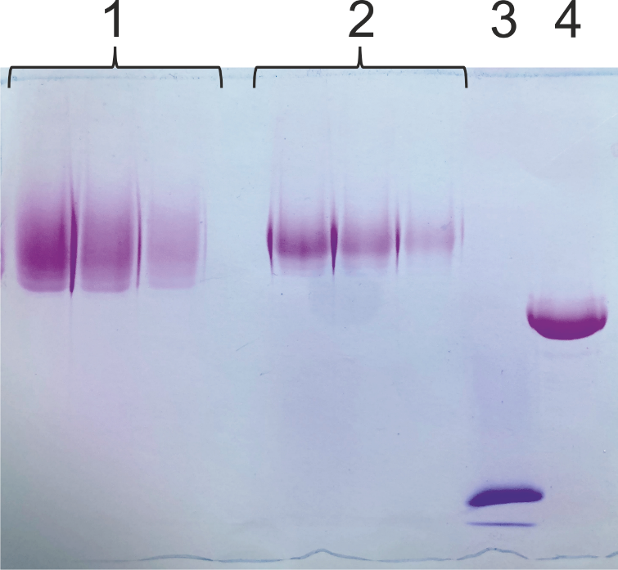
Fig. S3 SDS-PAGE analysis of purified, heterologously produced McGlc (with a polypeptide mass of 46.1 kDa) and PcGlc (with a polypeptide mass of 42.5 kDa) for the presence of carbohydrate moieties attached to the polypeptide chains. Glycoproteins are colored magenta. (1) PcGlc and (2) McGlc with 5, 10 and 15 µg of protein loaded per lane. (3) Soybean trypsin inhibitor as a negative control in blue (~20 kDa); visualized only in the Coomassie staining step, which followed the staining of the glycoproteins. (4) Horseradish peroxidase as a positive control (~44 kDa, which includes the polypeptide chain of 33.9 kDa)

Fig. S4 Activity-pH relationships of McGlc and PcGlc for hydrolysis of 2. The 15-min reactions were performed at 48 °C by adding 2 to a final concentration of 2.7 mM in the presence of 10 % dimethyl sulfoxide after a 30-min incubation of McGlc () or PcGlc () at 35 °C. Citrate buffers (50 mM) were used. The measurements were performed in triplicate

Fig. S5 Activity-temperature relationships for hydrolysis of 2 using McGlc or PcGlc. The reaction conditions were as follows: 10 % dimethyl sulfoxide, 2.7 mM of compound 2, pH 3.5 for McGlc (), or pH 5.0 for PcGlc (). The reactions were stopped after 15 min of incubation at a given temperature. The measurements were performed in triplicate

Fig. S6 Thermal stabilities of McGlc and PcGlc. The enzyme samples containing McGlc () or PcGlc () were incubated at different temperatures (20–75 °C) for 10 min at pH 4.0 or 5.0, respectively. The residual activity was determined at 30 °C in the presence of 10 % (v/v) dimethyl sulfoxide after adding compound 2 (final concentration of 5.0 mM)

a
b
Fig. S7 Initial velocity data with varying concentrations of compound 5. Reaction conditions: 48 °C, 50 mM citrate buffer. a McGlc (pH 4.0); b PcGlc (pH 5.0)

a
b

Fig. S8 Initial velocity data with varying concentrations of compound 1. Reaction conditions: 48 °C, 50 mM citrate buffer. a McGlc (pH 4.0); b PcGlc (pH 5.0)

a
b
Fig. S9 Initial velocity data with varying concentrations of compound 2. Reaction conditions: 48 °C, 50 mM citrate buffer. a McGlc (pH 4.0); b PcGlc (pH 5.0)

a

b
Fig. S10 Initial velocity data with varying concentrations of compound 3. Reaction conditions: 48 °C, 50 mM citrate buffer. a McGlc (pH 4.0); b PcGlc (pH 5.0)

a

b
Fig. S11 Initial velocity data with varying concentrations of compound 4. Reaction conditions: 48 °C, 50 mM citrate buffer. a McRut (pH 4.0); b PcGlc (pH 5.0)

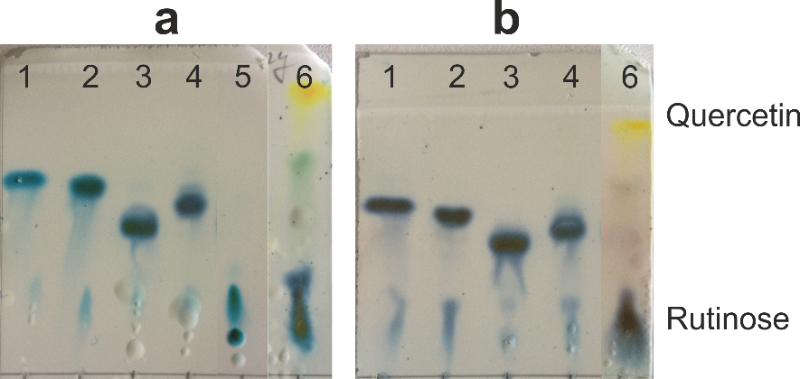
Fig. S12 Thin-layer chromatography: analysis of enzymatic reactions containing selected transglycosylation products as substrates. McGlc as a catalyst (a); PcGlc as a catalyst (b). Highly limited hydrolysis of pentyl rutinoside (lane 1), compound 6 (lane 2), 2-azidoethyl rutinoside (lane 3), and compound 7/8 (lane 4). Plain rutinose as a control (lane 5). The hydrolysis products were visualized using the anthrone reagent 24 h after the initiation of the reaction. Control reaction with compound 2 as a substrate, analyzed after 2 h of reaction (lane 6). The formation of quercetin and rutinose is indicated. Rutinose and the unreacted transglycosylation products are colored blue. Quercetin and residual 2 in the control reactions are colored yellow and green, respectively. Reaction conditions: 37 °C, McIlvaine buffer (pH 4.0 for McGlc-based reactions or pH 5.0 for PcGlc-based reactions), 15 mM transglycosylation product, 0.12 µg mL^{–1} enzyme. Pentyl rutinoside and 2-azidoethyl rutinoside were generated using AnRut (Brodsky et al. 2020)

a
b
Fig. S13 Initial velocity data of hydrolysis reactions with 2 as a substrate in the presence of various concentrations of compound 6. Three different concentrations of 2 were used: 50 µM (), 200 µM () and 750 µM (). The initial velocity measurements were performed in triplicate with either McGlc (a) or PcGlc (b) as catalysts. a 48 °C, McIlvaine buffer (pH 4.0), 10 % (v/v) dimethyl sulfoxide. b 48 °C, McIlvaine buffer (pH 5.0), 10 % (v/v) dimethyl sulfoxide

Fig. S14 Transglycosylation reactions in the presence of various acceptor concentrations (2-phenylethanol). The formation of quercetin (, ) and compound 6 (, ) was determined after 3 h of reaction at 35 °C in the presence of 100 mM 2, 25 % dimethyl sulfoxide, and McGlc (open symbols) or PcGlc (filled symbols). The S/E ratio was 67'000 mol mol^{–1} for both enzymes. The reactions were performed in McIlvaine buffer at pH 4.0 or 5.0 for the McGlc or PcGlc-based reactions, respectively. The measurements were performed in duplicate

a

b
Fig. S15 Time courses of transglycosylation reactions with 2-phenylethanol as an acceptor and 2 as a glycosyl donor. The concentrations of quercetin () and transglycosylation product 6 () are shown. The reactions were performed in triplicate in McIlvaine buffer (pH 4.0 or 5.0) at 35 °C in the presence of 25 % (v/v) dimethyl sulfoxide and 100 mM 2 using an S/E ratio of 67'000 mol mol^{–1} with 200 mM 2-phenylethanol and McGlc (a) or 400 mM 2-phenylethanol and PcGlc (b)

a
b

Fig. S16 Time courses of transglycosylation reactions with McGlc as a catalyst, 2-phenylethanol as an acceptor and 2 as a glycosyl donor. The concentrations of quercetin () and transglycosylation product 6 () are shown. The reactions were performed in triplicate in McIlvaine buffer (pH 4.0) at 35 °C in the presence of 25 % (v/v) dimethyl sulfoxide, 100 mM 2, and 400 mM 2-phenylethanol, using an S/E ratio of 67'000 (a) or 20'000 mol mol^{–1} (b)

Fig. S17 Quercetin production using McGlc or PcGlc in suspensions containing 2. Initial concentration of 2: 185 g L⁻¹ (300 mM). Purified McGlc (); purified PcGlc (). Reaction conditions: 35 °C, 0.34 mg mL⁻¹ of enzyme, McIlvaine buffer at pH 4.0 (McGlc) or pH 5.0 (PcGlc)

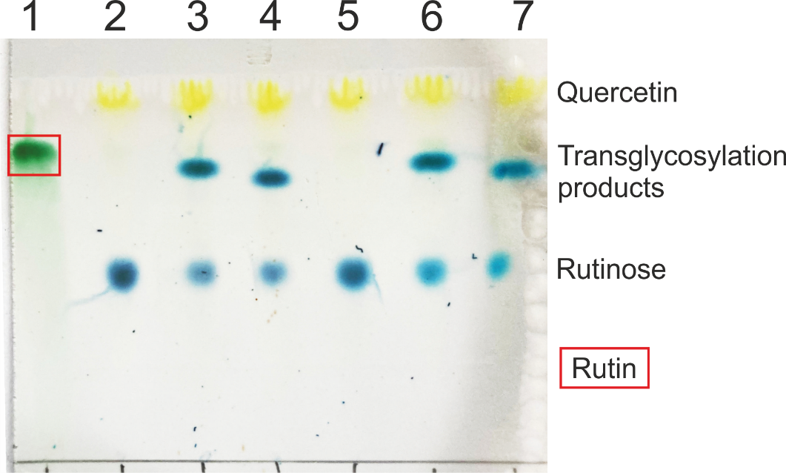
Fig. S18 TLC analysis of transglycosylation reactions using McGlc or PcGlc as a catalyst, compound 2 as a rutinosyl donor and 2-phenylethanol or 1,2-hexanediol as an acceptor. The 20-h reactions were performed at 35 °C in 50-mM citrate buffer (pH 4.0 for McGlc or pH 5.0 for PcGlc) with 2 at a concentration of 200 mM. The transglycosylation reactions were performed with either 2-phenylethanol (516 mM; lanes 3 and 6) or 1,2-hexanediol (496 mM; lanes 4 and 7) in the presence of 1.67 mg ml^{–1} of McGlc or PcGlc. Lane 1: no addition of enzyme; lanes 2–4: McGlc as a catalyst; lanes 5–7: PcGlc as a catalyst. Lanes 2 and 5: no acceptor added. The reaction products were visualized using the anthrone reagent. Mobile phase: ethyl acetate/2-propanol/water (3:2:2; v/v/v). The quercetin spots are colored yellow; spots of rutinose and compounds 6, 7 and 8 are colored blue. Residual 2 is colored green and boxed

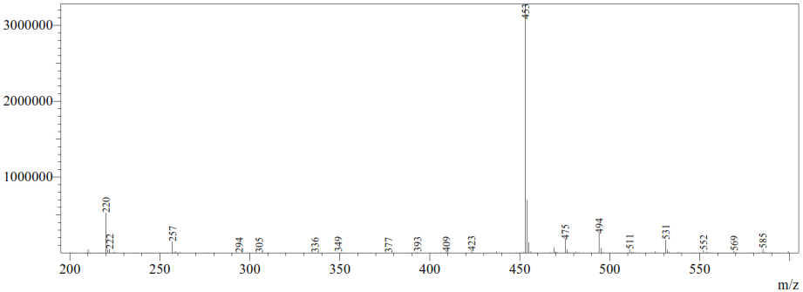
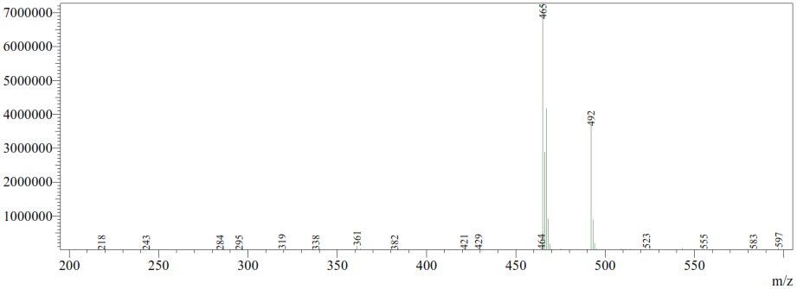

Fig. S19 Mass spectrometry (MS) analysis of compound 6 generated in a transglycosylation reaction with 2 as a glycosyl donor, 2-phenylethanol as an acceptor and McGlc as a catalyst. The preparative transglycosylation reaction was performed as described in the Materials and methods section. Upper MS spectrum (ESI⁺): m/z = 453 [M+Na]⁺, calculated mass for C₂₀H₃₀O₁₀Na: 453.4. Lower MS spectrum (ESI–): m/z = 465 [M+Cl]–, calculated mass for C₂₀H₂₉O₁₀Cl: 464.9; m/z = 492 [M+NO₃]–, calculated mass for C₂₀H₂₉O₁₃N: 491.4. Mass spectra were recorded with a Shimadzu Prominence LC analytical system (Shimadzu, Japan) consisting of a Shimadzu CBM-20A system controller, Shimadzu LC-20AD binary HPLC pump, a Shimadzu CTO-10AS column oven, a Shimadzu SIL-20ACHT cooling autosampler and a Shimadzu SPD-20MA diode array detector. The samples were dissolved in acetonitrile. The mobile phase was composed of acetonitrile; the flow rate was 0.3 mL min^{–1} (25 °C); the injection volume was 1 μL. The MS-ESI parameters were as follows: positive and negative mode; ESI interface voltage: 4.5 kV, –3.5 kV; detector voltage: 1.15 kV; nebulizing gas flow: 1.5 mL min^{–1}; drying gas flow: 15 mL min^{–1}; heat block temperature: 200 °C; temperature of desolvation line pipe: 250 °C; SCAN mode: 300–600 m/z. The spectra were analyzed using the software LabSolutions (ver. 5.75 SP2; Shimadzu, Japan)

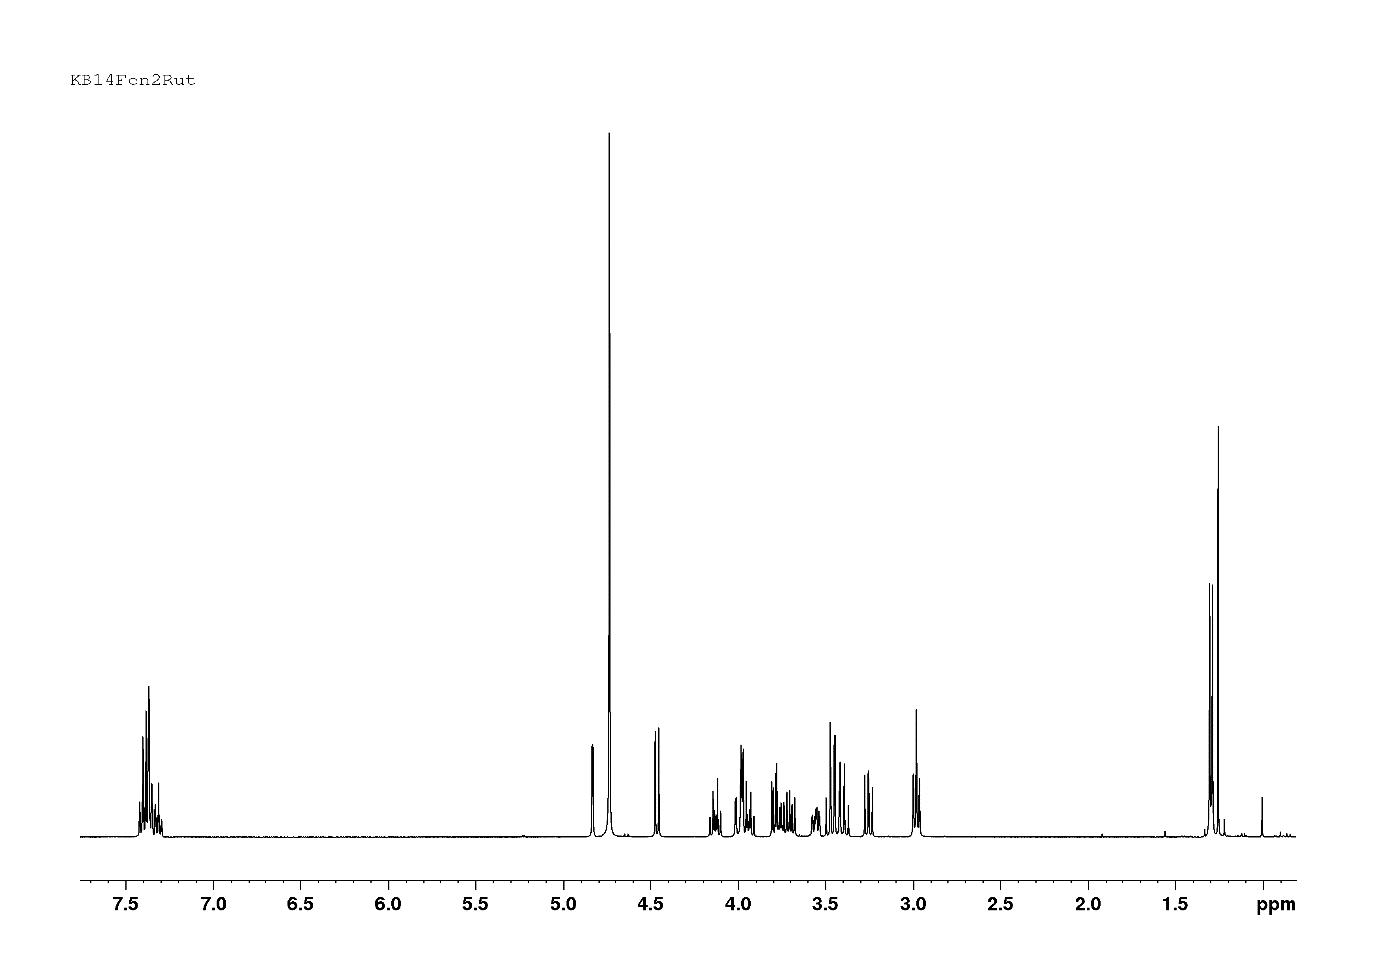
Fig. S20 ¹H NMR spectrum of compound 6 (399.87 MHz; D₂O; 30 ºC)

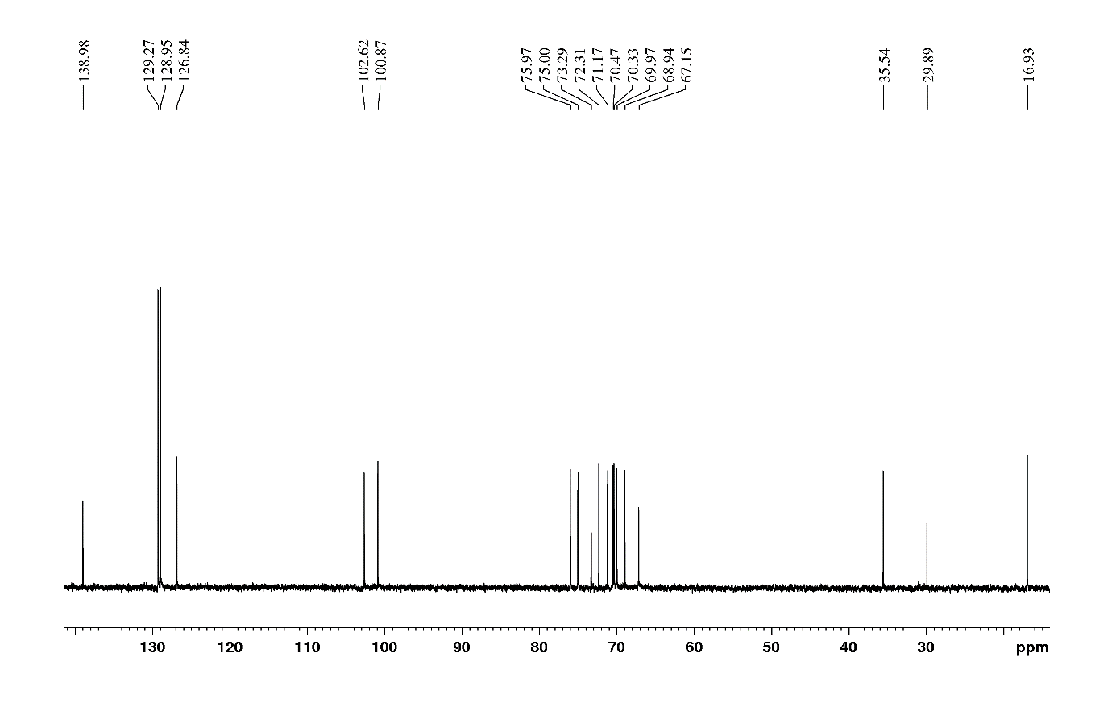
Fig. S21 ¹³C NMR spectrum of compound 6 (100.55 MHz; D₂O; 30 ºC)

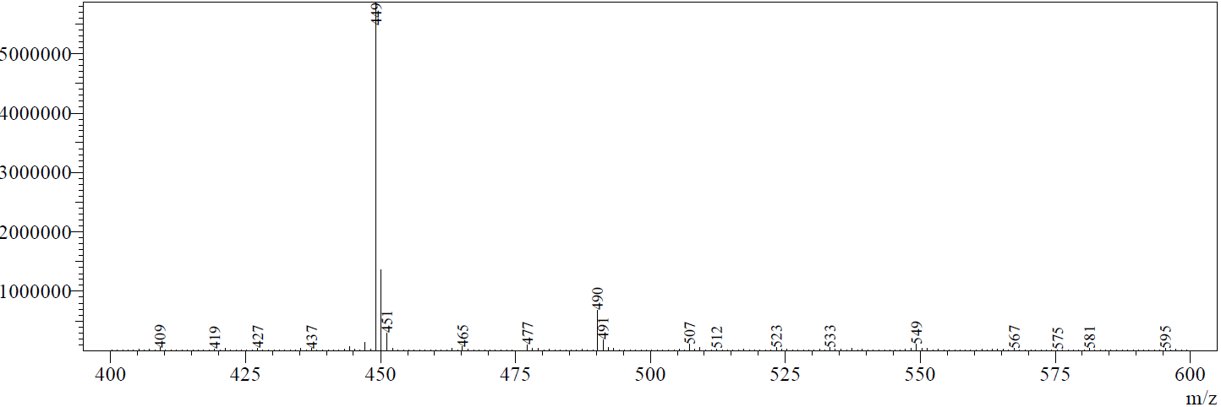
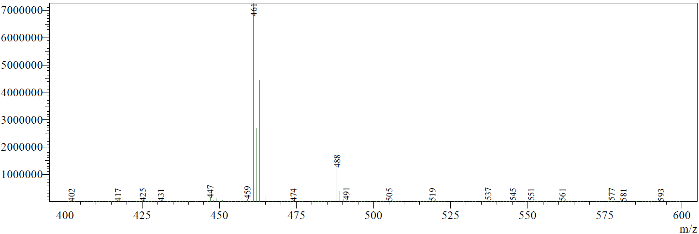
Fig. S22 Mass spectrometry analysis of a mixture of compounds 7 and 8 generated in a transglycosylation reaction with 2 as a glycosyl donor, 1,2-hexanediol as an acceptor and PcGlc as a catalyst. The preparative transglycosylation reaction was performed as described in the Materials and methods section. Upper MS spectrum (ESI⁺): m/z = 449 [M+Na]⁺, calculated mass for C₁₈H₃₄O₁₁Na: 449.4. Lower MS spectrum (ESI–): m/z = 461 [M+Cl]–, calculated mass for C₁₈H₃₃O₁₁Cl: 460.9. Mass spectra were recorded with a Shimadzu Prominence LC analytical system (Shimadzu, Japan) consisting of a Shimadzu CBM-20A system controller, Shimadzu LC-20AD binary HPLC pump, a Shimadzu CTO-10AS column oven, a Shimadzu SIL-20ACHT cooling autosampler and a Shimadzu SPD-20MA diode array detector. The samples were dissolved in acetonitrile. The mobile phase was composed of acetonitrile; the flow rate was 0.3 mL min^{–1} (25 °C); the injection volume was 1 μL. The MS-ESI parameters were as follows: positive and negative mode; ESI interface voltage: 4.5 kV, –3.5 kV; detector voltage: 1.15 kV; nebulizing gas flow: 1.5 mL min^{–1}; drying gas flow: 15 mL min^{–1}; heat block temperature: 200 °C; temperature of desolvation line pipe: 250 °C; SCAN mode: 300–600 m/z. The spectra were analyzed using the software LabSolutions (ver. 5.75 SP2; Shimadzu, Japan)

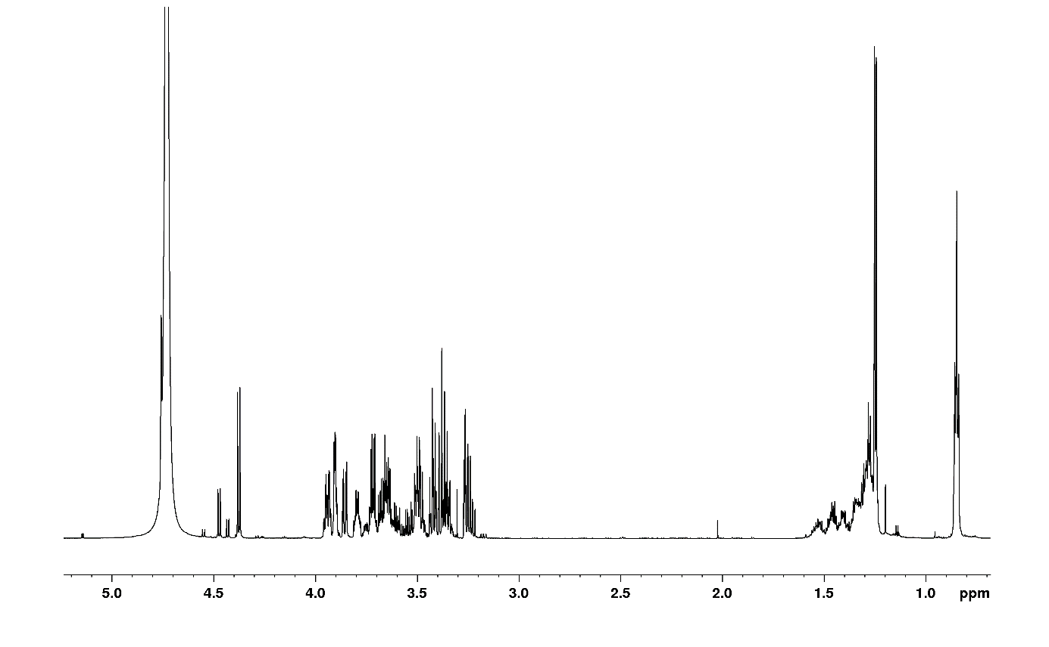
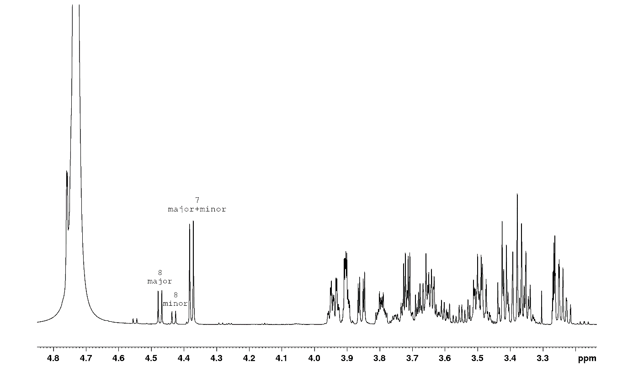
Fig. S23 ¹H NMR spectrum of both diastereomers of compounds 7 and 8 as a mixture (700.13 MHz; D₂O and MeOD (9:1, v/v); 30 ºC) – overview and close-up

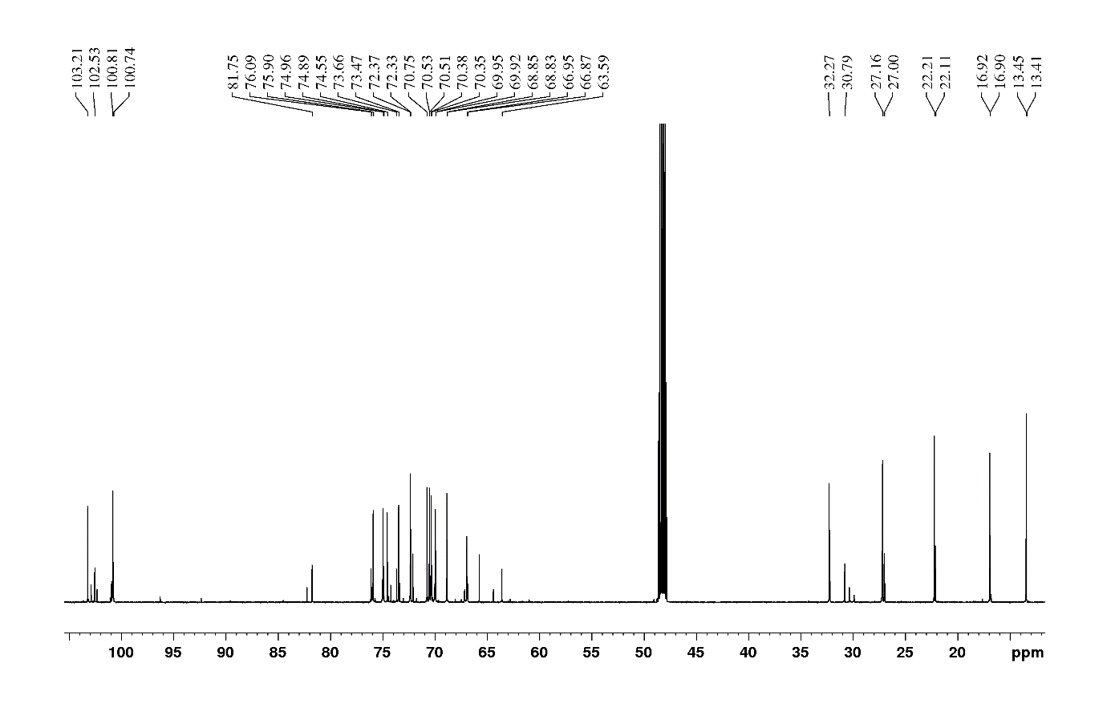
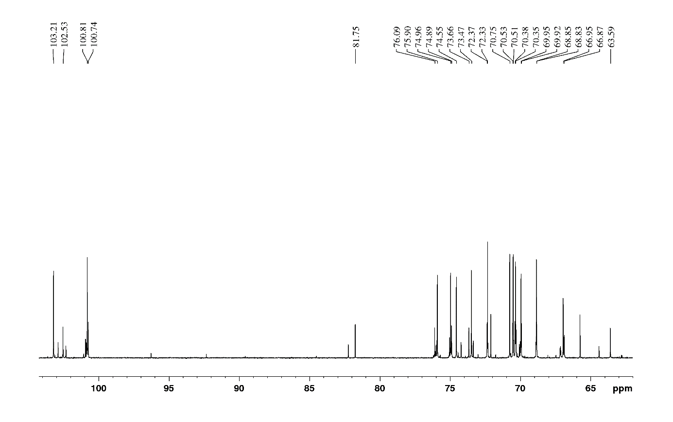
Fig. S24 ¹³C NMR spectra of both diastereomers of compounds 7 and 8 as a mixture (176.05 MHz; D₂O and MeOD (9:1, v/v); 30 ºC) – overview and close-up. Only signals of major diastereomers, reported in Tables S8 and S9, are labelled

Fig. S25 Correlation between the conversion of 2, the formation of transglycosylation product 6 and the acceptor (2-phenylethanol) concentration using McGlc as a catalyst. The reactions were performed in triplicate in McIlvaine buffer (pH 4.5) at 35 °C with 500 µg mL^{–1} of McGlc. Thirty minutes after the initiation of the reaction, the amount of 6 () and quercetin () were determined. The degree of conversion is based on the initial amount of 2 in the reaction mixture (0.3 M)

a
b
Fig. S26 Correlation between the conversion of 2, the formation of transglycosylation product 6 and the acceptor (2-phenylethanol) concentration using PcGlc as a catalyst. The reactions were performed in triplicate in McIlvaine buffer (pH 5.0) at 35 °C with 215 µg mL^{–1} (a) or 750 µg mL^{–1} of PcGlc (b). Thirty minutes after the initiation of the reaction, the amount of 6 () and quercetin () were determined. The degree of conversion is based on the initial amount of 2 in the reaction mixture (0.3 M)

a
b
Fig. S27 Time courses of conversion of 2 and product formation in transglycosylation reactions with 2-phenylethanol as an acceptor. The formation of quercetin () and 6 () is shown. McGlc (A) and PcGlc as catalysts. The reactions were performed at 35 °C with 0.3 M rutin and 1.5 M 2-phenylethanol in McIlvaine buffer (pH 4.5) with 254 µg mL^{–1} of McGlc (a) or in the presence of 0.3 M rutin and 1.2 M 2-phenylethanol in McIlvaine buffer (pH 5.0) with 234 µg mL^{–1} of PcGlc (b)
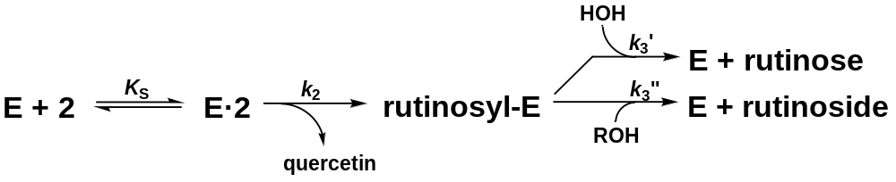
Fig. S28 Reaction scheme of retaining McGlc and PcGlc, exhibiting both hydrolysis and transglycosylation activities in the presence of 2. The first step of the double-displacement mechanism is the formation of a Michaelis complex, followed by the release of the leaving group quercetin, which results in the formation of a covalent glycosyl-enzyme intermediate (rutinosyl-E). The deglycosylation of the enzyme intermediate is initiated by the action of either an activated water molecule or another suitable acceptor molecule such as 2-phenylethanol. In the former case, hydrolysis occurs with the release of rutinose, in the latter case transglycosylation results in the formation of a new rutinoside. If the formation of the glycosyl-enzyme intermediate was rate-limiting, no increase in the overall activity would be observed in the presence of an acceptor because the acceptor would react after the rate-determining step. On the other hand, if the hydrolysis of the intermediate was rate-limiting, the added acceptor would increase the total reaction rate (Fig. 3), which is what was observed for both donors, 1 and 2

References
Benkert P, Biasini M, Schwede T (2011) Toward the estimation of the absolute quality of individual protein structure models. Bioinformatics 27:343–350
Brodsky K, Kutý M, Pelantová H, Cvačka J, Rebroš M, Kotik M, Kutá Smatanová I, Křen V, Bojarová P (2020) Dual substrate specificity of the rutinosidase from Aspergillus niger and the role of its substrate tunnel. Int J Mol Sci 21:5671
Pachl P, Kapešová J, Brynda J, Biedermannová L, Pelantová H, Bojarová P, Křen V, Řezáčová P, Kotik M (2020) Rutinosidase from Aspergillus niger: crystal structure and insight into the enzymatic activity. FEBS J 287:3315–3327

