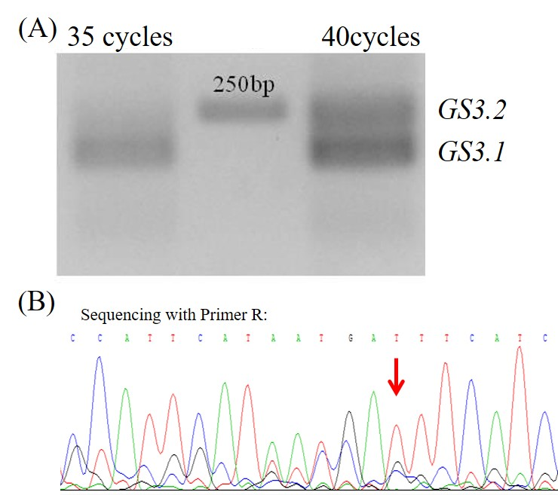
Supplemental Figure 1 GS3 is subjective to alternative splicing.
(A) GS3 AS variants were shown by agarose gel electrophoresis.
(B) GS3 AS variants were sequenced by reverse primer.

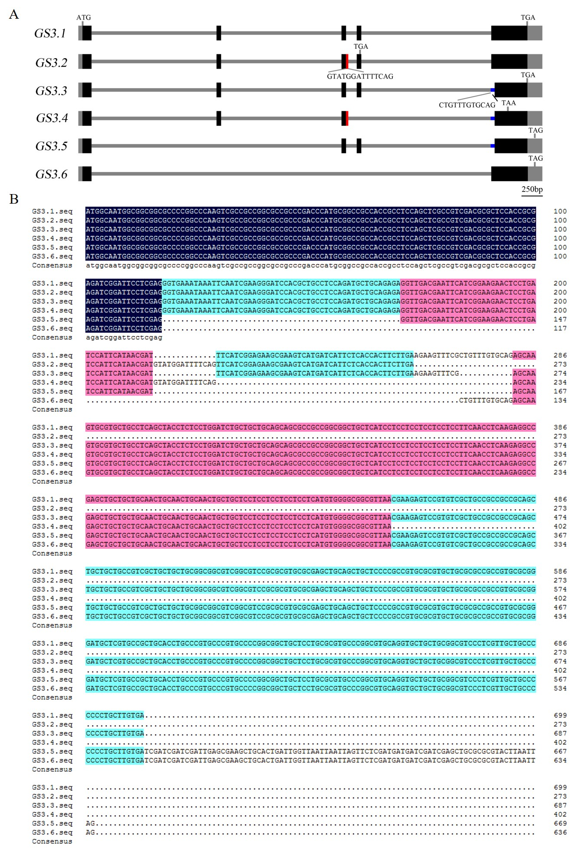
Supplemental Figure 2 Structures and sequences of GS3 alternative splicing variants.
(A) Structures of GS3 alternative splicing variants. Gray boxes represent UTR. Black and red boxes indicate exons. Gray and blue lines denote introns.
(B) Sequences of GS3 alternative splicing variants.
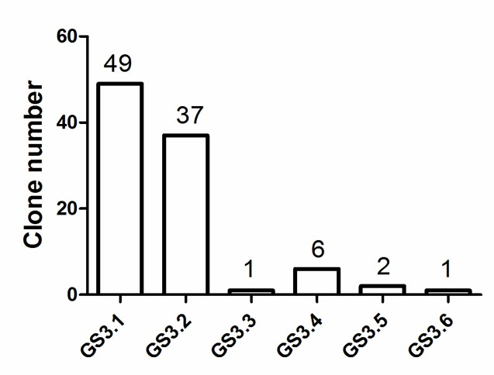
Supplemental Figure 3 Clone number of GS3 alternative splicing variants.

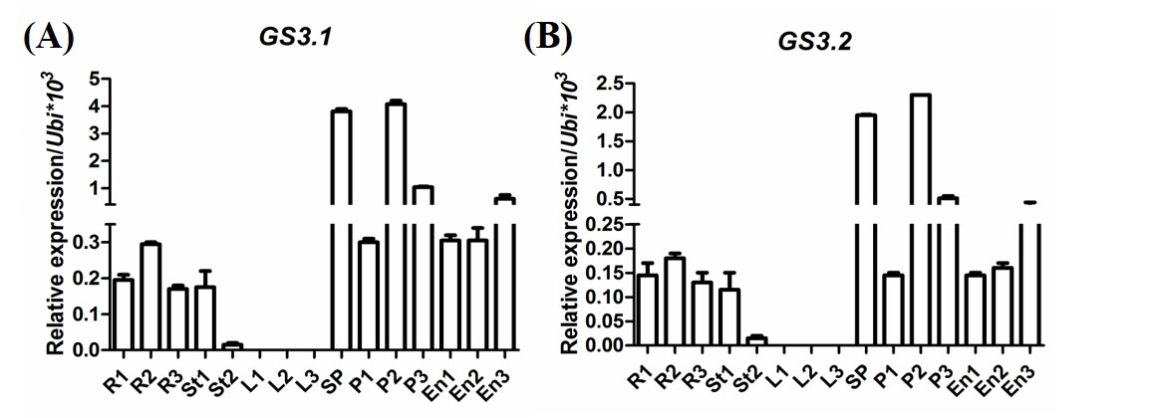
Supplementary Figure 4 Expression pattern analysis of (A) GS3.1 and (B) GS3.2 by qRT-PCR.
R1-3, root in seedling, tillering and heading stage, respectively.
St1-2, stem in elongation and heading stage, respectively.
L1-3, leaf in seedling, tillering and heading stage, respectively.
Sp, spikelet. P1-3, panicles with 2 mm, 3 cm and 5 cm length, respectively.
En1-3, Endosperm of 3, 12 and 20 days after pollination, respectively.
The results from three biological replicates are consistent.
Data are shown as mean ± SEM from three technical replicates.

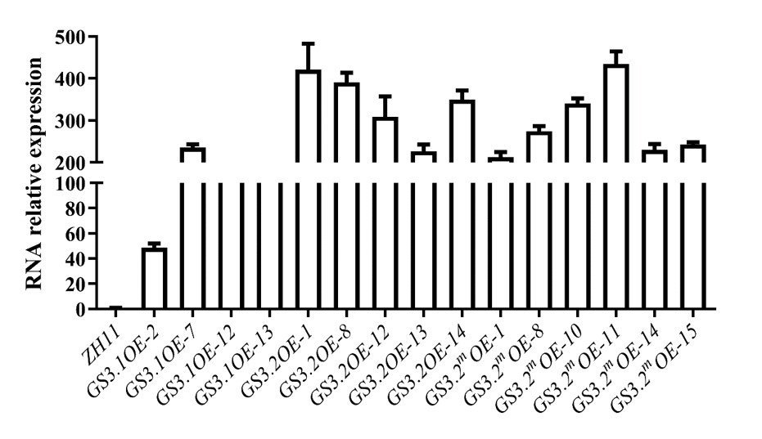
Supplemental Figure 5 Expression level analysis of GS3.1 and GS3.2 overexpressors by qRT-PCR. Ubiquitin was used as internal control. Data are shown as mean ± SEM.
Supplemental Table 1 Summary of grain traits of GS3 variants overexpressors.
Genotype | Grain length (mm) | Grain width (mm) | 1000-Grain weight (g)
ZH11-1 | 7.82 | 3.25 | 22.75
ZH11-2 | 7.75 | 3.22 | 23.83
GS3.1OE-2 | 7.29 | 2.84 | 16.48
GS3.1OE-7 | 6.72 | 2.91 | 13.79
GS3.1OE-12 | 7.47 | 2.99 | 16.18
GS3.1OE-13 | 7.32 | 2.94 | 16.54
GS3.2OE-1 | 8.01 | 3.18 | 24.73
GS3.2OE-8 | 7.59 | 3.10 | 23.27
GS3.2OE-12 | 7.51 | 3.03 | 24.08
GS3.2OE-13 | 7.74 | 3.21 | 22.89
GS3.2OE-14 | 7.84 | 3.25 | 24.06
GS3.2mOE-1 | 7.61 | 3.05 | 21.58
GS3.2mOE-8 | 7.89 | 3.12 | 23.34
GS3.2mOE-10 | 7.78 | 3.13 | 22.34
GS3.2mOE-11 | 7.88 | 3.23 | 24.61
GS3.2mOE-14 | 7.63 | 2.98 | 21.09
GS3.2mOE-15 | 7.72 | 3.16 | 23.06

Supplemental Table 2 Information of alternative splicing of GS3 homologs and effects on grain size.
Species | Effects on grain size | Reference | Alternative splicing
Arabidopsis thaliana L. | Positive | Li et al., 2012 | No
Brassica napus L. | Positive | Li et al., 2012 | No
Oryza sativa L. | Negative | Sun et al., 2018 | Yes
Triticum aestivum L. | Negative | Zhang et al., 2020 | Yes
Hordeum vulgare L. | ND |  | Yes
Brachypodium distachyon L. | ND |  | Yes
Oryza rufipogen | ND |  | Yes
Triticum urartu | ND |  | Yes
Aegilops speltoides | ND |  | Yes
Aegilops tauschii | ND |  | Yes

