Stabile SERS encoded silver silica nanocomposites for industrial labeling – the case of COVID-19 diagnosis
Can Xiaoª, Bernat Mir de Simón^{a,*}, Pilar Rivera-Gil^{a,*}
ª Integrative Biomedical Materials and Nanomedicine Lab, Department of Experimental and Health Sciences, University Pompeu Fabra, Doctor Aiguader 88, 08003 Barcelona, Spain.
* corresponding authors: bernat.mir@upf.edu ; pilar.rivera@upf.edu

SUPPORTING INFORMATION

EXPERIMENTAL SECTION
Materials and Reagents:
Ammonia solution, Tetraethyl orthosilicate, Silver nitrate (AgNO₃), Gold(III) chloride hydrate, Magnesium sulfate (MgSO₄), Ascorbic acid, 4-Mercaptobenzoic acid, Sodium hydroxide, carboxy-PEG12-thiol (CTPEG12), Ethanol, (3-Glycidyloxypropyl) trimethoxysilane (GPTMS), Ammonium Sulfate, Bovine Serum Albumin, HBSS, PBS, EIA/RIA 96 well plate, hydrogen peroxide (H₂O₂, 50wt.% in water), hydrochloric acid (HCl), nitric acid (HNO₃), were purchased from Merck. tri-Sodium Citrate 2-Hydrate (Na₃Cit) was purchased from PanReac Applichem. SARS-CoV/SARS-CoV-2 Spike antibody, Chimeric Mab (Cat: 40150-D001 and Cat: 40150-D003) and SARS-CoV Spike/RBD Protein (Cat: 40150-V08B2) were purchased from Sino Biological. Alexa Fluor® 488 AffiniPure Goat Anti-Mouse IgG (H+L) was purchased from JacksonImmuno. All the chemicals were used without further purification.
Silver and gold nanoparticles synthesis:
AgNO₃ 0.1 M, MgSO₄ 0.1 M, Na₃Cit 0.1 M and Ascorbic acid 0.1 M were prepared in aqueous solution. Solutions were prepared and used freshly. To avoid contamination, the glassware and magnets used were cleaned with Aqua Regia, basic piranha (RCA) before synthetizing silver nanoparticles (AgNPs) and gold nanoparticles (AuNPs).
For synthesizing AgNPs, two solutions were prepared separately. Solution 1 is prepared by mixing 5.115 mL 0.1 M Na₃Cit solution with 375 μL 0.1 M Ascorbic acid solution and solution 2 is prepared by mixing 839 μL 0.1 M MgSO₄ solution and 1.116 μL 0.1 M AgNO₃ solution. Two solutions were prepared at the same time when 250 mL Milli Q water was already boiled in an Erlenmeyer flask under homogeneous and strong stirring. Solution 1 was first added in one shot into this boiling aqueous solution after prepared for 4min. Then solution 2 was added in one shot after one more minute. The mixture was kept stirring at 300 ºC for 30 minutes. Then the solution was cooled down at room temperature without stirring. The nanoparticles (NPs) were protected from the light and stored at 4 ºC.
For synthesizing AuNPs, 250 mL Milli-Q water was heated in an Erlenmeyer flask at 300 ºC under homogeneous and strong stirring. Once water started boiling, 678 µL 0.1 M Na₃Cit added after water boiled. 2 min later, 623.7 µL 0.1 M HAuCl₄ added in one shot. Reaction was kept at 300 ºC for 30 min under stirring. Then the NPs was kept undisturbed and cooled down to room temperature, and further stored at 4 ºC and protected from the light.
Modification and controllable agglomeration of AgNPs and AuNPs
The modification and controllable agglomeration procedure applied for both AgNPs and AuNPs.
AgNPs or AuNPs synthesized were firstly cleaned by centrifugation 5400 rpm (2500 g) 20 min and adjusted to approx. 2.9x10¹⁰ NPs/mL with Milli-Q water calculated by UV-vis extinction. Raman probe MBA and stabilizer CTPEG12 were prepared in ethanolic solution with 10⁻³ M concentration and stored in 4 ºC. CTPEG12 and MBA amounts were calculated based on the metallic surface of the NPs which would be used for modification. 1 molecule/nm² of the CTPEG12 and 3 molecules/nm² of MBA added to curtain volume of ethanol under vigorous stirring. Equal volume of cleaned NPs (2.9x10¹⁰ NPs/mL) aqueous solution were added to this alcoholic solution under strong stirring after 5 min of the MBA and CTPEG12 addition. Then fresh prepared NaOH solution with final concentration 1.15 mM was added to NPs mixture. Reaction was kept under stirring for 24h to finish modification.
MBA modified AgNPs and AuNPs were agglomerated in a controlled manner by two centrifugation steps. First centrifugation at 4800 rpm (2000 g) 20min and a second centrifugation at 2000 rpm (350 g) 15min. NPs were redispersed with Milli-Q water.
The SERS spectra of MBA modified AgNPs agglomeration (AgNPs@MBA) were collected with a Renishaw’s inVia Qontor Raman system equipped with a Leica confocal microscope. The spectrograph used a high-resolution grating (1200 l cm⁻¹), band-pass filter optics, a NIR laser (785 nm) and a Peltier cooled CCD array detector, equipped with Windows-based Raman Environment (Wire™) software. 4.55X10¹⁰ NPs/mL (calculated by UV-vis extinction) 200 µl of AgNPs@MBA solution was added into 96 well plate for SERS spectra acquisition. The laser was focused into the samples with an 5X objective (NA 0.12), providing a laser spot diameter of approximate 8 μm. The spectra were collected with 1s exposure time and 100 mW laser power at the samples.
SiO₂ encapsulation
Silica encapsulation was conducted in the same way for agglomerated and non-agglomerated MBA modified AgNPs and agglomerated and non-agglomerated MBA modified AuNPs.
304.7 μl of NH₄OH (35%) were added into 15 mL of EtOH and mixed properly, followed by adding 2.3 mL (approx. 7x10¹⁰ NPs/mL) of modified NPs in aqueous solution, and mixing the whole system properly. 12.4 μl of TEOS 10% v/v diluted by ethanol were added consecutively into this mixture, and mixing the solution by stirring for 30 seconds. Then leave the reaction system undisturbed for approx. 12h. Silica coated modified NPs were cleaned by centrifugation thrice (6000 rpm, 20min). Samples were stored at 4 ºC and protected from light.
The morphology of silica encapsulated MBA modified AgNPs and AuNPs agglomerations (AgNPs@MBA@SiO₂ and AuNPs@MBA@SiO₂) were checked with transmission electron microscopy (TEM), using a JEOL JEM 1010 TEM operating at an acceleration voltage of 80 kV with a tungsten filament. For the preparation of TEM samples, 10 µL of AgNPs@MBA@SiO₂ or AuNPs@MBA@SiO₂ ethanolic solution were drooped on a TEM grid. TEM samples were completely dry at room temperature before we started TEM analysis. The morphology was checked and the average size and polydispersity was calculated with at least 100 particles by using image process software “Image J”.
Dynamic light scattering (DLS) and zeta potential measurements were performed with Malvern Zetasizer Nano ZS. Aqueous samples were transferred into disposable polystyrene cuvette for size measurements and disposable folded capillary cells for zeta potential measurements. Each sample was measured 3 repeats.
The extinction spectrum of each synthetic intermediate was recorded with Ultrospec™ 2100 pro UV-Visible spectrophotometer. 600 µL diluted aqueous samples were added into a Quartz cuvette (104-002-10-40, Hellma), and the extinction spectra between 250 and 900 nm wavelength were collected with Milli-Q water as a reference.
Labeling efficiency of AgNPs@MBA@SiO₂ onto different substrates
20 μl 7x10¹⁰ NPs/mL of AgNPs@MBA@SiO₂ were dropped on different materials and the composition was left to dry at room temperature. The materials used here are listed as following: semi-aniline leather, aniline leather, pigmented leather, polyester, silk, plastic (PVC), glass, brass, cotton, pigmented leather.
SERS characterization of all samples prepared here were conducted using Renishaw inVia Qontor Raman. 20X Leica objective was used with integration time 0.1 s and a power at the sample of 3 mW.
The surface of AgNPs@MBA@SiO₂ deposited materials were analyzed with a scanning electron microscope (SEM) from Phenom XL Desktop SEM with a Backscattered electron detector. The elemental analysis was conducted by energy-dispersive X-ray spectroscopy equipped with the SEM.
Biofunctionalization of AgNPs@MBA@SiO₂
Encoded AgNPs@MBA@SiO2 were primed with commonly used silane coupling agent GPTMS by mixing 1mL 4.5x10¹⁰ NPs/mL AgNPs@MBA@SiO₂ ethanolic solution with 105 μl 0.01% v/v GPTMS ethanolic solution under stirring at 60 °C for 12 h. This amount of GPTMS was calculated to provide approx. GPTMS 20 molecules/nm² of AgNPs@MBA@SiO₂ surface. Then GPTMS modified AgNPs@MBA@SiO₂ (AgNPs@MBA@SiO₂@GPTMS) was cleaned by centrifugation at 4000 rpm 8min with ethanol and phosphate buffered saline (PBS).
This 1mL AgNPs@MBA@SiO₂@GPTMS was further diluted with PBS into 2.5mL before biofunctionalization with SARS-CoV/SARS-CoV-2 Spike antibody (Anti-COV spike Ab, Cat: 40150-D003, MW 150 kDa). Then 2.5 mL of 2 M freshly prepared Ammonium sulphate solution in PBS and 25 μg Anti-COV spike Ab were added into AgNPs@MBA@SiO₂@GPTMS solution and reaction was kept for 24h on a rocker table with 110 rpm in a 37℃ room. When immobilization was concluded, final concentration of 0.1% bovine serum albumin (BSA) solution in PBS was added to avoid the adhesion of the NPs to the centrifuge tubes during centrifugation. The Anti-SARS-CoV-2 spike Ab functionalized AgNPs@MBA@SiO₂@GPTMS (AgNPs@MBA@SiO₂@Ab) were cleaned by centrifugation at 4000 rpm 8 min with 0.1% BSA PBS solution three times to eliminate any unbound antibody. AgNPs@MBA@SiO₂@Ab was resuspended into 0.1% BSA PBS solution to further stabilize the NPs in the saline environment with approx. concentration 9x10⁹ NPs/mL.
This successful immobilization was confirmed with confocal laser scanning microscope (CLSM) (Leica SP2 (inverted)). 10 μL 9x10⁹ NPs/mL AgNPs@MBA@SiO₂@Ab mixed with 15μL PBS and 25 μL secondary antibody (5μg/mL, Alexa Fluor® 488 AffiniPure Goat Anti-Mouse IgG) for 1 h at room temperature. One negative control was conducted with AgNPs@MBA@SiO₂ following the same method used for AgNPs@MBA@SiO₂@Ab.
SERS-based sandwich immunoassay to diagnose COVID-19.
Then we validate their performance to detect SARS-CoV-2 spike recombinant proteins in a sandwich ELISA-like immunoassay
Coating testing plates with capture Ab: Thawed and mixed by gently vortexing SARS-CoV/SARS-CoV-2 Spike antibody vials (capture Ab, Cat: 40150-D001, MW 150 kDa) before diluting in PBS. 96-well microtiter ELISA plates were coated with 50 μl of 6 μg/mL capture Ab per well. To avoid bubbles and ensure homogenous coating on the bottom of every well, lightly taped the plate against hard surface. Elisa plates were sealed with parafilm and aluminium foil to protecte from the light and incubated at 4°C overnight.
Blocking testing plates: Coated ELISA plates were washed 3 times with PBS containing 0.1% Tween 20 (PBS-T) solution by adding 300 μL PBS-T solution for each wash. To remove residual buffer, plates were blotted forcefully on a paper towel after each wash. Blocking solution was prepared by mixing BSA into PBS-T solution with concentration of 1%. 200 μl blocking solution was added into each well of the plates and incubated in a 37°C hot room for one hour. After the blocking incubation, throwed off the blocking solution and tapped the plates dry on a paper towel to remove residuals.
Spike protein assay: Spike protein (SARS-CoV Spike/RBD Protein, MW 26.5 kDa) were diluted with PBS into a series concentration: 0.01, 0.02, 0.1, 0.2, 0.4, 0.6, 0.8, 1, 1.2, 1.6 ng/μL. 50 μl of diluted spike protein (and PBS used as negative control) were transferred into wells in the ELISA plate. Plates were placed in a 37℃ hot room for 1h, followed by washing with PBS thrice. Then 50 μl 9x10⁹ NPs/mL AgNPs@MBA@SiO₂@Ab solution was added to each working well of the plate. Be sure to avoid touching the walls in order to avoid high background. Plates were incubated in a 37℃ hot room for 1h, then washed with PBS thrice. Plates were analyzed with Raman by checking SERS signal of labelled AgNPs@MBA@SiO₂@Ab. 5X Leica objective with integration time 1 s and a power at the sample of 50 mW was used for SERS spectra acquisition. SERS spectra were collected and intensity at 1075 cm⁻¹ were calculated by averaging with 8 spectra from 8 random places in Elisa plates.
Limit of detection (LOD)
The limit of detection (LOD) was calculated based on 3 times the signal to noise ratio, by measuring the intensity ratio with the presence and the absence of antigen at 1075 cm⁻¹.

RESULTS AND DISCUSSION
AgNPs@MBA@SiO₂ synthesis and characterization
Figure SI-1 shows a hydrodynamic diameter of 133.8 nm with PDI 0.130 for the AgNPs@MBA@SiO₂ and the zeta potential average of -24.7 mV. This hydrodynamic size agrees to the average size we measured with TEM. And the negative surface charge is typical for the silica outer layer.
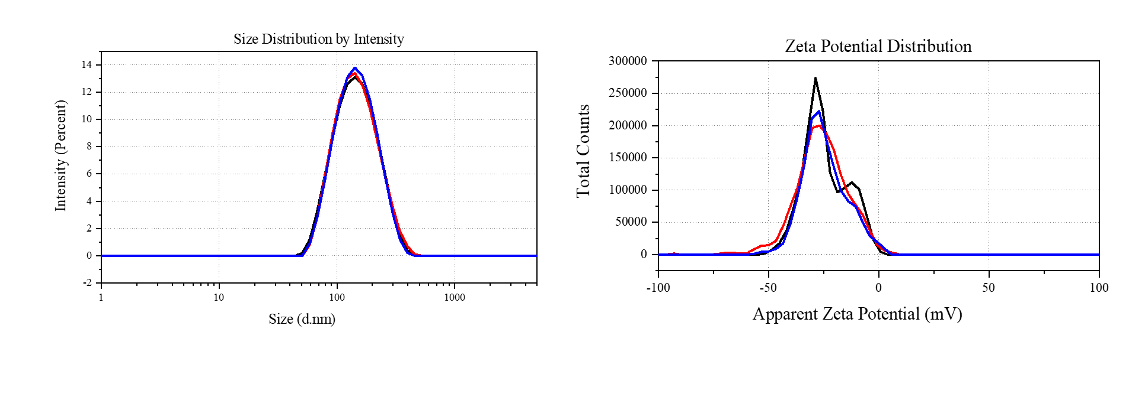Figure SI-1: Controlled agglomeration and silica coating. (A) Size measurements (3 repeated runs) of AgNPs@MBA@SiO₂. (B) Zeta potential measurements (3 repeated measurements) of AgNPs@MBA@SiO₂.

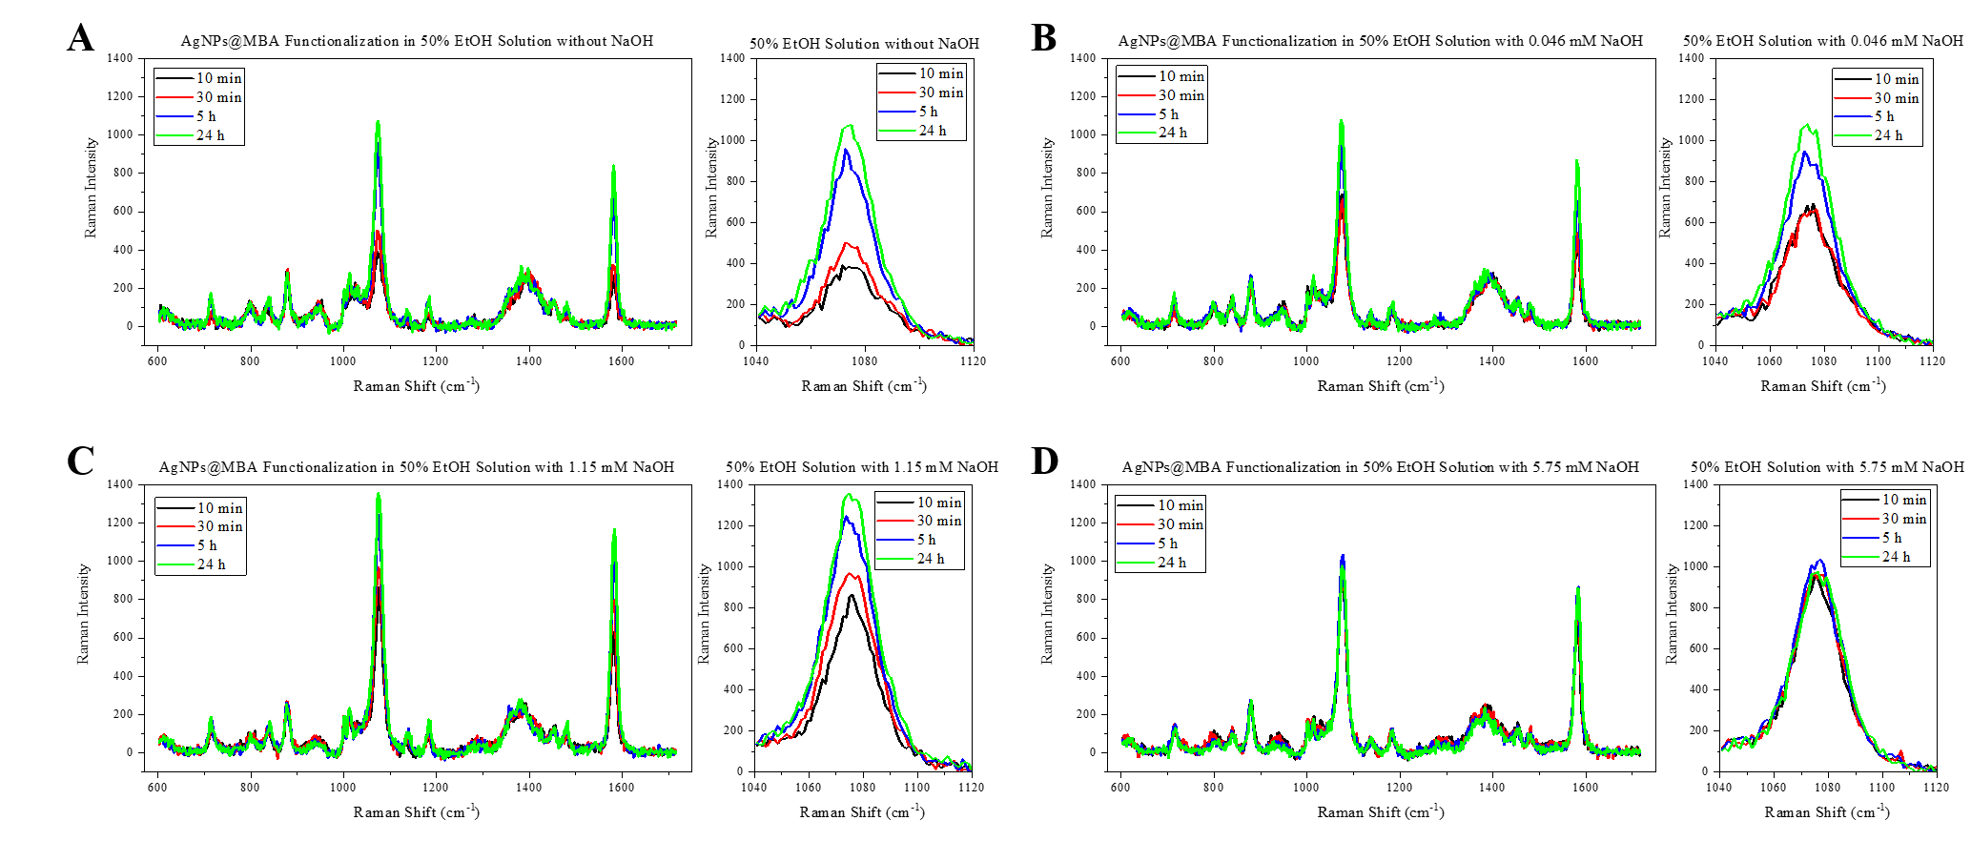 Figure SI-2: SERS spectra and zoomed spectra showing characteristic peak at 1075 cm⁻¹ of AgNPs@MBA in 50% EtOH/water solution without NaOH (A), with 1.15 mM NaOH (B), with 1.15 mM NaOH (C) and with 5.75 mM NaOH (D) at 10 min (in black), 30 min (in red), 5 h (in blue) and 24 h (in green).

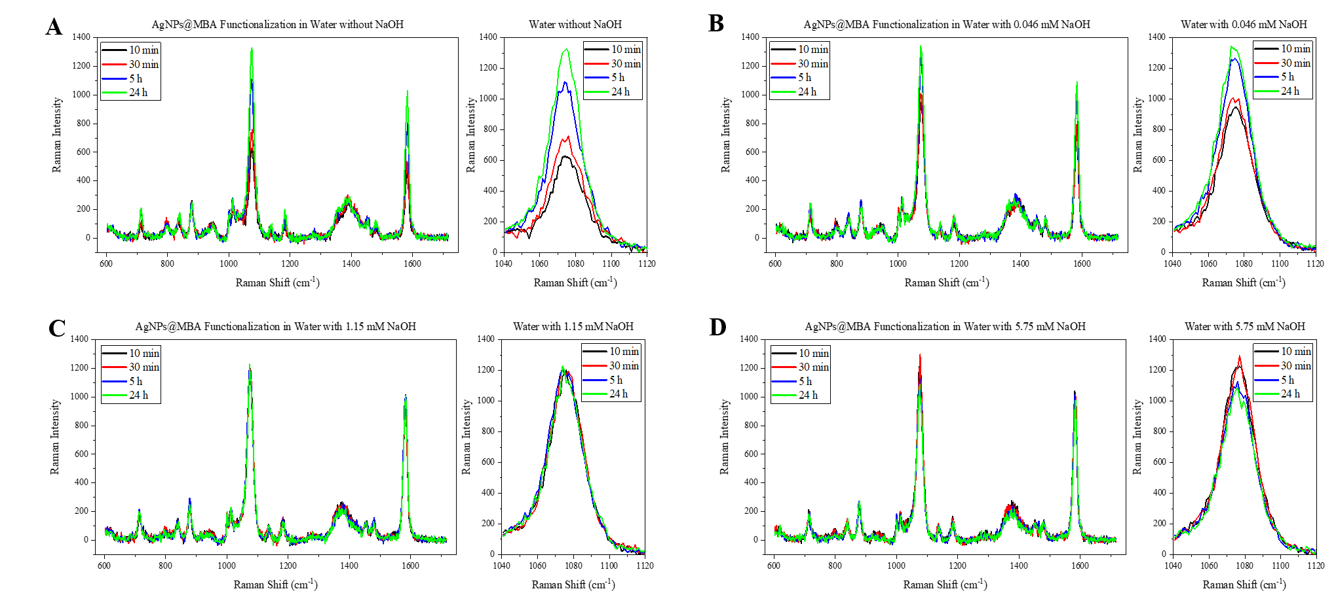 Figure SI-3: SERS spectra and zoomed spectra showing characteristic peak at 1075cm⁻¹ of AgNPs@MBA in aqueous solution without NaOH (A), with 1.15mM NaOH (B), with 1.15mM NaOH (C) and with 5.75mM NaOH (D) at 10min (in black), 30min (in red), 5h (in blue) and 24h (in green).

NaOH Amount | pH in aqueous solution | pH in 50% ethanol/water solution
without NaOH | 6 | 6.5
0.046mM NaOH | 8.5 | 6.5
1.15mM NaOH | 11 | 8
5.75mM NaOH | 11.5 | 9.5

Table SI-1: pH values for all conditions. The table present the measured pH (test strips) of all codification conditions used for MBA functionalization of AgNPs.
UV-vis was performed under all codification conditions after 24 h addition of the Raman probe to monitor their LSPR informing on their degree of agglomeration and geometrical changes (cf., SI, figure SI-4). As confirmed, both, AgNPs and AgNPs@MBA, showed the characteristic LSPR of isolated NPs at around 435 nm under all codification conditions. Furthermore, compared with the plamonic absorption of AgNPs, AgNPs@MBA suffered a red shift, around 12 nm, indicating proper adsorption of MBA onto the metallic surface. None of the NPs showed absorption features in the NIR region (approx. 650 nm) attributed to plasmonic coupling of interacting NPs (i.e., agglomeration) as shown for AgNPs@MBA@SiO₂ (figure 1C), confirming the different performance we got based on the kinetic results in Figure 1D and E were not related with any geometry changes in AgNPs@MBA.

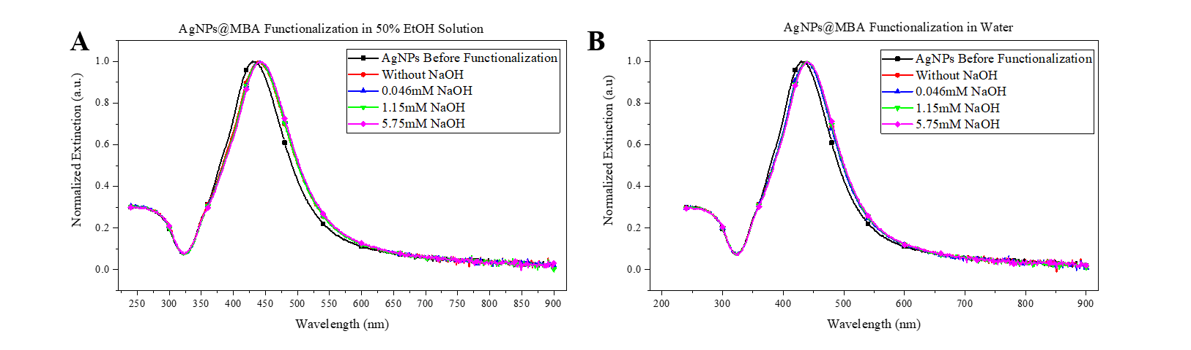 Figure SI-4 UV-Visible extinction spectra of MBA modified AgNPs (AgNPs@MBA) at different pH. Different ammoutns of NaOH were added to 50% EtOH/water solution (A) and to aqueous solution (B). Black line: AgNPs; Red line: AgNPs@MBA without NaOH; Blue line: AgNPs@MBA with 0.046 mM NaOH; Green line: AgNPs@MBA with 1.15 mM NaOH; Magenta line: AgNPs@MBA with 5.75 mM NaOH.
AuNPs are synthesized following the method reported as sodium citrate method(1). Then we performed the procedure described before for the Ag-based nanoagglomerates i.e., codification with MBA and stabilization with CTPEG12, controlled agglomeration and the SiO₂ encapsulation. The complete characterization is presented in Figure SI-5. Figure SI-5A shows the TEM image of AuNPs@MBA@SiO₂. The AuNPs were spherical and more than 60% of the NPs were agglomerated (measured from 100 NPs from TEM images). Figure SI-5B exhibit the size histogram of AuNPs@MBA@SiO₂ showing an average diameter of around 107 nm. This value was obtained by measuring 4 different angles of 100 NPs containing all populations (isolated NPs, dimers, trimers, tetramers, pentamers, and hexamers). Figure SI-5C shows that the AgNPs@MBA@SiO₂ have a hydrodynamic diameter of 113.6 nm with PDI 0.199, and a zeta potential average of -27.9 mV (figure SI-5D). The normalized extinction spectra of AuNPs and AuNPs@MBA@SiO₂ is presented in figure SI-5E. Spherical, isolated AuNPs have their characteristic LSPR peat at around 540 nm whereas the AuNPs@MBA@SiO₂ exhibited the characteristic absorption feature attributed to agglomerated NPs which is shifted to the NIR region, in this case to approx. 750nm. The SERS spectra and the peak intensity at 1075 cm⁻¹ of AuNPs@MBA@SiO₂ and non-agglomerated AuNPs@MBA@SiO₂ is presented in figure SI-5F. It demonstrates controlled agglomeration and adsorption of the Raman probe to increase the SERS efficiency (2 times).
Au-based nanoagglomerates present similar physicochemical characteristics (size, surface charge, polydispersity, agglomerates form) than Ag-based. The LSPR were different because it is related to composition of the plasmonic nanostructure (Ag vs Au). This demonstrates the reproducibility and robustness of our synthesis procedure. We did observe differences in the SERS performance. AuNPs@MBA@SiO₂ nanoagglomerates enhanced 2 times (cf., SI, figure SI-5F) whereas AgNPs@MBA@SiO₂ nanoagglomerates achieved almost 40 times higher signals (figure 1F) than their non-agglomerated counterparts.

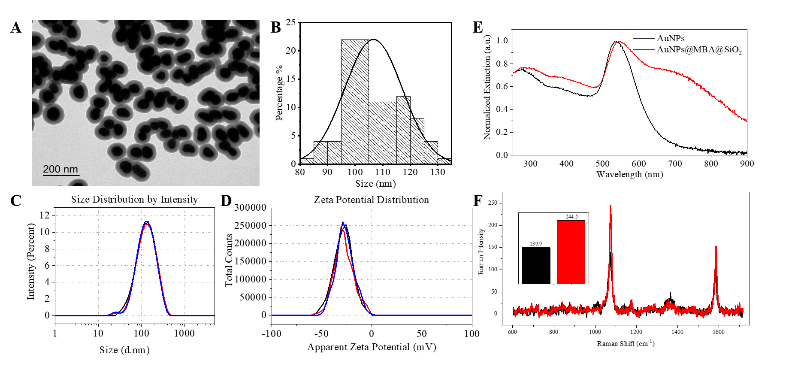 Figure SI-5: Synthesis and characterization of AuNPs@MBA@SiO₂. (A) TEM image of AuNPs@MBA@SiO₂. (B) Size distribution of AuNPs@MBA@SiO₂ based on TEM images of 100 NPs analyzed with ¨Image J¨. (C) Size measurements (3 repeated runs) of AuNPs@MBA@SiO₂, with mean value 113.6 nm and PDI 0.199; (D) Zeta potential measurements (3 repeated measurements) of AuNPs@MBA@SiO₂, with mean value -27.9 mV. (E) UV-Visible extinction spectra of AuNPs (in black) and AuNPs@MBA@SiO₂ (in red). (F) SERS spectra and SERS intensity at 1075cm⁻¹ (inset image) of non-agglomerated AuNPs@MBA@SiO₂ (in black) and AuNPs@MBA@SiO₂ (in red).
Stability of the AgNPs@MBA@SiO₂ SERS signal after labeling different types of substrates

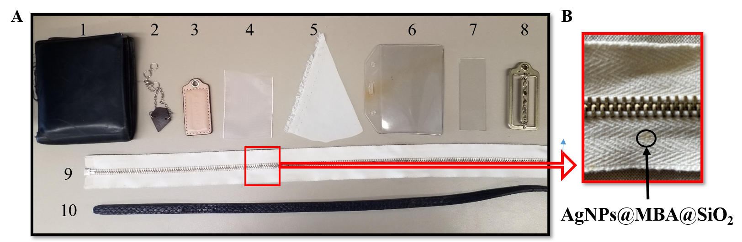 Figure SI-6: Measuring the stability of the SERS signal onto different materials. (A) Picture showing10 substrates labelled with AgNPs@MBA@SiO₂. (B) zoomed photo showing AgNPs@MBA@SiO₂ deposited on cotton. The materials are: 1, semi-aniline leather; 2, aniline leather; 3, pigmented leather; 4, polyester; 5, silk; 6, plastic (PVC); 7, glass; 8, brass; 9, cotton; and 10, dyed pigmented leather.

SERS-based sandwich immuneassay for the diagnosis of COVID-19
To confirm NPs’ surface bioconjugation, we incubate the AgNPs@MBA@SiO₂@Ab and the AgNPs@MBA@SiO₂ with a fluorescently labeled secondary antibody. Only AgNPs@MBA@SiO₂@Ab provide a bright fluorescent signal originated from the antibody recognition and confirming successful bioconjugation (cf., SI, figure SI-7).
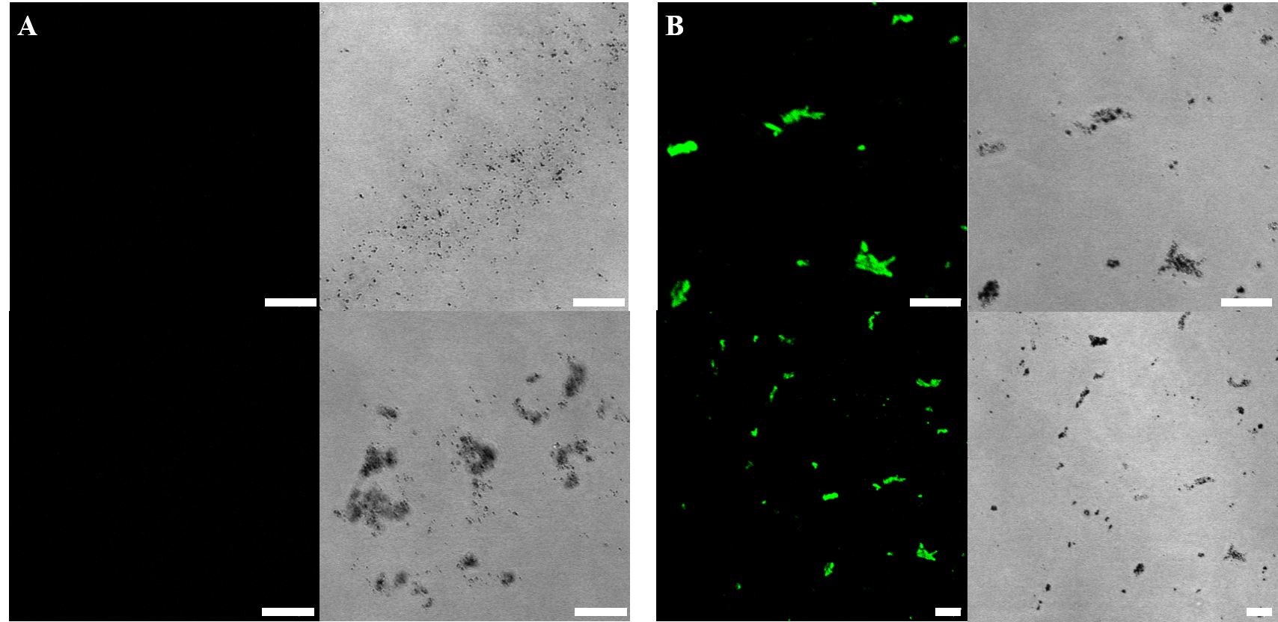
Figure SI-7: Synthesis and characterization of AgNPs@MBA@SiO₂@Ab. Confocal laser scanning microscopy images of AgNPs@MBA@SiO₂ (A) and AgNPs@MBA@SiO₂@Ab (B) incubated with a fluorescently labeled secondary antibody (Alexa Fluor® 488 AffiniPure Goat Anti-Mouse IgG) recognizing the antibody on the surface of the NPs. The scale bar in all confocal images correspond to 10 μm.
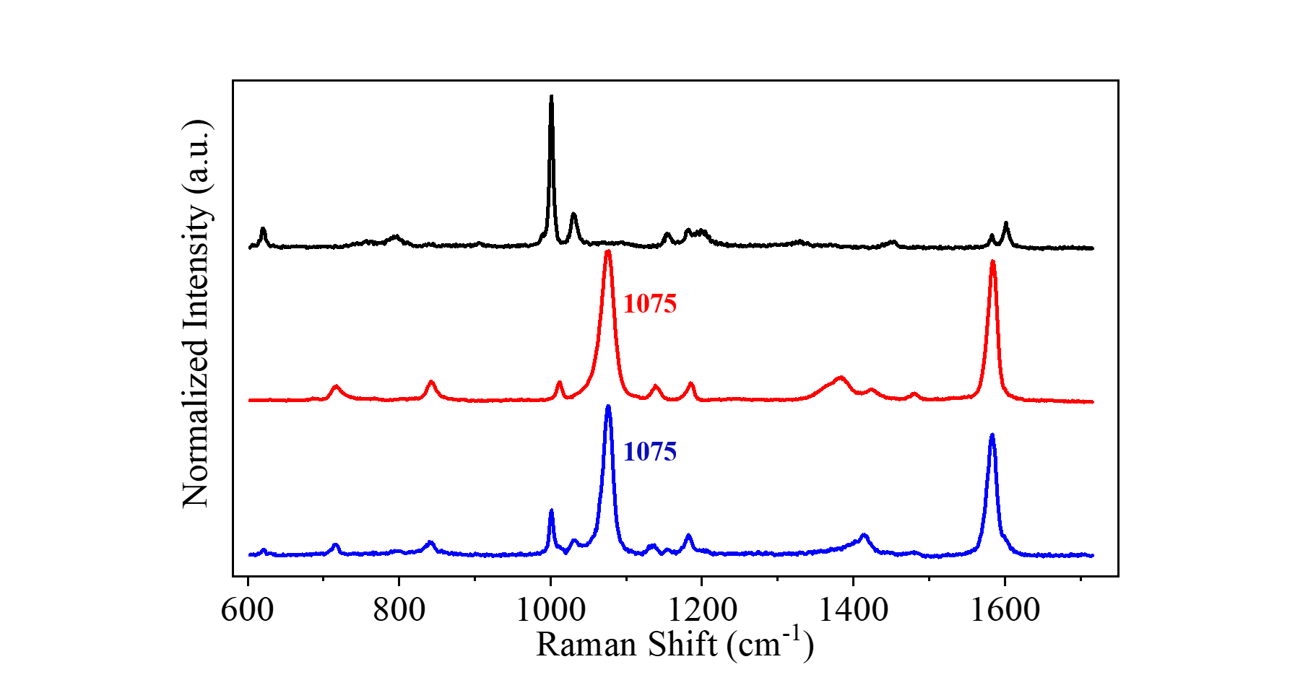
Figure SI-8: SERS response of the different components. The black spectrum corresponds to the ELISA plate (composed of polystyrene). The red spectrum was recorded from the AgNPs@MBA@SiO₂@Ab in buffer and showing the characteristic MBA peak at 1075 cm⁻¹. The blue spectrum corresponds to the recognition of 1 ng/μL SARS-CoV-2 spike protein immobilized onto an ELISA plate by our AgNPs@MBA@SiO₂@Ab. The appearance of the at 1075 cm⁻¹ confirms virus detection.
REFERENCES
1. Turkevich J, Stevenson PC, Hillier J. A study of the nucleation and growth processes in the synthesis of colloidal gold. Vol. 11, Discussions of the Faraday Society. 1951. p. 55–75.

