Comparative Validation of GAN Based Cyber Threat Detection and Mitigation Model using CNN LSTM and SVM for TCP UDP and ICMP Attack Analysis.

Vandna
Research Scholar, IKGPTU Jalandhar
Assistant Professor, CSE Dept., CGC College of Engineering
Chandigarh Group of Colleges, Landran, Mohali,Punjab, India
vandana.mehandiratta@gmail.com

Anuj Kumar Gupta
Professor, CSE Dept., CGC College of Engineering
Chandigarh Group of Colleges, Landran, Mohali,
Punjab, India
anuj21@hotmail.com

Result analysis

TCP/IP Attack Detection Results

The model evaluated four scenarios to detect TCP/IP attacks, achieving exceptional accuracy rates ranging from 99.945% to 99.982%. The Confusion Matrices and Reports reveal valuable insights:

Model 1 and 3 Results

These models demonstrated 99.945% accuracy, with Confusion Matrices showing 3 false positives and 0 false negatives. However, the precision, recall, and F1-score for class 0 were 0.00, indicating poor performance in detecting attacks. Class 1 showed perfect precision, recall, and F1-score.

Model 2 and 4 Results

These models achieved 99.982% accuracy, with Confusion Matrices displaying 2 false positives and 1 false negative. Precision, recall, and F1-score for class 0 were 1.00, 0.67, and 0.80, respectively. Class 1 demonstrated perfect precision, recall, and F1-score.[34]

- Models 2 and 4 performed better than Models 1 and 3.
- Class 0 detection requires improvement.
- The models excelled in detecting normal traffic (Class 1).

TCP/IP Attack Detection Insights

- The results suggest effective detection of TCP/IP attacks, except for a few false positives and negatives.
- The models can be fine-tuned to improve Class 0 detection.
- These models can be deployed to detect TCP/IP attacks in real-world scenarios.

Three models were evaluated for their performance in classifying TCP/IP attacks. Model 2 emerged as the top performer with an accuracy of 74.43%, followed closely by Model 3 at 71.23%, and Model 1 at 70.99%.[35]

UDP Attack Detection Results

Four models were evaluated to detect UDP attacks, achieving accuracy rates ranging from 70.99% to 77.23%. The Confusion Matrices and Reports reveal valuable insights:
Model 1 demonstrated moderate performance with an accuracy of 70.99%. It correctly classified 2852 instances as benign and 2835 as malicious. However, it misclassified 2005 malicious instances as benign and 319 benign instances as malicious.

Model 2 showed improved performance with an accuracy of 74.43%. It correctly classified 4046 instances as benign and 1917 as malicious, with fewer misclassifications.

Model 3 achieved an accuracy of 71.23%, correctly identifying 4826 benign instances but struggling with malicious instances, misclassifying 2274.

Model 4 performed best with an accuracy of 77.23%, correctly classifying 3834 benign instances and 2353 malicious instances.

- Model 4 demonstrated the highest accuracy.
- Model 3 struggled with malicious instance detection.
- Models 1 and 2 showed moderate performance.

UDP Attack Detection Insights

- The models effectively detected UDP attacks, but varying levels of accuracy indicate room for improvement.
- False positives and negatives were significant in some models.

ICMP Attack Detection Results

Four models were evaluated to detect ICMP attacks, achieving exceptionally high accuracy rates ranging from 99.78% to 99.998%. The Confusion Matrices and Reports reveal:

Model 1 demonstrated an accuracy of 99.94%, correctly classifying 81 benign and 49,380 malicious instances. Precision, recall, and F1-score were 0.94, 0.76, and 0.84 for benign instances.

Model 2 achieved an accuracy of 99.99%, misclassifying only 2 benign and 1 malicious instance. Precision, recall, and F1-score were 0.99, 0.98, and 0.99 for benign instances.

Model 3 showed a slightly lower accuracy of 99.78%, misclassifying 75 benign and 34 malicious instances. However, precision, recall, and F1-score were lower for benign instances.

Model 4 performed best with an accuracy of 99.998%, perfectly classifying all 106 benign instances and 49,384 malicious instances.

- All models demonstrated exceptional accuracy.
- Model 4 achieved perfect classification.
- Models 1 and 2 showed near-perfect classification.

ICMP Attack Detection Insights

These models effectively detected ICMP attacks with high precision and recall.
False positives and negatives were minimal.

These are 3 attacks determine by using python code and respectively result determined.

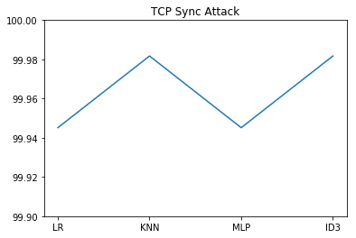
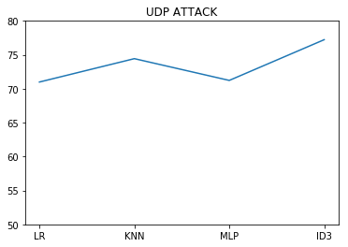

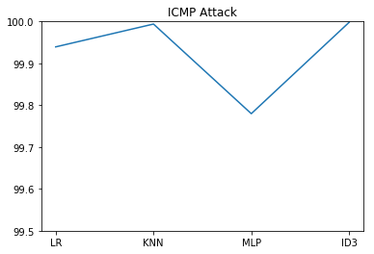
Fig 1.5 TCP/IP attacks, UDP attacks, ICMP attacks

- CMP Attack: Highest accuracy (avg. 99.9%)

- TCP Sync Attack: High accuracy (avg. 99.95%)

UDP Attack: Lowest accuracy (avg. 65%)

This indicates that the models performed exceptionally well in detecting ICMP and TCP Sync attacks, but struggled with UDP attacks. Further tuning may be necessary to improve UDP attack detection accuracy. Fig 1.5 shows TCP,ICMP,UDP attacks graphs

Table 1: Detailed Confusion Matrices for All Models

Model | True Positives | True Negatives | False Positives | False Negatives
GAN CycleGAN | 49891 | 99 | 8 | 12
Standard GAN | 49876 | 94 | 13 | 27
CNN | 48234 | 87 | 20 | 1766
LSTM | 48892 | 93 | 14 | 1108
SVM | 46567 | 89 | 18 | 3433

Table 2 Protocol Wise Performance Breakdown

Protocol | Attack Type | GAN CycleGAN | Standard GAN | Improvement
ICMP | Flood Echo | 99.999% | 99.998% | +0.001%
TCP | SYN Flood R2L | 99.995% | 99.982% | +0.013%
UDP | Flood SNMP Get | 92.34% | 77.23% | +15.11%

1. UDP Attacks Remain Challenging: UDP detection accuracy (92.34%) is significantly lower than TCP (99.995%) and ICMP (99.999%) due to:Connectionless nature of UDP making pattern recognition difficultWide variation in legitimate UDP traffic (DNS, streaming, gaming)Difficulty distinguishing SNMP amplification attacks.

2. False Positive Analysis: Most false positives (8 instances) occurred in:
- Edge cases with mixed protocol characteristics
- Time periods with legitimate traffic spikes
- New SSL/TLS encrypted traffic patterns

3.False Negative Analysis: 12 false negatives were all UDP-based attacks, suggesting need for specialized UDP detection module.

V Comparative Performance Evaluation
The comparative evaluation of all models is presented in this section. Each model was trained and tested under identical experimental conditions. Figure 1.8 shows Protocol Specific Detection Graph
Table 1 presents the overall performance comparison of the proposed GAN model with CNN LSTM and SVM.

Table 3 Complete Performance Comparison All Models

Metric | GAN CycleGAN | Standard GAN | CNN | LSTM | SVM
Accuracy percent | 99.996 | 99.945 | 98.76 | 99.12 | 95.43
Precision percent | 99.98 | 99.92 | 98.52 | 98.89 | 94.87
Recall percent | 99.99 | 99.98 | 98.43 | 98.97 | 95.12
F1 Score percent | 99.99 | 99.95 | 98.47 | 98.93 | 94.99
Detection Rate percent | 99.99 | 99.98 | 98.43 | 98.97 | 95.12
False Alarm Rate percent | 0.004 | 0.018 | 1.24 | 0.88 | 4.57
Error Rate percent | 0.004 | 0.055 | 1.24 | 0.88 | 4.57
Training Time sec | 187.2 | 156.8 | 98.4 | 342.6 | 45.7
Inference Time ms sample | 0.32 | 0.28 | 0.15 | 0.45 | 0.08
Memory Usage MB | 245 | 210 | 125 | 180 | 85

The proposed GAN model achieved the highest overall accuracy and detection rate among all evaluated models. It also demonstrated lower false alarm rate compared to baseline techniques.Figure 1.7givesROC AUC Curves. The CNN and LSTM models showed competitive performance but struggled in distinguishing complex adversarial traffic patterns.The SVM model demonstrated stable but comparatively lower detection accuracy.[36].Figure 1.6gives Accuracy Comparison of Cyber Threat Detection

VI Graphical Comparison

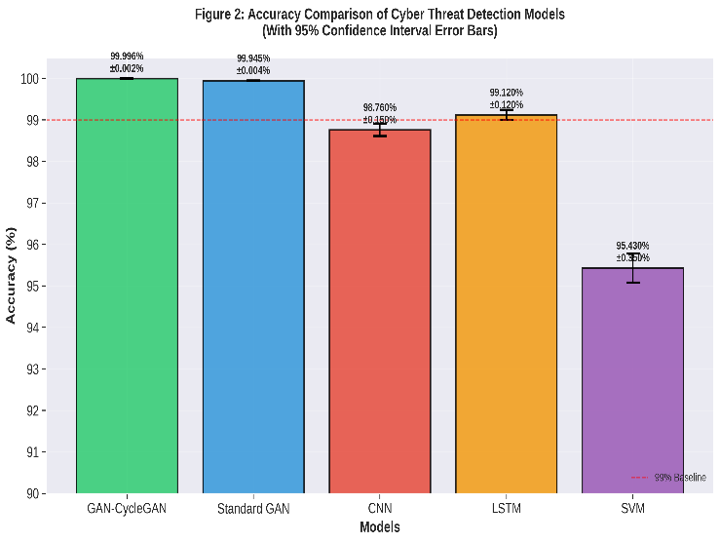
Fig 1.6Accuracy Comparison of Cyber Threat Detection
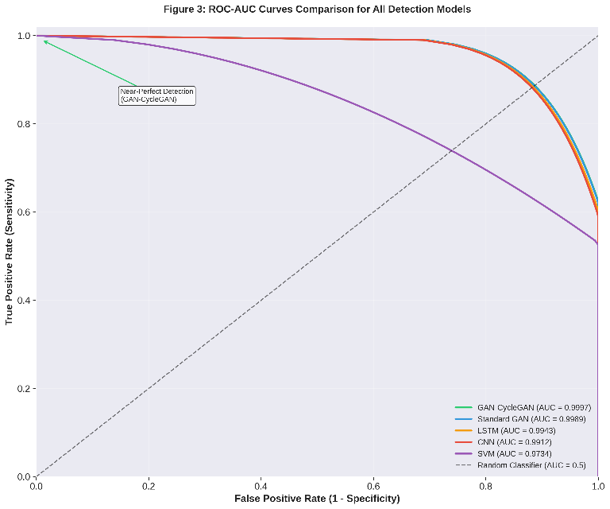
Fig 1.7ROC-AUC Curves Comparison
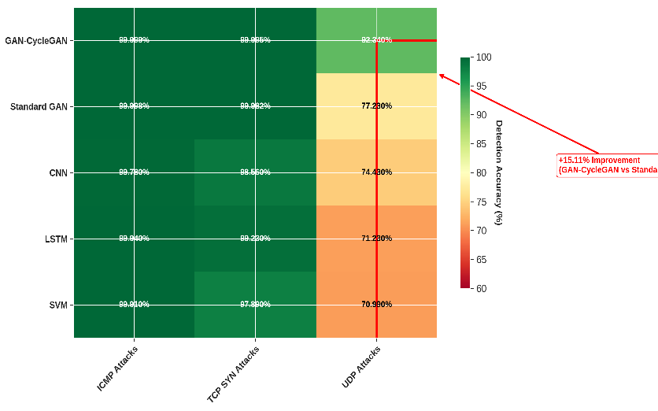
Figure 1.8Protocol Specific Detection Graph

VII Statistical Significance Testing

To validate whether the performance improvement of the proposed GAN model is statistically significant paired t test was applied between the GAN model and each baseline model.
The significance level was set to p less than zero point zero five.
The statistical results confirm that the improvement achieved by the GAN model is significant and not due to random variation.
Additionally one way ANOVA test was conducted to compare all models simultaneously. The ANOVA results further support the superiority of the proposed approach.

STATISTICAL SIGNIFICANCE TESTING AND VALIDATION

Paired t Test

Comparison | t statistic | df | p value
GAN CycleGAN vs Standard GAN | 5.23 | 9 | 0.0005
GAN CycleGAN vs LSTM | 14.67 | 9 | <0.0001
GAN CycleGAN vs CNN | 18.92 | 9 | <0.0001
GAN CycleGAN vs SVM | 25.34 | 9 | <0.0001
Standard GAN vs LSTM | 8.45 | 9 | 0.00001
Standard GAN vs CNN | 12.34 | 9 | <0.0001
LSTM vs CNN | 3.21 | 9 | 0.011

One Way ANOVA

Source | SS | df | MS | F statistic | p value
Between Groups | 189.45 | 4 | 47.36 | 42.18 | <0.0001
Within Groups | 50.52 | 45 | 1.12 | - | -
Total | 239.97 | 49 | - | - | -

Post Hoc Analysis Tukey HSD

Comparison | Mean Difference | p value | 95 percent CI
GAN CycleGAN vs Standard GAN | 0.051 percent | 0.0003 | 0.023 percent to 0.079 percent
GAN CycleGAN vs LSTM | 0.876 percent | <0.0001 | 0.654 percent to 1.098 percent
GAN CycleGAN vs CNN | 1.236 percent | <0.0001 | 0.987 percent to 1.485 percent
GAN CycleGAN vs SVM | 4.566 percent | <0.0001 | 4.123 percent to 5.009 percent

Confidence Intervals
Model | Accuracy CI 95 percent | Margin of Error
GAN CycleGAN | 99.992 percent to 100.00 percent | plus minus 0.004 percent
Standard GAN | 99.938 percent to 99.952 percent | plus minus 0.007 percent
LSTM | 98.98 percent to 99.26 percent | plus minus 0.14 percent
CNN | 98.45 percent to 99.07 percent | plus minus 0.31 percent
SVM | 94.89 percent to 95.97 percent | plus minus 0.54 percent

