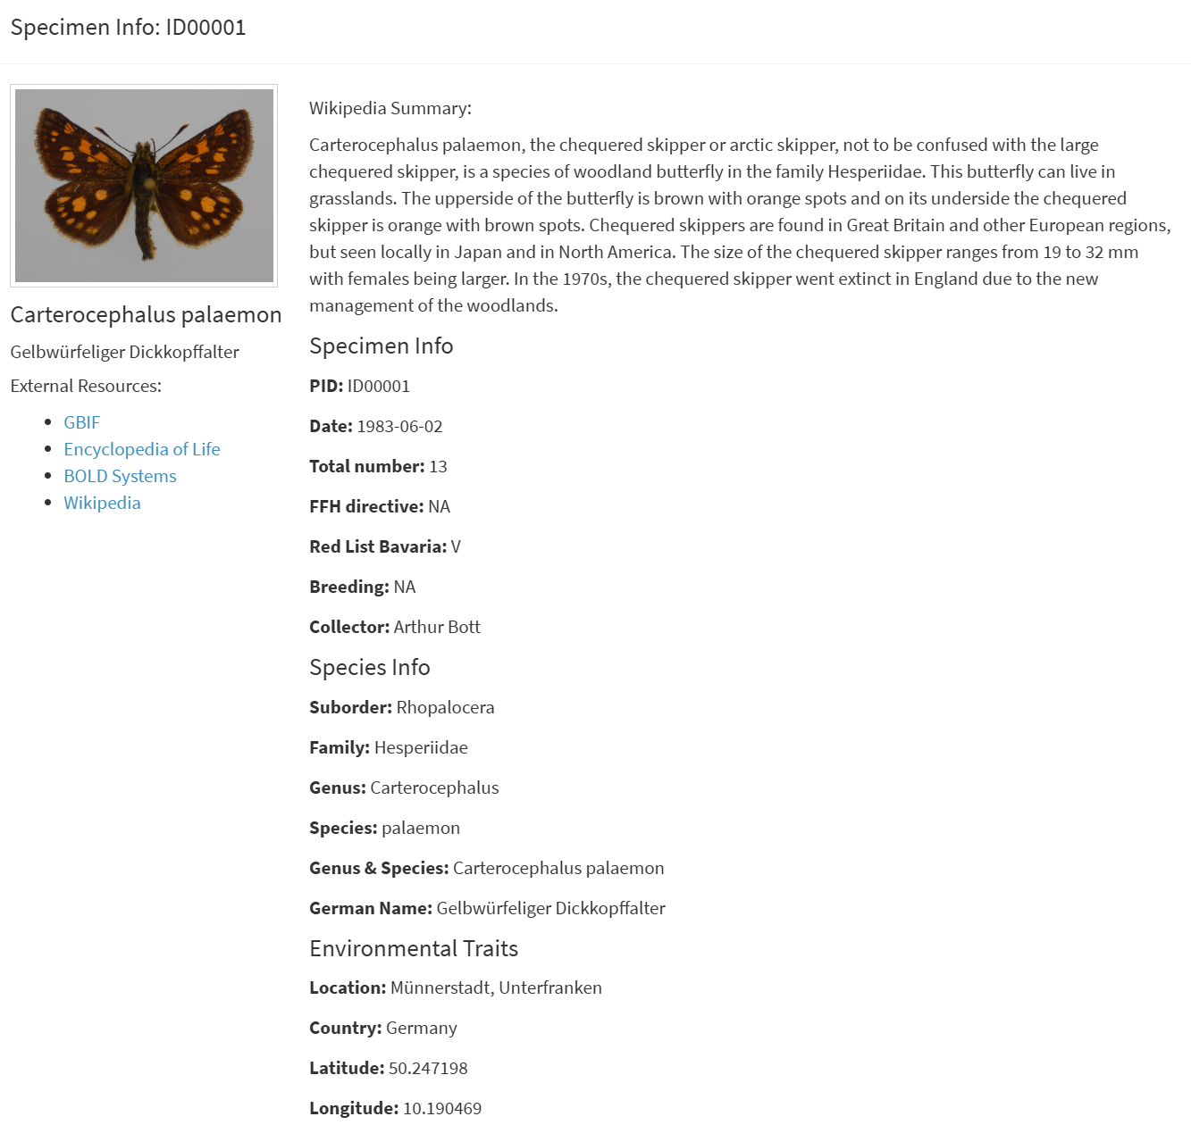
Supplementary Figure S1. Detailed specimen view with integrated external resources. Clicking on a specimen ID in the main interface opens a dedicated detail view displaying comprehensive metadata at specimen, species and location levels. The panel includes structured fields for collection data, taxonomic assignment, conservation status and environmental variables, and provides outbound links to GBIF, EOL, BOLD Systems and Wikipedia.

