Supporting Information
Water-accelerated dehydration of gypsum in desert: unveiling a synergistic mechanism under mechanical force
Changzhou Weng^{a, b, c}, Zhen Liuª, Jie Li^{b, c}, Chen Tian*^{a, d, e}, Zhang Lin*^{a, c, d, e}
a Chinese National Engineering Research Center for Control and Treatment of Heavy Metal Pollution, School of Metallurgy and Environment, Central South University, Changsha, Hunan 410083, China.
b School of Environment and Energy, Guangdong Provincial Key Laboratory of Solid Wastes Pollution Control and Recycling, South China University of Technology, Guangzhou, Guangdong 510006, China.
c The Key Laboratory of Pollution Control and Ecosystem Restoration in Industry Clusters (Ministry of Education), South China University of Technology, Guangzhou, Guangdong 510006, China.
d Hunan Golden Phoenix Home Building Materials Integrated Technology Co. LTD, Pingjiang, Hunan, 414501, PR China
e Hunan Research Center for Green and Low-Carbon Utilization of Industrial By-Product Gypsum, Pingjiang, Hunan, 414501,PR China

*Correspondence and requests for materials should be addressed to Chen Tian (Email: estianchen@csu.edu.cn)
*Correspondence and requests for materials should be addressed to Zhang Lin (Email: zhang_lin@csu.edu.cn)

This PDF file includes:
Methods
Figure S1 to S11
Tables S1
References

Contents
Methods 3
Figures 6
Tables 15
References 16

Methods

S1. Semi-quantitative XRD analysis
Using X'Pert HighScore Plus for semi-quantitative XRD analysis, the content of gypsum and bassanite was determined.
1. Import the test data and perform Strip K-Alpha2 preprocessing with the following settings: K-Alpha1 wavelength=1.540598, K-Alpha2 wavelength=1.544426, K-Alpha wavelength=1.541874. Choose the Rachinger method, set K-A2 / K-A1 Intensity ratio to 0.500000, run, and accept the results.
2. Conduct Determine Background with Granularity set to 20, Bending factor set to 5, and check the box for Use smoothed input data.
3. Perform Search Peaks with Minimum significance set to 2.0, Minimum tip width as 0.01°2Th., Maximum tip width as 1.00°2Th., Peak base width as 2.00°2Th., and the method as Minimum 2nd derivative.
4. Further Analysis by executing Search&Match, choosing the Multi-phase scoring scheme. Click search to obtain candidates, and the selected candidate includes Ref.code 01-074-1433 (gypsum) and 01-081-1848 (bassanite) from the ICOD card, obtaining their specific semi-quantitative values.

S2. Rietveld refinement
The unit cell parameters of calcium sulfate crystals were obtained using full-pattern refinement from XRD data. XRD measurements were conducted with a step size of 0.01° and step times ranging from 0.1s to 1.0s. To achieve high-quality spectra necessary for Rietveld refinement, step times of 0.1s and 1.0s were selected based on the crystallinity of gypsum and bassanite phases, respectively. Full-pattern refinement of XRD data was performed using TOPAS software developed by Bruker. The crystal structure data for the two calcium sulfate crystals, CaSO₄·2H₂O¹ and CaSO₄·0.5H₂O², were referenced from the literature.

S3. DFT calculations
Surface energy
In this work, the Vienna Ab initio Simulation Package (VASP)³ was employed for all calculations, utilizing the projector augmented wave (PAW) method⁴. The Perdew-Burke-Ernzerhof (PBE)³ functional, augmented with the DFT-D3 correction⁵, was employed for exchange-correlation calculations within the framework of the generalized gradient approximation (GGA) method. A plane-wave basis with a cut-off energy of 500 eV was utilized. Additionally, a 10 Å vacuum layer was included for surface models, with fixed bottom half layers and relaxed top half layers. Brillouin zone integration was performed using a 4*4*1 Gamma-centre kpoint sampling. Convergence was achieved with a self-consistent energy threshold of 10⁻⁵ eV, and equilibrium geometries were optimized with a maximum stress per atom of 0.05 eV/Å.

Adsorption energy
Calculations were conducted by using the Vienna Ab initio Simulation Package (VASP)³ with the projector augmented wave (PAW) method⁴. The Perdew-Burke-Ernzerhof (PBE)³ functional, coupled with the generalized gradient approximation (GGA) method, was employed for the exchange-correlation functional, along with DFT-D3 correction⁵. A cut-off energy of 500 eV was applied for the plane-wave basis. A vacuum thickness of 10 Å was introduced for surface models, with fixed bottom half layers and relaxed top half layers. Brillouin zone integration was performed using 3*2*1, 2*3*1 and 4*4*1 Gamma-centre kpoint sampling for (200), (020) and (204) surfaces, respectively. Self-consistent calculations utilized a convergence energy threshold of 10⁻⁵ eV, and equilibrium geometries were optimized with a maximum stress of 0.05 eV/Å on each atom.

S4. Calculation of preference growth
Calculating the preference for crystal facet growth based on XRD results, denoted as the P value, involved the following steps:
Step 1: Calculate the relative intensities of specific crystal facets, considering (400), (204), and (020) planes, to determine the relative intensity (RI_{bassanite}) of the (200) plane.
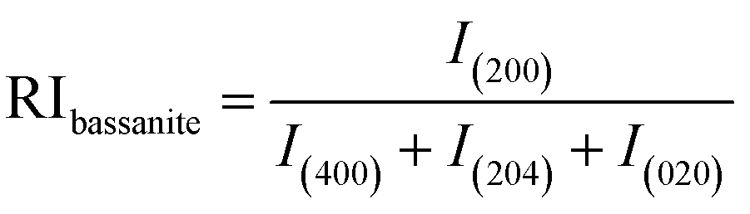
Step 2: Calculate the relative intensities of the experimental samples and standard specimens (using ICDD card number: #00-041-0224), as indicated in the formula above, to obtain the values for the relative intensity of the sample and the relative intensity of the standard.
Step 3: Calculate the preference growth (P) for gypsum and burnt gypsum samples using the following formula.

Figures
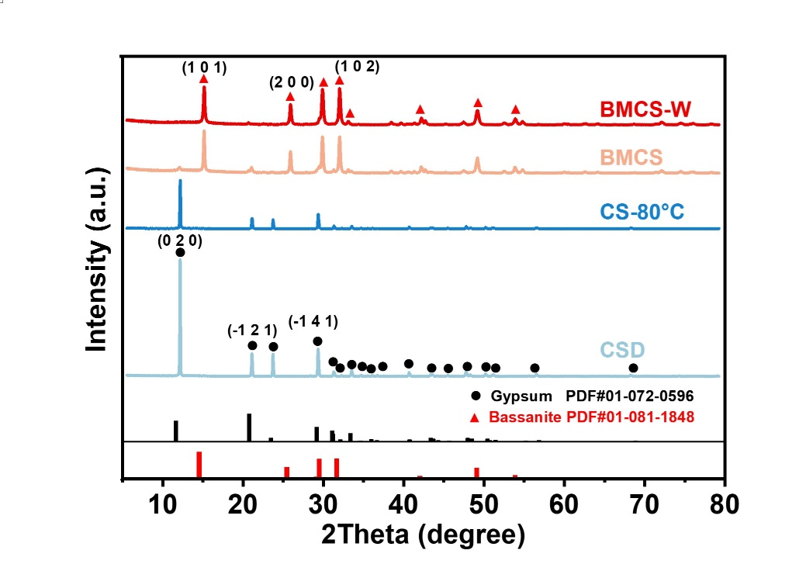
Supplementary Fig. S1 The XRD patterns of raw gypsum (CSD), gypsum heated at 80°C (CS-80°C), gypsum ball-milled directly without water (BMCS) and with water (BMCS-W) for 16 h.

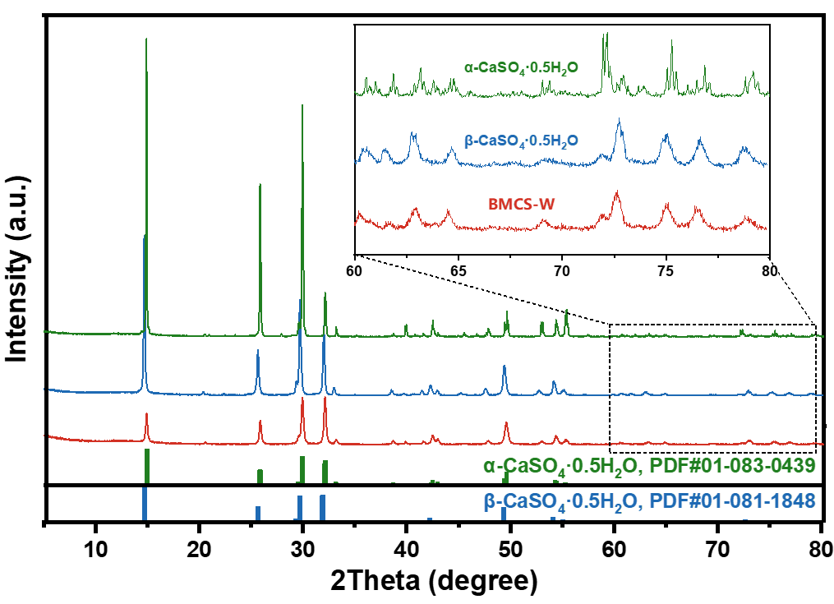
Supplementary Fig. S2 X-ray diffraction (XRD) patterns of α-CaSO₄·0.5H₂O, β-CaSO₄·0.5H₂O, and BMCS-W (milled 24h).

As shown in Fig. S3, the morphological features of BMCS and BMCS-W for 24 h did obviously differ from those of CSD and CS-80°C. The CSD consisted of bulk rods with lengths exceeding 5 μm, and the morphology of CS-80℃ was similar, exhibiting a smooth rod shape. In comparison, BMCS was aggregated by small size spherical particles, and the BMCS-W was constructed by uneven nanocrystal particles with individual size as small as 50 nm.
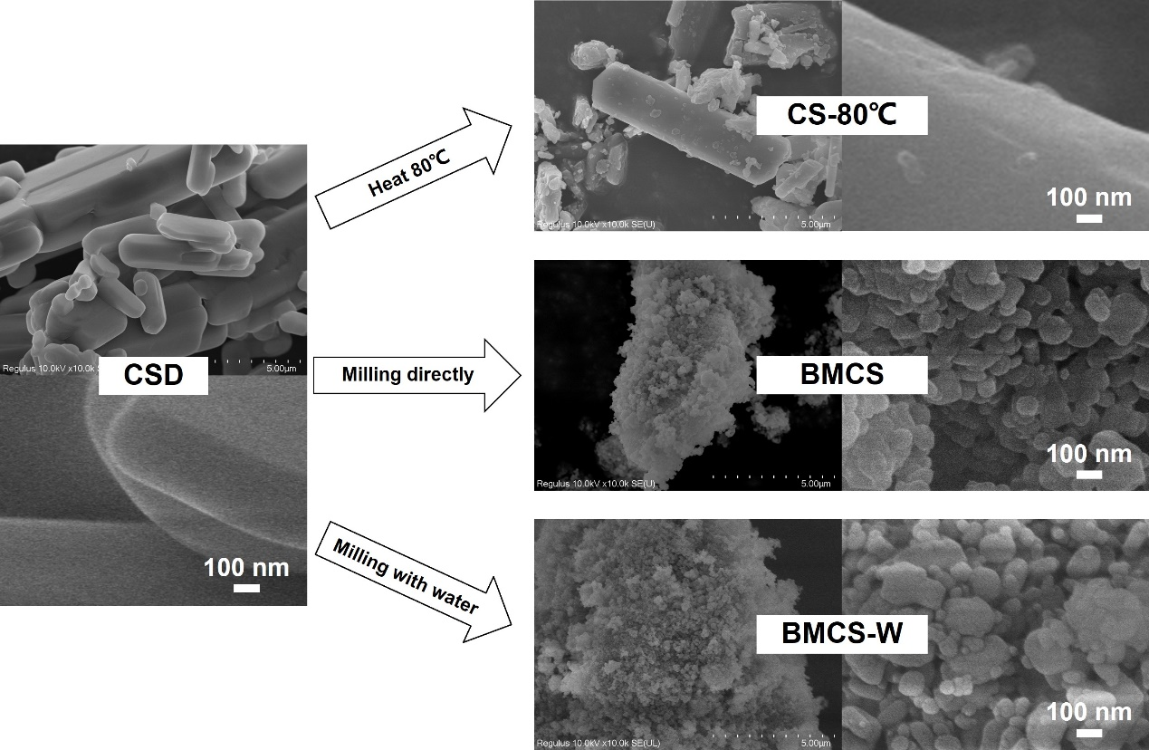
Supplementary Fig. S3 SEM images of the CSD, CS-80°, BMCS and BMCS-W.

Due to the mechanical forces generated by the collision and milling impact during ball-milling process, gypsum bulks were broken up by shear forces, resulting in the formation of surface defects (milled 2h).
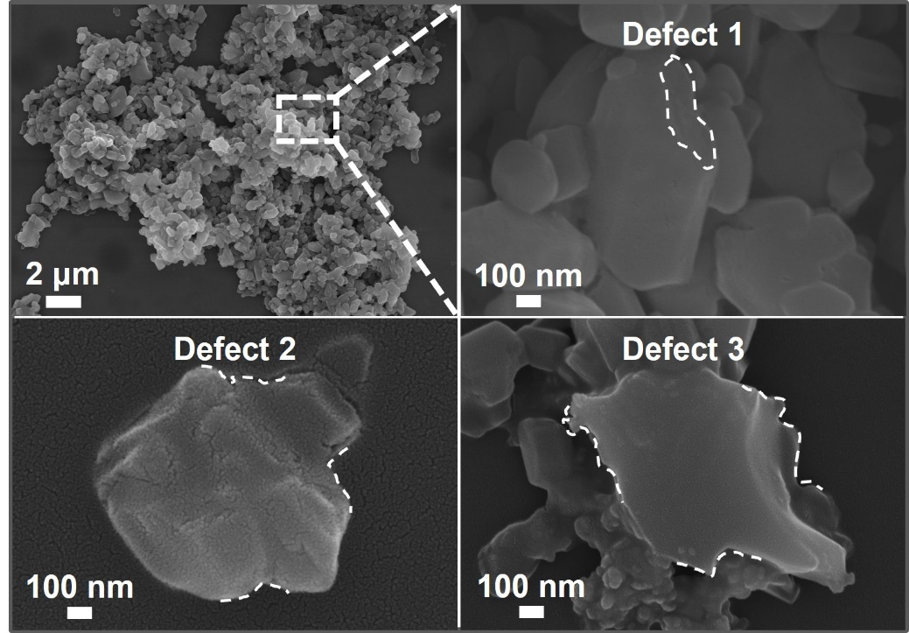
Supplementary Fig. S4 SEM images of the BMCS-W.

As shown in Fig..S5, the a, b and c parameter of BMCS-W was calculated by using Rietveld refinement of the X-ray diffraction data. Within the framework of the Rietveld method, the peak shape profile undergoes fitting employing a Voigt function—a composite of Gaussian (representing crystallite size) and Lorentzian (indicating microstrain) functions. The red dashed lines indicate the values from the ICDD database, gypsum 01-072-0596, bassanite 01-081-1848, the a0 and c0 are the unit cell parameters for the non-milled sample (raw gypsum, 0 min).
Compared to the database values and the crystal lattice parameters of raw gypsum (Fig. S5 A-C), the crystal lattice parameters of BMCS-W (remaining gypsum) exhibited noticeable variations under mechanical force. With the increase in milling time, the parameter a of BMCS-W (all marked by red circles 〇) initially decreased before increasing, parameter b gradually increased, and parameter c and a changed consistently. All three parameters were greater than the database values, which might be attributed to the formation of the product under intense non-equilibrium conditions, resulting in structural defects ^{[36]}. The increase in defects triggered the transfer and accumulation of surface energy. However, the magnitudes of the changes in BMCS-W were smaller than those in BMCS (marked by the dark gray circles 〇), indicating that the additional water mitigated a portion of the energy transfer and accumulation.
For Fig. S5，
Δa/a₀=(a-a₀)/a₀
Δc/c₀=(c-c₀)/c₀
where a₀ and c₀ were the unit cell parameters for raw gypsum, whereas a and c were the unit cell parameters of the gypsum during milling.
The parameter Δa/a₀ for BMCS was denoted by gray hollow star(☆), while BMCS-W was marked by red solid star (★).
The parameter Δc/c₀ for BMCS was denoted by gray hollow hexagon ( ), while BMCS-W was marked by red solid hexagon ( ).
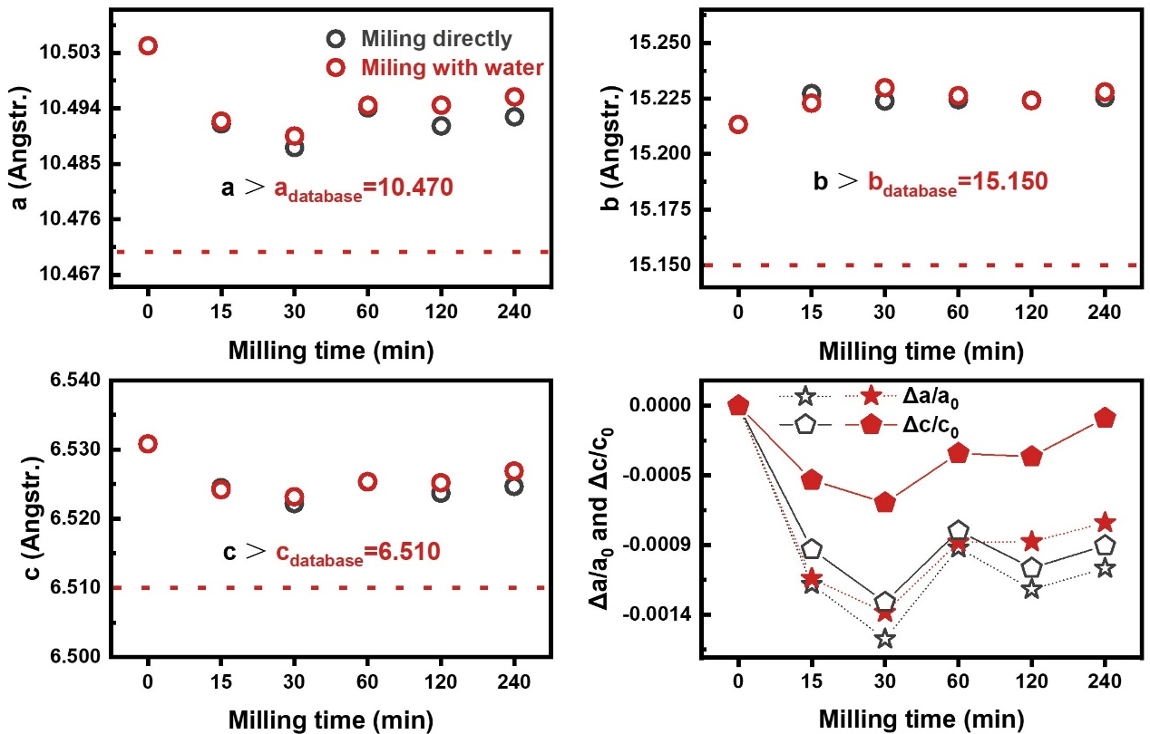
Supplementary Fig. S5 Evolution of the lattice parameters for BMCS-W (red) and BMCS (black) with the milling time.

As shown in Fig. S6, to further verify the presence of hydroxyl groups in the milled products, infrared spectra (FT-IR) were conducted on the dehydrated and rehydrated products under different conditions: CSH (calcium sulfate hemihydrate), BMCS-W (ball-milled calcium sulfate with water for 12h), BMCS-W-evac (ball-milled calcium sulfate with water then 6h evacuation at 60°C), BMCS-W-rehy (ball-milled calcium sulfate with water then evacuation and 2h rehydration in 99%RH), respectively
The FT-IR peaks occurred at 3608 cm⁻¹, 3554 cm⁻¹ and 1618 cm⁻¹ in Fig. S7A corresponded to the strong v₃(H₂O), v₁(H₂O) and v₂(H₂O) vibrational bands of bassanite, representing the OH stretching modes of water molecules in its structure. In comparison to CSH, BMCS-W exhibited a more pronounced OH peak (Fig. S7B). The normalized intensity ratio of the OH peak (with the intensity of the exclusive v₃(SO₄) band of bassanite as the denominator) was significantly higher than that of CSH, indicating more OH in bassanite after the hydroxylation modification via ball-milling with water (see the inset in Fig. S7B). Moreover, after evacuation and rehydration, the normalized intensity ratios of the OH peak in bassanite remained higher than that of CSH. This suggested that the hydroxyl groups in BMCS-W possessed increased stability (resistant to prolonged at high temperature) and affinity (effectively joint with H₂O).
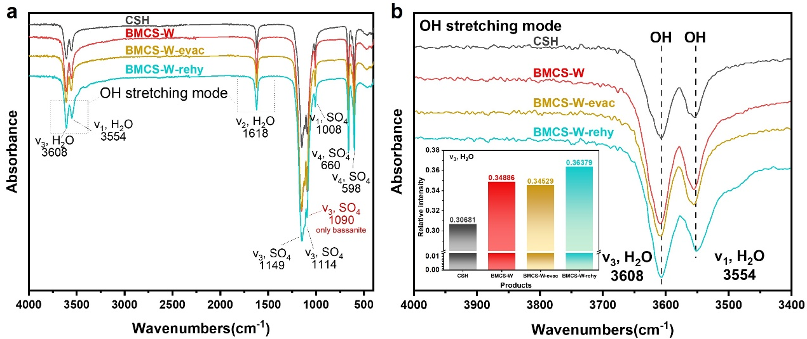
Supplementary Fig. S6 a, FT-IR spectra of CSH, BMCS-W, BMCS-W-evac, and BMCS-W-rehy, and b, normalized characteristic peaks.

As illustrated in Fig. S7, the surface characteristics of CSH, BMCS (milled 12h), BMCS-W (milled 12h), and BMCS-W-evac (ball-milled calcium sulfate with water then 6h evacuation at 60°C) were evaluated through surface contact angle analysis tests, providing insights into the affinity between bassanite and pure water. The contact angle between CSH and water was 100.67° (Fig. S7A), while for BMCS, it was 89.19° (Fig. S7B). Importantly, the contact angle of BMCS-W decreased to 41.7° (Fig. S7C), indicating an increased affinity with water. This observation might be attributed to the presence of more hydroxyl groups on the surface of milled product when introducing water during ball-milling. Moreover, the contact angle of BMCS-W-evac was 80.88° (Fig. S7D), which was attributed to the removal of surface hydroxyl groups, resulting in a decrease in affinity. The contact angle results indicated an enhanced chemical reactivity of the bassanite product milled by adding water. In comparison to CSH, the water introduced during mechanical force provided more hydroxyl groups to the BMCS-W.
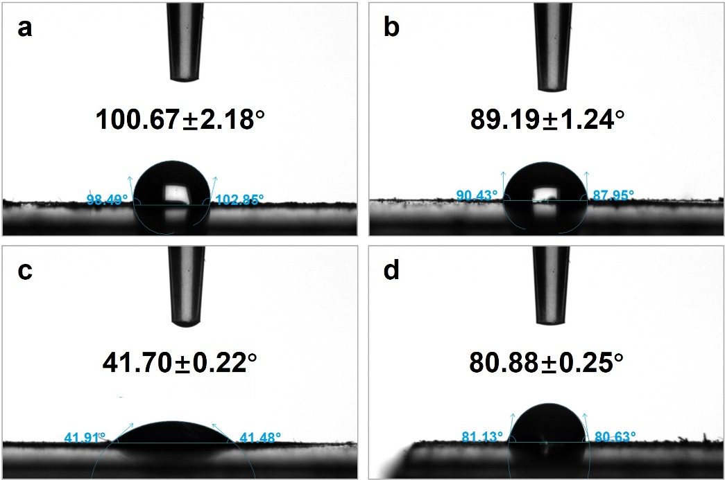
Supplementary Fig. S7 Contact angle measurements of a, CSH; b, BMCS; c, BMCS-W; and d, BMCS-W-evac.
In Fig. S8, the ¹H liquid-state NMR spectrum of the BMCS-W in deuterated methanol (CD₃OD) revealed seven distinct signals. Three signals at 0.03, 3.3 and 4.8 ppm were attributed to the -CH₃ and -OH resonances of methanol, respectively, while two additional resonances at 4.6 and 5.2 ppm were assigned to water molecules within the bassanite structure. Furthermore, two fresh signals appeared at 0.12 ppm and 0.13 ppm (marked with *), which were attributed to the presence of H₂O, and unique to the hydroxyl groups in the milled product (BMCS-W).
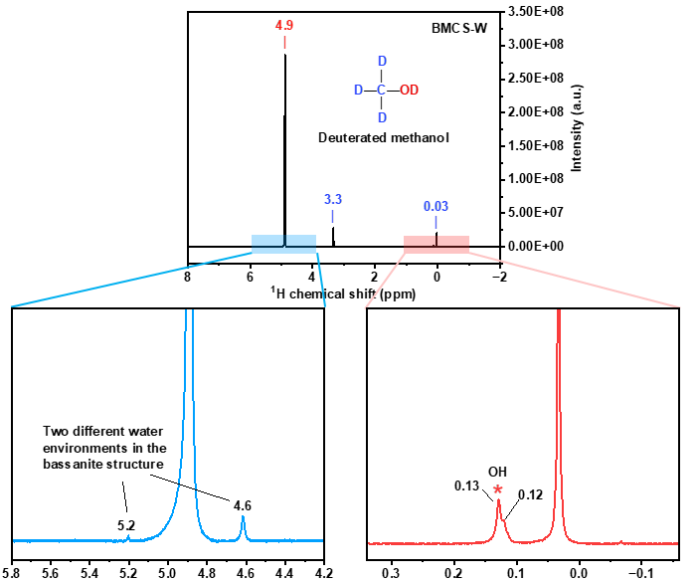
Supplementary Fig. S8 ¹H liquid-state NMR spectrum of the BMCS-W (milled 12h) dispersion in deuterated methanol.

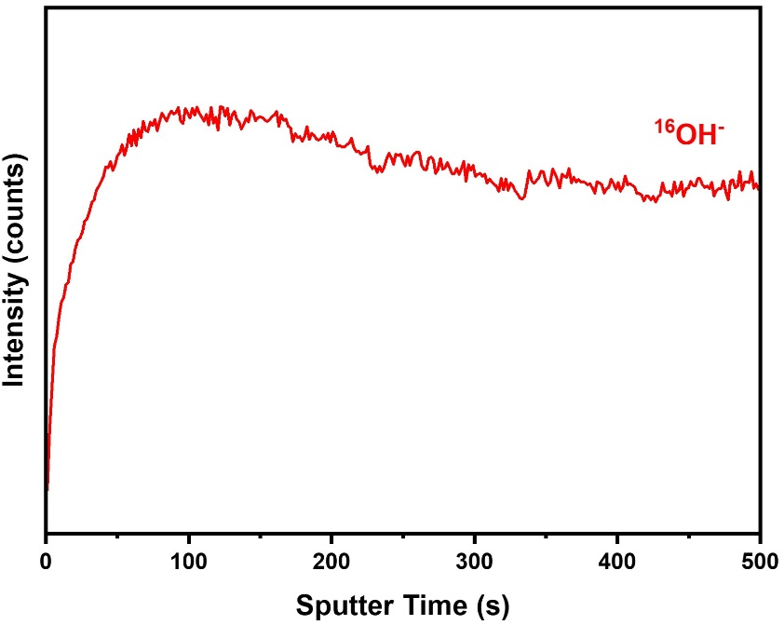
Supplementary Fig. S9 The depth-profile spectra of ¹⁶OH⁻ hydroxyl groups in the bassanite milled with H₂¹⁸O via ToF-SIMS.

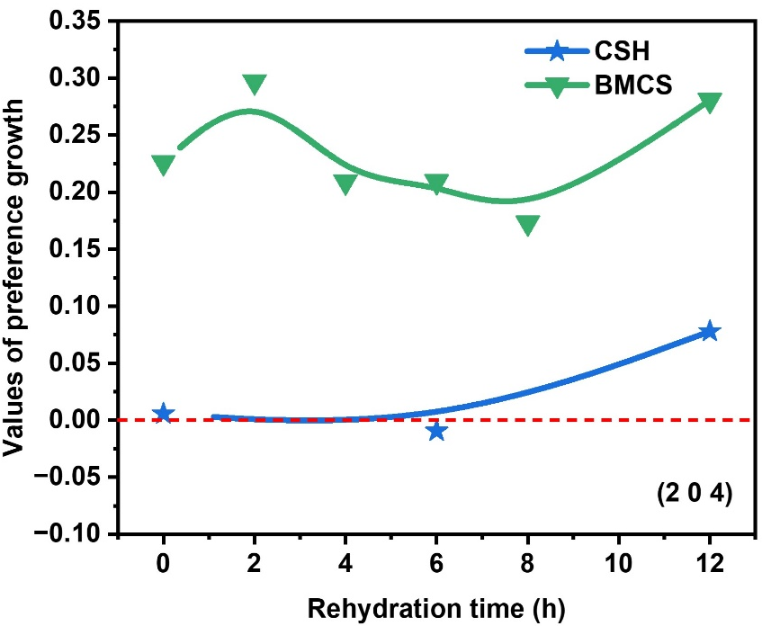
Supplementary Fig. S10 Crystal preference growth of (2 0 4) plane for CSH and BMCS rehydrated in different time interval via XRD analysis.

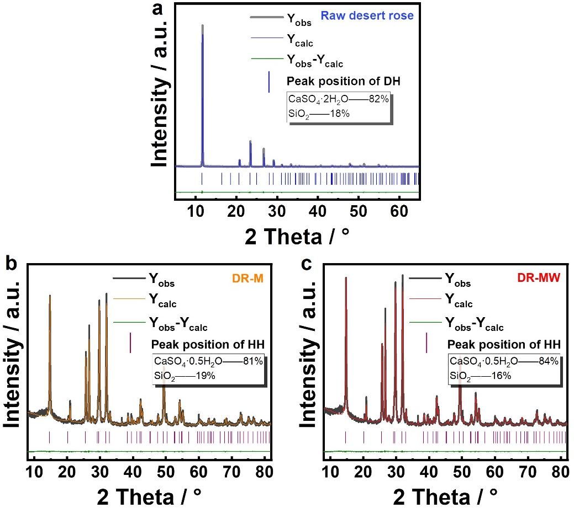
Supplementary Fig. S11 XRD refinement results for a, raw desert rose stone; b, mechanical force (DR-M) and c, water-synergized mechanical force (DR-MW) of desert roses for 6h (the same calculation method was used at other time points).

Tables
Supplementary Table S1. The proportion of bassanite (CaSO₄·0.5H₂O) in raw gypsum (CSD), gypsum heated at 80°C (CS-80°C), gypsum ball-milled directly without water (BMCS) and with water (BMCS-W) after real-time reaction variations by semi-quantitative XRD analysis.
Time/min | CSD | CS-80°C | BMCS | BMCS-W
0 | 0 | 0 | 0 | 0
15 | 0 | 0 | 0 | 0
30 | 0 | 0 | 0 | 0
60 | 0 | 0 | 0 | 0
120 | 0 | 0 | 5% | 0
240 | 0 | 0 | 29% | 24%
360 | 0 | 0 | 47% | 38%
480 | 0 | 0 | 63% | 100%
720 | 0 | 0 | 100% | 100%
960 | 0 | 0 | 83% | 100%
1440 | 0 | 20% | 56% | 100%
2880 | 0 | 81% | / | /
4320 | 0 | 92% | / | /
5760 | 0 | 100% | / | /

References
1. Prieto-Taboada, N. et al. The relevance of the combination of XRD and Raman spectroscopy for the characterization of the CaSO4–H2O system compounds. Microchem J. 122, 102-109 (2015).
2. Christensen, A. N., Jensen, T. R. & Nonat, A. A new calcium sulfate hemi-hydrate. Dalton Trans. 39, 2044 (2010).
3. Burke, K., Ernzerhof, M. & Perdew, J. P. Generalized Gradient Approximation Made Simple. Phys. Rev. Lett. 77, 3865-3868 (1996).
4. Kresse, G. & Joubert, D. From ultrasoft pseudopotentials to the projector augmented-wave method. Phys. Rev. B. 59, 1758-1775 (1999).
5. Grimme, S., Antony, J., Ehrlich, S. & Krieg, H. A consistent and accurate ab initio parametrization of density functional dispersion correction (DFT-D) for the 94 elements H-Pu. The Journal of Chemical Physics. 132, 154104 (2010).

