Supplemental material

Additional analyses

S1. Maastricht Gambling Task – MGT (Risk-taking behavior)

S1.1 Average value

 | Value | Standard Error | DF | t-value | p-value
(Intercept) | 59 | 0.92 | 14118 | 64.02 | <0.001
Group | -0.08 | 1.29 | 14118 | -0.06 | 0.95
SESSION | 0.98 | 0.26 | 14118 | 3.80 | <0.001
Group*SESSION | -0.99 | 0.36 | 14118 | -2.77 | 0.006

S1.2Probability scores
 | Value | Standard Error | DF | t-value | p-value
(Intercept) | 59 | 0.04 | 14118 | -20.09 | <0.001
Group | -0.08 | 0.06 | 14118 | 1.72 | 0.086
SESSION | 0.98 | 0.01 | 14118 | 1.63 | 0.103
Group*SESSION | -0.99 | 0.02 | 14118 | -3.17 | 0.002

S1.3Response time
 | Value | Standard Error | DF | t-value | p-value
(Intercept) | 1.29 | 0.04 | 13241 | 36.61 | <0.001
Group | 0.12 | 0.05 | 13241 | 2.48 | 0.013
SESSION | -0.17 | 8.36e-03 | 13241 | -20.90 | <0.001
Group*SESSION | -0.07 | 0.01 | 13241 | -6.18 | <0.001

S1.4 Correlations with control scales

Correlations between the risk-taking behavior estimated using the MGT and estimates obtained from the scales used as control measurements. Pearson correlations (r) are displayed. *p<0.05; **p<0.01; ***p<0.001.
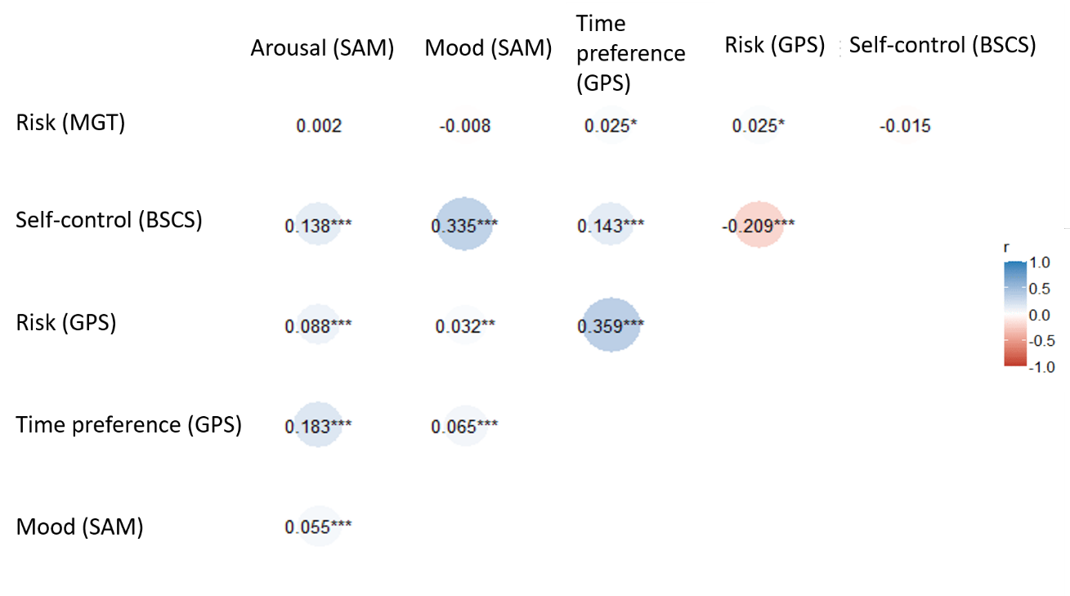

S2 Maastricht Choice Game – MCG (Intertemporal choices)

S2.1 Risk attitude (α)
 | Value | Standard Error | DF | t-value | p-value
(Intercept) | 0.90 | 0.21 | 13261 | 4.26 | <0.001
Group | -0.42 | 0.29 | 55 | -1.42 | 0.16
Session | -0.08 | 0.01 | 13261 | -9.89 | <0.001
Group * Session | 0.13 | 0.01 | 13261 | 11.10 | <0.001

S2.2 Response time
 | Value | Standard Error | DF | t-value | p-value
(Intercept) | -0.27 | 0.13 | 10979 | -2.16 | 0.03
Group | 0.40 | 0.21 | 10979 | 1.87 | 0.06
Session | -0.17 | 0.23 | 10979 | -0.69 | 0.49
Group * Session | 0.22 | 0.17 | 10979 | 1.28 | 0.20

S2.3 Correlations with control scales

Correlations between the intertemporal choices estimated using the MCG and the estimates obtained with the scales used as control measurements. Pearson correlations (r) are displayed. *p<0.05; **p<0.01; ***p<0.001.

