Proton and C NRM spectra of Betulinic acid, ursolic acid and epicatechin
Proton NMR spectrum of betulinic acid
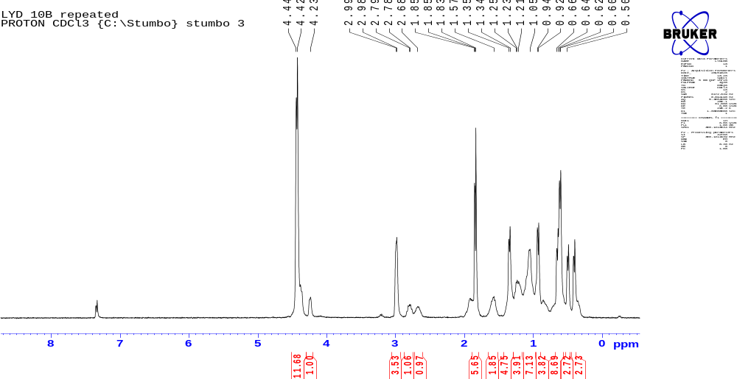

¹³Carborn NMR spectrum of betulinic acid
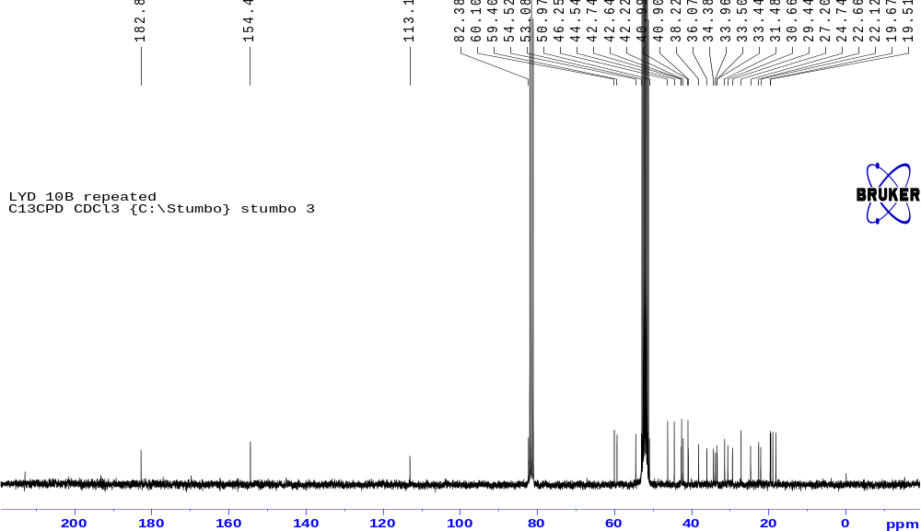

\
Proton NMR spectrum of Ursolic acid
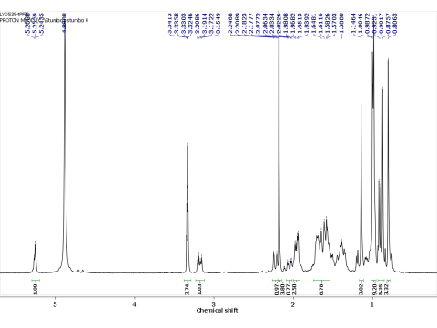

13Carborn NMR spectrum of usorlic acid
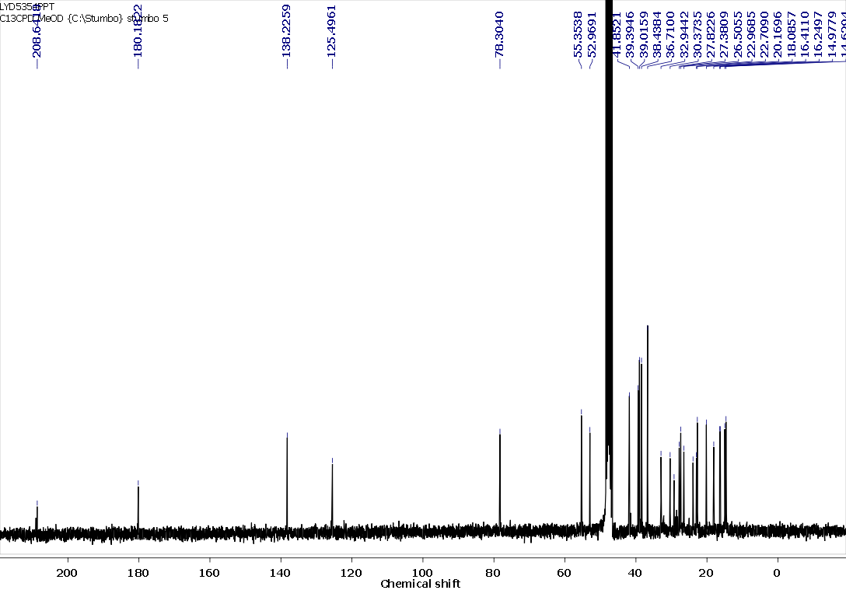

Proton NMR spectrum of Epicatechin

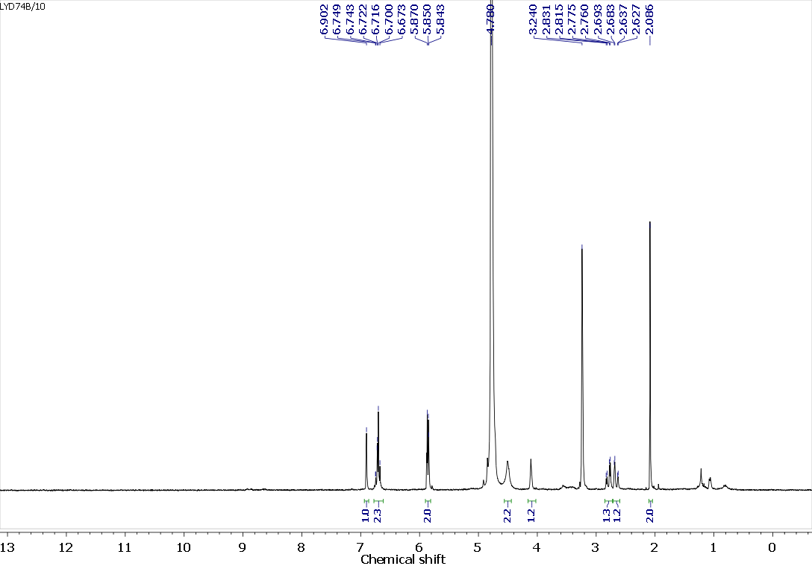

13Carborn NMR spectrum of Epicatechin

