Supplementary Material

Supplementary Notes

Supplementary Methods

Blood Sample Acquisition
Peripheral blood was collected at the time of diagnosis in CPT tubes (8 mL, containing either citrate or heparin anticoagulant and separation medium with polyester gel and FICOLL™ Hypaque™). Within 2 hours of collection, tubes were centrifuged at 1800×g for 20 min at room temperature (RT). Plasma was aliquoted and stored at −80 °C, and the PBMC fraction was recovered, washed with PBS 1×, and centrifuged at 300×g. Cell viability and total counts were assessed by Trypan Blue exclusion using an automated counter (LUNA, PBMC dil 2 program). For cryopreservation, PBMCs were resuspended in commercial freezing medium (ATCC or NutriFreez® D10) at ~10⁶ cells/mL, aliquoted into sterile cryovials, gradually cooled in a Mr. Frosty container at −80 °C, and transferred to liquid nitrogen for long-term storage.

PBMC Single-Cell 5’RNA Sequencing
The cryovials with the PBMCs were thawed in a water bath at 37°C. The thawed samples were transferred into a 50 ml tube using a wide bore tip. One ml prewarmed RPMI medium with 10% FBS was added dropwise to 1 ml sample (1:1) and incubated for 1 min at RT. The 1:1 dilution steps with prewarmed growth medium were repeated four times. Next, the sample was centrifuged at 300g for 5 min and the supernatant was removed. The cells were resuspended in 9 ml growth medium, centrifuged again and the supernatant was removed. The cell pellet was resuspended in 1 ml PBS with 0.04% BSA and transferred into an Eppendorf tube. The 50 ml tube was rinsed with 0.5 ml PBS with 0.04 BSA and the liquid was added to the sample. The Eppendorf tube was centrifuged, the supernatant was removed and the cells were resuspended in 0.5 ml PBS with 0.04% BSA. The cell number and viability rate was determined using a Countess® II Automated Cell Counter. In case the viability rate was below 85% and above 70%, the Dead Cell Removal Kit (Miltenyi Biotech) was applied and the cell count was determined again. In case the viability rate was below 70%, the second cryovial with PMBCs of the same patient was thawed. In case the sample showed cell aggregates, the cells were passed through a 30 um MACS Smart Strainer (Miltenyi Biotech).
The 10X 5’RNA sequencing was performed using the Chromium Next GEM Single Cell 5' HT Kit v2 (10X Genomics) according to the manual. The PBMCs were diluted to 700-1,200 cells per ul aiming a cell recovery of 7,000 cells. All samples were processed with the same batch of 10X reagents. For the GEX Sample Index PCR, 15 cycles were used. For library quality control, the DNA concentration was determined using the Qubit High Sensitivity DNA kit (Life Technologies) and the fragment length distribution was evaluated on a Bioanalyzer High Sensitivity dsDNA Chip (Agilent Technologies). The libraries were quantified using the KAPA Library Quantification Kit for Illumina (Roche), pooled in equimolar amounts and sequenced on an Illumina NovaSeq instrument.

T Cell Receptor Sequencing
The TCR-Seq libraries were prepared using the Chromium Single Cell V(D)J Amplification Kits, Human (10X Genomics) according to the manual. The same cDNA as of the 5’RNA-Seq library preparation was used for TCR-Seq library preparation and every sample received the same index combination as in the RNA-Seq experiment. For library quality control, the DNA concentration was determined using the Qubit High Sensitivity DNA kit (Life Technologies) and the fragment length distribution was evaluated on a Bioanalyzer High Sensitivity dsDNA Chip (Agilent Technologies). The libraries were quantified using the KAPA Library Quantification Kit for Illumina (Roche), pooled in equimolar amounts and sequenced on an Illumina NovaSeq instrument.

CSF Neuroinflammatory Marker and Noradrenaline Measurement
Lumbar punctures were performed in the morning to collect CSF samples. Briefly, CSF samples were thawed on ice, gently mixed, and centrifuged to remove debris prior to analysis. Samples were incubated with fluorescent-coded magnetic beads pre-coated with analyte-specific capture antibodies, followed by incubation with biotinylated detection antibodies and streptavidin–phycoerythrin. Data acquisition was carried out on a Luminex® xMAP platform, and analyte concentrations were calculated from standard curves generated using recombinant protein standards and a five-parameter logistic regression model. Quality control samples and calibration standards were included in each run. Laboratory personnel were blinded to clinical data during the analysis.
A panel of cytokines and neuroinflammatory markers in cerebrospinal fluid (CSF), including interleukin (IL)-6, IL-8, IL-10, monocyte chemoattractant protein-1 (MCP-1), tumor necrosis factor (TNF), intercellular adhesion molecule-1 (ICAM-1), triggering receptor expressed on myeloid cells 2 (TREM2), and complement component C3, was quantified using a multiplex bead-based immunoassay. Measurements were performed with commercially available kits (Human Cytokine Panel A [HCYTA-60K], Neurodegenerative Panel 1 [HNDG1MAG-36K], Neurodegenerative Panel 3 [HNDG3MAG-36K], and Neuroscience Panel 2 [HNS2MAG-95K]; Merck Millipore, Darmstadt, Germany) according to the manufacturer’s instructions.
Noradrenaline was quantified using a plasma-HPLC kit (Chromsystems), after the analytes were extracted from the CSF matrix through adsorption onto alumina.

ApoE Genotyping
APOE genotyping was performed via Sanger sequencing of the two defining single nucleotide polymorphisms (rs429358 and rs7412).

Autologous Mixed Lymphocyte Reaction (MLR) Assay
The autologous MLR assay consisted of incubation of memory CD45RO⁺ T cells with CD14⁺ monocytes, isolated from blood samples of the same person, and soluble anti-CD3 antibody to drive T cell activation. The CD14⁺ monocytes, which are professional antigen presenting cells (APC), express co-stimulatory receptors and the inhibitory molecule PD-L1, thereby regulating the activation of T cells. In this assay, the T cells and monocytes are co-cultured for several days in the presence of increasing concentration of the anti-PD-L1 antibody, or with IgG isotype control. Anti-PD-L1 antibody concentrations between log(10⁻¹¹) M to log(10⁻⁹) M were chosen based on previous results by Matalon et al., which define the experimental concentrations between the two plateaus of % PD-1 expressing cells ¹⁰⁸. Intensity of T cell activation was measured in terms of induced-expression of the T cell surface activation marker, PD-1, which is upregulated on stimulated T cells. Monocyte and memory T cells were isolated from thawed PBMCs by magnetic separation using human CD14 microbeads (Miltenyi Biotech; cat. #130-050-201), and by magnetic separation using human CD45RO microbeads (Miltenyi Biotech; cat. #130-046-001), respectively. The mixed cells were plated in 200μl of medium (RPMI with 10% heat-inactivated fetal bovine serum (hiFBS)) in a 96 well flat bottom plate at 125x10³ monocyte and 75x10³ memory CD45RO T cells per well. Cells were incubated (at 37⁰C, 5% CO2) for 4 days, with or without the activator soluble LeafTM anti-human CD3 (Biolegend; cat.#300414) and the tested anti-PD-L1 monoclonal antibody (IBC-Ab002; ImmunoBrain Checkpoint Inc.). Each experimental stimulation dose of the anti-PD-L1 antibody (10⁻¹¹, 10⁻¹⁰, 10⁻⁹ M) were performed in duplicates. Following the incubation period, immune cells were collected for flow cytometry immunophenotyping analysis.

Flow cytometry
Immunophenotyping of PBMCs was performed using flow cytometry (CytoFLEX flow cytometer; Beckman Coulter). The following fluorochrome-labelled monoclonal antibodies were purchased from BD Pharmingen: PE anti-human Ki-67 (cat. #556027); from BioLegend: FITC anti-human PD-1 (cat. #329904), FITC anti-human FoxP3 (cat. #320106), FITC anti-human KLRG-1 (cat. #367713), FITC anti-human CD4 (cat. #300506), PE anti-human CCR-7 (cat. #353204), PE anti-human LAG-3 (cat. #369306), PE anti-human CD16 (cat. #302008), PerCP/Cy5.5 anti-human CD3 (cat. #300328), PerCP/Cy5.5 anti human/mouse/rat ICOS-1 (cat. #313518), PerCP/Cy5.5 anti-human TIM-3 (cat. #345016), PerCP/Cy5.5 anti-human CD16 (cat. #302028), APC anti-human PD-1 (cat. #329908), anti human CD56 (cat. #318310), APC/Cy7 anti-human CD4 (cat. #317418), APC/Cy7 anti-human CD45RO (cat. #304228); and from Miltenyi Biotec: Live/dead staining (cat. #423114), PE anti-human KIR2D (cat. # 130-099-417), PE anti-human KIR3DL-1 (cat. #130-092-473), PE anti-human (NKG2A cat. #130-098-813). Intracellular markers were stained following fixation with Human Regulatory T cell Whole Blood Staining kit (cat. #88-8996-4; Invitrogen), and used according to the manufacturers' protocols. Fluorochrome-labelled monoclonal antibodies were used in staining mixes to evaluate different panels representing distinct immune cell populations, according to the gating strategy described in Suppl. Table 2.

Machine Learning Classifier Training Pipeline for Immunophenotyping Data
We used several machine learning classifiers, including logistic regression, SVM, Random Forest and XGBoost from the scikit-learn package (version 1.7.2). Based on the data from the deep immunophenotyping assay (see section “Flow Cytometry”), we performed hyperparameter optimization with a 10-fold nested cross-validation for each classifier. The search spaces for the hyperparameters are defined in Suppl. Table 3. We used KNNImputer for imputation of missing values with n_neighbors = 5 and the RobustScaler for scaling of the data after data splitting to avoid data leakage. The data set splits were stratified by diagnosis. Classifiers were trained on binary classification for HC vs. MCI, HC vs. AD and HC vs. MCI + AD and evaluated based on area under the receiver-operating characteristic curve (AUROC).

Representation Learning for scRNA-seq Data and Cognitive Assessments

Cognitive Assessments
The cognitive assessments performed in our study are grouped into categories, including neuropsychiatric symptoms, global cognitive function, memory, language, praxis, visual perception and spatial processing, executive function and digital cognitive assessment (Suppl. Table 4). To obtain a low-dimensional representation for each cognitive assessment category, we applied a dimensionality reduction technique that takes into account the limited sample number. First, we calculated the Spearman rank correlation matrix for each cognitive test category, then performed a PCA. The first eigenvector was used as the low-dimensional representation in the following steps.

scRNA Sequencing Data
Low-dimensional embeddings of the scRNA sequencing data were designed to represent the dysregulation of immune system pathways in certain cell types. The gene expression profiles of each cell type were extracted for relevant immune system pathways. We used a selection of KEGG pathways and GO Biological Process terms which include pathways related to inflammatory signalling, IFN-gamma, ICOS, KLRG1, KIR, T-bet and EOMES signalling (Suppl. Table 5 and Table 6). The R packages limma (3.62.2), AnnotationDbi (1.68.0) and org.Hs.eg.db (3.20.0) were used to find the corresponding genes of KEGG pathway IDs and GO Biological Process terms. A conditional variational autoencoder was trained per cell type and pathway using scvi-tools (1.3.0) ^{131,132} after a hyperparameter optimization of 20 trials on the best parameters selected for minimizing the validation loss. The search space for the hyperparameters is documented in Suppl. Table 7.

AI-Based Directed Acyclic Graph Learning
We investigated the complex relationships between several modalities of interest that were gathered for the ADIS cohort. We used DAGMA (1.1.1) ¹³³ to learn a directed acyclic graph (DAG) by optimizing nonlinear structural equation models with multilayer perceptrons under an exact smooth acyclicity constraint. This AI-based approach is favorable because it scales to high-dimensional settings, naturally handles heterogeneous outcomes, and can identify edge directions under nonlinear assumptions better than conventional Bayesian Network structure learning methods. We performed bootstrapping with 100 samples for fitting a nonlinear model and used the L1 penalty coefficient = 0.02 and L2 penalty coefficient = 0.005 as fixed model parameters. To discourage spurious confounding, we added an L1 penalty term on incoming weights to the constrained nodes (age, gender, ApoE), thereby shrinking incoming edges of demographics and genotype.
We applied this nonlinear DAG learning approach to integrate heterogeneous modalities after z-score normalization and low-dimensional embedding of high‑dimensional features. Immune pathway activity was summarized by pathway- and cell type-specific cVAE embeddings from scRNA‑seq, and cognitive domains were reduced via correlation‑informed PCA (first eigenvector) (see below).
We included the following data, which we grouped into the following data types:
- Cognition: Language, memory, praxis, visual perception and spatial processing, global cognitive function, executive functions, neuropsychiatric inventory questionnaire, anxiety, GDS depression, Altoida
- Demographics: age, gender
- Genotype: ApoE
- Sleep: PSQI, ESS, time in bed, assumed sleep, sleep latency, nonzero activity, rest per 24 h, M10 average, relative amplitude, intra-daily variability, naps
- Cytokines: IL-6, IL-8, IL-10, MCP-1, TNF, ICAM-1, TREM2, complement C3, noradrenaline
- T cell receptor: Richness index (ACE), clonal abundance (small), clonal abundance (large)
- Immune System: immune system-related KEGG pathways and GO Biological Process embeddings of scRNA-seq data
- MRI: hypothalamus, locus coeruleus, gray matter
- Immunophenotyping: %PD-1 expressing CD4⁺/CD8⁺ T cells with anti-CD3 stimulation and complementary anti-PD-L1 stimulation in increasing concentrations

The actigraphy measures were compared across diagnostic groups: variables meeting normality assumptions were analyzed with one-way ANOVA followed by Tukey’s HSD for pairwise comparisons, whereas non-normally distributed variables were analyzed with the Kruskal–Wallis test followed by Dunn’s post hoc test with adjustment for multiple comparisons. Significant variables with p<0.05 were retained for downstream analyses, including time in bed, assumed sleep, sleep latency, total activity score divided by the number of epochs in the assumed sleep period (mean nonzero activity per epoch) and rest per 24 hours, total nap times, the average activity level for the sequence of the highest 10 active hours (M10 average), the normalized difference in average activity level between the sequence of highest 10 and least 5 active hours (relative amplitude) and the intra-daily variability which quantifies the degree of fragmentation of activity-rest periods. MRI volumes of the respective regions were normalized by intracranial volume.

Supplementary Results

Flow Cytometry NK and T Cell Phenotypes Provide Modest Discrimination Between Controls and Subjects With AD
Conventional flow cytometric immunophenotyping captures aspects of early immune dysregulation and provides modest diagnostic discrimination. To complement the single-cell transcriptomic analyses, we performed flow cytometry–based immunophenotyping of memory T cells, exhausted/activated T cells, NK/NKT/T cells, hyporesponsive NK cells and proliferating/FoxP3⁺ Tregs using a predefined marker panel (Suppl. Table 8).
Within hyporesponsive NK cells, frequencies of subpopulations defined by different combinations of CD3 and CD56 expression and by KIR⁻/NKG2A⁻ expression differed significantly between HC and AD. Within total NK cells, various CD3/CD56 positive and negative defined subsets also differed between HC and AD. In the FoxP3⁺ CD3⁺CD4⁺ Treg compartment, subpopulations defined by PD‑1 and Ki‑67 high/low expression differed between MCI and AD. PD‑1 receptor expression was significantly decreased in hyporesponsive NK cells in MCI compared with HC for CD3⁺CD56⁺ hyporesponsive NK cells and for a KIR⁺NKG2A⁺ subset within this population. In FoxP3⁺ CD3⁺CD4⁺ Tregs, PD‑1 expression was increased and Ki‑67 expression was decreased in AD compared with MCI
(Suppl. Figure 18 A and Suppl. Figure 19).
We next trained logistic regression, support vector machine, random forest and XGBoost classifiers to predict diagnostic status using only immunophenotyping features. Hyperparameters were optimised using stratified 10-fold nested cross-validation (Suppl. Table 3). Cytometry-based features yielded an AUC-ROC of 0.68 ± 0.048 for distinguishing HC from individuals with MCI or AD. For pairwise comparisons, performance was 0.53 ± 0.127 for MCI versus HC and 0.63 ± 0.219 for AD versus HC (Suppl. Figure 18 B). Feature importance analyses indicated that several NK-related gates contributed strongly to classification, including variables implicating hyporesponsive NK subtype frequencies and PD-1 and CD16 levels within the subtype populations were strongly contributing to the model’s decision on the classification of each patient based on their immunophenotyping data (Suppl. Figure 18 C).
We hereby found that NK cell gates from flow cytometry can discriminate between individuals with MCI and AD at a moderate level of accuracy, but not separate between HC and MCI. These results show that conventional flow cytometric NK-cell phenotypes capture aspects of early immune dysregulation and provide modest, non-invasive discrimination between controls and individuals with MCI or AD, supporting their potential as components of a peripheral immune biomarker panel for early AD.

Supplementary Figures
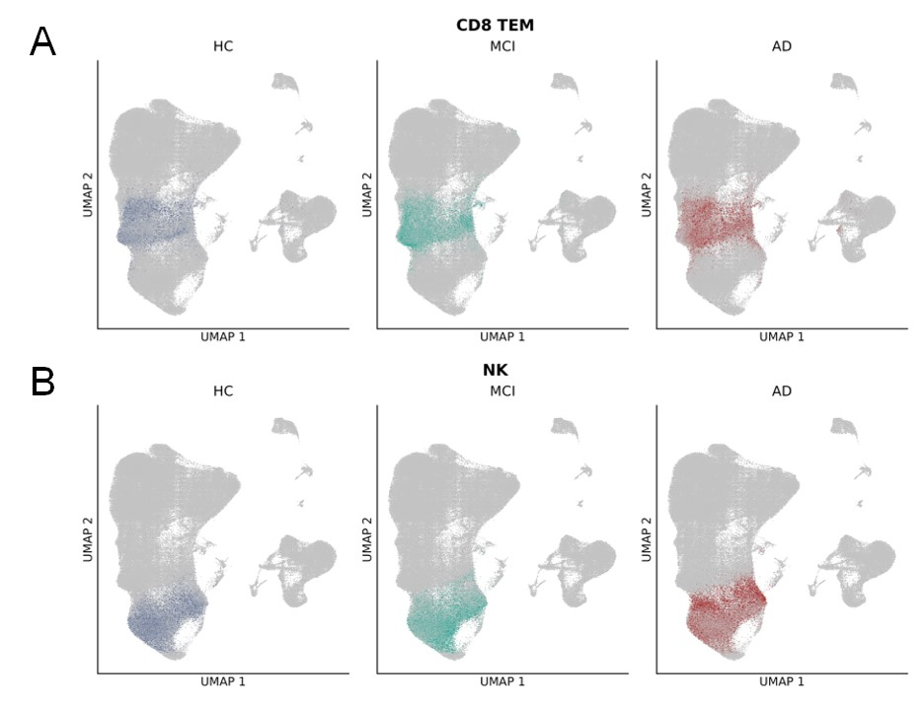

Suppl. Figure 1. UMAP representations of cell shifts of A) CD8⁺ TEM cells and B) NK cells between HC, subjects with MCI and with AD.

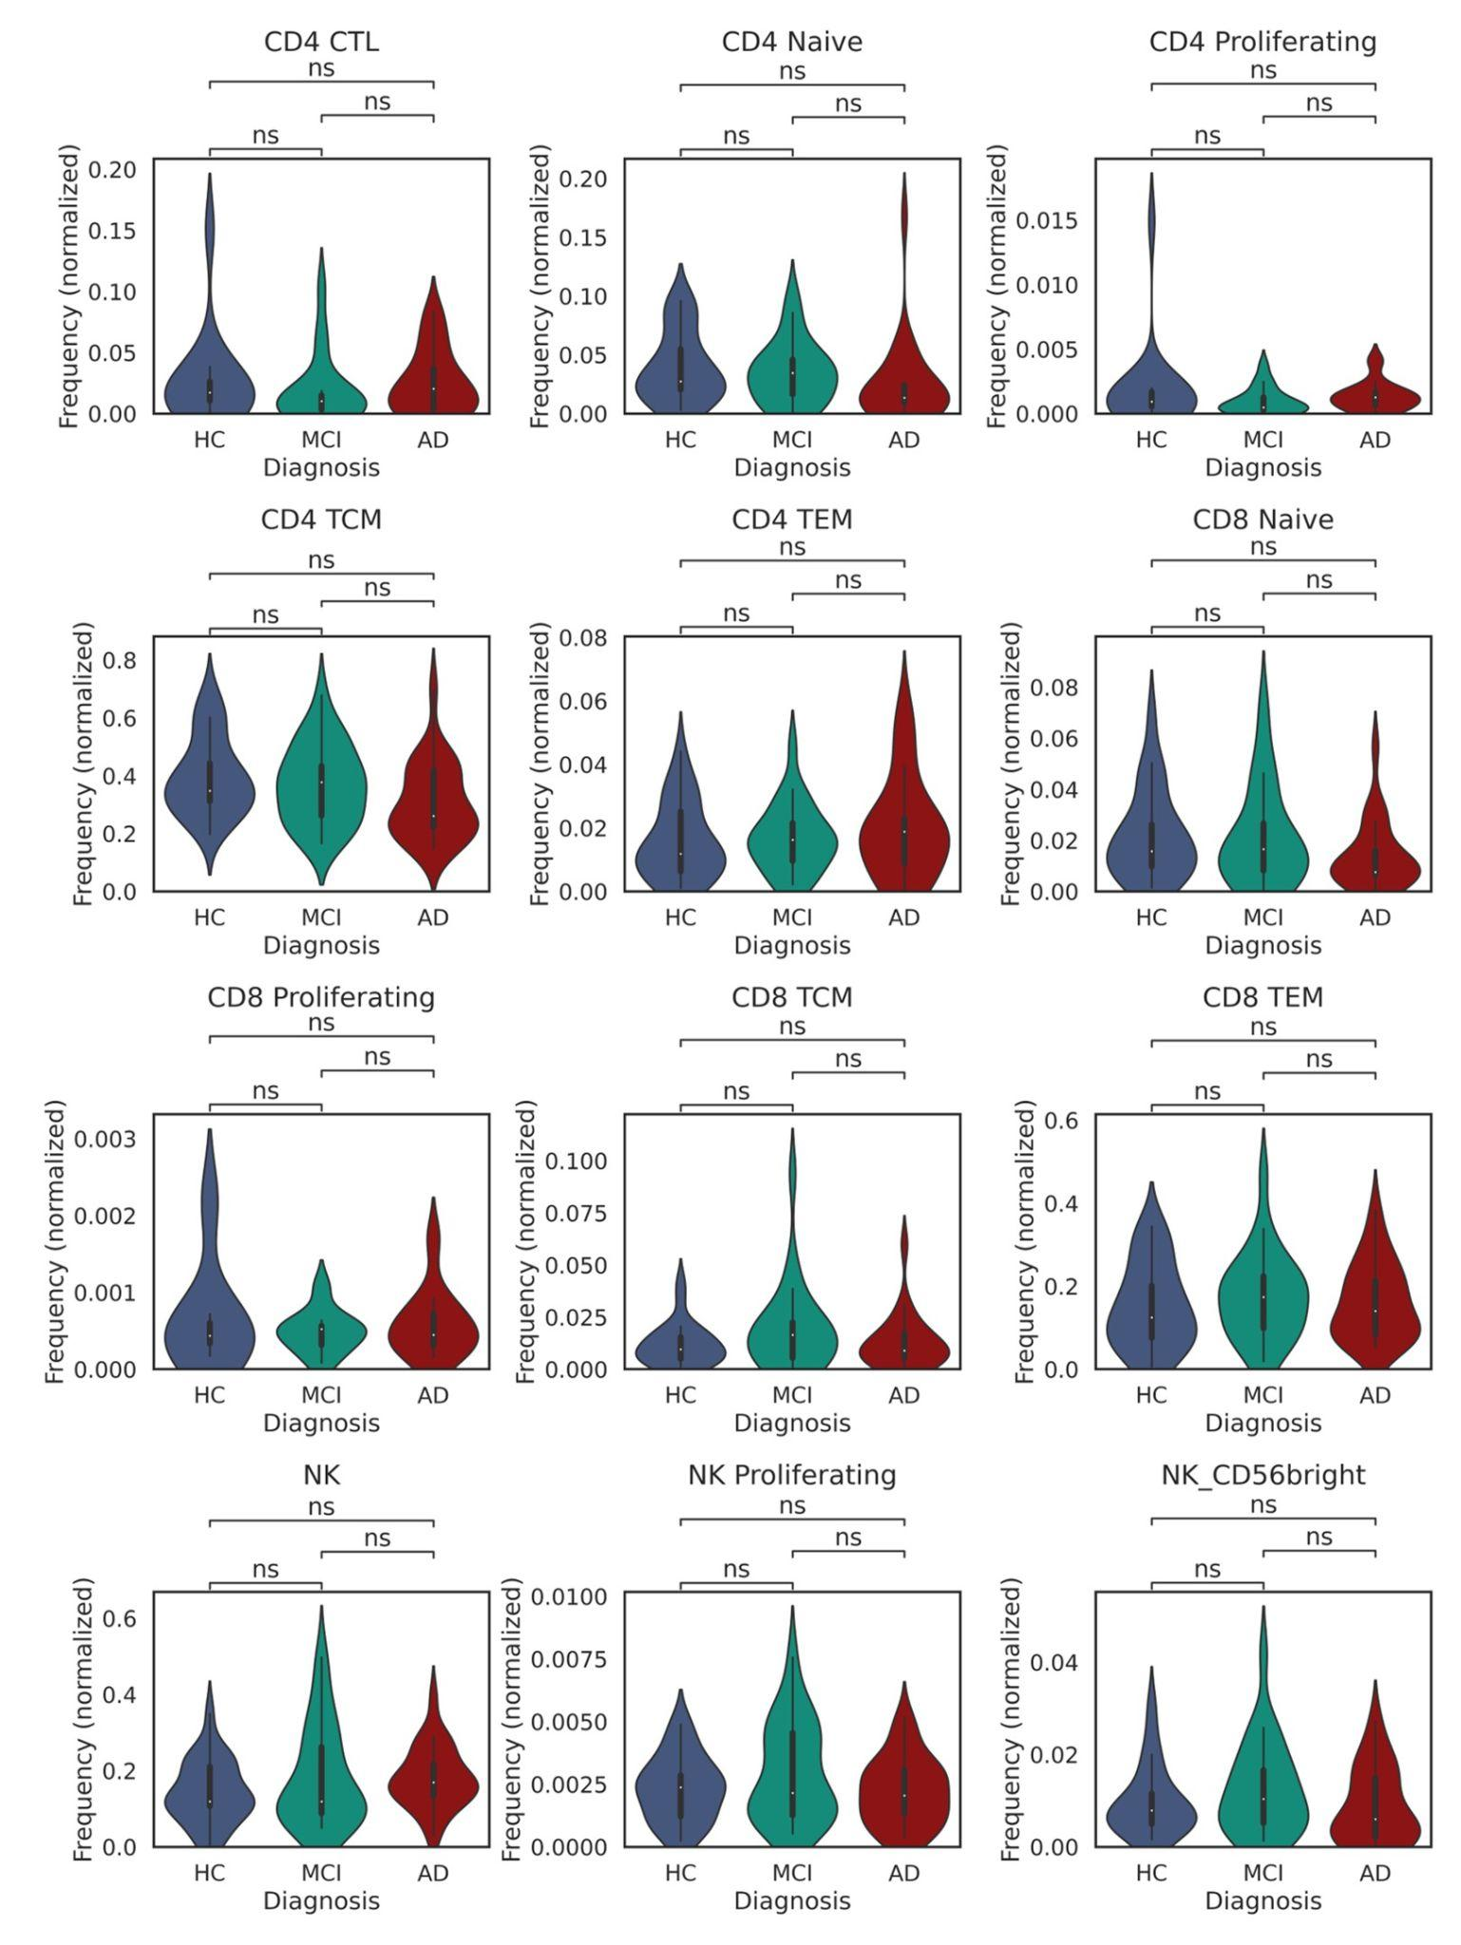
Suppl. Figure 2. Cell type distribution between HC, subjects with MCI and AD in the ADIS cohort of CD8⁺ T cells, CD4⁺ T cells and NK cells. Cell type frequencies were normalized by total cell count per patient. Statistical significance was tested via the Kruskal-Wallis test, p-values are indicated as “ns” are non significant.

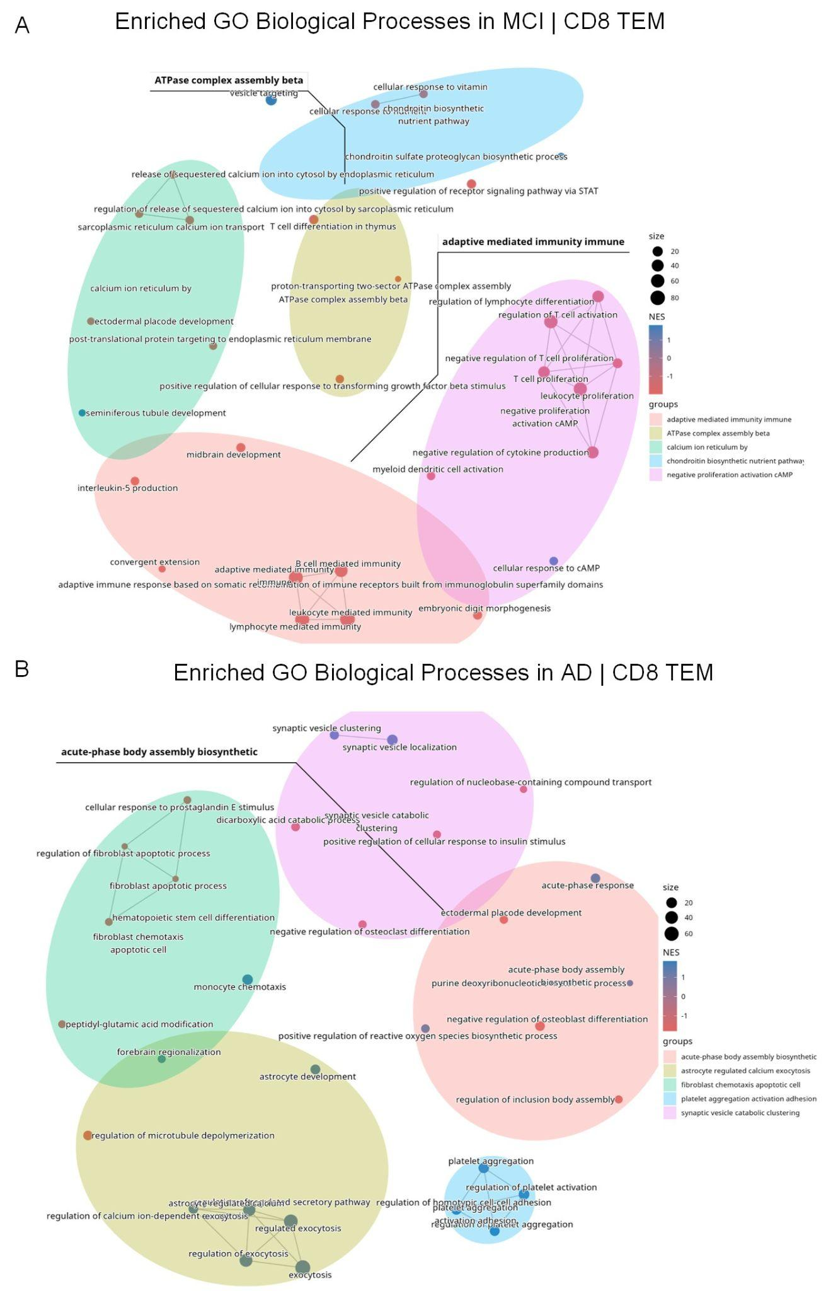
Suppl. Figure 3. Enrichment maps from GSEA analysis on CD8⁺ TEM. A) Enriched GO Biological Process terms in MCI compared to HC in CD8⁺ TEM cells. B) Enriched GO Biological Process terms in AD compared to HC in CD8⁺ TEM cells.
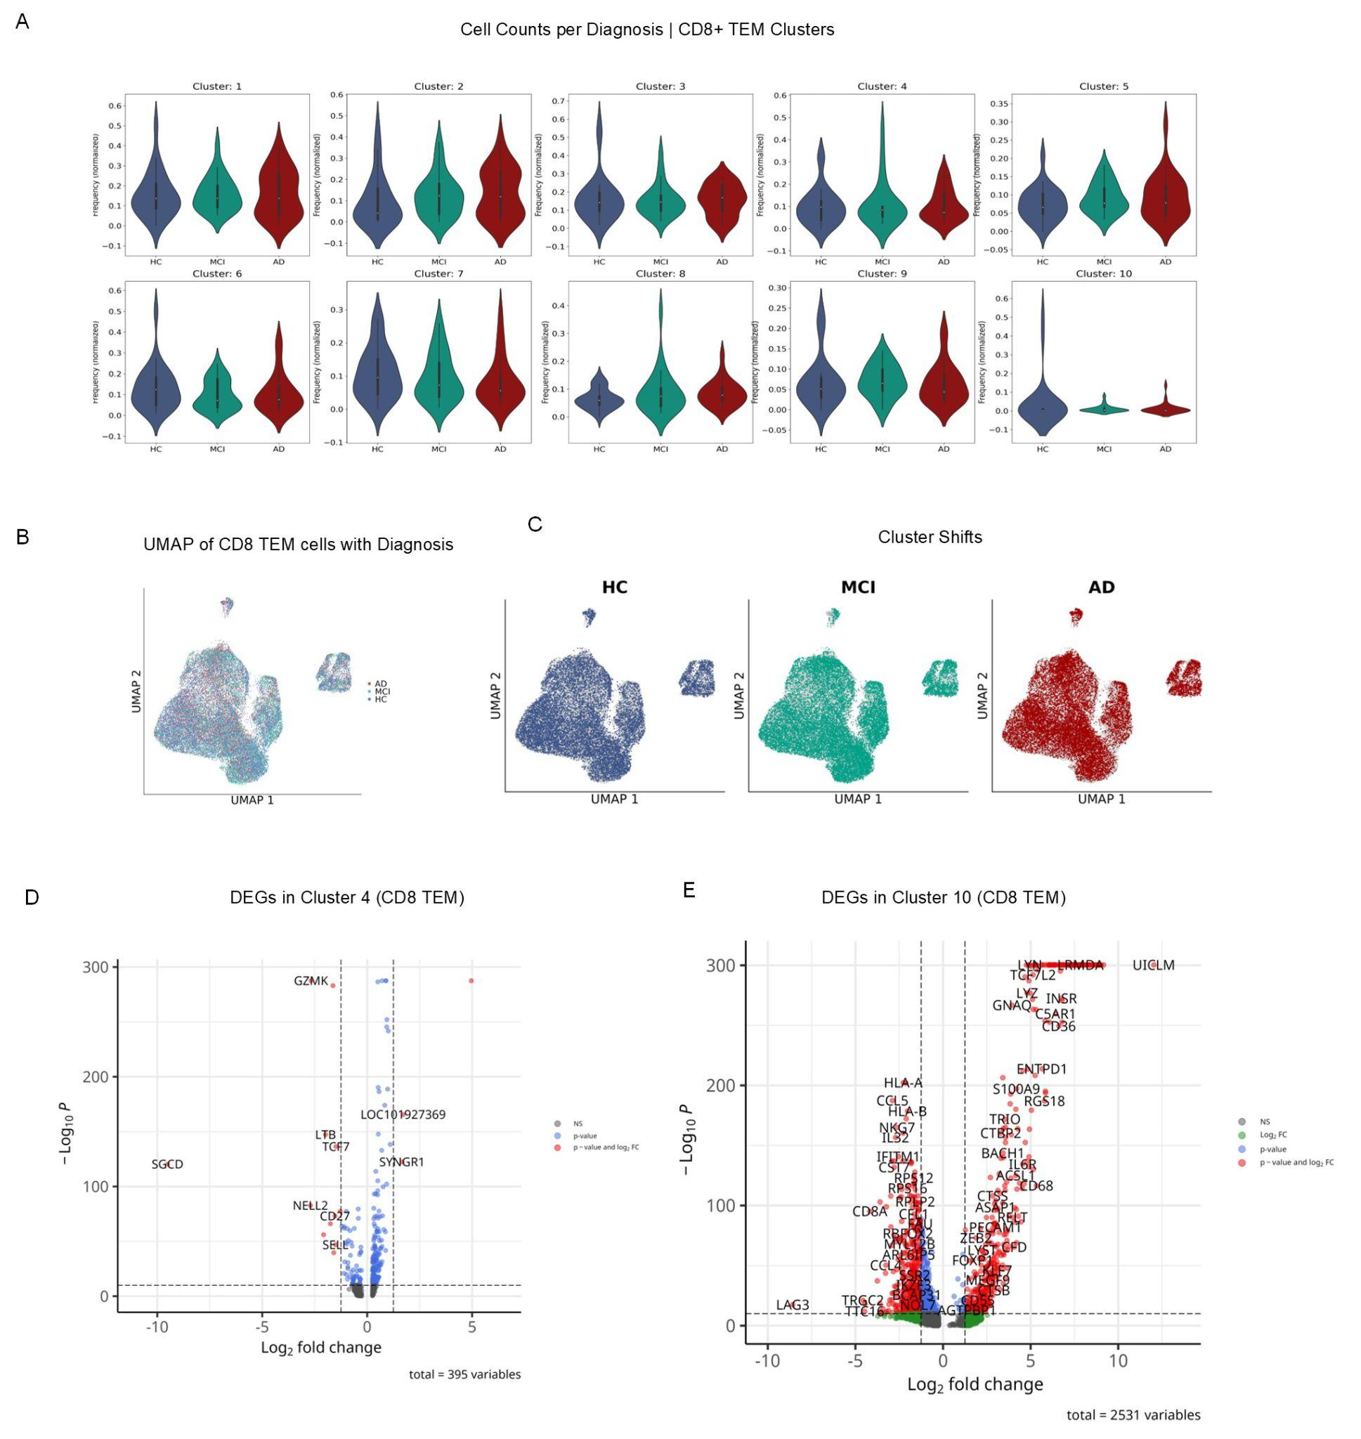
Suppl. Figure 4. CD8⁺ TEM cluster cell type and DEG analysis. A) Cell counts per diagnosis of clusters of CD8⁺ TEM cells. B) UMAP of CD8⁺ TEM labeled cells in diagnostic stages HC, MCI and AD. C) UMAPs of CD8⁺ TEM labeled cells across diagnostic stages. Volcano plots of DEGs of CD8⁺ TEM cells of D) cluster 4 and E) cluster 10.

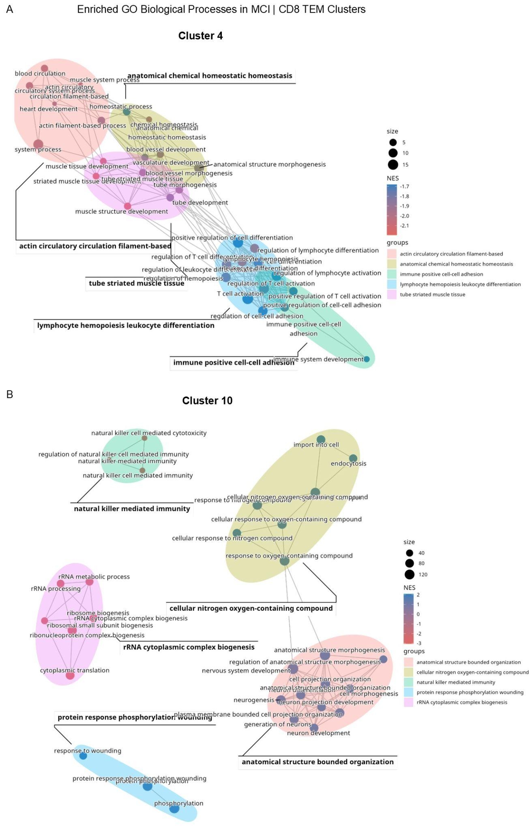
Suppl. Figure 5. Enrichment maps from GSEA analysis on CD8⁺ TEM. A) Enriched GO Biological Process terms in MCI compared to HC in CD8⁺ TEM cluster 4. B) Enriched GO Biological Process terms in MCI compared to HC in CD8⁺ TEM cluster 10.
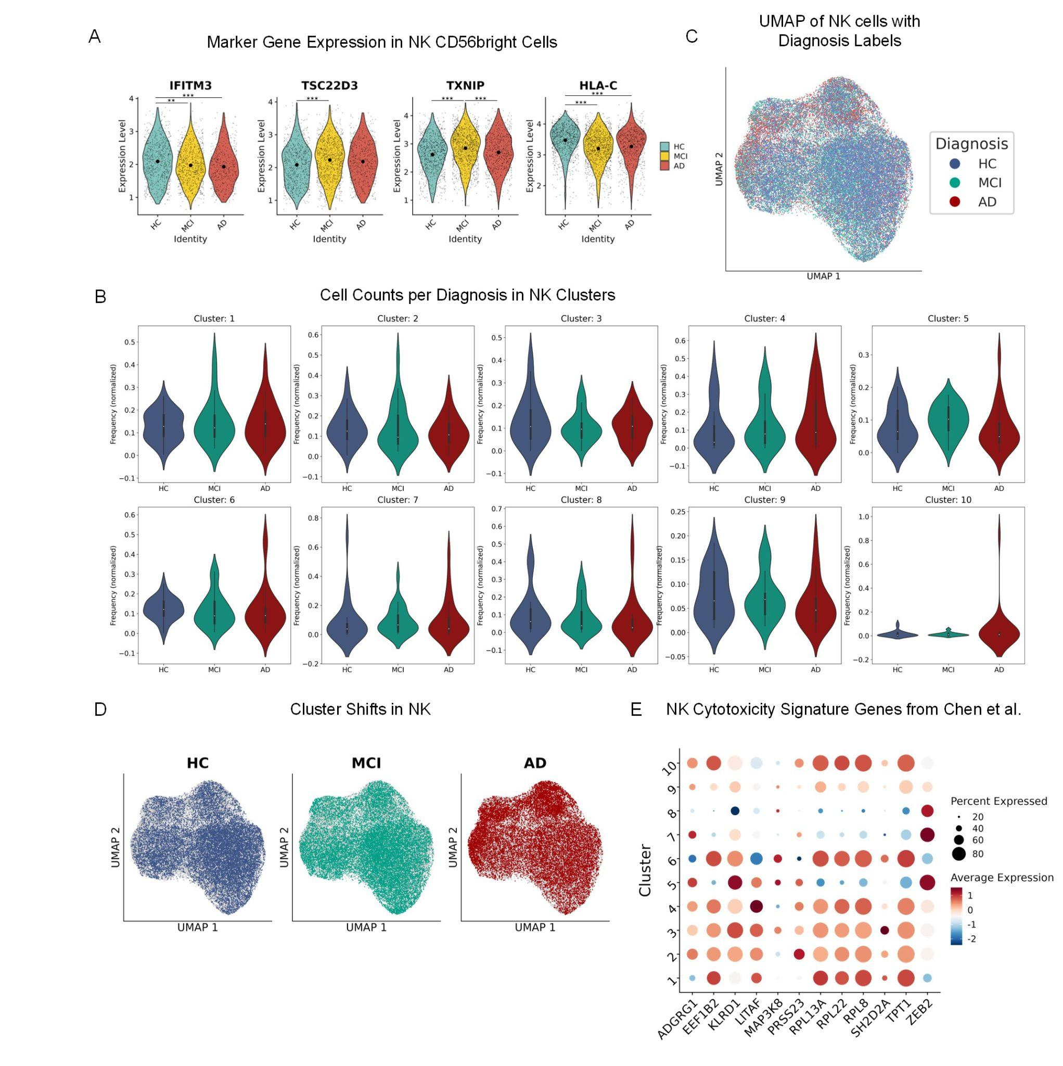
Suppl. Figure 6. NK cell type and DEG analysis. A) Normalized marker gene expression in NK CD56^{bright} cells. DE testing was performed with Wilcoxon Rank Sum test and adjusted for multiple testing with Benjamini-Hochberg method (IFITM3, MCI vs. HC: $p=0.002$, AD vs. HC: $p=1.49e^{-09}$; TSC22D3, MCI vs. HC: $p=0.0003$; TXNIP, MCI vs. HC: $p=1.27e^{-11}$, AD vs. MCI: $p=0.0003$; HLA-C, MCI vs. HC: $p=3.18e^{-30}$, AD vs. HC: $p=2.05e^{-12}$). B) Cell counts per diagnostic stage in NK cell clusters. C) UMAP of NK cells with diagnosis labels. D) UMAP of NK labeled cells in diagnostic stages HC, MCI and AD. E) Expression of NK cytotoxicity signature genes from Chen et al. in NK cell clusters ⁷⁴.

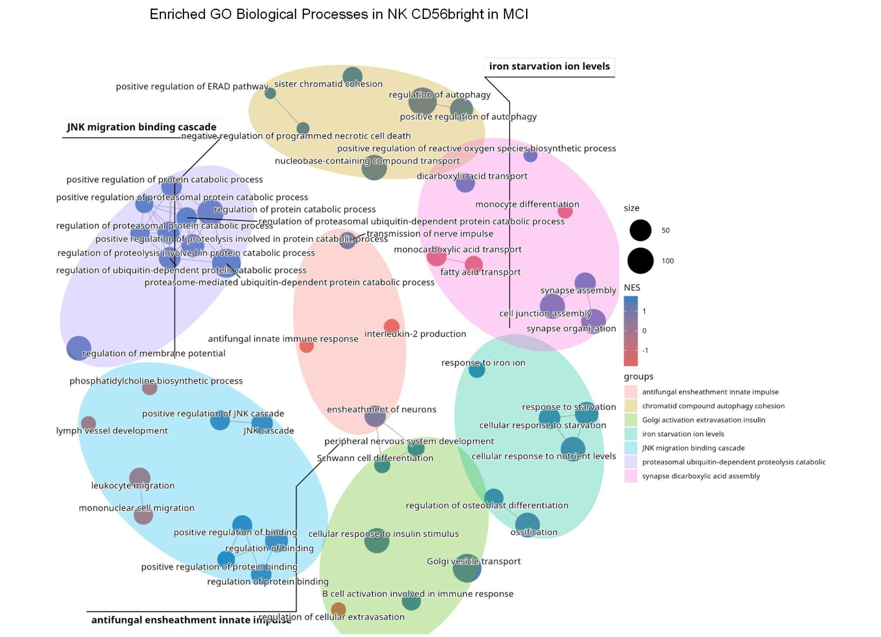
Suppl. Figure 7. Enrichment map from GSEA analysis on GO Biological Processes in NK CD56^{bright} cells.

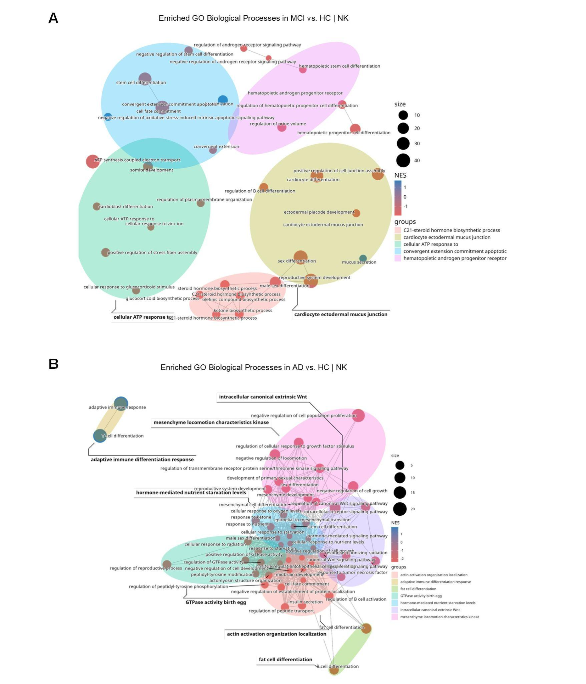
Suppl. Figure 8. Enrichment maps from GSEA analysis on NK cells. Enriched GO Biological Process terms in NK cells in A) MCI compared to HC and B) AD compared to HC.
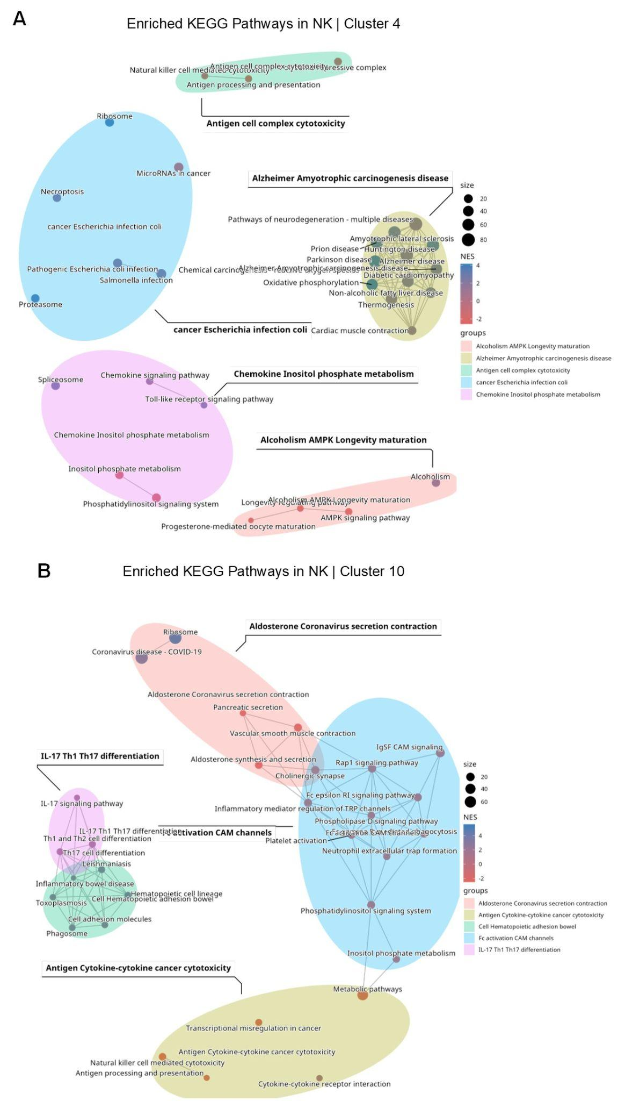
Suppl. Figure 9. Enrichment maps from GSEA analysis on NK cells. Enriched GO KEGG pathways in MCI compared to HC in NK A) cluster 4 and B) cluster 10.
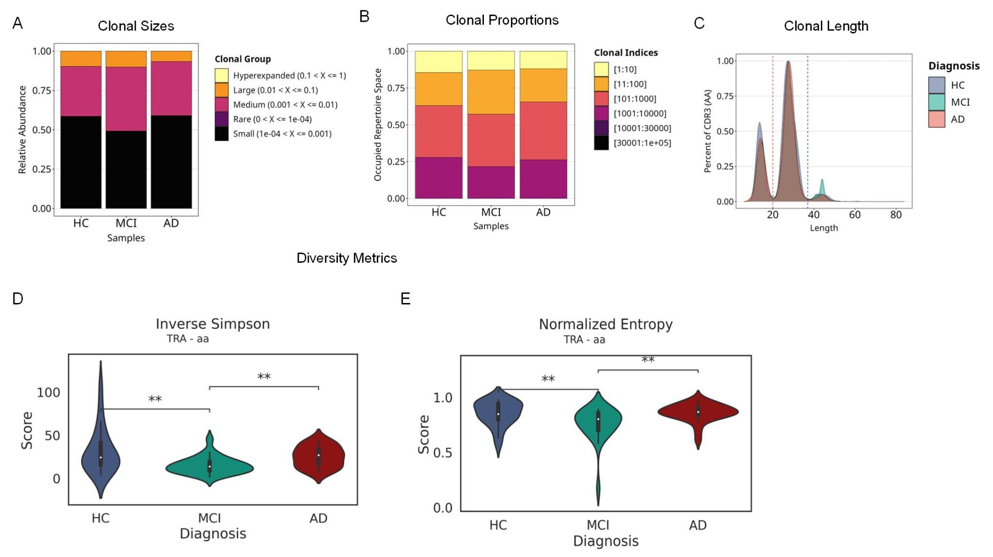
Suppl. Figure 10. scTCR analysis of the TRA chain. A) Occupied repertoire space of top clones per diagnostic group. B) Relative abundance of clonotypes of clonal sizes per diagnostic group; sizes “Rare” = 0 - 1e-04, “Small” = 1e-4 - 0.001, “Medium” = 0.001 - 0.01, “Large” = 0.01 - 0.1, ”Hyperexpanded” = 0.1 - 1. C) Distribution of CDR3 amino acid sequence length per diagnostic group. D-E) Violinplot of diversity metrics per diagnostic group of the amino acid (aa) sequence, Inverse Simpson (left) (MCI vs. HC: $H(2, N=50)=7.01, p=0.008$; AD vs. MCI: $H(2, N=50)= 8.41, p=0.003$) and Normalized Entropy (right) (MCI vs. HC: $H(2, N=50)=7.33, p=0.007$; AD vs. MCI: $H(2, N=50)=10.82, p=0.001$). Significance testing was performed via t-test, Welch’s test or Kruskal-Wallis test for parametric or non-parametric data and multiple testing correction was performed via Bonferroni-Holm’s method.

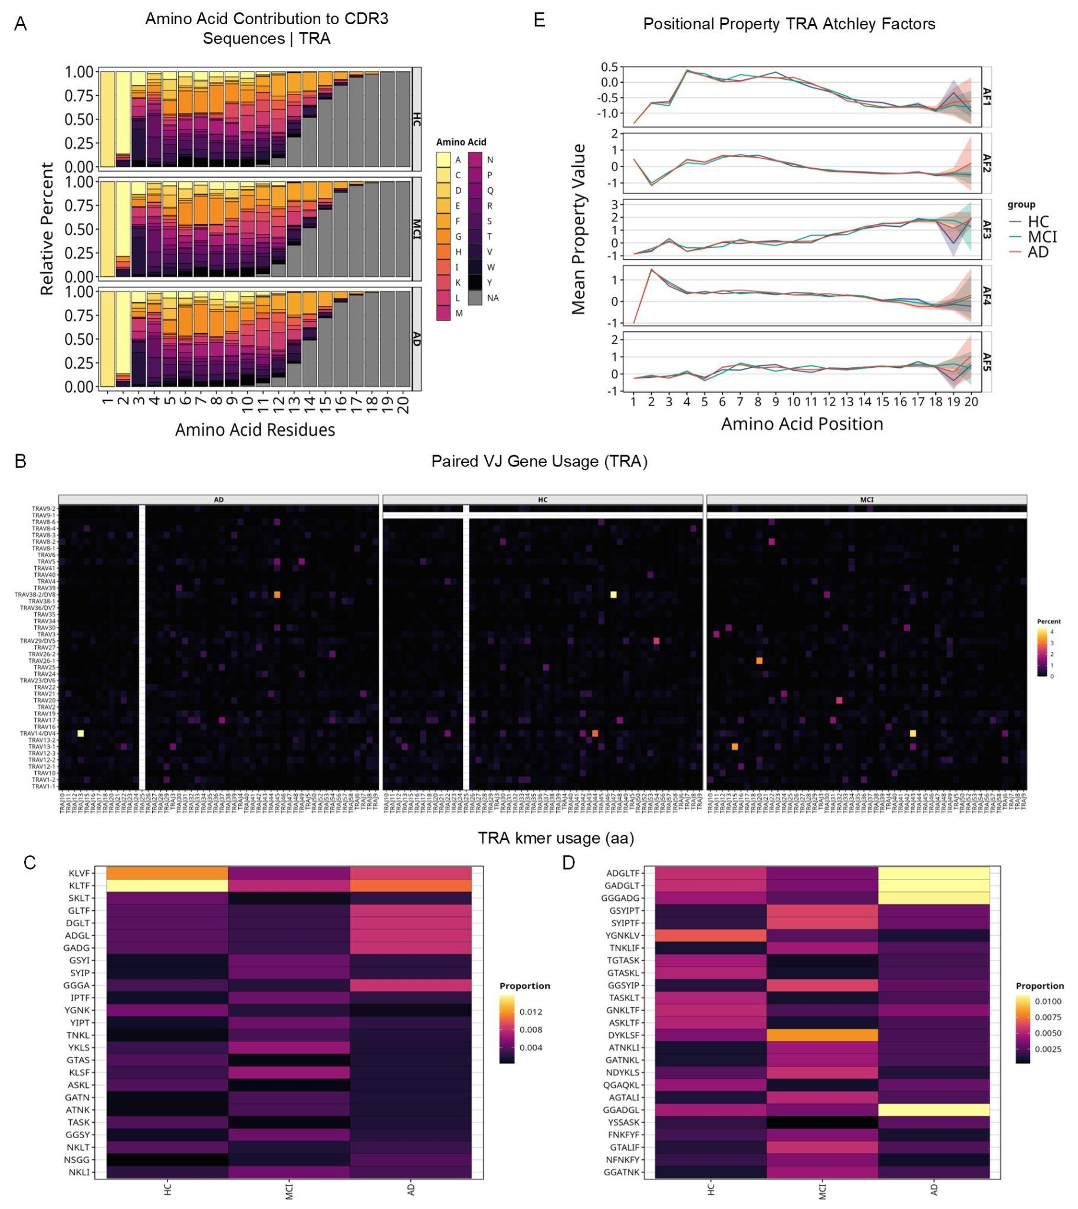
Suppl. Figure 11. scTCR analysis of the TRA chain. A) Amino acid contributions to CDR3 sequences per diagnostic group. B) Heatmap of paired VJ gene usage per diagnostic group. C)-D) Heatmap of TRA kmer usage, with k=4 (left) and k=6 (right). E) Atchley factors for amino acid positions per diagnostic group.

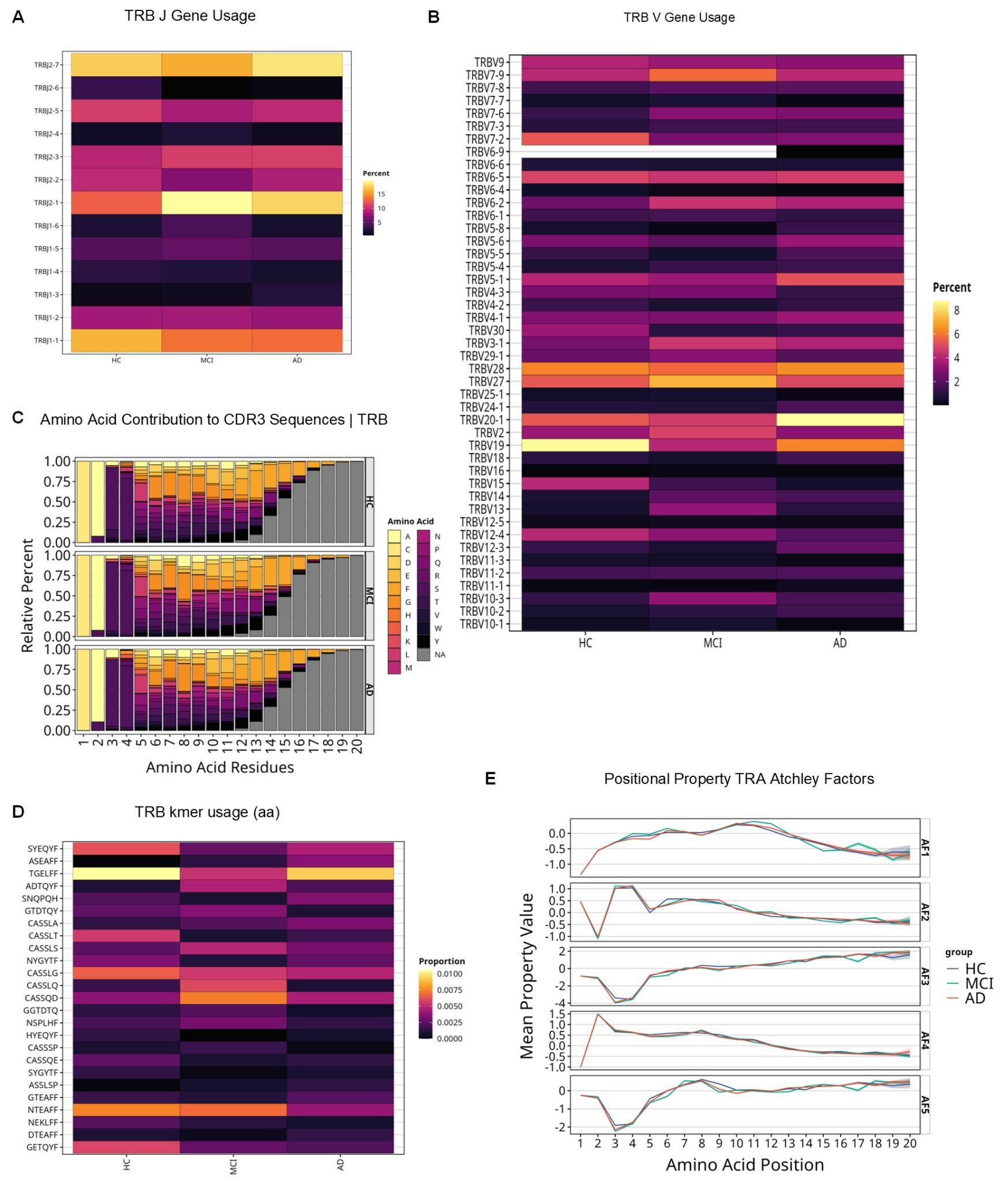
Suppl. Figure 12. scTCR-seq analysis of the TRB and TRA chain. Heatmap of TRB A) J gene and B) V gene usage per diagnostic group. C) Amino acid contributions to the CDR3 sequence per diagnostic group. D) Heatmap of kmer usage (k=6) of amino acids per diagnostic group. E) Positional properties per amino acid positions of TRA Atchley factors per diagnostic group.

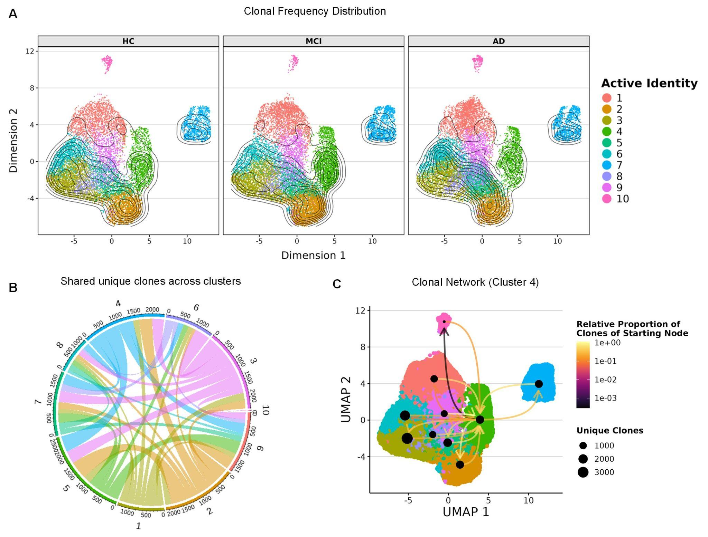
Suppl. Figure 13. scTCR-seq analysis on cluster level. A) UMAPs of CD8⁺ TEM colored by cluster identity with overlay of clonal frequency distribution. B) Chord diagram of shared unique clones across clusters displaying interconnectivity of clusters. C) UMAP visualization of network interaction of clones shared between cluster 4 and other clusters.

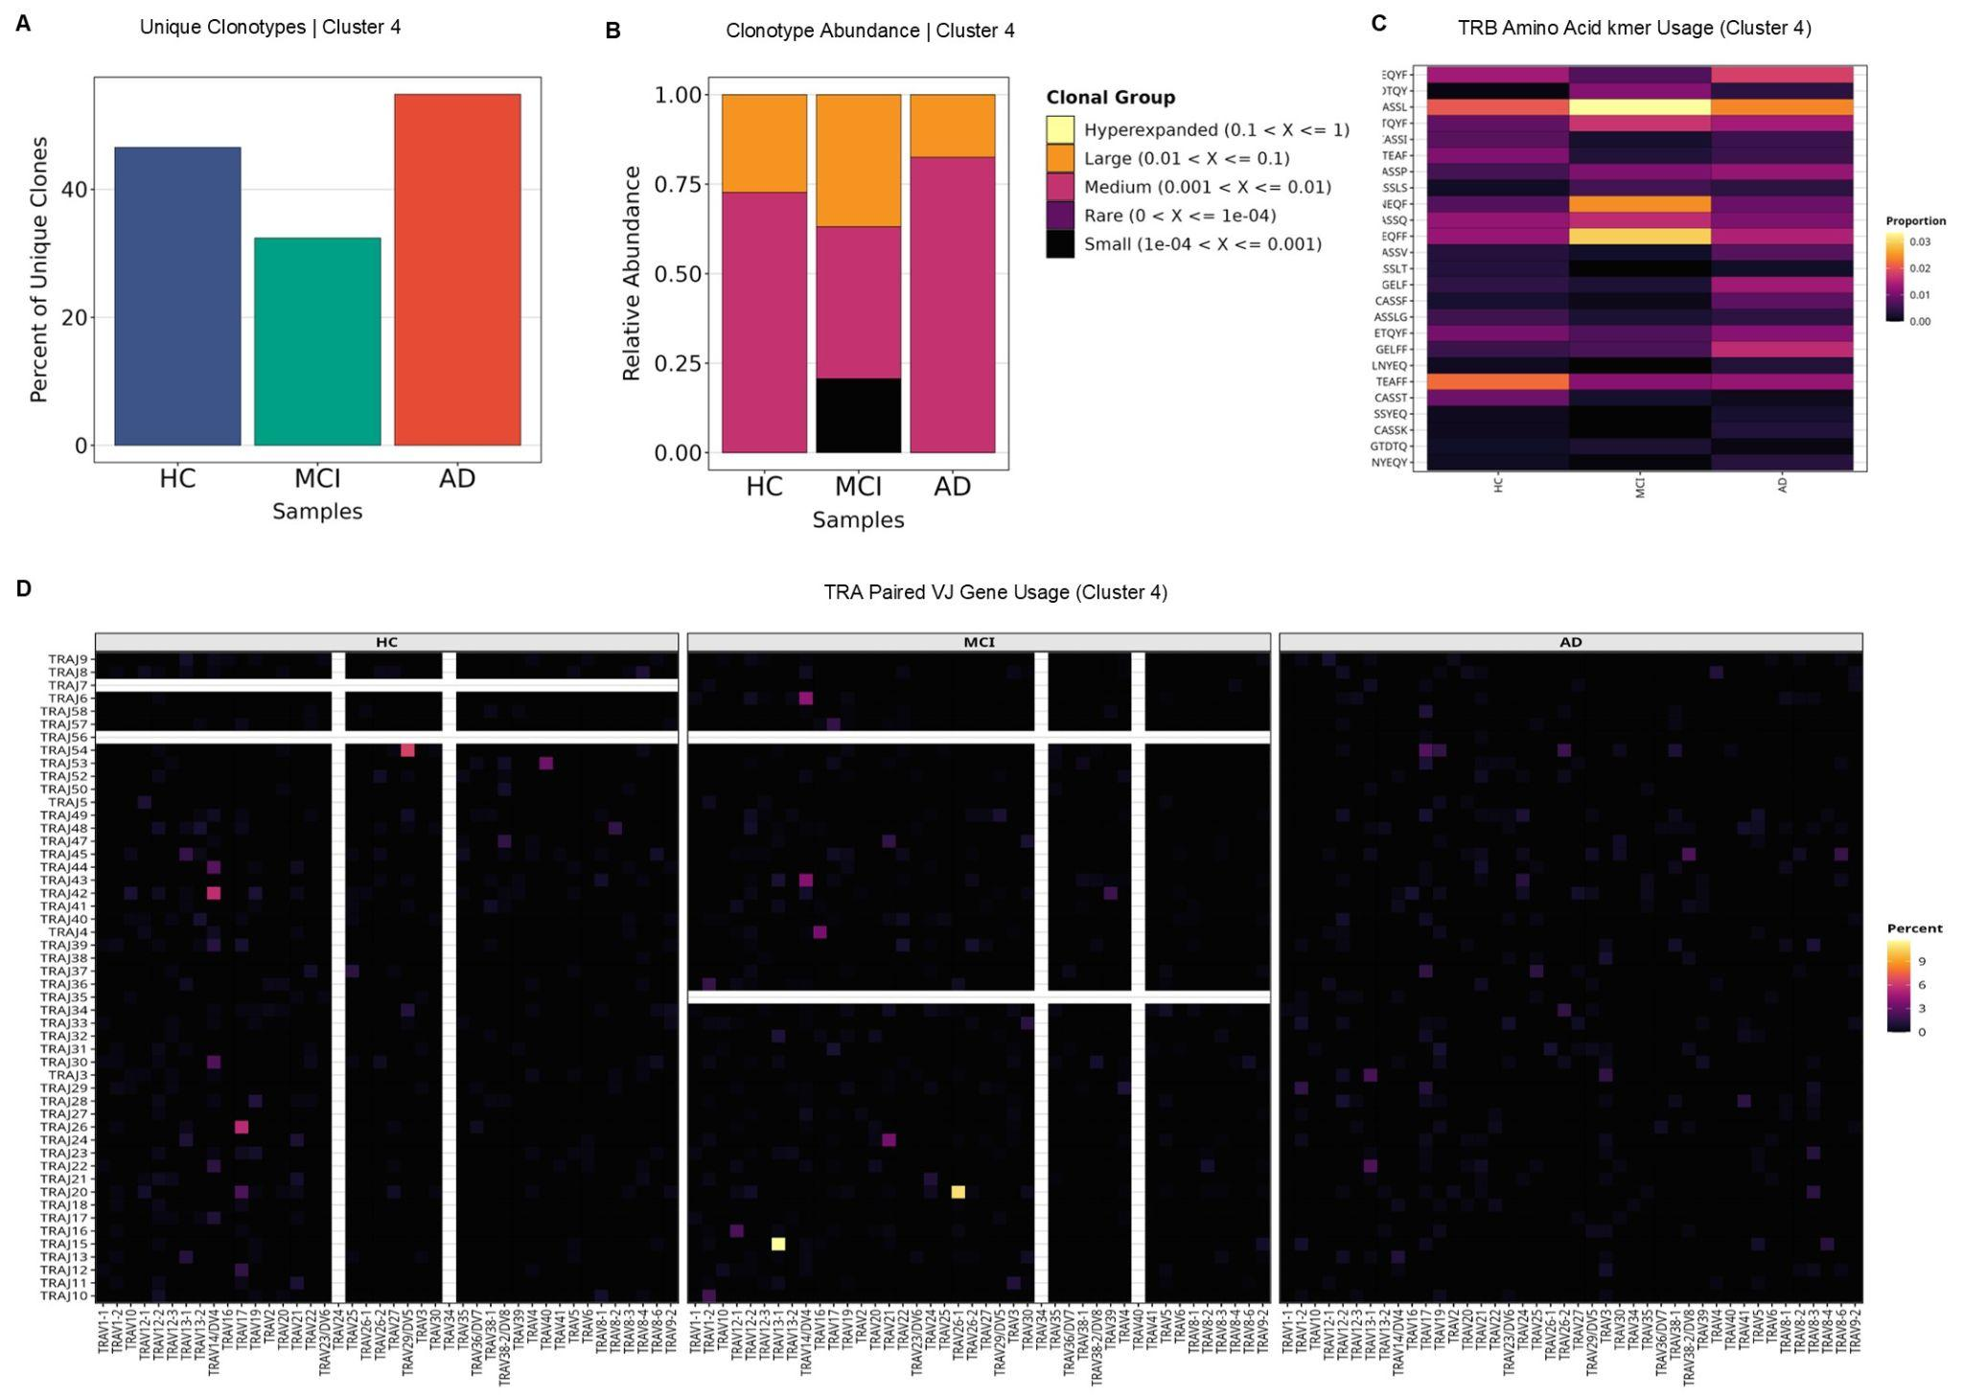
Suppl Figure 14. scTCR-seq analysis on cluster level. A) Percentage of unique clones in cluster 4 diagnostic groups. B) Relative abundance of clonotypes of clonal sizes in cluster 4 per diagnostic group; sizes “Rare” = 0 - 1e-04, “Small” = 1e-4 - 0.001, “Medium” = 0.001 - 0.01, “Large” = 0.01 - 0.1, ”Hyperexpanded” = 0.1 - 1. C) Heatmap of TRB amino acid kmer (k=4) usage in cluster 4. D) Heatmap of paired VJ gene usage in cluster 4 per diagnostic group.

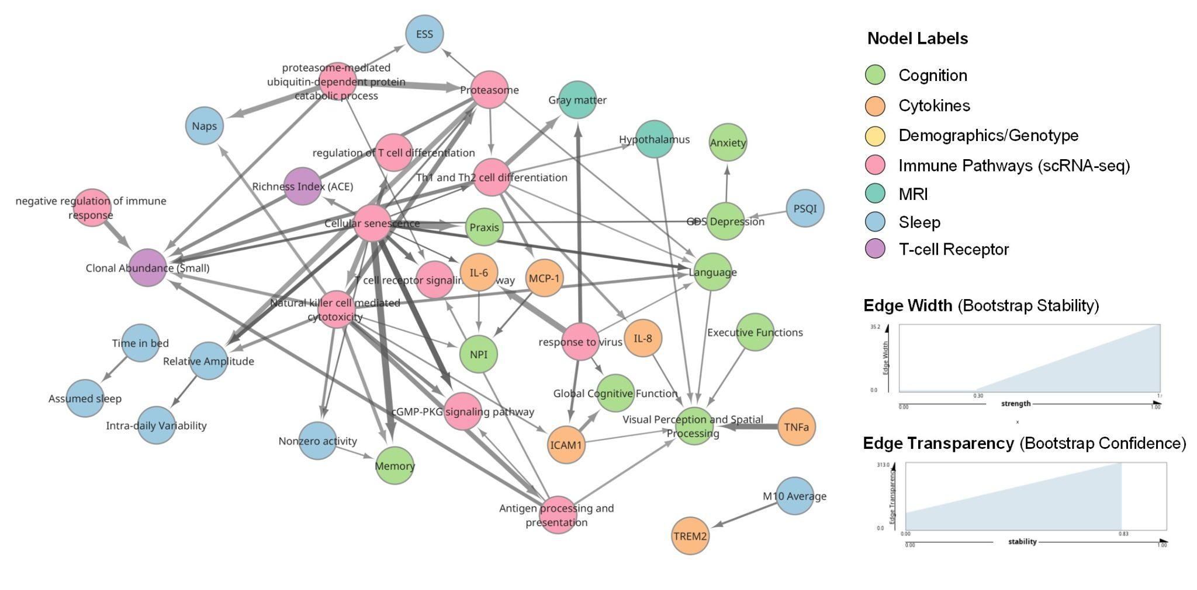
Suppl Figure 15. Directed acyclic graph learning of ADIS cohort module data based on cognitive assessments, CSF cytokine measurements, scRNA-seq low-dimensional representations of immune system pathways, descriptive scTCR-seq metrics, demographics and ApoE genotype, MRI, and sleep questionnaires. Shown is the averaged edge stability and edge strength over 100 bootstrap resamples. Immune system pathway scRNA-seq representations were computed for CD8⁺ TEM cells.

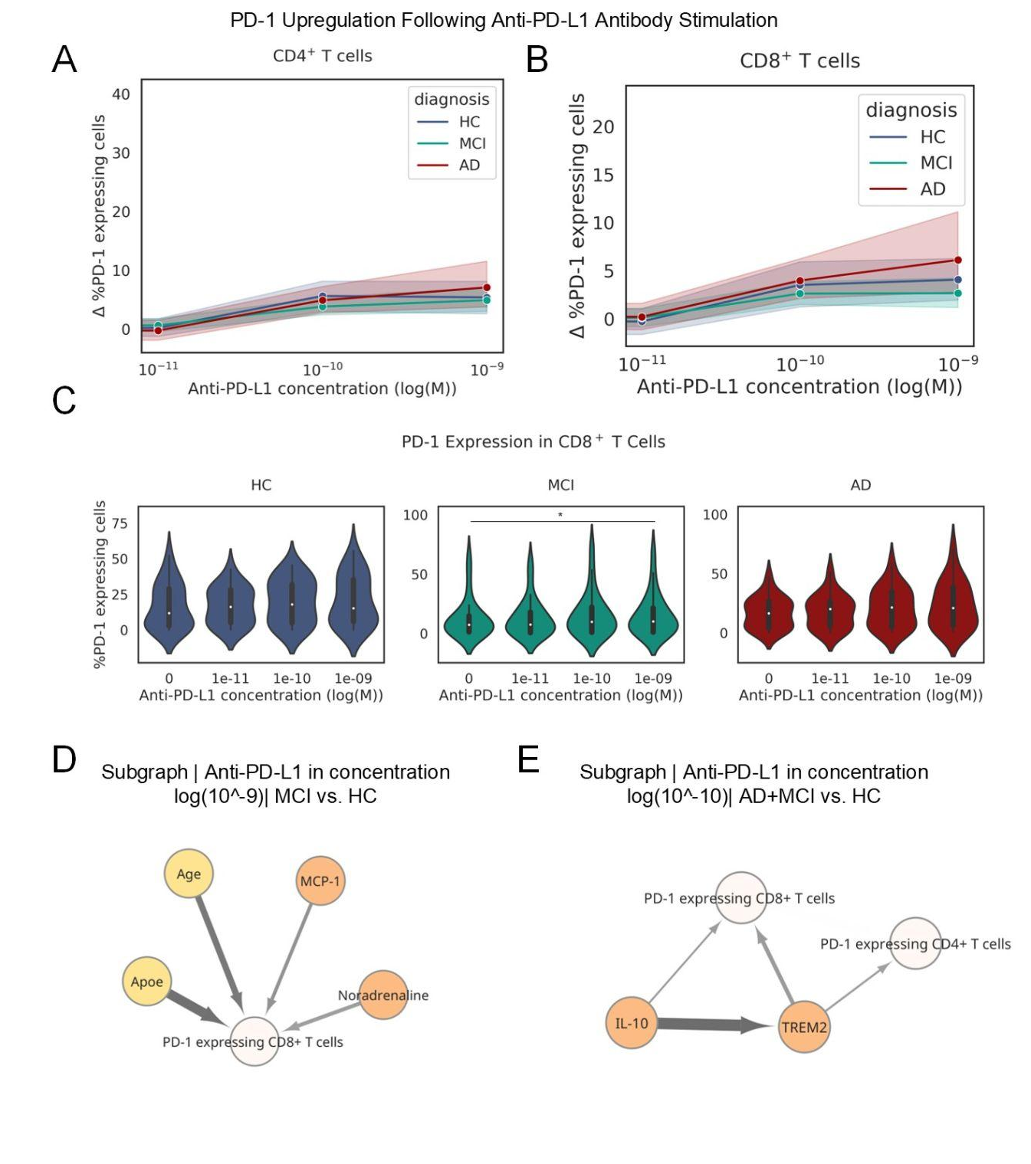
Suppl. Figure 16. A)-B) PD-1 upregulation following anti-PD-L1 antibody stimulation in CD4⁺ and CD8⁺ T cells with 95% confidence interval. Increase of PD-1 expressing cells at treatment with anti-PD-1 antibody from stimulation with anti-CD3 antibody shown in percentage of total CD4⁺ or CD8⁺ T cells. Significance testing was performed between log(10⁻¹¹) M and log(10⁻⁹) M between the diagnostic groups with one-way ANOVA and multiple testing correction with Tukey’s HSD test. C) %PD-1 expressing CD8⁺ T cells with anti-CD3 stimulation and complementary anti-PD-L1 stimulation in increasing concentrations for HC, MCI and AD. Significance testing was performed with paired t-test and multiple testing correction with Bonferroni-Holm (MCI log(10⁻¹¹) vs. 0 M: $t(25)=-3.16, p=0.038$). D)-E) Directed acyclic graph learning of ADIS cohort module with anti-PD-L1 immune stimulation , shown are subgraphs with first neighborhood of % PD-1 expressing CD4⁺ and CD8⁺ T cells in anti-PD-L1 concentrations of log(10⁻⁹) M and log(10-¹⁰) M.

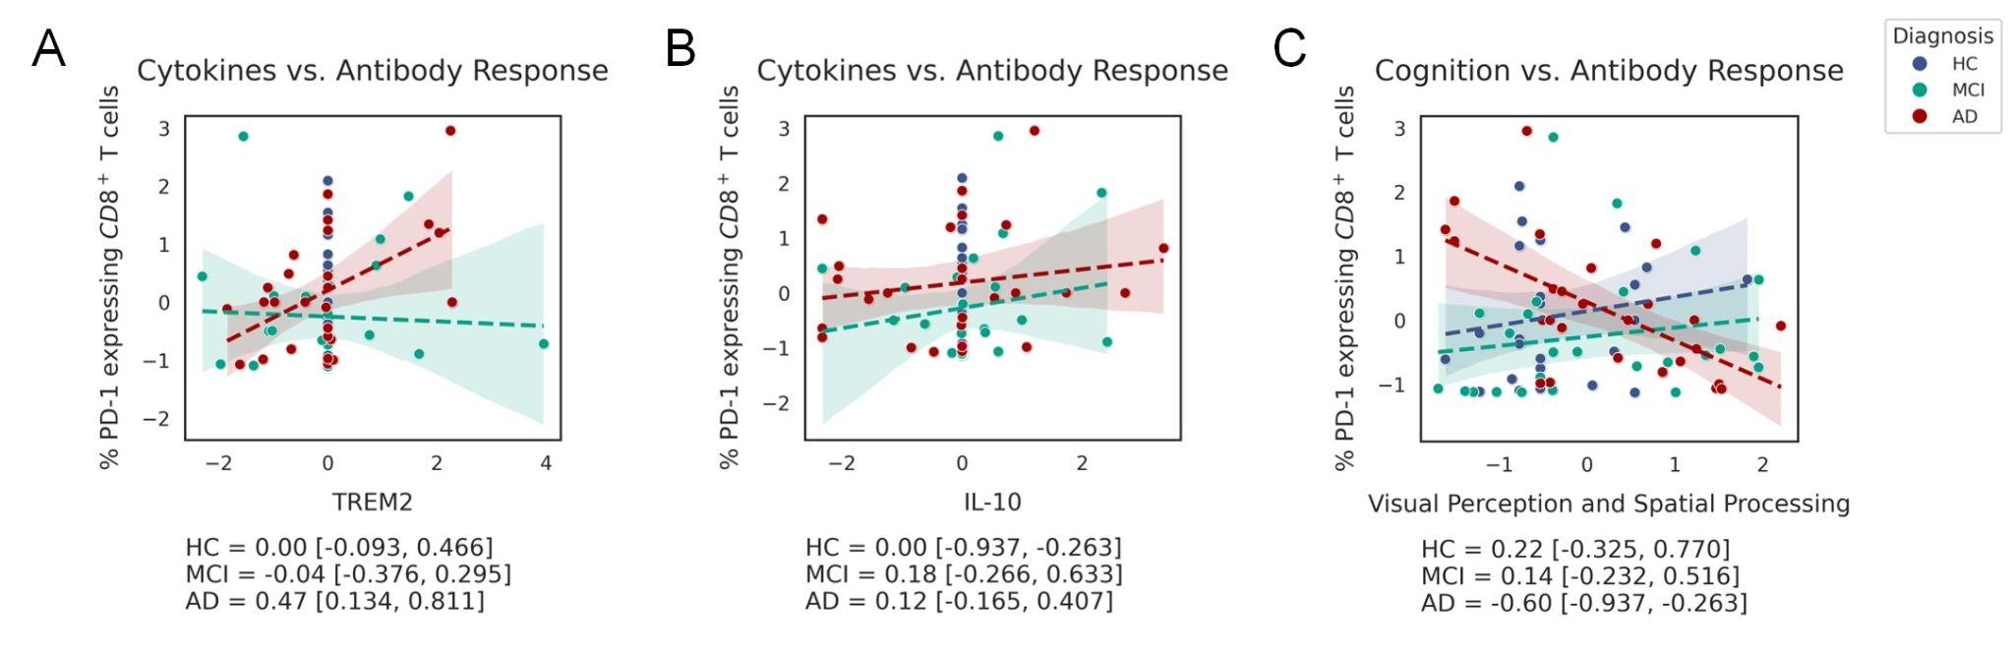
Suppl. Figure 17. A-C) Dependency plots between immune system pathways, cognitive test performance and %PD-1 expressing CD8⁺ T cells. Variable values are transformed per module, i.e. z-score normalized or embedded into lower dimensions, as described in the Methods section “AI-Based Directed Acyclic Graph Learning”. Linear regression trendlines were calculated per diagnostic category.

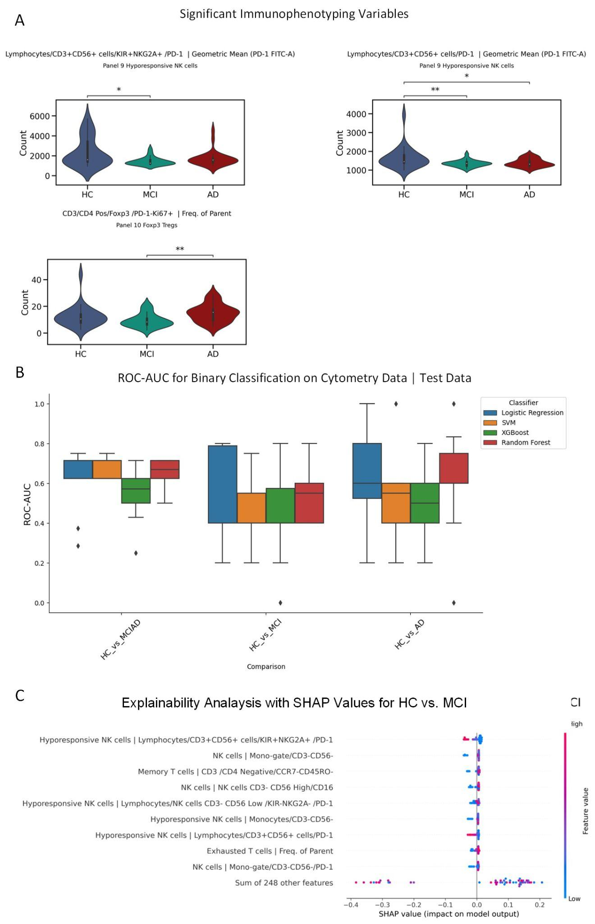
Suppl. Figure 18. Immunophenotyping of NK cells and T cells. A) Significant immunophenotyping variables between HC and MCI or AD (Panel 9 Hyporesponsive NK cells Lymphocytes/CD3⁺CD56⁺ cells/KIR⁺NKG2A⁺/PD-1 Geometric Mean (PD-1 FITC-A), MCI vs. HC: $H(2, N=50)=5.98, p=0.014$; Panel 9 Hyporesponsive NK cells Lymphocytes/CD3⁺CD56⁺ cells/PD-1 Geometric Mean (PD-1 FITC-A), MCI vs. HC:$H(2, N=50)=8.99, p=0.003$, AD vs. HC: $H(2, N=51)=4.53, p=0.03$; Panel 10 Foxp3 Tregs CD3/CD4 Pos/Foxp3/PD-1⁻Ki67⁺ Freq. of Parent, AD vs. MCI: $H(2, N=51)=9.73, p=0.002$). B) Classifier performance on test set on binary classification with Logistic regression, SVM, XGBoost and Random Forest in 10 fold nested cross-validation, measured in ROC-AUC. C) Explainability analysis of best classifier for combined binary classification task (HC vs MCI+AD) with SHAP values.

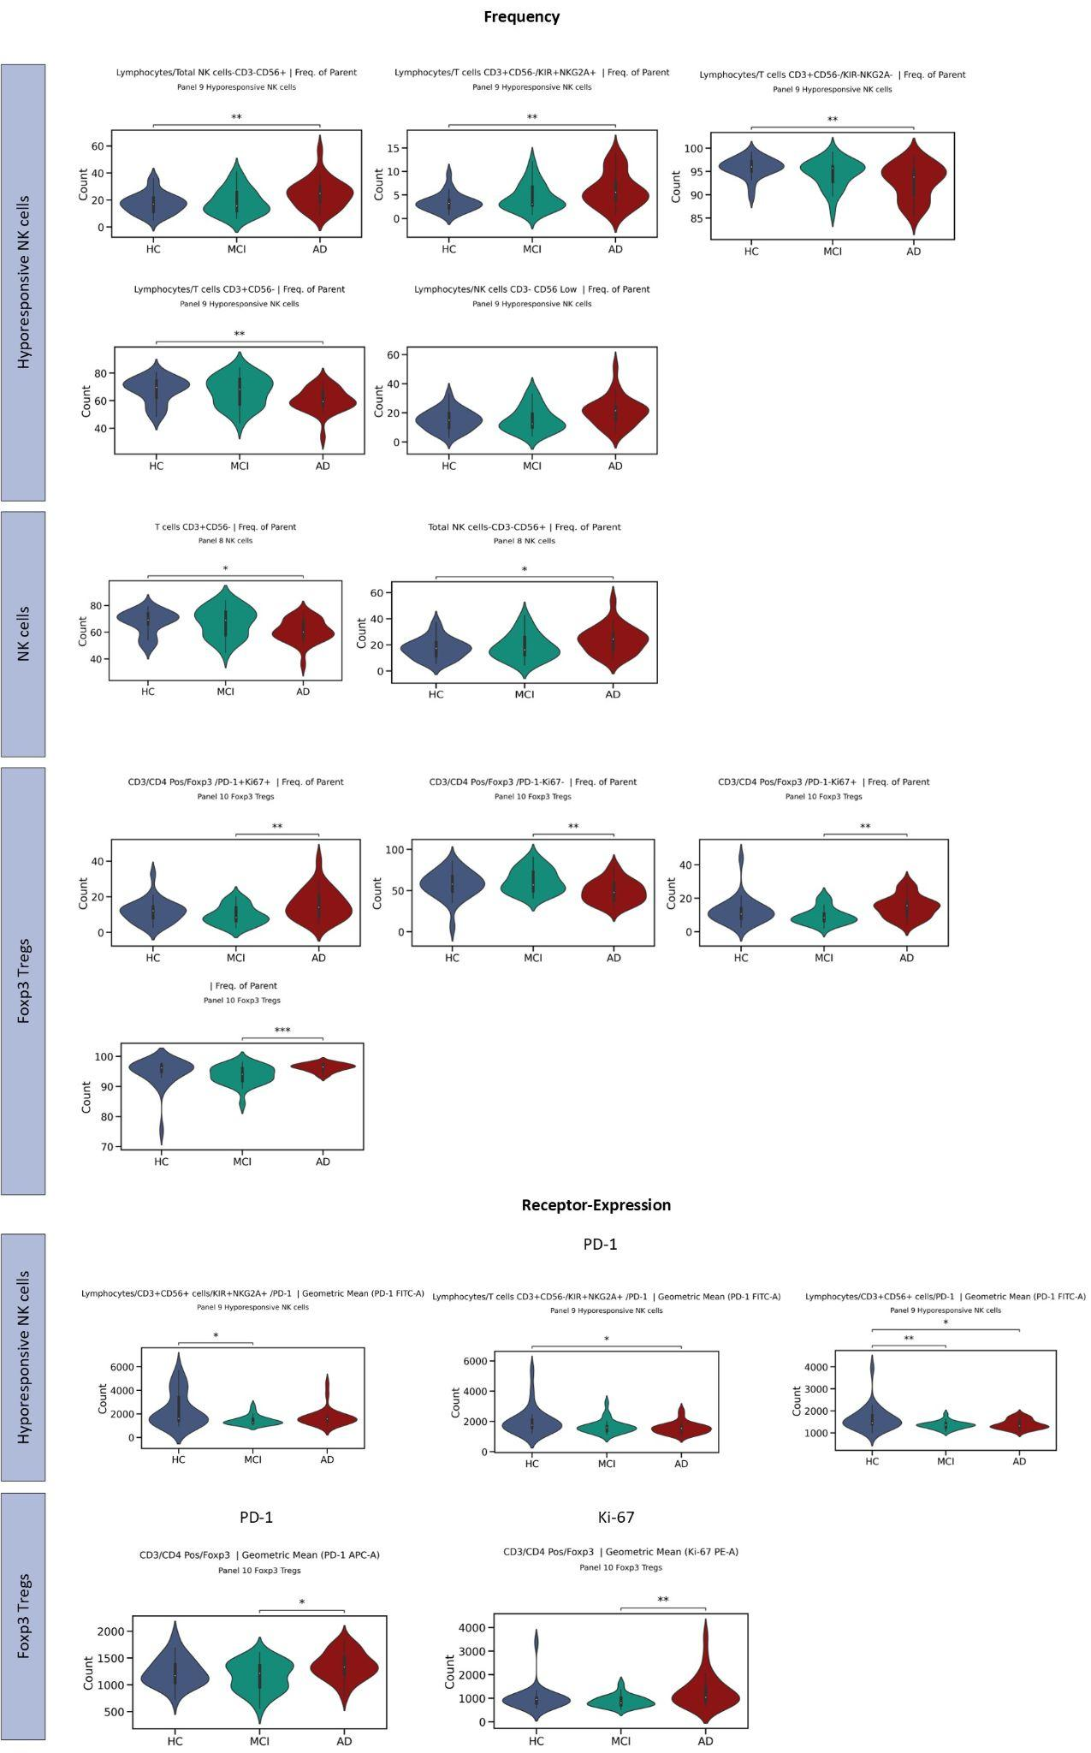
Suppl. Figure 19. Immunophenotyping with flow cytometry of hyporesponsive NK cells, NK cells and FoxP3⁺ Tregs. Significant frequencies of cell populations identified by indicated gates of the parent population (top) and receptor expression of PD-1 and/or Ki-67 (bottom).

Supplementary Tables

Chain | Present in Condition | CDR3 Sequence | Known Antigen | Reference | VDJdb confidence score
TRA | MCI | CAASETSYDKVIF | Epstein-Barr | ¹³⁴ | 0
TRA | MCI | CAASIGNFGNEKLTF | CMV | ¹³⁵ | 0
TRA | MCI | CAVLDSNYQLIW | SARS-Cov-2 | ¹³⁵ | 0
TRA | MCI | CAVLMDSNYQLIW | Epstein-Barr | ¹³⁴ | 0
TRA | MCI | CAVMDSNYQLIW | CMV/SARS-CoV-2 | ^{136,137} | 0
TRA | AD | CAEDNNARLMF | Epstein-Barr | ^{134,138,139} | 2
TRA | AD | CILPLAGGTSYGKLTF | Epstein-Barr | ¹⁴⁰ | 3
TRA | AD | CALNTGNQFYF | SARS-Cov-2 | ^{141,142} | 0
TRA | AD | CARNTGNQFYF | CMV | ^{138,143} | 1
TRB | MCI | CASSQGPNYEQYF | - | - | -
TRB | AD | CASSLGQAYEQYF | - | - | -
TRB | AD | CASSSANYGYTF | CMV | ^{144,145} | 2
Suppl. Table 1. CDR3 sequences present in subjects with MCI and AD with a count of ≥ 3.
Suppl. Table 2. Flow cytometry marker combinations for definition of distinct cell populations.

Classifier | Hyperparameter | Min | Max | Options
Logistic Regression | C | 0.01 | 100
Logistic Regression | solver |  |  | liblinear, lbfgs
SVM | C | 0.01 | 10
SVM | kernel |  |  | linear, rbf, poly, sigmoid
SVM | degree | 2 | 4
SVM | coef0 | 0 | 1
SVM | shrinking |  |  | True, False
XGBoost | n_estimators | 100 | 300
XGBoost | learning_rate | 0.001 | 0.2
XGBoost | loss |  |  | log_loss, exponential
XGBoost | min_samples_split | 2 | 10
XGBoost | min_samples_leaf | 1 | 4
XGBoost | max_depth |  |  | None, 3, 5, 10, 20, 40
Random Forest | n_estimators | 100 | 300
Random Forest | max_depth |  |  | None, 3, 5, 10, 20, 40
Random Forest | min_samples_split | 2 | 10
Random Forest | min_samples_leaf | 1 | 4
Random Forest | max_features |  |  | sqrt, log2, None
Suppl. Table 3. Hyperparameter ranges for the cytometry immunophenotyping classifiers.

Suppl. Table 4. Inventory of cognitive assessments performed in the ADIS study.
Suppl. Table 5. KEGG pathways used in generation of low-dimensional embeddings of scRNA sequencing data.
Suppl. Table 6. GO Biological Process terms used in generation of low-dimensional embeddings of scRNA seq data.

Hyperparameter Name | Search Space
Size of hidden layers | [64, 128, 256]
Number of latent dimensions | [1, 2, 3, 4, 5, 6, 7, 8, 9, 10]
Number of layers | [1, 2, 3]
Batch size | [64, 128, 512, 1024]
Learning rate | log(1e-4, 1e-2)
Suppl. Table 7. Hyperparameter search space for conditional variational autoencoder for representation learning of scRNA-seq data.
Suppl. Table 8. Immunophenotyping marker combinations significantly altered in MCI or AD. Significant changes are indicated as arrows directed up or down, p-value ≤ 0.05, BH corrected.

