Supplementary material added for submission
Supplementary Table S1. Extracted genotype distributions of PNPLA3 rs738409 in cases and controls.
Study ID | Ethnic group | Country | Year | Cases n | Controls n | Case CC | Case CG | Case GG | Control CC | Control CG | Control GG | Data note
NAF-PN-2 | Vietnamese descent | Vietnam | 2025 | 135 | 270 | 58 | 57 | 20 | 145 | 98 | 27 | Direct/reconstructed; matches Table 2 ORs
NAF-PN-3 | Caucasian descent | Italy | 2012 | 144 | 257 | 55 | 68 | 21 | 146 | 95 | 16 | Direct/reconstructed; matches Table 2 ORs
NAF-PN-5 | Chinese descent | China | 2022 | 162 | 100 | 33 | 69 | 60 | 43 | 46 | 11 | Direct/reconstructed; matches Table 2 ORs
NAF-PN-6 | Caucasian descent | Belgium | 2013 | 208 | 79 | 81 | 103 | 24 | 47 | 32 | 0 | Provisional reconstruction; full-text verification recommended
NAF-PN-7 | Chinese descent | China | 2013 | 315 | 336 | 45 | 128 | 142 | 155 | 139 | 42 | Direct/reconstructed; matches Table 2 ORs
NAF-PN-8 | Chinese descent | China | 2018 | 203 | 188 | 73 | 91 | 39 | 89 | 81 | 18 | Direct/reconstructed; matches Table 2 ORs
NAF-PN-10 | Indian descent | India | 2013 | 162 | 173 | 112 | 35 | 15 | 149 | 16 | 8 | Direct/reconstructed; matches Table 2 ORs
NAF-PN-11 | Chinese descent | China | 2022 | 246 | 169 | 61 | 112 | 73 | 65 | 78 | 26 | Direct/reconstructed; matches Table 2 ORs
NAF-PN-13 | Japanese descent | Japan | 2015 | 119 | 472 | 23 | 69 | 27 | 143 | 249 | 80 | Direct/reconstructed; matches Table 2 ORs
NAF-PN-14 | Japanese descent | Japan | 2010 | 253 | 575 | 45 | 111 | 97 | 175 | 296 | 104 | Direct/reconstructed; matches Table 2 ORs
NAF-PN-15 | Brazilian descent | Brazil | 2019 | 248 | 134 | 77 | 117 | 54 | 66 | 55 | 13 | Direct/reconstructed; matches Table 2 ORs
NAF-PN-16 | Chinese descent | China | 2016 | 376 | 382 | 122 | 191 | 63 | 169 | 174 | 39 | Direct/reconstructed; matches Table 2 ORs
NAF-PN-18 | Chinese descent | Taiwan, China | 2014 | 191 | 606 | 58 | 95 | 38 | 238 | 293 | 75 | Direct/reconstructed; matches Table 2 ORs
NAF-PN-22 | Indian descent | India | 2017 | 147 | 75 | 44 | 68 | 35 | 45 | 27 | 3 | Direct/reconstructed; matches Table 2 ORs
Note: CC, CG, and GG refer to rs738409 genotypes. Most genotype counts were reverse-checked against the genotype-specific ORs in Table 2. The NAF-PN-6 row should be verified against the original full-text table before final journal submission because the available working file did not contain a fully explicit raw genotype table.

Supplementary Table S2. PRISMA 2020 checklist for the revised manuscript.
PRISMA item | Topic | Checklist content | Location in revised manuscript
1 | Title | Identifies the report as a systematic review and meta-analysis. | Title page
2 | Abstract | Structured summary covering background, methods, results, and conclusions. | Abstract
3 | Rationale | Explains why the review was conducted in light of inconsistent population-specific evidence. | Introduction
4 | Objectives | States objective to assess PNPLA3 rs738409 and NAFLD susceptibility with ethnicity-stratified evaluation. | Introduction
5 | Eligibility criteria | Defines eligible designs, genotype availability, NAFLD diagnosis, and exclusion criteria. | Materials and Methods
6 | Information sources | Lists PubMed, Embase, Web of Science, ScienceDirect, CNKI, Wanfang, and Chinese Medical Association database. | Search strategy
7 | Search strategy | Reports English search terms and states equivalent Chinese terms. | Search strategy
8 | Selection process | Describes duplicate removal, title/abstract screening, full-text review, and quantitative inclusion. | Results; Figure 1
9 | Data collection process | Describes extracted study characteristics, genotype counts, and ORs. | Data extraction
10a | Data items - outcomes | Reports genotype contrasts and NAFLD susceptibility outcomes. | Statistical analysis; Tables 2-3
10b | Data items - other variables | Reports ethnicity, country, year, and sample size. | Table 1
11 | Risk of bias assessment | Uses Newcastle-Ottawa Scale. | Quality assessment; Figure 2
12 | Effect measures | Uses odds ratios with 95% confidence intervals. | Statistical analysis
13a | Synthesis methods - eligibility for synthesis | Includes studies with extractable case/control genotype data. | Eligibility criteria
13b | Synthesis methods - data preparation | Adds genotype extraction/reconstruction and HWE assessment. | Data extraction; Supplementary Table S1 and Table 4
13c | Synthesis methods - tabulation/visualization | Summarizes study characteristics, study-specific ORs, pooled ORs, forest plots, and funnel plot. | Tables 1-3; Figures 4-8
13d | Synthesis methods - heterogeneity | Uses Cochran's Q and I2; random-effects model when I2 > 50%. | Statistical analysis
13e | Synthesis methods - sensitivity/subgroups | Reports ethnicity subgroup analysis and leave-one-out sensitivity analysis; adds HWE sensitivity note. | Results; Table 4
13f | Synthesis methods - reporting bias | Uses funnel plot, Egger's test, and Begg's test. | Publication bias
14 | Reporting bias assessment | Reports no statistical evidence of publication bias but notes modest number of studies. | Publication bias
15 | Certainty assessment | Not formally performed; should be stated if required by the target journal. | Limitations/Methods
16a | Study selection - results | Reports 5,315 records, 24 full texts assessed, 14 studies included. | Results; Figure 1
16b | Study selection - exclusions | Reports 10 full-text exclusions; detailed reasons should be retained in screening log. | Results; Supplementary Figure S1
17 | Study characteristics | Provides included study characteristics. | Table 1
18 | Risk of bias in studies | Reports NOS scores >= 7. | Quality assessment; Figure 2
19 | Results of individual studies | Provides study-specific ORs and 95% CIs. | Table 2
20a | Results of syntheses | Reports pooled ORs under five genetic models. | Table 3
20b | Results of syntheses - heterogeneity | Reports I2 and Q statistics. | Table 3
20c | Results of syntheses - sensitivity/subgroups | Reports ethnicity subgroup and leave-one-out sensitivity; adds HWE sensitivity note. | Results; Table 4
20d | Results of syntheses - absolute effects | Not applicable to genotype association OR meta-analysis. | Not applicable
21 | Reporting biases | Reports Egger, Begg, and funnel plot. | Publication bias; Figure 7
22 | Certainty of evidence | Not formally graded; should be acknowledged if target journal requests GRADE or credibility assessment. | Discussion/Limitations
23a | Discussion - interpretation | Interprets PNPLA3 rs738409 association and ethnicity-related differences. | Discussion
23b | Discussion - limitations | Discusses heterogeneity, uneven ethnic representation, and gene-environment data limitations. | Discussion
23c | Discussion - implications | Discusses ethnicity-aware genetic risk assessment and future research. | Discussion/Conclusion
24a | Registration/protocol | States protocol not registered. | Reporting framework
24b | Registration/protocol access | Not applicable because protocol not registered. | Reporting framework
24c | Registration amendments | Not applicable. | Not applicable
25 | Support | Funding/support statement should be added according to author information. | Declarations
26 | Competing interests | Competing interest statement should be added before submission. | Declarations
27 | Availability of data/code/materials | Genotype data and HWE table added; analysis files should be made available upon request or as supplement. | Supplementary Table S1 and Table 4

Supplementary Figure S1. Updated PRISMA 2020 flow diagram with final search date.
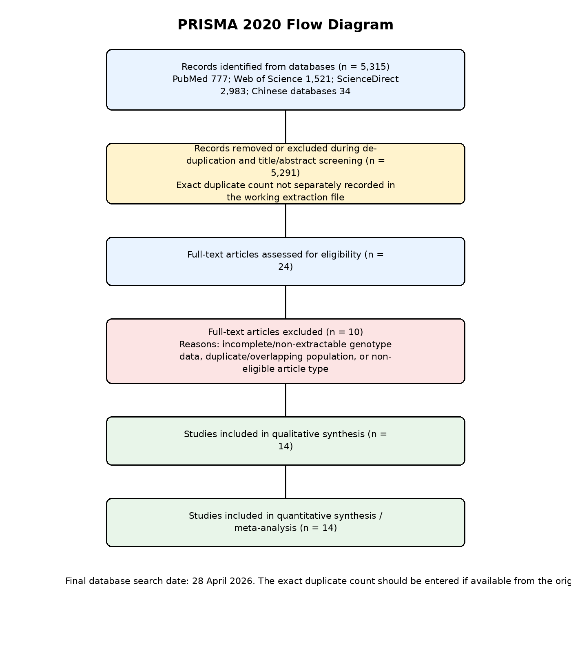
Note: The available working extraction file records the combined number removed during duplicate removal and title/abstract screening, but not the exact duplicate count separately. If the original search log is available, the exact duplicate count should replace this combined value before submission.

