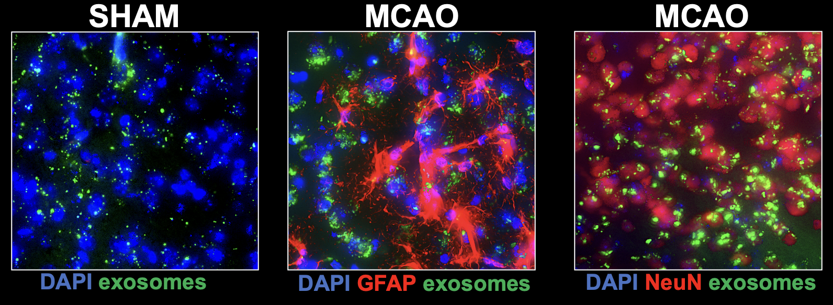
Figure S1. Examples of images demonstrating tracking of green fluorescent-protein-labeled exosomes after intracerebroventricular injection in mice subjected to either middle cerebral artery occlusion or sham control surgery. Tissue is co-labeled to identify astrocytes (GFAP) and neurons (NeuN). Scale bar = 50 mm

