Record-breaking 2023 fires signal a new era of smoke-driven darkening on the Greenland Ice Sheet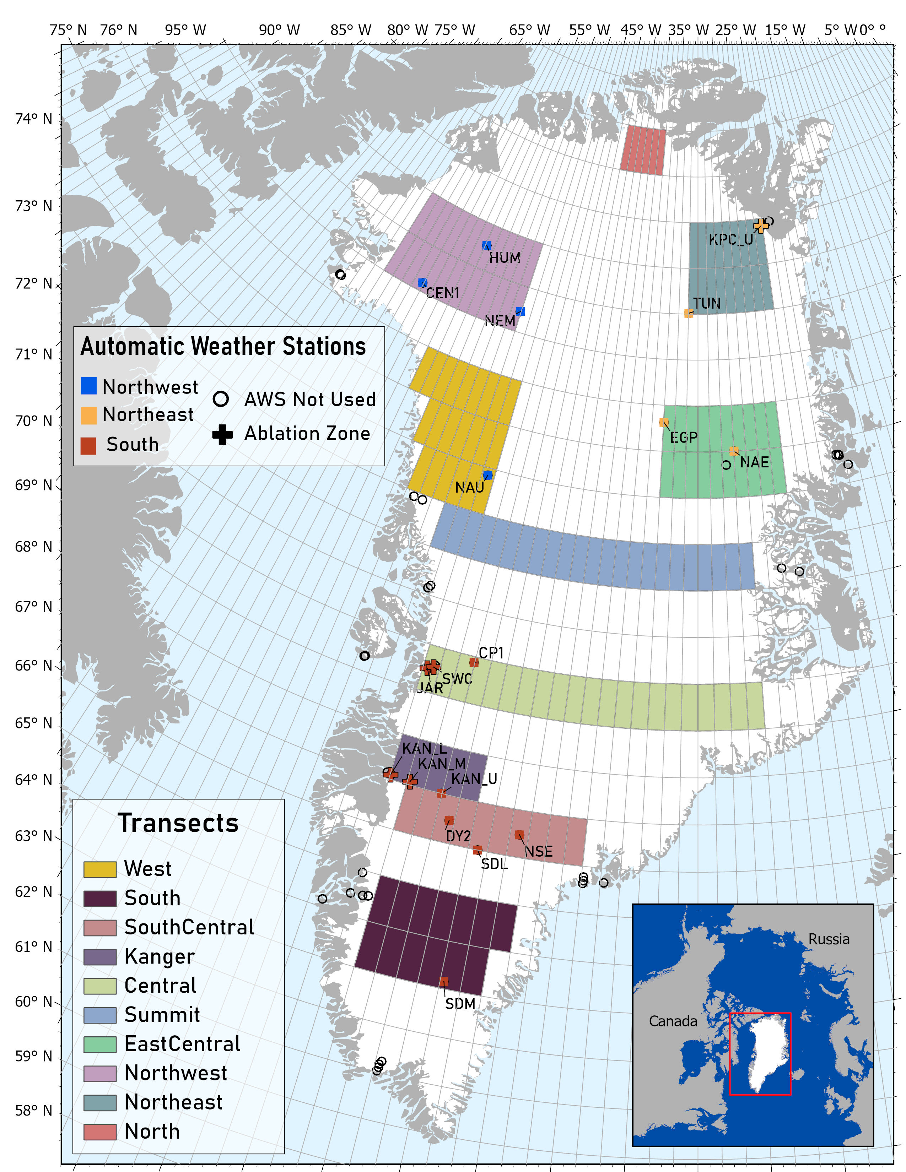
Figure SI-1. Map of Greenland with 1º grid showing the ten study area transects made up of 1ºx1º tiles matching the resolution of the NAAPS model. Locations of PROMICE and GC-Net AWSs used in this analysis are symbolized as points. The colors of each point indicate the geographic region of the ice sheet the station is located in (Northwest, Northeast, South) and AWSs symbolized with crosses indicate their position in the ablation zone. All other stations are within the accumulation zone. AWSs not used in this analysis are symbolized as open circles. AWS acronyms are defined in Table ED-2.

Table SI-2. Site characteristics of the ten transects. The centroid coordinate range indicates the center points of the 1° × 1° tiles comprising each transect, with longitude values increasing by 1º from west to east. For transects that include multiple rows of tiles, coordinates in the table are listed from north to south.
Transect | # Tiles | Centroid Coordinate Range | Tile Area (km²) | Transect Area (km²) | Average Elevation (m)
North | 6 | 81.5ºN, 43.5ºW – 81.5ºN, 38.5ºW | 1,867 | 11,202 | 1,584.15
Northwest | 28 | 78.5ºN, 64.5ºW – 78.5ºN, 51.5ºW  _________________________________  77.5ºN, 64.5ºW – 77.5ºN, 51.5ºW | 2,503  _________  2,714 | 73,402 | 1,963.11
Northeast | 18 | 79.5ºN, 33.5ºW – 79.5ºN, 25.5ºW  _________________________________  78.5ºN, 33.5ºW – 78.5ºN, 25.5ºW | 2,243  _________  2,503 | 42,714 | 1,509.6
West | 22 | 75.5ºN, 57.5ºW – 75.5ºN, 49.5ºW  _________________________________  74.5ºN, 55.5ºW – 74.5ºN, 49.5ºW  _________________________________  73.5ºN, 54.5ºW – 73.5ºN, 49.5ºW | 3,147  _________  3,310  _________  3,556 | 72,829 | 1,769.91
East Central | 20 | 75.5ºN, 35.5ºW – 75.5ºN, 26.5ºW  _________________________________  74.5ºN, 35.5ºW – 74.5ºW, 26.5ºW | 3,147  _________  3,310 | 64,570 | 2,540.85
Summit | 22 | 72.5ºN, 51.5ºW – 72.5ºN, 29.5ºW | 3,723 | 85,629 | 2,775.73
Central | 20 | 69.5ºN, 49.5ºW – 69.5ºN, 29.5ºW | 4,341 | 91,161 | 2,386.22
Kanger | 5 | 67.5ºN, 49.5ºW – 67.5ºN, 45.5ºW | 4,737 | 23,685 | 1,644.52
South Central | 10 | 66.5ºN, 48.5ºW – 66.5ºN, 39.5ºW | 5,046 | 50,460 | 2,130.47
South | 13 | 64.5ºN, 48.5ºW – 64.5ºN, 42.5ºW  _________________________________  63.5ºN, 48.5ºW – 63.5ºN, 43.5ºW | 5,428  _________  5,543 | 71,254 | 2,420.28

Table SI-3. Information about the PROMICE / GC-Net AWSs that were selected for analysis. Asterisks (*) indicate stations where data does not span the whole time period of NAAPS dataset (2003 – 2023). Surface mass balance (SMB) zone as indicated by station metadata.
AWS Acronym | AWS Long Name | Coordinates | Region | SMB Zone | Project | Installation Date
DY2 | DYE-2 | 66.48, -46.28 | South | Accumulation | GC-Net | 1996-05-24
JAR | JAR1 | 69.48, -49.72 | South | Ablation | GC-Net | 1996-06-19
KAN_L | Kangerlussuaq Lower | 67.08, -49.97 | South | Ablation | PROMICE | 2008-09-01*
KAN_M | Kangerlussuaq Middle | 67.07, -48.84 | South | Ablation | PROMICE | 2008-09-02*
KAN_U | Kangerlussuaq Upper | 67.00, -47.03 | South | Accumulation | PROMICE | 2009-04-04*
NSE | NASA-SE | 66.48, -42.48 | South | Accumulation | GC-Net | 1998-04-24
SDL | Saddle | 66.00, -44.50 | South | Accumulation | GC-Net | 1997-04-20
SDM | South Dome | 63.15, -44.82 | South | Accumulation | GC-Net | 1997-04-23
SWC | Swiss Camp | 69.54, -49.38 | South | Ablation | GC-Net | 1990-06-01
CP1 | Crawford Point 1 | 68.86, -47.04 | South | Accumulation | GC-Net | 1995-06-22
CEN1 | GITS | 77.17, -61.11 | Northeast | Accumulation | GC-Net | 1995-06-07
HUM | Humboldt | 78.53, -61.12 | Northeast | Accumulation | GC-Net | 1995-06-22
NAU | NASA-U | 73.84, -49.53 | Northeast | Accumulation | GC-Net | 1995-05-31
NEM | NEEM | 77.43, -51.07 | Northeast | Accumulation | GC-Net | 2006-03-29*
EGP | EastGRIP | 75.63, -35.97 | Northwest | Accumulation | GC-Net | 2014-05-17*
KPC_U | Kronprins Christian Land Upper | 79.84, -25.15 | Northwest | Ablation | PROMICE | 2008-07-17*
NAE | NASA-E | 75.00, -29.98 | Northwest | Accumulation | GC-Net | 1997-05-03
TUN | Tunu-N | 78.02, -33.95 | Northwest | Accumulation | GC-Net | 1996-05-16

