Reactive transport modelling of element leach behavior in high-level radioactive waste disposal glass
Ping Chenª, Shengchao Liª, Mingfang Zhouª, Dongsheng Xuª, Chengming Shangª, Duo Zhouª, Guoxin Tianª, Shengheng Tanª, *, Yu Zhang^{a,} *
ªDepartment of Radiochemistry, China Institute of Atomic Energy, Beijing 102413, China
* Corresponding author

Table S1. Chemical composition of the glass form
Component | wt%
SiO₂ | 45.04
B₂O₃ | 13.04
Na₂O | 7.63
Li₂O | 2.00
CaO | 9.84
Al₂O₃ | 2.00
TiO₂ | 2.00
BaO | 1.00
CdO | 0.15
Ce₂O₃ | 1.84
Cs₂O | 1.30
La₂O₃ | 0.70
MoO₃ | 2.55
Nd₂O₃ | 2.94
SeO₂ | 0.03
Sm₂O₃ | 0.12
SnO | 0.13
SrO | 0.08
TeO₂ | 0.29
Y₂O₃ | 0.27
ZrO₃ | 2.87
PdO | 0.88
Pr₂O₃ | 0.11
Rb₂O | 0.23
Ru₂O₃ | 1.77
MnO₂ | 0.58
UO₃ | 0.35

Fig S1. Impact of factors effective diffusion coefficient, D_{e}, on leached Si, B and U in solution. a) D_{e} of U influence on Si; b) D_{e} of U influence on B; c) D_{e} of U influence on U.
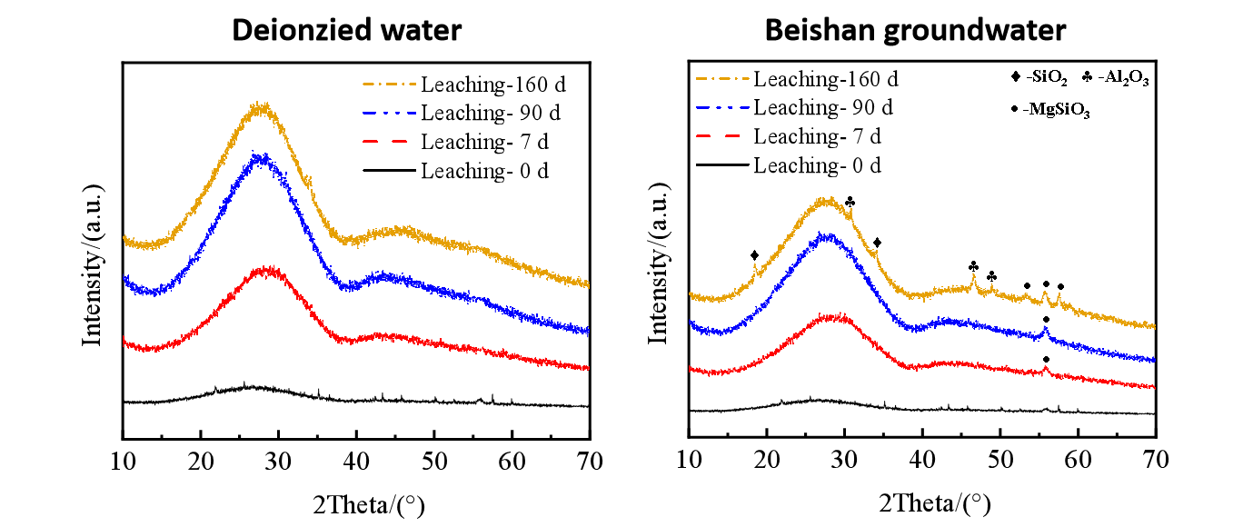
Fig S2. The XRD patterns from leached glasses under different immersion solutions. XRD patterns reveal that under deionized water soaking, the initial structure of the glass solidified body remains stable, with bridge oxygens (B-O-B/Si-O-Si) predominating in the network

