Supporting Information
Programmable and rapid responsive self-sensing soft actuator based on asymmetric poly (N-isopropylacrylamide)/alginate hydrogel with reversible network
Xingchen Cui,^{1,2} Xinyu Liu,⁵ Shuai Wang,⁶ Fuqiang Fan,² Shunsheng Ye,² Yu Fu,^{2,4} Bing Zhang,³* Tieqiang Wang,²* Xiaoqian Xu¹*
1. School of Intelligent Medicine, China Medical University, Shenyang, 110122, P. R. China
2. Department of Chemistry, College of Sciences, Northeastern University, Shenyang, 110819, P. R. China
3. College of Science, Shenyang University of Chemical Technology, Shenyang 110142, P. R. China
4. School of Chemical and Environmental Engineering, Sichuan University of Science and Engineering, Zigong 643000, P. R. China
5. Shengjing Hospital of China Medical University, Shenyang, 110004, P. R. China
6. The People’s Hospital of Liaoning Province, Shenyang, 110015, P. R. China
Corresponding Author
E-mail: zhangbing@syuct.edu.cn (B. Zhang); wangtieqiang@mail.neu.edu.cn (T. Wang); xqxu@cmu.edu.cn (X. Xu)

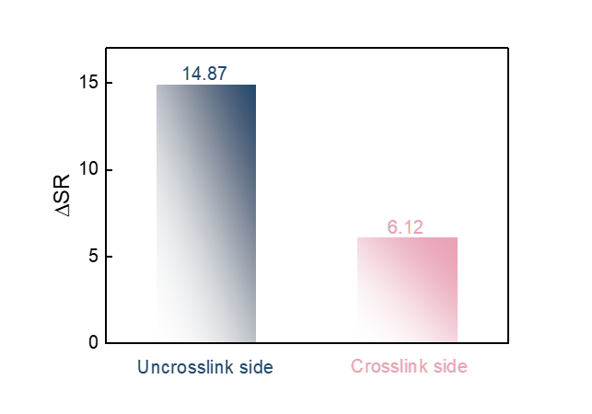
Fig. S1. ΔSR of different side of SA-Fe³⁺/SL-s-IPN hydrogel.

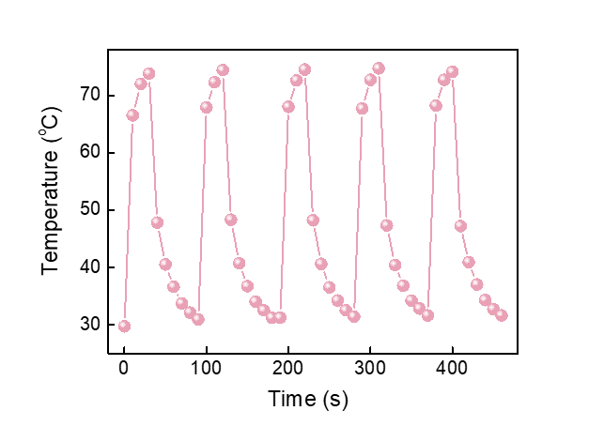
Fig. S2. NIR-induced temperature change of SA-Fe³⁺/SL-s-IPN hydrogel for 5 cycles.

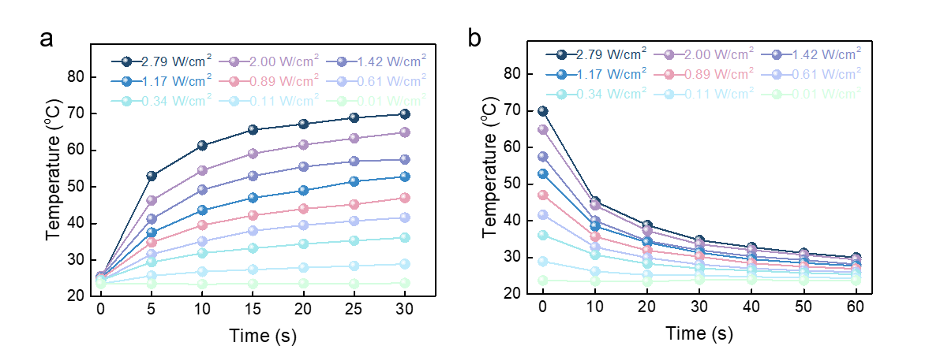
Fig. S3. Temperature of SA-Fe³⁺/SL-s-IPN hydrogel under NIR light with different intensities. (a) light on; (b) light off.

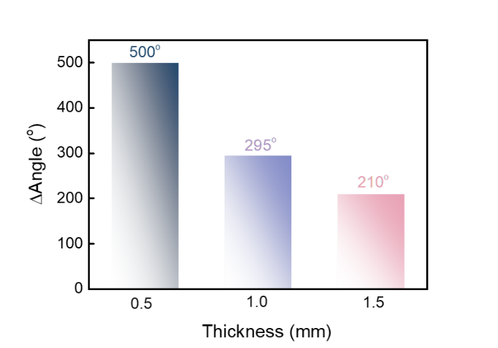
Fig. S4. Bending angle change of programmed SA-Fe³⁺/SL-s-IPN asymmetric hydrogel with different thicknesses.

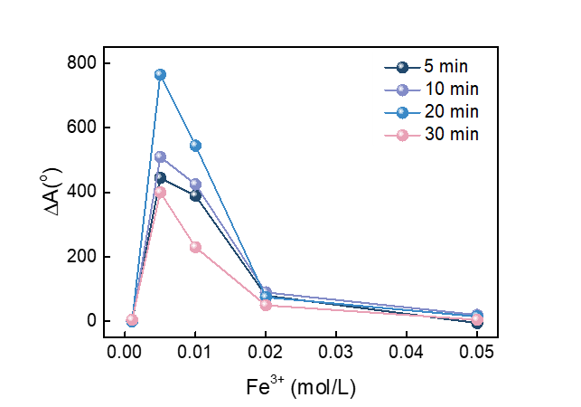
Fig. S5. Bending angle change of programmed SA-Fe³⁺/SL-s-IPN asymmetric hydrogel with different Fe³⁺ ion concentration and cross-linking time.

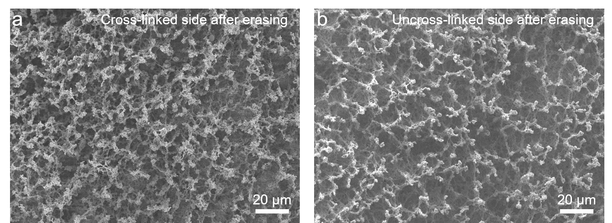
Fig. S6. SEM images of programmed SA-Fe³⁺/SL-s-IPN asymmetric hydrogel after erasing. (a) Cross-linked side; (b) Uncross-linked side.

Table S1 Concentration of Fe³⁺ for the fabrication of hydrogel
Sample | Group 1 | Group 2 | Group 3 | Group 4 | Group 5
Concentration  (mol/L) | 0.001 | 0.005 | 0.01 | 0.02 | 0.05

Table S2 Cross-linking time for the fabrication of hydrogel
Sample | Group 1 | Group 2 | Group 3 | Group 4
Time (min) | 5 | 10 | 20 | 30

