Supplementary Materials
This section is appended for review convenience and can be separated during journal submission.
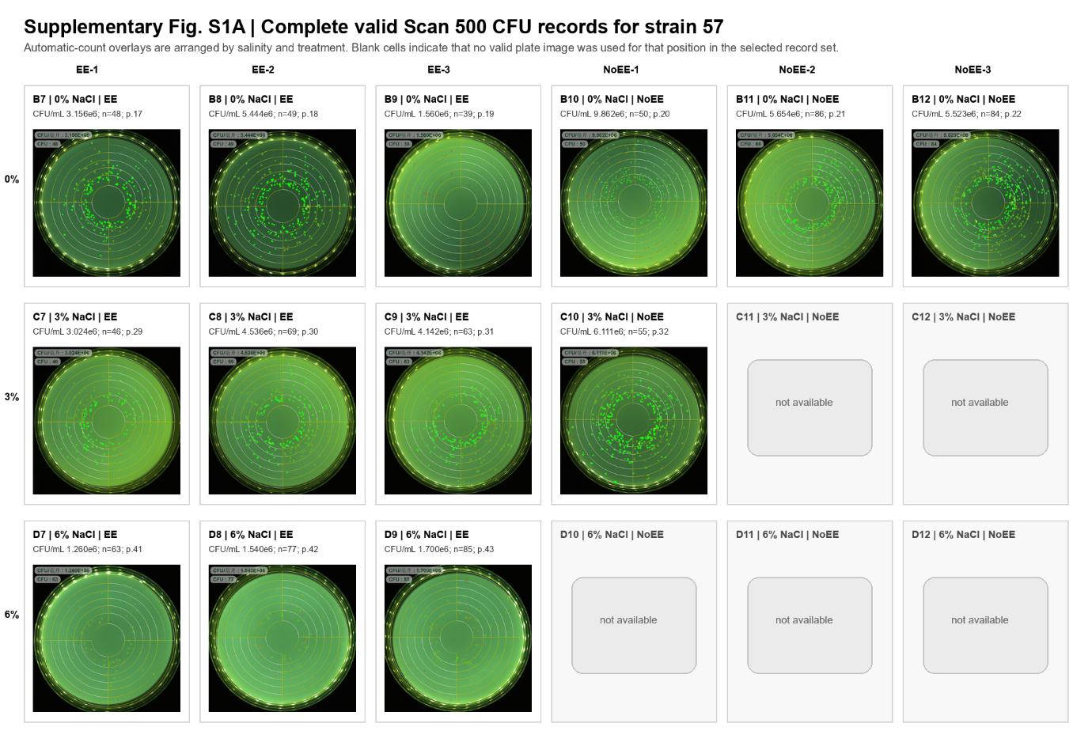
Supplementary Figure S1A. Complete valid Scan 500 automatic-count overlay images for strain 57 at 0%, 3%, and 6% NaCl. Panels are arranged by NaCl concentration and treatment group and show automatic colony detection with corresponding CFU/mL outputs.

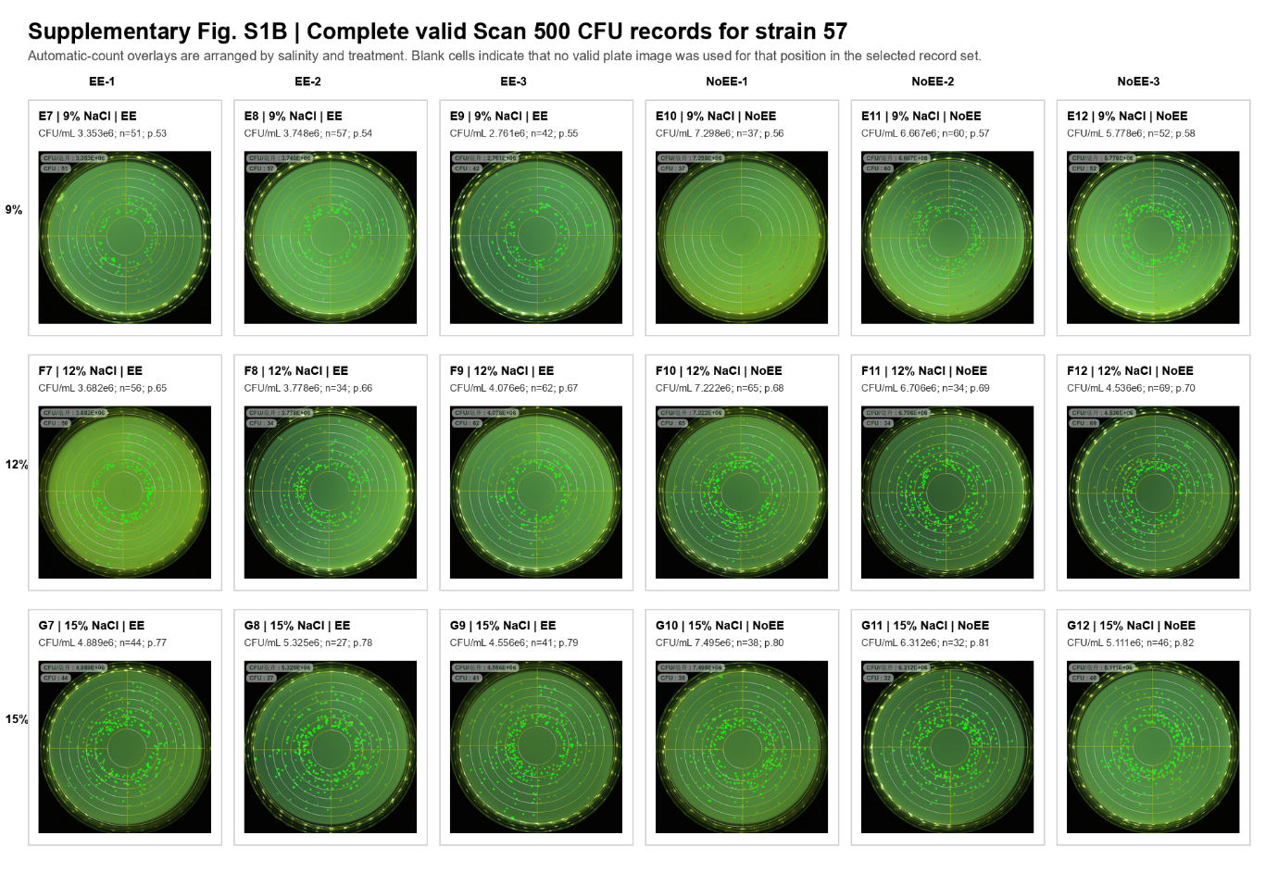
Supplementary Figure S1B. Complete valid Scan 500 automatic-count overlay images for strain 57 at 9%, 12%, and 15% NaCl. Panels are arranged by NaCl concentration and treatment group and show automatic colony detection with corresponding CFU/mL outputs.

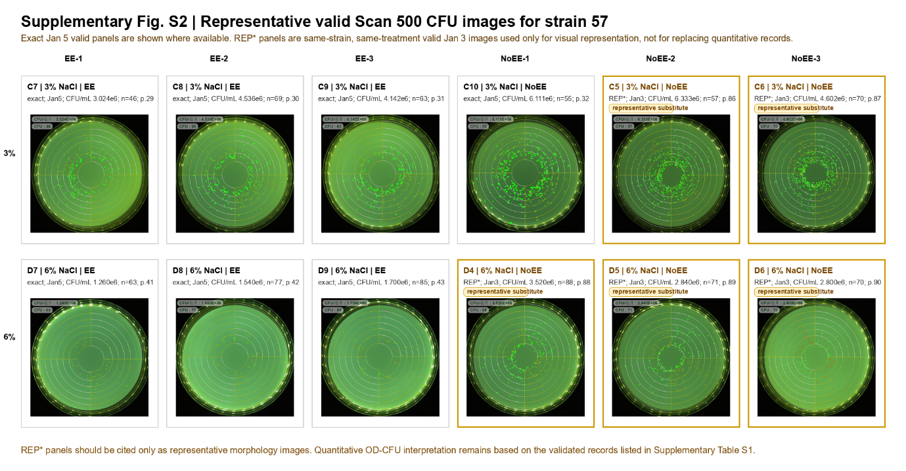
Supplementary Figure S2. Representative valid Scan 500 automatic-count images for strain 57 under 3% and 6% NaCl conditions. Quantitative OD-CFU interpretation is based on the validated records listed in Supplementary Table S1.

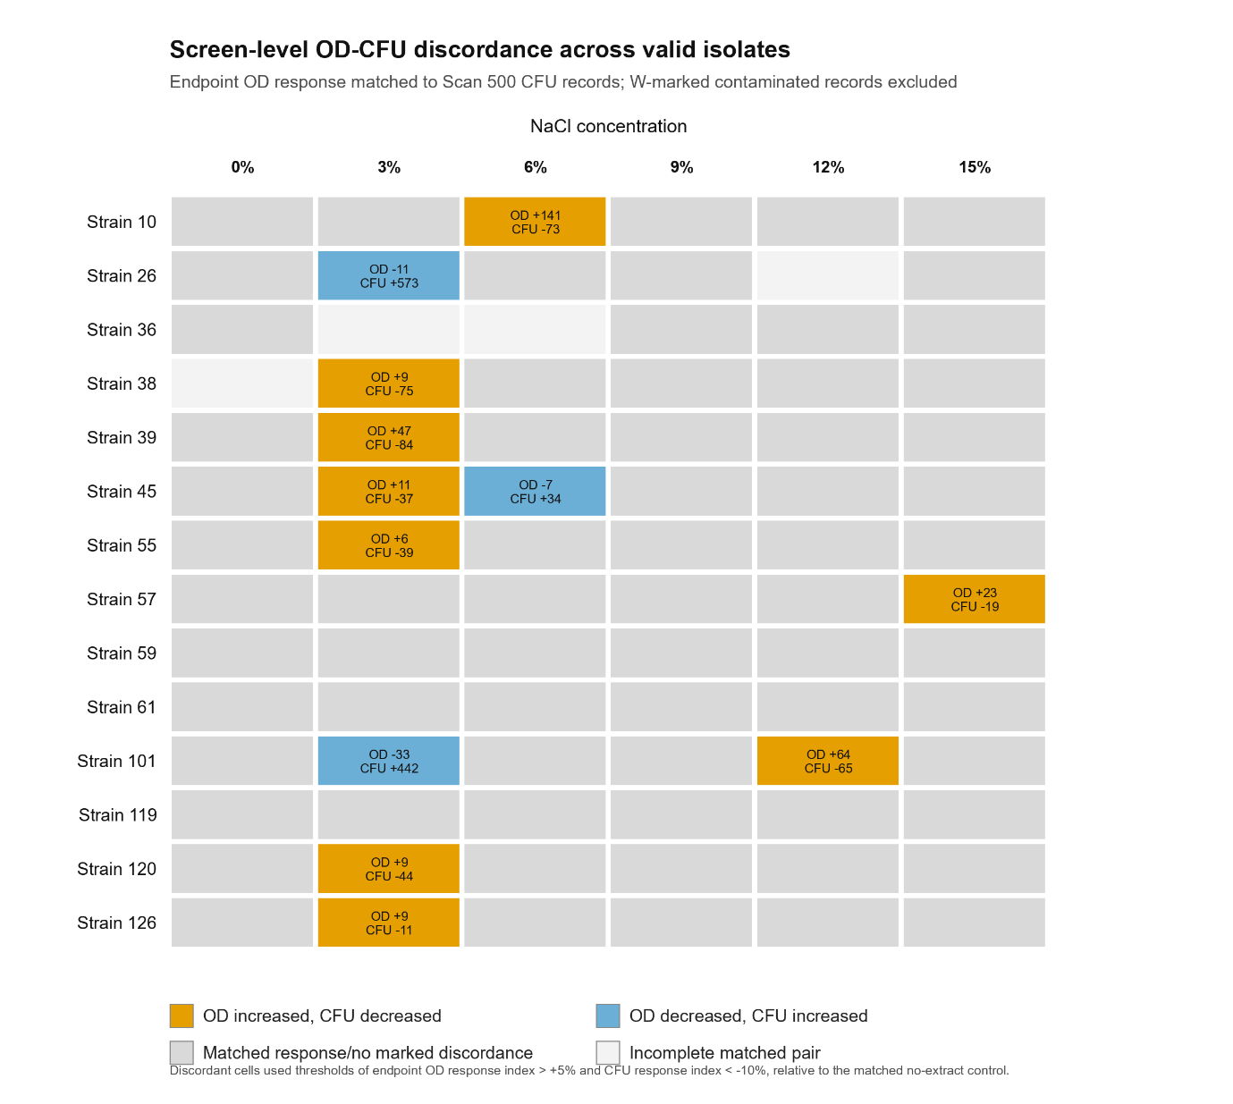
Supplementary Figure S3. Screen-level OD-CFU discordance across 14 valid isolates. Endpoint OD responses were paired with Scan 500 CFU records by strain, NaCl concentration, and treatment. Contaminated records marked with W were excluded. Orange cells indicate saline conditions in which earthworm extract increased endpoint OD by more than 5% and reduced CFU recovery by more than 10% relative to the matched no-extract control.

Supplementary Table S2. Saline-condition OD-positive/CFU-negative cases in the 14-isolate screen.
Strain | NaCl (%) | Endpoint OD WRI (%) | CFU WRI (%) | n OD EE | n OD NoEE | n CFU EE | n CFU NoEE
10 | 6 | 140.7 | -72.6 | 3 | 3 | 3 | 3
38 | 3 | 8.6 | -74.7 | 3 | 3 | 3 | 3
39 | 3 | 46.6 | -83.7 | 3 | 3 | 3 | 3
45 | 3 | 11.1 | -36.9 | 3 | 3 | 3 | 3
55 | 3 | 6.4 | -39.2 | 2 | 3 | 3 | 3
57 | 15 | 23.1 | -19.0 | 6 | 6 | 6 | 6
101 | 12 | 64.3 | -65.4 | 3 | 3 | 3 | 3
120 | 3 | 9.0 | -44.3 | 3 | 3 | 3 | 3
126 | 3 | 8.7 | -10.6 | 3 | 3 | 3 | 3

