Systematic evidence-mapping of climate change adaptation challenges in urban water systems
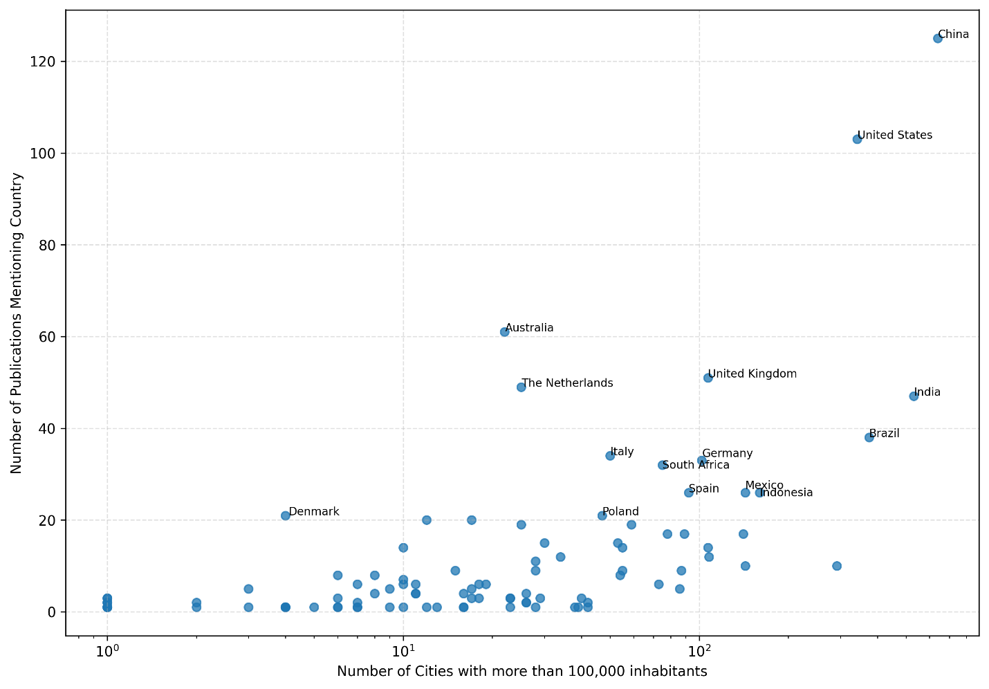
Fig. SX1. Frequency of number of cities with over 100k population per country mentioned in publication
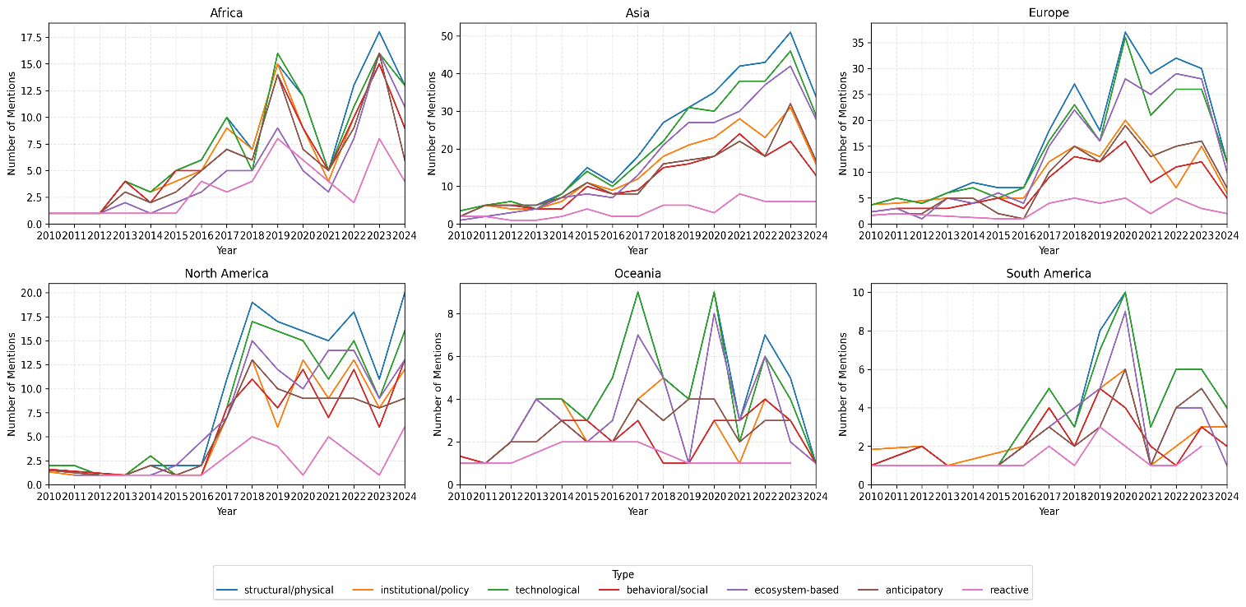
Fig. SX2. Temporal evolution of CCA measure categories mentioned in the scientific literature per continent
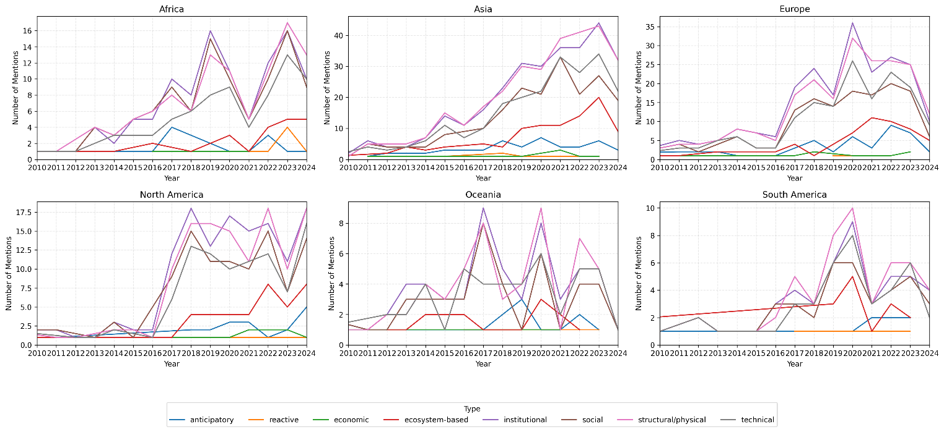
Fig. SX3. Temporal evolution of CCA measure categories mentioned in the scientific literature per continent

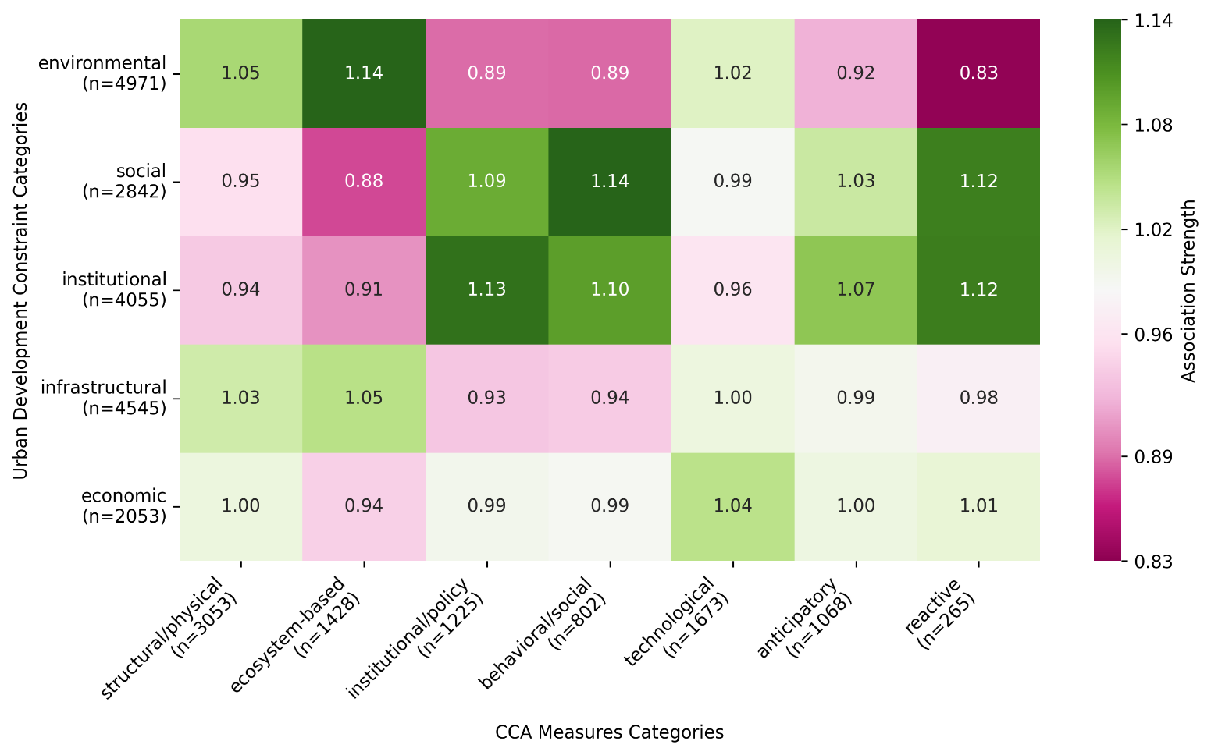
Fig. SX4. Heat map showing association strength between urban development constraint categories and CCA measure categories

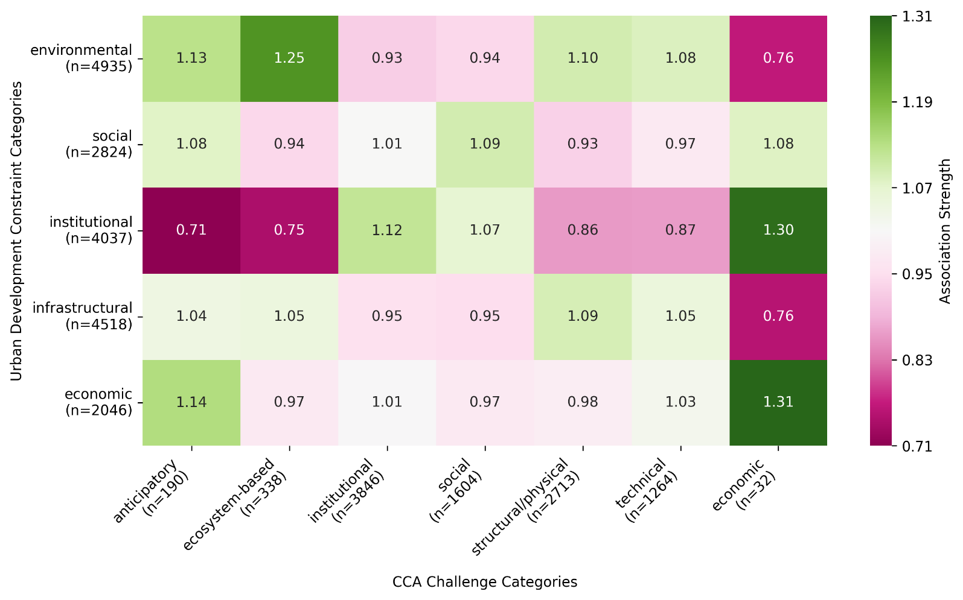
Fig. SX5. Heat map showing association strength between urban development constraints and CCA challenges

