Supplementary Information

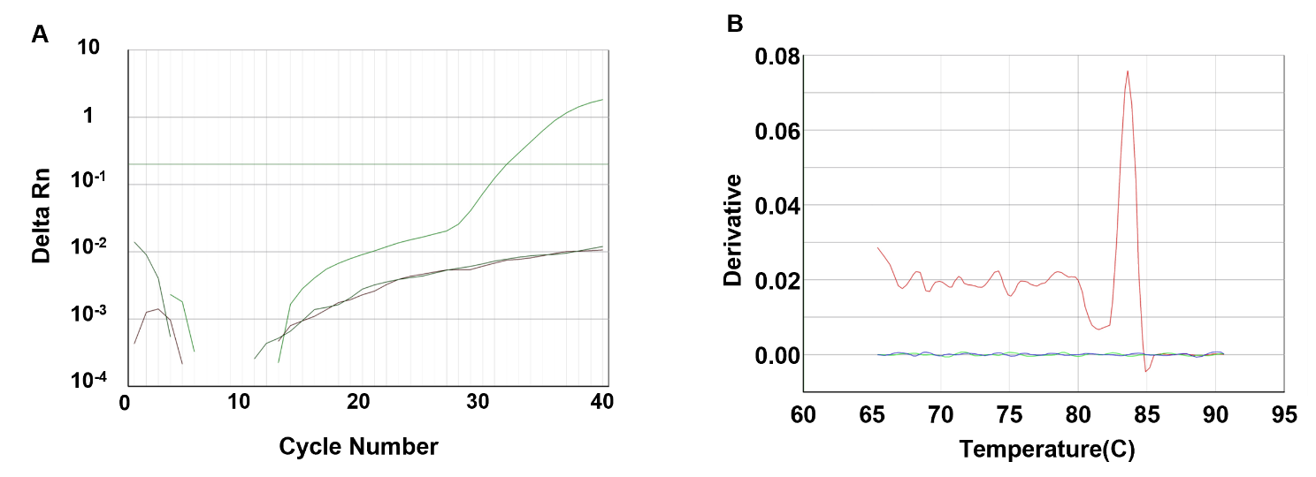

Supplementary Figure 1. Validation of qPCR detection of bdnf transcripts in medaka brain.
(A) Representative qPCR amplification curves showing fluorescence signal (ΔRn) plotted against cycle number. The curves exhibit clear exponential increases, indicating robust amplification of target transcripts.
(B) Melting curve analysis showing the derivative of fluorescence with respect to temperature (–dF/dT) plotted against temperature. A single sharp peak is observed, indicating specific amplification of a single PCR product without detectable nonspecific products or primer–dimer artifacts. No amplification was observed in no-template control reactions. Experimental procedures, including RNA extraction, qPCR conditions, and primer sequences, are described in the Methods section.
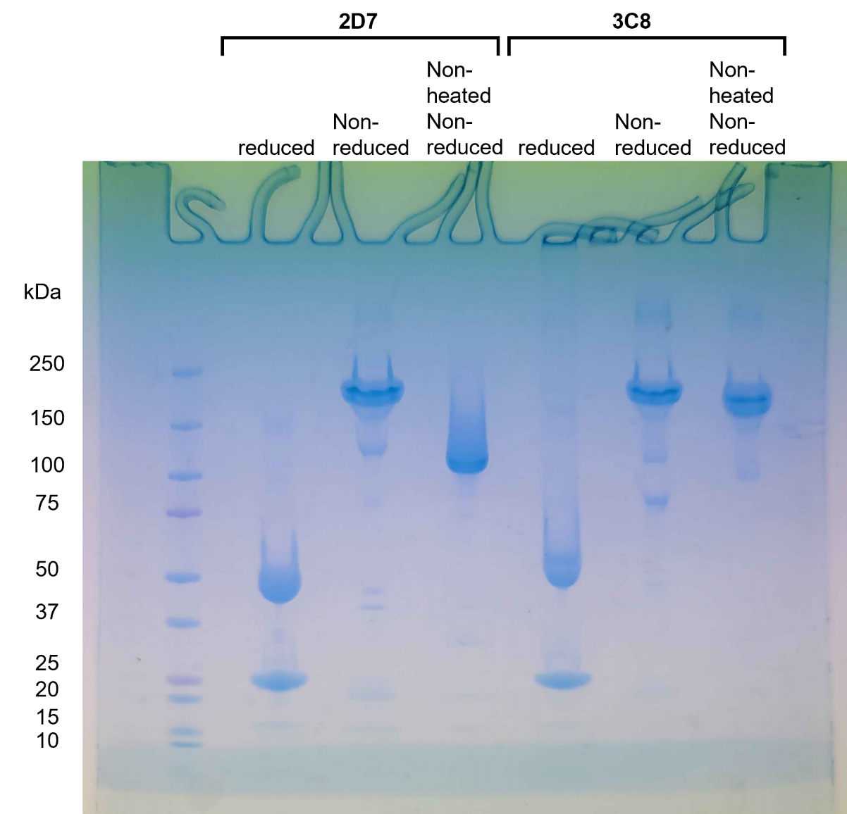

Supplementary Figure 2. Full-length blot corresponding to Fig. 1A.
The regions shown in the main figure are indicated. Additional lanes present on the original blot were not included in Fig. 1A because they were not relevant to the experiment shown.

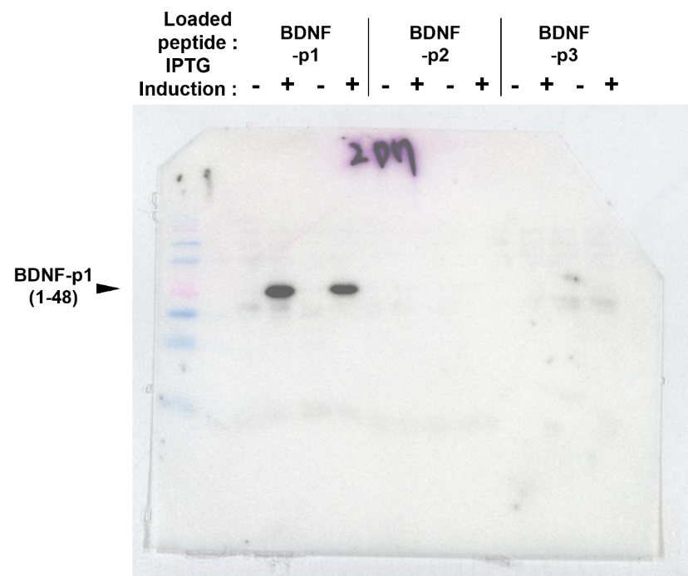

Supplementary Figure 3. Full-length gel/blot corresponding to the left panel of Fig. 2B.
The cropped region shown in Fig. 2B is indicated. Additional adjacent lanes were present on the same gel/blot but were not included in the main figure because they were not relevant to the experiment shown.

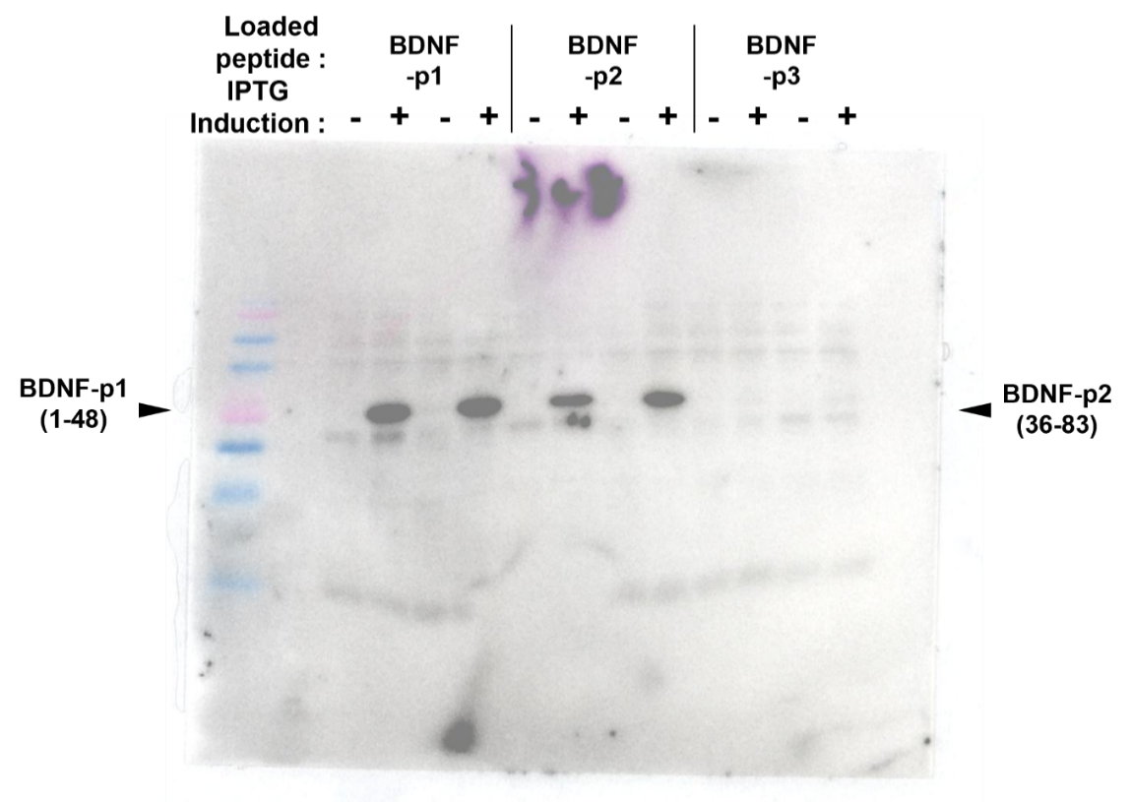

Supplementary Figure 4. Full-length gel/blot corresponding to the right panel of Fig. 2B.
The cropped region shown in Fig. 2B is indicated. Additional adjacent lanes were present on the same gel/blot but were not included in the main figure because they were not relevant to the experiment shown.

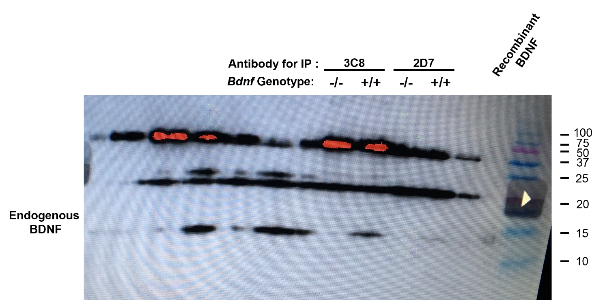

Supplementary Figure 5. Full-length blot corresponding to Fig. 2D.
The cropped regions shown in Fig. 2D are indicated. Additional adjacent lanes were present on the same blot but were not included in the main figure because they were not relevant to the experiment shown.

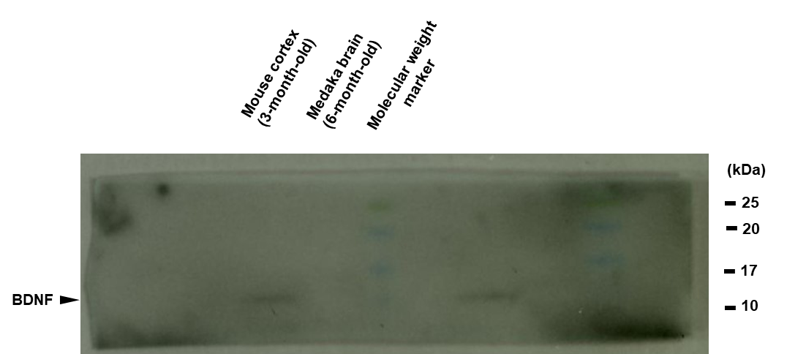

Supplementary Figure 6. Full-length blot corresponding to the BDNF blot in the upper panel of Fig. 4B.
The cropped region shown in Fig. 4B is indicated. Additional adjacent lanes were present on the same blot but were not included in the main figure because they were not relevant to the experiment shown.

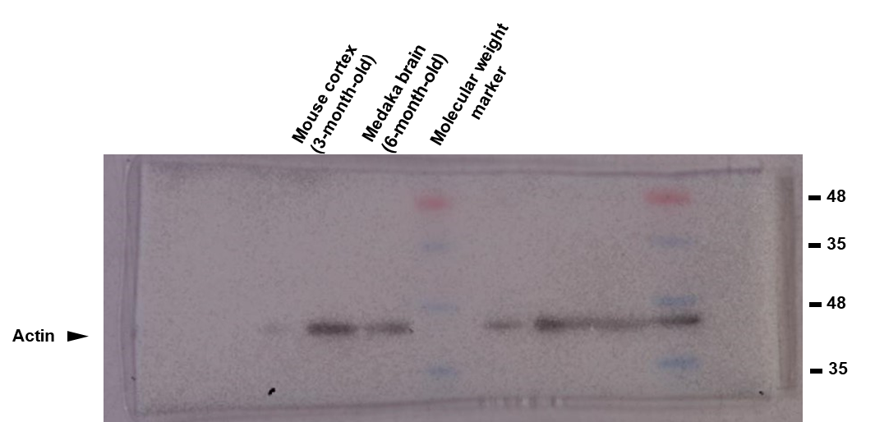

Supplementary Figure 7. Full-length blot corresponding to the β-actin blot in the lower panel of Fig. 4B.
The cropped region shown in Fig. 4B is indicated. The BDNF and actin signals were detected on different parts of the same membrane after membrane cutting. Additional adjacent lanes were present on the same blot but were not included in the main figure because they were not relevant to the experiment shown.

