Supplementary Note

Divergent effects of HLA-DQA1:p.Gln198Glu on Crohn's disease and ulcerative colitis disease trajectories

Supplementary Table 1 | Association of HLA-DQA1:p.Gln198Glu with Crohn’s disease behaviour and ulcerative colitis disease severity in individual datasets and meta-analysis.
 | Case/Control | OR | 95% CI | P_value | P_het
CD behaviour (B2/B3 v.s. B1), covariates: 4 PCs, sex, and disease location
IBDBR | 5,022/8,537 | 1.12 | 1.06-1.18 | 2.38x10⁻⁵ | NA
UKIBDGC - dataset 1 | 748/537 | 1.29 | 1.07-1.57 | 8.90x10⁻³ | NA
UKIBDGC - dataset 3 | 1,499/2,615 | 1.23 | 1.11-1.36 | 1.16x10⁻⁴ | NA
Meta-analysis | 7,269/11,689 | 1.15 | 1.10-1.20 | 2.41x10⁻⁹ | 1.39x10⁻¹
UC severity (severe v.s. mild), covariates: 4 PCs and sex
IBDBR | 7,604/3,475 | 0.84 | 0.79-0.89 | 2.64x10⁻⁸ | NA
UKIBDGC - dataset 2 | 282/347 | 0.50 | 0.37-0.67 | 5.44x10⁻⁶ | NA
UKIBDGC - dataset 3 | 443/570 | 0.76 | 0.61-0.94 | 1.17x10⁻² | NA
Meta-analysis | 8,329/4,392 | 0.81 | 0.77-0.86 | 8.98x10⁻¹² | 3.28x10⁻³
Meta-analysis (colectomy v.s. no colectomy) | 1,286/11,060 | 0.69 | 0.62-0.76 | 6.74x10⁻¹² | 1.33x10⁻¹

The UK IBDGC cohort was genotyped across three independent batches; each genotyping array batch was therefore analysed separately prior to meta-analysis.
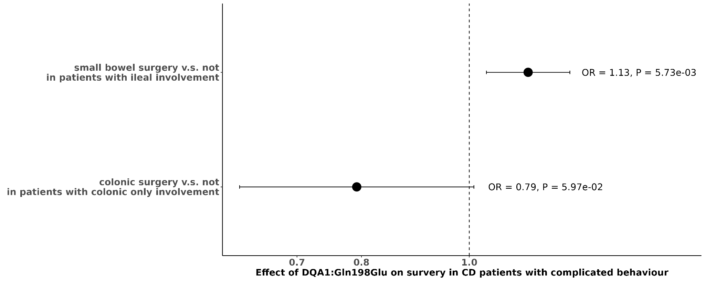
Supplementary Figure 1 | Association of DQA1:p.Gln198Glu with surgical requirement in CD patients with complicated behaviour (stricturing or penetrating). Small bowel surgery was assessed in patients with ileal involvement, whereas colonic surgery was assessed in patients with colonic-only disease.

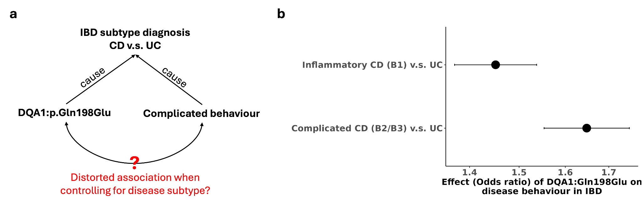
Supplementary Figure 2 | Effect of DQA1:p.Gln198Glu on disease behaviour in IBD. a, Causal diagram illustrating the potential collider bias introduced by the study design (selection bias) when evaluating separately the effect on CD and UC. b, Effect estimates for DQA1:p.Gln198Glu on disease behaviour across IBD from multinomial regression, with UC used as the reference group.

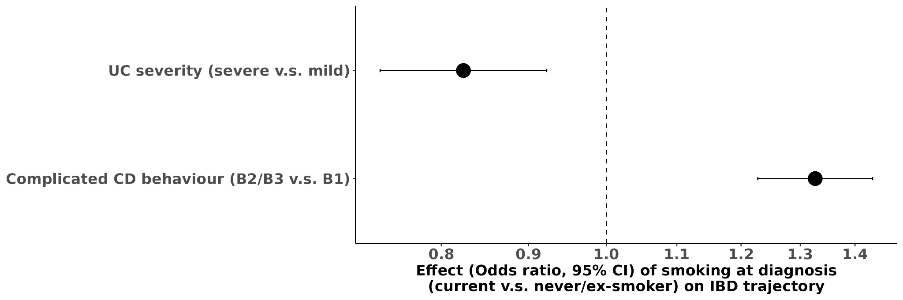
Supplementary Figure 3 | Effect of smoking at diagnosis on UC severity and complicated CD behaviour.

