Supplementary materials

Supplementary Figure S1. Ablation Experiment

To verify the necessity of each key component, we conducted ablation experiments on the HUP full queue (n=54) and compared three configurations: (A) using only MAE reconstruction loss, with reconstruction error as the anomaly score; (B) Using MAE+subject comparison loss and reconstruction error as anomaly score; (C) Using MAE+subject comparison loss and Mahalanobis distance as anomaly score (method proposed in this paper).

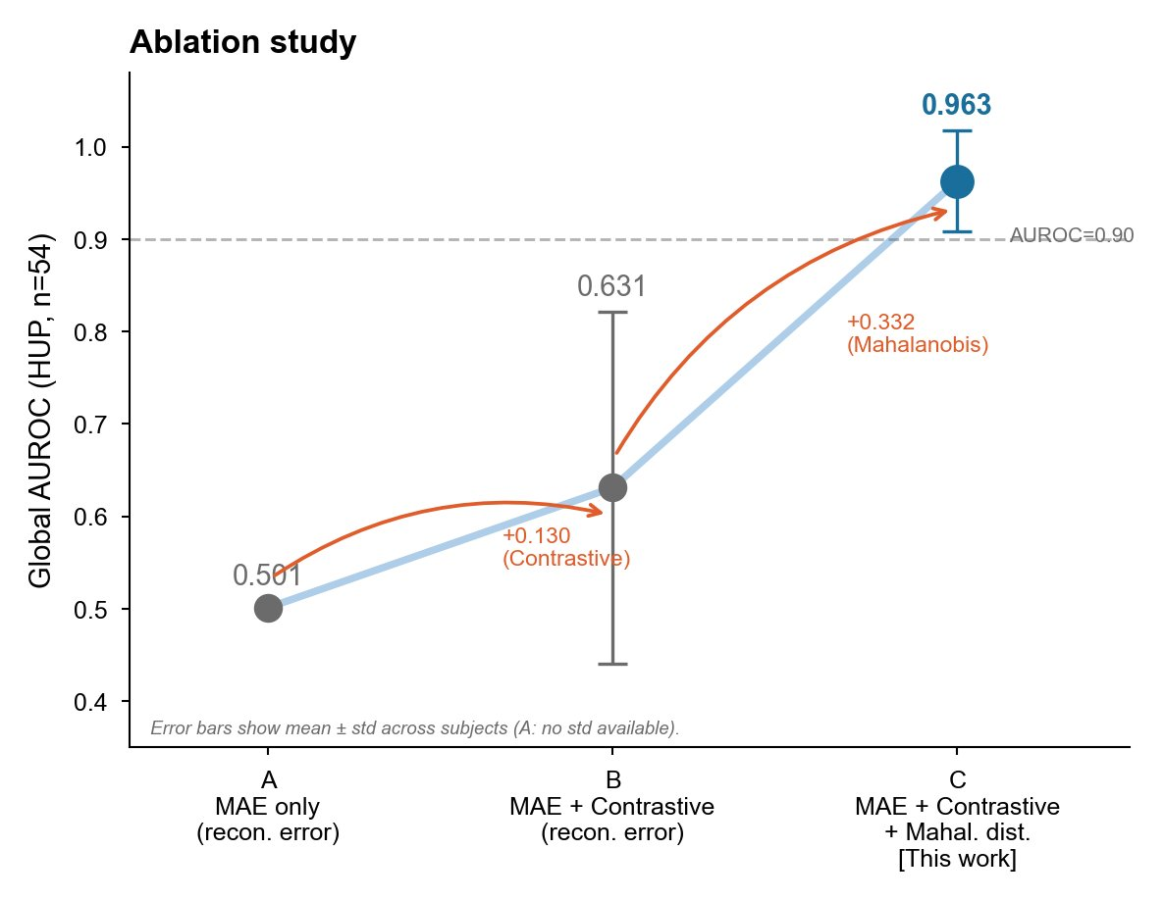

Supplementary Figure S1. Ablation Experiment. Three configurations of global AUROC on the HUP dataset (n=54). A=MAE only+reconstruction error (0.501); B=MAE+Contrastive+reconstruction error (0.631 ± 0.190); C=MAE+Contrastive+Mahalanobis distance (0.963 ± 0.055, in this article). The error bar is the mean ± standard deviation (A has no standard deviation, as the results for each subject were not saved in early experiments). The orange curved arrows indicate the improvement of each step:+0.130 (compared learning contribution) and+0.332 (Mahalanobis distance contribution).

The ablation results clearly revealed the independent contributions of two key components: (1) the subject contrastive loss increased the global AUROC from 0.501 to 0.631 (+0.130), indicating that contrastive learning improved the discriminability of the feature space; (2) Using Mahalanobis distance instead of reconstruction error as the anomaly score further increases the AUROC from 0.631 to 0.963 (+0.332), which is the main driving factor for performance improvement. This indicates that individualized multivariate statistical modeling is far superior to univariate reconstruction error threshold methods.

Supplementary Figure S2. Representative Attack Detection Sequence Diagram

To visually demonstrate the working mechanism of the method, Figure S2 shows the Mahalanobis distance anomaly time series curves of three representative subjects (HUP106, HUP094, HUP114) in the seizure detection scenario.

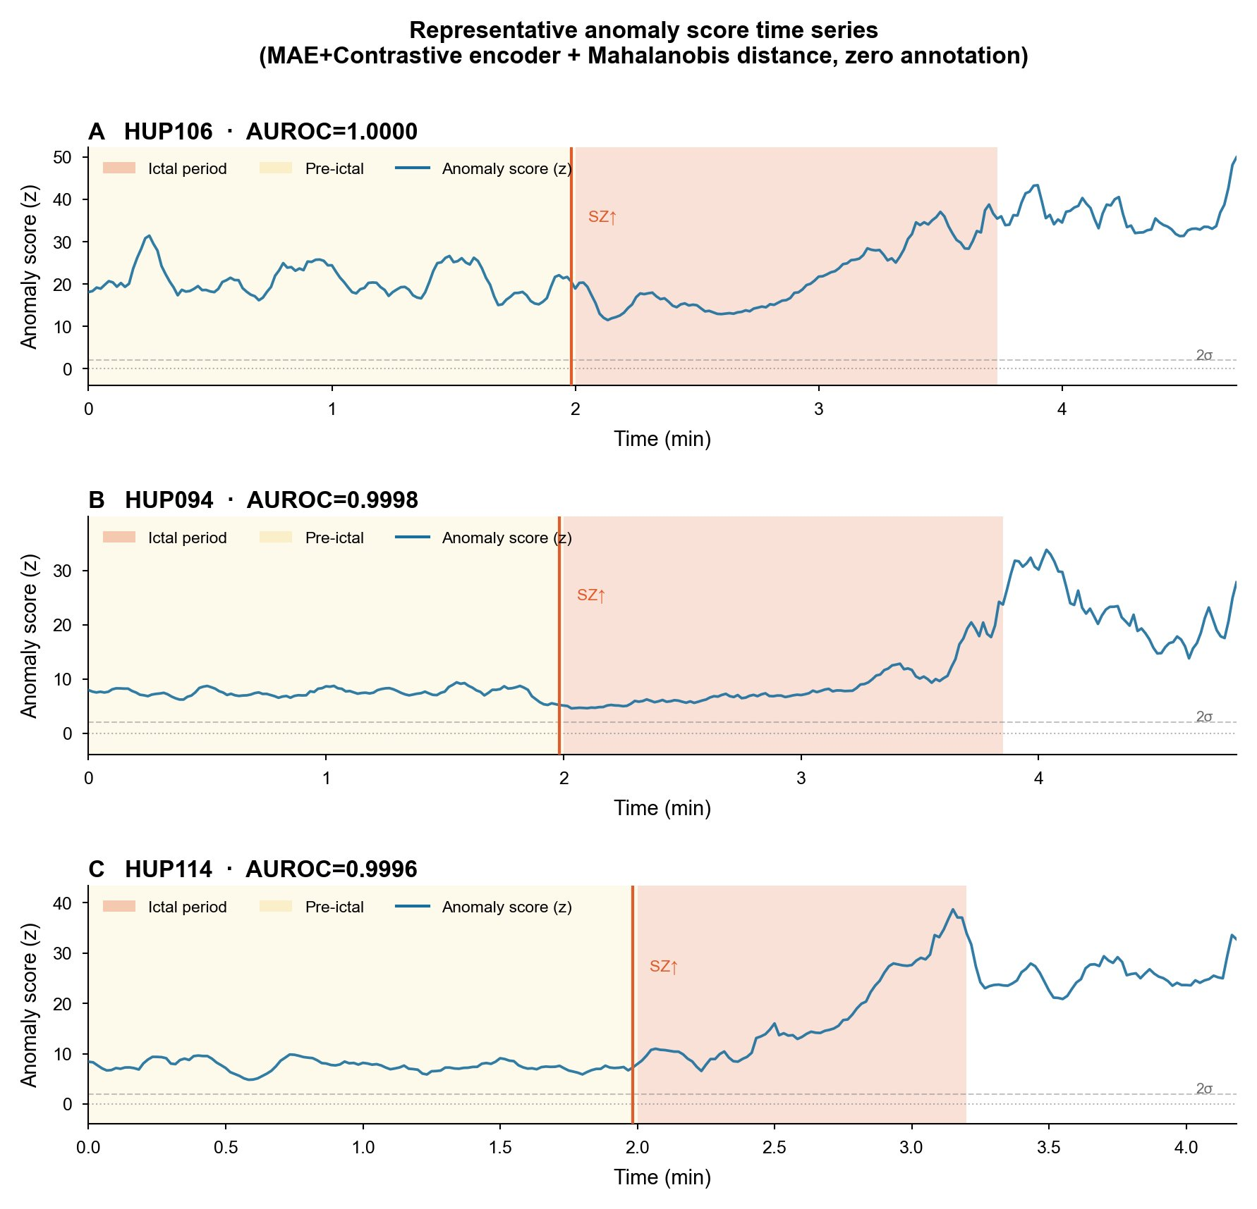

Supplementary Figure S2. Representative seizure detection timing diagram (HUP106, HUP094, HUP114). The horizontal axis represents time (minutes), and the vertical axis represents Mahalanobis distance anomaly score (z-score, relative to the subject's baseline interval). The orange background represents the seizure period area, the yellow background represents the pre seizure area (marked by events. tsv), the orange vertical line and "SZ ↑" mark the onset time, and the gray dashed line marks the 0 and 2 σ reference lines. The individual AUROC of the three subjects were 1.000, 0.9998, and 0.9996, respectively.

From the figure, a typical detection pattern can be seen: abnormal scores during the interval between attacks fluctuate steadily at a low level close to 0; At the onset of the attack (marked with SZ ↑), the score rapidly increases and remains at a high level (during the attack period), and then gradually decreases after the end of the attack. In HUP106 and HUP114, there is a warning upward trend (pre ictal increase) in the pre attack period, which is consistent with the statistical result of AUROC 0.845 in the pre attack period.

Supplementary Figure S3. SWEC-ETHZ Failure Case Analysis

Mechanism analysis was conducted on 7 SWEC-ETHZ subjects with AUROC below 0.80 to explore the influencing factors of performance decline.

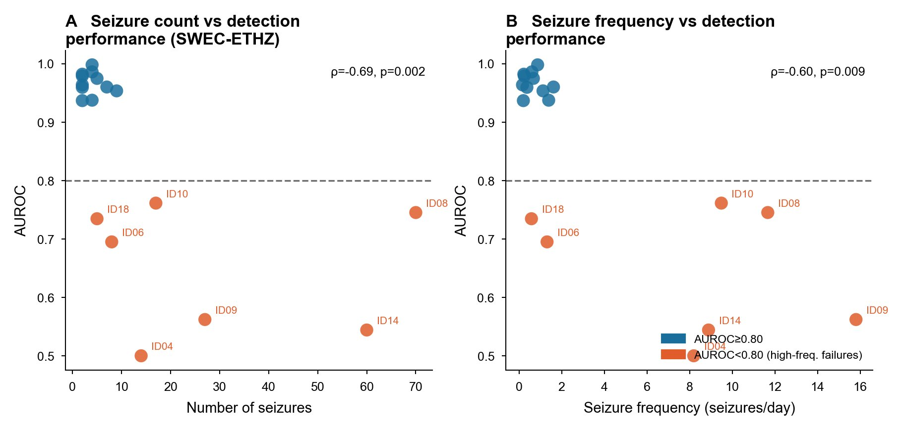

Supplementary Figure S3. Analysis of SWEC-ETHZ External Verification Failure Cases. A, The relationship between the total number of seizures and AUROC (Spearman ρ=-0.69, p=0.002); B, The relationship between seizure frequency (times/day) and AUROC (Spearman ρ=-0.60, p=0.009). The blue dots represent subjects with AUROC ≥ 0.80, and the orange dots represent subjects with AUROC<0.80. Failure cases are labeled with IDs. The gray dashed line represents the reference line for AUROC=0.80.

Analysis shows that a high frequency of attacks (up to 70 times, ID08) and a high frequency of attacks (up to about 16 times/day, ID09) are significantly associated with a decrease in AUROC. Mechanism speculation: A large number of subclinical episodes or discharges during the interictal period were mixed in the data of patients with high-frequency attacks, resulting in contamination of the Mahalanobis distance reference distribution estimated from interictal data, thereby reducing the distinguishability between episodes and intervals. Note that ID08 (70 episodes but AUROC=0.745) and ID09 (27 episodes but AUROC=0.562) both belong to this type of high-frequency failure case. This limitation suggests the need to develop more robust reference distribution estimation methods for patients with high-frequency attacks.

