Supplementary information

Supplementary figures
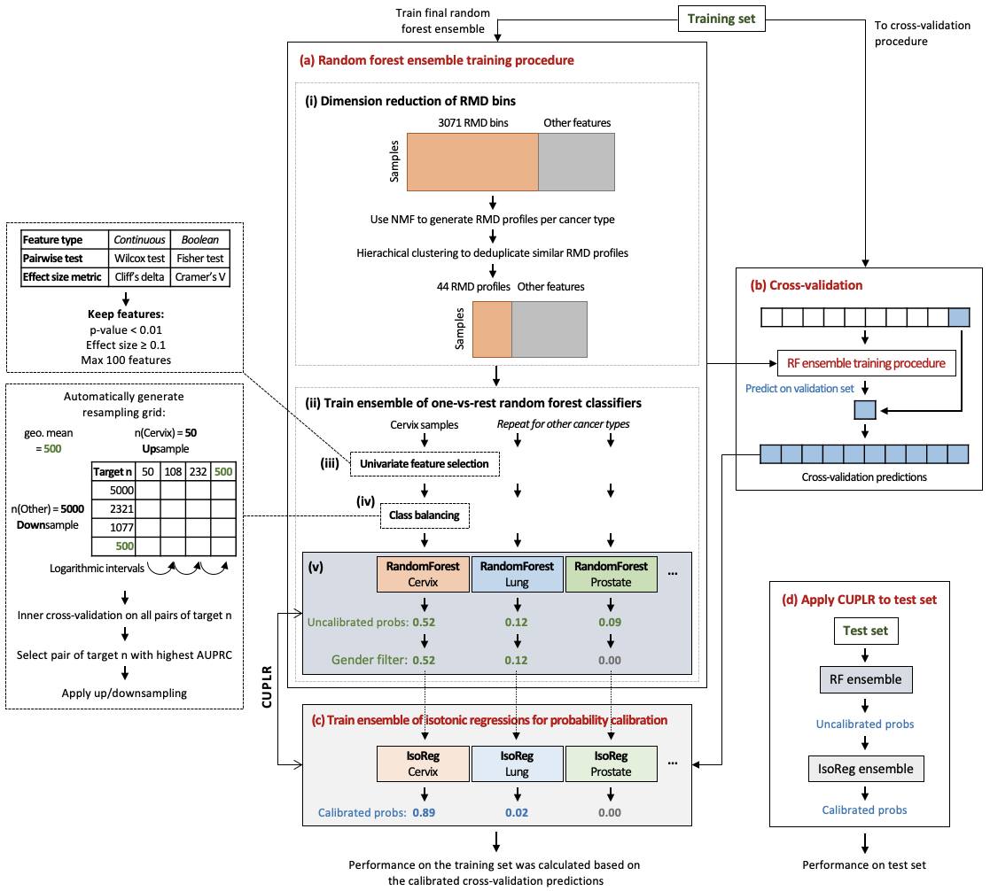
Supplementary figure 1: CUPLR training procedure. (a) An ensemble of binary random forest classifiers was trained each to discriminate one cancer type versus other cancer types. (i) Dimension reduction via non-negative matrix factorization (NMF) was performed on the 3071 RMD bins independently for each cancer type to ultimately produce 44 cancer type specific RMD profiles (see Supplementary figure 2 for a detailed schematic), prior to random forest training as shown in (ii). (iii) Univariate feature selection was performed to remove irrelevant features. (iv) Class resampling was performed to alleviate imbalances in the number of samples for each cancer type. (v) The random forests are trained. Breast, ovary and cervix probabilities from the random forest are set to 0 for male samples, and prostate probabilities are set to 0 for female samples. (b) The whole training procedure in (a) was subjected to 15-fold cross-validation to obtain cancer type probabilities for the training samples. (c) These probabilities were then used to train the isotonic regressions for probability calibration. The calibrated probabilities were also used to calculate cross-validation performance. (d) Performance was also determined by applying CUPLR to a held out test set.
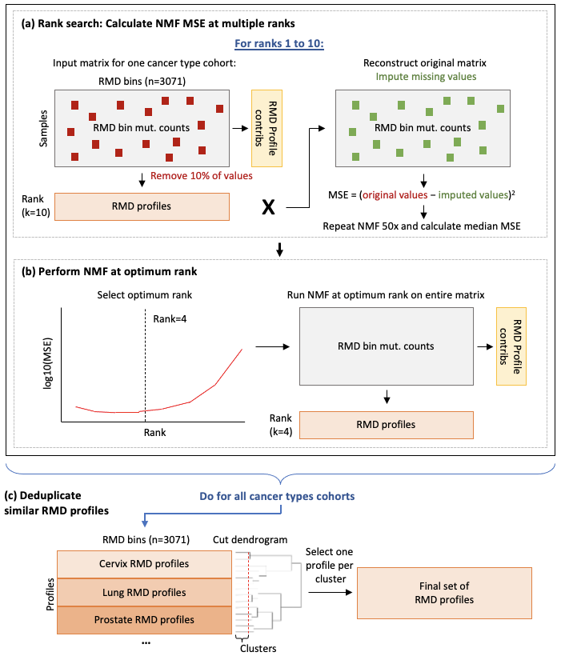
Supplementary figure 2: Extraction of regional mutational density (RMD) profiles. (a) Non-negative matrix factorization (NMF) was performed for several ranks to determine the optimum rank. For each rank, 10% of values were removed from the input matrix, NMF was performed, the original matrix was reconstructed, the missing values were imputed, and mean squared error between the original missing values and the imputed values. This was repeated 50 times and median MSE was calculated. (b) The optimum rank was the one at which the log10(MSE) value began to increase rapidly. NMF was performed on the entire input matrix (i.e. without removing values) to yield the RMD profiles for one cancer type cohort. (c) The procedures in (a) and (b) were performed for all cancer types to yield RMD profiles for all cancer types. Hierarchical clustering was performed to group profiles that were similar. One profile was selected per cluster to yield the final set of RMD profiles.
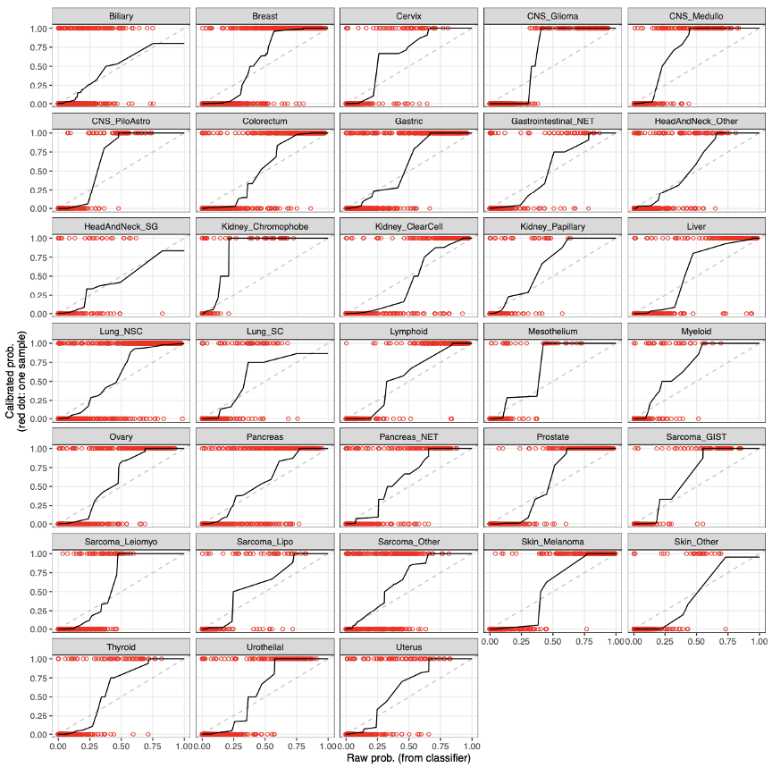
Supplementary figure 3: Isotonic regression calibration curves for each random forest in CUPLR. Red dots at y=1 are samples that were predicted by the respective cancer type random forest as that cancer type, whereas dots at y=0 are samples that were predicted as not being that cancer type. Cancer type predictions were obtained by cross-validation.
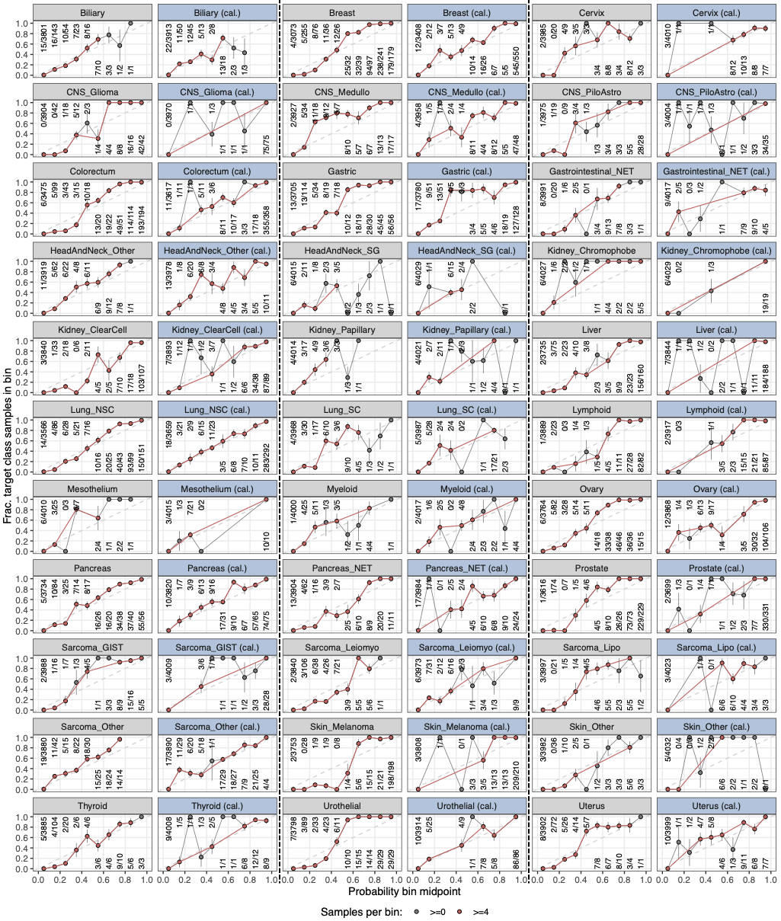
Supplementary figure 4: Reliability curves showing the probability biases before and after calibration. Grey panels show the curves before calibration and the blue panels show the curves after calibration. Each dot represents the fraction of samples of the target cancer type in a particular probability bin (a bin at e.g. 0.05 would represent probabilities between 0 and 0.1). Dots above the diagonal are probabilities where the random forest is overconfident whereas dots below the diagonal are probabilities where it is underconfident. A properly calibrated classifier has a reliability curve close to the diagonal. Two curves are shown in each panel, one filtered such that each bin has sufficient (≥4) samples for plotting a stable curve, and one where each bin has ≥0 samples representing the raw reliability curve.
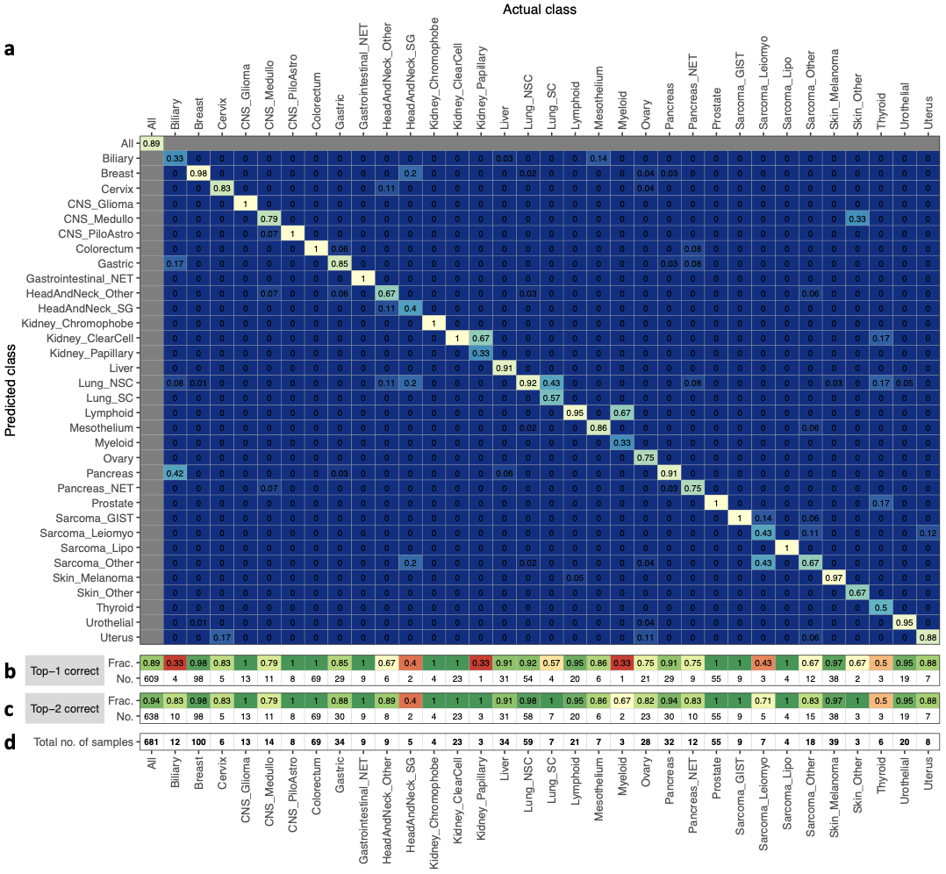
Supplementary figure 5: Accuracy of CUPLR based on predictions on the holdout set. (a) A heatmap showing the accuracy of CUPLR where columns represent the fraction of samples in a cancer type cohort predicted as a particular cancer type. The diagonal represents the fraction of samples correctly predicted as a particular cancer type (i.e. accuracy). (b) The fraction and number of correctly classified samples, equivalent to the diagonal in (a). (c) The fraction and number of correctly classified samples when considering the 2 highest probability cancer types. (d) The total number of samples for each cancer type. Abbreviations; CNS: central nervous system; CNS_Medullo: medulloblastoma; CNS_PiloAstro: pilocytic astrocytoma; Gastrointestinal_NET: gastrointestinal neuroendocrine tumor; HeadAndNeck_SG: salivary gland cancer; HeadAndNeck_Other: head and neck cancers other than salivary gland cancer; Lung_NSC: non-small cell lung cancer; Lung_SC: small cell lung cancer; Pancreas_NET: pancreatic neuroendocrine tumor; Sarcoma_GIST: gastrointestinal stromal tumor; Sarcoma_Leiomyo: leiomyosarcoma; Sarcoma_Lipo: liposarcoma; Sarcoma_Other: sarcomas other than leiomyosarcoma, liposarcoma or gastrointestinal stromal tumors; Skin_Other: non-melanoma skin cancer.
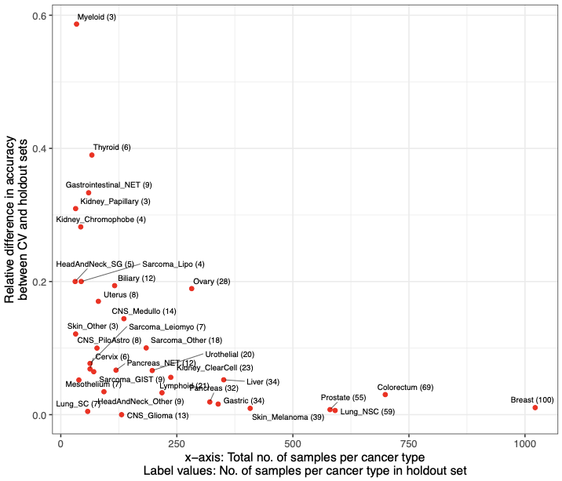
Supplementary figure 6: Relative difference in accuracy of CUPLR between the cross-validation (CV) predictions and predictions on the holdout set. The relative difference ranges between 0 and 1 and was calculated using the formula: |a - b| / max(a, b); where a = CV accuracy and b = holdout accuracy. Small cancer type cohorts show higher variation between CV and holdout accuracy.
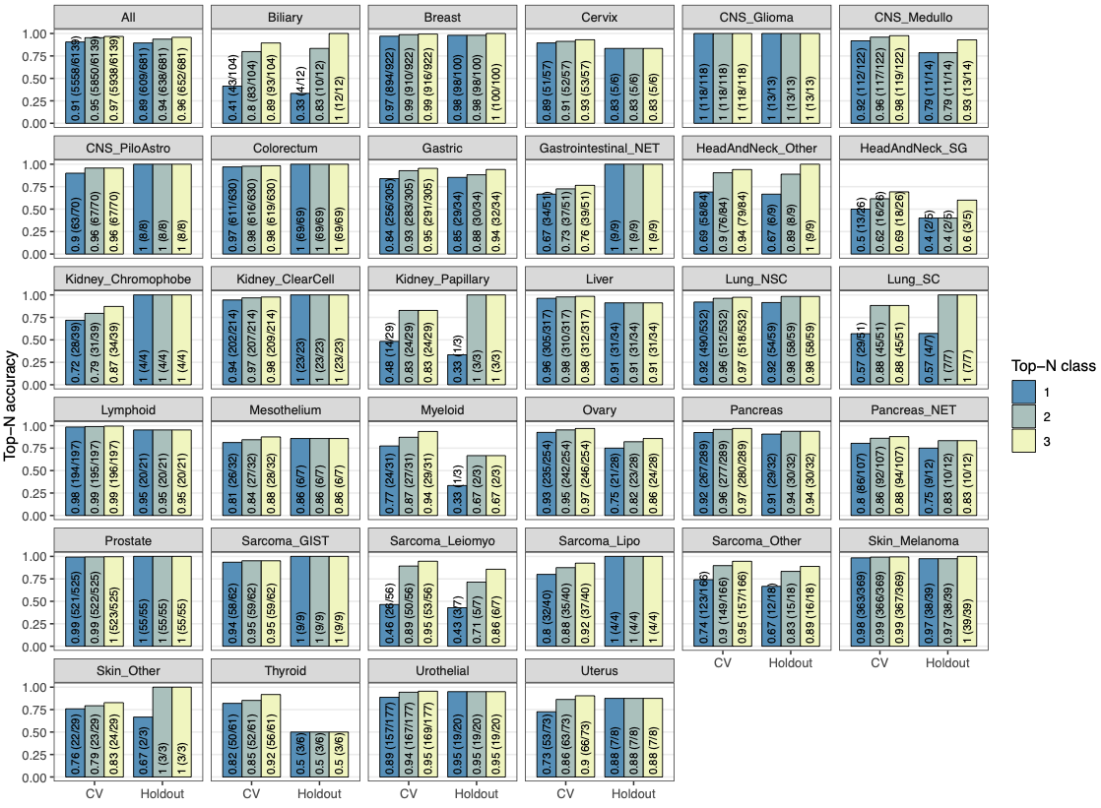
Supplementary figure 7: Top-N accuracy of CUPLR based on cross-validation and holdout predictions. Top-3 accuracy would for example represent the fraction of samples for which the correct cancer type is amongst the top 3 predicted cancer types. Bars are labelled with the top-N accuracy value, as well as in brackets the number of correctly predicted samples and the total number of samples.
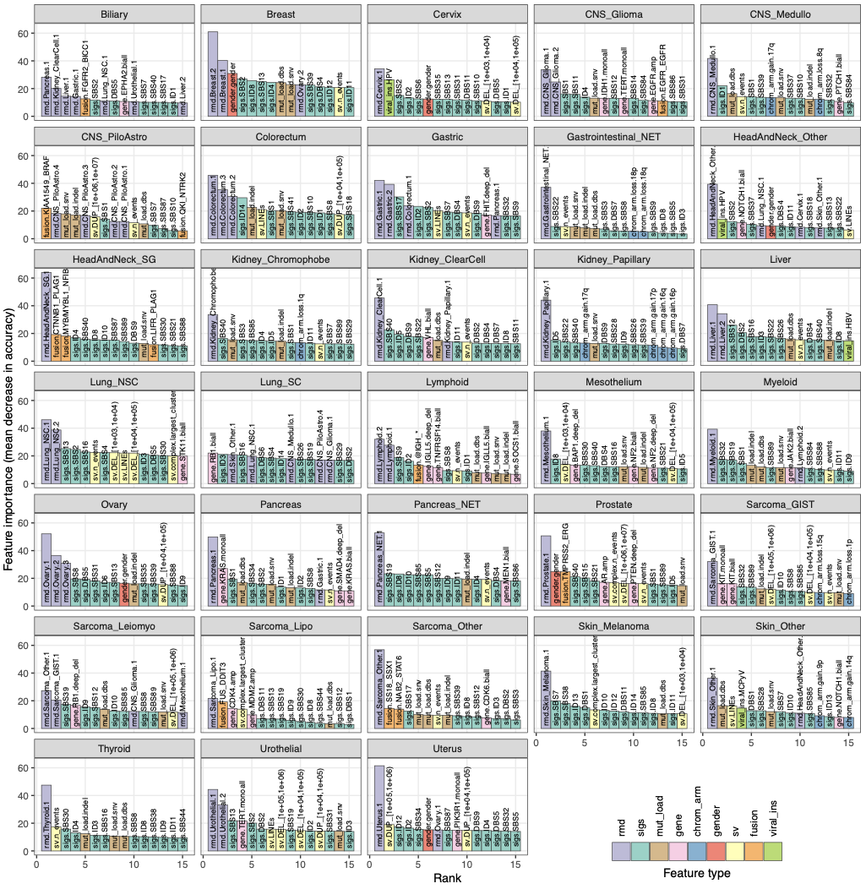
Supplementary figure 8: Importance of the top 15 features for each random forest within CUPLR. Feature importance is measured by mean decrease in accuracy across all trees in a random forest upon removing a particular feature. Feature names are in the form {feature type}.{feature name}. Feature type definitions; sigs: mutational signatures; rmd: regional mutation density profiles; mut_load: total number of single base substitutions, double base substitutions or indels, sv: structural variants; gene: presence of gene gain or loss of function events; chrom_arm: chromosome arm copy number difference compared to overall genome ploidy; fusion: presence of gene fusions; gender: sample gender as determined by copy number data; viral_ins: presence of viral sequence insertions. For a full description of each feature, see Supplementary data 3.
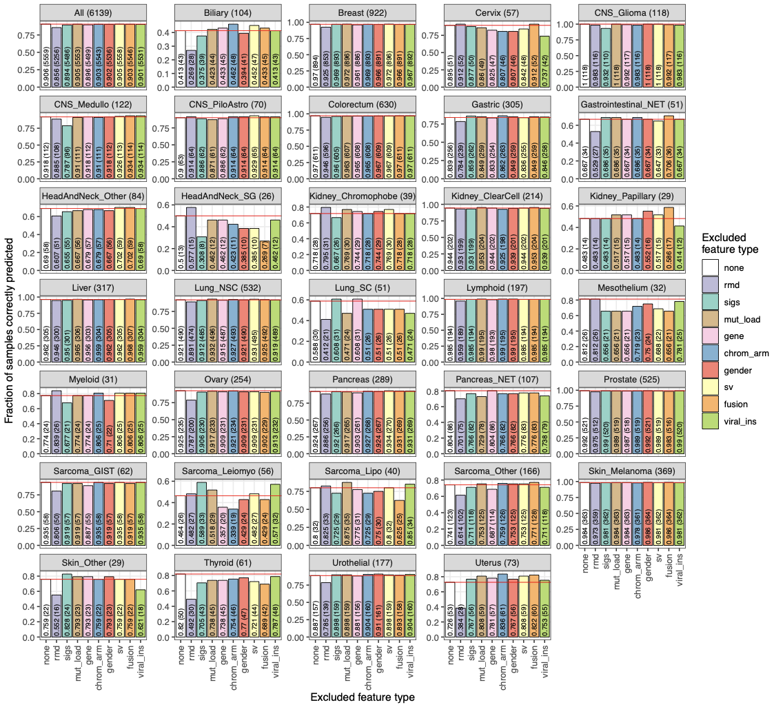
Supplementary figure 9: Cancer type prediction accuracy when excluding feature types from the training data. Accuracy (i.e. fraction of sample correctly predicted) was determined using cross validation. Panel titles indicate the cancer type and the total number of samples for that cancer type. Bars are labelled with the accuracy as well as the number of correctly predicted samples. The red line shows the accuracy when no feature types are excluded. Feature type definitions; sigs: mutational signatures; rmd: regional mutation density profiles; mut_load: total number of single base substitutions, double base substitutions or indels, sv: structural variants; gene: presence of gene gain or loss of function events; chrom_arm: chromosome arm copy number difference compared to overall genome ploidy; fusion: presence of gene fusions; gender: sample gender as determined by copy number data; viral_ins: presence of viral sequence insertions. For a full description of each feature, see Supplementary data 3.
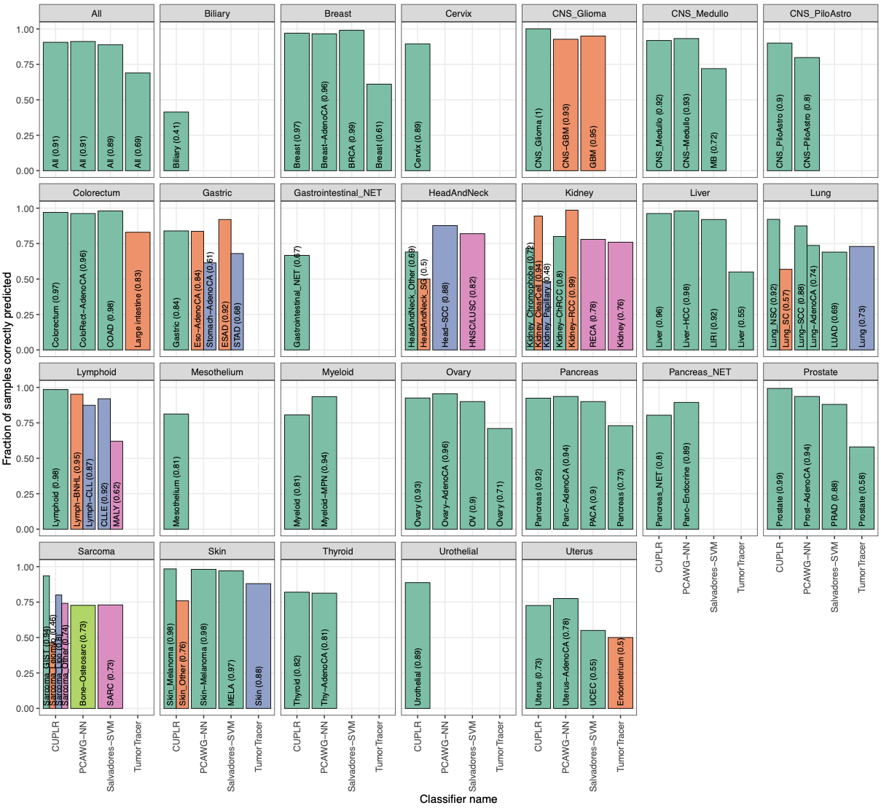
Supplementary figure 10: Comparison of cancer type prediction accuracy of CUPLR to other published classifiers. Accuracy (i.e. fraction of sample correctly predicted) for CUPLR was determined using cross validation. Bars are labeled with the cancer type class names from the respective classifiers as well as the accuracy value. Cancer type class names representing the same cancer type across different classifiers are represented by the same bar colors. The names of the published classifiers refer to the following studies; PCAWG-NN: PCAWG neural network by Jiao et al. 2020, Salvadores-SVM: support vector machine by Salvadores et al. 2019, TumorTracer: Marquard et al. 2015.
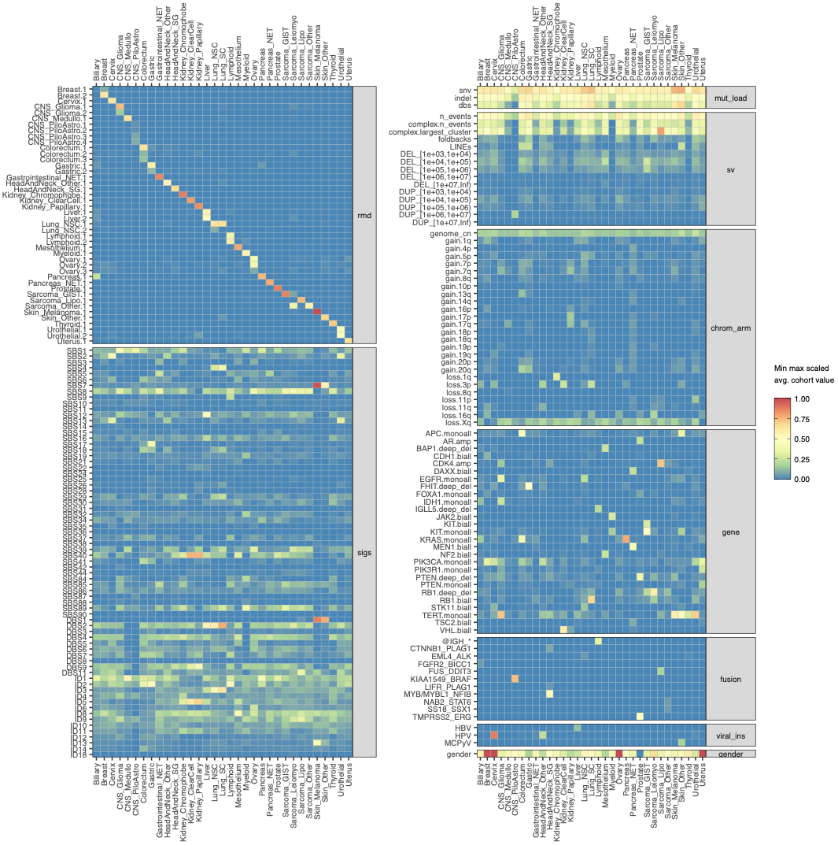
Supplementary figure 11: Average scaled feature value per cancer type for the top 200 features (of 496 in total). Feature values are scaled from 0 to 1 based on the minimum and maximum value for each feature across all samples. For gender, feature values towards 1 represent more female samples and values towards 0 more male samples. Feature type definitions; sigs: mutational signatures; rmd: regional mutation density profiles; mut_load: total number of single base substitutions, double base substitutions or indels, sv: structural variants; gene: presence of gene gain or loss of function events; chrom_arm: chromosome arm copy number difference compared to overall genome ploidy; fusion: presence of gene fusions; gender: sample gender as determined by copy number data; viral_ins: presence of viral sequence insertions. For a full description of each feature, see Supplementary data 3.

Supplementary notes

Impact of confounding factors on performance
Since the RMD profiles and mutational signatures were the most important feature types for CUPLR, we assessed whether the presence of certain confounding factors to these feature types would lead to more incorrect predictions. Firstly, this included DNA repair deficiencies including microsatellite instability (MSI) and homologous recombination deficiency (HRD) which lead to SBS/indel accumulation across the genome and could lead to different RMD profiles than would be expected for a particular cancer type. Secondly, the impact of common chemotherapies including platinum and 5-fluorouracil (5FU) was assessed as treatment induced mutations could also lead to altered RMD profiles. Furthermore, treatment associated mutational signatures could be erroneously predictive of certain cancer types (e.g. platinum signature SBS35 for ovarian cancer) despite them not being intrinsic properties of those cancer types. Lastly, smoking history was assessed for lung cancer patients to determine whether lack of smoking, and by extension the absence of SBS4 (smoking mutational signature), would reduce performance for lung cancer. We found that MSI in gastric cancer and platinum treatment in colorectal cancer did lead to significantly more incorrect predictions (p<0.01, one-sided Fisher’s exact test), though the number of incorrectly predicted samples was low (6 and 4 respectively). However, the presence of the majority of confounding factors did not lead to more incorrect predictions (p≥0.01, one-sided Fisher’s exact test; Supplementary table 1).
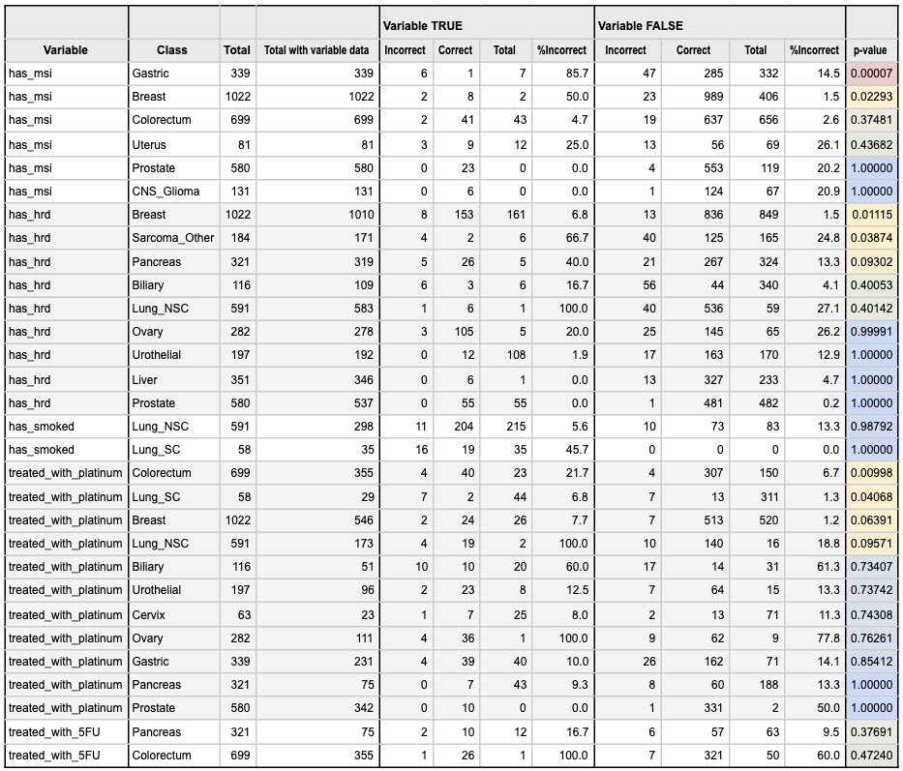
Supplementary table 1: Comparison of the number of correctly and incorrectly predicted samples between patients with and without: microsatellite instability (MSI), homologous recombination deficiency (HRD), smoking history, treatment with platinum, and treatment with 5-fluorouracil (5FU). One-sided Fisher’s exact tests were performed to determine if there were more incorrectly predicted patients with versus without the respective variable. Only cancer types with at least 5 patients being positive for the respective variable (Variable TRUE: Total) are shown.
As subclonal variants are enriched for treatment induced mutations, we also compared the performance of CUPLR when RMD and mutational signatures were extracted from all mutations versus only clonal mutations (i.e. treatment induced mutations excluded) (Supplementary figure 12). No differences in overall accuracy were found (all mutations: 91% vs. clonal mutations 90%), although large differences in accuracy were observed for Gastrointestinal_NET (all mutations: 71% vs. clonal mutations 39%) and Sarcoma_Leiomyo (all mutations: 50% vs. clonal mutations 73%). However, no clear trend of gain or loss in accuracy was observed across the individual cancer types. Treatment induced mutations thus have minimal impact on the performance of CUPLR.

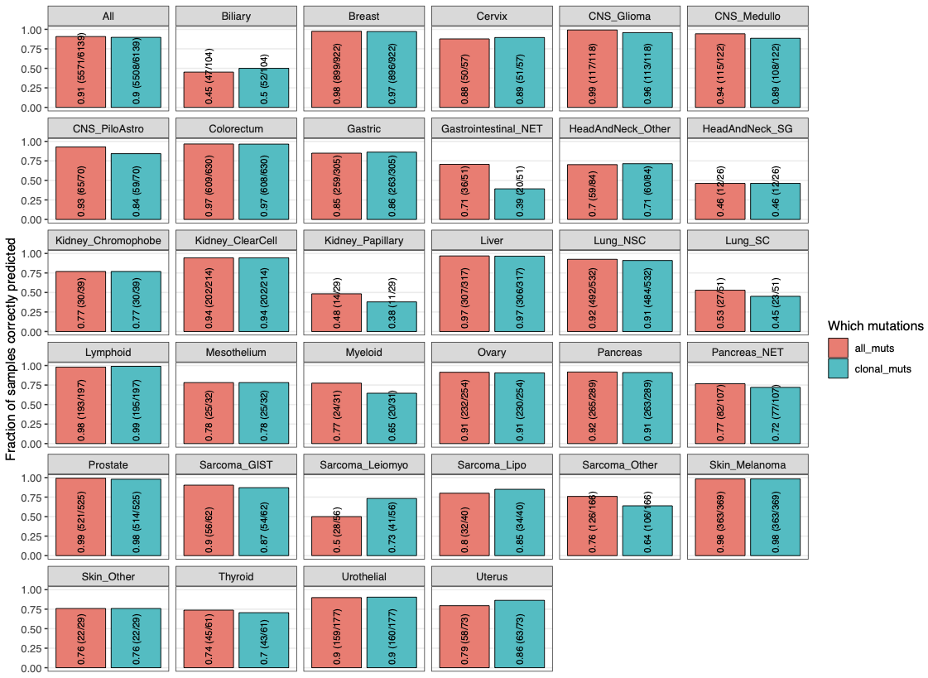Supplementary figure 12: Comparison of cancer type prediction accuracy when using all mutations versus only clonal mutations to generate the regional mutational density and mutational signature features. Accuracy (i.e. fraction of sample correctly predicted) for CUPLR was determined using cross validation. Bars are labelled with the accuracy value, as well as in brackets the number of correctly predicted samples and the total number of samples.

