Part 1: Introduction and Initial Problem Framing
Project Overview (8:00-8:05): The purpose and goals of the project were re-introduced to participants.
Initial Problem Framing (8:05-8:25): Participants filled out a survey with demographics, information on their role relative to the mobile crisis workforce, and a problem framing activity based on the method outlined by Fokkinga et al.²⁸ In this activity, participants state their view of the main problem, its causes, effects, and potential solutions (See Supplementary File 2). Later, participants who joined late were requested to share missing demographic information via email.
Introductions (8:25-8:45): The group introduced themselves to one another. Concurrently, facilitators used ChatGPT-4o to summarize the results of the initial problem-framing activity for participants and compiled a preliminary list of unique workforces within the mobile crisis workforce (e.g. ESs, CCs) based on the problems named by participants.

Part 2: Individual Activities
Summary of Initial Problem Framing (8:45 – 8:55): Participants reviewed the ChatGPT-generated summary, designed to expand their thinking on mobile crisis workforce issues to include other perspectives. This design allowed for a before-and-after comparison of how participants understood the MCT workforce pipeline.
Basic Stock and Flow Diagrams Tutorial and Creation (8:55-9:20): Participants were taught the basics of stock-and-flow diagramming using the example of the nursing workforce. This example included variables which impact the inflow and outflow into a stock called nursing workforce; variables were also given an “S” or an “O” to indicate if the number of nurses in the workforce changed in the same or the opposite direction as the size of the nursing workforce (Figure 1) or decreased alongside the variable. Participants then generated their own stock and flow diagrams using one of the workforces captured from the initial problem framing activity; they were also given the option to choose a relevant workforce not present on the list.

Supplemental Figure S1-1: Example Presented During GMB Session to Illustrate Stock and Flow Diagrams
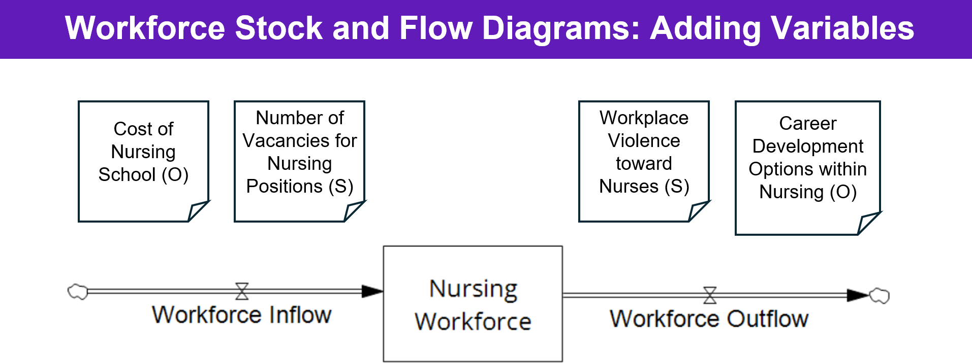
Note: “S” indicates the variable changes in the same direction as the likelihood of burnout (e.g. as one increases or decreases, the other does the same). “O” indicates the variable changes in the opposite direction as the likelihood of burnout (e.g. as one increase or decreases, the other does the opposite).

Recess and Independent Viewing (9:20-9:40): A brief recess from the meeting was given, during which participants were encouraged to view each other’s individual stock and flow diagrams. A list of other potential variables related to the mobile crisis workforce were also presented to participants to further widen their perspectives toward the system level.

Part 3: Bringing in Complexity
Complex Stock and Flow Diagrams Tutorial (9:40-9:50): Participants were then shown a more complex stock and flow diagram of the nursing workforce, priming them to consider how such a diagram would look for the mobile crisis workforce.
Complex Stock and Flow Diagram Creation (9:50-10:45): Two breakout rooms were then created, one to map the ES workforce, and one to map the CC workforce. Each breakout room had two members of the research team present to facilitate the mapping of the given workforce using Stella Architect software.²⁴ Facilitators elicited key stocks and flows from participants, and then elicited key variables and policies that may impact the capacity of the given workforce.
Complex Model Presentation and Discussion (10:55-12:10): After a 10-minute break, the facilitators and members of each of the two breakout rooms presented their stock and flow model to the rest of the group. After each presentation, time was given for discussion of the diagrams, during which corrections and updates were made based on the feedback of the rest of the group.
Final Problem Framing Activity (12:10-12:30): At the end of the session participants were asked to again fill out the problem framing activity.

