Supplementary material

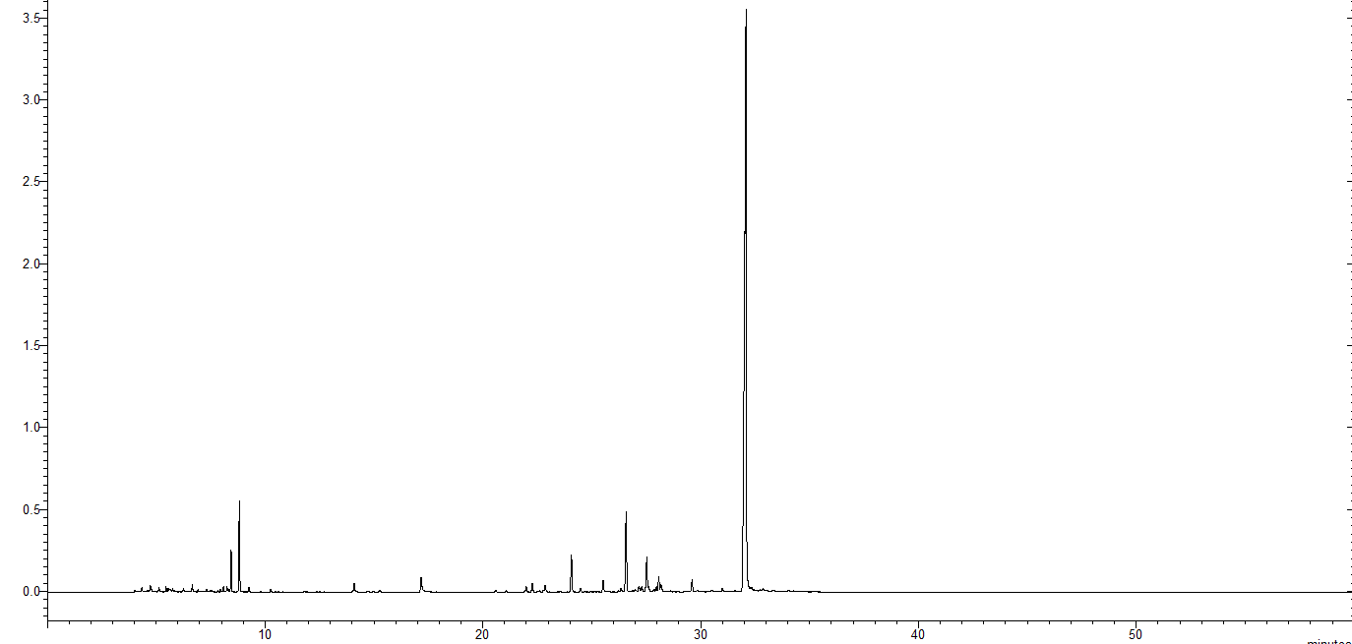
Figure 1. Chromatogram of the essential oil of Piper aduncum.
Figure 2. Chromatogram of the essential oil of Carum carvi.

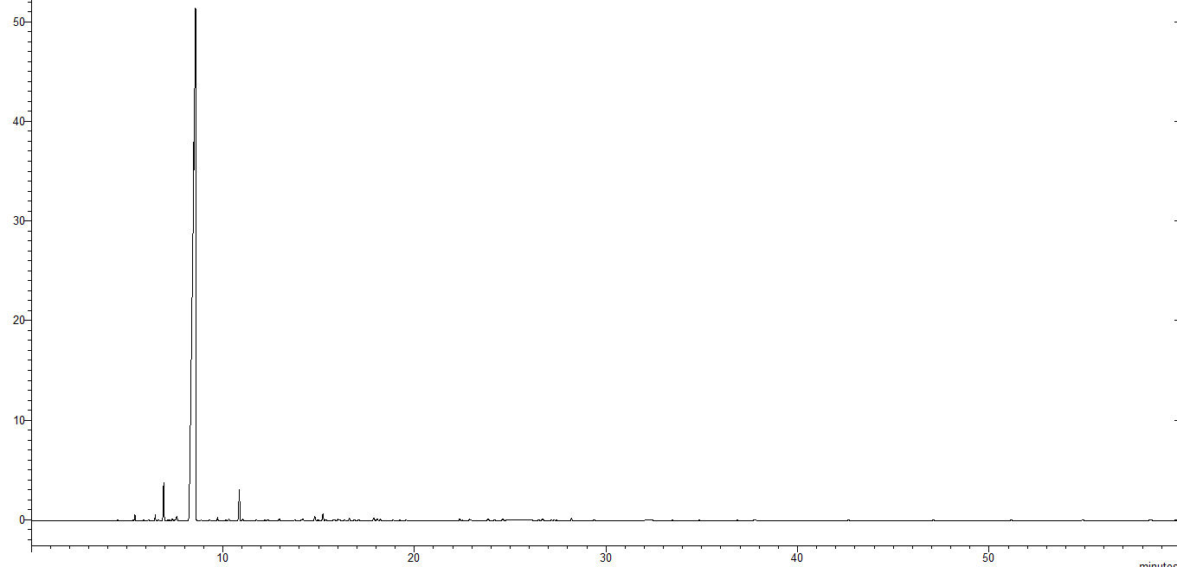
Figure 3. Chromatogram of the essential oil of Citrus sinensis.

